MSDS-422-SEC56 Quick Assignment Data Transformation Daniel Zaremba

**MinMaxScaler Data Observations**

Selected field MORTDUE and normalized it without using MinMaxScaler. The below shows the results are similar to MinMaxScaler.

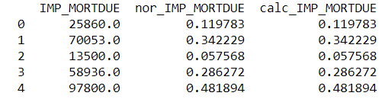

**StandardScaler Data Observations**

Selected field MORTDUE and normalized it without using StandardScaler. The below shows the results are similar to StandardScaler.

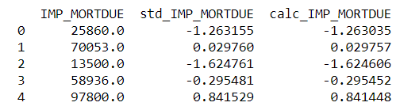

**Notes & Observations**

Two traditional ways to scale the data, first one is the MinMaxScale, where we take the min and max and scale everything between 0-1. Second way is to standardize the data, subtract by the mean and divide by the standard deviation everything will be between +- 3 usually. Both methods MinMaxScaler and StandardScaler require the data to be numeric, need to take out the categorical variables. For this assignment it was imperative to handle the outliers prior to normalizing the variables, in this exercise we dropped the outliers that were 3+ standard deviations. The screenshots above show that the manually normalized fields match the calculations performed by StandardScaler and MinMaxScaler.