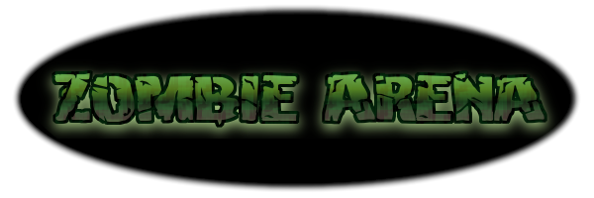

Draft Game Design Document

CS-360

Justin Wahlers

Brandon Ruiz

Scott Lilonsky

Adam Liscio

1 - Overview

In Zombie Arena, the player has been captured by a Lich, an evil, undead wizard, and trapped in his arena of undead minions and monsters where he/she is forced to fight for their life, and for the entertainment of their captor. Enemies attack the player in waves, becoming more difficult with each passing wave. The player has several ways to defend his/herself including 3 different attacks, powerups and upgrades. The player earns points by surviving as many waves as possible and defeating enemies.

2 - Gameplay Mode

Setting: The villains evil deathtrap, The Arena, placed in a fantasy setting.

Perspective: 2-Dimensional Side Scrolling View

Interaction Model: ‘A’ and ‘D’ keys are used to move left and right respectively. Spacebar is used to dodge/dash in the most recently traveled direction. The Up arrow is used to fire some projectile and is used to kill A type enemies. The Left and right arrow keys are used to deliver a melee attack that strikes G type enemies in their respective directions. The Down arrow key is used to attack the ground, crushing/escaping U type enemies.

Challenges: The primary challenge is to defeat the four types of enemies: Aerial (A), Ground (G), Underground (U) and Boss (B). A type enemies attack the player from above, often lobbing projectiles at the player or diving at him/her. G type enemies attack the player head on, shambling toward him/her and attempting to whack, bite, or otherwise strike the player. U type enemies burrow toward the player and attempt to grab his/her legs to prevent the player from moving. B type enemies are special enemies that behave differently from A, U and G types, and often require special tactics to survive and eliminate. Additionally these enemies become more powerful with each passing wave.

Actions: The player can attack Upwards (at a 45 degree angle), left, right, or down. The player can pause the game between waves in order to purchase upgrades. The player can dodge/dash through enemies to avoid taking damage.

3 - Core Features

Visuals

Each of the following will have a unique, identifiable graphic element: A enemies, G enemies, U enemies, each individual B type enemy, the player, each individual powerup, enemy projectiles, player projectiles, The Arena (background).

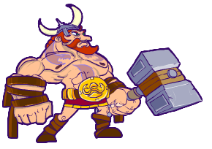

**Our Hero!**

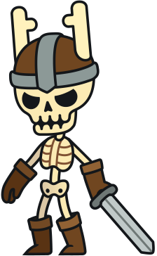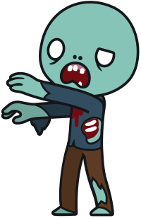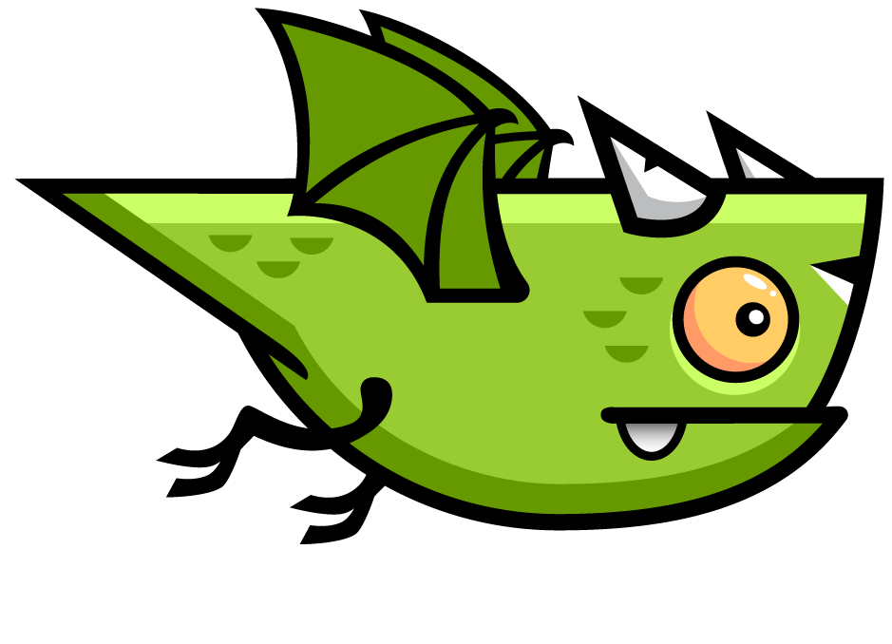

**Enemies!**

Internal Economy

Health Points - Enemies will occasionally drop an identifiable health item that refunds a small amount of health to the player. Players will also be returned to full health each time they defeat a B type enemy.

Ammo - The player’s “Up” attack has unlimited ammunition, but varying sums of special ammunition can be acquired by defeating enemies. Special ammunition deals increased damage.

Points - The player is awards points for defeating enemies. Point rewards are based on enemy type, the amount of time passed since the player last received damage, and wave number.

Game Balance

Positive Feedback - The player is awarded points, powerups, and resources for defeating enemies. The player can also earn additional points and temporary “combo buffs”, stat increases or powerups, for destroying multiple enemies in succession without taking damage.

Negative Feedback - The player loses hit points for being struck by enemy attacks, and temporarily loses the ability to attack. Combo buffs are also lost whenever the player takes damage. If the player loses all of their hit points, the game ends. Hit Points will be shown with a health bar. Each enemy attack depending on type and the attack will do a certain set of damage.

Game Difficulty (and adjustment): Every wave after wave 3 increases the strength of the enemies. The player may also select a difficulty on startup to make enemies easier or harder from the start.

Victory Conditions

Player Goals - The player’s goal is to accumulate a high score by defeating enemies and surviving waves. The player can actually defeat the final Boss for a significant point gain, at which point the game resets to the first wave, with increased difficulty. The player continues to play through these waves until they “DIE PAINFULLY”.

Losing the Game - The player “loses” once they have lost all of their hit points. At this time the player’s total score is calculated and displayed on screen.

4 - Project Organization

Justin Wahlers - Lead Programmer

Brandon Ruiz - Head of Documentation

Adam Liscio – Director of Game Testing

Scott Lilonsky - CHIEF of Media Development and Design