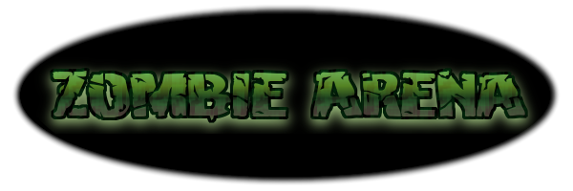

Zombie Arena

Design Document

CS-360

Justin Wahlers

Brandon Ruiz

Scott Lilonsky

Adam Liscio

1 - Overview

In Zombie Arena, the player has been captured by a Lich, an evil, undead wizard, and trapped in his arena of undead minions and monsters where he/she is forced to fight for their life, and for the entertainment of their captor. Enemies attack the player in waves, becoming more difficult with each passing wave. The player has several ways to defend his/herself including 3 different attacks, powerups and upgrades. The player earns points by surviving as many waves as possible and defeating enemies.

2 - Gameplay Mode

Setting: The villain’s evil deathtrap, The Arena, placed in a fantasy setting.

Perspective: 2-Dimensional Side Scrolling View

Interaction Model: ‘A’ and ‘D’ keys are used to move left and right respectively. Spacebar is used to dodge/dash in the current facing direction. The Up arrow is used to throw an axe and is used to kill A type enemies. The Left and right arrow keys are used to deliver a melee attack that strikes G type enemies in their respective directions. The Down arrow key is used to attack the ground, crushing/escaping U type enemies.

Challenges: The primary challenge is to defeat the three types of enemies: Aerial (A), Ground (G), and Underground (U). A type enemies attack the player from above, often lobbing projectiles at the player or diving at him/her. G type enemies attack the player head on, shambling toward him/her and attempting to whack, bite, or otherwise strike the player. U type enemies burrow toward the player and attempt to grab his/her legs to prevent the player from moving. Additionally these enemies become more powerful with each passing wave.

Actions: The player can attack Upwards (at a 45 degree angle), left, right, or down. The player can pause the game between waves in order to purchase upgrades. The player can dodge/dash through enemies to avoid taking damage while dashing.

3 - Core Features

Visuals

Each of the following will have a unique, identifiable graphic element: A enemies, G enemies, U enemies, the player, each individual powerup, enemy projectiles, player projectiles, The Arena (background).

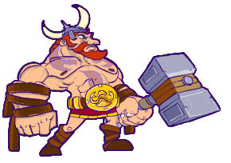

**Our Hero!**

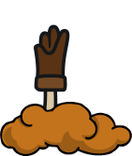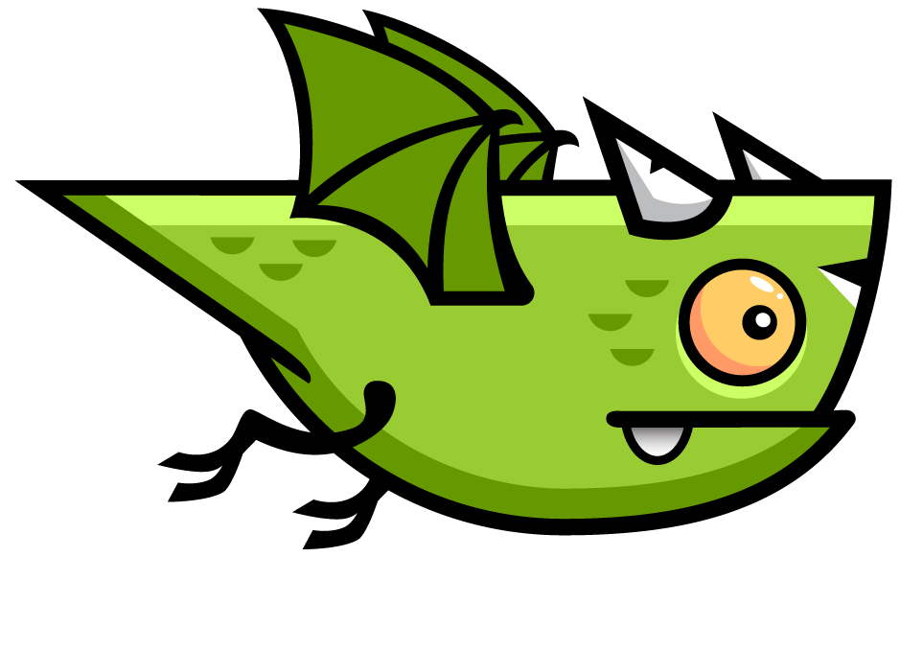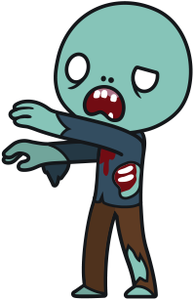

**Enemies!**

Internal Economy

Health Points - Enemies will occasionally drop an identifiable health item that refunds a small amount of health to the player.

Ammo - The player’s “Up” attack has unlimited ammunition, however it is stuck on a timer. The timer is related to how long the animation takes to play out completely. This can be shortened by increasing attack speed.

Points - The player is awards points for defeating enemies. Point rewards are based on enemy type, the amount of time passed since the player last received damage, and wave number.

Game Balance

Positive Feedback - The player is awarded points, and powerups for defeating enemies. The player can also earn additional points and temporary “combo buffs”, stat increases or powerups, for destroying multiple enemies in succession without taking damage.

Negative Feedback - The player loses hit points for being struck by enemy attacks. Combo buffs are also lost whenever the player takes damage. If the player loses all of their hit points, the game ends. Hit Points will be shown with a health bar. Each enemy attack depending on type will do a certain amount of damage.

Game Difficulty (and adjustment): Enemies will start to spawn in greater numbers and will have their health continue to grow incrementally each round the player advances to.

4. Victory Conditions

Win Conditions

Player Goals - The player’s goal is to accumulate a high score by defeating enemies and surviving waves.

Lose Conditions

Losing the Game - The player “loses” once they have lost all of their hit points. At this time the player’s total score is calculated and displayed on screen.

5 – Interface Designs

4.1 Initial Startup Screen

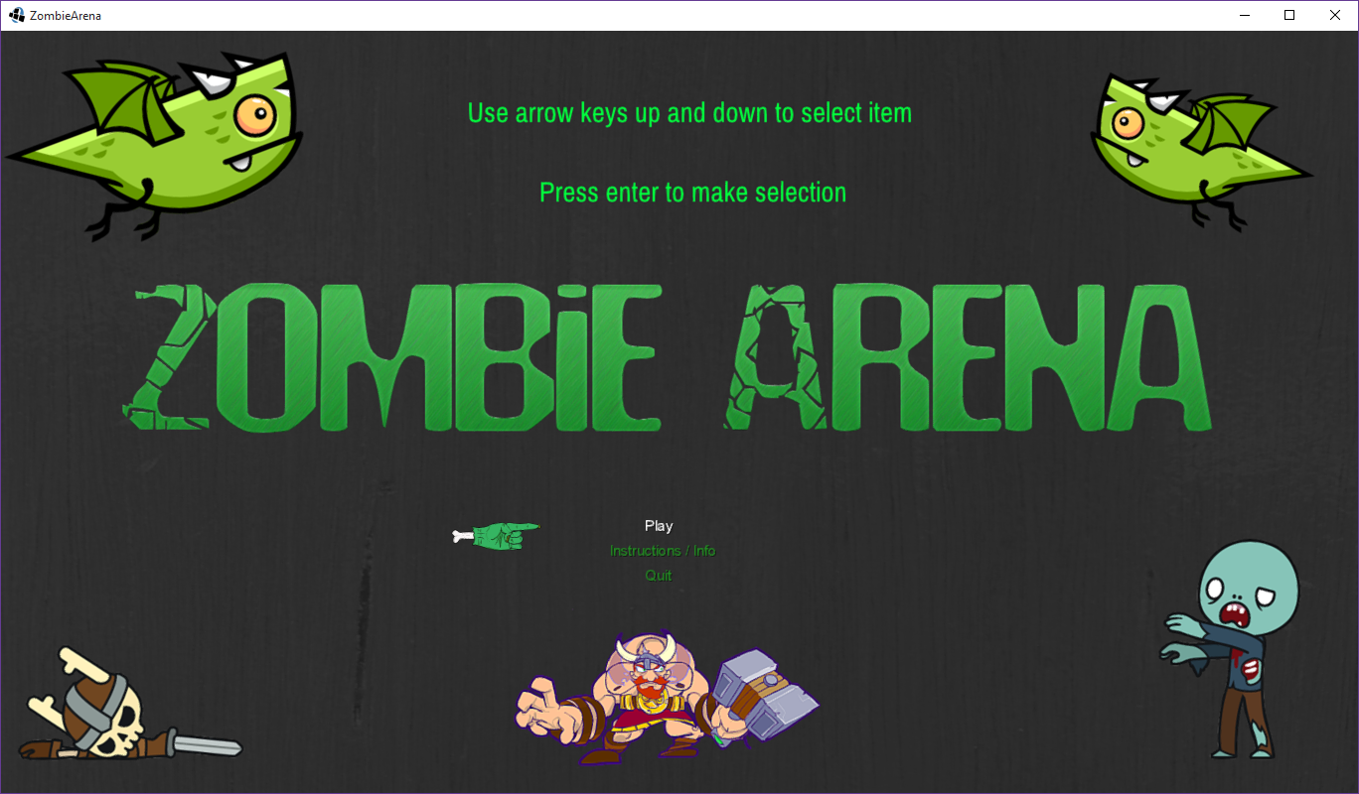

This is the first screen a user will see upon starting the game.

They may press enter to play, look at the instructions and info or press quit to exit the game.

4.2 Information Screens

A.

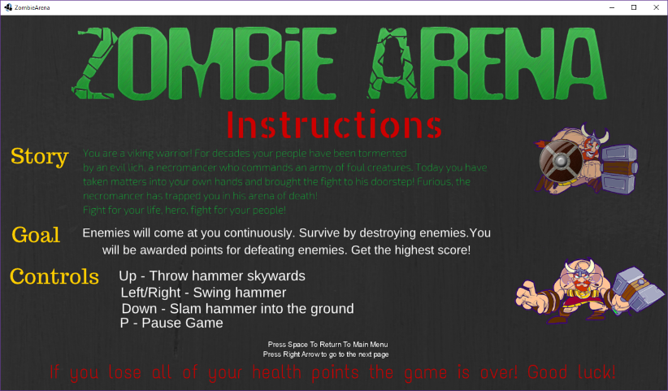

The first information page the player will see. They press right to see more information or space to return to the menu.

B.

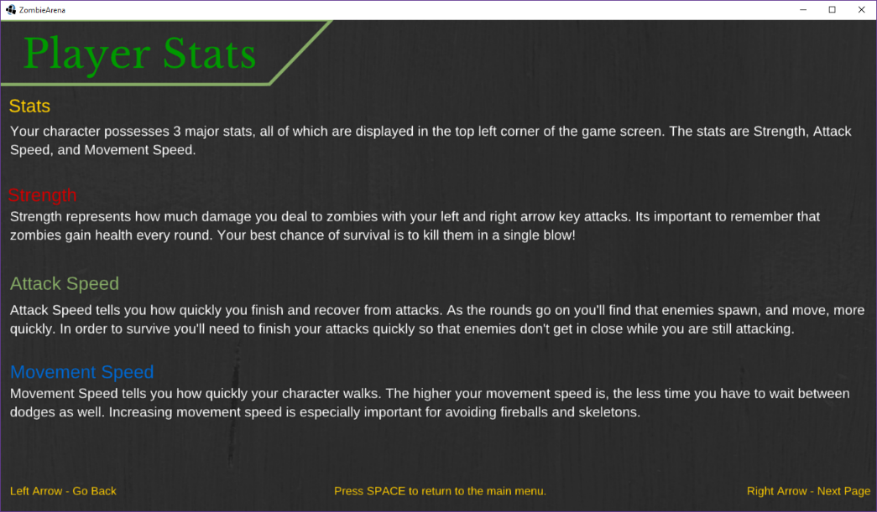

This shows the player’s stats and is the second page of information shown to the player. They may press right again for more information, left for the previous page or space for the main menu.

C.

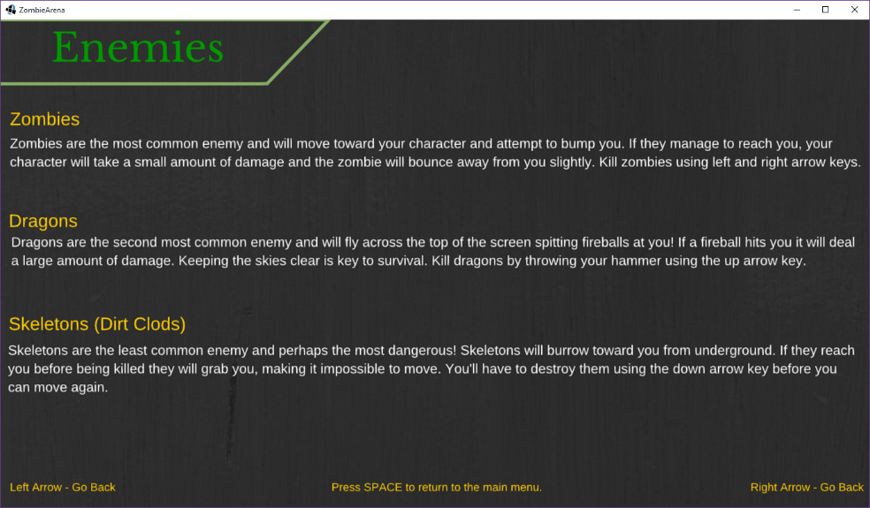

This page talks about the enemies in the game. Players may press left to go back to the stats page, space for the menu or right for the F.A.Q. screen.

D.

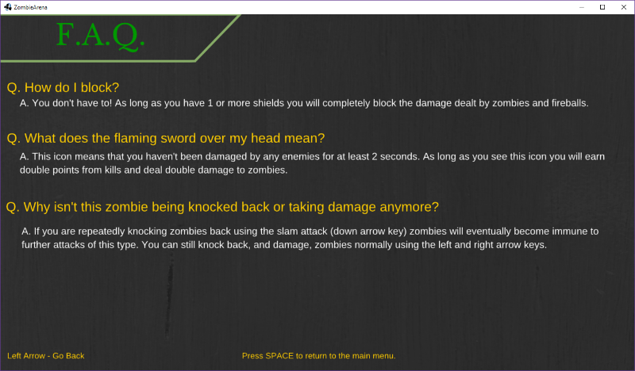

This is the F.A.Q. screen to answer potential basic questions one may have for the game. The player may press left to go back to the enemy page or space for the main menu once again.

4.3 Play Screens

A.

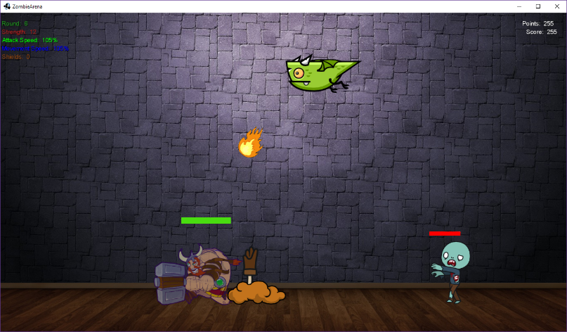

This shows a moment in game. The player is currently in the dash animation to avoid damage and enemies. All three enemies of the game are drawn and the dragon is shooting its fireball at the player. The skeleton failed its attempt to grab the player as well (thanks to them dashing). The player stats, shield count and round number are displayed in the top left of the screen. Zombies’ health bars are displayed above their heads. The player health bar is above the player as well.

B.

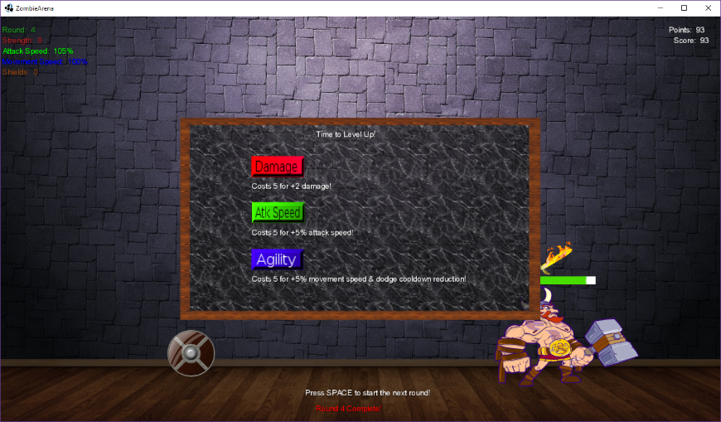

This shows what happens in between rounds, the game is temporarily stopped to allow the player to buy stat upgrades in three categories, damage, attack speed, and agility (movement speed). The player requires a certain number of points to buy each upgrade and each upgrade costs more to upgrade each subsequent time it is purchased. The game resumes when the player presses space.

C.

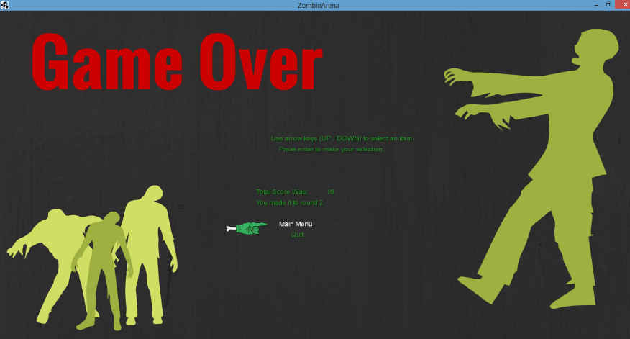

The final screen of the game is the game over screen. This shows up when the player’s health bar is depleted to zero and thus the player loses the game. When this screen is shown, it will display the player’s total score and the round that they survived until.

6 - Project Organization

Justin Wahlers - Lead Programmer

Brandon Ruiz - Head of Documentation

Adam Liscio – Director of Game Testing

Scott Lilonsky - CHIEF of Media Development and Design

Development information

* + The IDE used for the group was IntelliJ.
  + We additionally used the internet for royalty free sounds, music, and sprites.
  + The voice of The Viking is William Wahlers and was recorded by Justin Wahlers
  + Background music was written, played, and recorded by Justin Wahlers
  + We edited the sprites with GIMP.
  + We made our screens using canva.com
  + As a group we’re managing the project and keeping history using Github.com