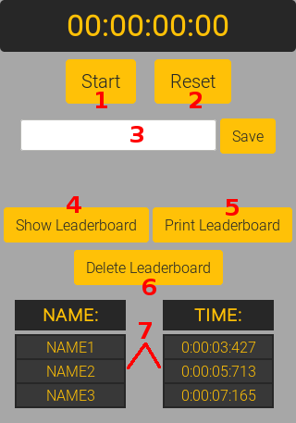

1 – Start/Stop button :
When « Start » is displayed : Starts the stopwatch @ the top using JS « timer » function that . Replace « Start » text by « stop » using innerHTML.

When « Stop » is displayed : Stops the stopwatch by freezing the timer function. Replace « Stop » by « Start » using innerHTML.

2 – Reset button : Just reload the webpage to reset the « timer » function. Can’t be easier.

3 – Name input/Save button : The save button add the name/time association to an object in an array & saved in local storage.

4- « Show Leaderboard » button: display the array’s object in 2 lists down below.

5 - « print » button : lauch a « window.print() » function.

6- « delete leaderboard » button : this button clears the leaderboard list & the localstorage.

7 – leaderboard : parse the local storage in 2 separated lists (Name & Time)

