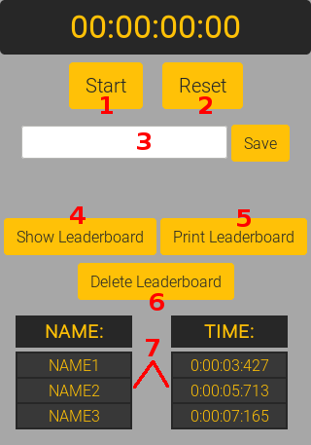

1 – « Start/Stop » button : Starts & stops the stopwatch.

2 – Bouton « Reset » : Reload the webpage, who resets the stopwatch.

3 – « Nickname input » : Put your name/nickname here & push « Save » button to save your time. /!\ This input is essential for the good save of your score. /!\

4 – « Show Leaderboard » button : Display the leaderboard with names & saved times.

5 – « Print Leaderboard » button : Print the leaderboard.

6 – « Delete Leaderboard » button : Resets the leaderboard /!\ Resetting the leaderboard deletes scores forever. Even Dr. Strange can’t bring it back. /!\

7 – Leaderboard : Show every names/times saved.

