**Case 1**

First number: 23

Second number: 6

Selected Operation: 4 (Division)

Result of program:

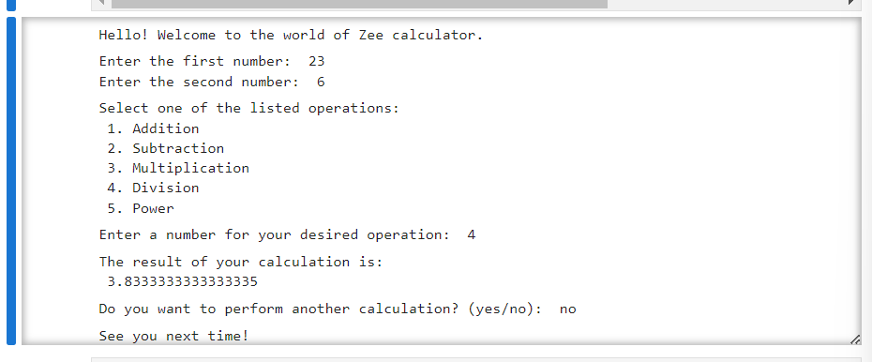

**Case 2**

First number: 50

Second number: ha

Result of program:

**Case 3**

First number: rt

Second number: 65

Result of program:

**Case 4**

First number: 106

Second number: 5

Selected Operation: 9 (invalid)

Result of program:

