Project Name: Lighthouse
Wellbeing and Self-Reflection Web Platform
Date: August 05, 2026
Environment: Web Application (Static Frontend + Supabase Backend)
Architecture: Serverless / Backend-as-a-Service (BaaS) with Row Level Security (RLS)
Document Version: 1.0 (Technical Documentation & Lab Report)
Target Display Resolution: Full HD 1920 x 1080 (16:9 Aspect Ratio)
_________________________________________________________________________________

1. Objective
The primary objective of Project Lighthouse is to develop a highly secure, private, and user-centric wellbeing and self-reflection platform. The application provides an elegant, responsive, and calm workspace where users can track key metrics, perform emotional checks, evaluate psychological scenarios, and record private thoughts without fearing data leakage. In parallel, the system provides an administrative layer that allows platform operators to monitor engagement trends and trigger care interventions for high-risk users, without ever exposing users' personal journal texts.
Key objectives of the "Lighthouse" platform are:
- Structured Habit & Mood Tracking: Empowering individuals to monitor structured wellbeing metrics (sleep, mood, productivity, physical activity, water intake) on a daily basis.
- Guided Daily Journey (Core Loop): Streamlining user engagement through a cohesive 4-step sequence (Check-in -> Scenario Assessment -> Visual Reflection -> Journal).
- Privacy-First Architecture: Ensuring complete data ownership. Row Level Security (RLS) restricts access to personal records. Under no circumstances can admin operators view private journal text.
- Platform-Side Attention Heuristics: Evaluating user check-in history to flag cases of consecutive low mood, sleep deprivation, or high social avoidance, allowing moderators to act proactively.
- Soft Platform Care: Enabling admins to log notes, initiate watchlist monitoring, and dispatch gentle 'nudge' notifications to users needing attention.
- Real-time and Demo Analytics: Supplying interactive data visualizations powered by Chart.js and Recharts for both individual users and platform administrators.

2. System Architecture & Sidebar Layout
The application is built around an integrated App Shell featuring a modern, collapsible Left Sidebar Navigation. This layout ensures fast, single-click access across all primary modules on desktop, tablet, and mobile displays without overcrowding the viewport header.

3. Detailed Module Walkthrough & Screenshots
This section presents a step-by-step walkthrough of every user interface in The Lighthouse. Each module is documented with its operational role, key feature set, and embedded 16:9 Full HD (1920x1080) visual screenshot placeholders.
3.1 Authentication & User Onboarding | SECURITY & SESSION MANAGEMENT
The authentication module handles user sign-in and account creation securely through Supabase Auth. It enforces client-side validation, password metering, and securely manages JWT tokens to persist user sessions across browser reloads.
[PASTE 1920x1080 (16:9 FHD) SCREENSHOT HERE]
Figure 3.1: The Login and Sign-Up interface featuring form validation and secure user onboarding.
3.2 Main Dashboard | CENTRAL CONTROL HUB
The Main Dashboard functions as the primary control center for the user. It aggregates streak counters, daily journey progress, recent entry statistics, and score indicators into a single unified view.
[PASTE 1920x1080 (16:9 FHD) SCREENSHOT HERE]
Figure 3.2: Upper Dashboard section containing streak statistics, score overview cards, and journey steps.
3.3 Daily Check-In | EMOTIONAL ANALYTICS
The Mood Log allows users to quickly record their emotional state throughout the day using intuitive visual sliders. The accumulated data is automatically plotted into mood trend line charts.
[PASTE 1920x1080 (16:9 FHD) SCREENSHOT HERE]
Figure 3.3: Daily check-in widget with emotion selector sliders and visual distribution charts.
3.4 Reflection Journal | REFLECTIVE WRITING
The Journal module enables users to log daily reflections in a private space. Upon entering text, the system parses linguistic patterns to compute real-time scores for emotional tone.
[PASTE 1920x1080 (16:9 FHD) SCREENSHOT HERE]
Figure 3.4: The Reflection Journal featuring interactive writing prompts and saved entries.
3.5 Scenario Assessment | SITUATIONAL ANALYSIS
Users are presented with one of 50 curated real-life scenarios evaluating decision-making, conflict resolution, and coping mechanisms under pressure.
[PASTE 1920x1080 (16:9 FHD) SCREENSHOT HERE]
Figure 3.5: A multiple-choice Scenario Assessment questionnaire card.
3.6 Scenario Feedback | COGNITIVE RESTRUCTURING
After completing a scenario assessment, immediate feedback is provided, highlighting alternative coping perspectives and constructive behavior recommendations.
[PASTE 1920x1080 (16:9 FHD) SCREENSHOT HERE]
Figure 3.6: Constructive feedback card displayed following scenario selection.
3.7 Visual Memory Challenge | INTERACTIVE BRAIN TRAINING
A cognitive mini-game designed to track short-term memory patterns over time. Game performance metrics feed directly into the user's cognitive evaluation log.
[PASTE 1920x1080 (16:9 FHD) SCREENSHOT HERE]
Figure 3.7: The Visual Memory Challenge active game canvas area.
3.8 Reaction Time Challenge | COGNITIVE RESPONSE
A visual tracking game that monitors the user's cognitive reaction speeds in milliseconds, measuring alertness, focus, and visual processing speed.
[PASTE 1920x1080 (16:9 FHD) SCREENSHOT HERE]
Figure 3.8: The Reaction Time Challenge interface with real-time response counters.
3.9 Click Accuracy Challenge | PRECISION METRICS
The final cognitive test measures motor precision and sustained attention by tracking target hits and misses under time constraints.
[PASTE 1920x1080 (16:9 FHD) SCREENSHOT HERE]
Figure 3.9: The Click Accuracy Challenge target canvas area.
3.10 Lighthouse AI Companion | VIRTUAL WELLNESS COMPANION
The AI Assistant provides a conversational chat interface powered by Groq LLM routing. It reads recent wellness context (moods, journal sentiment, game scores) to offer empathetic guidance.
[PASTE 1920x1080 (16:9 FHD) SCREENSHOT HERE]
Figure 3.10: Conversational chat window showing personalized reflection prompts and AI advice.
3.11 User Analytics & History | AGGREGATED INSIGHTS
The Analytics page brings together all logged data sources—wellness index, average mood, cognitive scores—into a unified, side-by-side analytical dashboard.
[PASTE 1920x1080 (16:9 FHD) SCREENSHOT HERE]
Figure 3.11: Comprehensive Analytics dashboard displaying aggregated metric cards and trend charts.
3.12 Admin Platform Analytics | ADMINISTRATIVE OVERSIGHT
A high-level dashboard exclusively for administrators. It aggregates platform health, active users, check-in completion rates, and system engagement.
[PASTE 1920x1080 (16:9 FHD) SCREENSHOT HERE]
Figure 3.12: Admin Analytics dashboard displaying global platform metrics.
3.13 Admin User Directory | COMMUNITY HEALTH
A comprehensive directory of registered users. Administrators can search, filter by risk bands (Low, Moderate, High), and identify users needing support.
[PASTE 1920x1080 (16:9 FHD) SCREENSHOT HERE]
Figure 3.13: Admin User Directory with search and filtering capabilities.
3.14 Admin Care Panel | INTERVENTION STRATEGIES
The Care Panel allows administrators to review attention signals, manage watchlists, and send gentle in-app nudges without ever exposing private journal text.
[PASTE 1920x1080 (16:9 FHD) SCREENSHOT HERE]
Figure 3.14: The Care Panel interface showing watchlist controls and nudge features.
3.15 Scenario Management | CONTENT ADMINISTRATION
A full CRUD (Create, Read, Update, Delete) interface for the platform's scenario bank, allowing admins to edit, disable, or author scenarios.
[PASTE 1920x1080 (16:9 FHD) SCREENSHOT HERE]
Figure 3.15: Scenario Management table displaying all 50 platform scenarios with serial numbering.

4. Technology Stack & Implementation Details
System Layer | Technology Selected | Implementation Role
Frontend Framework | Vanilla JavaScript, HTML5, CSS3 | Renders a fast, lightweight single-page web application without heavy framework overhead.
Styling & UI | Custom Vanilla CSS, Flexbox/Grid | Delivers modern dark-themed components, glassmorphism, and responsive layouts.
Data Visualization | Chart.js & Recharts | Draws responsive area, line, bar, and radar charts for user and admin dashboards.
Backend & Database | Supabase (PostgreSQL & Auth) | Manages user authentication, RLS security policies, and PostgreSQL database tables.
AI Integration | Groq API (Llama 3.3 70B) | Provides high-speed conversational AI responses tailored to user reflection data.
Export Engine | jsPDF & python-docx | Renders structured HTML and automated DOCX lab reports.

5. Application Flowchart
The following flowchart illustrates the high-level architecture and user navigation paths throughout the Lighthouse platform, starting from authentication through to the core modules and administrative controls.
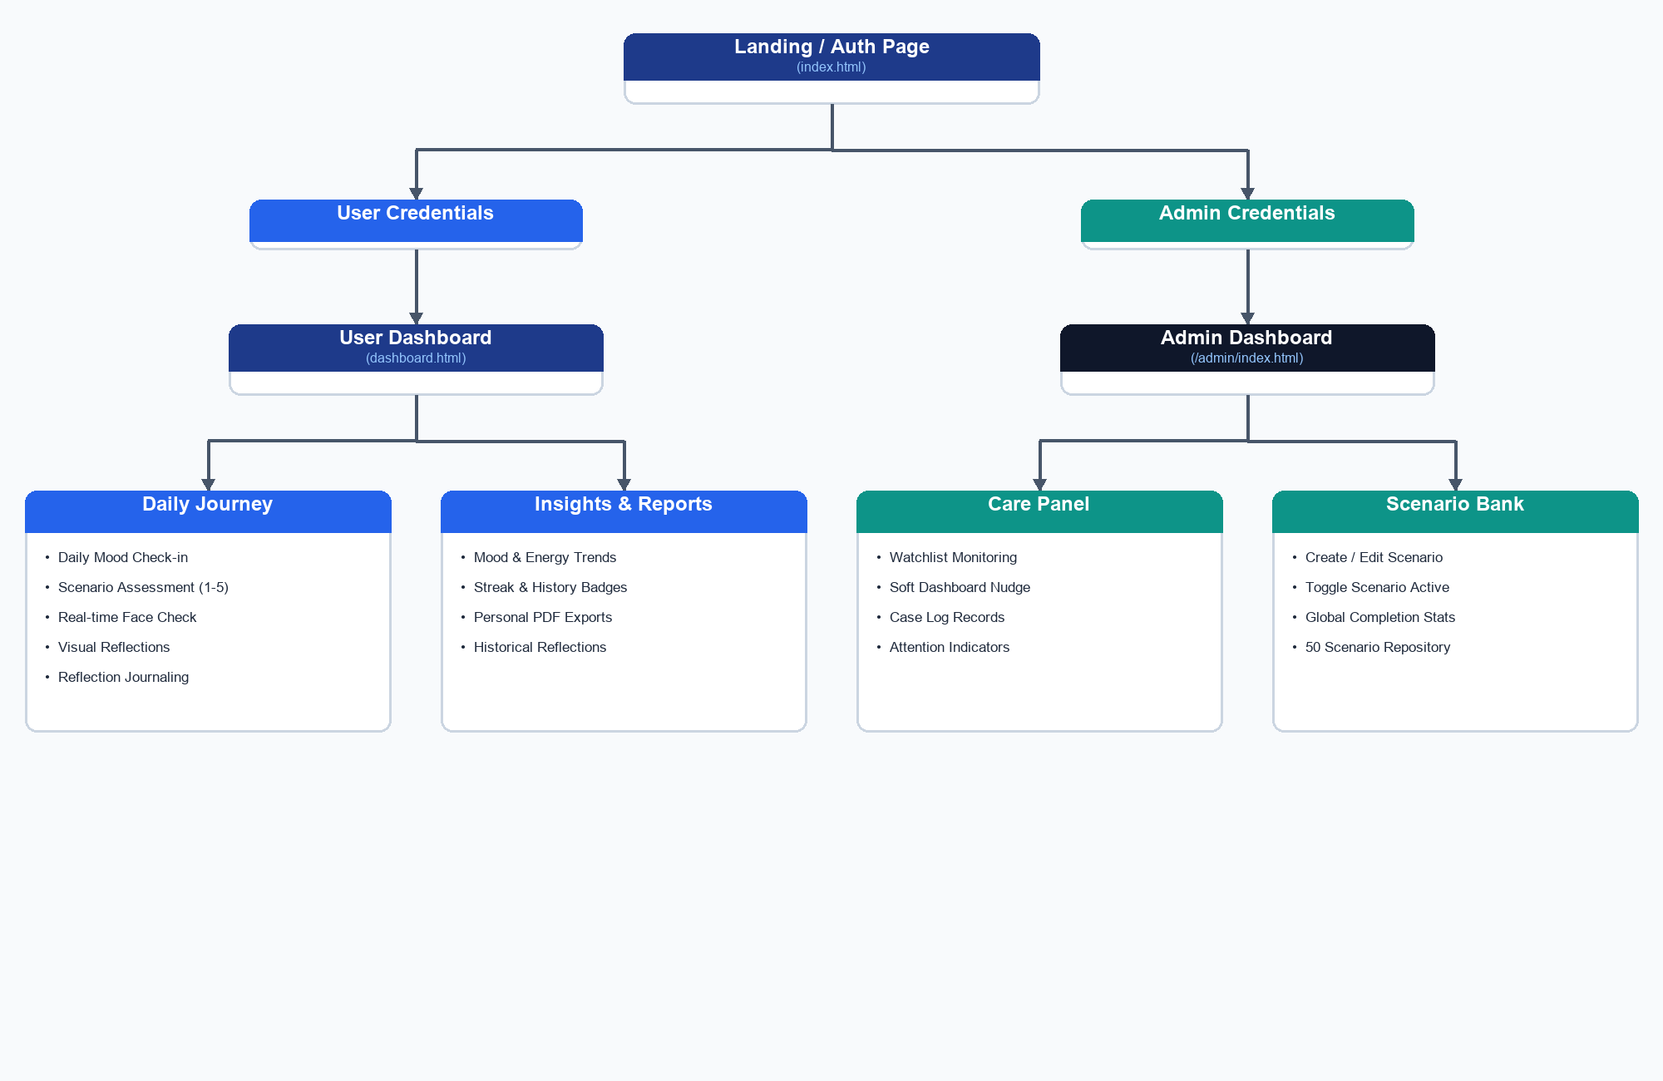
Figure 5.1: High-Level Application Flowchart Diagram

6. Functionality
User Panel Features
- Daily Check-in: A form where users check in on structured indicators like hours of sleep, mood levels (scale of 1-5), energy levels, productivity, physical activity (None to High), water intake, and general notes. Data is stored in daily_checkins.
- Scenario Assessments (Slots 1-5): Presents short, daily, randomized scenarios from the scenario bank. The user selects a coping option (A, B, C, or D), which maps to specific behavioral indicators. The results are recorded under scenario_responses. Up to 5 slots are allocated per day.
- Real-time Face Check: An ML-powered step that accesses the user's webcam (with full offline, skipped, or fallback support) to run clientside facial detection. It extracts expressions (happy, neutral, sad, surprised, angry, fearful, disgusted) and stores the dominant expression scores in behavioral_activity_results under 'face_check'.
- Visual Reflections: Allows users to select an abstract photographic theme (e.g., Ocean, Forest, Storm Sky) that represents their current emotional context. Saves category choices under visual_reflections.
- Reflection Journal: A private, rich text field where users can write open reflections. Data is encrypted/secured in reflections, linked to the user's UUID, and completely shielded from administrative eyes.
- Insights Dashboard: Generates interactive trend charts using Chart.js for sleep patterns, mood shifts, productivity curves, selected visual themes, and facial expression distributions. Features a 'Demo Analytics' mock toggle to show complete dashboards when history is thin.
- Lighthouse AI Companion: An intelligent, Groq LLM-powered assistant (Llama 3.3 70B) designed specifically for Lighthouse data interpretation. It securely reads the user's check-in trends, mood logs, reflection entries, and game scores to answer context-aware questions and provide personalized wellbeing insights.
- Personal Report Export: Integrates jsPDF on the client side, allowing the user to download a clean, formatted PDF report of their weekly or monthly check-in history and reflection frequency.

Admin Panel Features
- Platform Health & Analytics: Displays overall usage counts, user registration numbers, total journal submissions, completed scenarios, and active participant numbers over time.
- Flagged User Care Panel: Aggregates attention flags without exposing private texts. Admins can place high-risk users on a 7-day watchlist, log private case notes, and trigger gentle soft nudges shown on user home screens.
- Care Flagging Logic: Heuristics evaluate recent data logs: (1) low mood streaks (>=3 checkins under 'Neutral' in the last 5 checkins), (2) sleep deprivation (<5 hours in multiple logs), (3) social avoidance (selecting avoidant options in scenario responses), and (4) inactivity gaps (>=4 days without check-ins).
- Scenario Bank Manager: Provides interface elements to create new scenario items, edit existing stories, define choices (A, B, C, D), and toggle items as active or inactive.
- High-Value PDF Packs: Generates structured PDF packages on the fly via jsPDF, including Platform Snapshots, Engagement Logs, Flagged User Case Summaries, and User Cohort breakdowns.

7. Conclusion
The Lighthouse platform successfully integrates cognitive tracking, interactive brain training, emotional reflection, and conversational AI into a unified web application. The clean modular architecture, responsive layout, elegant font choices, and robust administrative tools make it a highly effective and visually appealing system for personal wellbeing management.

