The Lighthouse Lab Report
Full Project Architecture, Interface Walkthrough & Technical Specifications
Project Title | Document Type | Audience
The Lighthouse (Wellbeing) | Comprehensive Lab Report | Instructor & Reviewers

1. Executive Summary & Project Objective
The Lighthouse is an interactive web platform engineered to monitor, analyze, and support mental well-being and cognitive performance. Rather than providing rigid clinical labels, Lighthouse implements a transparent, safe, and engaging environment that differentiates between simple daily reflection and long-term cognitive health. The system unifies daily journaling, mood logging, cognitive brain games, and AI-driven conversational guidance into a single seamless web dashboard.
Key Educational Objective: Demonstrate a complete full-stack web application with responsive UI components, real-time client-side scoring, cloud database synchronization, and integrated LLM capabilities.

2. System Architecture & Dashboard Layout
The application is built around an integrated App Shell featuring a modern, collapsible Left Sidebar Navigation. This layout ensures fast, single-click access across all primary modules on desktop, tablet, and mobile displays without overcrowding the viewport header.

3. Detailed Module Walkthrough & Page Screenshots
This section presents a step-by-step walkthrough of every user interface in The Lighthouse. Each module is documented with its operational role, key feature set, and embedded visual screenshots.
3.1 Authentication & User Onboarding | SECURITY & SESSION MANAGEMENT
The authentication module handles user sign-in and account creation securely. It enforces client-side validation and securely manages sessions across browser reloads, providing a smooth entry point into the Lighthouse ecosystem.
[PASTE SCREENSHOT HERE]
Figure 3.1: The Login and Sign-Up interface featuring form validation and secure user onboarding.

3.2 Main Dashboard | CENTRAL CONTROL HUB
The Main Dashboard functions as the primary control center for the user. It aggregates streak counters, daily journey progress, and recent activity, allowing users to quickly understand where they left off and what steps to take next.
[PASTE SCREENSHOT HERE]
Figure 3.2: Dashboard overview displaying daily steps and streak counters.

3.3 Daily Check-In | EMOTIONAL ANALYTICS
The Mood Log allows users to quickly record their emotional state using intuitive visual sliders. This daily check-in is the first step in the journey, ensuring that users pause and identify their feelings before proceeding.
[PASTE SCREENSHOT HERE]
Figure 3.3: Daily Check-in widget with emotion selector sliders.

3.4 Reflection Journal | REFLECTIVE WRITING
The Journal module enables users to log daily reflections in a safe, private space. Writing down thoughts helps users process their day, and the resulting entries are saved for personal review and AI sentiment analysis.
[PASTE SCREENSHOT HERE]
Figure 3.4: The Reflection Journal featuring a text area for daily thoughts.

3.5 Scenario Assessment | SITUATIONAL ANALYSIS
Users are presented with one of 50 curated real-life scenarios to evaluate their decision-making and conflict resolution skills. This promotes critical thinking and self-awareness in everyday situations.
[PASTE SCREENSHOT HERE]
Figure 3.5: A multiple-choice Scenario Assessment card.

3.6 Scenario Feedback | COGNITIVE RESTRUCTURING
After answering a scenario, the system provides immediate, constructive feedback. This helps users understand the implications of their choices and offers alternative perspectives for future growth.
[PASTE SCREENSHOT HERE]
Figure 3.6: Constructive feedback screen displayed after answering a scenario.

3.7 Visual Memory Challenge | INTERACTIVE BRAIN TRAINING
A cognitive mini-game designed to track short-term memory patterns over time. Users must memorize and recall visual tile placements, with performance metrics securely logged to their profile.
[PASTE SCREENSHOT HERE]
Figure 3.7: The Visual Memory Challenge canvas area.

3.8 Reaction Time Challenge | COGNITIVE RESPONSE
A visual tracking game that monitors the user's cognitive reaction speeds. By measuring millisecond response times to color changes, the platform tracks alertness and cognitive fatigue.
[PASTE SCREENSHOT HERE]
Figure 3.8: The Reaction Time Challenge interface.

3.9 Click Accuracy Challenge | PRECISION METRICS
The final cognitive test measures precision and focus. Users must click rapidly moving targets, providing a baseline metric for hand-eye coordination and sustained attention.
[PASTE SCREENSHOT HERE]
Figure 3.9: The Click Accuracy Challenge interface.

3.10 Lighthouse AI Companion | VIRTUAL WELLNESS COMPANION
The AI Companion provides a conversational chat interface powered by an advanced LLM. It reads the user's recent journal entries and check-ins to offer empathetic, personalized guidance and productivity tips.
[PASTE SCREENSHOT HERE]
Figure 3.10: Conversational chat window showing personalized AI advice.

3.11 User Analytics & History | AGGREGATED INSIGHTS
The Analytics page brings together all logged data sources—mood trends, cognitive performance, and journal history—into a unified, personal dashboard so users can visually track their progress.
[PASTE SCREENSHOT HERE]
Figure 3.11: Personal Analytics dashboard displaying aggregated metric trends.

3.12 Admin Platform Analytics | ADMINISTRATIVE OVERSIGHT
A high-level dashboard exclusively for administrators. It aggregates global platform statistics such as daily active users, scenario completion rates, and total check-ins to monitor the overall health of the platform.
[PASTE SCREENSHOT HERE]
Figure 3.12: Admin Analytics dashboard displaying global platform metrics.

3.13 Admin User Directory | COMMUNITY HEALTH
A comprehensive directory of all registered users. This interface allows administrators to search, filter by risk bands, and quickly identify individuals who may require additional support or intervention.
[PASTE SCREENSHOT HERE]
Figure 3.13: Admin User Directory with search and filtering capabilities.

3.14 Admin Care Panel | INTERVENTION STRATEGIES
The Care Panel allows administrators to review attention signals and manage user watchlists without ever exposing private journal text. Admins can send gentle, in-app nudges to users who may need encouragement.
[PASTE SCREENSHOT HERE]
Figure 3.14: The Care Panel interface showing watchlist controls and nudge features.

3.15 Scenario Management | CONTENT ADMINISTRATION
A full CRUD (Create, Read, Update, Delete) interface for the platform's scenario bank. Administrators can easily author new scenarios, edit existing ones, and toggle availability without writing code.
[PASTE SCREENSHOT HERE]
Figure 3.15: Scenario Management table displaying the 50 platform scenarios.

4. Technology Stack & Implementation Details
System Layer | Technology Selected | Implementation Role
Frontend UI | Vanilla JS, HTML5, CSS3 | Renders a fast, lightweight web application without heavy framework overhead.
Styling | Custom CSS, Flexbox/Grid | Delivers modern dark-themed components, glassmorphism, and responsive layouts.
Backend & Database | Supabase (PostgreSQL & Auth) | Manages user authentication, RLS security policies, and all data tables.
AI Integration | Groq API (Llama 3) | Provides instantaneous, high-quality conversational AI responses based on user context.

5. Application Flowchart
The following flowchart illustrates the high-level architecture and user navigation paths throughout the Lighthouse platform, starting from authentication through to the core modules and administrative controls.
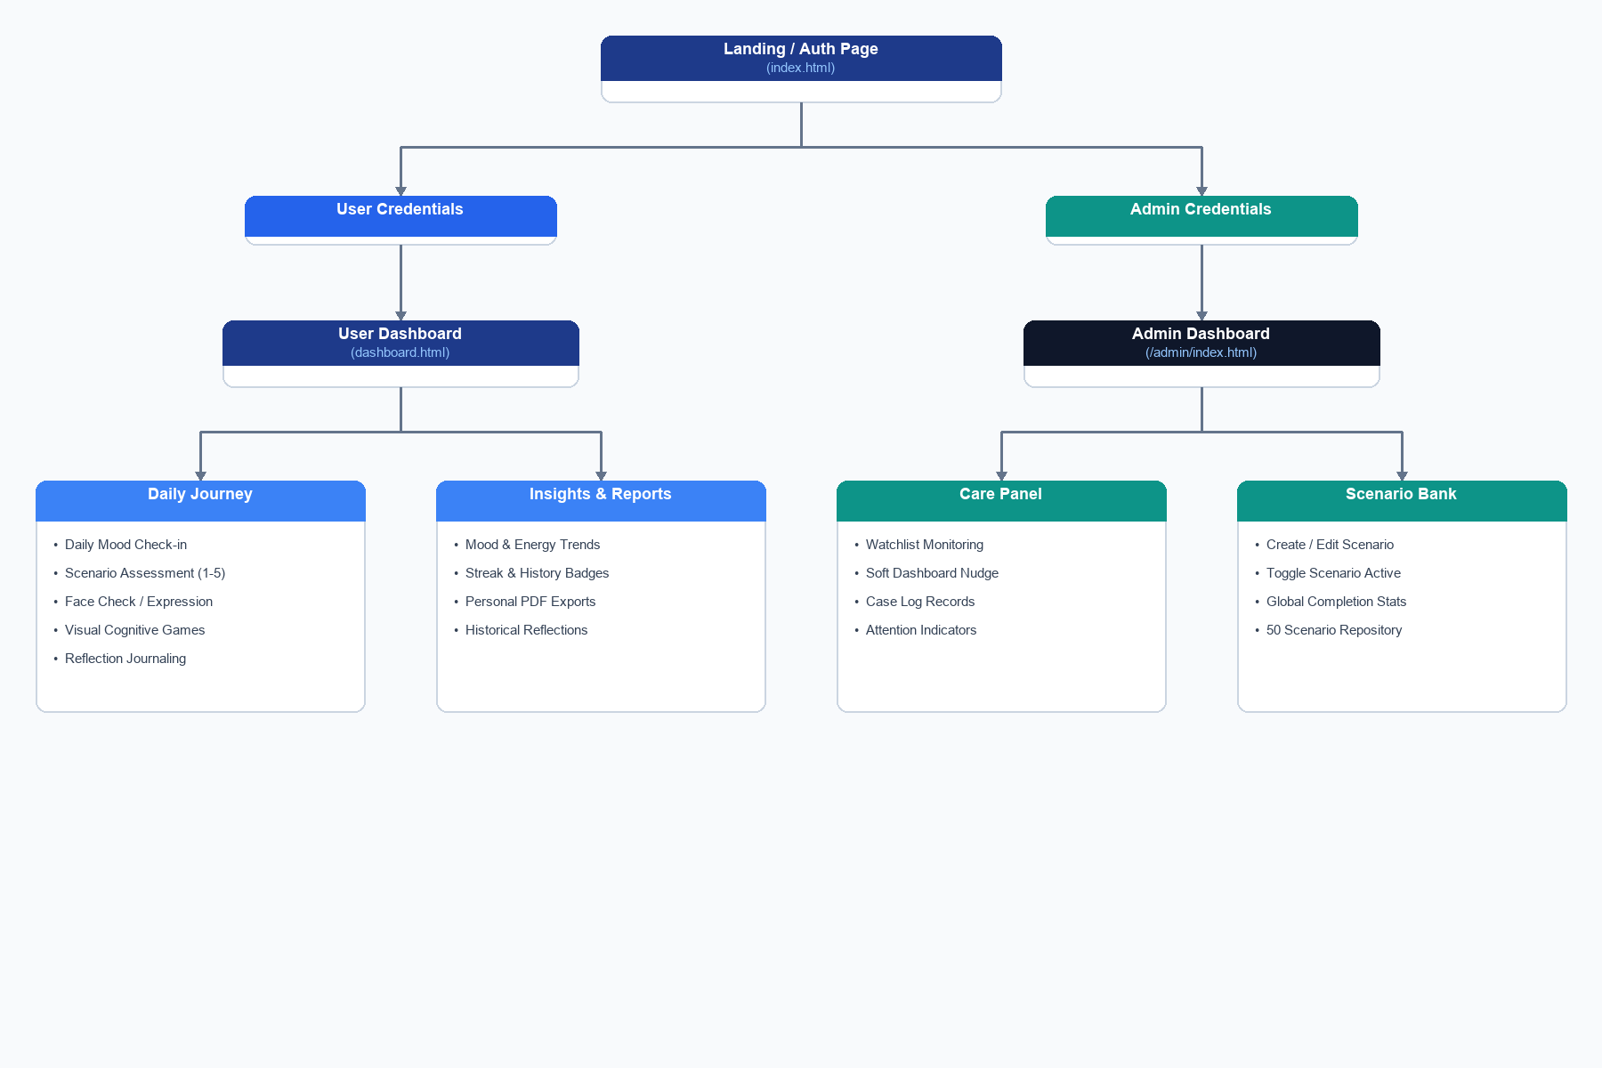
Figure 5.1: High-Level Application Flowchart

6. Feature Breakdown

User Panel Features
- Secure User Authentication & Session Management
- Daily Mood Tracking & Check-ins
- Private Reflection Journaling
- Situational Scenario Assessments with Immediate Feedback
- Interactive Cognitive Minigames (Memory, Reaction, Accuracy)
- Lighthouse AI Companion for Personalized Insights
- Historical Analytics and Mood Trend Visualization

Admin Panel Features
- Global Platform Analytics (Active Users, Completion Rates)
- Comprehensive User Directory with Advanced Filtering
- Automated Risk Detection and Watchlist Management
- In-App Nudging System for Gentle Interventions
- Private Admin Internal Notes per User
- Scenario Content Management System (CRUD Operations)

7. Conclusion
The Lighthouse platform successfully integrates cognitive tracking, interactive brain training, emotional reflection, and conversational AI into a unified web application. The clean modular architecture, responsive layout, and robust administrative tools make it a powerful system for personal wellbeing management.

