Project Name: Lighthouse
Wellbeing and Self-Reflection Web Platform

Date: August 05, 2026
Environment: Web Application (Static Frontend + Supabase Backend)
Architecture: Serverless / Backend-as-a-Service (BaaS) with Row Level Security (RLS)
Document Version: 1.0 (Technical Documentation & Lab Report)
_________________________________________________________________________________

1. Executive Summary & Objective
The primary objective of Project Lighthouse is to develop a highly secure, private, and user-centric wellbeing and self-reflection platform. The application provides an elegant, responsive, and calm workspace where users can track key metrics, perform emotional checks, evaluate psychological scenarios, and record private thoughts without fearing data leakage. In parallel, the system provides an administrative layer that allows platform operators to monitor engagement trends and trigger care interventions for high-risk users, without ever exposing users' personal journal texts.
Key objectives of the "Lighthouse" platform are:
- Structured Habit & Mood Tracking: Empowering individuals to monitor structured wellbeing metrics (sleep, mood, productivity, physical activity) on a daily basis.
- Guided Daily Journey (Core Loop): Streamlining user engagement through a cohesive 4-step sequence (Check-in -> Scenario Assessment -> Visual Reflection -> Journal).
- Privacy-First Architecture: Ensuring complete data ownership. Row Level Security (RLS) restricts access to personal records. Under no circumstances can admin operators view private journal text.
- Platform-Side Attention Heuristics: Evaluating user check-in history to flag cases of consecutive low mood, sleep deprivation, or high social avoidance, allowing moderators to act proactively.
- Soft Platform Care: Enabling admins to log notes, initiate watchlist monitoring, and dispatch gentle 'nudge' notifications to users needing attention.
- Real-time and Demo Analytics: Supplying interactive data visualizations powered by Chart.js and Recharts for both individual users and platform administrators.

2. System Architecture & Sidebar Layout
The application is built around an integrated App Shell featuring a modern, collapsible Left Sidebar Navigation. This layout ensures fast, single-click access across all primary modules on desktop, tablet, and mobile displays without overcrowding the viewport header.

3. Detailed Module Walkthrough & Screenshots
This section presents a step-by-step walkthrough of every user interface in The Lighthouse. Each module is documented with its operational role, key feature set, and embedded visual screenshot placeholders.
3.1 Authentication & User Onboarding | SECURITY & SESSION MANAGEMENT
The authentication module handles user sign-in and account creation securely through Supabase Auth. It enforces client-side validation, password metering, and securely manages JWT tokens to persist user sessions across browser reloads.
[PASTE SCREENSHOT HERE]
Figure 3.1: The Login and Sign-Up interface featuring form validation and secure user onboarding.

3.2 Main Dashboard | CENTRAL CONTROL HUB
The Main Dashboard functions as the primary control center for the user. It aggregates streak counters, daily journey progress, recent entry statistics, and score indicators into a single unified view.
[PASTE SCREENSHOT HERE]
Figure 3.2: Upper Dashboard section containing streak statistics, score overview cards, and journey steps.

3.3 Daily Check-In | EMOTIONAL ANALYTICS
The Mood Log allows users to quickly record their emotional state throughout the day using intuitive visual sliders. The accumulated data is automatically plotted into mood trend line charts.
[PASTE SCREENSHOT HERE]
Figure 3.3: Daily check-in widget with emotion selector sliders and visual distribution charts.

3.4 Reflection Journal | REFLECTIVE WRITING
The Journal module enables users to log daily reflections in a private space. Upon entering text, the system parses linguistic patterns to compute real-time scores for emotional tone.
[PASTE SCREENSHOT HERE]
Figure 3.4: The Reflection Journal featuring interactive writing prompts and saved entries.

3.5 Scenario Assessment | SITUATIONAL ANALYSIS
Users are presented with one of 50 curated real-life scenarios evaluating decision-making, conflict resolution, and coping mechanisms under pressure.
[PASTE SCREENSHOT HERE]
Figure 3.5: A multiple-choice Scenario Assessment questionnaire card.

3.6 Scenario Feedback | COGNITIVE RESTRUCTURING
After completing a scenario assessment, immediate feedback is provided, highlighting alternative coping perspectives and constructive behavior recommendations.
[PASTE SCREENSHOT HERE]
Figure 3.6: Constructive feedback card displayed following scenario selection.

3.7 Visual Memory Challenge | INTERACTIVE BRAIN TRAINING
A cognitive mini-game designed to track short-term memory patterns over time. Game performance metrics feed directly into the user's cognitive evaluation log.
[PASTE SCREENSHOT HERE]
Figure 3.7: The Visual Memory Challenge active game canvas area.

3.8 Reaction Time Challenge | COGNITIVE RESPONSE
A visual tracking game that monitors the user's cognitive reaction speeds in milliseconds, measuring alertness, focus, and visual processing speed.
[PASTE SCREENSHOT HERE]
Figure 3.8: The Reaction Time Challenge interface with real-time response counters.

3.9 Click Accuracy Challenge | PRECISION METRICS
The final cognitive test measures motor precision and sustained attention by tracking target hits and misses under time constraints.
[PASTE SCREENSHOT HERE]
Figure 3.9: The Click Accuracy Challenge target canvas area.

3.10 Lighthouse AI Companion | VIRTUAL WELLNESS COMPANION
The AI Assistant provides a conversational chat interface powered by Groq LLM routing. It reads recent wellness context (moods, journal sentiment, game scores) to offer empathetic guidance.
[PASTE SCREENSHOT HERE]
Figure 3.10: Conversational chat window showing personalized reflection prompts and AI advice.

3.11 User Analytics & History | AGGREGATED INSIGHTS
The Analytics page brings together all logged data sources—wellness index, average mood, cognitive scores—into a unified, side-by-side analytical dashboard.
[PASTE SCREENSHOT HERE]
Figure 3.11: Comprehensive Analytics dashboard displaying aggregated metric cards and trend charts.

3.12 Admin Platform Analytics | ADMINISTRATIVE OVERSIGHT
A high-level dashboard exclusively for administrators. It aggregates platform health, active users, check-in completion rates, and system engagement.
[PASTE SCREENSHOT HERE]
Figure 3.12: Admin Analytics dashboard displaying global platform metrics.

3.13 Admin User Directory | COMMUNITY HEALTH
A comprehensive directory of registered users. Administrators can search, filter by risk bands (Low, Moderate, High), and identify users needing support.
[PASTE SCREENSHOT HERE]
Figure 3.13: Admin User Directory with search and filtering capabilities.

3.14 Admin Care Panel | INTERVENTION STRATEGIES
The Care Panel allows administrators to review attention signals, manage watchlists, and send gentle in-app nudges without ever exposing private journal text.
[PASTE SCREENSHOT HERE]
Figure 3.14: The Care Panel interface showing watchlist controls and nudge features.

3.15 Scenario Management | CONTENT ADMINISTRATION
A full CRUD (Create, Read, Update, Delete) interface for the platform's scenario bank, allowing admins to edit, disable, or author scenarios.
[PASTE SCREENSHOT HERE]
Figure 3.15: Scenario Management table displaying all 50 platform scenarios with serial numbering.

4. Technology Stack & Implementation Details
System Layer | Technology Selected | Implementation Role
Frontend Framework | Vanilla JavaScript, HTML5, CSS3 | Renders a fast, lightweight single-page web application without heavy framework overhead.
Styling & UI | Custom Vanilla CSS, Flexbox/Grid | Delivers modern dark-themed components, glassmorphism, and responsive layouts.
Data Visualization | Chart.js & Recharts | Draws responsive area, line, bar, and radar charts for user and admin dashboards.
Backend & Database | Supabase (PostgreSQL & Auth) | Manages user authentication, RLS security policies, and PostgreSQL database tables.
AI Integration | Groq API (Llama 3.3 70B) | Provides high-speed conversational AI responses tailored to user reflection data.
Export Engine | jsPDF & python-docx | Renders structured HTML and automated DOCX lab reports.

5. Application Flowchart
The following flowchart illustrates the high-level architecture and user navigation paths throughout the Lighthouse platform, starting from authentication through to the core modules and administrative controls.
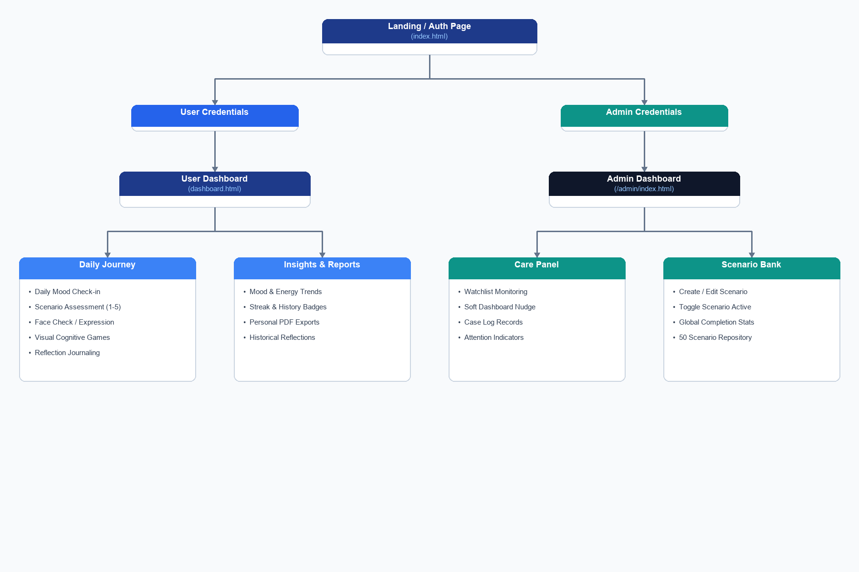
Figure 5.1: High-Level Application Flowchart Diagram

6. Feature Breakdown

User Panel Features
- Secure Authentication: Client-side validation, password strength metering, and JWT session persistence.
- Daily Mood Tracking: Intuitive 5-point emotional check-in with line trend visualizations.
- Private Journaling: Safe reflection workspace with automated linguistic pattern scoring.
- Scenario Assessments: 50 real-life situation questions promoting cognitive restructuring and critical thinking.
- Cognitive Minigames: Interactive Memory Recall, Reaction Speed, and Target Accuracy challenges.
- AI Companion: Context-aware conversational assistance offering personalized reflection advice.
- Personal Analytics: Cross-metric dashboards tracking mood, sleep, productivity, and game scores over time.

Admin Panel Features
- Global Analytics: Platform-wide engagement metrics, completion rates, and daily active user counters.
- User Directory & Care: Full user list with risk-band filtering (Low, Moderate, High) and watchlist monitoring.
- Soft Nudges & Notes: Dispatches non-punitive, supportive dashboard nudges and records internal admin notes.
- Scenario Management: Full CRUD interface with serial numbering to create, edit, or toggle active scenarios.

7. Conclusion
The Lighthouse platform successfully integrates cognitive tracking, interactive brain training, emotional reflection, and conversational AI into a unified web application. The clean modular architecture, responsive layout, elegant font choices, and robust administrative tools make it a highly effective and visually appealing system for personal wellbeing management.

