Howard University
College of Engineering and Architecture
Department of Electrical Engineering & Computer Science

Large Scale Programming
Fall 2024

Midterm Exam – Part I
October 17, 2024

Part I: 50 pts. (essay questions)

Instructions:
- Submit completed exam to your github repository under package org.howard.edu.lsp.midterm

Verify that the commit(s) completed successfully

- OPEN BOOK, OPEN NOTES. THERE IS NO COLLABORATION ON THIS EXAM
- Site any and ALL references for anything obtained off the internet.

Question 1. (10 pts.)

You are reviewing the following class in a Fitness Tracking System. The class is intended to manage various aspects of a user’s fitness activities.

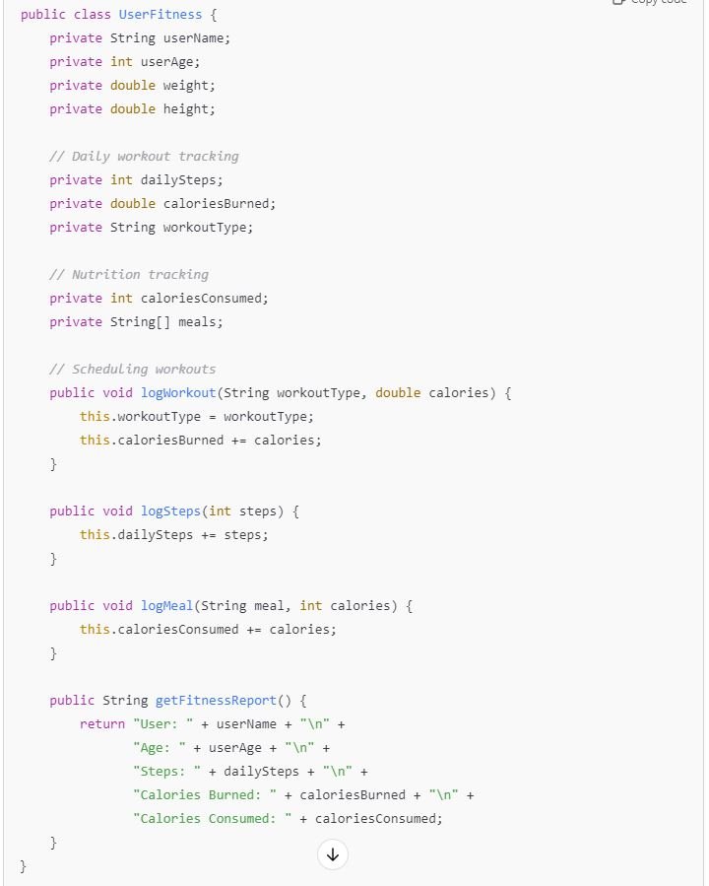

Tasks:
- Analyze the UserFitness class. Explain why this class has low cohesion. (5 pts.)

Ans: The UserFitness class has low cohesion due to its encompassing multiple, distinct responsibilities that are not closely related. Cohesion refers to the degree to which the responsibilities of a class are aligned with a single, well-defined purpose. In this case, the class manages user information (such as name and age), tracks daily workouts (including steps and calories burned), oversees nutrition (calories consumed and meals), and generates fitness reports. This lack of focus makes the class more complex and difficult to maintain, as changes in one aspect (e.g., nutrition tracking) may unintentionally impact another (e.g., workout tracking), leading to potential errors and confusion.

- Describe, in general, how you would split the UserFitness class into more cohesive classes. Your answer should not be a complete design. (5 pts.)

Ans: To enhance cohesion, the UserFitness class should be split into several more specialized classes, each addressing a specific area of responsibility. First, a separate User class could manage user attributes like name, age, weight, and height. Next, a WorkoutTracker class could focus solely on logging workouts, steps, and calories burned. Additionally, a NutritionTracker class would handle nutrition-related data, including meal logging and calorie tracking. Optionally, a FitnessReport class could be introduced to compile and format reports by integrating data from both the WorkoutTracker and NutritionTracker. This restructuring would ensure each class has a clear, singular focus, improving maintainability and understanding of the system.

Question 2. (5 pts.)
Given the following, answer the below questions.

A university manages its students using a program that has a class Student with subclasses FirstYear, SecondYear, and ThirdYear for year-specific state and behaviors. The program has a List that contains all Students.

Should Student be a class, an abstract class or an interface? Explain your answer

Ans: It should not be an interface because students have a state and methods, not just methods. This leaves us with it being either an abstract class or class since FirstYear, SecondYear and ThirdYear all share common attributes and methods while each having their own specific behavior. The reason it is an abstract class and not a class is because there is no instance of a student that is not a FirstYear, SecondYear or ThirdYear (there are year specific requirements like coursework), so you wouldn’t make Student a class, but an abstract class. An abstract class provides shared logic without instantiation.

- At the end of each year, the third-year students graduate and must be removed. This is done by passing the list to the following method:

void removeThirdYears(List<Students> students) {
for (Student student : students) {
try {
ThirdYear = (ThirdYear) student;
students.remove(thirdyear);
}
}
}

Why is the above method flawed? Hint: Another Arthur Riel heuristic (5 pts.)

Ans: The method above is flawed because you are directly modifying the list you are iterating over which will throw up an error. This violates Heuristic 2.7: “Classes should only exhibit nil or export coupling with other classes, that is, a class should only use operations in the public interface of another class or have nothing to do with that class.”. The removeThirdYears method should instead collect the third-year students to remove them after the iteration is complete, preserving the integrity of the list during the loop. You could use a temporary list to store the students to be removed and then process the removal after completing the iteration.

Question 3. (5 pts.)
Given the following, answer the below questions.

public class BankAccount {
public String accountHolderName;
public String accountNumber;
public double balance;
public double interestRate;

public BankAccount(
String accountHolderName,
String accountNumber,
double initialDeposit,
double interestRate) {
this.accountHolderName = accountHolderName;
this.accountNumber = accountNumber;
this.balance = initialDeposit;
this.interestRate = interestRate;
}

// Exposed implementation for adding interest
public void addInterest() {
double interest = balance * (interestRate / 100);
balance += interest;
}

// Exposed implementation for deposits
public void deposit(double amount) {
balance += amount;
}

// Exposed implementation for withdrawals
public void withdraw(double amount) {
balance -= amount;
}
}

- Is BankAccount well-encapsulated? Why or why not? If so, describe what changes you would make to the class. Otherwise, state nothing. (5 pts.)

Ans: This is not well-encapsulated since its fields (accountHolderName, accountNumber, balance, and interestRate) are public and can be modified outside of class. I would change them to private, for example “private String accountHolderName;” The withdraw and deposit don’t have validation of balance, you could withdraw past balance or deposit negative funds, to fix this I would add conditionals to check that I am depositing positive and not going negative in balance.

Question 4. (10 pts.)
Given the following, answer the below questions.

Given:
A car manufacturer uses Java software to track current vehicles being built. The UML diagram below shows an excerpt of the current software structure. You should assume the presence of other appropriate fields and methods

Car
getTrimLevel()
Engine
accelerate()
getFuelLevel()
Base
Sports
Luxury
Electric
Petrol

Each car can be built to one of three trim levels: Base, Luxury or Sport. They can also be configured with an electric or petrol engine. At various points in the manufacturing process the customer can choose to change the trim level.

Task:
- Explain in detail why the current structure does not support this. (5 pts.)

Ans: The current structure of the car manufacturing software seems to rely on inheritance to define the car classes, with a direct relationship between the Car class and its trim levels (Base, Luxury, and Sport) as subclasses. This design does not support dynamic changes in trim levels for several reasons. If trim levels are implemented as subclasses, changing a car's trim level requires creating a new instance of the desired subclass, which is inefficient and impractical during the manufacturing process. Also subclassing does not allow for the flexible combination of features; once a car is instantiated with a specific trim level, altering its attributes or behaviors to accommodate a new trim level becomes difficult. Additionally, managing the interactions and dependencies between the Car class and its trim subclasses complicates the code and may lead to tight coupling, making it challenging to implement changes without impacting other parts of the system.

- Describe how to refactor the structure to allow trim-level change for a car to dynamically change. Hint: How would you modify Car to use composition to solve the problem? (5 pts.)

Ans: I would create a TrimLevel class. This class would encapsulate the logic and data related to different trim levels. It could provide methods like getBaseTrimLevel(), getSportTrimLevel(), and getLuxuryTrimLevel() to create instances of specific trim levels. I would also Modify Car class: The Car class would now have a trimLevel attribute of type TrimLevel. Methods like getTrimLevel() would return the current trim level, and a new method setTrimLevel() would allow for dynamically changing the trim level.

Question 5. (5 pts.)
Suppose you are about to code a particular class and find that you have written another class with nearly the functionality that you now are developing. This means that the two classes in large parts contain the same code, but in smaller parts have different code. Explain in detail why this may be a problem and how to solve it. Give your answer in terms of Arthur Riel’s design heuristics.

Ans: Having two classes with overlapping functionality can lead to several problems, including code duplication, increased complexity, and fragile code. This violates Heuristic 2.3 (minimize the number of messages in the protocol) and Heuristic 2.8 (classes should capture one key abstraction), making maintenance difficult and introducing the risk of inconsistencies. To resolve this issue, identify common behaviors (aligning with Heuristic 2.9, which emphasizes keeping related data and behavior together), and consider using inheritance or composition to create a shared base class or utility class. Finally, refactor the code to eliminate duplication and ensure that the new structure is thoroughly tested, adhering to Heuristic 3.1 (distributing system intelligence evenly) to maintain a clean and maintainable design.

Question 6. (5 pts.)
Suppose we need to store instances of the classes Car and BankAccount in a database. To obtain low coupling it may seem as if the functionality to save an instance should be in precisely those classes, since they have the information that shall be saved. Why is it unwise to place the database calls there?

Ans: Putting database calls directly within the Car and BankAccount classes is unwise because the primary responsibility of the Car and BankAccount classes should be to represent their respective entities and manage their specific behaviors and attributes, not to handle persistence. This can make the classes more complex and harder to maintain. Also if multiple classes need to interact with the database, the database access code would be duplicated in each class, leading to maintenance issues and potential inconsistencies.

Question 7. (5 pts.)
Given a set of requirements, what conditions must be met to make it appropriate to create a new class hierarchy using inheritance? Neither superclass nor subclass exist before, the question is about designing a new class hierarchy.

Ans: To design a new class hierarchy using inheritance, there has to be a clear "is-a" relationship between the superclass and subclass, ensuring that the subclass is a specialized version of the superclass. You should be able to indentify shared attributes and behavior. The superclass should encapsulate shared behavior and attributes that can be inherited, promoting code reuse. Subclasses should only extend or override specific functionalities without altering the core purpose of the superclass.

Question 8. (2.5 pts.)
Describe the difference between inheritance and composition why would you choose one over the other.

Ans: Inheritance is a way to create a "is-a" (parent-child) relationship between classes, where one class extends the functionality of another. This can lead to tightly coupled code. Composition creates a "has-a" relationship, where one class uses objects of other classes. Composition is more flexible and promotes loose coupling, making it easier to modify and reuse code. Inheritance is best used when there's a clear parent-child relationship between classes, while composition is better for combining behaviors and creating more modular designs.

Question 9. (2.5 pts.)
Explain the meaning of cohesion and describe whether low or high cohesion is better.

Ans: Cohesion measures the degree to which a class or function is focused on a single task. High cohesion means that the unit's responsibilities are closely related and well-defined. This makes the code easier to understand, modify, and reuse. Low cohesion means that a unit handles multiple unrelated tasks. This can make the code more complex and difficult to maintain. High cohesion is better in software design.

