**TUGAS 3**

**Intraksi Manusia Dan Komputer**

**Dosen Pengampuh:**

**Wenti ayu Wahyuni,M.Kom**

**Nama :Fergi Yuniar Kriswanti**

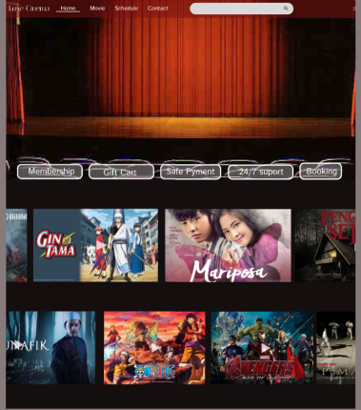**Nim: 23TI111**

**Prodi : TIC**

[**https://www.figma.com/design/7r6QeALmeLQ8QdF9Tb8M6H/Untitled?node-id=0-1&m=dev&t=hX7y2wkW0ljlKaPL-1**](https://www.figma.com/design/7r6QeALmeLQ8QdF9Tb8M6H/Untitled?node-id=0-1&m=dev&t=hX7y2wkW0ljlKaPL-1)

**s**

