** East West University**

**Department of Computer Science and Engineering**

**Semester: Fall 2021**

**Course name: Computer Aided Engineering Drawing**

**Course code: CSE200**

**Section-1**

**Submitted to:**

**Touhid Ahmed**

**Lecturer,**

**Department of Computer Science and Engineering**

**Submitted by:**

**Zarin Tasnim Nuzhat**

**Student Id: 2020-1-60-211**

**Submission Date: 12/01/2022**

**MINI-PROJECT**

**2D drawing Floor plan**

**What Floor Planning Is:**

Floor plans are scale drawings that show the relationship between rooms, spaces and physical features viewed from above.

A floor plan is carefully dimensioned to ensure that items such as walls, columns, doors, windows, openings, stairs, and other particulars are correctly located for construction.

**Benefits of Floor Planning:**

Plans help to plan out the interior spaces wisely prior the construction begins. They help to plan out the placement of the furniture along with the landscapes around. It helps to calculate the available open spaces in the interiors free circulation and the used up areas under furniture placement.

**Rough Sketch of My Living Space:**

I had taken a measuring tape to measure the inner dimension from a wall to another wall of the apartment where I live in. I have showed the dimension in figure-1, I was able to measure dimensions from inside the room.

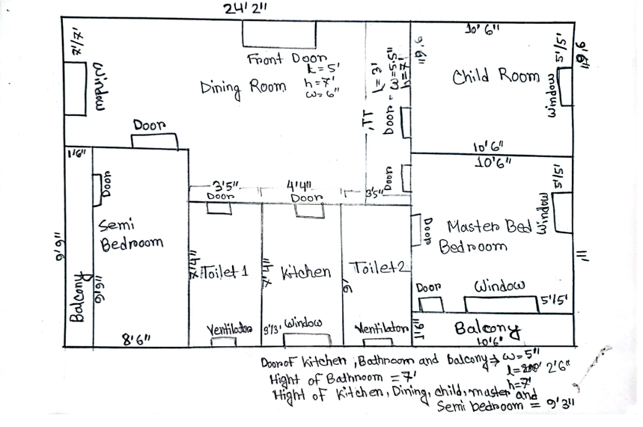

**Figure 1**

* **Dimension:** The rough sketch of my own living space is shown in the given Figure above. All the measurements are depicted in **feet & inch** scale. Dimensions are in **inch** scale.

**Inner wall dimension:** 5inch, which I have measured from the width of the middle wall of every room, kitchen, bathroom and balcony.

**Outer wall dimension:** 6inch, which I have found from width of the window of dining room.

* **Door Type and window type:**

Making this apartment, the owner of this house has used three types of door, four types of window and a ventilator.

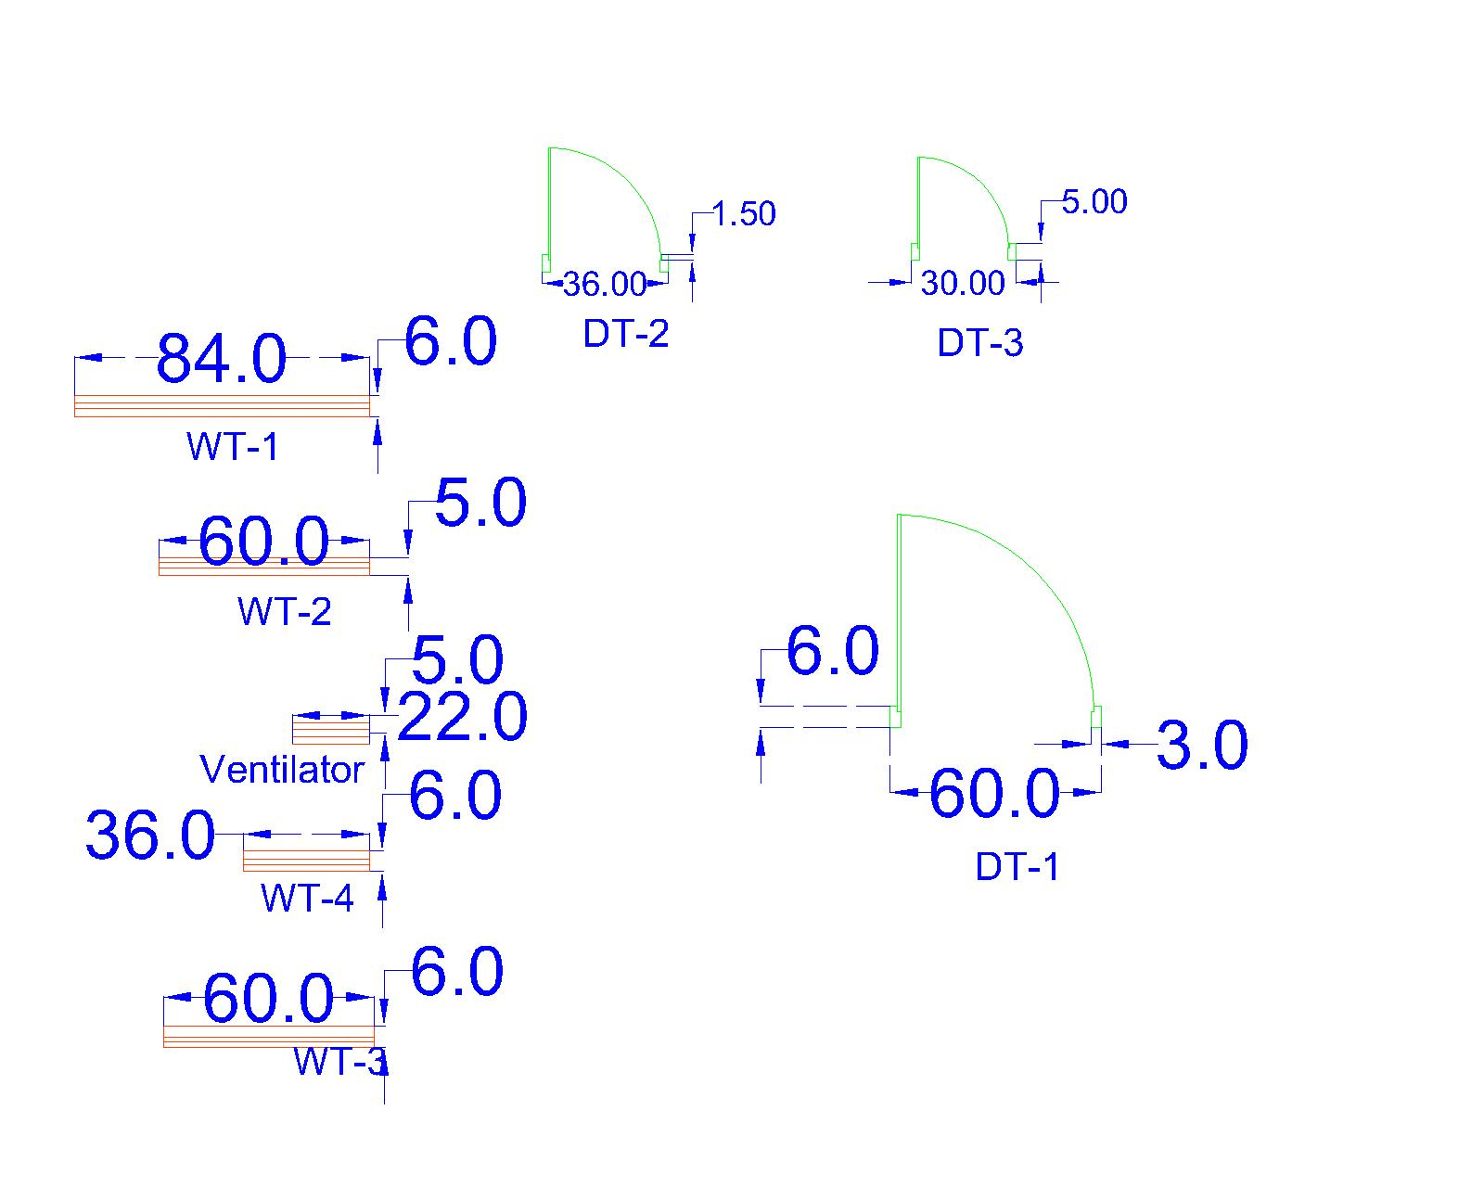

I have mentioned all the types in figure-2 .Where DT means door type and WT means window type. The dimensions of the windows and doors are also mentioned there. These dimensions was not mentioned in the main figure, because these makes the drawing look very bad.

**Drawing of AutoCAD:**

Firstly, I have created different layers for Door, Window, Dimension and boundaries. The layer for boundary is the given layers by AutoCAD named ‘0’. I have changed its Line weight to 1mm. Therefore, the boundaries are drawn in continuous thick line. Door, window and dimensions are drawn in continuous thin line.

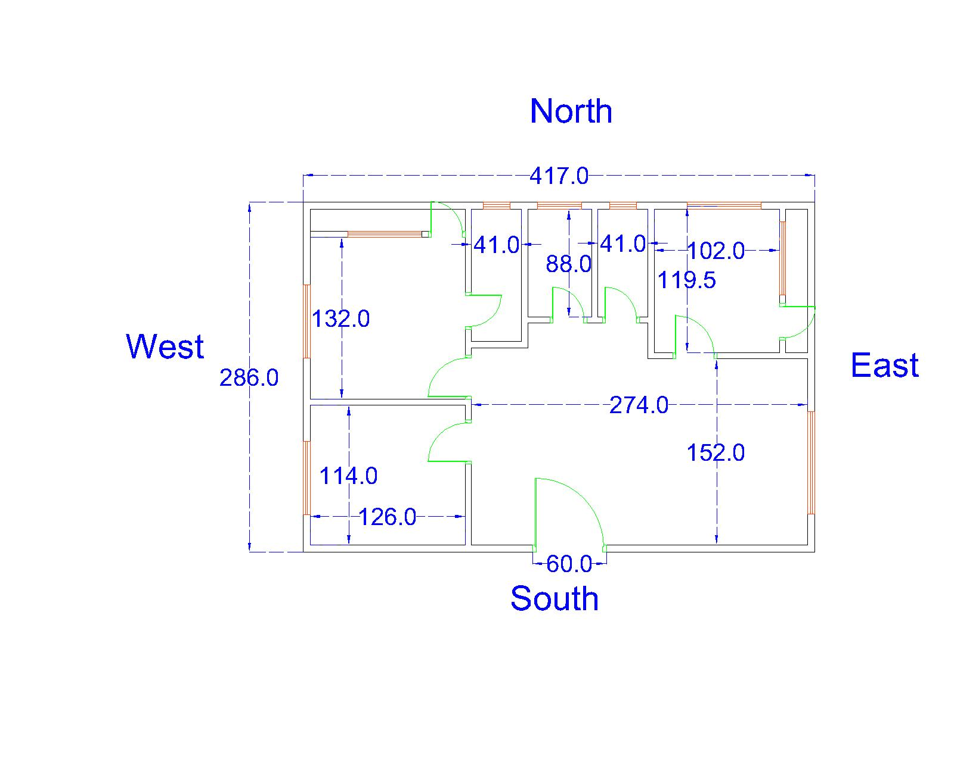

**Figure 3**

Then I have drawn the figure in AutoCAD I have sketched in my paper. Then I mentioned only the dimensions in the figure-3, So that understanding the dimensions becomes easier.

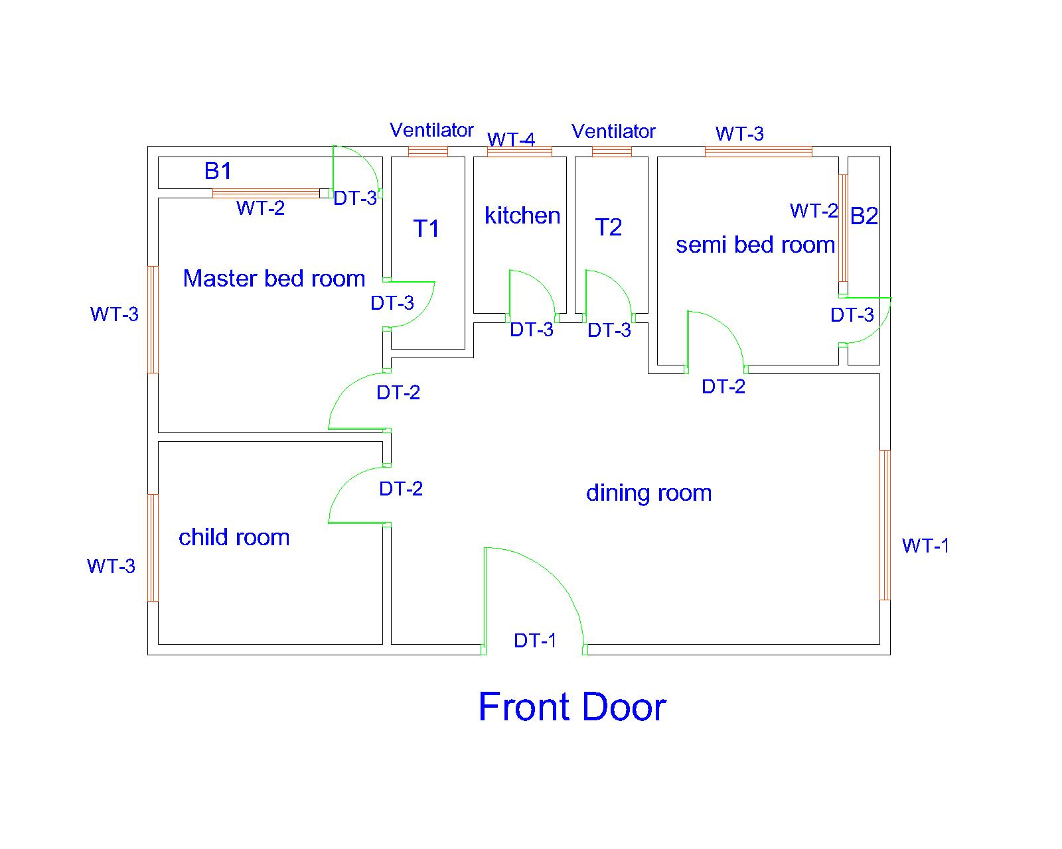

**Figure 4**

Then I have drawn the general figure-4 where I have mentioned room names, kitchen, dining room, number of toilets-T1 and T2, door type and window type. Then I have plotted the every figure separately.