

**Marketing Strategy for Sailor**

**Title:** Sailor

**Submitted to:**

Mashruha Zabeen

Senior Lecturer

Department of Business Administration

**Submitted by:**

Name: Samiu Esika Upoma

ID:2020-1-60-082

Name: Israfil Arman

ID:2020-1-60-086

Name: Zarin Tasnim Hassan

ID:2020-1-60-169

Name: Fariha Mosharof

ID:2020-1-60-171

Name: Zarin Tasnim Nuzhat

ID:2020-1-60-211

Name: Md Habibuzzaman

ID:2020-1-60-212

Name: Tanjilul Haq

ID:2020-1-60-214

Name: Yusuf Salehin

ID:2020-2-60-126

**Date of submission:**

**Letter of Transmittal:**

May 7, 2022

Mashruha Zabeen

Senior Lecturer

Department of Business Administration

East West University

**Subject: Letter of Transmittal**

Dear Ma’am,

With due respect we, the undersigned students of section 4 have reported on “Marketing strategy of Sailor” under the course: Principles of Marketing.

Though we are in learning curve, this report enabled us to gain insight into Sailor’s marketing strategy. It becomes as an extremely challenging and interesting experience for all of us. Thank you for your guidance and supportive consideration for formulating an idea.

Lastly we would be thankful once again if you please give your judicious advice on our effort.

Sincerely

Tanjilul Haq

ID: 2020-1-60-214

(On behalf of the group)

**Acknowledgement:**

Habibur Rahman

Merchandiser

Marketing and Merchandising Department

Epyllion Group

**Executive summary:** The main goal of the report is to know about the marketing strategy of “Sailor” as we worked on it. Sailor is one of the Epyllion’s SBU. With the motto “Human Spirit”, Epyllion Group started its journey in 1994 with a readymade garment’s unit in Dhaka. As a clothing fashion brand Sailor is renowned for its unique style and variety of collections. For making this report we gathered information from Habibur Rahaman Merchandiser Marketing and Merchandising Department Epyllion group and from the website of Sailor and Epyllion. The introduction and organizational profile part have done by taking idea from Epyllion’s website.

For introduction and overview, it was done by fariha mosarof. She gathered information from the website of epyllion.

For Organizational Profile, it was done by zarin tasnim hasan. She also gathered information from the website of epyllion.

For segmentation, targeting, positioning & differentiation, it was done by Israfil arman and he gathered the information the website of sailor, and got some advice from Habibur Rahman, the merchandiser epyllion group.

For product and price, it was done by Yusuf Salehin. He gathered information from the website of sailor. For packaging information, he went to a showroom of sailor.

For distribution and promotional mix, it was done by zarin tasnim nuzat. It was advised by Habibur Rahman, the merchandiser epyllion group. Also gathered information from website of sailor.

For SWOT Analysis, it was done by tanjilul haq and he gathered the information from the websites, and he also did some personal analysis

For recommendation and conclusion, it was done by MD. habibuzzaman, he took some advice from the merchandiser epyllion group who gave him some for recommendation.

In marketing strategy: segmentation ,positioning ,targeting ,pricing ,Distribution and differentiation each information gathered from the Sailor’s Merchandiser Habibur Rahaman and from different Websites .After gathering all information we do the SWOT analysis of Sailor .

**Table of content:**

|  |  |  |
| --- | --- | --- |
| Serial Number | Topic | Page number |
| 1 | Title Page | i |
| 2 | Letter of transmittal | iii |
| 3 | Acknowledgement | iv |
| 4 | Executive summary | v |
| 5 | Introduction and overview | 1 |
| 6 | Organizational Profile | 2 |
| 7 | Marketing strategy | 4 |
| 8 | SWOT Analysis | 16 |
| 9 | Recommendation and conclusion | 17 |

**Introduction and overview:** Epyllion Group started its journey as a house of Readymade Garments (RMG) engaged in manufacturing and exporting of Knit Apparels since 1994 and has been considered today as one of the biggest conglomerates with substantial establishment of its backward linkage of all kinds of knit garments, textile, wet processing & garments accessories. Reazuddin Al Mamoon is the CEO of this group. It has the state of art vertically integrated garments manufacturing facility which ensures one stop service to the buyers. They have established themselves as an important garments manufacturer for a number of renowned brand apparels of Europe, USA & Australia.

Their products cater the world from east to west, which includes Europe, America, Africa and Asia. The links among Epyllion members made it possible for the world to witness the unique ability of Epyllion’s entities to turn the lives of otherwise ordinary citizens into local talents. This is a central theme of their design thinking. Continuations of harnessing Epyllion group’s creative aspect have been ensuring that they are and will remain as mold breaker and successful one for the coming years and beyond.

Epyllion group has both Foreign and Local retailer. As it stands today, Epyllion Group became the name of lifestyle of its personnel, suppliers & buyers. For the greater commitment & care - Epyllion Group always plays a significant role in its every activity by protecting environment and has earned an iconic image among the green corporate houses. These achievements of the group prevailing due to the personnel of the Epyllion Group are placed at their right positions according to their caliber and inspiration.

Epyllion Group is known as an entity whose main driven force is it’s human resources. Within the framework of the group, human resource plays a vital role in its success. The group believes that it is not only to produce and deliver high quality, reliable safe goods and services to the clients, but also to give them the sense of trust which builds a strong bondage among them.

The overall management of the group is segregated into Executive Board Members & Management Committee (MANCOM). The Executive Board Members are involved in the policy matters & decision making. The MANCOM comprises of 7 top executives is responsible to construct strategic planning and to review the implementations. They also keep their eyes on integrity of the overall management both at corporate and sub-business units. This team ensures that all the personnel of the group are at ease in their well beings.

Other than that, Epyllion group follow some Code of Ethics which is basically a set of guiding principles. These codes are being set based on the values of an organization. Epyllion group has Ethical Standard codes like Prohibition of child labor, Prohibition of forced labor, **Prohibition of sexual harassment & abuse, Health & workplace safety and many more. For Business code they have Anti-Corruption Practices, Entity must be free from all political affiliation, Access to the data and information etc. For Employee code they’ve Comply with rules & procedures, Health & Safety, Drug & Alcohol Substances, Political activities, Disclosure of Official Information, Signing of Business Contract and so on.** These codes help a company to conduct their business with honesty and integrity.

**Organizational Profile:**

**History:** Epyllion group started its journey in 1994 as a house of readymade garments. Currently, Epyllion is a business house producing textile, garments, and garments accessories for worldwide export. Reaz Uddin Al-Mamoon is the Managing Director of Epyllion Group and Managing Trustee of Epyllion Foundation. He mentioned in an interview that “I dreamt of starting Epyllion Group when I was a banker by profession. With a limited financial investment, I started Epyllion with an RMG factory of two sewing lines and 200 employees in 1994.” Firstly It was located in Mirpur Industrial Area. Epyllion started growing up and till this day, is still in its growing phase. It has positive growth in employment generation, annual turnover, and has maintained a sustainable supply chain. In nowadays with a workforce of more than 16,000 skilled officials and ensuring environmental sustainability, Epyllion Group is sustaining and will sustain the optimum business development in terms of profit and people. In 2004 they got the Best Supplier Award of C&A.

**Vision:** The vision of the company Epyllion is to become a window through which all their interacting parties can see and feel their prospect and dream about their success. Epyllion will become a lifestyle towards its employees, suppliers, buyers and above all shall become a role model of a green corporate house which will be regarded as an icon brand in the country.Currently, Epyllion is a business house with textile, garments, and garments accessories for exporting RMG products worldwide. With all these business units, Epyllion Group is now a pioneer in Bangladesh’s retail fashion industry.

**Mission:** Epyllion will be known as an entity whose main driven force is its human resources. With such a motivated, highly skilled and professional workforce, Epyllion has started marching towards its glory of success which is not profit but to enjoy the joy of life. Epyllion’s focus point in its journey is to be an institution which will concentrate on human development and social contributions while profit will come as the byproduct. The company is all about new initiatives, new ventures, new aims with rooted principles and ethical views. Currently, Epyllion is a business house with textile, garments, and garments accessories for exporting RMG products worldwide. Soon we will also have a food & beverage unit which is currently waiting for its nationwide commercial launch.

**SBU:** The full form SBU is a strategic business unit. SBU is a fully-functional unit of a business that has its own vision and direction.

**Garments Divisions**

Dekko Knitwears Limited

Epyllion Knitwears Limited

Dazzling Dresses Limited

**Backward Linkage**

Textile unit

Epyllion Knitex Limited

Epyllion Fabrics Limited

**Testing Laboratory:**

Epyllion Testing Lab Limited

**Washing Unit:**

Epyllion Washing Unit

**Real Estate:**

Nina Holdings Limited

**Food & Beverage Unit:**

Epyllion Food & Beverage Limited

**Retail Brand:**

**Sailor:** With the theme “Sailing Life” Sailor launched in 2015. Now it’s a famous clothing brand. Sailor is a sister concern brand of Epyllion group.

**Marketing Strategy:**

**Segmentation:**

**Geographic:** Geographically sailor’s targeted area is all over Bangladesh. In every division there are at least 1 large showroom. In this pie chart below the geographical segmentation has been given. we can see many outlets are in Dhaka because of the demand. There is total 18 outlets in Bangladesh where 7 outlets in Dhaka. As demand, there are also more outlets in other divisions all over Bangladesh.

**Demographic:** Demographically sailor is divided into some other segmentation like gender, age, income.

Gender wise, sailor’s products are for male, female, kids both boys and girls. Their outlets are organized well for the separate customers.

Age wise the maximum products are for young adults, adults, and seniors. There is a good number of outfits collection there. Also, kids outfits are available there.

Income wise higher and higher-middle income groups people are targeted for sailor.

**Behavioral:**

Occasionally, Eid, Pohela-Boishakh and other Bengali events are so much important for all the clothing brands like sailor. Specialized dresses are designed for separate occasion. Eid and Bengali cultural events cover most of the chart. Outfits for business events are also have a segment.

**Targeting:**

Differentiated or segmented marketing strategy is applicable for sailor. This brand targets several different market segments of the customers. They must have separate offers for each segment.

**Positioning:**

**Value Propositions:** The main competitors of Sailor are Aarong, Le reve, Yellow, Infinity etc. Eventually all this brands product quality is almost same. High quality fabrics. But their main difference is in their pricing. Some of them offer more price some offer less. For Sailor we think they offer comparatively less price than their competitor and offer almost the same benefits. So, we can say Sailor’s value proposition is “The same for less”

**Positioning statement:** We think the best statement for Sailor is “For fashion and comfort conscious people Our brand Sailor is an eminent lifestyle brand that delivers quality products at affordable price.”

**Differentiation:**

**1.Product:**

|  |  |  |  |  |
| --- | --- | --- | --- | --- |
| **Product category** | **Sailor** | **Aarong** | **Le Reve** | **Yellow** |
| Shirts | Have | Have | Have | Have |
| T-shirts | Have | Have | Have | Have |
| Panjabi | Have | Have | Have | Have |
| Sharee | Have not | Have | Have | Have |
| Kurta | Have | Have | Have not | Have |
| Kamiz | Have | Have | Have | Have |
| Kids | have | Have | Have | Have |

**2.****Price:**

|  |  |  |  |  |
| --- | --- | --- | --- | --- |
| **Product category** | **Sailor** | **Aarong** | **Le Reve** | **Yellow** |
| Men ware | 540-11990tk | 335-14428tk | 590-8690tk | 1485-4995tk |
| Women ware | 550-6675tk | 1349-44000tk | 1990-9299tk | 595-10795tk |
| Kids | 340-3200tk | 247-4437tk | 485-4000 | 395-4495tk |
| Newborn | 175-2000tk | 105-1358tk | Does not sell | Does not sell |

**3.Service:** All of these 4 brands provide almost same services. There is not that much different.

**4.****Channel:**

**Showrooms:**

|  |  |  |  |  |
| --- | --- | --- | --- | --- |
|  | **Sailor** | **Aarong** | **Le Reve** | **Yellow** |
| Number of showrooms | 18 | 25 | 19 | 18 |

**Distribution:** All the 4 brands distribute product on their outlets and also have online purchase option through their own website.

**5.Image:** All the 4 brands have their own brand images.

**Marketing mix:**

**Product**

**Product lines:** Sailors almost provide all kinds of outfits of all ages for both male and female.

Men’s casual and formal: Fashion Express Shirt, Tracker Shirt, Business Formal Shirt , Smart Casual Shirt , Formal Shirt , Polo ,T-Shirt , Suit ,Blazer

MENS BOTTOM: Denim ,Chino ,trouser , Shorts ,Pajama

MENS ETHNIC :Kabli , Kurta Set ,Premium Kurta , Fusion Kurta , Classic Kurta ,Panjabi

Women’s KURTI: Luxury Cotton, Half Silk , Rayon , Silk , Wrinkle Chiffon ,Cotton , Long Kurtis ,Chiffon

Women’s SALWAR SUIT **:** Cotton , Half Silk ,Silk ,Rayon ,Chiffon ,Salwar Suit

Women’s TOP:Silk ,Cotton , Chiffon ,POP , Rayon ,Viscose ,Single Jers[ey](https://www.sailor.clothing/womens-knit-top)

Women’s BOTTOM: Skirt , Den[im](https://www.sailor.clothing/womens-denim) , Palaz[zo](https://www.sailor.clothing/womens-palazzo)

Accessories for men and women :Laptop Bag , Wallet , Belt ,Bag ,Sunglass

Footwear for men and women; Men’s Boot , PreSandalmium , Formal Shoe , Premium Form[al Shoe](https://www.sailor.clothing/formal-shoe-premium) , Loafer ,Premium Loafer ,Sandal ,Sandal (Flip-Flop) ,Sneaker ,Womens Sneaker

WINTER WEAR for men and women : Blazer , Hoodie , Cashmere Shawl , PU Leather Jacket , Hoodie , Muffler

KIDS OUTFIT: All sorts of kids outfits are available for both boys and girls including footwear.

**Product quality:** They always try to provide the best quality of outfits at a reasonable price. They never compromise with qualities. As sailor has its own garment for swing dresses and they also import best quality products. They use the best quality fabrics as possible for the products at this medium range reasonable prices. Also imported qualitiful products are being added nowadays in the showrooms such as imported high premium quality Chinese t shirts, handmade swing and printed high quality suits are also available.

**Product strength**: Customized designing shirts ,Punjabis and other men's outfits are available here which brings unique look also considering local products. Good quality products and no compromising with qualities is also a strength of this brand. The outfits which are not imported are made by customized and standard design by professional trailers and designers such as having some senior engineers of Butex for manufacturing raw clothes and designers also. It Has its own manufacturer and garments company in Gazipur, Shewrapara which reduces making costs and also helps to provide the best quality on their own which is one of the strengthened points of view for the brand.

**Weakness:** Some raw materials are taken from local places which they can't manufacture on their own.

**Name of the brand:** Sailor

**Slogan:** Sail the life.

Logo :

**Packaging:** They use a customized shopping bag as a package of the products.Some times they use a new design shopping bag at some festival on particular products for a particular time . The common shopping bag of the brand which are being used all time in all showrooms are given below.

**Pricing:**

**Value based pricing -**

**Good value pricing -** As this brand is located in Bangladesh only this brand is using the value based pricing strategy. Here it takes the thinking level of the satisfaction of the targeted customers. As their main target market is middle class and high class people ,they are giving proper attention to the quality of the product and setting price at medium reasonable which would be affordable to the middle class people also. Such as we need at least one thousand taka for a shirt at this case they are also setting qualitiful shirts as one thousand five hundred taka.As the targeted customers are middle class and high class also so they are easily giving good quality products .After determining the cost of the quality full product they determine the cost of the product by the sub office which is situated in Uttara and after the final design they make the products.

**Value-Added Pricing -** As the targeted customers are higher class also.They keep some premium collections and keep high prices by satisfying the product quality.Such as they keep some high quality formal suits for men, quality leather formal and casual shoes.There are also some premium hand made sarees which is made of premium silk and design.

**Updating Price in Monopolistic market:** Sailor also follows this method by setting up price.As it has some opponent brands such as Infinity,Freezone,Splash,It also compares when setting up a price of a product of same quality considering these brands.

**Competition based pricing:** As there are also similar types of brands in our country the brand sets price considering others brands' prices and qualities.Such as in winter when the competitive brands give market offerings ,Sailor also gives market offerings on some particular products to hold the value to customers.

**Distribution:**

Distribution is one of the four components of the marketing mix. Distribution is the method of making a product or service available to target the consumer or business user who needs it. Specifically the producer or service provider or utilizing indirect channels will do this with distributors like wholesaler and retailer or mediators.

1**. Geographical Coverage:** Geographic coverage in marketing refers to the discussion of where the product is being distributed in the whole country. Sailor, a brand whose distribution is all over Bangladesh. Their distribution is division based.

**2. Distribution Channels and Partners:** A dispersion channel represents a chain of businesses or mediators through which the ultimate buyer buys a good or service. Distribution channels incorporate wholesalers, retailers, distributors, and the Web. In a coordinated distribution channel, the producer offers specifically to the consumer. Sailors, Clothing companies have their own warehouses from where supplies are delivered to all Sailor outlets through their own transport system.

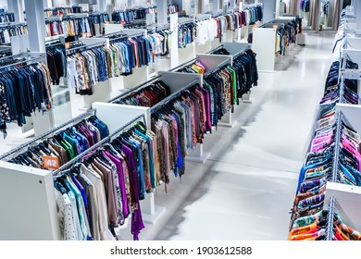

**3. Physical Distribution and Logistics:** Physical distribution incorporates all activities related to the delivery of finished goods to buyers at each step from the production line. Vital physical delivery functions incorporate customer service, order processing, stock control, transportation and logistics, and packaging and materials. Sailor has many outlets for physical distribution. Consumers can go there and shop as per their choice.

**4. Electronic Distribution**: E-distribution is a type of distribution that uses purely electronic media. It is often interpreted as the buying or selling of services or goods over a public network without the physical media; this is usually done by downloading from the Internet to the consumer's electronic device. Sailor has own official website. Through that site, the public can easily purchase any kind of product. Consumers can reach them by social media also. Customers contact with them though Messenger, WhatsApp etc.

**Promotional Mix:**

The promotion mix is the specific blend of promotion tools that the company uses to persuasively communicate customer value and build customer relationships.

**1. Advertising:** It is any paid form of non-personal presentation and promotion of ideas, goods, or services by an identified sponsor. The Sailor Clothing brand promotes their products through advertising. They do advertising through billboards, online, digital media, social media etc.

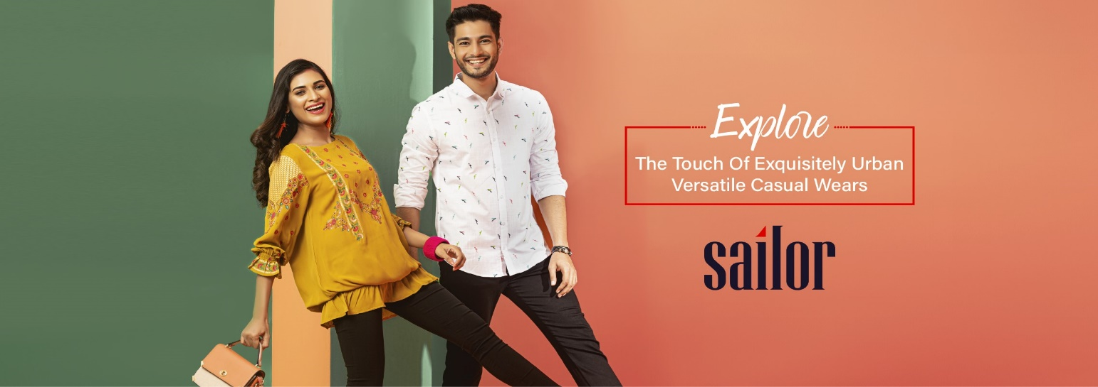

**2. Sales promotion:** It is the short-term incentive to encourage the purchase or sale of a product or service. There is seen offering occasional or seasonal offers or discounts in SAILOR. They sometimes give discounts up to 30% or 70% on selective products and sometimes give discounts for cardholders or paying with BKASH OR NAGAD. Those who are employees of Epyllion get a 30% discount.

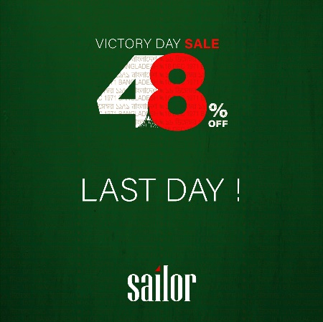 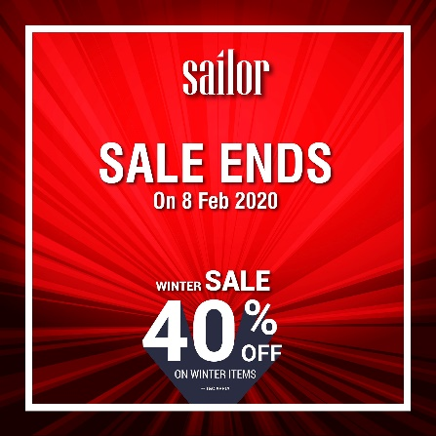 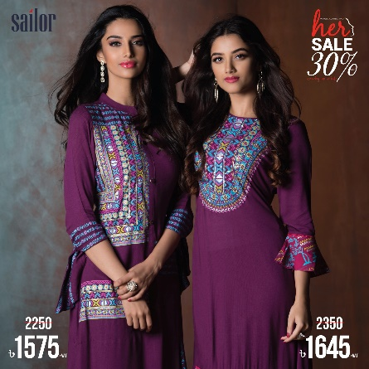

**3. Publicity and public relation:** It is building great relations with the company’s different publics by getting favorable publicity, building up a great corporate image, and taking care of or heading off unfavorable rumors, stories, and occasions. Sailor sponsors various events to build up good public relations.

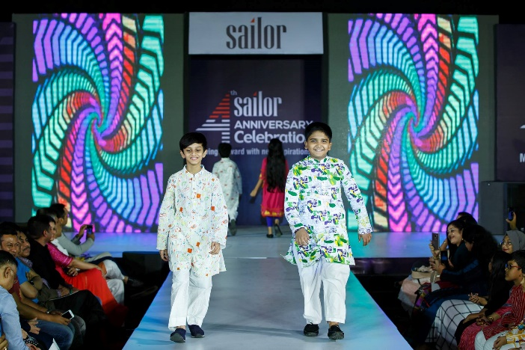 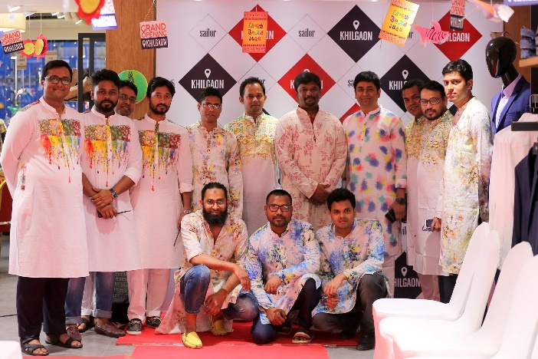

**4. Electronic Promotion:** Digital promotion uses social media, phones, and other electronic gadgets to promote or sponsor a product or service. These include favor electronic billboards along highways and in overwhelming trafficking zones. Those who purchase products for once from Sailor, get a membership. Sailor inform update every single member through message.

**5. Word of Mouth:** It is the process when a consumer's interest in a company's product or service is reflected in their daily dialogues. Essentially, it is free advertising triggered by customer experiences and usually, something that goes beyond what they expected. Since Sailor's products are very good and quality, its reviews are also very good. Its customers always have a good reputation for it.

**SWOT Analysis:**

1. **Strength:** They have their own unique and standard clothing design. They have individual designer for individual products. They try to full fill the customers demand that is why they have a good fanbase. They have their outlets in every division as a result people can reach out them easily. Even if people failed to reach their outlets they can order on online through Sailor’s website.
2. **Weakness**: For all products they cannot produce the raw material of their own, they need to buy those from local producers, for their lather products they design their own products but for manufacture they cannot do that here. To produce them they manufacture those products in China.
3. **Opportunity**: In many festivals like, Eid-ul-fitar, Eid-ul-Adah, Puja, Christmas and occasions Valentines,21st February, Pahela Baisakh their sell increases a lot as they have exclusive designs based of festival theme. Besides clothing they have bags, shoe, belts, wallet etc. Which attracts the customer because they can get full outfit with matching products. In upcoming days, they want to open their outlets in different foreign country.
4. **Threads**: they have strong competitors, so they always have a price war, some of the competitors produce their own raw materials so they have good advantages. Pandemic like Covid19 was a great intimidation for Sailor. Some competitors produce their own bags, shoe, belts, wallet where Sailor manufactures this type of products from China which increases their producing costs.

**Recommendation and conclusion:**

Sailor started their brand in 2015 and withing this short time they positioned them in a good place in the market. Besides, they have quite a good number of outlets all over Bangladesh. They are aware of customers demand and they keep them up to date with designs. For their extraordinary collection they have a good image among the customers. Also, customers are happy for Sailor’s good product quality with the affordable price.

Though Sailor is a good brand, but they can always look for improvement in the brand. To build good customer relationship, they can introduce club marketing program as their competitors are doing. Besides, along with other clothing products they can also add Saree as their new product. Moreover, they have outlets almost in every division except Mymensingh. Thus, it would be better if they can establish an outlet there and pursue customers in that region. Furthermore, they buy their raw materials from local producer and in case the local producers stop producing the raw materials then the brand will face supply shortage and fail to fulfil the demand in the market. Thus, if they also produce their own raw materials, they will not have this type of risk. As their manufacturing cost for accessories is quite high because they manufacture those products in China. They can decrease the cost if they bring the machineries and manufacture those products in Bangladesh.

In conclusion, building a good brand image is the biggest achievement to a brand and Sailor has already done it. Now is the time they keep up with their competitors and keep producing good products. With that they should be creative with their new products and services and look thoroughly if there is a chance of improvement of the existing products and services.

**Reference:**

1. Epyllion website link: <https://www.epylliongroup.com/>
2. Sailor website link: <https://www.sailor.clothing/>
3. Aarong website link: <https://www.aarong.com/>
4. Le reve website link: <https://www.lerevecraze.com/>
5. Yellow website link: <https://www.yellowclothing.net/>