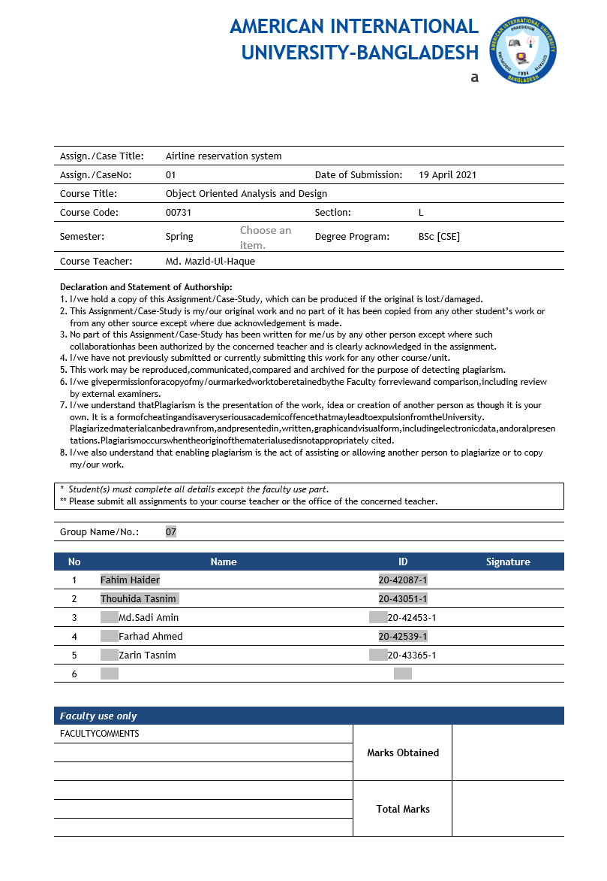

**Contribution:**

**1**.Fahim Haider-20-42087-1 (Activity diagram)-20%

**2.**Thouhida Tasnim-20-43051-1(Class diagram)-20%

**3.**Md. Sadi Amin-20-42453-1(Sequence diagram)-20%

**4.**Farhad Ahmed-20-42539-1(State chart diagram)-20%

**5.**Zarin Tasnim-20-43365-1(Use case diagram)-20%

**Project Scenario:**

In an airline reservation system, A customer will search for flight in airport server. The customer can check the availability. The customer will select the details of the flight. First, he/she have to select destination. Then he/she have to select the preferable date and time. After selecting, the server will check if there is any flight available of that particular time. If yes then server will ask for further details and if not, the server will deny. For the available flight, customer will check no. of seat and category of seat which are available. There are two category of seats which are economy and business class. Then server asks if the customer is interested to go further for reservation. To confirm the flight, the customer will login to the server as a passenger. After verifying the information of the customer by server, the server will show the amount to pay. If the customer wants to confirm the reservation, he/she have to pay the bill. To pay the amount the customer will enter the credit card info and verify it. If the information is not verified it will ask again to enter correct details. After verifying the customer will pay the bill and confirm the reservation.

**Use Case Diagram:**

**Case study for Use Case diagram:**

In an airline reservation system, A customer will search for flight in airport server. The customer can check the availability. The customer will select the details of the flight. First, he/she have to select destination. Then he/she have to select the preferable date and time. After selecting, the server will check if there is any flight available of that particular time. If yes then server will ask for further details and if not, the server will deny. For the available flight, customer will check no. of seat and category of seat which are available. There are two category of seats which are economy and business class. Then server asks if the customer is interested to go further for reservation. To confirm the flight, the customer will login to the server as a passenger. After verifying the information of the customer by server, the server will show the amount to pay. If the customer wants to confirm the reservation, he/she have to pay the bill. To pay the amount the customer will enter the credit card info and verify it. If the information is not verified it will ask again to enter correct details. After verifying the customer will pay the bill and confirm the reservation.

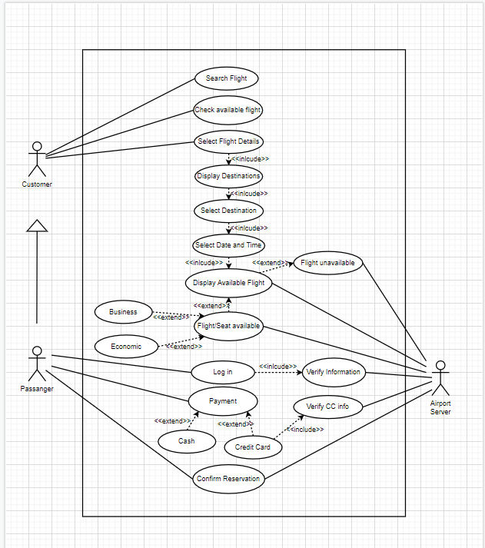**Class Diagram:**

**Case study for class diagram:**

In an airline reservation system, A customer will see any number of flights in airport server. The customer may select exactly one destination of flight from server. Each destination has any number of customers. The server may check zero or more flight available of that particular Destination. Every flight has to be in airport server. The customer can reserve zero or one seat from any category of seat through the server. Each seat has exactly one customer. There are two category of seats which are economy and business class belongs to every flight. Each category has any number of passengers. One passenger may belong to exactly one flight at a time. Not all customers are passengers.

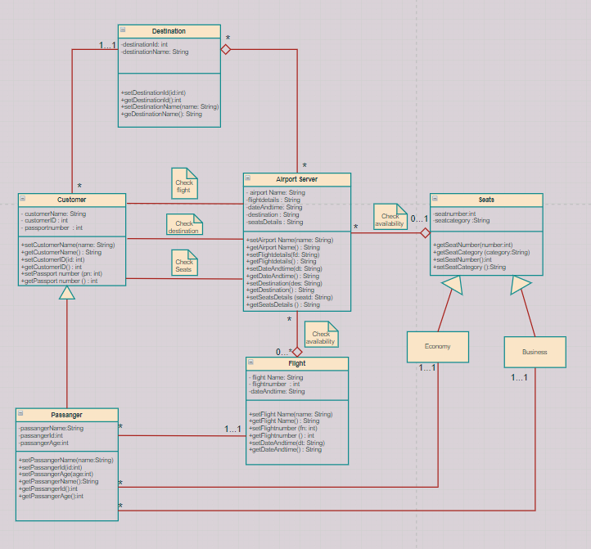**Sequence Diagram:**

**Case study for sequence diagram:**

In an airline reservation system, A customer will search for flight in airport server. To know the availability, the customer has to select the details of the flight so that the customer can be sure about confirming. First, the customer will select details like destination, date & time. After selecting, the server will see if there is any flight available of that particular time. If yes then server will ask for further details and if not, the server will deny. For the available flight, customer will select the flight. Now the server will ask the customer to select seats from that flight. But customer needs to login to select seats. Then the server will show the customer the summary of that flight. Then comes the booking process. If the customer wants to confirm the reservation, he/she have to pay the bill otherwise the ticket will be cancelled. To pay the amount the customer will enter the credit card info and verify it. After verifying the customer will pay the bill and confirm the reservation. If payment gets verified, the server will return a passenger copy and show the tickets to the customer. If not, then the server will decline the reservation.

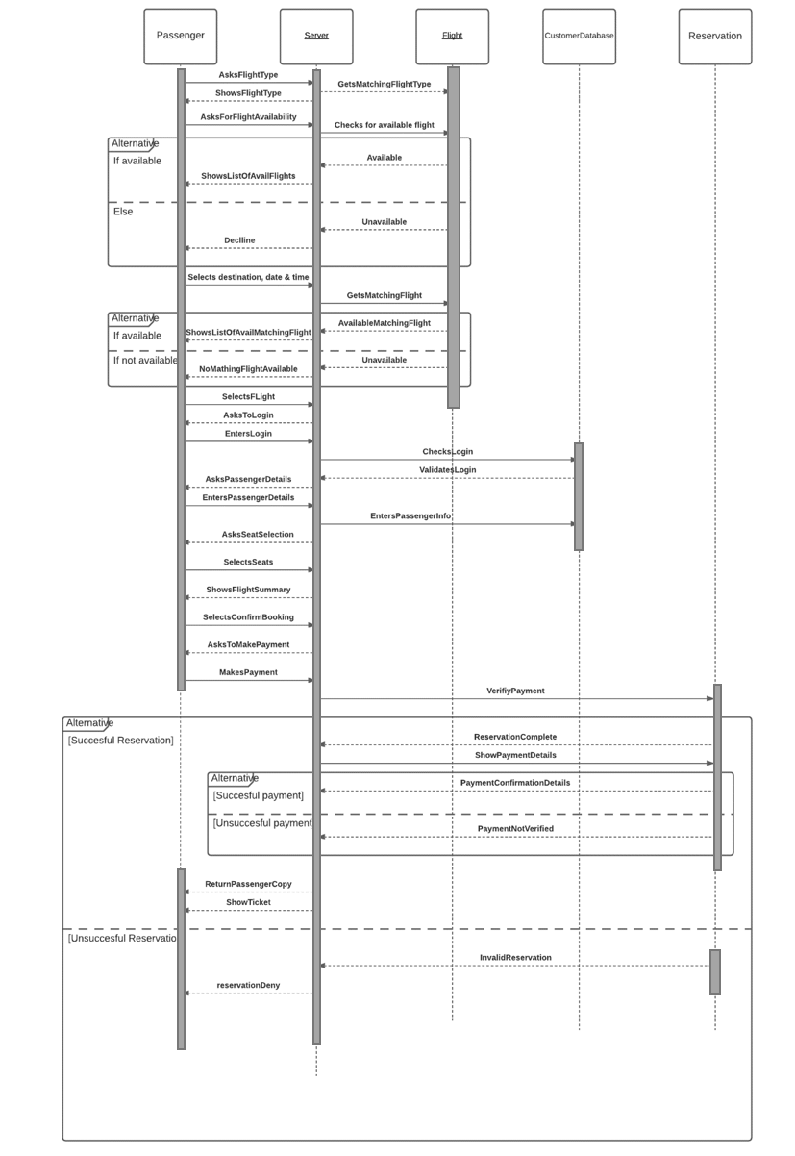

**Activity Diagram:**

**Case study for activity diagram:**

In an airline reservation system, A customer will search for flight in airport server. Among various choices, in order to find his desired flight, the customer has to select the details of the flight. First the server will show a list of available destinations. After the customer selects the destination, server asks for preferable time and date. As the customer selects date and time, server shows available flights. If there are flights available for selected choices, he is asked how many seats he needs. As customer selects the seats, the amount is calculated. The server shows details of the flight like destination, seat numbers, time of flight, amount to be paid etc. If there is no seat available, the process ends showing a message “No available seat”. Now the server asks if he want to confirm the reservation or not. If the customer wants to complete reservation, he will be promoted to log in. Otherwise, the ticket will be cancelled.

To confirm reservation, server asks the customer to login. Customer enters login info. The customer fills in required info like email, password and solves captcha. If the captcha is not right it asks to solve another captcha. After captcha is solved correctly the login information passes and the server verify login info, if it corrects it shows flight details and total bill to be paid. If the login information is incorrect, he is asked to enter login info again. Customer has 2 options for payment, cash and credit card. For credit card payment, customer has to enter card information. Server verifies the info. If its correct, the reservation is confirmed. Else he is asked to enter cc info again. For cash payment, after paying the reservation is confirmed.

**Activity diagram for checking flight info:**

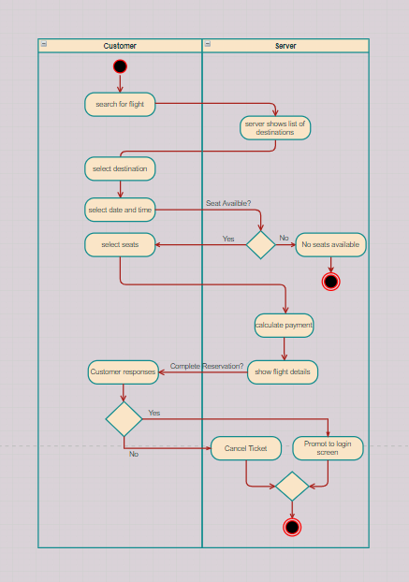

**Activity diagram for confirm reservation:**

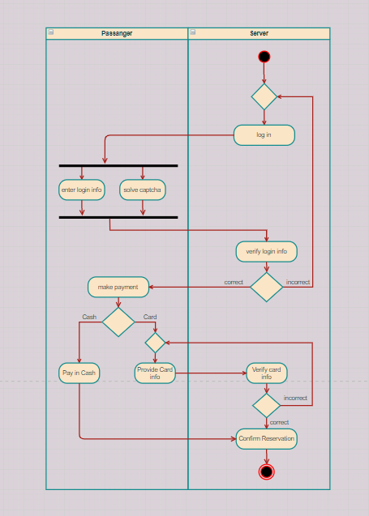

**State chart Diagram:**

**Case study for state chart diagram:**

In an airline reservation system, Airport server object is created. A customer will search for flight in airport server. Among various choices, in order to find his desired flight, the customer has to select the details of the flight. First the server will show a list of available destinations. After the customer selects the destination, server asks for preferable time and date. As the customer selects date and time, server shows available flights. If there are flights available for selected choices, he is asked how many seats he needs. As customer selects the seats, the amount is calculated. The server shows details of the flight like destination, seat numbers, time of flight, amount to be paid etc. If there is no seat available, the process ends showing a message “No available seat”. Now the server asks if he want to confirm the reservation or not. If the customer wants to complete reservation, he will be promoted to log in. Otherwise, the ticket will be cancelled.

To confirm reservation, server asks the customer to login. Customer enters login info. The customer fills in required info like email, password and solves captcha. If the captcha is not right it asks to solve another captcha. After captcha is solved correctly the login information passes and the server verify login info, if it corrects it shows flight details and total bill to be paid. If the login information is incorrect, he is asked to enter login info again. Customer has 2 options for payment, cash and credit card. For credit card payment, customer has to enter card information. Server verifies the info. If its correct, the reservation is confirmed. Else he is asked to enter cc info again. For cash payment, after paying the reservation is confirmed.

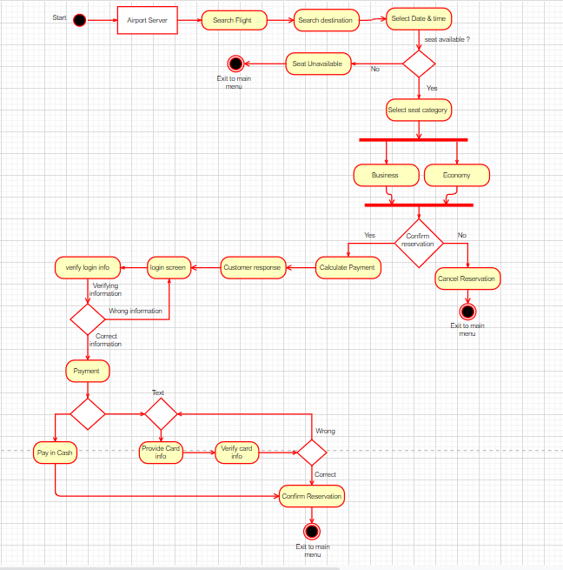

**COCOMO (Constructive cost model):**

**In this project: -**

• Software Project Type: Semi-detached

• SLOC (Source Lines of Code): 3000

• P (Project Complexity): 1.12

• Coefficient<Effort factor>: 3.0

• T (SLOC Dependent Coefficient): 0.35

**1. Effort/PM (Person-months needed for Project)**

Coefficient<Effort Factor>*(SLOC/1000) ^P

= 3.0 * (3000/1000) ^1.12

= 10.268

**2. Development time /DM**

=2.50(PM)^T

= 2.50*(10.268) ^0.35

= 5.65

**3. Required Number of People/ ST**

=PM/DM

= 10.268 /5.65

= 1.82