

Functional Specification
Project Name

Version 1.4
Last modified 09 May 2019
Number of pages 7
Document History
Date | Description | Author(s)

Table of Contents
1. Introduction 4
1.1. Document Identifier 4
1.2. Scope 4
1.3. Definitions of Terms and Acronyms 4
1.4. References 4
2. Problem Statement 4
3. Platform Requirements 4
4. Overview of Solution 4
5. Black-box Description 5
6. Use Cases Coverage 5
7. Questions and Answers 5
8. Appendix 5

Introduction

Document Identifier
This is a functional specification of Messenger Instigate Training 2019.

Scope
The document defines the components of Mesenger project and communications between them.

Definitions of Terms and Acronyms
This section contains a glossary of the used terms and acronyms.
JSON – (JavaScript Object Notation) is a lightweight data-interchange format. It is easy for humans to read and write. It is easy for machines to parse and generate.

References
This section includes the links of the sources that are referred from this document, with brief description of the content of the document.
- Messenger Use Cases

Problem Statement
Messenger is an application for the communication. It allows user to register and to send/receive text messages and files to/from other registered users. Also it allows to create chat groups for communication. The messages that send to the offline user are available hence the user becomes online.

Platform Requirements
This section should include description of the supported hardware platform and operating systems.

Overview of Solution
This section should briefly define the supported functionality, the description can be presented visually by diagrams or illustrations of the functional structure and supported actions. For a GUI project this can be mock-ups of the developed graphical applications.

Login Window
This window allows user to register or sign in. For registration user provides unique name (username, nick) and be marked as new user. No password is required for the initial version.
To sign in user provides registered unique name.
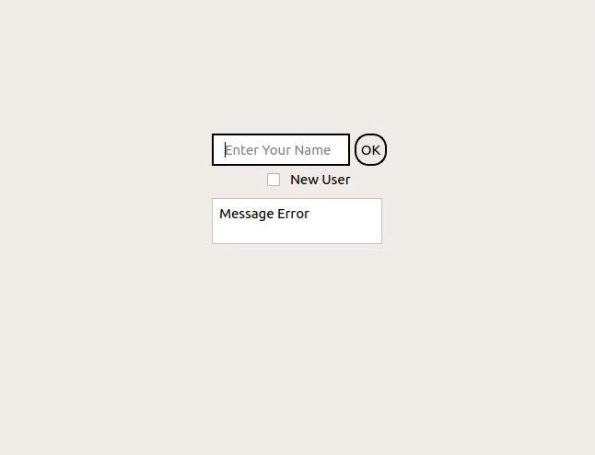

Users Window
The window shows all registered online/offline users. Online users differ with green mark next to name. The window shows chats that user participates in as well. There is Logout button in tool bar. Information messages on status bar informs about user online status changes. Double click on specific chat/user name opens the chat window.

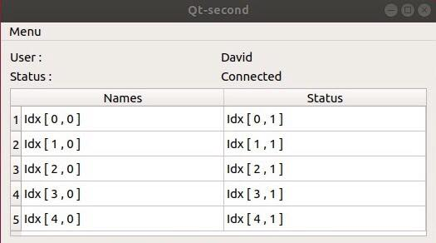

Chat Window
The chat window has line edit for message writing. To send the message to other participants user press enter or “Send” button. It is possible to send files by pressing “Attach” button.
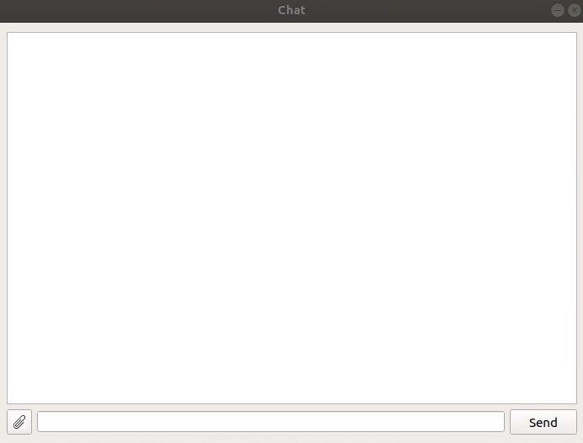

Black-box Description

Client
Client is an application with a GUI. Client has following functionality:
- Provides interface for user registration and login/logout
- Shows users and chats list
- Provides interface for users communications via messages and files

Server
Server is an application without a GUI which has well-known IP address and port. Server performs the following tasks:
- Stores/updates registered users list
- Waits for connection requests from clients
- Responsible for data transmissions between users
- Keeping information of all chats

Description of the solution
Client and Server communicate by commands. Some commands (e.g. register command) are initiated by client and responded by server. There are commands that initiated by Server (e.g. notifications about other user status changes). So it is decided to have duplex channel (both client and server wait for incomming commands).
Each command has name, passing arguments and corresponding response. The commands format follows JSON formatting.

Registration
For user registration Client sends to Server “REGISTER” command with chosen username.
C->S
{ “command” : “REGISTER”, “username” : “USER” }
S->C
{ “response” : “DONE”} in case of success
{ “response” : “FAILED”, “reason” : “error description”}

Login
C→S
{ “command” : “LOGIN”, “username” : “USER” }
S→C
{ “response” : “DONE”} in case of success
{ “response” : “FAILED”, “reason” : “error description”}
The following command is sent by server to all online clients
S→C
{ “command” : “UPDATE”, “username” : “USER”, “status” : “online” }
C→ S
{ “response” : “DONE”} in case of success

Logout
C->S
{ “command” : “LOGOUT”, “username” : “USER” }
S->C
{ “response” : “DONE”} in case of success
{ “response” : “FAILED”, “reason” : “error description”}
The following command is sent by server to all online clients
S→C
{ “command” : “UPDATE”, “username” : “USER”, “status” : “offline” }
C→ S
{ “response” : “DONE”} in case of success

Appendix
This section may be added to include additional information.

