# Project Name : FraudLabs

**Introduction:**

The rise of online transactions has led to an increased risk of payment fraud. This project aims to develop a robust online payment fraud detection system using machine learning techniques. The system will analyze transaction data in real-time to identify and prevent fraudulent transactions, enhancing the security and trust of online payment systems.

**Objectives:**

- Develop a machine learning model to detect fraudulent online payment transactions.

- Build a user-friendly interface for interacting with the fraud detection system.

- Provide real-time analysis and alerts for potential fraudulent transactions.

- Enhance the accuracy and efficiency of fraud detection using advanced machine learning algorithms.

- Generate comprehensive reports on detected fraudulent activities.

**Features:**

Real-time Transaction Monitoring: The system will continuously monitor online transactions, analyzing transaction details such as transaction amount, location, user behavior, and more.

Machine Learning Model: A machine learning model will be trained on historical transaction data to identify patterns indicative of fraud. Features such as transaction frequency, IP address, device information, and transaction amount will be used.

User Authentication: The system will incorporate multi-factor authentication to ensure the legitimacy of users and prevent unauthorized access.

Customizable Risk Thresholds: Users can set their preferred risk thresholds for transaction approval. Transactions exceeding the set risk threshold will trigger additional verification steps.

Alerts and Notifications: Users will receive real-time alerts and notifications via email or SMS for suspicious or high-risk transactions.

Transaction History and Reports: Users can access their transaction history and generate detailed reports, including a breakdown of legitimate and flagged transactions.

System Architecture:

The project will involve the following components:

- Data Collection and Preprocessing

- Feature Engineering

- Machine Learning Model Training

- User Interface Development

- Real-time Transaction Monitoring

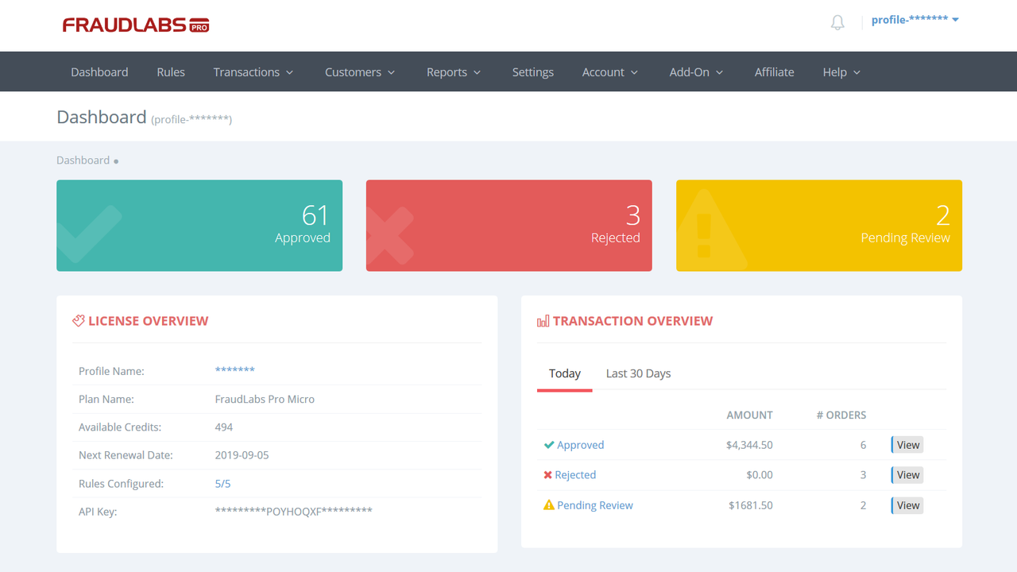

**Interactions with Users:**

The user will interact with the system through a user-friendly web-based interface. Screenshots/mockups of the interface will include:

Dashboard: An overview of recent transactions and their statuses.

Transaction History: A list of past transactions with their details and statuses.

Alerts: Notifications for flagged transactions and actions required.

Settings: Options to customize risk thresholds and notification preferences.

**Diagram:**

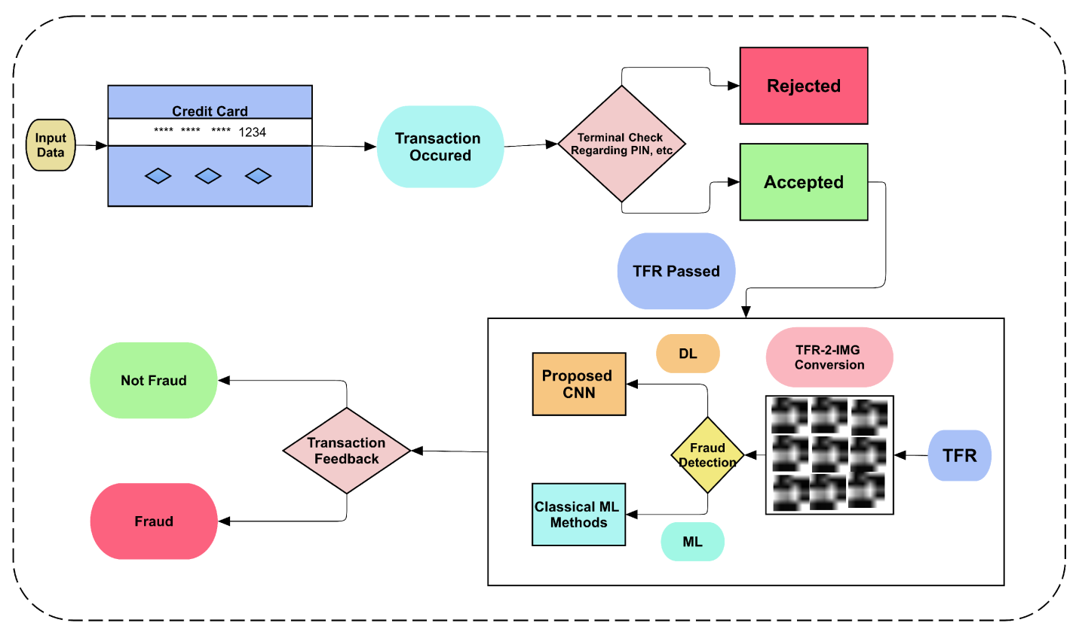

**Merits:**

Improved Security: Enhance online payment security by identifying and preventing fraudulent transactions.

Real-time Monitoring: Detect suspicious activities as they occur, reducing potential losses.

User Empowerment: Provide users with control over risk settings and transaction verification.

Comprehensive Reporting: Generate detailed reports for users to understand their transaction patterns.

**Demerits:**

False Positives: The system might occasionally flag legitimate transactions as fraud, inconveniencing users. Initial Training: Requires a substantial amount of historical transaction data to train the machine learning model effectively.

Maintenance: Regular updates and maintenance are essential to adapt to evolving fraud tactics.

**Conclusion:**

The proposed project "Online Payment Fraud Detection using Machine Learning in Python" addresses the critical need for enhancing the security of online payment systems. By implementing a real-time fraud detection system and providing users with customizable controls, the project aims to mitigate the risks associated with online payment fraud.