SAFEX SOLUTIONS
AI FAQ Assistant Prototype
Internship Case Study

Zarman Sattar
Internship: SafeX Solutions — AI/ML Prototype Track

Date: 01 July 2026

1. Objective
Build a small, working AI/ML prototype that demonstrates practical value for SafeX Solutions, and document the approach and results as a portfolio case study. The brief allowed three directions (FAQ chatbot, engagement forecast model, or data dashboard); an FAQ assistant was selected because SafeX's public-facing site (safexsolutions.com) has no dedicated FAQ page, and a grounded Q&A assistant is a concrete, demonstrable way to close that gap while giving visitors instant answers about services, mission, and contact details.

2. Problem
Visitors to safexsolutions.com currently have to read through the About, Services, and Mission sections manually to find specific answers — for example, "does SafeX offer cybersecurity?" or "how do I get in touch?" There's no interactive way to query this content. A chatbot grounded in the site's real content solves this without requiring a human to be on standby, and can be extended later into a lead-qualification or support tool.

3. Approach
The prototype uses retrieval-augmented generation (RAG) — a technique where the system first retrieves the most relevant pieces of trusted source content for a question, then passes only that content to a language model to compose a natural-language answer. This keeps answers grounded in facts SafeX actually publishes, rather than letting a model improvise or hallucinate answers about services, pricing, or policies that were never stated.

3.1 Data source
All knowledge base content was extracted directly from safexsolutions.com — the homepage, About, Mission, Services, and Contact sections — with no fabricated or assumed facts. The knowledge base is organized into ten topic chunks:
Chunk ID | Topic
company-overview | Company overview, tagline, scale
mission | Mission, Trust model, social impact
services-core | Six core service icons from the homepage (Web Dev, Database Design, Software Dev, AI Dev, Cyber Security, Data Management)
services-tech | Technology & IT solutions (detailed)
services-marketing | Digital marketing & brand growth
services-creative | Creative media & visual production
services-training | Training & workforce development
who-they-serve | Client profile (startups, SMBs, enterprise)
contact | Email, phone, social channels
philosophy | Company philosophy and long-term vision
testimonial | Client feedback

The services-core chunk was added after reviewing the homepage directly, since the six-icon service row is a distinct, high-visibility taxonomy visitors are likely to ask about by name (e.g. "do you do AI development?").

3.2 Retrieval layer
Since this is a small, fixed knowledge base (ten chunks), a lightweight keyword-overlap scoring retriever was implemented in JavaScript rather than a full vector database — appropriate for the scale of the problem and avoiding unnecessary infrastructure. For each user question:
- The question is tokenized and stripped of stopwords (e.g. "the", "does", "can").
- Each knowledge base chunk is scored by token overlap with the question (exact matches weighted higher than partial/substring matches).
- The top 2–3 highest-scoring chunks are selected as context.
- If no chunk scores above zero (i.e. the question is off-topic or asks something SafeX doesn't publish, like pricing), the retriever falls back to the general company overview chunk rather than returning nothing — this lets the model honestly say "that's not something we publish" instead of failing silently.

3.3 Generation layer
The retrieved context is inserted into a system prompt that instructs the model to answer only from the provided context, to keep responses concise (2–4 sentences), and — critically — to say so and point to SafeX's contact email rather than inventing an answer if the context doesn't cover the question. This constraint is the main defense against hallucination in a customer-facing tool. Generation runs on Groq's LLaMA 3.3 70B model (llama-3.3-70b-versatile), called server-side with a low temperature (0.3) to keep answers factual and consistent rather than creative.

3.4 Backend and interface
Unlike a purely client-side demo, this prototype was built as a real local full-stack project so the API key never reaches the browser:
- Backend: Node.js + Express server (server.js) exposes a single POST /api/ask endpoint. It runs the retrieval step, builds the grounded system prompt, calls the Groq API, and returns the answer plus which knowledge topics it was grounded in.
- Frontend: Static HTML/CSS/JS served by the same Express server (public/index.html, style.css, app.js) — a chat widget styled to match SafeX's actual site (white background, navy header, blue accent, the SafeX shield logo) rather than a generic AI chat template.
- Config: API key stored in a local .env file (GROQ_API_KEY), excluded from version control via .gitignore.

This mirrors the same pattern used in the BidLens internship project (Groq + LLaMA 3.3 70B, Node-based backend), keeping the two internship deliverables consistent in approach.

4. Architecture
Browser (public/index.html + app.js) → POST /api/ask { question } → Express server (server.js) → tokenize and strip stopwords → score all knowledge chunks (data/knowledge_base.js) by keyword overlap → select top 2–3 relevant chunks (or fall back to the overview chunk if nothing matches) → insert chunks into the system prompt as grounding context → Groq API (LLaMA 3.3 70B) generates an answer using only that context → JSON response { answer, sources } returned to the browser → answer rendered with a "Grounded in: [topic names]" tag.

Project structure
- server.js — Express server, /api/ask route, retrieval logic
- package.json
- .env — GROQ_API_KEY (not committed)
- .gitignore
- data/knowledge_base.js — SafeX content chunks
- public/index.html — chat UI markup
- public/style.css — SafeX-matched white/blue styling
- public/app.js — frontend logic, calls /api/ask

5. Results — sample interactions
Retrieval accuracy was first validated against seven representative test questions in isolation (before wiring up generation), confirming the retriever consistently surfaces the correct topic:
Question | Retrieved topic(s) | Correct?
"What services does SafeX offer?" | Company overview, Technology & IT services | Yes
"How can I contact SafeX?" | Contact information | Yes
"What is SafeX's mission?" | Mission and values | Yes
"Do you offer internships?" | Training and workforce development | Yes
"Can you help with cybersecurity?" | Technology & IT services | Yes
"Do you do photography or videography?" | Creative media & visual production | Yes
"What is your pricing?" (intentionally unanswerable) | Falls back to overview; model correctly declines to invent a number | Yes

After wiring up the full stack (Express backend + Groq generation), the same behavior was confirmed end to end in the browser. The screenshot below shows the live local app answering "What services does SafeX offer?" with the source topics it was grounded in shown directly under the answer:
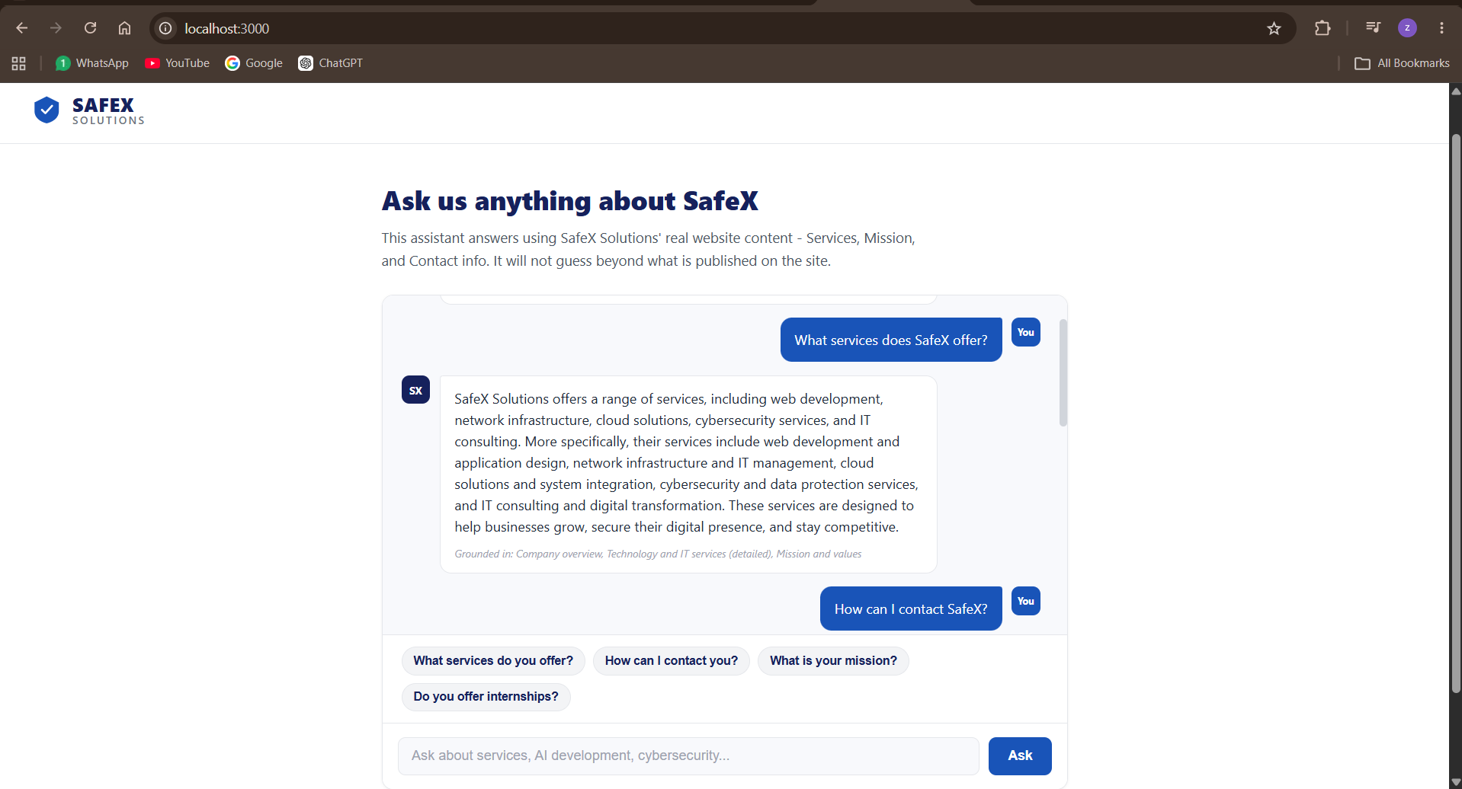
Live local demo: localhost:3000, SafeX FAQ assistant
The pricing test case remains the most important validation: SafeX's site does not publish pricing, and the system correctly avoids fabricating one — instead directing the user to contact SafeX directly. This confirms the grounding constraint holds up under the real generation model (Groq/LLaMA), not just in the retrieval-only test, which matters more for a customer-facing tool than getting the easy questions right.

Guardrail verification
Two further live tests confirm the assistant correctly recognizes the limits of its own knowledge rather than guessing:
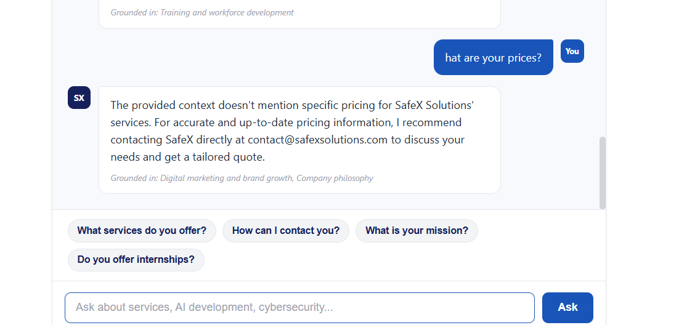
Test 1: "What are your prices?" — declines to invent a figure, redirects to contact@safexsolutions.com
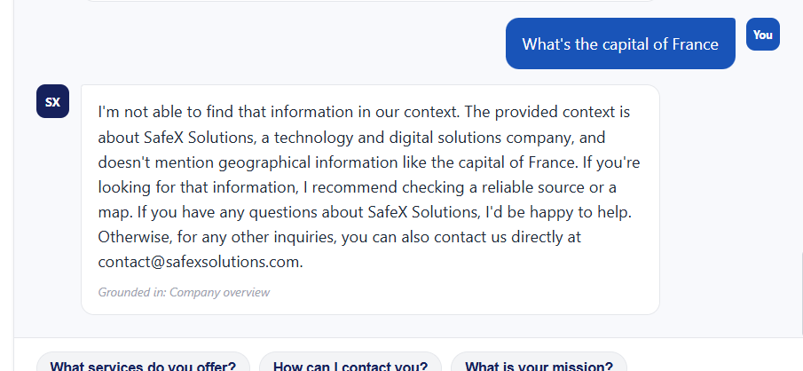
Test 2: "What's the capital of France?" — recognizes the question is unrelated to SafeX entirely and redirects, rather than force-fitting an answer from the knowledge base
Both tests demonstrate the same underlying property: the assistant treats its knowledge base as a hard boundary, not a starting point for improvisation. This is the central design goal of the retrieval-augmented approach — a chatbot that knows what it doesn't know is more trustworthy in a customer-facing role than one that always produces a confident-sounding answer.

6. Limitations
Knowledge base is limited to homepage/About content. SafeX's site does not currently have a dedicated FAQ, pricing, or case-studies page, so the assistant cannot answer questions in those areas. Expanding the knowledge base as SafeX publishes more content would directly expand what the assistant can answer.
Keyword-overlap retrieval is simple by design. It works well at this scale (10 chunks) but would need to be replaced with embedding-based semantic search if the knowledge base grows past roughly 30–50 chunks, since keyword overlap doesn't understand synonyms or rephrased questions as well as vector similarity would.
No conversation memory. Each question is currently answered independently; a production version would carry recent conversation history so follow-up questions ("what about pricing for that?") resolve correctly.
Not yet connected to a live inbox or CRM. Questions the assistant can't answer are shown to the user with a suggestion to email SafeX directly, but aren't automatically logged or routed to a human — a natural next step for a production deployment.
Runs locally only. The current build is a local Node.js app (localhost:3000); it has not yet been deployed to a public host, so it cannot be shared via a link in its current state.

7. Next steps (if extended beyond prototype)
- Expand the knowledge base as SafeX adds an FAQ, pricing, or case-study pages.
- Replace keyword retrieval with embedding-based semantic search once the knowledge base grows.
- Add conversation memory for multi-turn follow-ups.
- Log unanswered questions to identify real gaps in published content.
- Deploy the Express app (e.g. to Render or Vercel) and embed it directly into safexsolutions.com as a widget.

8. Deliverable
A working local full-stack prototype is included alongside this case study:
- server.js — Express backend and retrieval logic
- data/knowledge_base.js — SafeX content chunks
- public/index.html, public/style.css, public/app.js — chat interface

Run locally with "node server.js", then open http://localhost:3000 in a browser. Requires a .env file with a valid GROQ_API_KEY (not included, for security).

