**IS 360  
LAB 2  
Lists and Tables**

**In the following exercise, you will work with lists and nested lists.**

1. Create a blank HTML 5 document just as you did in the first lab.
2. Create an unordered list with the following elements. Make sure that each list element appears in a bold typeface.

* **Monday**
* **Tuesday**
* **Wednesday**
* **Thursday**
* **Friday**

1. Create a list that looks like the following one. As you can see, the following list has nested elements. That is, you are creating one unordered list inside of another. The amounts should appear in boldface.

* First quarter
  + Revenues **$125,000**.
  + Margin 45%
* Second quarter
  + Revenues **$135,000**.
  + Margin 46%
* Third quarter
  + Revenues **$144,000**.
  + Margin 44.5%
* Fourth quarter
  + Revenues **$154,000**.
  + Margin 43.5%

**In the following exercise, you will use the W3C validation service.**

1. Make sure that you have saved the Web page that you created in the previous exercise.
2. In the browser of your choosing, visit the W3C Markup Validation Service at <http://validator.w3.org>.
3. Click the **Validate by File Upload** tab so that you can upload the Web page.
4. Click the **Browse** button to select the file to upload.
5. Click the **More Options** button to select the DTD. The selections you make should be similar to those in the following figure:  
     
   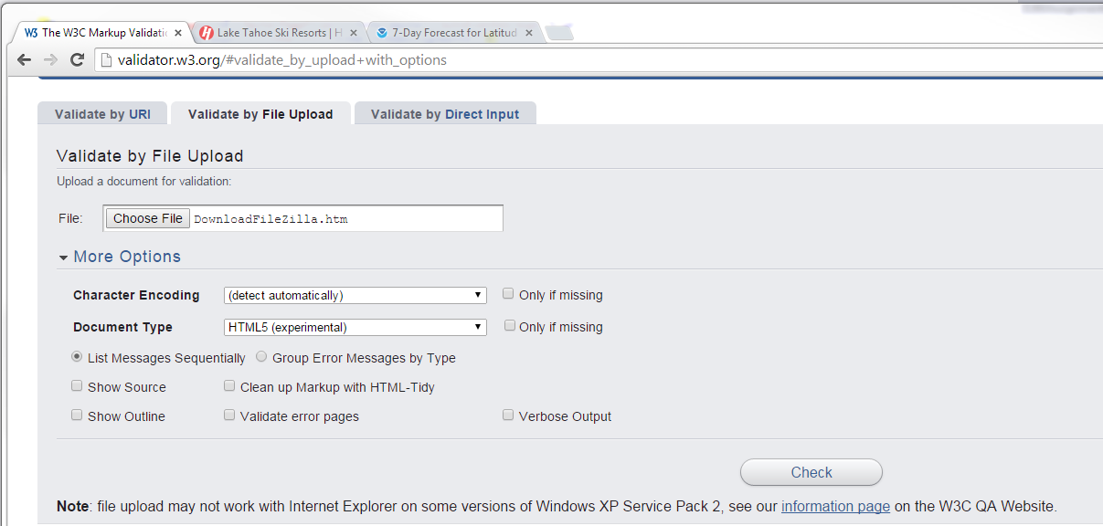
6. Click **Check** to run the validator.
7. Review the errors.
8. Note that there are two acceptable errors. On indicates that the HTML 5 validator is experimental. The second is a byte encoding warning.

**In the following exercise, you will work with a simple table.**

1. Create a second blank HTML document. Name it FirstTable.htm
2. Create a table that looks like the following. Note that the second column contains links to Web pages. The table should have the following characteristics:  
     
   The table should have a border that is 2 pixels wide.  
     
   The data in each column should be centered.  
     
   The header column should appear in a bold typeface.  
     
   The data in the second column should behave as a link <a> tag.  
     
   The table should fill 90% of the browser window.  
     
   The first column should occupy 30% of the table’s width and the second column should occupy the 70% of the table’s width.

|  |  |
| --- | --- |
| **Description** | **Link** |
| Google | <http://google.com> |
| Yahoo | <http://yahoo.com> |
| Microsoft | <http://bing.com> |
| Ask | <http://ask.com> |

**In the following exercise, you will create a more complex table than the first one.**

1. Create the following table with these characteristics:

* Boldface the cells in the first and last rows as shown.
* The data in the first two rows should be centered.
* The data in the remaining rows should be right-justified.

|  |  |  |  |  |  |  |  |  |  |  |  |
| --- | --- | --- | --- | --- | --- | --- | --- | --- | --- | --- | --- |
| **2010** | | | | **2011** | | | | **2012** | | | |
| Q1 | Q2 | Q3 | Q4 | Q1 | Q2 | Q3 | Q4 | Q1 | Q2 | Q3 | Q4 |
| 1 | 2 | 4 | 3 | 2 | 3 | 5 | 4 | 3 | 3 | 6 | 8 |
| 1 | 3 | 5 | 7 | 3 | 3 | 5 | 7 | 2 | 8 | 3 | 5 |
| **2** | **5** | **9** | **10** | **5** | **6** | **10** | **11** | **5** | **11** | **9** | **13** |

**In the following exercise, you will work with nested tables:**

1. Create the following table with these characteristics:

* Create an outer table with 2 rows and 2 columns (4 cells) to hold the inner table.
* Inside the outer table, each inner table has the same structure. The four inner tables should be titled Grid 1, Grid 2, Grid 3, and Grid 4.
* Align the table data as shown in the following figure:
* Create a bulleted list inside of each cell in the outer table as follows:

|  |  |  |  |  |  |  |  |  |  |  |  |  |  |
| --- | --- | --- | --- | --- | --- | --- | --- | --- | --- | --- | --- | --- | --- |
| Grid 1   |  |  | | --- | --- | | X | 123.45 | | Y | 17.84 | | Value | 208.33 |  * Notes: | Grid 2   |  |  | | --- | --- | | X | 13.45 | | Y | 13.84 | | Value | 166.33 |  * Notes: |
| Grid 3   |  |  | | --- | --- | | X | 1123.45 | | Y | 117.84 | | Value | 1208.33 |  * Notes: | Grid 4   |  |  | | --- | --- | | X | 2123.45 | | Y | 217.84 | | Value | 2208.33 |  * Notes: |