--QUESTION 1

SELECT ItemID "itemid",

Description "ItemDescription",

ListPrice "ListPrice"

FROM TblItem

WHERE typeID = 12 OR typeID = 15

ORDER BY ItemID;

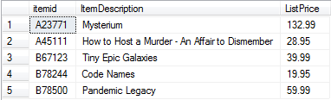

--QUESTION 2

SELECT TblItem.ItemID "itemid",

TblItem.Description "ItemDescription",

TblItemType.CategoryDescription "CategoryDescription",

TblItem.ListPrice "ListPrice"

FROM TblItem

INNER JOIN TblItemType

ON TblItem.TypeID = TblItemType.TypeID

WHERE TblItem.typeID = 12 OR TblItem.typeID = 15

ORDER BY ItemID;

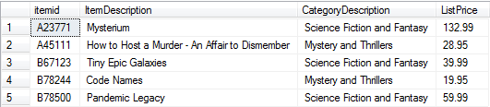

--QUESTION 3

SELECT TblItem.ItemID "itemid",

TblItem.Description "ItemDescription",

TblItemType.CategoryDescription "CategoryDescription",

CASE

WHEN TblOrderLine.OrderID IS NULL

THEN '\*n/a\*'

ELSE

TblOrderLine.OrderID

END "OrderID",

TblOrderLine.Quantity "Quantity",

TblItem.ListPrice "ListPrice",

TblOrderLine.Price "Price",

TblOrderLine.Price - TblItem.ListPrice "PriceDifference"

FROM TblItem

INNER JOIN TblItemType

ON TblItem.TypeID = TblItemType.TypeID

LEFT OUTER JOIN TblOrderLine

ON TblItem.ItemID = TblOrderLine.ItemID

WHERE TblItem.typeID = 12 OR TblItem.typeID = 15

ORDER BY ItemID;

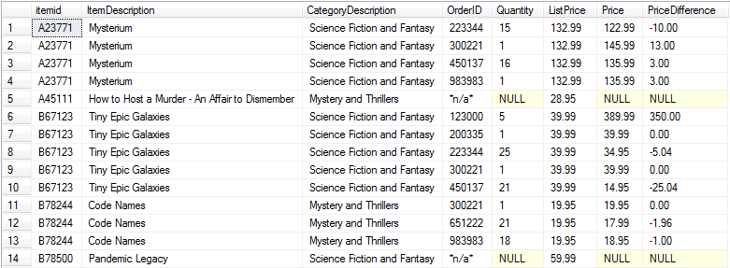

--QUESTION 4

SELECT TblItem.ItemID "itemid",

TblItem.Description "ItemDescription",

TblItemType.CategoryDescription "CategoryDescription",

CASE

WHEN TblOrderLine.OrderID IS NULL

THEN '\*n/a\*'

ELSE

TblOrderLine.OrderID

END "OrderID",

CONVERT(VARCHAR(12), TblOrder.OrderDate, 107) "OrderDate",

CASE

WHEN TblOrder.CustomerID IS NULL

THEN 'No Current Order'

ELSE

CONCAT(TblCustomer.LastName, ', ', TblCustomer.FirstName)

END "CustomerName",

TblOrderLine.Quantity "Quantity",

TblItem.ListPrice "ListPrice",

TblOrderLine.Price "Price",

TblOrderLine.Price - TblItem.ListPrice "PriceDifference"

FROM TblItem

INNER JOIN TblItemType

ON TblItem.TypeID = TblItemType.TypeID

LEFT OUTER JOIN TblOrderLine

ON TblItem.ItemID = TblOrderLine.ItemID

LEFT OUTER JOIN TblOrder

ON TblOrderLine.OrderID = TblOrder.OrderID

LEFT OUTER JOIN TblCustomer

ON TblOrder.CustomerID = TblCustomer.CustomerID

WHERE TblItem.typeID = 12 OR TblItem.typeID = 15

ORDER BY ItemID;

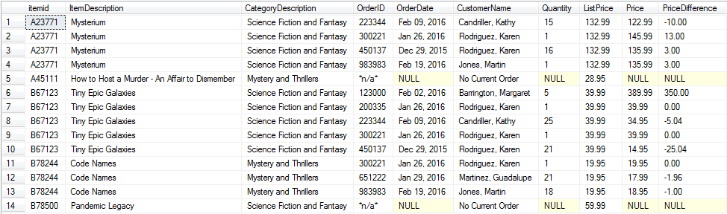

--QUESTION 5

SELECT TblItem.ItemID "ItemID",

TblItem.Description "Description",

TblItem.ListPrice "ListPrice",

TblItemType.CategoryDescription "CategoryDescription"

FROM TblItem

INNER JOIN TblItemType

ON TblItem.TypeID = TblItemType.TypeID

WHERE EXISTS (SELECT \*

FROM TblReview

WHERE TblReview.ItemID = TblItem.ItemID);

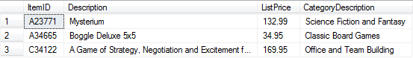

--QUESTION 6

SELECT DISTINCT CONCAT(TblCustomer.LastName, ', ', TblCustomer.FirstName) "CustomerName",

(SELECT COUNT(\*)

FROM TblOrder

WHERE TblOrder.CustomerID = TblCustomer.CustomerID) "CountOfOrders"

FROM TblCustomer

INNER JOIN TblOrder

ON TblCustomer.CustomerID = TblOrder.CustomerID;

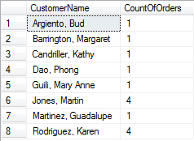

--QUESTION 7

SELECT DISTINCT CONCAT(TblCustomer.LastName, ', ', TblCustomer.FirstName) "CustomerName",

(SELECT COUNT(\*)

FROM TblOrder

WHERE TblOrder.CustomerID = TblCustomer.CustomerID) "CountOfOrders",

(SELECT COUNT(\*)

FROM TblOrderLine

WHERE TblOrder.OrderID = TblOrderLine.OrderID

GROUP BY TblOrderLine.OrderID) "CountOfItems",

(SELECT AVG(TblOrderLine.Price)

FROM TblOrderLine

WHERE TblOrder.OrderID = TblOrderLine.OrderID) "AveragePrice",

(SELECT MIN(TblOrderLine.Price)

FROM TblOrderLine

WHERE TblOrder.OrderID = TblOrderLine.OrderID) "MinimumPrice",

(SELECT MAX(TblOrderLine.Price)

FROM TblOrderLine

WHERE TblOrder.OrderID = TblOrderLine.OrderID) "MaximumPrice"

FROM TblCustomer

INNER JOIN TblOrder

ON TblCustomer.CustomerID = TblOrder.CustomerID;

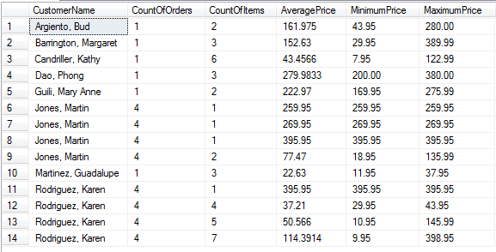

--QUESTION 8

SELECT DISTINCT TOP 1 CONCAT(TblCustomer.LastName, ', ', TblCustomer.FirstName) "CustomerName",

(SELECT COUNT(\*)

FROM TblOrder

WHERE TblOrder.CustomerID = TblCustomer.CustomerID) "CountOfOrders",

(SELECT COUNT(\*)

FROM TblOrderLine

WHERE TblOrder.OrderID = TblOrderLine.OrderID

GROUP BY TblOrderLine.OrderID) "CountOfItems",

(SELECT AVG(TblOrderLine.Price)

FROM TblOrderLine

WHERE TblOrder.OrderID = TblOrderLine.OrderID) "AveragePrice",

(SELECT MIN(TblOrderLine.Price)

FROM TblOrderLine

WHERE TblOrder.OrderID = TblOrderLine.OrderID) "MinimumPrice",

(SELECT MAX(TblOrderLine.Price)

FROM TblOrderLine

WHERE TblOrder.OrderID = TblOrderLine.OrderID) "MaximumPrice"

FROM TblCustomer

INNER JOIN TblOrder

ON TblCustomer.CustomerID = TblOrder.CustomerID;

