Graphs One UAV One AP

Configurations
Configurations
Fixed Parameter | Value
Network AP Location | 0,0 m
STA1 Location | 1,1 m
STAs Locations | 10,10m
Frequency | 5GHz
Number of STAs | 1
Traffic Type | UDP
STA 1 Traffic Data Rate | 5Mbps
MCS Value of DataRate  (MCS5) | wifi.SetRemoteStationManager("ns3::ConstantRateWifiManager",  "DataMode", StringValue("HeMcs5"),  "ControlMode", StringValue("HeMcs0"));
Channel Settings | 50, 160, BAND_5GHZ, 0
Access Category Wifi6 | AX
Simulation Time | 10s
Propagation Loss Model | Default YansCHannel Loss Model

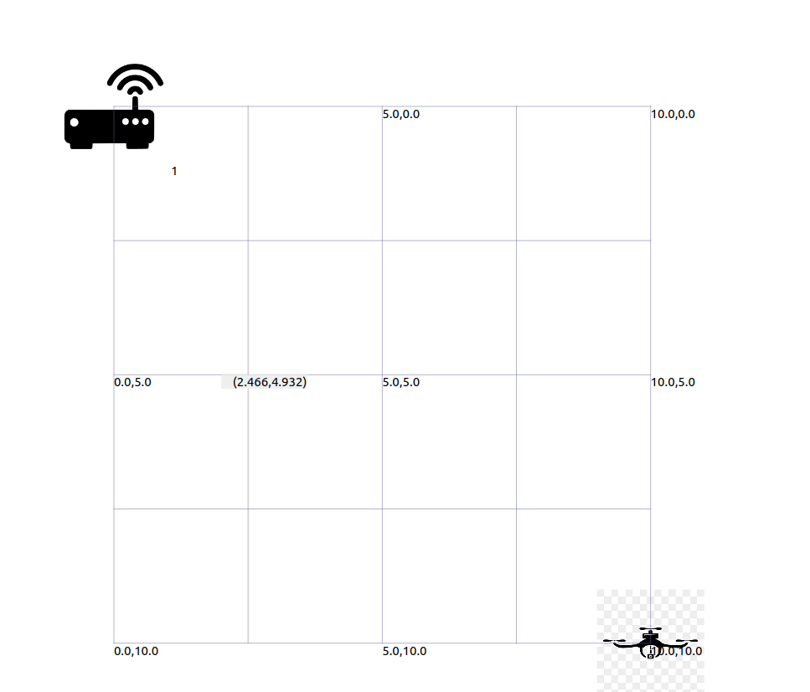

Results Table

Throughput(Mbps) | Delay(s) | Jitter(s) | QoS | Access PointUAV Distance | UAV Distance METERS
5.0964 | 0.0000815718 | 0.0000061403 | 1.01928 | (0,0,0) | (1,1,0)
5.09639 | 0.0000816617 | 0.00000611202 | 1.01928 | (0,0,0) | (10,10,0)
5.0964 | 0.000800663 | 0.000813772 | 1.01928 | (0,0,0) | (13,13,0)
5.09515 | 0.00485025 | 0.00254009 | 1.01903 | (0,0,0) | (13.5,13.5,0)
5.06057 | 0.0556422 | 0.0041724 | 1.01211 | (0,0,0) | (14,14,0)
2.79408 | 0.492657 | 0.00299743 | 0.558816 | (0,0,0) | (14.3,14.3,0)
0.172175 | 0.50257 | 0.00584001 | 0.0344351 | (0,0,0) | (14.5,14.5,0)
0 | 0 | 0 | 0 | (0,0,0) | (20,20,0)

Results:
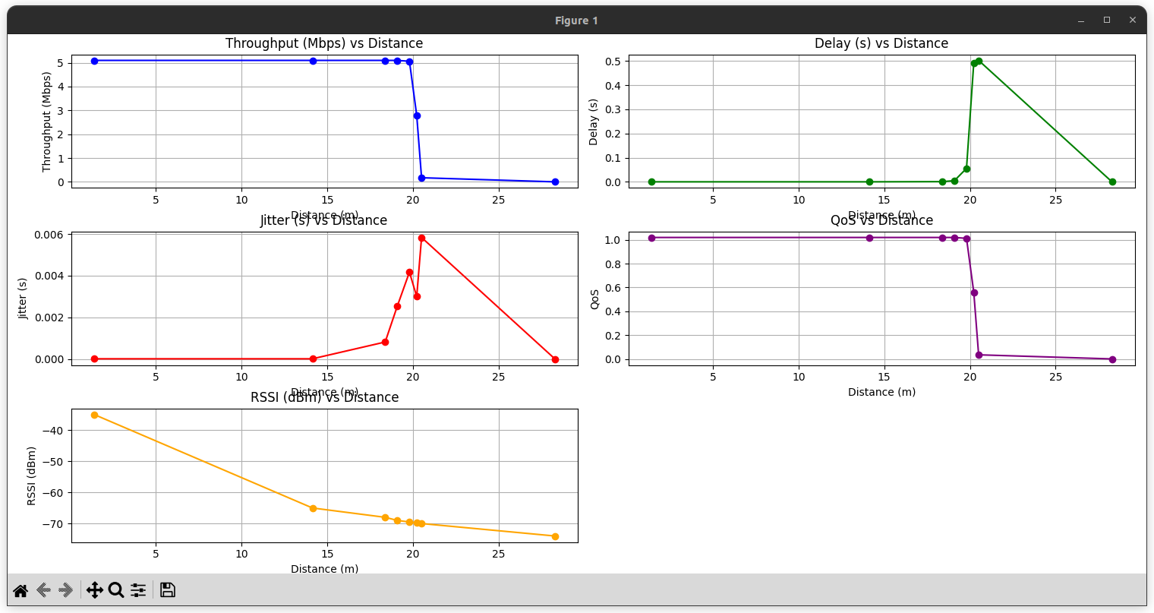

Access Point at Location 10,10

UAV1 Transmitter Node at 1,1 meters

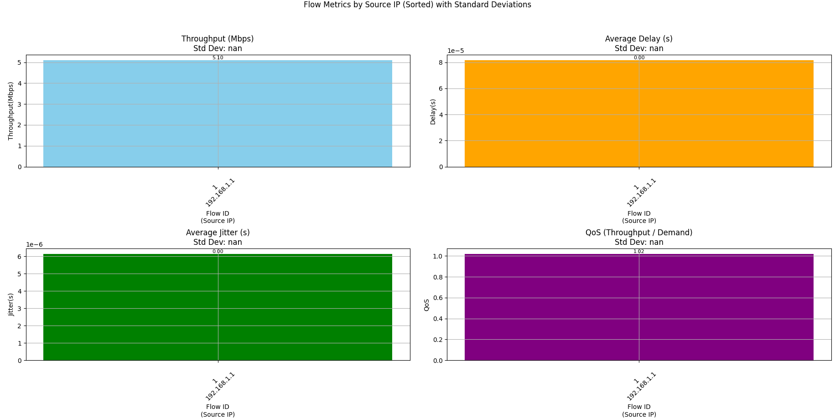

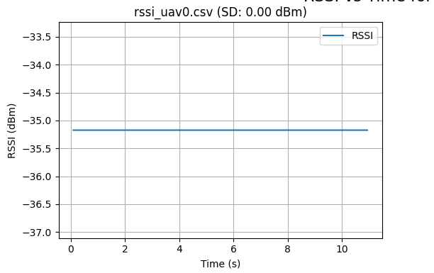

Test Case 2
UAV1 Transmitter Node at 10,10 meters

.

Results

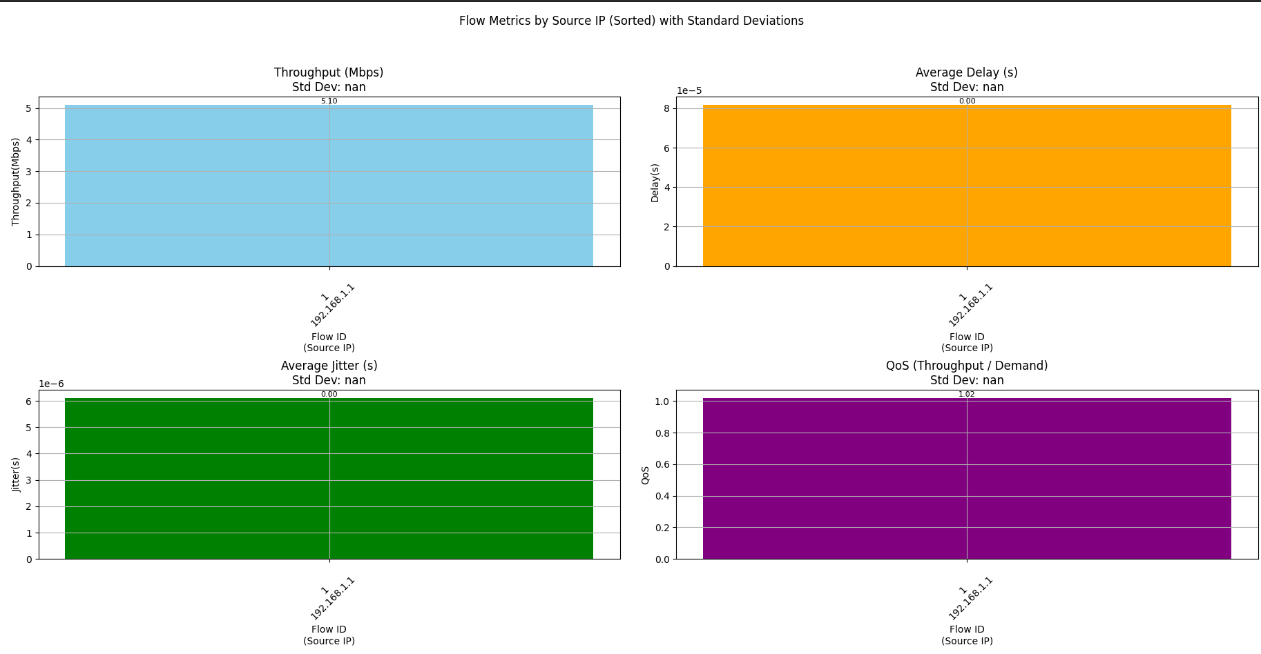

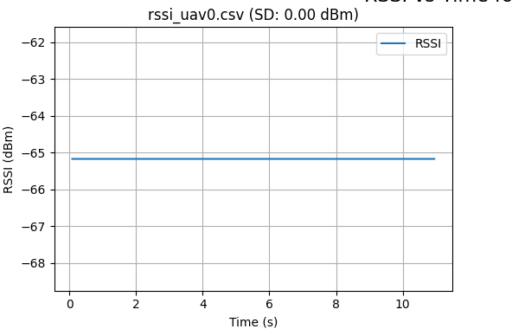

Test Case 3
UAV1 Transmitter Node at 13 and 13 meters
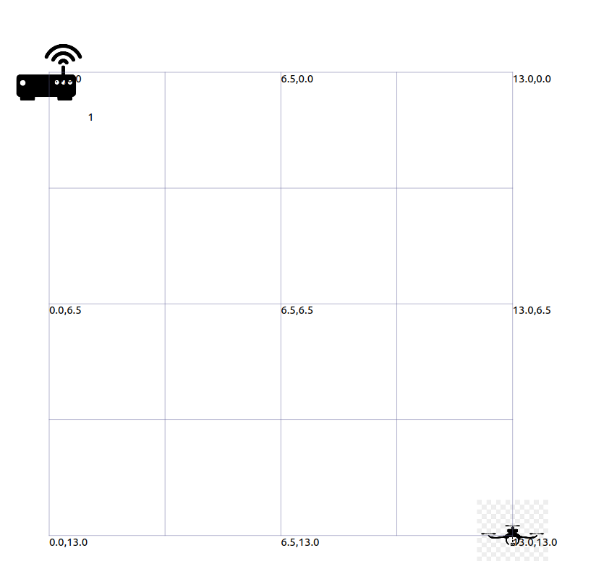
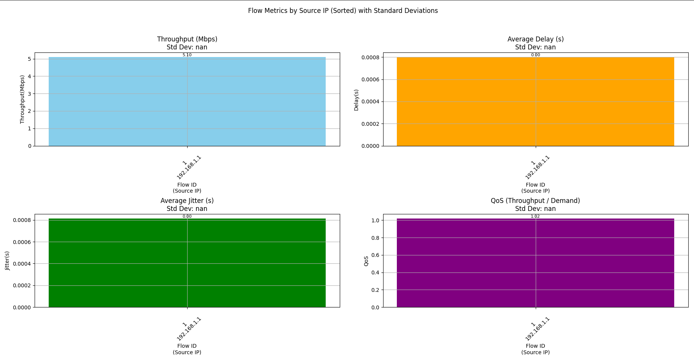
.

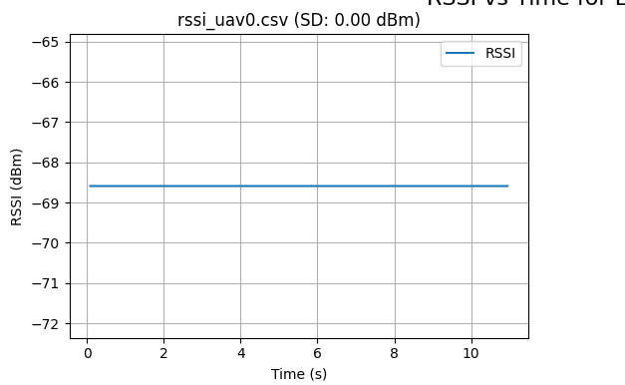
Test Case 4
UAV1 Transmitter Node at 13.5 and 13.5 meters

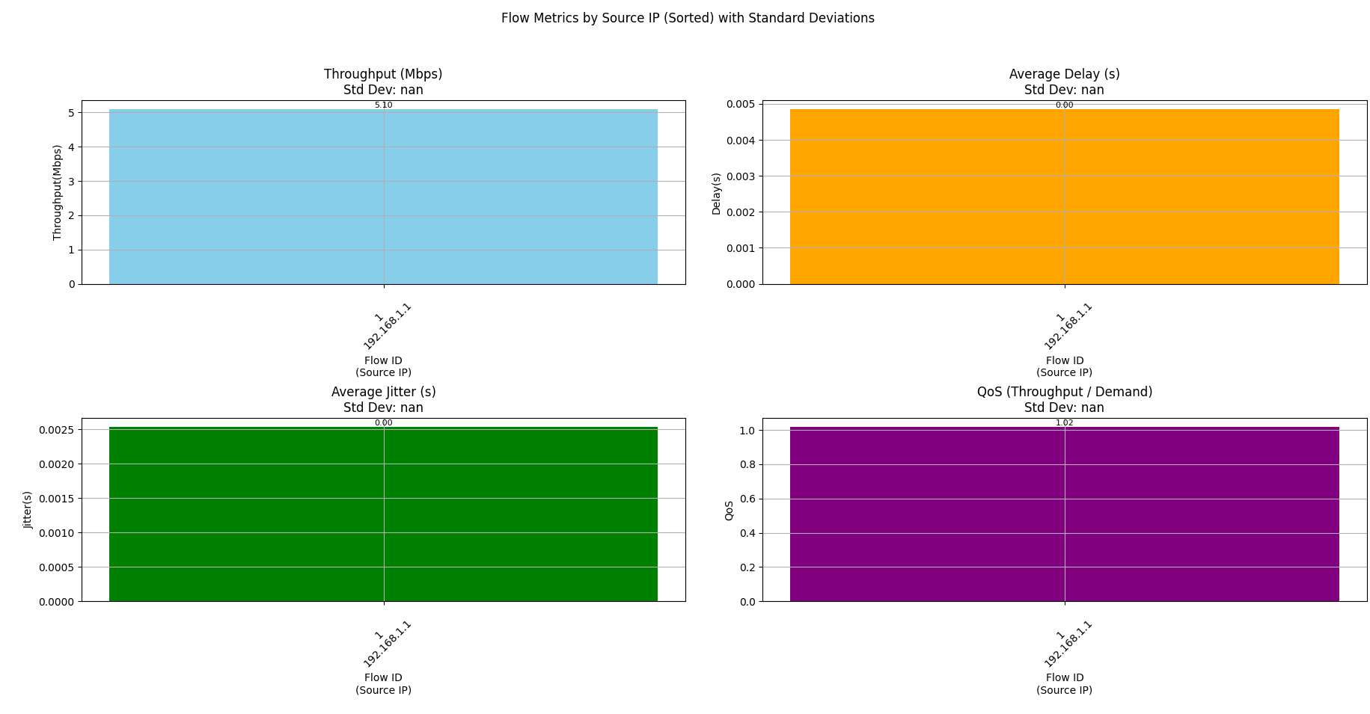
.

Test Case 5
UAV1 Transmitter Node at 14. and 14.0 meters
Results
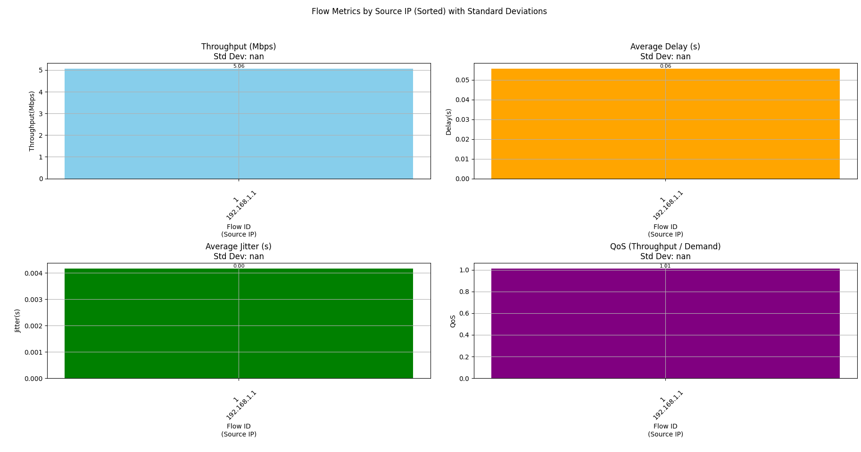

Test Case 6
UAV1 Transmitter Node at 14.3 and 14.3 meters
Results

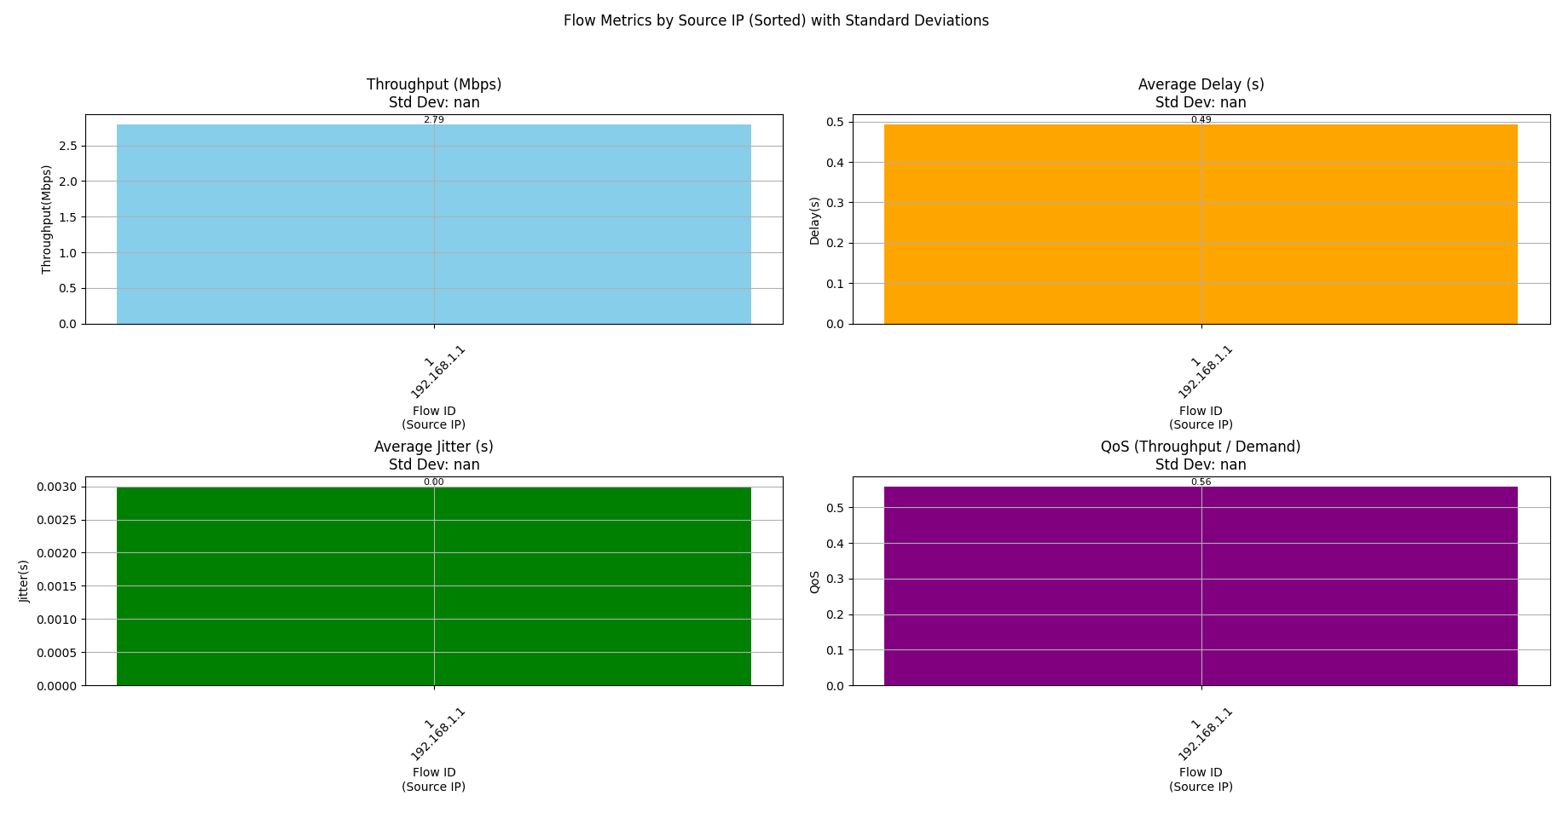

Test Case 6
UAV1 Transmitter Node at 14.5, 14.5 meters

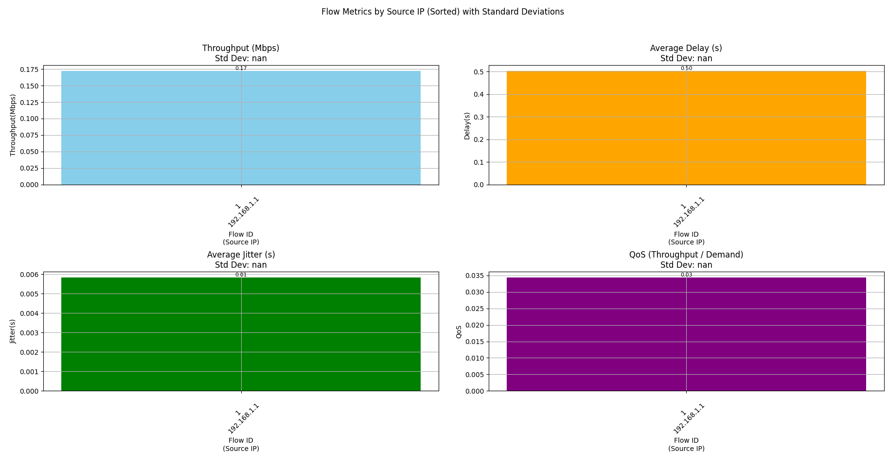

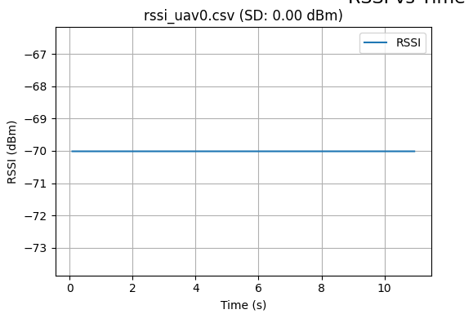

Test Case 7
UAV1 Transmitter Node at 20, 20 meters

Results :
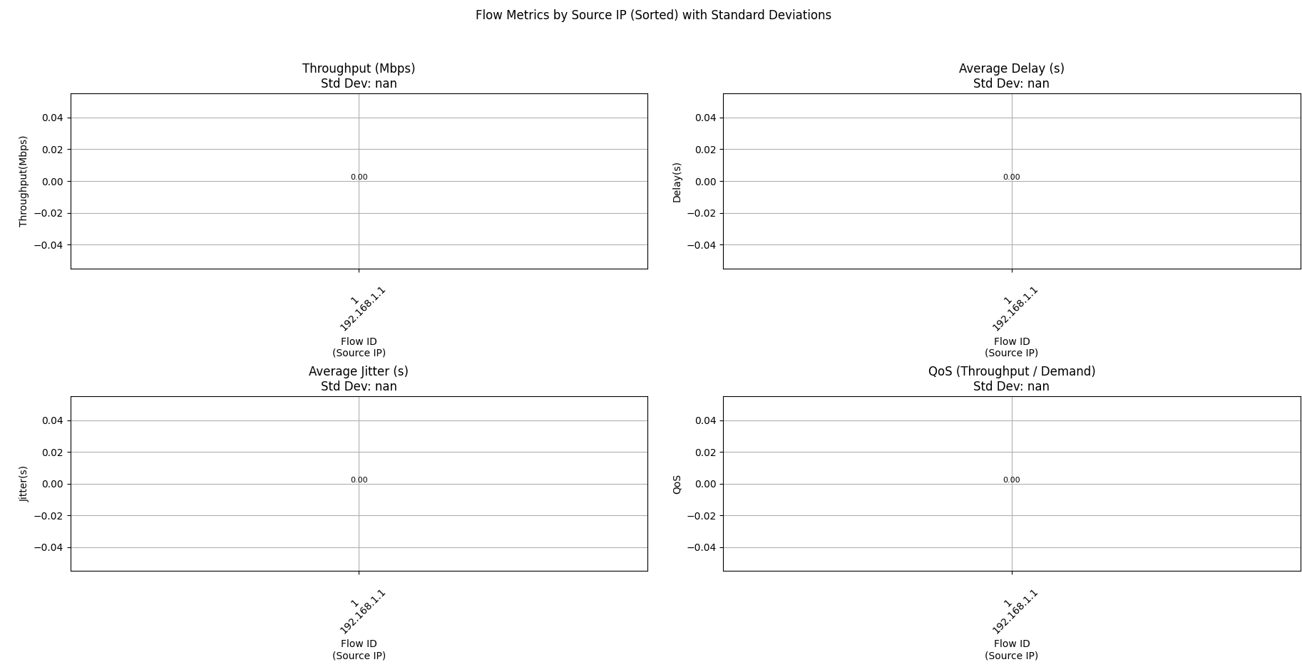

RSSI Values

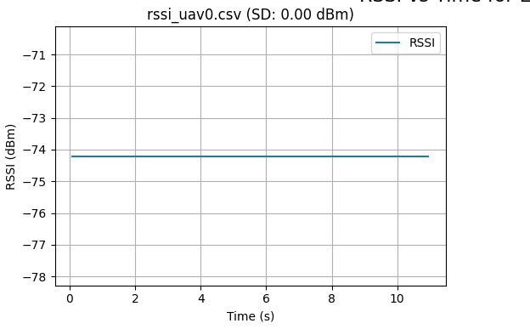

Analysis

