Graphs One Access Points Two UAVs

Configurations
Fixed Parameter | Value
Network AP Location | 0,0 m
STA1 Location | 1,1 m
STAs Locations | 10,10m
Frequency | 5GHz
Number of STAs | 2
Traffic Type | UDP
STA 1 Traffic Data Rate | 5Mbps
STA 2 Traffic Data Rate | 50Mbps
MCS Value of DataRate  (MCS5) | wifi.SetRemoteStationManager("ns3::ConstantRateWifiManager",  "DataMode", StringValue("HeMcs5"),  "ControlMode", StringValue("HeMcs0"));
Channel Settings | 50, 160, BAND_5GHZ, 0
Access Category Wifi6 | AX
Simulation Time | 10s
Propagation Loss Model | Default YansCHannel Loss Model
MCS Table
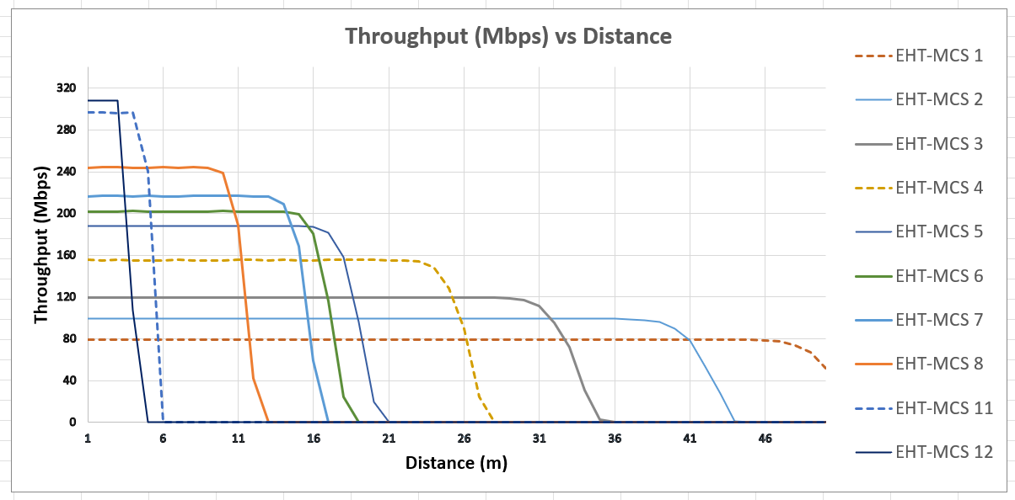

Results Table
Results:
Access Point at Location 10,10
UAV1 Transmitter Node at 1,1 meters
UAV2 Transmitter Node at 10,10 meters
UAV 1 Static
UAV2 Moving Away
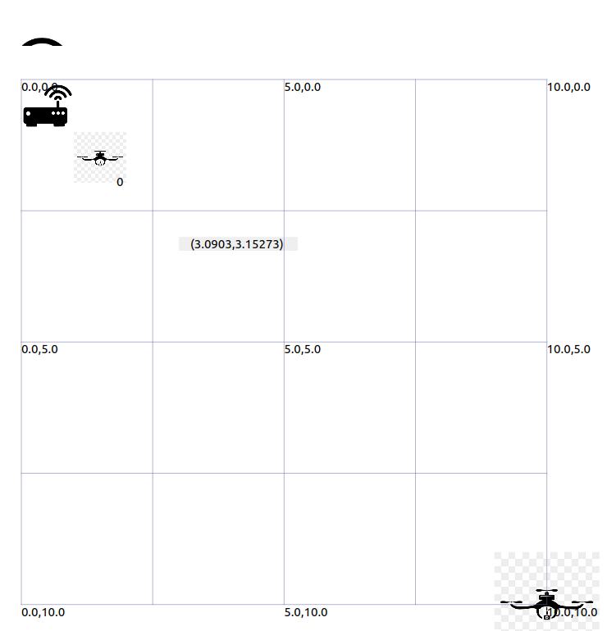

.

Results Analysis UAV1 ( Fixed Location but UAV2 Moved Away and Impacts on UAV1 a little)

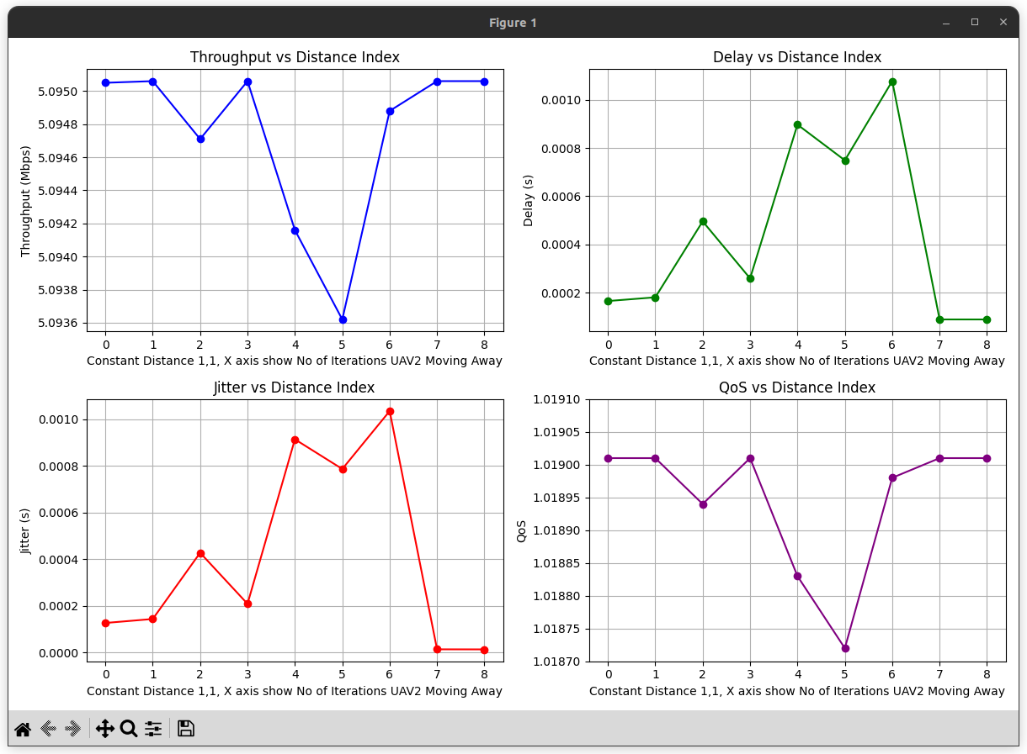

Analysis UAV2 ( UAV2 Moves Away and UAV1 Static)

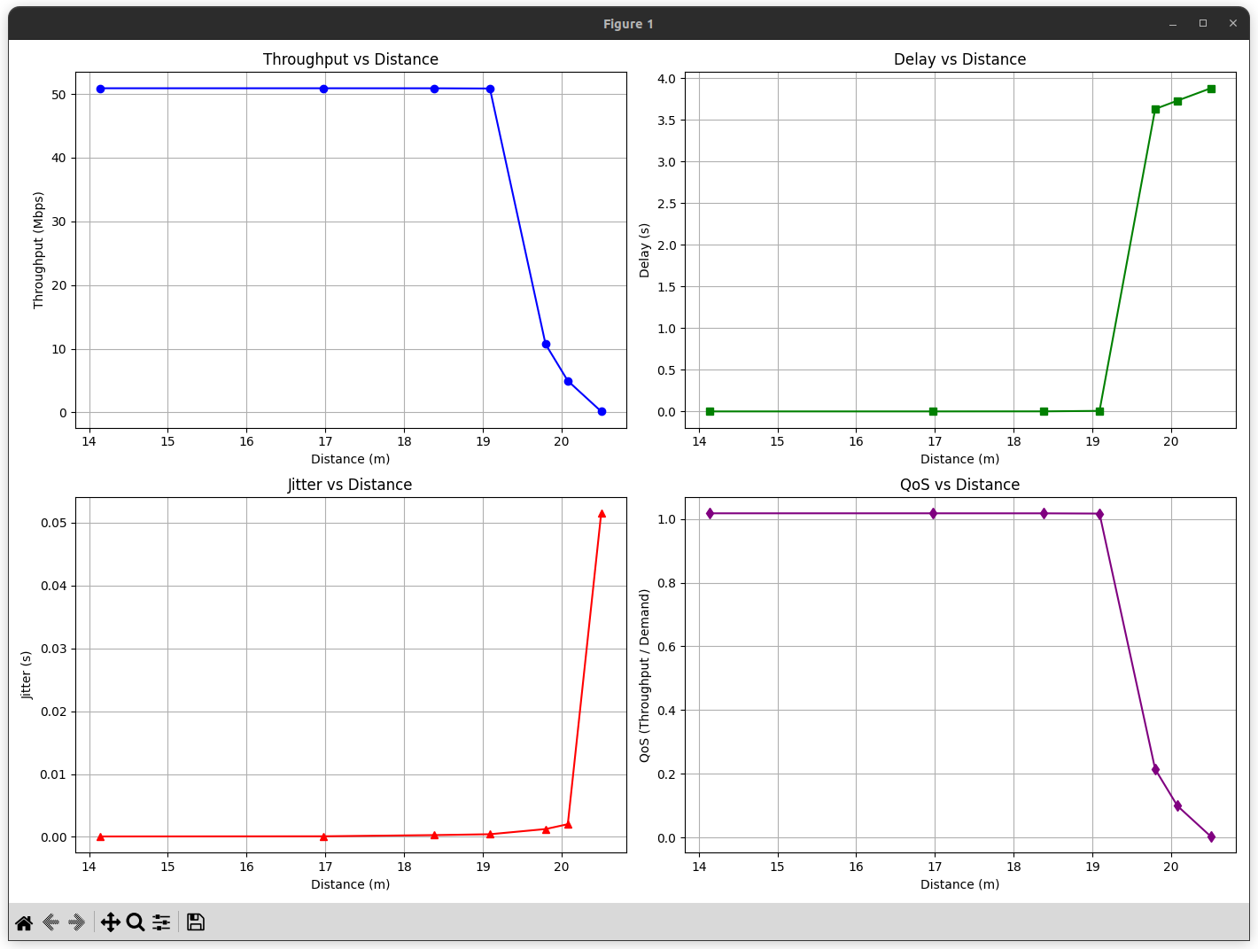
.

UAV1 Data:

Throughput(Mbps) | Delay(s) | Jitter(s) | QoS | RSSI Value  (dBm) | Distance From AP
5.09505 | 0.00016474 | 0.000126506 | 1.01901 | -35 | 1.4
5.09506 | 0.000180214 | 0.000143511 | 1.01901 | -35 | 1.4
5.09471 | 0.000495536 | 0.000427242 | 1.01894 | -35 | 1.4
5.09506 | 0.000258826 | 0.0002085 | 1.01901 | -35 | 1.4
5.09416 | 0.000897354 | 0.000913462 | 1.01883 | -35 | 1.4
5.09362 | 0.000749084 | 0.000786326 | 1.01872 | -35 | 1.4
5.09488 | 0.00107788 | 0.00103454 | 1.01898 | -35 | 1.4
5.09506 | 0.000088311 | 0.0000134928 | 1.01901 | -35 | 1.4
5.09506 | 0.0000882225 | 0.0000132386 | 1.01901 | -35 | 1.4

.

UAV2 Data:

Throughput(Mbps) | Delay(s) | Jitter(s) | QoS | RSSI Value | Distance From AP
50.8968 | 0.000200461 | 0.0000680681 | 1.01794 | -65 | 14
50.8965 | 0.000238734 | 0.0000965413 | 1.01793 | -76 | 17
50.8561 | 0.00656082 | 0.000424252 | 1.01712 | -68 | 18.5
50.8924 | 0.000920942 | 0.000286555 | 1.01785 | -68 | 19.2
10.72 | 3.63 | 0 | 0.21 | -68 | 19.8
4.96023 | 3.73035 | 0.00201776 | 0.0992046 | -68 | 20.1
0.15691 | 3.87901 | 0.0514474 | 0.00313819 | -69 | 20.6
0 | 0 | 0 | 0 | -71 | 22
0 | 0 | 0 | 0 | -74 | 25

