Data-rate Effect One Access Points Two UAVs

Configurations
Fixed Parameter | Value
Network AP Location | 0,0 m
STA1 Location | 1,1 m
STAs Locations | 13,13m
Frequency | 5GHz
Number of STAs | 2
Traffic Type | UDP
STA 1 Traffic Data Rate | 90Mbps,60Mbps,40mbps, 20Mbps,10Mbps,5Mbps
STA 2 Traffic Data Rate | 90 Mbps
MCS Value of DataRate  (MCS5) | wifi.SetRemoteStationManager("ns3::ConstantRateWifiManager",  "DataMode", StringValue("HeMcs5"),  "ControlMode", StringValue("HeMcs0"));
Channel Settings | 50, 160, BAND_5GHZ, 0
Access Category Wifi6 | AX
Simulation Time | 10s
Propagation Loss Model | Default YansCHannel Loss Model
MCS Table
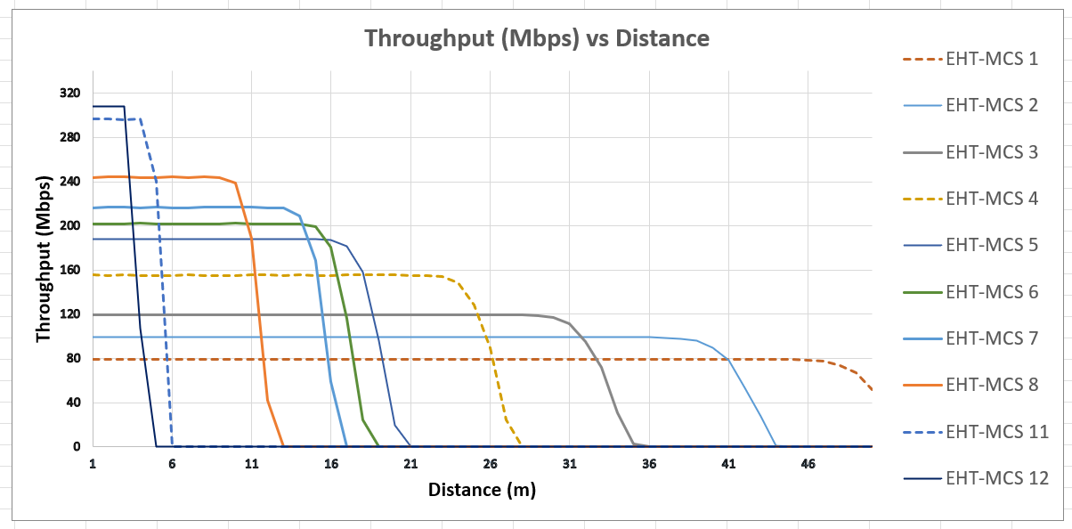

Animation File:
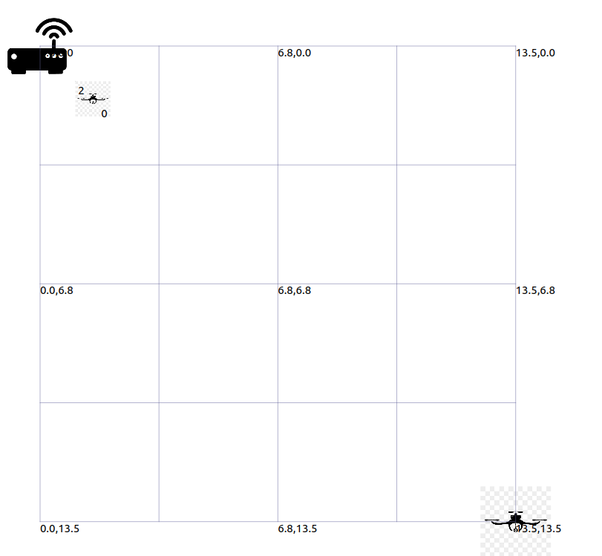
Results Table
Results:
Access Point at Location 0,0

UAV1 Transmitter Node at 1,1 meters

UAV2 Transmitter Node at 13,13 meters

UAV 1 Static ( Data Rate Demand of UAV1 will effect QoS of UAV2)

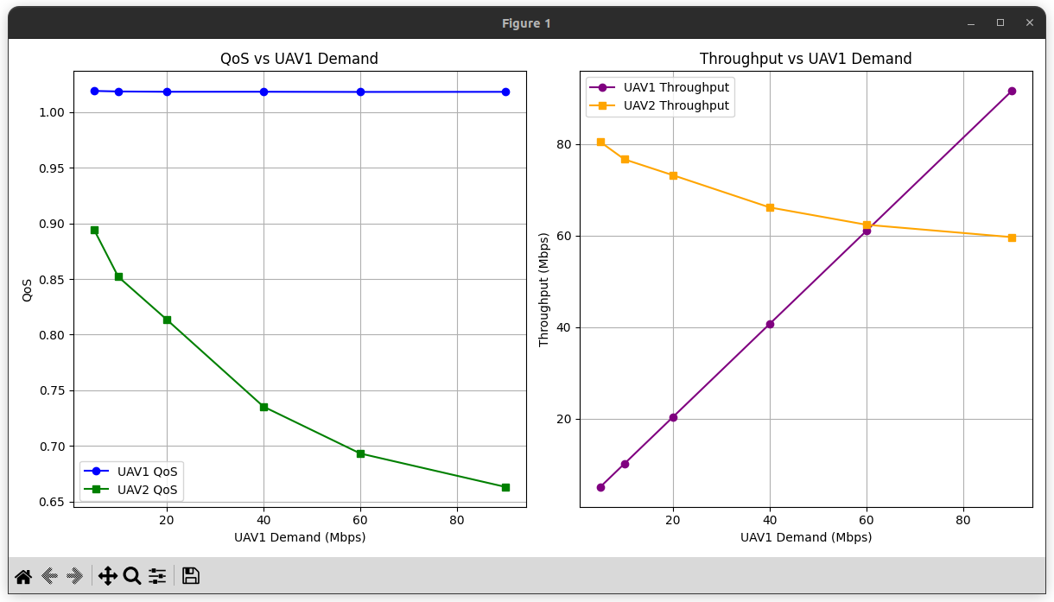

UAV1 Data

Throughput(Mbps) | Delay(s) | Jitter(s) | QoS | Access Point UAV Distance | Demand(Mbps)
91.6324 | 0.00134823 | 0.000189139 | 1.01814 | 1.41 | 90
1.41 | 0.00121926 | 0.000285316 | 1.01805 | 1.41 | 60
1.41 | 0.00118481 | 0.000425213 | 1.01822 | 1.41 | 40
1.41 | 0.00121171 | 0.000771547 | 1.01821 | 1.41 | 20
1.41 | 0.00122625 | 0.000980159 | 1.01848 | 1.41 | 10
1.41 | 0.00130834 | 0.00119395 | 1.01897 | 1.41 | 5

UAV2 Data

Throughput(Mbps) | Delay(s) | Jitter(s) | QoS | Distance (m) | Deamand(mbps)
59.6826 | 1.53849 | 0.000361469 | 0.66314 | 19 | 90
62.386 | 1.43976 | 0.000347251 | 0.693178 | 19 | 90
66.1774 | 1.29715 | 0.000327409 | 0.735304 | 19 | 90
73.2222 | 1.02743 | 0.000296311 | 0.81358 | 19 | 90
76.6782 | 0.821218 | 0.000284938 | 0.85198 | 19 | 90
80.491 | 0.57962 | 0.00027707 | 0.894344 | 19 | 90

