Web Technologies

Assignment No 2

# Question 1

## Code

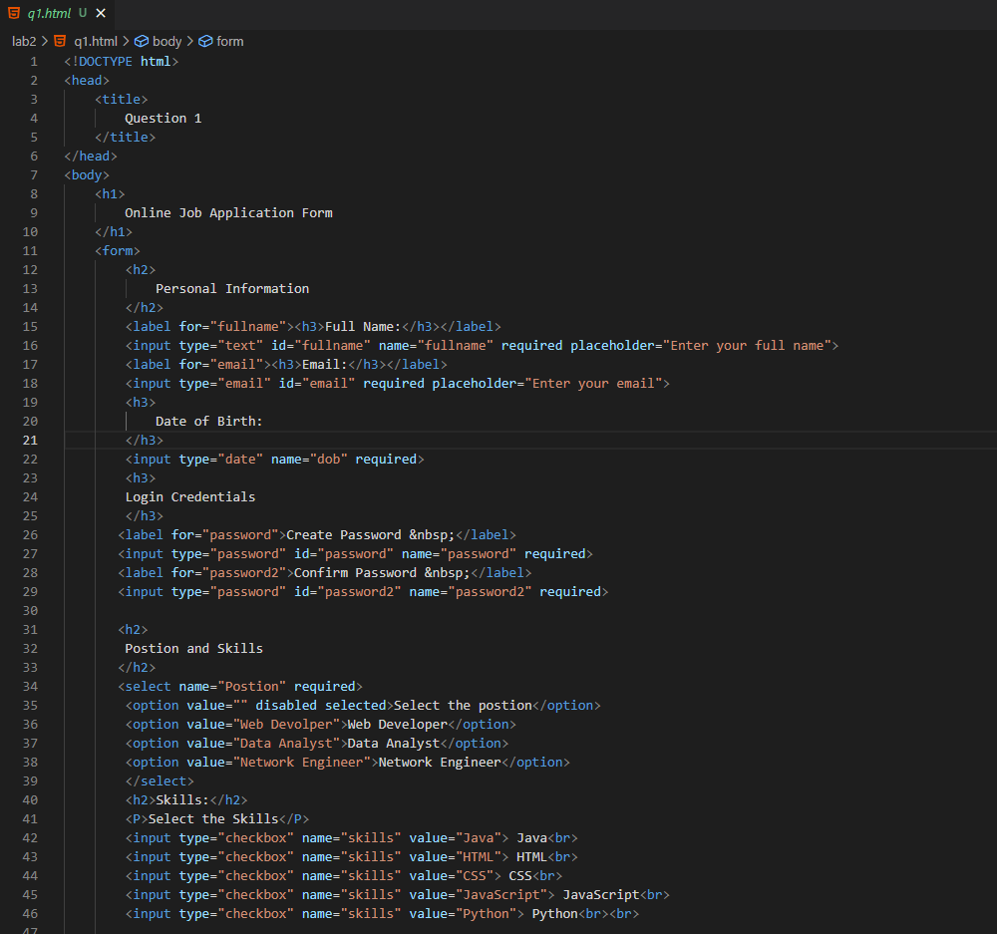

## Output

# Question 2

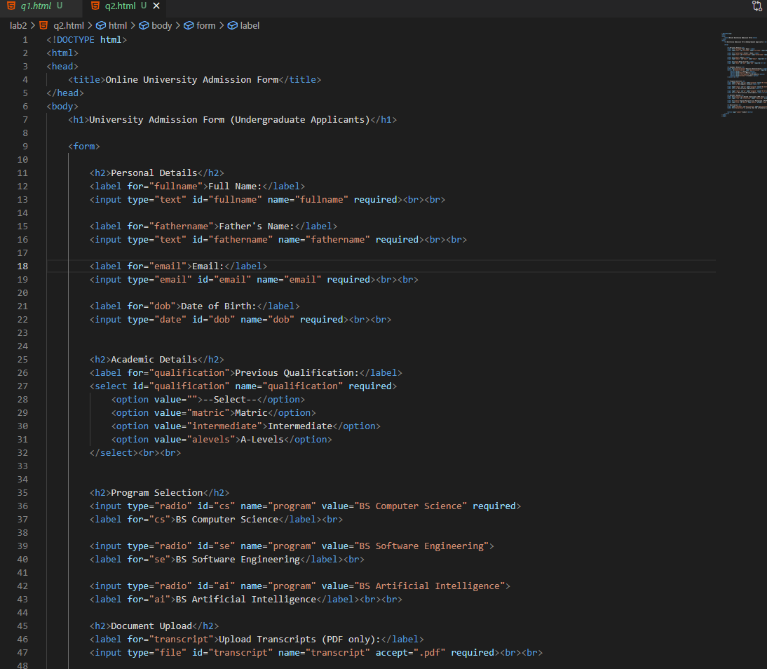

## Output

# Question 3

## Code

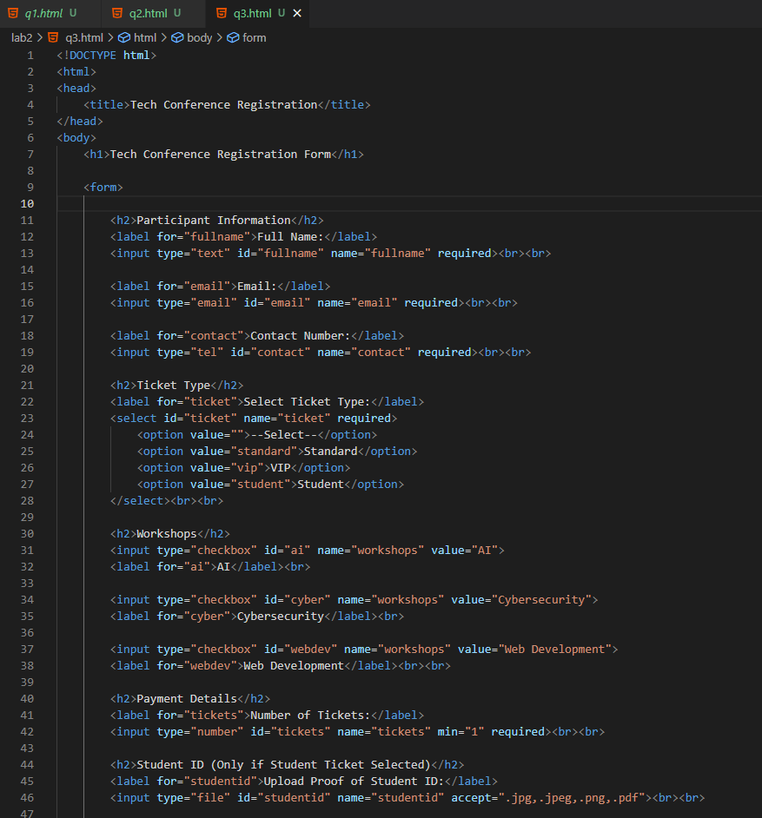

## Output

# Question 4

## Code

## Output

