Diagram 1
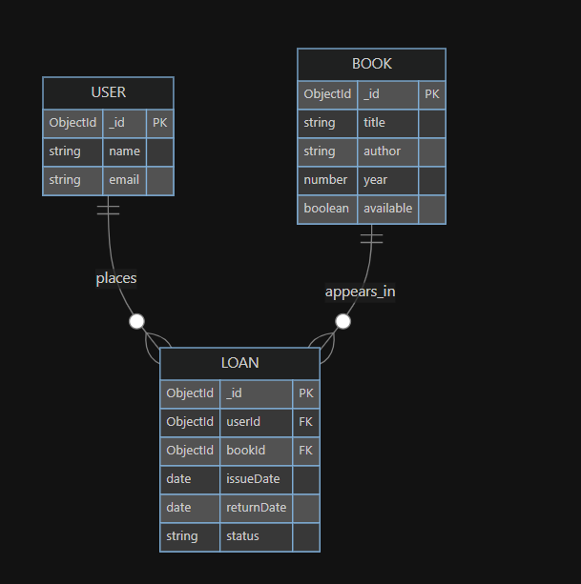

Entities and relationships:
User — represents a library member. Fields: _id (ObjectId), name (String), email (String, unique).
Book — represents a physical or digital title. Fields: _id (ObjectId), title (String), author (String), year (Number), available (Boolean).
Loan — the join entity that tracks who borrowed what and when. Fields: _id (ObjectId), userId (ref → User), bookId (ref → Book), issueDate (Date), returnDate (Date, nullable), status (String: active | returned).
Cardinalities: A User can have many Loans. A Book can appear in many Loans. Each Loan belongs to exactly one User and one Book.
MongoDB design choice — referencing over embedding: Loan holds userId and bookId as references (ObjectIds). This is the right call here because both User and Book documents are queried independently, updated frequently (available toggles), and could grow unboundedly in loan history. Embedding loans inside Book would make toggling available awkward and bloat the document. A separate loans collection keeps concerns clean.

Diagram 2
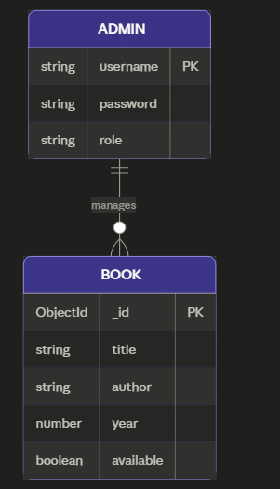
Relationship: ADMIN ||--o{ BOOK — one admin manages zero or many books. The crow's foot notation reflects that the admin can have an empty library or a full one, but there's always exactly one admin.

