**系統程式設計**

**Lab7 setjmp/longjmp**

1. **Where are the errors located?   
   email格式不能有一個以上的@**

**不能有 # * .. 的字元或字串**

**在@之後必須至少要有一個 .**

1. **What is the error message format?  
   (you must not print any message after you print error message)**

**Email format error: at least one @**

**Email format error: more than one @**

**Email format error: can’t exist #**

**Email format error: can’t exist \***

**Email format error: can’t exist ..**

**Email format error: at least one . behind @**

1. **How did you use the setjmp/longjmp function?  
   使用longjmp回傳jmpbuffer並給定回傳值，setjmp會收到longjmp回傳的jmpbuffer，依照不同的值對應不同的狀況。**
2. **Final result.**

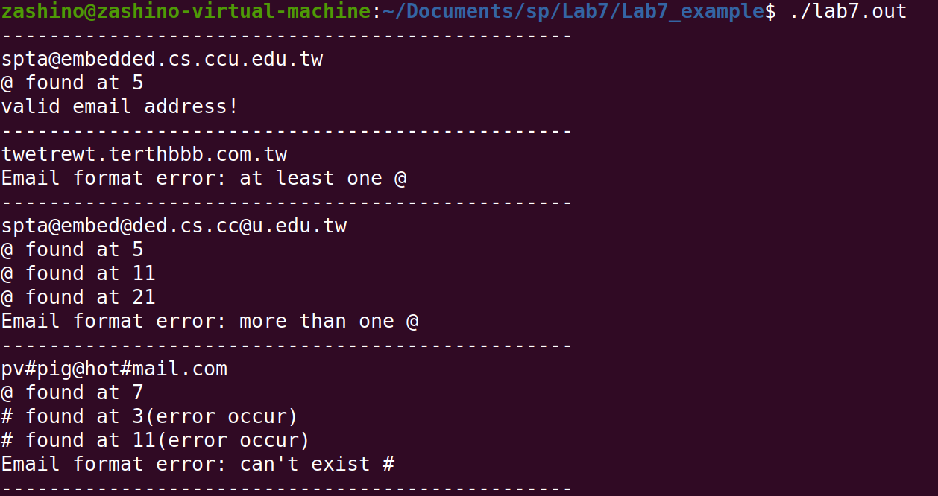 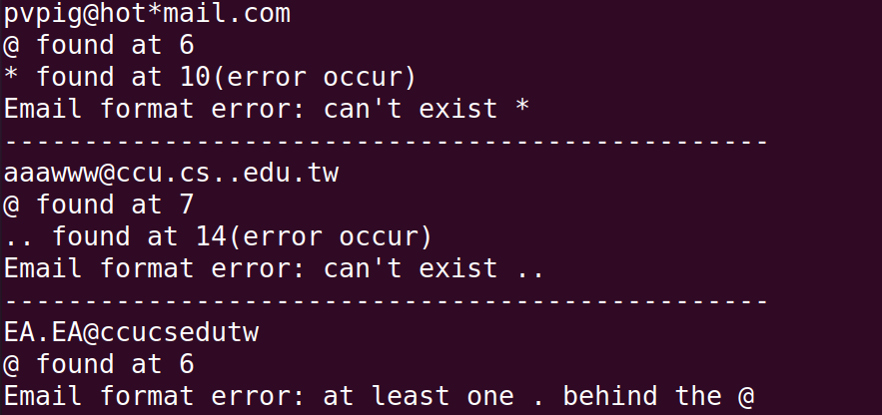 **Please attach screenshot !**