Scenario: a person with visual deficiencies wants to buy Brown cupcake cups in amazon (has never used the service before)

Start page

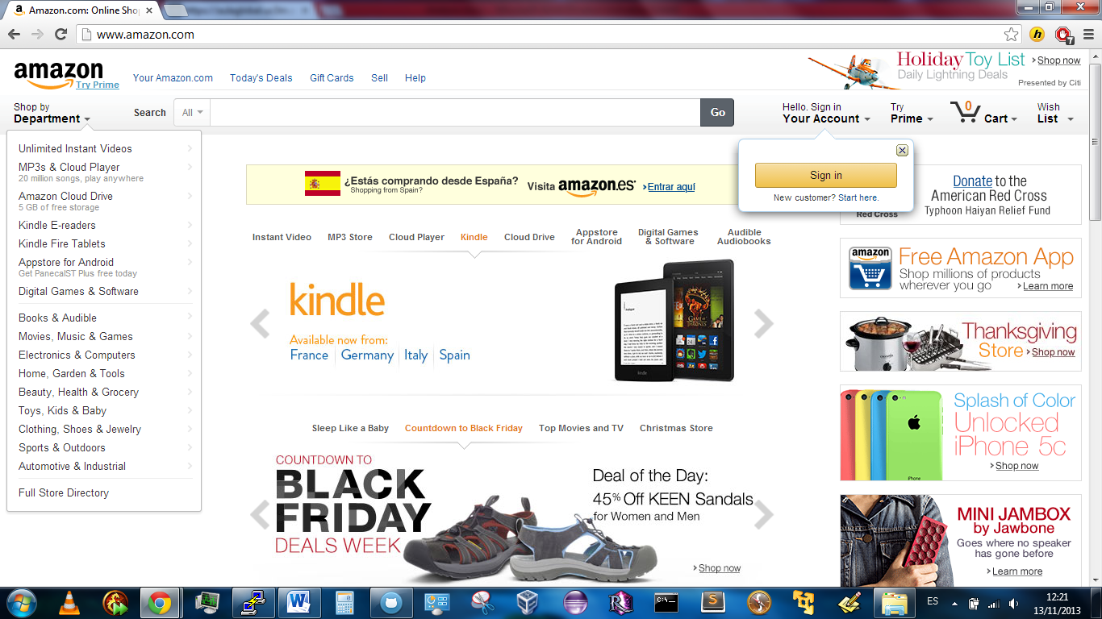

Lo logico ahora (si nosabes usarlo) es buscar lo que quieres

Search results

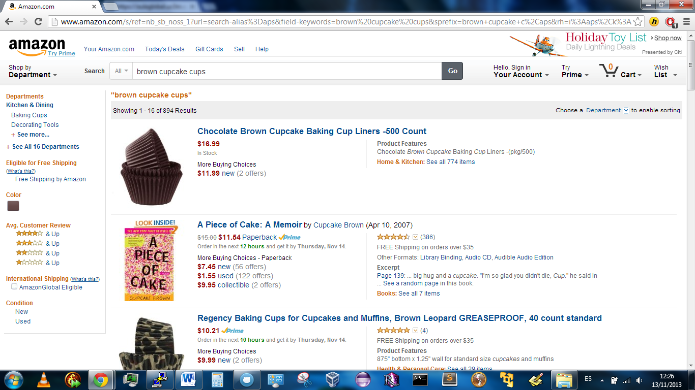

Product detail

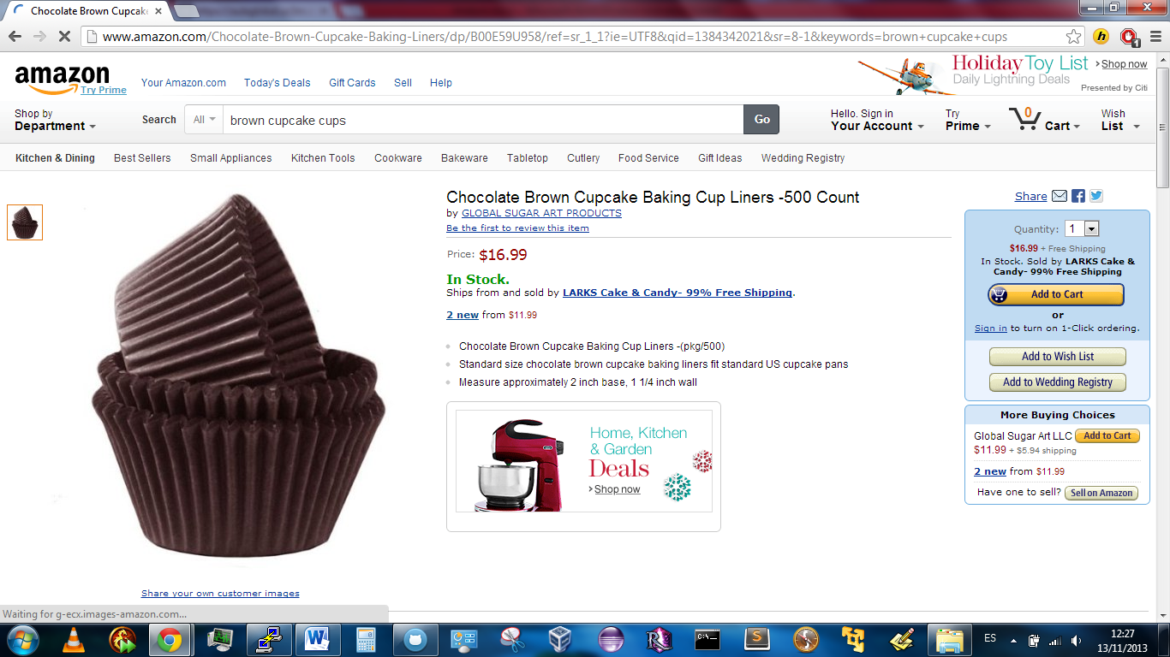

Cart addition

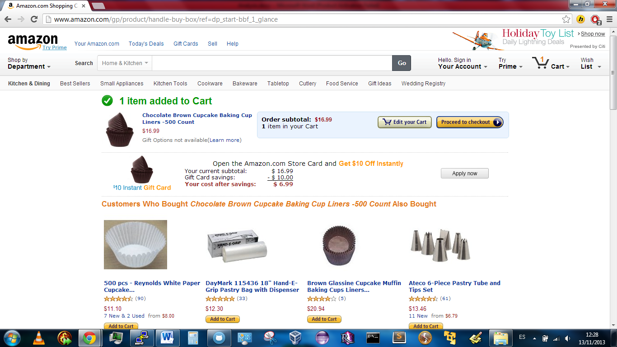

Checkout 🡪 forces registering

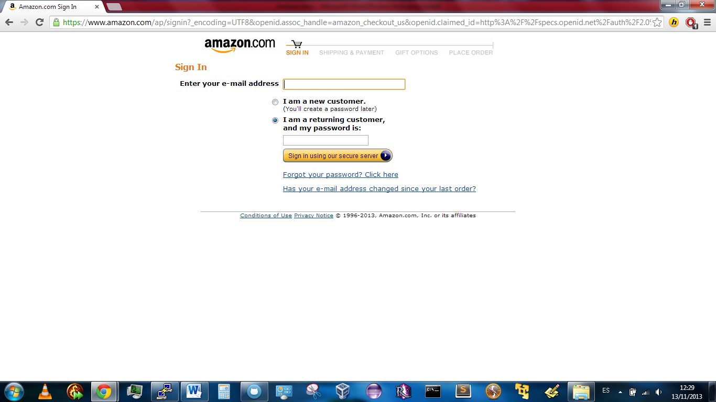

Registering

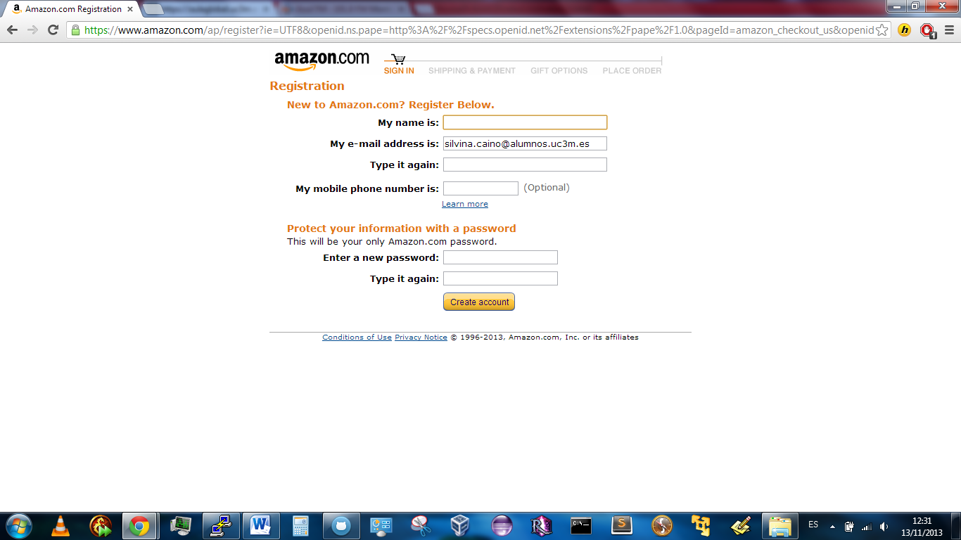

More crap to get the shipment

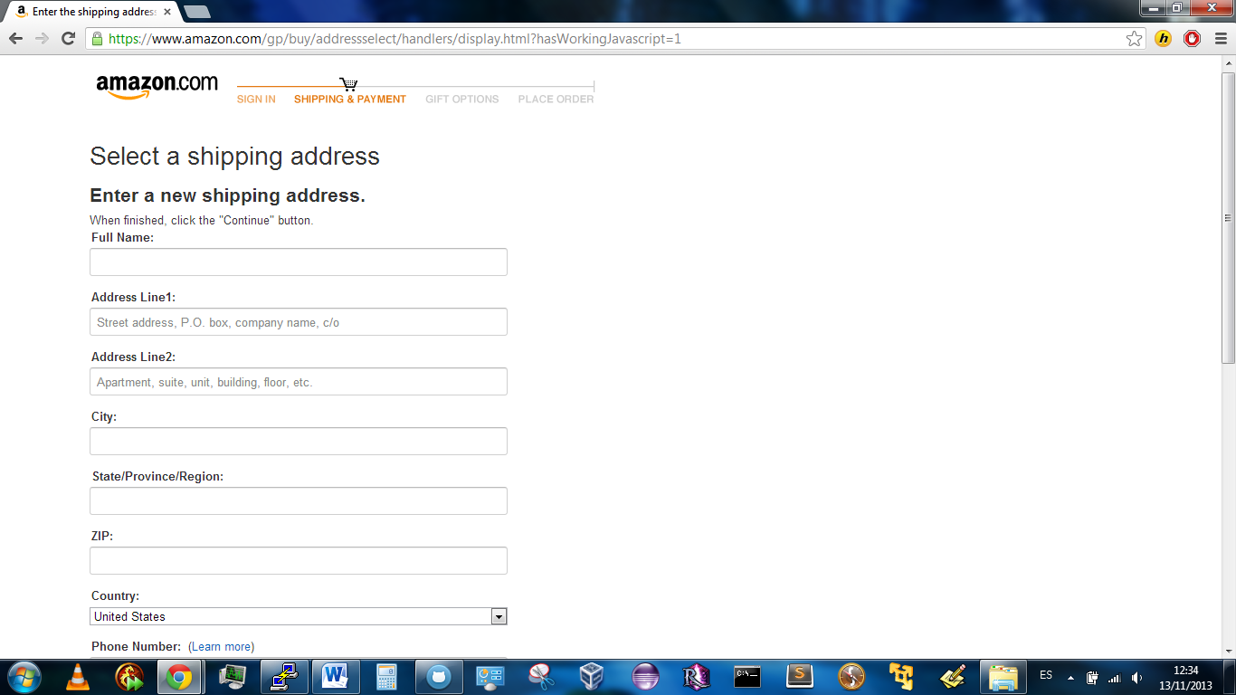

Yet more crap

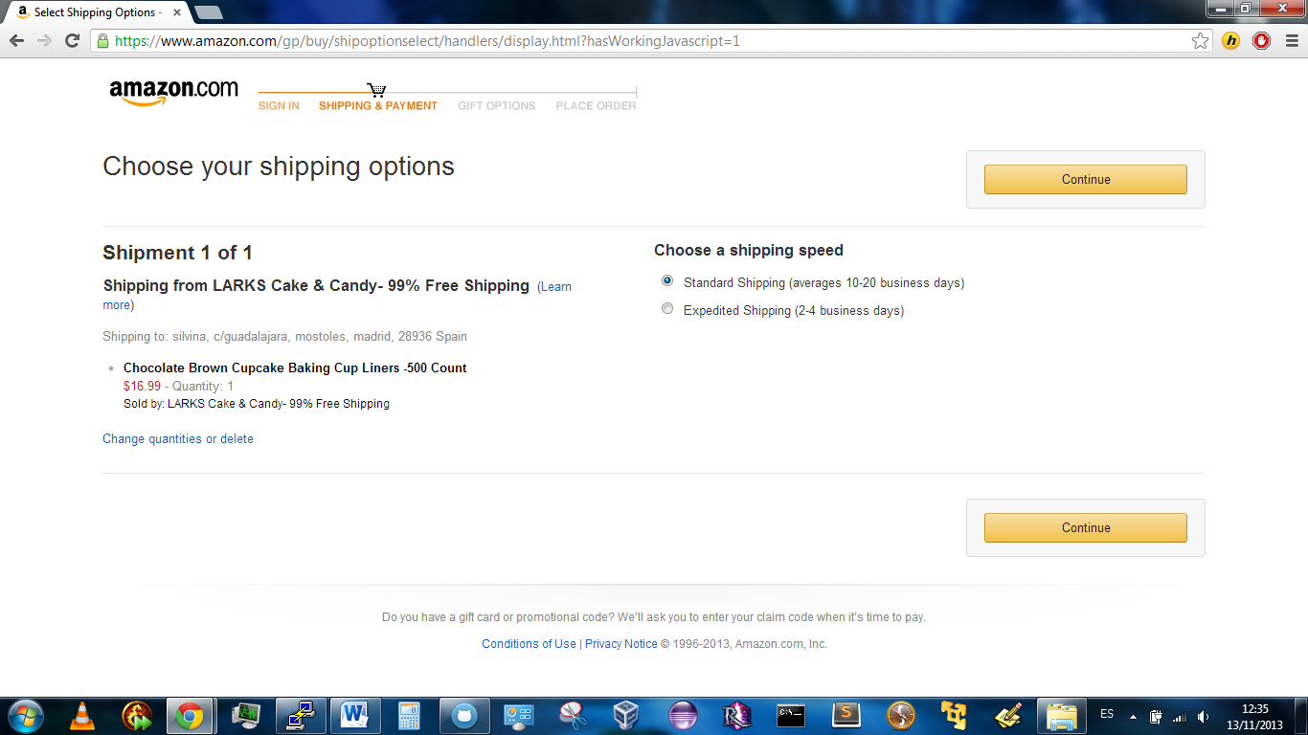

Y asi sigue, como hoy no voy a comprar nada no lo pongo xD