|  |
| --- |
| Heuristic Evaluation |
| *User Interfaces* |
| Óscar Seguro Alonso -  Silvina Caíno Lores - 100303556  Ramses J Salas Machado - 100292149 |

# INDEX

SCENARIO 1

CONCLUSION 6

# SCENARIO

A user wants to buy brown cupcake cups in amazon and he will use the service for the first time.

Start page

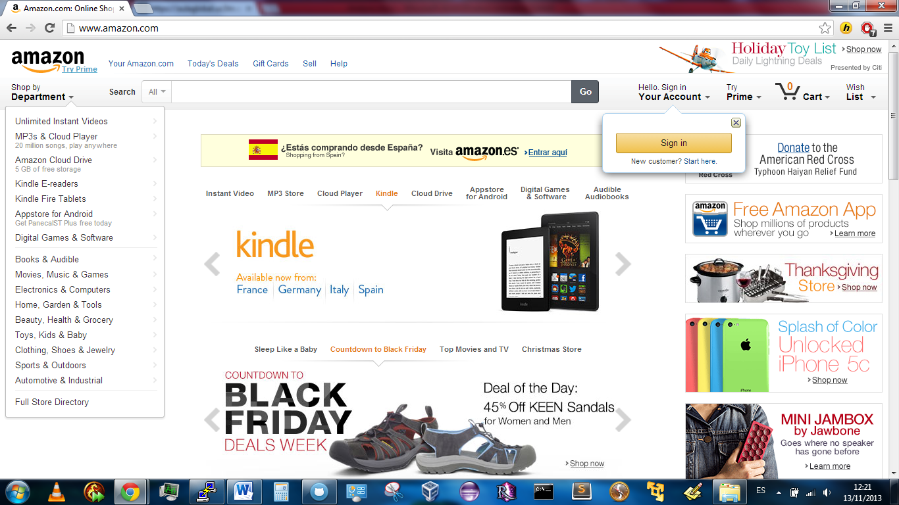

The user proceeds to perform the search using the “search bar” typing “brown cupcake cups” and he appreciates how the system guides him in order to prevent errors. Even when a clear “search bar” exist, he notices that the page is saturated with advertising and text.

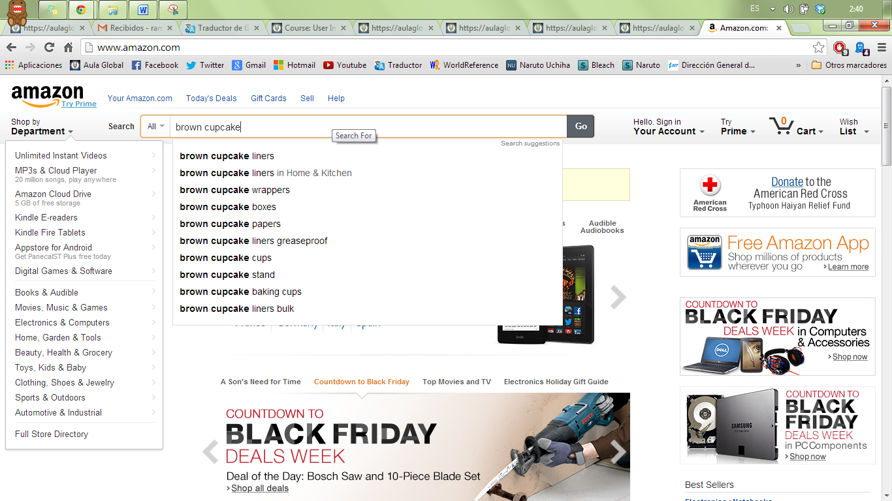

In the other hand the left navigation is populated unnecessary content, removing it could result in an improvement making the navigation panel clearer and helpful.

Search results

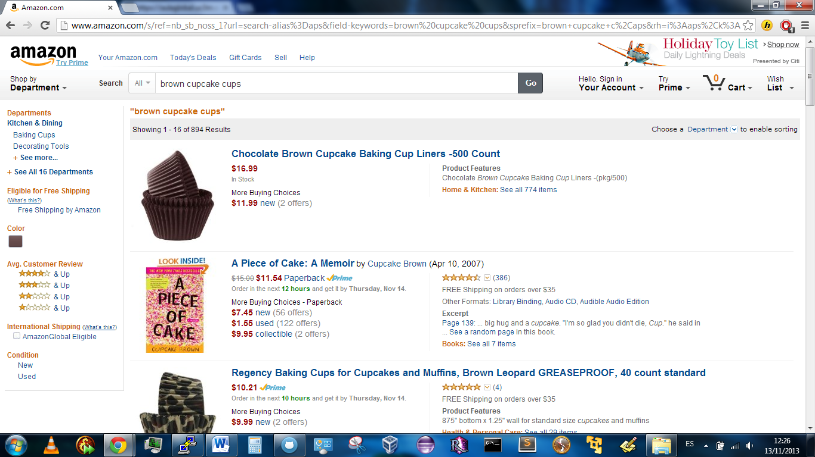

After perform the search the website offers to the user a useful left side bar in order to filter and improve the search. The user founds what he wants in the first link, but he feels confused with two prices highlighted. The different provider choices might be clearer if it were not highlighted with the same color as the principal one.

He proceeds to click the link provided by the tittle.

Product detail

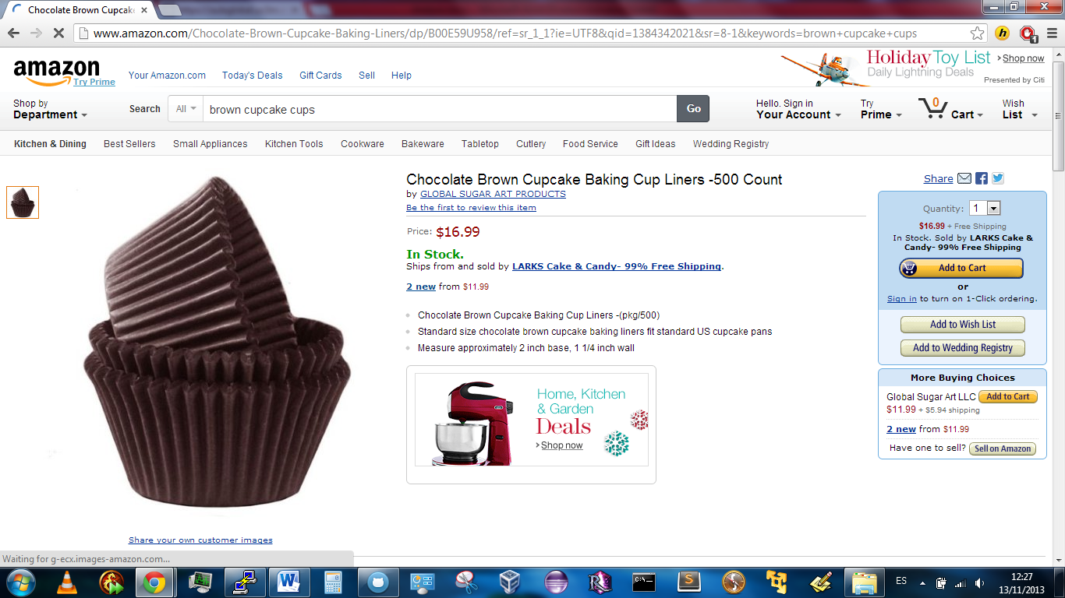

The user clicks on the button “add to cart” at the right side bar. The price and the “In Stock” sentence are highlighted in red and green and may not cause the expected impact in color blindness people, changing the combination of color may solve the problem.

Cart addition

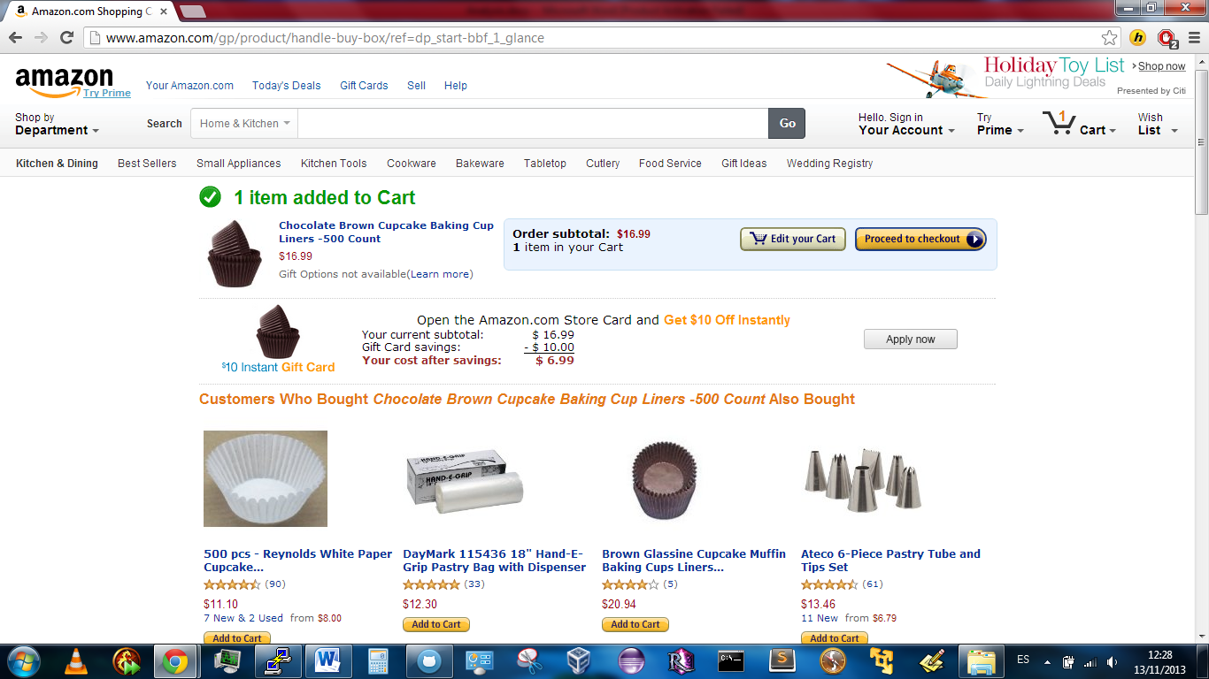

The system provides feedback to the user notifying him that the item has been added to the cart. Error prevention technique is present in the “edit your Cart” option button.

The user clicks the button “Proceed to checkout”.

Forces registering

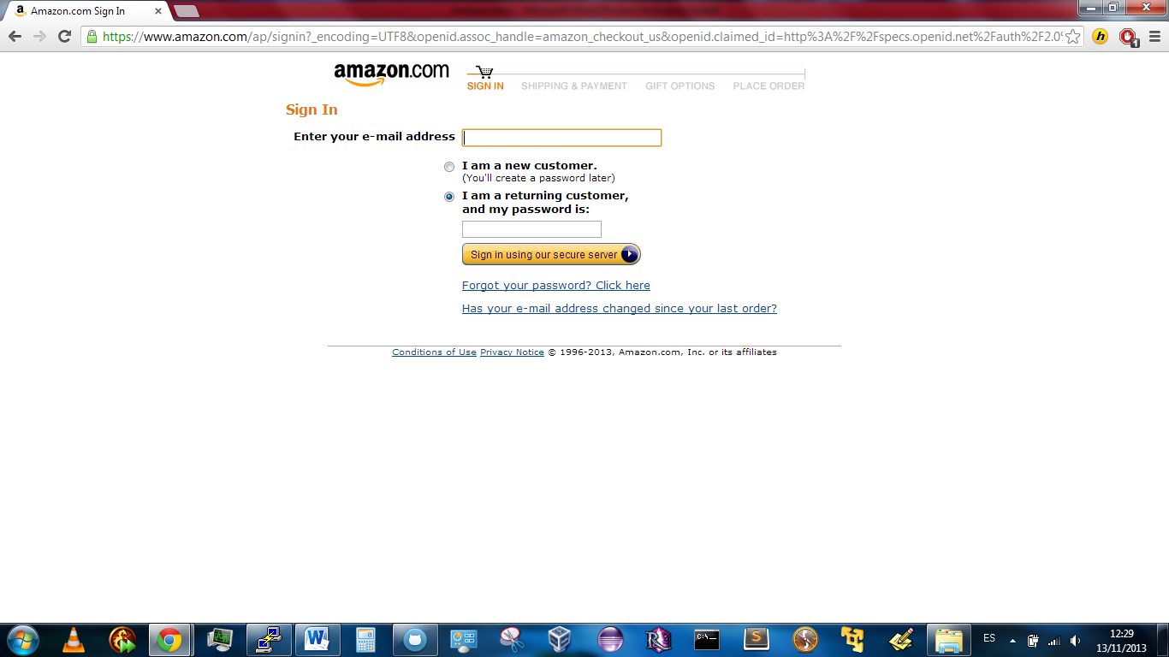

The user is obliged to follows the registration process starting filling the previous form. The button to continue the process has the same format until now making it familiar to the user.

A progress bar is present at the top of the form letting the user know the current state of the whole process.

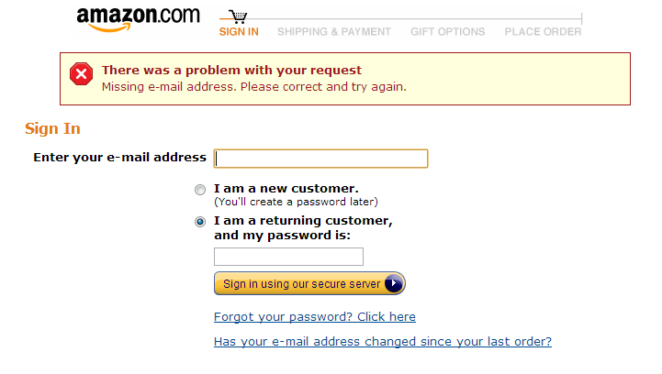

The user accidentally clicked the button without filling the form. An error message pop ups specifying the missing information in order to continue.

After filling the

Registering

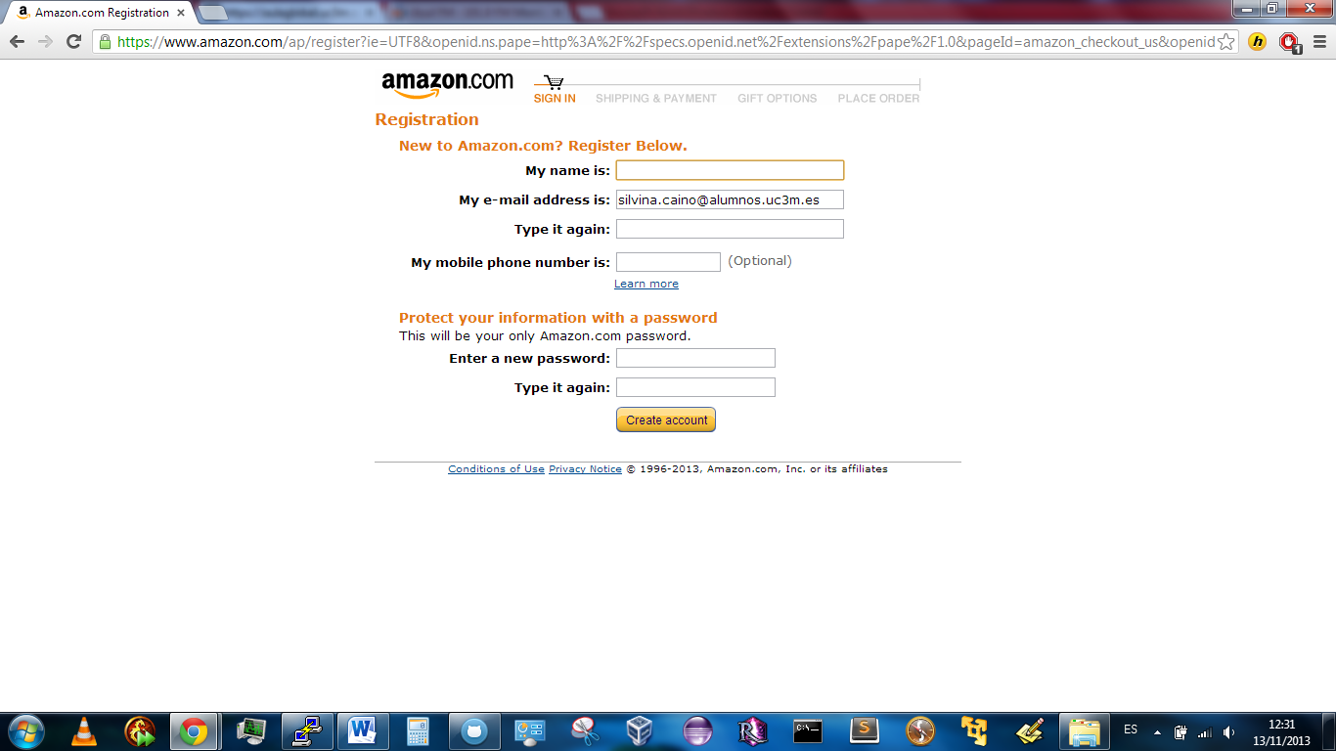

Amazon then requires the user to provide details about the shipping address to which the product will be shipped. The user is required to fulfill a form.

This form is quite simple and clear. However, maybe some users might not understand what information they are being asked for. Specially, form fields “Address Line 1” and “Address line 2” are not self-explanatory, and a message explaining what information is expected in those fields could be an useful improvement.

A positive aspect of the chosen interface is the top bar, which shows in an intuitive and visual format the step of the registration process in which the user currently is.

Shipment

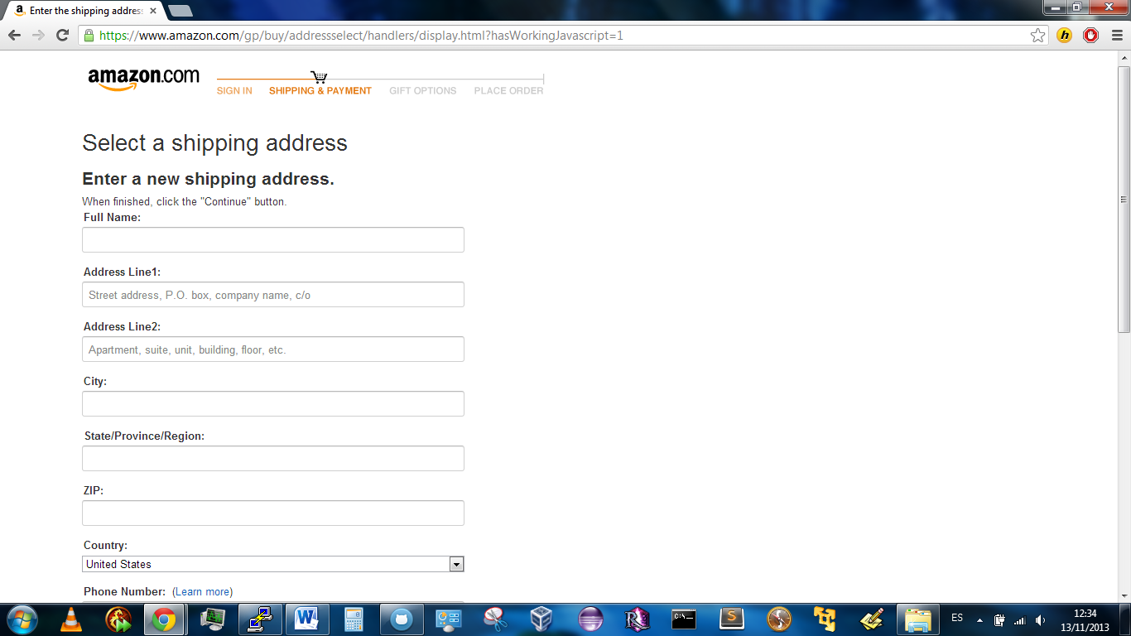

The user is given a choice between several shipping speeds, with different prices. The user can choose between them via some radio buttons. Also, while doing this, Amazon shows the summary of the purchase in the left side of the screen: name of the product, shipping company and seller, price and shipping address. The user is given the choice of learning something more about the seller through a “learn more” link, too.

An improvement could be a clearer display of this information, as there is a lot of information provided to the user in a relatively small space. For example, a list with titles (“seller: <the seller>; shipping company: <the company>; product: <the product>, etc) would be very clear and intuitive.

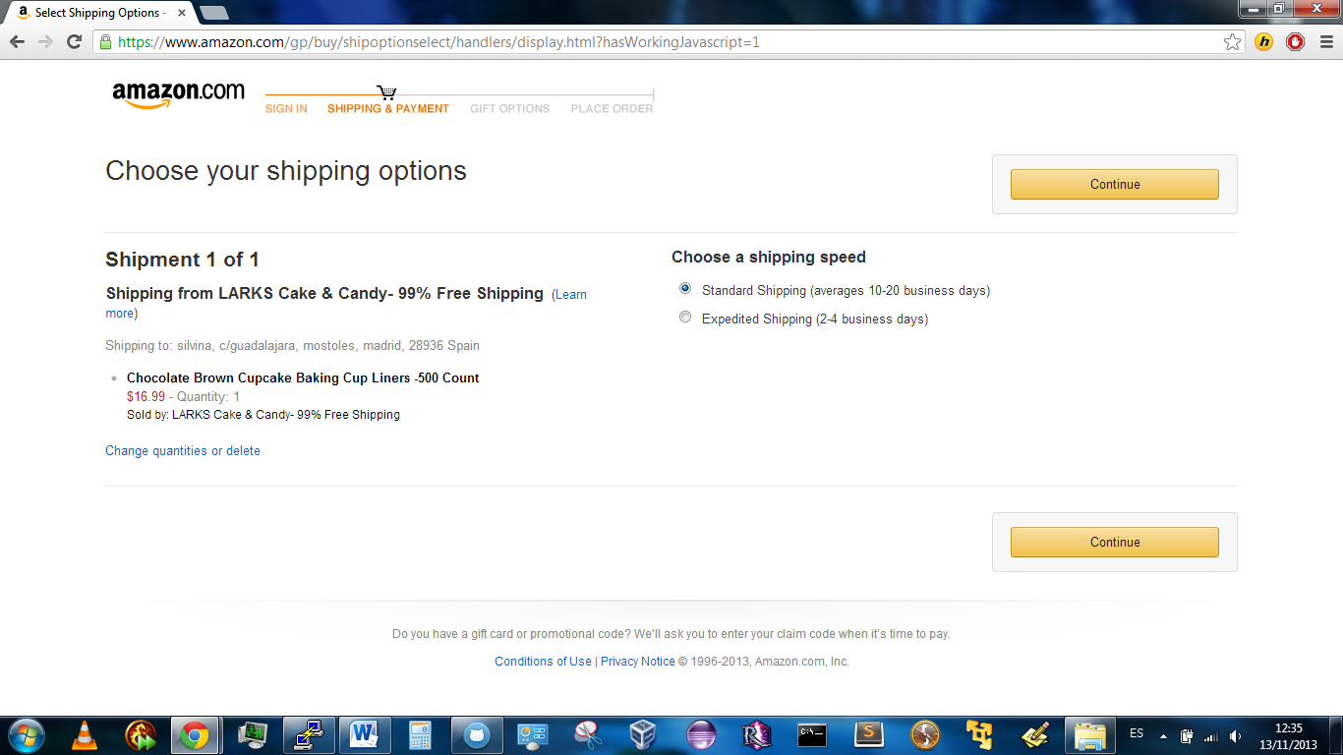

The buying process continues through a confirmation of successful purchase. However, that would mean to actually buy the product. **As we are not going to buy it in real life**, we are not able to analyze that last interface. However, we think the analysis of the rest of the process is more than enough to be able to do a complete Heuristic Evaluation.

# CONCLUSION

From the analysis of this particular case, we can extract the following conclusions:

* The system to purchase goods online is pretty intuitive for people with experience with online stores. However, it is a little less intuitive if you are a newcomer to online stores. The existence of a lot of option might be counter-productive for people only looking for a "search" and a "buy" button.
* The system guides you through the process of buying step by step, with buttons whose names are logical ("Search" for a search bar, "Add to cart" to add items to the online cart...). Maybe, for people with not that much of a experience in the world of Internet, a message explaining the utility of each button while the cursor is over would be useful.
* Although the steps for recursive visitors are only a few, newcomers to Amazon are required to provide a lot of information. It is indeed necessary, but might be somehow tiring. The first purchase takes longer.
* The choice of a step-by-step process seems to be a good choice, as it allows the usage of simple steps instead of a too-long and too-tiring single step.
* Advertisements for featured sometimes make the interface to be too annoying, subtracting space in the screen and importance to the product you are looking for. However, the addition of a "similar to this product" space sometimes is quite useful.
* Advanced search options are small and might not be noticed if the customer is not looking for them explicitly.

These conclusions could be reunited in a single conclusion that summarizes the overall idea Amazon's interface transmits to customers:

A lot of options that might not be used can make the interface less intuitive. Also, sometimes the advertisements of featured products get annoying. However, the step-by-step interface guides the customer through the process of buying in Amazon with a maybe necessarily tiring but efficient process.