FINkNN: A Fuzzy Interval Number k-Nearest Neighbor Classifier for
Prediction of Sugar Production from Populations of Samples
Vassilios Petridis PETRIDIS@ENG.AUTH.GR
Division of Electronics & Computer Engineering
Department of Electrical & Computer Engineering
Aristotle University of Thessaloniki
GR-54006 Thessaloniki, Greece
Vassilis G. Kaburlasos VGKABS@TEIKAV.EDU.GR
Division of Computing Systems
Department of Industrial Informatics
Technological Educational Institute of Kavala
GR-65404 Kavala, Greece
Editor: Haym Hirsh
Abstract
This work introduces FINkNN, a k-nearest-neighbor classifier operating over the metric lattice of conventional interval-supported convex fuzzy sets. We show that for problems involving populations of measurements, data can be represented by fuzzy interval numbers (FINs) and we present an algorithm for constructing FINs from such populations. We then present a lattice-theoretic metric distance between FINs with arbitrary-shaped membership functions, which forms the basis for FINkNN’s similarity measurements. We apply FINkNN to the task of predicting annual sugar production based on populations of measurements supplied by Hellenic Sugar Industry. We show that FINkNN improves prediction accuracy on this task, and discuss the broader scope and potential utility of these techniques.
Keywords: k Nearest Neighbor (kNN), Fuzzy Interval Number (FIN), Metric Distance, Classification, Prediction, Sugar Industry.

Introduction
Learning and decision-making are often formulated as problems in N-dimensional Euclidean space R^{N}, and numerous approaches have been proposed for such problems (Vapnik, 1988; Vapnik & Cortes, 1995; Schölkopf et al., 1999; Ben-Hur et al., 2001; Mangasarian & Musicant, 2001; Citterio et al., 1999; Ishibuchi & Nakashima, 2001; Kearns & Vazirani, 1994; Mitchell, 1997; Vidyasagar, 1997; Vapnik, 1999; Witten & Frank, 2000). Nevertheless, data representations other than flat, attribute-value representations arise in many applications (Goldfarb, 1992; Frasconi et al., 1998; Petridis & Kaburlasos, 2001; Paccanaro & Hinton, 2001; Muggleton, 1991; Hutchinson & Thornton, 1996; Cohen, 1998; Turcotte et al., 1998; Winston, 1975). This paper considers one such case, in which data take the form of populations of measurements, and in which learning takes place over the metric product lattice of conventional interval-supported convex fuzzy sets.
Our testbed for this research concerns the problem of predicting annual sugar production based on populations of measurements involving several production and meteorological variables supplied by the Hellenic Sugar Industry (HSI). For example, a population of 50 measurements, which correspond to the Roots Weight (RW) production variable from the HSI domain is shown in Figure 1. More specifically, Figure 1(a) shows 50 measurements on the real x-axis whereas Figure 1(b) shows, in a histogram, the distribution of the 50 measurements in intervals of 400 Kg/1000 m². Previous work on predicting annual sugar production in Greece replaced a population of measurements by a single number, most typically the average of the population. Classification was performed using methods applicable to N-dimensional data vectors (Stoikos, 1995; Petridis et al., 1998; Kaburlasos et al., 2002).
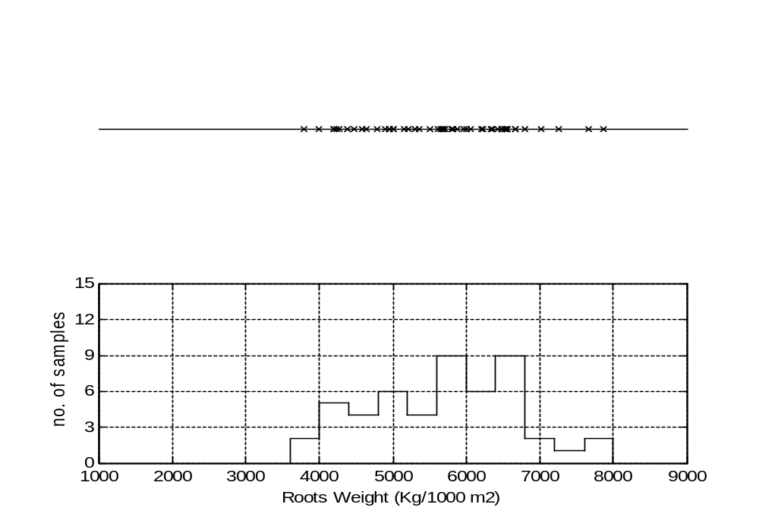
(a)
(b)

Figure 1: A population of 50 measurements which corresponds to Roots Weight (RW) production variable from the HSI domain.
(a) The 50 RW measurements are shown along the x-axis.
(b) A histogram of the 50 RW measurements in steps of 400 Kg/1000 m².

In previous work (Kaburlasos & Petridis, 1997; Petridis & Kaburlasos, 1999) the authors proposed moving from learning over the Cartesian product R^{N}=R×...×R to the more general case of learning over a product lattice domain L=L₁×...×L_{N} (where R represents the special case of a totally ordered lattice), enabling the effective use of disparate types of data in learning. For example, previous applications have dealt with vectors of numbers, symbols, fuzzy sets, events in a probability space, waveforms, hyper-spheres, Boolean statements, and graphs (Kaburlasos & Petridis, 2000, 2002; Kaburlasos et al., 1999; Petridis & Kaburlasos, 1998, 1999, 2001). This work proposes to represent populations of measurements in the lattice of fuzzy interval numbers (FINs). Based on results from lattice theory, a metric distance d_{K} is then introduced for FINs with arbitrary-shaped membership functions. This forms the basis for the k-nearest-neighbor classifier FINkNN (Fuzzy Interval Number k-Nearest Neighbor), which operates on the metric product lattice F^{N}, where F denotes the set of conventional interval-supported convex fuzzy sets.
This work shows that lattice theory can provide a useful metric distance on the collection of conventional fuzzy sets defined over the real number universe of discourse. In other words, the learning domain in this work is the collection of conventional fuzzy sets (Dubois & Prade, 1980; Zimmerman, 1991). We remark that even though the introduction of fuzzy set theory (Zadeh, 1965) made an explicit connection to standard lattice theory (Birkhoff, 1967), to our knowledge no widely accepted lattice-inspired tools have been crafted in fuzzy set theory. This work explicitly employs results from lattice theory to introduce a useful metric distance d_{K} between fuzzy sets with arbitrary shaped membership functions.
Various distance measures have previously been proposed in the literature involving fuzzy sets. For instance, in Klir & Folger (1988) Hamming, Euclidean, and Minkowski distances are shown to measure the degree of fuzziness of a fuzzy set. The Hausdorf distance is used in Diamond & Kloeden (1994) to compute the distance between classes of fuzzy sets. Also, metric distances have been used in various problems of fuzzy regression analysis (Diamond, 1988; Yang & Ko, 1997; Tanaka & Lee, 1998). Nevertheless, all previous metric distances are restricted because they only apply to special cases, such as between fuzzy sets with triangular membership functions, between whole classes of fuzzy sets, etc. The metric distance function d_{K} introduced in this work can compute a unique distance for any pair of fuzzy sets with arbitrary-shaped membership functions. Furthermore the metric d_{K} is used here specifically to compute a distance between two populations of samples/measurements, and is shown to result in improved predictions of annual sugar production.
The layout of this work is as follows. Section 2 delineates an industrial problem of prediction based on populations of measurements. Section 3 presents the CALFIN algorithm for constructing a FIN from a population of measurements. Section 4 presents mathematical tools introduced by Kaburlasos (2002), including convenient geometric illustrations on the plane. Section 5 introduces FINkNN, a k-nearest-neighbor (kNN) algorithm for classification in metric product-lattice F^{N} of Fuzzy Interval Numbers (FINs). FINkNN is employed in Section 6 on a real task, prediction of annual sugar production. Concluding remarks as well as future research are presented in section 7. Appendix A shows useful definitions in a metric space, furthermore Appendix B describes a connection between FINs and probability density functions (pdfs).

An Industrial Yield Prediction Problem
The amount of sugar required for the needs of the Greek market is supplied, at large, by the production of Hellenic Sugar Industry (HSI). Sugar is produced in Greece from an annual (in farm practicing) plant, namely Beta Vulgaris L or simply sugar-beet. An early season accurate prediction of the annual production of sugar allows for both production planning and timely decision-making to fill efficiently the gap between supply and demand of sugar. An algorithmic prediction of annual sugar production can be effected based on populations of measurements involving both production and meteorological variables as explained below.

Data Acquisition
Sample measurements of ten production variables and eight meteorological variables were available in this work for eleven years from 1989 to 1999 from three agricultural districts in central and northern Greece, namely Larisa, Platy, and Serres. Tables 1 and 2 show, respectively, the production variables and the meteorological variables used in this work. Sugar production was calculated as the product POL*RW. The production variables were sampled every 20 days in a number of pre-specified pilot fields per agricultural district, whereas the meteorological variables were sampled daily in one local meteorological station per agricultural district. Production and meteorological variables are jointly called here input variables. The term population of measurements is used here to denote either 1) a number of production variable samples obtained during 20 days from each pilot field in an agricultural district, or 2) a collection of meteorological variable samples obtained daily during the aforementioned 20 days.

 | Production Variable Name | Unit
1 | Average Root Weight | g
2 | POL - percentage of sugar in fresh root weight | -
3 | α-amino-Nitrogen (α-N) | meq/100g root
4 | Potassium (K) | meq/100g root
5 | Sodium (Na) | meq/100g root
6 | Leaf Area Index (LAI) - leaf area per field area ratio | -
7 | TOP: plant top weight | kg/1000 m²
8 | Roots Weight (RW) | kg/1000 m²
9 | Nitrogen-test (N-test) - NO₃-N content in pedioles | mg.kg⁻¹
10 | the Planting Date | -

Table 1: Production variables used for Prediction of Sugar Production.

 | Meteorological Variable Name | Unit
1 | Average (daily) Temperature | ºC
2 | Maximum (daily) temperature | ºC
3 | minimum (daily) Temperature | ºC
4 | Relative Humidity | -
5 | Wind Speed | miles/hour
6 | Daily Precipitation | mm
7 | Daily Evaporation | mm
8 | Sunlight | hours/day

Table 2: Meteorological variables used for Prediction of Sugar Production.

Algorithmic Prediction of Sugar Production
Prediction of sugar production is made on the basis of the trend in current year compared to the corresponding trend in previous years. In previous work a population of measurements was typically replaced by a single number, the average value of the population. However, using the average value of a population of measurements in a prediction model can be misleading. For instance, two different daily precipitation patterns in a month may be characterized by identical average values, nevertheless their effect on the annual sugar production level might be drastically different. Previous annual sugar yield prediction models in Greece include neural networks (Stoikos, 1995), interpolation-, polynomial-, linear autoregression- and neural-predictors (Petridis et al., 1998), and intelligent clustering techniques (Kaburlasos et al., 2002). The best sugar prediction accuracy of 5% was reported in Kaburlasos et al. (2002).

Prediction by Classification
In order to capture to the fullest the diversity of a whole population of measurements this work proposes representing a population of measurements by a FIN (Fuzzy Interval Number) instead of representing it by a single number. Prediction is then made by classification.
In line with the common practice by the agriculturalists at the HSI, the goal in this work was to achieve prediction of sugar production by classification in one of the classes “good”, “medium” or “poor”. In particular, the goal here was to predict the sugar production level in September based on data available by the end of July. The characterization of a sugar production level (in Kg/1000 m²) as “good”, “medium” or “poor” was not identical for different agricultural districts as shown in Table 3 due to the different sugar production capacities of the corresponding agricultural districts. For instance, “poor sugar production” for Larisa means 890 Kg/1000 m², whereas “poor sugar production” for Serres means 980 kg/1000 m². (Table 3 contains approximate values provided by an expert agriculturalist.)

Sugar | Agricultural District
Production
Level | Larisa | Platy | Serres
“good” | 1040 | 1045 | 1165
“medium” | 970 | 960 | 1065
“poor” | 890 | 925 | 980

Table 3: Annual sugar production levels (in Kg/1000 m²) for “good”,
“medium”, and “poor” years, in three agricultural districts.

A Driving Idea for Prediction by Classification
Suppose that populations of measurements for various input variables are given for a year whose (unknown) sugar production level is to be predicted. The question is to predict the unknown sugar production level based on populations of measurements of other years whose sugar production level is known. The driving idea for prediction by classification in this work is the following. Compute a distance between populations of measurements, which correspond to a year, and populations of measurements, which correspond to the other years; then predict a sugar production level similar to the nearest year’s (known) sugar production level.
There are two issues which need to be addressed for effecting the aforementioned prediction-by-classification. First, there is a representation issue. Second, there is an issue of defining a suitable distance. The first issue is addressed in section 3 where a population of measurements is represented by a FIN (Fuzzy Interval Number); for instance, Figure 2 shows four FINs, namely MT89, MT91, MT95 and MT98, constructed from populations of 31 samples/measurements of the maximum daily temperatures (in centigrades) during the month of July in years 1989, 1991, 1995 and 1998 in the Larisa agricultural district. The second issue above is addressed in section 4 by a metric distance between fuzzy sets (FINs) with arbitrary-shaped membership functions.

Algorithm CALFIN for Constructing a FIN from a Population of Measurements
Consider a population of n samples/measurements stored incrementally in vector x= [x₁,…,x_{n}], that is x₁ ≤ x₂ ≤ … ≤ x_{n}. Algorithm CALFIN in Figure 3, in pseudo-code format, shows a recursive calculation of a FIN from vector x.
We remark that the median median(x) of a vector x= [x₁, x₂,…,x_{n}] of (real) numbers is a number such that half of the n entries x₁, x₂,…,x_{n} of vector x are smaller than median(x) and the other half ones are larger than median(x). For example, median([1, 3, 7])= 3, whereas the median([-1, 2, 6, 9]) might be any number in the interval [2, 6] for instance median([-1, 2, 6, 9])= (2+6)/2= 4.
The operation of algorithm CALFIN is explained in the following. Given a population of measurements stored incrementally in vector x= [x₁, x₂,…,x_{n}], algorithm CALFIN returns two vectors: 1) vector pts, and 2) vector val, the latter vectors represent a FIN. More specifically, vector pts holds the abscissae whereas vector val holds the ordinate values of the corresponding FIN’s fuzzy membership function. Step-1 in Figure 3 computes vector pts; by construction, |pts| equals the smallest power of 2 which is larger than |x| (minus one). Step-3 computes vector val. By construction, a FIN attains its maximum value of 1 at one point.

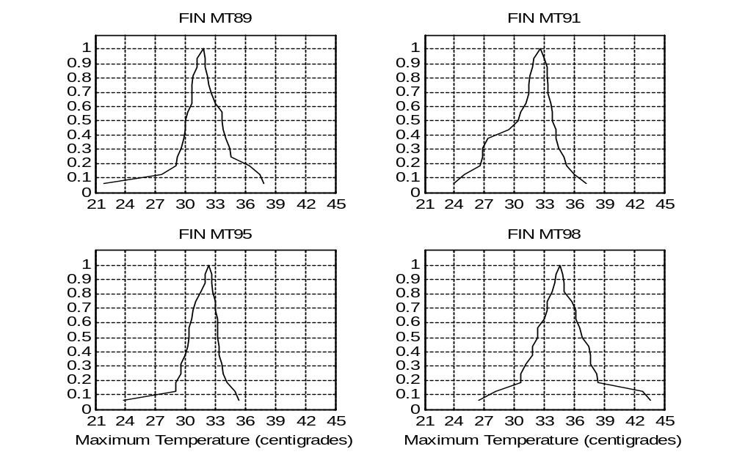

Figure 2: FINs MT89, MT91, MT95 and MT98 constructed from maximum daily temperatures during July in the Larisa agricultural district, Greece.

Step-1: function abscissae(x)
{ if (n ≠ 1)
med ← median(x)
x_left ← left half of vector x % all numbers in x less-than med
x_right ← right half of vector x % all numbers in x larger-than med
abscissae(x_left)
abscissae(x_right)
endif
return med in vector pts
}
Step-2: Sort vector pts incrementally.
Step-3: Let |pts| denote the cardinality of vector pts. Store in vector val, |pts|/2 numbers from 0 up to 1 in steps of 2/|pts| followed by another |pts|/2 numbers from 1 down to 0 in steps of 2/|pts|.

Figure 3: Algorithm CALFIN above computes a Fuzzy Interval Number (FIN) from a population of measurements stored incrementally in vector x.

An application of algorithm CALFIN on the population of measurements shown in Figure 1(a) is illustrated in Figure 4. More specifically, a FIN is computed in Figure 4(b2) from a population of 50 samples/measurements of the Roots Weight (RW) input variable from 50 pilot fields in the last 20 days of July 1989 in the Larisa agricultural district. Identical figures Figure 4(a1) and Figure 4(a2) show the corresponding 63 median values computed in vector pts by algorithm CALFIN. Figure 4(b1) shows, in a histogram, the distribution of the 63 median values in intervals of 400 Kg/1000 m². Furthermore, Figure 4(b2) shows the ordinate values in vector val versus the abscissae values in vector pts.
A motivation for proposing algorithm CALFIN to represent a population of numeric data by a fuzzy set (FIN) is that algorithm CALFIN guarantees construction of convex fuzzy sets which comply with definition 4.2 in section 4, and thus proposition 4.4 can be used for computing a metric distance between two fuzzy sets with arbitrary-shaped membership functions. Any other algorithm that guarantees construction of convex fuzzy sets would also have this property. Finally, we point out that there is a one-one correspondence between FINs constructed by algorithm CALFIN and probability density functions (pdfs). This connection is explained further in Appendix B.
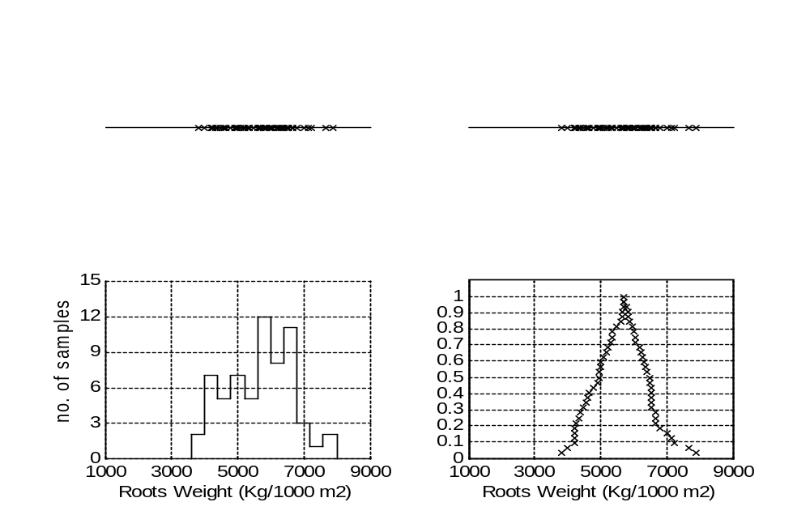
(a1)
(a2)
(b1)
(b2)

Figure 4: Calculation of a FIN from a population of samples/measurements.

(a1), (a2) 63 median values in vector pts computed by algorithm CALFIN from the 50 samples shown in Figure 1(a).
(b1) A histogram of the 63 median values in Figure 4(a1) in steps of 400 Kg/1000 m².
(b2) The 63 median values of vector pts in Figure 4(a2) have been mapped to the corresponding entries of vector val computed by algorithm CALFIN.

Metric Lattice F of Fuzzy Interval Numbers (FINs)
A grounded example for computing a distance between FINs is shown in the following. In particular, Figure 5 shows four FINs, namely RW89, RW91, RW95 and RW98, constructed by algorithm CALFIN from populations of the Roots Weight (RW) input variable. We would like to quantify the proximity of two years based on the corresponding populations of measurements. Table 4 shows metric distances (d_{K}) computed between the abovementioned FINs. The remaining of this section details the analytic computation of a metric distance d_{K} between arbitrary-shaped FINs following the original work by Kaburlasos (2002).

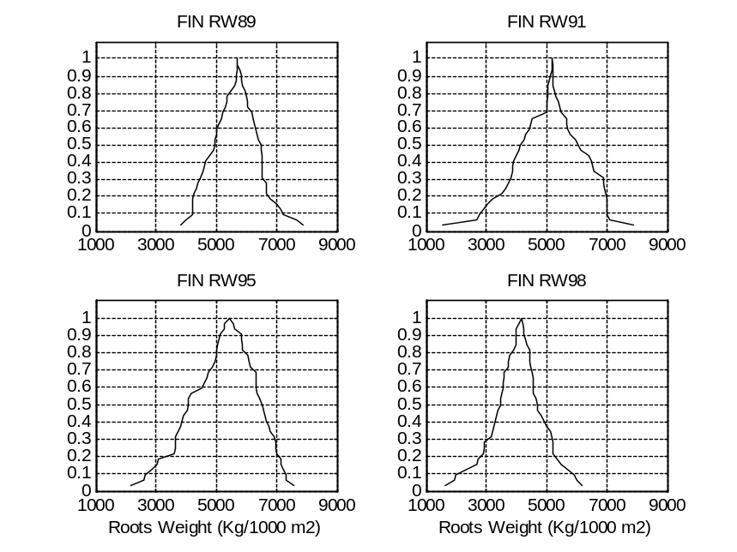

Figure 5: FINs RW89, RW91, RW95 and RW98 were constructed from samples of Roots Weight (RW) production variable in 50 pilot fields during the last 20 days of July in the Larisa agricultural district, Greece.

FIN | RW89 | RW91 | RW95 | RW98
RW89 | 0 | 541 | 349 | 1576
RW91 | 541 | 0 | 286 | 1056
RW95 | 349 | 286 | 0 | 1292
RW98 | 1576 | 1056 | 1292 | 0

Table 4: Distances d_{K} between FINs RW89, RW91, RW95 and RW98 in (Figure 5)

The basic idea for introducing a metric distance between arbitrary-shaped FINs is illustrated in Figure 6, where FINs RW89 and RW91 are shown. Recall that a FIN is constructed such that any horizontal line ε_{h}, h∈[0,1] intersects a FIN at exactly two points – without loss of generality only for h=1 there exists a single intersection point. A horizontal line ε_{h} at h=0.8 results in a “pulse” of height h=0.8 for a FIN as shown in Figure 6. More specifically, Figure 6 shows two pulses for the two FINs RW89 and RW91, respectively. The aforementioned pulses are called generalized intervals of height h=0.8. Apparently, if a metric distance could be defined between two generalized intervals of height h then a metric distance is implied between two FINs simply by computing the corresponding definite integral from h=0 to h=1.

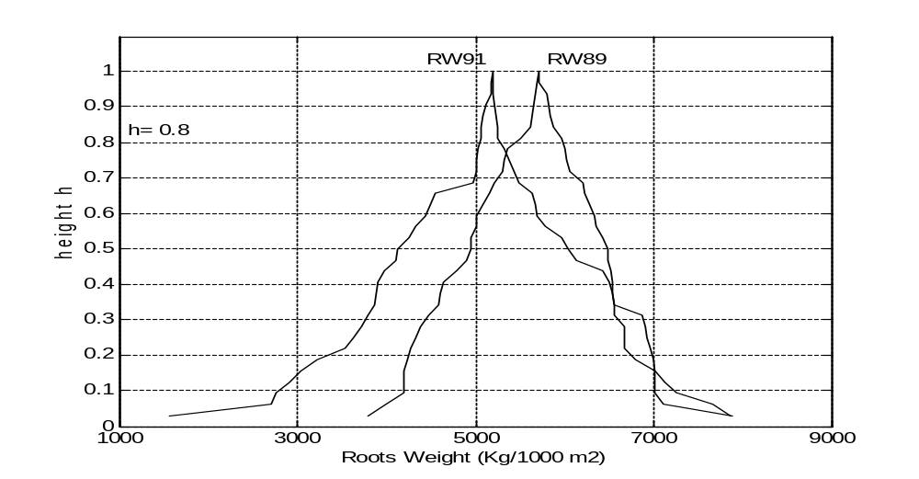
Figure 6: Generalized intervals of height h=0.8 which correspond to FINs RW89 and RW91.

Metric Lattices M^{h} of Generalized Intervals
Consider the notion generalized interval (of height h).

Definition 4.1 A generalized interval of height h is a real function given either by 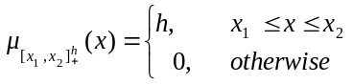, or by 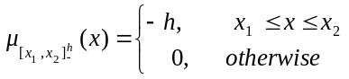, where h∈(0,1] is called height of the corresponding generalized interval.

A generalized interval may simply be denoted by 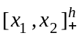 (positive generalized interval) or by 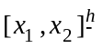 (negative generalized interval). The collection of generalized intervals of height h will be denoted by P^{h}. An ordering relation can be introduced in P^{h} as follows.
(R1) 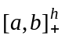 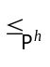 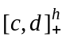 ⇔ c ≤ a ≤ b ≤ d,
(R2) 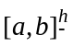 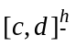 ⇔ , and
(R3) ⇔ [a,b]∩[c,d]≠∅, where [a,b] and [c,d] denote conventional intervals (sets) of numbers.
The ordering relation is a partial ordering relation, furthermore the set P^{h} is a lattice.
The set M^{h} with elements [a,b]^{h} as described in the following is also a lattice: (1) if a<b then [a,b]^{h}∈M^{h} corresponds to ∈P^{h}, (2) if a>b then [a,b]^{h}∈M^{h} corresponds to 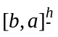∈P^{h}, and (3) [a,a]^{h}∈M^{h} corresponds to both 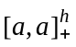 and 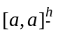 in P^{h}. To avoid redundant terminology, an element of M^{h} is called generalized interval as well, and it is denoted by [a,b]^{h}. Figure 7 shows exhaustively all combinations for computing the lattice join q₁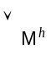q₂ and meet q₁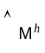q₂ for two different generalized intervals q₁,q₂ in M^{h}. No interpretation is proposed here for negative generalized intervals because it is not necessary. It will be detailed elsewhere how an interpretation of negative generalized intervals is application dependent.
Real function v(.), defined as the area “under” a generalized interval, is a positive valuation function in lattice M^{h} therefore function d(x,y)= v(xy)-v(xy), x,y∈M^{h} defines a metric distance in M^{h} as explained in Appendix A. For example, the metric distance between the two generalized intervals [5049, 5284]^{0.8} and [5447, 5980]^{0.8} of height h=0.8 shown in Figure 6 equals d([5049, 5284]^{0.8},[5447, 5980]^{0.8}])= v([5049, 5980])-v([5447, 5284])= 0.8(931)+0.8(163)= 875.2.
Even though the set M^{h} of generalized intervals is a metric lattice for any h>0, the interest in this work is focused on metric lattices M^{h} with h∈(0,1] because the latter lattices arise from a-cuts of convex fuzzy sets as explained below. The collection of all metric lattices M^{h} for h in (0,1] is denoted by M, that is M= 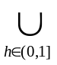M^{h}.

The Metric Lattice F of FINs
A Fuzzy Interval Number, or FIN for short, is a conventional interval-supported convex fuzzy set. In order to facilitate mathematical analysis below, the following definition is proposed for a FIN.

Definition 4.2 A Fuzzy Interval Number, or FIN for short, is a function F: (0,1]→M such that h₁ ≤ h₂ ⇒ support(F(h₁)) ⊇ support(F(h₂)), 0 < h₁ ≤ h₂ ≤ 1.

We remark that the support of a generalized interval in M^{h} is a function which maps a generalized interval to its interval support (set), in particular support([a,b]^{h})=[a,b] if a≤b, whereas support([a,b]^{h})=[b,a] if a≥b. Figure 8 shows the supports support(F(h₁)) and support(F(h₂)) of two generalized intervals, respectively, F(h₁) and F(h₂) stemming from a FIN F.
The support(F(a)) of a generalized interval F(a) equals, by definition, the a-cut Γ_{a} of the corresponding “fuzzy set F with membership function μ: R→[0,1]”. Recall that an a-cut Γ_{a} has been defined in Zadeh (1965) as Γ_{a}= {x|μ(x) ≥ a}; that is Γ_{a} equals the set of real numbers x whose degree μ(x) of membership in F is greater-than or equal-to a. Apparently, an a-cut Γ_{a} for a FIN is an interval.
Let F denote the collection of FINs. An ordering relation 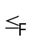 is defined as follows.

Definition 4.3 Let F₁,F₂∈F, then F₁ F₂ if and only if F₁(h)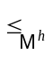F₂(h), h∈(0,1].

(a1)
q₁
q₂
q_{1∧M}^{h}q₂
q_{1∨M}^{h}q₂
(a2)
h
h
q_{1∧M}^{h}q₂
q_{1∨M}^{h}q₂
(b2)
q₁
q₂
(b1)
h
h
-h

q_{1∨M}^{h}q₂
(c2)
-h
-h
(c1)
q₁
q₂
q_{1∧M}^{h}q₂
q_{1∧M}^{h}q₂
q_{1∨M}^{h}q₂
(d2)
q₁
q₂
(d1)
-h
h
-h

q₁
q₂
(e2)
(e1)
q_{1∧M}^{h}q₂=q₂
q_{1∨M}^{h}q₂=q₁
h
-h
h
-h
h
q₁
q₂
(f1)
(f2)
q_{1∧M}^{h}q₂
q_{1∨M}^{h}q₂
-h
h
-h

Figure 7: The join (q₁∨_{M}^{h}q₂) and meet (q₁∧_{M}^{h}q₂) for generalized intervals q₁,q₂∈M^{h}.
(a) “Intersecting” positive generalized intervals q₁ and q₂,
(b) “Non-intersecting” positive generalized intervals q₁ and q₂,
(c) “Intersecting” negative generalized intervals q₁ and q₂,
(d) “Non-intersecting” negative generalized intervals q₁ and q₂,
(e) “Intersecting” positive (q₁) and negative (q₂) generalized intervals, and
(f) “Non-intersecting” positive (q₁) and negative (q₂) generalized intervals.
support(F(h₁))
support(F(h₂))
1
h₂
h₁
0
FIN F

Figure 8: FIN F: (0,1] → M maps a real number h in (0,1] to a generalized interval F(h). The domain of function F is shown on the vertical axis, whereas the range of function F includes “rectangular shaped pulses” on the plane.

It has been shown that F is a lattice. More specifically, the lattice join F₁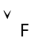F₂ and lattice meet F₁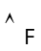F₂ of two incomparable FINs F₁ and F₂, i.e. neither F₁≤_{F}F₂ nor F₂≤_{F}F₁, are shown in Figure 9. The theoretical exposition of this section concludes in the following result.

Proposition 4.4 Let F₁(h) and F₂(h), h∈(0,1] be FINs in F. A metric distance function d_{K}: F×F→R is given by d_{K}(F₁,F₂)= 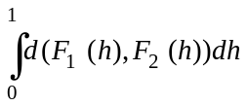, where d(.,.) is the metric in lattice M^{h}.

We remark that a similar metric distance between fuzzy sets has been presented and used previously by other authors (Diamond & Kloeden, 1994; Chatzis & Pitas, 1995) in a fuzzy set theoretic context. Nevertheless the calculation of d_{K}(.,.) based on generalized intervals implies a significant capacity for “tuning” as it will be shown elsewhere. The following two examples demonstrate the computation of metric distance d_{K}.

Example 4.5

Figure 10 illustrates the computation of the metric distance d_{K} between FINs RW89 and RW91 (Figure 10(a)), where generalized intervals RW89(h) and RW91(h) are also shown. FINs RW89 and RW91 have been constructed from real samples of the Roots Weight (RW) production variable in the years 1989 and 1991, respectively.
For every value of the height h∈(0,1] there corresponds a metric distance d(RW89(h),RW91(h)) as shown in Figure 10(b). Based on proposition 4.4 the area under the curve in Figure 10(b) equals the metric distance between FINs RW89 and RW91. It was calculated d_{K}(RW89,RW91)= 541.3.
A practical advantage of metric distance d_{K} is that it can capture sensibly the relative position of two FINs as demonstrated in the following example.

Example 4.6

In Figure 11 distances d_{K}(.,.) are computed between pairs of FINs with triangular membership functions. In particular, in Figure 11(a) distances d_{K}(F₁, H₁) ≈ 5.6669, d_{K}(F₂, H₁) ≈ 5, and d_{K}(F₃, H₁) ≈ 4.3331 have been computed. FINs F₁, F₂, and F₃ have a common base and equal heights. Figure 11(a) was meant to demonstrate the “common sense” results obtained analytically for metric d_{K}, where “the more a FIN F_{i}, i=1,2,3 leans towards FIN H₁” the smaller the corresponding distance d_{K} is. Similar results are shown in Figure 11(b), the latter has been produced from Figure 11(a) by shifting the top of FIN H₁ to the left. It has been computed analytically d_{K}(F₁, H₂) ≈ 5, d_{K}(F₂, H₂) ≈ 4.3331, and d_{K}(F₃, H₂) ≈ 3.6661. Note that d_{K}(F_{i}, H₂) ≤ d_{K}(F_{i}, H₁), i=1,2,3 as expected by inspection because FIN H₂ leans more towards FINs F₁, F₂, F₃ than FIN H₁ does. We also cite the following distances d_{K}(F₁, F₂) ≈ 0.6669, d_{K}(F₁, F₃) ≈ 1.3339, and d_{K}(F₂, F₃) ≈ 0.6669.

F₁
F₂
1
h₂
h₁
0

(a)
F_{1∨F}F₂
F_{1∧F}F₂
1
h₂
h₁
0

(b)

Figure 9: (a) Two incomparable FINs F₁ and F₂, i.e. neither F₁≤_{F}F₂ nor F₂≤_{F}F₁.
(b) F₁∨_{F}F₂ is the lattice join, whereas F₁∧_{F}F₂ is the lattice meet of FINs F₁ and F₂.

FINkNN: A Nearest Neighbor Classifier
Let g be a category function g: F→D which maps a FIN in F to an element of a label set D. Classification in metric lattice (F, d_{K}) can be effected, first, by storing all the labeled training data pairs (E₁, g(E₁)),…,(E_{n}, g(E_{n})) and, second, by mapping a new FIN E to the category g(E) which receives the majority vote among the k Nearest Neighbor (kNN) FINs.
This work has considered N-dimensional vectors F of FINs F= (E₁,…,E_{N}) where a vector component E_{i}, i=1,…,N corresponds to an input variable, i.e. a production variable or a meteorological variable. The kNN classifier described above has been applied, in principle, in product lattice F^{N}. In particular, since (F, d_{K}) is a metric lattice, it follows that d^{p}(x,y)= {d_{K}(E₁,H₁)^{p}+…+d_{K}(E_{N},H_{N})^{p}}^{1/p}, p≥1, where x=(E₁,…,E_{N}),y=(H₁,…,H_{N})∈F^{N}, is a metric distance in product lattice F^{N}. In conclusion a kNN classifier, namely FINkNN, has been applied here in the metric lattice (F^{N}, d¹).
Classifier FINkNN has been cast in the framework of k Nearest Neighbor (kNN) classifiers, nevertheless FINkNN was applied in this work for k=1 for two reasons. First, there were only a few (11) pieces of data from 11 years partitioned in three categories and, second, k=1 gave better results than other values of k in this application. Classifier FINkNN is described below.

Classifier FINkNN

1. Store all labeled training data (F₁, g(F₁)),…,(F_{n}, g(F_{n})), where F_{i}∈F^{N}, g(F_{i})∈D, i=1,…,n.
2. Classify a new datum F∈F^{N} to category g(F_{J}), where J= 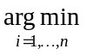{ d¹(F, F_{i}) }.
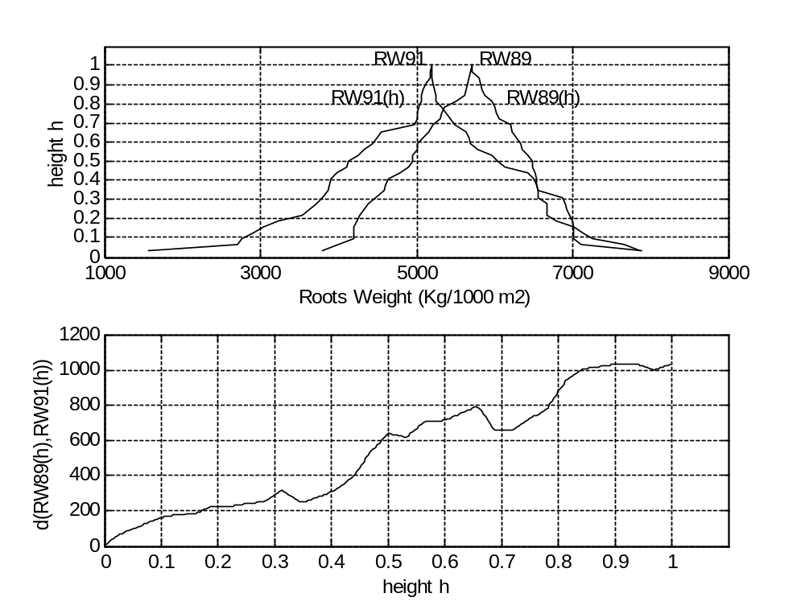
(a)
(b)

Figure 10: Computation of the metric distance d_{K}(RW89,RW91) between FINs RW89 and RW91.

(a) FINs RW89 and RW91. Generalized intervals RW89(h) and RW91(h) are also shown.
(b) The metric distance d(RW89(h),RW91(h)) between generalized intervals RW89(h) and RW91(h) is shown as a function of the height h∈(0,1]. Metric d_{K}(RW89,RW91)= 541.3 equals the area under the curve d(RW89(h),RW91(h)).

Apparently, classifier FINkNN is “memory based” (Kasif et al., 1998) like other methods for learning including instance-based learning, case-based learning, k nearest neighbor (Aha et al., 1991; Kolodner, 1993; Dasarathy, 1991; Duda et al., 2001); the name “lazy learning” (Mitchell, 1997; Bontempi et al., 2002) has also been used in the literature for memory-based learning.
A critical difference between FINkNN and other memory-based learning algorithms is that the FINkNN can freely intermix “number attributes” and “FIN attributes” any place in the data, therefore “ambiguity”, in a fuzzy set sense (Dubois & Prade, 1980; Ishibuchi & Nakashima, 2001; Klir & Folger, 1988; Zadeh, 1965; Zimmerman, 1991), can be dealt with.

Experiments and Results
In this section classifier FINkNN is applied on vectors of FINs, the latter stem from populations of measurements of production and/or meteorological variables. The objective is prediction of annual sugar production by classification.
In the first place the significant differences in scale between different input variables, e.g. Maximum Temperature (Figure 2) versus Roots Weight (Figure 5), had to be smoothed out by a data preprocessing normalization procedure otherwise an input variable could be disregarded as noise. Therefore a mapping to [0,1] was done by, first, translating linearly to 0 and, second, by scaling.
A “leave-one-out” series of eleven experiments was carried out such that one year among years 1989 to 1999 was left out, in turn, for testing whereas the remaining ten years were used for training.

8
9
x
4
7
F₃
F₂
h
1
2
H₁
F₁
5
6
1
0
3

(a)
x
7
F₃
F₂
h
1
2
8
H₂
F₁
5
6
9
1
0
3
4

(b)

Figure 11: (a) It has been computed d_{K}(F₁, H₁) ≈ 5.6669, d_{K}(F₂, H₁) ≈ 5, and d_{K}(F₃, H₁) ≈ 4.3331. That is “the more a FIN F_{i}, i=1,2,3 leans towards FIN H₁” the smaller is the corresponding distance d_{K} as expected intuitively by inspection.
(b) This figure has been produced from the above figure by shifting the top of FIN H₁ to the left. It has been computed d_{K}(F₁, H₂) ≈ 5, d_{K}(F₂, H₂) ≈ 4.3331, and d_{K}(F₃, H₂) ≈ 3.6661.

Input Variable Selection
Prediction of sugar production was based on populations of selected input variables among 18 input variables x₁,…,x₁₈. We remark that variable selection might itself be an important problem in both engineering system design (Hong & Harris, 2001) and in machine learning applications (Koller & Sahami, 1996; Boz, 2002). A subset of input variables have been selected based on an optimization of an objective/fitness function as described in this section.
Using data from ten training years a symmetric 10×10 matrix S_{k} of distances was calculated for each input variable x_{k}, k=1,…,18. Note that an entry in matrix S_{k}, say entry e_{ij}, i,j∈{1,…,10}, quantifies a proximity between two years ‘i’ and ‘j’ based on the corresponding populations of input variable x_{k}. A sum matrix S was defined as S= S_{m}+…+S_{n} for a subset {m,…,n} of input variables. A training year was associated with another one which corresponded to the shortest distance in a matrix S. A contradiction occurred if two training years (associated with the shortest distance) are in different categories among “good”, “medium” or “poor”. An objective/fitness function C(S) was defined as “the sum of contradictions”. There follows the optimization problem: Find a subset of indices m,…,n∈{1,…,18} such that C(S) is minimized. Apparently there exist a total number of 2¹⁸ subsets of indices to choose from.
The above optimization problem was dealt with using, first, a genetic algorithm (GA), second, a GA with local search and, third, human expertise, as described in the following. First, the GA implementation was a simple GA, that is no problem-specific-operators or other techniques were employed. The GA encoded the 18 input variables using 1 bit per variable resulting in a total genotype length of 18 bits. A population of 20 genotypes (solutions) was employed and it was left to evolve for 50 generations. Second, in addition to the GA above a simple local search steepest descent algorithm was employed by considering different combinations of input variables at Hamming distance one; note that the idea for local search around a GA solution has been inspired from the microgenetic algorithm for generalized hill-climbing optimization (Kazarlis et al., 2001). Third, a human expert selected the following input variables: variables Relative Humidity and Roots Weight were selected for Larisa agricultural district, variables Daily Precipitation, Sodium (Na) and Average Root Weight for Platy, and variables Daily Precipitation, Average Root Weight and Roots Weight were selected for the Serres agricultural district.
The optimization problem was solved eleven times leaving, in turn, each year from 1989 to 1999 out for testing whereas the remaining ten years were used for training. Two types of distances were considered between two populations of measurements: 1) the metric distance d_{K}, and 2) the “L1-distance” representing the distance between the average values of two populations.

Experiments and Comparative Results
The leave-one-out paradigm was used to evaluate comparatively FINkNN’s capacity for prediction-by-classification as it has been described above. After selecting a subset of input variables, prediction was effected by assigning the “left out” (testing) year to the category corresponding to the nearest training year. The experimental results are shown in Table 5.
The first line in Table 5 shows the average prediction accuracy over all testing years for Larisa, Platy and Serres, respectively, using algorithm FINkNN with expert selected input variables; line 2 shows the results using L1-distances kNN (with expert input variable selection). Line 3 shows the results using FINkNN (with GA local search input variable selection); line 4 in Table 5 shows the best results obtained using a L1-distances kNN (with a GA local search input variable selection). Line 5 reports the results obtained by FINkNN (with GA input variable selection); line 6 in Table 5 shows the results using L1-distances kNN (with GA input variable selection). The last three lines in Table 5 were meant to demonstrate that prediction-by-classification is well posed in the sense that a small prediction error is expected from the outset. In particular, selection “medium” each year resulted in error rates 5.22%, 3.44%, and 5.54% for the Larisa, Platy, and Serres factories, respectively (line 7). Line 8 shows the average errors when a year was assigned randomly (uniformly) among the three choices “good”, “medium”, “poor”. Line 9 in Table 5 shows the minimum prediction error which would be obtained should each testing year be classified correct in its corresponding class “good”, “medium” or “poor”. The nearest to the latter minimum prediction error was clearly obtained by classifier FINkNN with an expert input variable selection.
Table 5 clearly shows that the best results were obtained for the combination of d_{K} distances (between FINs) with expert-selected input variables. The L1-distance kNN results (lines 2, 4, and 6) use average values of populations of measurements, and were reported in previous work (Kaburlasos et al., 2002). In contrast, FINkNN is sensitive to the skewness of the distribution of measurements due to its use of FINs and the d_{K} metric. In all but one of the nine possible comparisons in Table 5 (FINkNN versus L1-distance kNN for each region and for each selected set of input variables) results are improved using FINkNN. In general, it appears that an employment of FINs tends to improve classification results. Finally, we also observe that the selection of input variables significantly affects the outcome of classification. Input variables selected by a human expert produced better results than input variables selected computationally through optimization of an objective/fitness function.

 | Prediction Method | Larisa | Platy | Seres
1 | FINkNN  (with expert input variable selection) | 1.11 | 2.26 | 2.74
2 | L1-distances kNN  (with expert input variable selection) | 2.05 | 2.87 | 3.17
3 | FINkNN  (with GA local search input variable selection) | 4.11 | 3.12 | 3.81
4 | L1-distances kNN  (with GA local search input variable selection) | 3.89 | 4.61 | 4.58
5 | FINkNN  (with GA input variable selection) | 4.85 | 3.39 | 3.69
6 | L1-distances kNN  (with GA input variable selection) | 5.59 | 4.05 | 3.74
7 | “medium” selection | 5.22 | 3.44 | 5.54
8 | Random prediction | 8.56 | 4.27 | 6.62
9 | minimum prediction error | 1.11 | 1.44 | 1.46

Table 5: Average % prediction error rates using various methods for three factories of Hellenic Sugar Industry (HSI), Greece.

Computation time for algorithm “random prediction” in line 8 of Table 5 was negligible, i.e. the time required to generate a random number in a computer. However more time was required for the algorithms in lines 1 - 6 of Table 5 to select the input variables on a conventional PC using a Pentium (r) II processor. More specifically, algorithm “L1-distances kNN” (with GA input variable selection) required computer time of the order 5-10 minutes. In addition, algorithm “L1-distances kNN” (with GA local search input variable selection) required less than 5 minutes to select a set of input variables. In the last two cases the corresponding algorithm FINkNN required slightly more time due to the computation of distance d_{K} between FINs. Finally, for either algorithm “FINkNN” or “L1-distances kNN” (with expert input variable selection) an expert needed around half an hour to select a set of input parameters. As long as input variables had been selected then computation time for all algorithms in lines 1 - 6 of Table 5 was less than 1 second to classify a year to a category “good”, “medium” and “bad”.

Conclusion and Future Research
A nearest neighbor classifier, FINkNN, was introduced that applies in the metric product-lattice F^{N} of fuzzy interval numbers (FINs), which are conventional interval-supported convex fuzzy sets. FINkNN effectively predicted annual sugar production based on populations of measurements supplied by the Hellenic Sugar Industry. The algorithm CALFIN was presented for constructing FINs from populations of measurements, and a novel metric distance was presented between fuzzy sets with arbitrary-shaped membership functions.
The improved prediction results presented in this work have been attributed to the capacity of FINs to capture the state of the real world more accurately than single numbers because a FIN represents a whole population of samples/measurements. Future work includes an experimental comparison of FINkNN with alternative classification methods, e.g. decision trees, etc.
The metric d_{K} might potentially be useful in a number of applications. For instance, d_{K} could be used to compute a metric distance between populations of statistical samples. Furthermore, d_{K} could be useful in Fuzzy Inference System (FIS) design by calculating rigorously the proximity of two fuzzy sets. Note also that a FIN can always be computed for any population size therefore a FIN could be useful as an instrument for data normalization and dimensionality reduction.
Acknowledgements
The data used in this work is a courtesy of Hellenic Sugar Industry S.A, Greece. Part of this research has been funded by a grant from the Greek Ministry of Development. The authors acknowledge the suggestions of Maria Konstantinidou for defining metric lattice M^{h} out of pseudo-metric lattice P^{h}. We also thank Haym Hirsh for his suggestions regarding the presentation of this work to a machine-learning audience.

This Appendix shows a metric distance in the lattice M^{h} of generalized intervals of height h. Consider the following definition.

Definition A.1 A pseudo-metric distance in a set S is a real function d: S×S→R such that the following four laws are satisfied for x,y,z∈S:
(M1) d(x,y) ≥ 0, (M3) d(x,y) = d(y,x), and
(M2) d(x,x) = 0, (M4) d(x,y) ≤ d(x,z) + d(z,y) - Triangle Inequality

If, in addition to the above, the following law is satisfied

(M0) d(x,y) = 0 ⇒ x=y

then real function d is called a metric distance in S.

Given a set S equipped with a metric distance d, the pair (S, d) is called metric space. If S=L is a lattice then metric space (L, d) is called, in particular, metric lattice.
A distance can be defined in a lattice L as follows (Birkhoff, 1967). Consider a valuation function in L, that is a real function v: L→R which satisfies v(x)+v(y)= v(x∨_{L}y)+v(x∧_{L}y), x,y∈L. A valuation function is called monotone if and only if x≤_{L}y implies v(x)≤v(y). If a lattice L is equipped with a monotone valuation then real function d(x,y)=v(x∨_{L}y)-v(x∧_{L}y), x,y∈L defines a pseudo-metric distance in L. If, furthermore, monotone valuation v(.) satisfies “x<_{L}y implies v(x)<v(y)” then v(.) is called positive valuation and function d(x,y)=v(x∨_{L}y)-v(x∧_{L}y) is a metric distance in L. A positive valuation function is defined in the set M^{h} of generalized intervals in the following.
Let v: P^{h}→R be a real function which maps a generalized interval to its area, that is function v maps a positive generalized interval to non-negative number h(b-a) whereas function v maps a negative generalized interval to non-positive number -h(b-a). It has been shown (Kaburlasos, 2002) that function v is a monotone valuation in P^{h}, nevertheless v is not a positive valuation. In order to define a metric in the set of generalized intervals, an equivalence relation ∼ has been introduced in P^{h} such that x∼y ⇔ d(x,y)=0, x,y∈P^{h}. The quotient (set) of P^{h} with respect to equivalence relation ∼ is lattice M^{h}, symbolically M^{h}= P^{h}/∼. In conclusion M^{h} is a metric lattice with distance d given by d(x,y)= v(xy)-v(xy).

A one-one correspondence is shown in this Appendix between FINs and probability density functions (pdfs). More specifically, based on the one-one correspondence between pdfs and Probability Distribution Functions (PDFs), a one-one correspondence is shown between PDFs and FINs as follows. In the one direction, a PDF G(x) was mapped to a FIN F with membership function μ_{F}(.) such that: if G(x₀)= 0.5 then μ_{F}(x)= 2G(x) for x≤x₀, whereas μ_{F}(x)=2[1-G(x)] for x≥x₀. In the other direction, a FIN F was mapped to a PDF G(x) such that: if μ_{F}(x₀)= 1 then G(x)= μ_{F}(x) for x≤x₀, whereas G(x)= 1-μ_{F}(x) for x≥x₀. Recall, from the remarks following algorithm CALFIN, that μ_{F}(x₀)= 1 at exactly one point x₀.
A statistical interpretation of a FIN is presented in the following. Algorithm CALFIN implies that when a FIN F is constructed then approximately 100(1-h) % of the population of samples are included in interval support(F(h)). Hence, if a large number of samples is drawn independently from one probability distribution then interval support(F(h)) could be regarded as “an interval of confidence at level-h”.
The previous analysis may also imply that FINs could be considered as vehicles for accommodating synergistically tools from, on the one hand, probability-theory/statistics and, on the other hand, fuzzy set theory. For instance two FINs F₁ and F₂ calculated from two pdfs f₁(x) and f₂(x), respectively, could be used for calculating a metric distance (d_{K}) between pdfs f₁(x) and f₂(x) as follows: d_{K}(f₁(x), f₂(x))=d_{K}(F₁, F₂). Moreover two FINs F₁ and F₂ calculated from two populations of measurements could be used for computing a (metric) distance between populations of measurements.
References
D.W. Aha, D.F. Kibler, and M.K. Albert. Instance-Based Learning Algorithms. Machine Learning, 6:37-66, 1991.
A. Ben-Hur, D. Horn, H.T. Siegelmann, and V. Vapnik. Support Vector Clustering. Journal of Machine Learning Research, 2(Dec):125-137, 2001.
G. Birkhoff. Lattice Theory. American Mathematical Society, Colloquium Publications, vol. 25, Providence, RI, 1967.
G. Bontempi, M. Birattari, and H. Bersini. Lazy Learning: A Logical Method for Supervised Learning. In New Learning Paradigms in Soft Computing, L.C. Jain and J. Kacprzyk (editors), 84: 97-136, Physica-Verlag, Heidelberg, Germany, 2002.
O. Boz. Feature Subset Selection by Using Sorted Feature Relevance. In Proceedings of the Intl. Conf. On Machine Learning and Applications (ICMLA’02), Las Vegas, NV, USA, 2002.
P.-T. Chang, and E.S. Lee. Fuzzy Linear Regression with Spreads Unrestricted in Sign. Computers Math. Applic., 28(4):61-70, 1994.
V. Chatzis, and I. Pitas. Mean and median of fuzzy numbers. In Proc. IEEE Workshop Nonlinear Signal Image Processing, pages 297-300, Neos Marmaras, Greece, 1995.
C. Citterio, A. Pelagotti, V. Piuri, and L. Rocca. Function Approximation – A Fast-Convergence Neural Approach Based on Spectral Analysis. IEEE Transactions on Neural Networks, 10(4):725-740, 1999.
W. Cohen. Hardness Results for Learning First-Order Representations and Programming by Demonstration. Machine Learning, 30:57-88, 1998.
B.V. Dasarathy, editor. Nearest Neighbor (Nn Norms: Nn Pattern Classification Techniques), IEEE Computer Society Press, 1991.
P. Diamond. Fuzzy Least Squares. Inf. Sci., 46:141-157, 1988.
P. Diamond, and P. Kloeden. Metric Spaces of Fuzzy Sets. World Scientific, Singapore, 1994.
P. Diamond, and R. Körner. Extended Fuzzy Linear Models and Least Squares Estimates. Computers Math. Applic., 33(9):15-32, 1997.
D. Dubois, and H. Prade. Fuzzy Sets and Systems - Theory and Applications. Academic Press, Inc., San Diego, CA, 1980.
R.O. Duda, P.E. Hart., and D.G. Stork. Pattern Classification, 2nd edition. John Wiley & Sons, New York, N.Y., 2001.
P. Frasconi, M. Gori, and A. Sperduti. A General Framework for Adaptive Processing of Data Structures. IEEE Transactions on Neural Networks, 9(5):768-786, 1998.
L. Goldfarb. What is a Distance and why do we Need the Metric Model for Pattern Learning. Pattern Recognition, 25(4):431-438, 1992.
X. Hong, and C.J. Harris. Variable Selection Algorithm for the Construction of MIMO Operating Point Dependent Neurofuzzy Networks. IEEE Trans. on Fuzzy Systems, 9(1):88-101, 2001.
E.G. Hutchinson, and J.M. Thornton. PROMOTIF – A program to identify and analyze structural motifs in proteins. Protein Science, 5(2):212-220, 1996.
H. Ishibuchi, and T. Nakashima. Effect of Rule Weights in Fuzzy Rule-Based Classification Systems. IEEE Transactions on Fuzzy Systems, 9(4):506 -515, 2001.
V.G. Kaburlasos. Novel Fuzzy System Modeling for Automatic Control Applications. In Proceedings 4th Intl. Conference on Technology & Automation, pages 268-275, Thessaloniki, Greece, 2002.
V.G. Kaburlasos, and V. Petridis. Fuzzy Lattice Neurocomputing (FLN): A Novel Connectionist Scheme for Versatile Learning and Decision Making by Clustering. International Journal of Computers and Their Applications, 4(2):31-43, 1997.
V.G. Kaburlasos, and V. Petridis. Fuzzy Lattice Neurocomputing (FLN) Models. Neural Networks, 13(10):1145-1170, 2000.
V.G. Kaburlasos, and V. Petridis. Learning and Decision-Making in the Framework of Fuzzy Lattices. In New Learning Paradigms in Soft Computing, L.C. Jain and J. Kacprzyk (editors), 84:55-96, Physica-Verlag, Heidelberg, Germany, 2002.
V.G. Kaburlasos, V. Petridis, P.N. Brett, and D.A. Baker. Estimation of the Stapes-Bone Thickness in Stapedotomy Surgical Procedure Using a Machine-Learning Technique. IEEE Transactions on Information Technology in Biomedicine, 3(4):268-277, 1999.
V.G. Kaburlasos, V. Spais, V. Petridis, L, Petrou, S. Kazarlis, N. Maslaris, and A. Kallinakis. Intelligent Clustering Techniques for Prediction of Sugar Production. Mathematics and Computers in Simulation, 60(3-5): 159-168, 2002.
S. Kasif, S. Salzberg, D.L. Waltz, J. Rachlin, and D.W. Aha. A Probabilistic Framework for Memory-Based Reasoning. Artificial Intelligence, 104(1-2):287-311, 1998.
S.A. Kazarlis, S.E. Papadakis, J.B. Theocharis, and V. Petridis, “Microgenetic algorithms as generalized hill-climbing operators for GA optimization”, IEEE Trans. on Evolutionary Computation, 5(3): 204-217, 2001.
M.J. Kearns, and U.V Vazirani. An Introduction to Computational Learning Theory. The MIT Press, Cambridge, Massachusetts, 1994.
G.J. Klir, and T.A. Folger. Fuzzy Sets, Uncertainty, and Information. Prentice-Hall, Englewood Cliffs, New Jersey, 1988.
D. Koller, and M. Sahami. Toward Optimal Feature Selction. In ICML-96: Proceedings of the 13th Intl. Conference on Machine Learning, pages 284-292, San Francisco, CA, 1996.
J. Kolodner. Case-Based Reasoning. Morgan Kaufmann Publishers, San Mateo, CA, 1993.
O.L. Mangasarian and D.R. Musicant. Lagrangian Support Vector Machines. Journal of Machine Learning Research, 1:161-177, 2001.
T.M. Mitchell. Machine Learning. The McGraw-Hill Companies, Inc., New York, NY, 1997.
S. Muggleton. Inductive Logic Programming. New Generation Computing, 8(4):295-318, 1991.
A. Paccanaro, and G.E. Hinton. Learning Distributed Representations of Concepts Using Linear Relational Embedding. IEEE Transactions on Knowledge and Data Engineering, 13(2):232-244, 2001.
V. Petridis, and V.G. Kaburlasos. Fuzzy Lattice Neural Network (FLNN): A Hybrid Model for Learning. IEEE Transactions on Neural Networks, 9(5):877-890, 1998.
V. Petridis, and V.G. Kaburlasos. Learning in the Framework of Fuzzy Lattices. IEEE Transactions on Fuzzy Systems, 7(4):422-440, 1999 (Errata in IEEE Transactions on Fuzzy Systems, 8(2):236, 2000).
V. Petridis, and V.G. Kaburlasos. Clustering and Classification in Structured Data Domains Using Fuzzy Lattice Neurocomputing (FLN). IEEE Transactions on Knowledge and Data Engineering, 13(2):245-260, 2001.
V. Petridis, A. Kehagias, L. Petrou, H. Panagiotou, and N. Maslaris. Predictive Modular Neural Network Methods for Prediction of Sugar Beet Crop Yield. In Proceedings IFAC-CAEA’98 Conference on Control Applications and Ergonomics in Agriculture, Athens, Greece, 1998.
B. Schölkopf, S. Mika, C.J.C. Burges, P. Knirsch, K.-R. Muller, G. Rätsch, and A.J. Smola. Input Space Versus Feature Space in Kernel-Based Methods. IEEE Transactions on Neural Networks, 10(5):1000-1017, 1999.
G. Stoikos. Sugar Beet Crop Yield Prediction Using Artificial Neural Networks (in Greek). In Proceedings of the Modern Technologies Conference in Automatic Control, pages 120-122, Athens, Greece, 1995.
H. Tanaka, and H. Lee. Interval Regression Analysis by Quadratic Programming Approach. IEEE Trans. Fuzzy Systems, 6(4):473-481, 1998.
M. Turcotte, S.H. Muggleton, and M.J.E. Sternberg. Learning rules which relate local structure to specific protein taxonomic classes. In Proceedings of the 16th Machine Intelligent Workshop, York, U.K., 1998.
V. Vapnik. The support vector method of function estimation. In Nonlinear Modeling: Advanced Black-Box Techniques, J. Suykens, and J. Vandewalle (editors), 55-86, Kluwer Academic Publishers, Boston, MA, 1988.
V. Vapnik. An Overview of Statistical Learning Theory. IEEE Transactions on Neural Networks, 10(5):988-999, 1999.
V. Vapnik, and C. Cortes. Support vector networks. Machine Learning, 20:1-25, 1995.
M. Vidyasagar. A Theory of Learning and Generalization: With Applications to Neural Networks and Control Systems (Communications and Control Engineering). Springer Verlag, New York, NY, 1997.
P. Winston, Learning Structural Descriptions from Examples. The Psychology of Computer Vision. P. Winston (ed.), 1975.
I.H. Witten, and E. Frank. Data Mining: Practical Machine Learning Tools and Techniques with Java Implementations. Morgan Kaufmann, 2000.
M.-S. Yang, and C.-H. Ko. On Cluster-Wise Fuzzy Regression Analysis. IEEE Trans. Systems, Man, Cybernetics - Part B: Cybernetics, 27(1):1-13, 1997.
L.A. Zadeh. Fuzzy Sets. Information and Control, 8:338-353, 1965.
H.-J. Zimmermann. Fuzzy Set Theory - and Its Applications. Kluwer Academic Publishers, Norwell, MA, 1991.

Recall that a relation is called partial ordering relation if and only if it is 1) reflexive (x≤x), 2) antisymmetric (x≤y and y≤x imply x=y), and 3) transitive (x≤y and y≤z imply x≤z). A lattice L is a partially ordered set any two of whose elements have a unique greatest lower bound or meet denoted by x∧_{L}y, and a unique least upper bound or join denoted by x∨_{L}y.
We point out that the theoretical formulation presented in this work, regarding FINs with negative membership functions, might be useful for interpreting significant improvements reported in Chang and Lee (1994) in fuzzy linear regression problems involving triangular fuzzy sets with negative spreads. Note that fuzzy sets with negative spreads are not regarded as fuzzy sets by some authors (Diamond and Körner, 1997).

