**IDS PRACTICE**

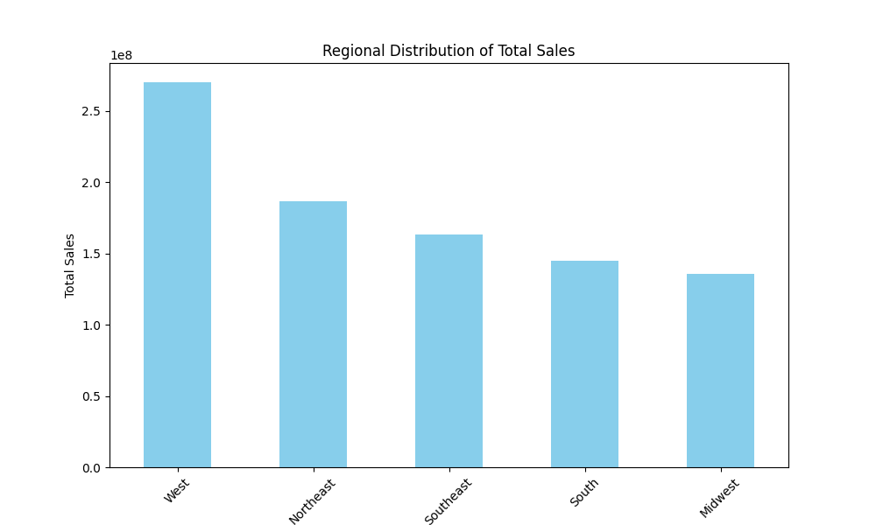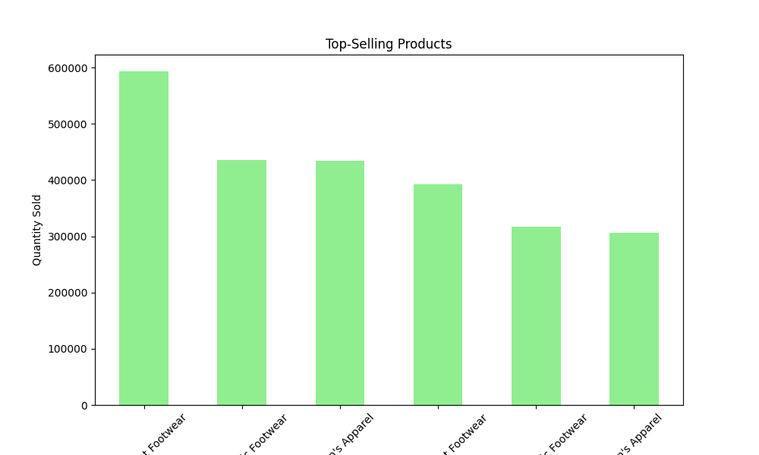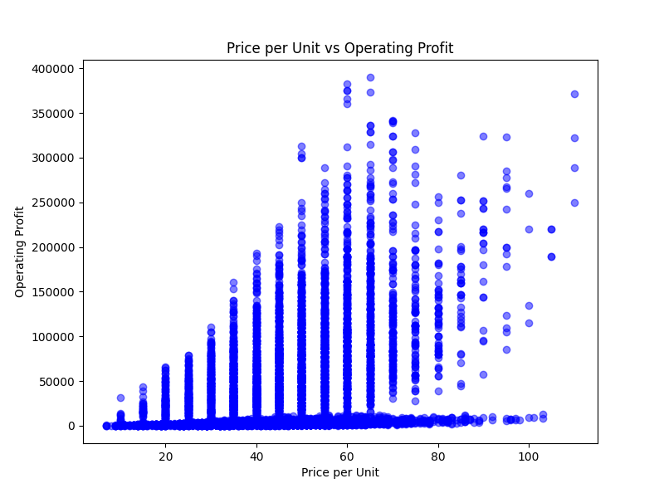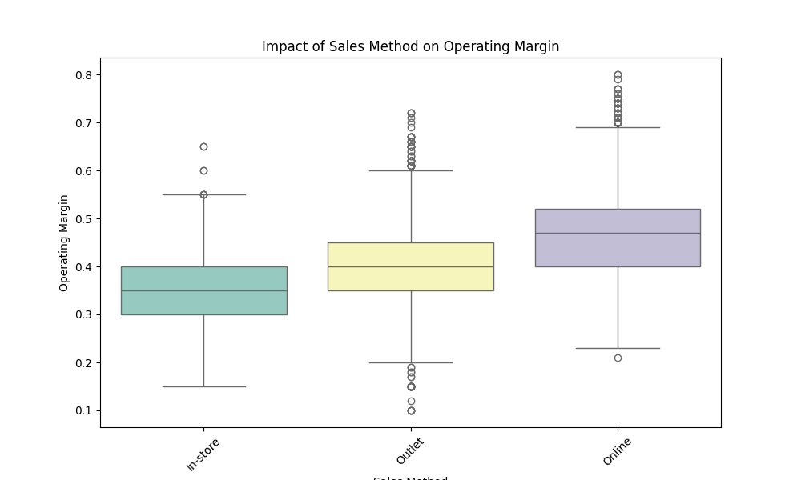

* **INSIGHTS**

The visualizations reveal intriguing insights into the sales data. It's evident that outwear products have proven to be the top-selling category, with significant quantities sold. Additionally, the Western region emerges as a robust market for Adidas products, characterized by a higher volume of sales. Interestingly, online sales appear to have a substantial share, despite fewer units sold in this channel. This suggests a potential for higher-priced items, which could be contributing to the overall revenue, highlighting the significance of e-commerce in the sales strategy.