**Evrişimsel Sinir Ağlar MODELİ KULLANARAK**

**COVID-19 SINIFLANDIRILMASI**

152120161109 - Zaurela DIBRA1 – [zaureladibra@gmail.com](mailto:zaureladibra@gmail.com)

1 Eskişehir Osmangazi Üniversitesi, Mühendislik Mimarlık Fakültesi, Eskişehir, Türkiye

|  |  |
| --- | --- |
| **Anahtar Kelimeler** | **Öz** |
| *Sınıflandırma,*  *Covid-19,*  *Evrişimsel Sinir Ağları,*  *Derin Öğrenme,*  *Hasta* | *Bu projede Covid-19 hastalarını, göğüs röntgeni görüntülerine göre pozitif veya negatif olmak üzere sınıflandıracağız. Diğer bir deyişle, bu proje, CNN derin öğrenme algoritmasını kullanarak Covid ve normal X-Ray görüntüleri arasında sınıflandırmaya yardımcı olacaktır. Bu yazının amacı, Coronavirüs'ün neden olduğu zorluklarla mücadelede AI uygulamalarına ilişkin kapsamlı bir araştırma yapmaktır. Bu uygulamalar sayesinde Covid'in farklı test türleri aracılığıyla teşhis edilmesine yardımcı olması hedeflenmektedir.* |

**COVID-19 PNEUMONIA CLASSIFICATION USING CNN MODEL**

|  |  |
| --- | --- |
| **Keywords** | **Abstract** |
| *Classification,*  *Covid-19,*  *CNN model,*  *Deep Learning,*  *Patient* | *In this project we will classify Covid-19 patients based on their chest X-Ray images. In other words, this project will help to classify between Covid and normal X-Ray images using CNN deep learning algorithm. The aim of this paper is to perform a comprehensive survey on the applications of AI in battling against the difficulties that Coronavirus has caused. To manage the problems, these applications are helping to diagnose Covid via different types of tests.* |

**1. Introduction**

COVID-19 is a virus that belongs to the family of coronaviridae. SARS CoV-2 was first reported to be observed in Wuhan City, in China in December 2019. Since then it has continuously spread around the world. The disease causes flu, shortness of breath and pneumonia. AI approaches are adopted to manage the effects of the disease. Examples of AI approaches include Deep learning, machine learning, Artificial Neural Networks and evolutionary algorithms.

Currently, testing to find covid-19 positive cases relies heavily on Reverse Transcription-Polymerase Chain Reaction (RT-PCR), which is time consuming and has false-negative error. Thus, developing new approaches for detecting patients at a faster rate with higher accuracy is a matter of importance. Our project will help to detect patients via X-Ray images which require more easily accessible equipment. By processing these images, one can detect the patients even before they have developed symptoms like fever or coughing so this method would bring a great management of pandemia.

**2.** **Scientific Literature Review**

Since SARS CoV-2 was first reported a number of research have tried to perform approaches in tacking the pandemic. Artificial Intelligence will be key to supporting clinical and academic studies of covid-19. In this section, some of the related works will be described. First, an AI algorithm is proposed in research paper **[1]** that uses CT images, clinical symptoms, exposure history and laboratory testing to diagnose covid-19 cases. The authors collect data from 905 patients, of which 419 are laboratory-confirmed covid-19 positive cases. Second, a machine learning and an ANN with a simple statistical test is used in another research paper **[2]**, to identify covid-19 patients based on full blood counts without data from symptoms or history of the individuals.

In order to prescribe adequate medicine, it is important to have information from laboratory testing and their triangulation with clinical outcomes. In a research paper **[3]**, the data of 181 covid-19 positive and 7,775 negative cases related to 1.3 million tests are studied and it is found that covid-19 patients tend to have higher plasma fibrinogen levels, low platelet counts and around 25% of patients showing outright thrombocytopenia. The data were fed to a neural network-powered extraction system for the system. In **[4]**, data from 1590 patients from 575 medical centers are used to train a deep learning model that predicts the risk of covid-19 patients developing critical illness based on clinical characteristics. Lastly, an AI-based smartphone application is proposed in **[5]**, which uses different sensors including temperature, microphone, camera and color sensor to monitor people and patients.

**3. Methods**

In this section, we will discuss the data set used, work methodology, model architecture, implementation and training.

* 1. Dataset

Finding the right dataset is the key to obtain a good accuracy. The dataset consist of 1811 total train images and 484 total test images. Table I shows the summary of the prepared dataset. Figure 1 below shows some samples of chest X-ray images from the prepared dataset. In order to overcome the overfitting problem, we used data augmentation technique. Overfitting means that our model is not able to generalize well the model because it has learned the features of the training set extremely well. If we give our model any data that deviates from the data used during training it is unable to predict the output. On the other hand, augmentation technique is the process of creating a new data based on the modification of our existing data. We can augment image data by flipping them horizontally or vertically, rotated or zoom.

Table 1: Dataset Summary

|  |  |
| --- | --- |
| Train dataset Covid image | 545 |
| Train dataset Normal image | 1266 |
| Test dataset Covid image | 167 |
| Test dataset Normal image | 317 |

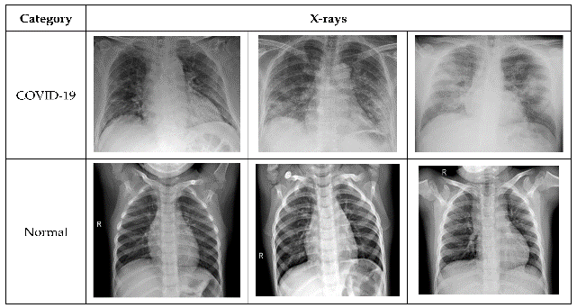

Figure 1. Normal vs Covid-19 X-Ray images

* 1. Convolutional Neural Network (CNN)

Convolutional neural networks also known as CNN are a type of neural network with at least one layer of convolution. So far been most popularly used for analyzing images. Generally, we can think of CNN as an artificial neural network that has some type specialization for being able to pick out or detect patterns and make sense of them. So, this pattern detection is what makes CNN so useful for image analysis. The deep architecture helps these networks learn many different and complex features which a simple neural network cannot learn. CNN has hidden layers called convolution layers and non-convolution layers such as convolution, ReLU, Pooling, normalization, fully connected and softmax layer. In the convolution neural networks, classification process takes place in fully connected layers and softmax layer.

We will discuss in detail each of the layers:

3.2.1 Convolutional Layer:

Convolution layer is the core building block of a Convolutional Neural Network which uses convolution operation (represented by *) in place of general matrix multiplication. Its parameters consist of a set of learnable filters also known as kernels. The main task of the convolutional layer is to detect features found within local regions of the input image that are common throughout the dataset and mapping their appearance to a feature map. The convolution operation is given as:

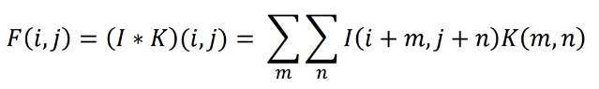 *Eq (1)*

I- is the input matrix

K- is the 2D filter of size m x n

F- is the output 2D feature map

I is convolved with the filter K and produces the feature map F. This convolution operation is denoted by I*K.

The output of each convolutional layer is fed to an activation function to introduce non-linearity. There are number of activation functions available but the one which is recognized for deep learning is Rectified Linear Unit (ReLU). ReLU simply computes the activation by thresholding the input at zero. In other words, ReLU outputs 0 if the input is less than 0, and raw output otherwise. It is mathematically given as:

C:\Users\iNTECO\Downloads\WhatsApp Image 2021-01-09 at 23.11.07.jpeg *Eq (2)*

3.2.2 Subsampling (Pooling) Layer

In CNN, the sequence of convolution layer is followed by an optional pooling or down sampling layer to reduce the spatial size of the input and thus reducing the number of parameters in the network. A pooling layer takes each feature map output from the convolutional layer and down samples it i.e., pooling layer summarizes a region of neurons in the convolution layer. There most common pooling technique is Max Pooling which simply outputs the maximum value in the input region.

3.2.3 Fully Connected Layer

In fully connected layer each neuron from previous layer is connected to every neuron in the next layer and every value contributes in predicting how strongly a value matches a particular class. The output of last fully connected layer is then forwarded to an activation function which outputs the class scores. Softmax and Support Vector Machines (SVM) are the two main classifiers used in CNN. Softmax function which computes the probability distribution of the n output classes is given as:

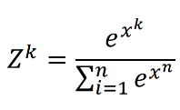 *Eq (3)*

Where x is the input vector and Z is the output vector. The sum of all outputs (Z) equals to 1. The proposed model CoroNet uses Softmax, to predict the class to which the input X-ray image belongs to. All the layers discussed above are stacked up to make a full CNN architecture. In addition to these main layers mentioned above, CNN may include optional layers like batch normalization layer to improve the training time and dropout layer to address the overfitting issue.

* 1. Model Architecture and Development

We are going to use Keras API which is a is a neural network library, and the Keras sequential class to build simple models, because most of the neural networks can be built using sequential class and it is really easy to construct deep learning models with it.

1. We call the Sequential method. Then, we pass the list of the Keras layers one by one. We have used padding as same so we do not lose any information in the image, also we have added a non-linearity to the network so that the network runs more complex functions which is the ReLu non-linearity. For the input shape of our images, we have given 150, 150 which represents the dimensions of the image (in pixels), we also specify the RGB channel.
2. We add the pooling layer which reduces the image, because there are lots of data that are not necessary. We will give the pool size 2,2 which reduces the size of the image in half.
3. We add the dropout layer which dropouts 50% of the neurons to avoid overfitting of the data. (if we give 0.5). This layer helps to minimize the overfitting as well. We repeat these three steps except now we do not specify the input shape on the convolution layer.
4. Since the size of the images have been squeezed enough with the features served, now we can flatten it. Flattening converts the image you have got from 2D image to a 1D image.
5. We add the dense layer with 256 amounts of nodes, and activation function as ReLu.
6. Again, we dropout 50% of the neurons.
7. We add the output layer dense which has 1 node, and the activation function is sigmoid.
8. In the end we just call the summary, which gives the summary of our model.

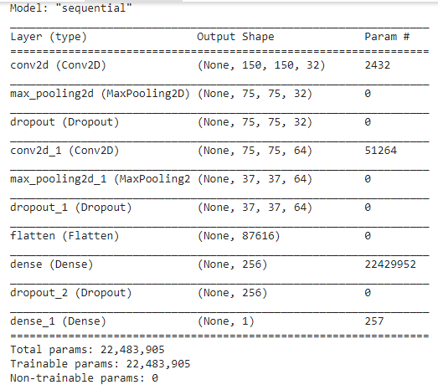

Figure 2: Sequential Method

**4. Results**

In our model we obtain the record of the progress of the network during the training. Four values will be the indication of how good our model is trained including loss, accuracy, validation loss and validation accuracy. The training loss and accuracy it is making a guess to the classification of the train data and than measuring it against the new label. While the accuracy provides the correct guess than the validation accuracy it is the measurament with the data that it has not been used in training. Over the number of epoches, the loss will decrease and the accuracy will increase.

Our final result recorded around 97% training accuracy and 98% validation accuracy. Also, we will plot the graph between training and validation to see how model will work during the training fees. Firstly we will visualize the graph between the training and validation loss (Graph 1). From here we realized that we have fitted the data well by keeping both the training and the validation loss at a minimum.

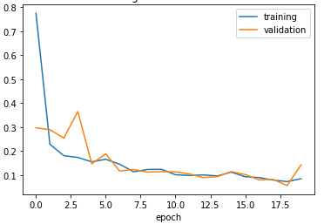

Graph 1. Training and Validation Loss

Similarly, we visualized the graph between the training and validation accuracy (Graph 2). By looking at the graph we can say that since the starting point the training and validation accuracy will get increased and finally reaching 97% accuracy for training and 98% for the validation. No overfitting has occurred since there is no gab between training and validation accuracy.

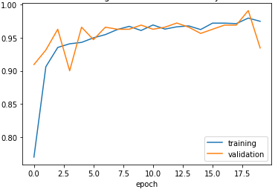

Graph 2. Training and Validation Accuracy

**5. Discussion**

In this project, we proposed a CNN deep model based architecture to detect COVID-19 cases from chest X-ray images. Our model achieved an accuracy of 97 % and no overfitting has occurred. The results obtained by our proposed model are superior compared to other studies.

Wang and Wong **[6]** presented a residual deep architecture called COVID-Net for detection of COVID-19 from chest X-ray images. COVID-Net is one of the early works done on COVID-19 which uses deep neural network to classify chest X-ray images into four categories (COVID, Normal, Pneumonia bacterial and Pneumonia Viral). COVID-Net achieved an accuracy of 83.5% for four classes.

Apostolopoulos and Mpesiana **[7]** evaluated various state-of-the-art deep architectures on chest X-ray images. With transfer learning their best model VGG19 managed to achieve an accuracy of 93.48% and 98.75% for 3-class and 2-class classification tasks respectively on a dataset consisting of 224 COVID-19, 700 pneumonia and 504 normal X-ray images.

Ozturk et al **[8]** proposed a CNN model based on DarkNet architecture to detect and classify COVID-19 cases from X-ray images. Their model achieved binary and 3-class classification accuracy of 98.08%.

**6. Conclusion**

As the cases of COVID-19 pandemic are increased since one year before many countries are facing shortage of resources. During this health emergency, it is important that every single positive case is identified in time. With this thing in mind, we proposed a deep learning approach to detect COVID-19 cases from chest X-Ray images. The proposed method is a convolutional neural network (CNN) designed to identify COVID-19 cases using chest X-ray images.

The model has been trained and tested on a dataset with a total of 1811 train images and 484 total test images. The performance can further be improved once more training data becomes available. Finally, we can also generate a friendly user interface in cases if we want to bring the application in to the market and help the doctors to better identify Covid-19 positive cases.

**References**

**[1]** X. Mei, H.-C. Lee, K. Diao, M. Huang, B. Lin, C. Liu,

Z. Xie, Y. Ma, P. M. Robson, M. Chung, A. Bernheim,

V. Mani, C. Calcagno, K. Li, S. Li, H. Shan, J. Lv,

T. Zhao, J. Xia, Q. Long, S. Steinberger, A. Jacobi,

T. Deyer, M. Luksza, F. Liu, B. P. Little, Z. A. Fayad,

Y. Yang, Artificial intelligence-enabled rapid diagnosis

of covid-19 patients, medRxivdoi:10.1101/2020.

04.12.20062661.

**[2]** J. Wu, P. Zhang, L. Zhang, W. Meng, J. Li, C. Tong,

Y. Li, J. Cai, Z. Yang, J. Zhu, M. Zhao, H. Huang, X. Xie,

S. Li, Rapid and accurate identification of covid-19 infection through machine learning based on clinical available blood test results, medRxiv.

**[3]** C. Pawlowski, T. Wagner, A. Puranik, K. Murugadoss,

L. Loscalzo, A. Venkatakrishnan, R. K. Pruthi, D. E.

Houghton, J. C. O’Horo, W. G. Morice, J. Halamka,

A. D. Badley, E. S. Barnathan, H. Makimura, N. Khan,

V. Soundararajan, Longitudinal laboratory testing tied to

pcr diagnostics in covid-19 patients reveals temporal evolution of distinctive coagulopathy signatures, medRxiv.

**[4]** W. Liang, J. Yao, A. Chen, Q. Lv, M. Zanin, J. Liu,

S. Wong, Y. Li, J. Lu, H. Liang, et al., Early triage of

critically ill covid-19 patients using deep learning, Nature Communications 11 (1) (2020) 1–7.

**[5]** H. S. Maghdid, K. Z. Ghafoor, A. S. Sadiq, K. Curran,

D. B. Rawat, K. Rabie, A novel ai-enabled framework

to diagnose coronavirus covid 19 using smartphone embedded sensors: Design study (2020). arXiv:2003.

07434.

**[6]** Wang L, Wong A. COVID-Net: A Tailored Deep Convolutional Neural Network Design for Detection of COVID-19 Cases from Chest Radiography Images. arXiv preprint arXiv:2003.09871. 2020 Mar 22.

**[7]** Apostolopoulos ID, Mpesiana TA. Covid-19: automatic detection from X-ray images utilizing transfer learning with convolutional neural networks. Physical and Engineering Sciences in Medicine. 2020 Apr 6:1

**[8]** Ozturk T, Talo M, Yildirim EA, Baloglu UB, Yildirim O, Acharya UR. Automated detection of COVID-19 cases using deep neural networks with X-ray images. Computers in Biology and Medicine. 2020 Apr 28:103792