

|  |  |
| --- | --- |
| **Title** | Homework 3 |
|  |  |
| **Module** | EE5904 |
|  |  |
| **Name** | Zavier Ong Jin Jie |
|  |  |
| **Matriculation No.** | A0138993L |
|  |  |

# Q1. Function Approximation with RBFN

## 1a. Exact Interpolation method

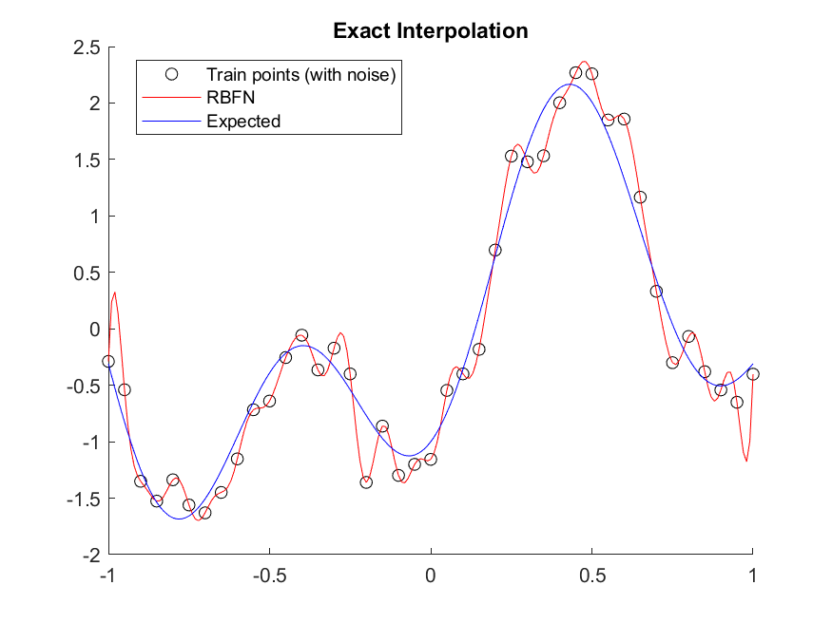

Figure 1. Exact Interpolation



Figure 2. MSE on test set

As observed in Figure 2, the Mean Square Error on the test set 0.067. From Figure 1, it can be observed that the RBFN is overfitting as it follows the training points present with noise very closely. As a result, leading to poor fitting results on the test set.

## 1b. Fixed Centers Selected at Random

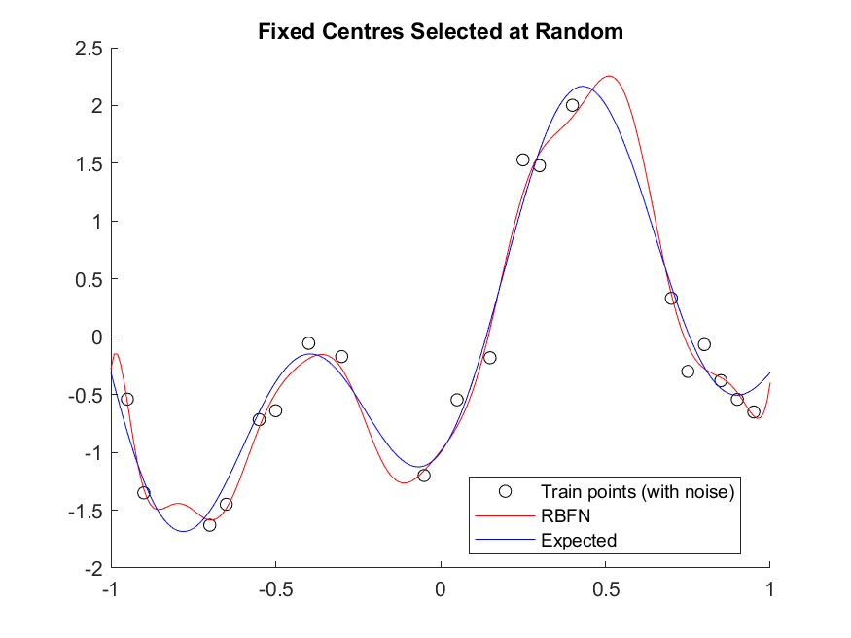

Figure 3. Fixed Centers Selected at Random



Figure 4. MSE on test set

Comparing Figure 4 and Figure 2, it is observed that the MSE on the test set is reduced. In Figure 3, the RBFN is able to fit to the test set better as compared to the exact interpolation method. Though noise is still present in the data, as only 20 centers are randomly selected among the sampling points, this strategy can reduce the degree of overfitting.

## 1c. Exact Interpolation with regularization

|  |  |
| --- | --- |
| C:\Users\eleojjz\Documents\Masters\EE5904_Neural_Networks\EE5904\Homework3\q1_img\q1c_0.000.png | C:\Users\eleojjz\Documents\Masters\EE5904_Neural_Networks\EE5904\Homework3\q1_img\q1c_0.001.png |
| C:\Users\eleojjz\Documents\Masters\EE5904_Neural_Networks\EE5904\Homework3\q1_img\q1c_0.010.png | C:\Users\eleojjz\Documents\Masters\EE5904_Neural_Networks\EE5904\Homework3\q1_img\q1c_0.100.png |
| C:\Users\eleojjz\Documents\Masters\EE5904_Neural_Networks\EE5904\Homework3\q1_img\q1c_1.000.png | C:\Users\eleojjz\Documents\Masters\EE5904_Neural_Networks\EE5904\Homework3\q1_img\q1c_10.000.png |
| C:\Users\eleojjz\Documents\Masters\EE5904_Neural_Networks\EE5904\Homework3\q1_img\q1c_100.000.png | C:\Users\eleojjz\Documents\Masters\EE5904_Neural_Networks\EE5904\Homework3\q1_img\q1c_mse.PNG |

Figure 5. Exact Interpolations with varying regularization factors

Figure 5 depicts the approximate performances of the RBFN using the same centers and widths determined in part a) while applying different regularization factors ranging from 0 to 100 at magnitudes of 10 (0, 0.001, 0.010, 0.1, 1, 10, 100). As shown in the bottom left corner in Figure 5, when regularization factor (lambda) is 1, it produces the least error and best performance of the RBFN. By observing the MSE errors as well as the plots, when lambda is small, the RBFN would over fit towards the training data, resulting to poor performance. On the flip side, when lambda is large, the smoothness constraint would dominate, leading to under fitting and ultimately decreasing performance of the RBFN.

# Q2. Handwritten Character Classification with RBFN

## 2a. Exact Interpolation method

|  |  |
| --- | --- |
| C:\Users\eleojjz\Documents\Masters\EE5904_Neural_Networks\EE5904\Homework3\q2_img\q2a_lambda_0.0000.png | C:\Users\eleojjz\Documents\Masters\EE5904_Neural_Networks\EE5904\Homework3\q2_img\q2a_lambda_0.0001.png |
| C:\Users\eleojjz\Documents\Masters\EE5904_Neural_Networks\EE5904\Homework3\q2_img\q2a_lambda_0.0010.png | C:\Users\eleojjz\Documents\Masters\EE5904_Neural_Networks\EE5904\Homework3\q2_img\q2a_lambda_0.0100.png |
| C:\Users\eleojjz\Documents\Masters\EE5904_Neural_Networks\EE5904\Homework3\q2_img\q2a_lambda_0.1000.png | C:\Users\eleojjz\Documents\Masters\EE5904_Neural_Networks\EE5904\Homework3\q2_img\q2a_lambda_1.0000.png |
| C:\Users\eleojjz\Documents\Masters\EE5904_Neural_Networks\EE5904\Homework3\q2_img\q2a_lambda_10.0000.png | C:\Users\eleojjz\Documents\Masters\EE5904_Neural_Networks\EE5904\Homework3\q2_img\q2a_lambda_100.0000.png |

Figure 6. Exact Interpolation with varying regularization factors

Figure 6 depicts the exact interpolation method with varying regularization factors (lambda) on the training set. The first plot of Figure 6 (0,0) displays the performance of the RBFN without regularization. It is observed that the peak accuracy is at about 85%, suggesting that the RBFN could be over fitted to the model. After comparing the performances of the different RBFN with different regularization factors, RBFN with a lambda of 0.001 produces the best results. As lambda increases, the performance consistently deteriorates on both the training and test set.

## 2b. Fixed Centers Selected at Random

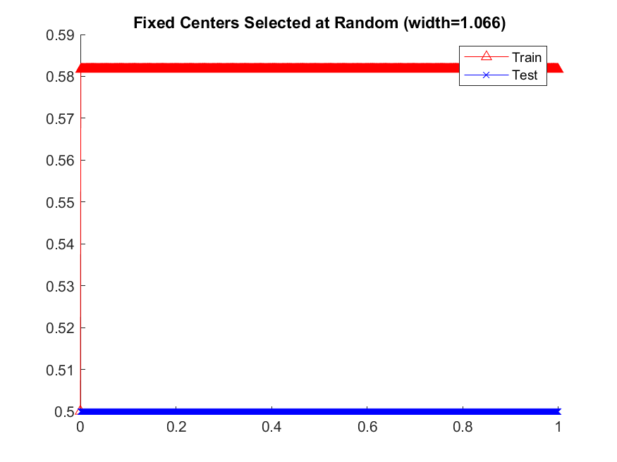

Figure 7. Width fixed at appropriate size

The sigma of fixed centers can be found by:

Based on Figure 7, we can see that the individual RBFs have bad performance as it is too peaked, which suggests that the center points are redundant and M should have a smaller value.

|  |  |
| --- | --- |
| C:\Users\eleojjz\Documents\Masters\EE5904_Neural_Networks\EE5904\Homework3\q2_img\q2b_lambda_0.100.png | C:\Users\eleojjz\Documents\Masters\EE5904_Neural_Networks\EE5904\Homework3\q2_img\q2b_lambda_1.000.png |
| C:\Users\eleojjz\Documents\Masters\EE5904_Neural_Networks\EE5904\Homework3\q2_img\q2b_lambda_10.000.png | C:\Users\eleojjz\Documents\Masters\EE5904_Neural_Networks\EE5904\Homework3\q2_img\q2b_lambda_100.000.png |
| C:\Users\eleojjz\Documents\Masters\EE5904_Neural_Networks\EE5904\Homework3\q2_img\q2b_lambda_1000.000.png | C:\Users\eleojjz\Documents\Masters\EE5904_Neural_Networks\EE5904\Homework3\q2_img\q2b_lambda_10000.000.png |

Figure 8. Fixed Centers Selected at Random with varying widths

Observing Figure 8, we can see that widths of 0.1 and 1 produces similar results to Figure 7, suggesting that the RBFs are too peaked while widths of 100, 1000 and 10000 are a little flat producing relatively poorer performances as compared to width 10. In this setting, the width of 10 seems to produce the best results with highest accuracy.

## 2c. K-Mean Clustering

|  |  |
| --- | --- |
| C:\Users\eleojjz\Documents\Masters\EE5904_Neural_Networks\EE5904\Homework3\q2_img\q2c_lambda_0.0001.png | C:\Users\eleojjz\Documents\Masters\EE5904_Neural_Networks\EE5904\Homework3\q2_img\q2c_lambda_0.0010.png |
| C:\Users\eleojjz\Documents\Masters\EE5904_Neural_Networks\EE5904\Homework3\q2_img\q2c_lambda_0.0100.png | C:\Users\eleojjz\Documents\Masters\EE5904_Neural_Networks\EE5904\Homework3\q2_img\q2c_lambda_0.1000.png |
| C:\Users\eleojjz\Documents\Masters\EE5904_Neural_Networks\EE5904\Homework3\q2_img\q2c_lambda_1.0000.png | C:\Users\eleojjz\Documents\Masters\EE5904_Neural_Networks\EE5904\Homework3\q2_img\q2c_lambda_10.0000.png |
| C:\Users\eleojjz\Documents\Masters\EE5904_Neural_Networks\EE5904\Homework3\q2_img\q2c_lambda_100.0000.png | C:\Users\eleojjz\Documents\Masters\EE5904_Neural_Networks\EE5904\Homework3\q2_img\q2c_lambda_1000.0000.png |

Figure 9. K-mean Clustering with varying regularization factors

As shown in Figure 9, different regularization factors were attempted to achieve a better result to no avail. However, it seems like the best accuracy would be when lambda is 1.

|  |  |
| --- | --- |
| C:\Users\eleojjz\Documents\Masters\EE5904_Neural_Networks\EE5904\Homework3\q2_img\q2c_k_centers.png  Figure 10. Visualization of K-mean centers | C:\Users\eleojjz\Documents\Masters\EE5904_Neural_Networks\EE5904\Homework3\q2_img\q2c_mean_imgs.png  Figure 11. Visualization of Mean of training images |

Comparing Figure 10 (Obtained Centers) and Figure 11 (Mean training images), we can see both images resembles the letters ‘K’ and ‘R’. However, it is interesting to note that the obtained center for letter ‘K’ has an additional faded line demarcated in Figure 10 by a red box. This additional line causes the letter ‘K’ to become somewhat similar to the letter ‘R’ as well, resulting in an inaccurate performance of the RBFN and K-means centers.

# Q3. Self-Organizing Map

## 3a. SOM mapping to 1D output layer to ‘sinusoid curve’

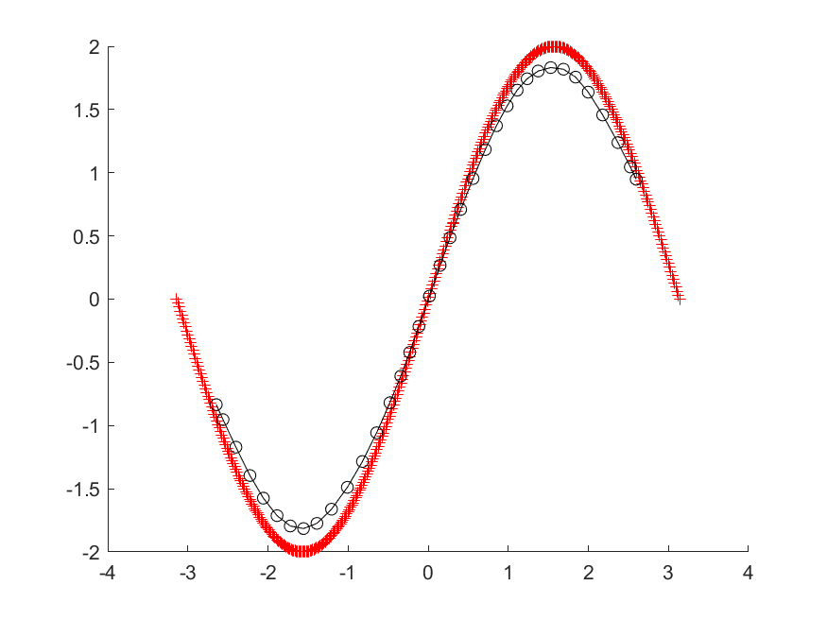

Figure 12. Visualization of SOM neurons trained by sinusoid curve

## 3b. SOM mapping to 2D output layer to ‘circle’

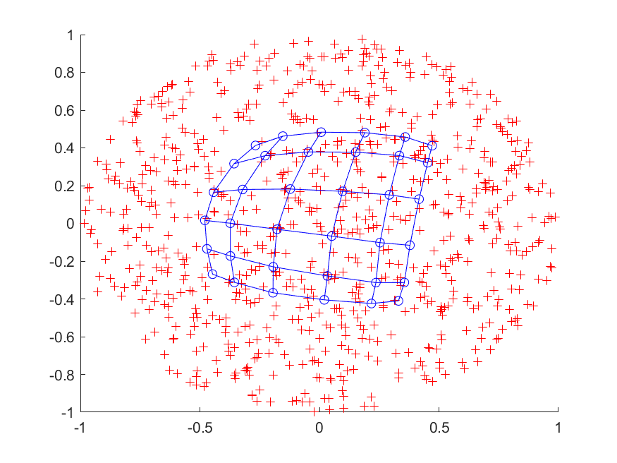

Figure 13. Visualization of SOM neurons trained by 'circle' data

## 3c. SOM that cluster and classifies handwritten characters

### c-1)

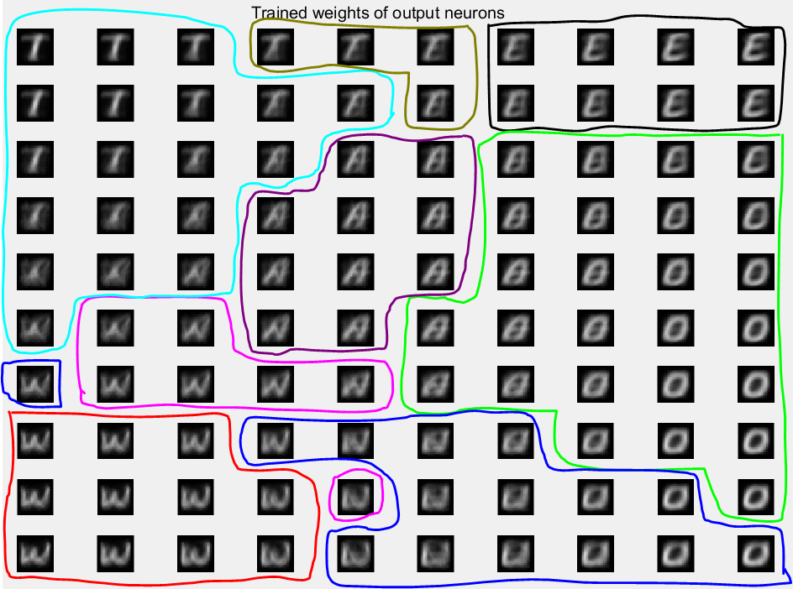

Figure 14. Corresponding Semantic Map of trained SOM

|  |  |  |  |  |  |  |  |  |
| --- | --- | --- | --- | --- | --- | --- | --- | --- |
| Label(Char) | 0 (N) | 1 (E) | 2 (U) | 4 (A) | 5 (L) | 6 (T) | 7 (W) | 8 (O) |
| Color | pink | black | blue | purple | cyan | olive | red | green |

As shown in Figure 14, the trained SOM forms a semantic map where the similar samples belonging to the same label are mapped close together and dissimilar ones apart. For example, we can see the letters ‘U’ and ‘W’ are mapped close together as they both have a downwards curve. However, the letters ‘W’ and ‘E’ are mapped far apart are they do not have much similarities. In addition, neurons that are near the bounders drawn in Figure 14 tend to be ambiguous, containing multiple letters overlapped against each other.

### c-2)

C:\Users\eleojjz\Documents\Masters\EE5904_Neural_Networks\EE5904\Homework3\q3_img\q3c2.png

Figure 15. Classification accuracy on test set

The classification accuracy on the test set is relatively low. This could be because the recommended iteration is set to 1000. However, the total number of training points are 2400. Since at each iteration, we would update the weights based on only 1 training point, there would be another 1400 sample points (or even more considering how the points are sampled). As a result, depending on the sample points, the output neurons would be skewed towards the label that has been chosen at random more.

This can be shown in Figure 14, where there are only 4 neurons that labelled 6 (‘T’) while there are 26 neurons that are labelled as 8 (‘O’). This would suggest that when classifying test images, it would be more likely that the trained SOM would classify the letter ‘O’ correctly while letter ‘T’ incorrectly.

There are 2 possible methods to minimize this issue:

1. Ensure that all labels are being sampled uniformly when updating the weights.
2. Increase the number of iterations to allow uniform distribution of sampled labels.

# Appendix

## **Q1a**

clc

clear

close all

%for reproducibility

rng(3);

% train data

train\_x = -1:0.05:1;

train\_y = 1.2\*sin(pi\*train\_x) - cos(2.4\*pi\*train\_x) + 0.3\*randn(1, size(train\_x, 2));

% test data

test\_x = -1:0.01:1;

test\_y = 1.2\*sin(pi\*test\_x) - cos(2.4\*pi\*test\_x);

% exact interpolation on train

% no need to square or sqrt since x has only 1 value

r = abs(train\_x'-train\_x);

% gaussian rbf

phi = exp( (r.^2) / (-2\*((0.1)^2)) );

w = phi \ train\_y';

%predict y

r\_test = abs(test\_x' - train\_x);

phi = exp( (r\_test.^2) / (-2\*((0.1)^2)) );

y\_predict = (phi\*w)';

fig = figure();

hold on

plot(train\_x,train\_y,'ok')

plot(test\_x,y\_predict, 'r')

plot(test\_x,test\_y, 'b')

legend('Train points (with noise)','RBFN','Expected', 'Location', 'Best')

title('Exact Interpolation')

saveas(fig, 'q1a.png')

hold off

%MSE of test

mse\_test = sum((y\_predict-test\_y).^2)/size(y\_predict, 2);

fprintf('Mean Square Error on test: %f\n', mse\_test);

## **Q1b**

clc

clear

close all

%for reproducibility

rng(3);

% train data

train\_x = -1:0.05:1;

train\_y = 1.2\*sin(pi\*train\_x) - cos(2.4\*pi\*train\_x) + 0.3\*randn(1, size(train\_x, 2));

% test data

test\_x = -1:0.01:1;

test\_y = 1.2\*sin(pi\*test\_x) - cos(2.4\*pi\*test\_x);

% randomly select 20 centers

m = 20;

center\_idx = randperm(size(train\_x, 2));

mew\_x = train\_x(center\_idx(1:m));

mew\_y = train\_y(center\_idx(1:m));

% no need to square or sqrt since x has only 1 value

r = abs(train\_x'-mew\_x);

dist\_cen = abs(mew\_x'-mew\_x);

% maximum dist between chosen centers

dmax = max(dist\_cen, [], 'all');

% rbf

phi = exp( -(m/dmax^2) \* r.^2 );

w = phi \ train\_y';

%predict y

r\_test = abs(test\_x' - mew\_x);

% rbf

phi = exp( -(m/dmax^2) \* r\_test.^2 );

y\_predict = (phi\*w)';

fig = figure();

hold on

plot(mew\_x,mew\_y,'ok')

plot(test\_x,y\_predict, 'r')

plot(test\_x,test\_y, 'b')

legend('Train points (with noise)','RBFN','Expected', 'Location', 'Best')

title('Fixed Centres Selected at Random')

saveas(fig, 'q1b.png')

hold off

%MSE of test

mse\_test = sum((y\_predict-test\_y).^2)/size(y\_predict, 2);

fprintf('Mean Square Error on test: %f\n', mse\_test);

## **Q1c**

clc

clear

close all

%for reproducibility

rng(3);

% train data

train\_x = -1:0.05:1;

train\_y = 1.2\*sin(pi\*train\_x) - cos(2.4\*pi\*train\_x) + 0.3\*randn(1, size(train\_x, 2));

% test data

test\_x = -1:0.01:1;

test\_y = 1.2\*sin(pi\*test\_x) - cos(2.4\*pi\*test\_x);

r\_factors = [0, 0.001, 0.01, 0.1, 1, 10, 100];

for i = r\_factors

% exact interpolation on train

% no need to square or sqrt since x has only 1 value

lambda = i;

r = abs(train\_x'-train\_x);

% gaussian rbf

phi = exp( (r.^2) / (-2\*((0.1)^2)) );

% applying regularization method to determine new weights

w = pinv((phi'\*phi) + lambda\*eye(size(phi, 2))) \* (phi'\*train\_y');

%predict y

r\_test = abs(test\_x' - train\_x);

phi = exp( (r\_test.^2) / (-2\*((0.1)^2)) );

y\_predict = (phi\*w)';

fig = figure();

hold on

plot(train\_x,train\_y,'ok')

plot(test\_x,y\_predict, 'r')

plot(test\_x,test\_y, 'b')

legend('Train points (with noise)','RBFN','Expected', 'Location', 'Best')

title(sprintf('Exact Interpolation (lambda=%.3f)', i))

saveas(fig, sprintf('q1c\_%.3f.png', i))

hold off

%MSE of test

mse\_test = sum((y\_predict-test\_y).^2)/size(y\_predict, 2);

fprintf('Mean Square Error on test (lambda = %0.3f): %f\n', i, mse\_test);

end

## **Q2a**

clc

clear

close all

% Matric A0138993L

% Classes chosen: 9 and 3

load('characters10.mat');

train\_idx = find(train\_label == 3 | train\_label == 9);

% 9 --> 1 and 3 --> 0

TrLabel = train\_label(train\_idx);

TrLabel(TrLabel == 9) = 1;

TrLabel(TrLabel == 3) = 0;

train\_x = train\_data(train\_idx, :);

% normalizing train data

train\_x = mat2gray(train\_x(:,:));

test\_idx = find(test\_label == 3 | test\_label == 9);

TeLabel = test\_label(test\_idx);

TeLabel(TeLabel == 9) = 1;

TeLabel(TeLabel == 3) = 0;

test\_x = test\_data(test\_idx, :);

% normalizing test data

test\_x = mat2gray(test\_x(:,:));

r\_factors = [0, 0.0001, 0.001, 0.01, 0.1, 1, 10, 100];

sd= 100;

for i = r\_factors

% exact interpolation on train

lambda = i;

r\_train = pdist2(train\_x, train\_x, 'squaredeuclidean');

% gaussian rbf

phi = exp( r\_train / (-2\*((sd)^2)) );

% applying regularization method to determine new weights

if (i == 0)

w = phi \ TrLabel;

else

w = ((phi'\*phi) + lambda\*eye(size(phi, 2))) \ (phi'\*TrLabel);

end

% TrPred

TrPred = (phi\*w)';

%TePred

r\_test = pdist2(test\_x, train\_x, 'squaredeuclidean');

%gaussian rbf

phi = exp( r\_test / (-2\*((sd)^2)) );

TePred = (phi\*w)';

fig = figure();

TrAcc = zeros(1,1000);

TeAcc = zeros(1,1000);

thr = zeros(1,1000);

TrN = length(TrLabel);

TeN = length(TeLabel);

for j = 1:1000

t = (max(TrPred)-min(TrPred)) \* (j-1)/1000 + min(TrPred);

thr(j) = t;

TrAcc(j) = (sum(TrLabel(TrPred<t)==0) + sum(TrLabel(TrPred>=t)==1)) / TrN;

TeAcc(j) = (sum(TeLabel(TePred<t)==0) + sum(TeLabel(TePred>=t)==1)) / TeN;

end

hold on

plot(thr, TrAcc, '-^r');

plot(thr, TeAcc, '-xb');

legend('Train','Test');

title(sprintf('Exact Interpolation (lambda=%.4f)', i))

saveas(fig,sprintf('q2a\_lambda\_%.4f.png',i))

hold off

end

## **Q2b**

clc

clear

close all

% Matric A0138993L

% Classes chosen: 9 and 3

load('characters10.mat');

%imshow(reshape(train\_data(2997,:), [28,28]));

train\_idx = find(train\_label == 3 | train\_label == 9);

% 9 --> 1 and 3 --> 0

TrLabel = train\_label(train\_idx);

TrLabel(TrLabel == 9) = 1;

TrLabel(TrLabel == 3) = 0;

train\_x = train\_data(train\_idx, :);

% normalizing train data

train\_x = mat2gray(train\_x(:,:));

test\_idx = find(test\_label == 3 | test\_label == 9);

TeLabel = test\_label(test\_idx);

TeLabel(TeLabel == 9) = 1;

TeLabel(TeLabel == 3) = 0;

test\_x = test\_data(test\_idx, :);

% normalizing test data

test\_x = mat2gray(test\_x(:,:));

% randomly select 100 centers

m = 100;

% seed for reproducibility

rng(3)

center\_idx = randperm(size(train\_x, 1));

selected\_train\_x = train\_x(center\_idx(1:m), :);

selected\_TrLabel = TrLabel(center\_idx(1:m), :);

r\_train = pdist2(train\_x, selected\_train\_x, 'squaredeuclidean');

dist\_cen = pdist2(selected\_train\_x, selected\_train\_x, 'squaredeuclidean');

dmax\_squared = max(dist\_cen, [], 'all');

sigma = sqrt(dmax\_squared/(2\*m));

vary\_width = [sigma, 0.1, 1, 10, 100, 1000, 10000];

for i = vary\_width

width = i;

phi = exp( -(r\_train / (2\*(width^2))) );

w = phi \ TrLabel;

%TrPred

TrPred = (phi\*w);

%TePred

r\_test = pdist2(test\_x, selected\_train\_x, 'squaredeuclidean');

phi = exp ( -(r\_test / (2\*(width^2))) );

TePred = (phi\*w);

fig = figure();

TrAcc = zeros(1,1000);

TeAcc = zeros(1,1000);

thr = zeros(1,1000);

TrN = length(TrLabel);

TeN = length(TeLabel);

for j = 1:1000

t = (max(TrPred)-min(TrPred)) \* (j-1)/1000 + min(TrPred);

thr(j) = t;

TrAcc(j) = (sum(TrLabel(TrPred<t)==0) + sum(TrLabel(TrPred>=t)==1)) / TrN;

TeAcc(j) = (sum(TeLabel(TePred<t)==0) + sum(TeLabel(TePred>=t)==1)) / TeN;

end

hold on

plot(thr, TrAcc, '-^r');

plot(thr, TeAcc, '-xb');

legend('Train','Test');

title(sprintf('Fixed Centers Selected at Random (width=%.3f)', i))

saveas(fig,sprintf('q2b\_lambda\_%.3f.png',i))

hold off

end

## **Q2c**

clc

clear

close all

% Matric A0138993L

% Classes chosen: 9 and 3

load('characters10.mat');

train\_idx = find(train\_label == 3 | train\_label == 9);

% 9(K) --> 1 and 3(R) --> 0

TrLabel = train\_label(train\_idx);

TrLabel(TrLabel == 9) = 1;

TrLabel(TrLabel == 3) = 0;

train\_x = train\_data(train\_idx, :);

% normalizing train data

train\_x = mat2gray(train\_x(:,:));

test\_idx = find(test\_label == 3 | test\_label == 9);

TeLabel = test\_label(test\_idx);

TeLabel(TeLabel == 9) = 1;

TeLabel(TeLabel == 3) = 0;

test\_x = test\_data(test\_idx, :);

% normalizing test data

test\_x = mat2gray(test\_x(:,:));

rng(3);

k = 2;

center\_idx = randperm(size(train\_x, 1));

curr\_cen = train\_x(center\_idx(1:k), :);

old\_cen = zeros(size(curr\_cen));

%K means clustering

while ~isequal(curr\_cen, old\_cen)

old\_cen = curr\_cen;

% assignment

distance = pdist2(old\_cen, train\_x);

[~, label] = min(distance, [], 1);

% updating

curr\_cen(1,:) = mean(train\_x(label==1, :), 1);

curr\_cen(2,:) = mean(train\_x(label==2, :), 1);

end

%obtained centers

fig = figure();

sgtitle('Obtained centers');

subplot(121);

imshow(reshape(curr\_cen(1,:), [28,28]));

subplot(122);

imshow(reshape(curr\_cen(2,:), [28,28]));

saveas(fig, 'q2c\_k\_centers.png');

%mean of training image

fig = figure();

sgtitle('Mean of training images');

subplot(121);

imshow(reshape(mean(train\_x(TrLabel==1, :), 1), [28,28]));

subplot(122);

imshow(reshape(mean(train\_x(TrLabel==0, :), 1), [28,28]));

saveas(fig, 'q2c\_mean\_imgs.png');

%training

r\_factors = [0.0001, 0.001, 0.01, 0.1, 1, 10, 100, 1000];

sigma = 100;

for i=r\_factors

lambda = i;

r\_train = pdist2(train\_x, curr\_cen, 'squaredeuclidean');

phi = exp( r\_train / (-2\*((sigma)^2)) );

w = ((phi'\*phi) + lambda\*eye(size(phi, 2))) \ (phi'\*TrLabel);

%TrPred

TrPred = (phi\*w)';

%TePred

r\_test = pdist2(test\_x, curr\_cen, 'squaredeuclidean');

%gaussian rbf

phi = exp( r\_test / (-2\*((sigma)^2)) );

TePred = (phi\*w)';

fig = figure();

TrAcc = zeros(1,1000);

TeAcc = zeros(1,1000);

thr = zeros(1,1000);

TrN = length(TrLabel);

TeN = length(TeLabel);

for j = 1:1000

t = (max(TrPred)-min(TrPred)) \* (j-1)/1000 + min(TrPred);

thr(j) = t;

TrAcc(j) = (sum(TrLabel(TrPred<t)==0) + sum(TrLabel(TrPred>=t)==1)) / TrN;

TeAcc(j) = (sum(TeLabel(TePred<t)==0) + sum(TeLabel(TePred>=t)==1)) / TeN;

end

hold on

plot(thr, TrAcc, '-^r');

plot(thr, TeAcc, '-xb');

legend('Train','Test');

title(sprintf('K-Means Clustering (lambda=%.4f)', i))

saveas(fig,sprintf('q2c\_lambda\_%.4f.png',i))

hold off

end

## **Q3a**

clc

clear

close all

%training points sampled from sine curve

x = linspace(-pi, pi, 400);

train\_x = [x; 2\*sin(x)]; %2x400 matrix

%SOM

T = 600;

N = 1;

M = 36;

lr0 = 0.1;

sigma0 = sqrt(M^2\*N^2) / 2;

tau = T / log(sigma0);

weights = rand(2, 36);

for n = 1:T

lr = lr0\*exp(-n/T);

sigma = sigma0\*exp(-n/tau);

%sample input vector

i = randperm(400, 1);

%determine winner

distance = sum((train\_x(:,i) - weights).^2,1);

[~, winner] = min(distance, [], 2);

neuron\_position = (1:36);

d = abs(neuron\_position - winner);

h = exp(-d.^2/(2\*sigma^2));

% Update

weights = weights + lr\*h.\*(train\_x(:,i) - weights);

end

fig = figure();

hold on

plot(train\_x(1,:), train\_x(2,:), '+r');

plot(weights(1,:), weights(2,:), '-ok');

hold off

saveas(fig, 'q3a.png');

## **Q3b**

clc

clear

close all

rng(43)

X = randn(800,2);

s2 = sum(X.^2,2);

train\_x = (X.\*repmat(1\*(gammainc(s2/2,1).^(1/2))./sqrt(s2),1,2))';

%SOM

T = 600;

lr0 = 0.1;

sigma0 = sqrt(6^2\*6^2) / 2;

tau = T / log(sigma0);

weights = rand(2, 6, 6);

for n = 1:T

lr = lr0\*exp(-n/T);

sigma = sigma0\*exp(-n/tau);

%sample input vector

i = randperm(800, 1);

%determine winner

distance = squeeze(sum((train\_x(:,i) - weights).^2,1))';

[~,winner] = min(distance,[],'all','linear');

[col, row] = ind2sub(size(distance), winner);

%get time-carying neighborhood function

neuron\_position = (1:6);

d\_j = (neuron\_position - col).^2;

d\_i = (neuron\_position - row).^2;

dji = d\_j' + d\_i;

h = exp(-dji./(2\*sigma^2));

% Update

h = permute(repmat(h,[1,1,2]),[3 2 1]);

weights = weights + lr\*h.\*(train\_x(:,i) - weights);

end

fig = figure();

hold on

plot(train\_x(1,:), train\_x(2,:), '+r');

weights\_1 = squeeze(weights(1, :, :));

weights\_2 = squeeze(weights(2, :, :));

for i = 1:6

plot(weights\_1(i,:), weights\_2(i,:), 'bo-');

plot(weights\_1(:,i), weights\_2(:,i), 'bo-');

end

hold off

saveas(fig, 'q3b.png');

## **Q3c1**

clc

clear

close all

% Matric A0138993L

% Classes chosen: 9 and 3

load('characters10.mat');

% set seed for reproducibility

rng(234);

train\_idx = find(train\_label ~= 3 & train\_label ~= 9);

TrLabel = train\_label(train\_idx);

train\_x = train\_data(train\_idx, :);

% normalizing train data

train\_x = mat2gray(train\_x(:,:))';

T = 1000;

lr0 = 0.1;

sigma0 = sqrt(10^2\*10^2) / 2;

tau = T / log(sigma0);

weights = rand(784, 10, 10);

for n = 1:T

lr = lr0\*exp(-n/T);

sigma = sigma0\*exp(-n/tau);

%sample input vector

i = randperm(2400, 1);

%determine winner

distance = squeeze(sum((train\_x(:,i) - weights).^2,1))';

[~,winner] = min(distance,[],'all','linear');

[col, row] = ind2sub(size(distance), winner);

%get time-carying neighborhood function

neuron\_position = (1:10);

d\_j = (neuron\_position - col).^2;

d\_i = (neuron\_position - row).^2;

dji = d\_j' + d\_i;

h = exp(-dji./(2\*sigma^2));

% Update

h = permute(repmat(h,[1,1,784]),[3 2 1]);

weights = weights + lr\*h.\*(train\_x(:,i) - weights);

end

fig = figure();

fig.Position = [100 100 1200 800];

sgtitle('Trained weights of output neurons');

marked\_neuron = zeros(10);

for i = 1:size(weights, 2)

for j = 1:size(weights, 3)

distance = squeeze(sum((train\_x(:,:)-weights(:,i,j)).^2, 1))';

[~, win\_idx] = min(distance, [], 'all', 'linear');

winner\_label = TrLabel(win\_idx);

marked\_neuron(i, j) = winner\_label;

subplot(10,10, ((i-1)\*10+j));

imshow(reshape(weights(:,i,j), 28, 28));

end

end

saveas(fig, 'q3c1.png');

## **Q3c2**

clc

clear

close all

% Matric A0138993L

% Classes not chosen: 9 and 3

load('characters10.mat');

%set seed for reproducibility

rng(234);

train\_idx = find(train\_label ~= 3 & train\_label ~= 9);

TrLabel = train\_label(train\_idx);

train\_x = train\_data(train\_idx, :);

% normalizing train data

train\_x = mat2gray(train\_x(:,:))';

test\_idx = find(test\_label ~= 3 & test\_label ~= 9);

TeLabel = test\_label(test\_idx);

test\_x = test\_data(test\_idx, :);

% normalizing test data

test\_x = mat2gray(test\_x(:,:))';

T = 1000;

lr0 = 0.1;

sigma0 = sqrt(10^2\*10^2) / 2;

tau = T / log(sigma0);

weights = rand(784, 10, 10);

for n = 1:T

lr = lr0\*exp(-n/T);

sigma = sigma0\*exp(-n/tau);

%sample input vector

i = randperm(2400, 1);

%determine winner

distance = squeeze(sum((train\_x(:,i) - weights).^2,1))';

[~,winner] = min(distance,[],'all','linear');

[col, row] = ind2sub(size(distance), winner);

%get time-carying neighborhood function

neuron\_position = (1:10);

d\_j = (neuron\_position - col).^2;

d\_i = (neuron\_position - row).^2;

dji = d\_j' + d\_i;

h = exp(-dji./(2\*sigma^2));

% Update

h = permute(repmat(h,[1,1,784]),[3 2 1]);

weights = weights + lr\*h.\*(train\_x(:,i) - weights);

end

marked\_neuron = zeros(10);

for i = 1:size(weights, 2)

for j = 1:size(weights, 3)

distance = squeeze(sum((train\_x(:,:)-weights(:,i,j)).^2, 1))';

[~, win\_idx] = min(distance, [], 'all', 'linear');

winner\_label = TrLabel(win\_idx);

marked\_neuron(i, j) = winner\_label;

end

end

TePred = zeros(size(TeLabel, 1), 1);

for i = 1:size(test\_x, 2)

distance = squeeze(sum((test\_x(:,i)-weights).^2, 1))';

[~, win\_idx] = min(distance, [], 'all', 'linear');

[col, row] = ind2sub(size(distance), win\_idx);

TePred(i, 1) = marked\_neuron(row, col);

end

TeAcc = sum(TePred == TeLabel)/size(test\_x, 2);

fprintf('Classification accuracy on test set: %.4f\n', TeAcc);