**Documentation**

**Step 1: Upload**

Upload these files/folders on google drive :

* Updated_Manga_Pages_Bubble_OCR.ipynb
* yolov8_trained.pt

You don’t need to upload other files.

**Step 2: Setup**

1. Open Updated_Manga_Pages_Bubble_OCR.ipynb from drive by clicking on it and it will open into google collab directly.
2. Connect the environment
3. Mount drive by clicking on mount icon on this page :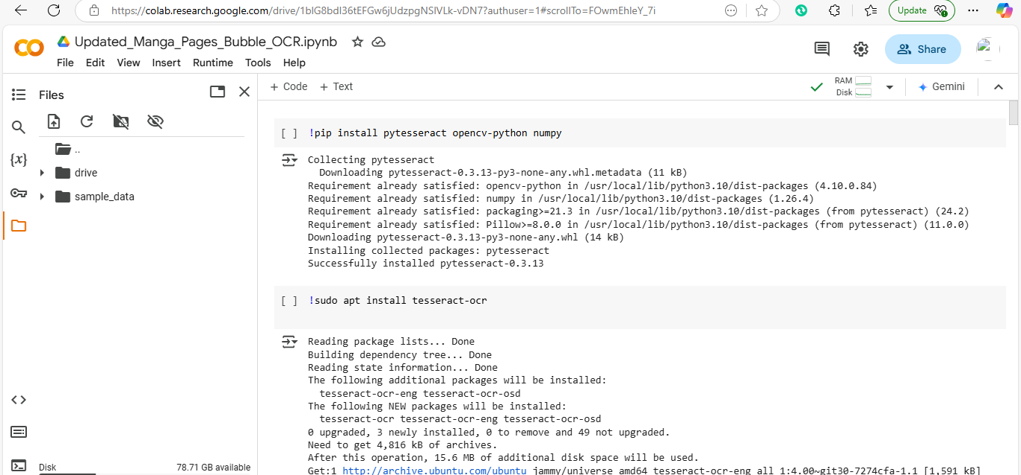

1. Upload image which you want to test by clicking here 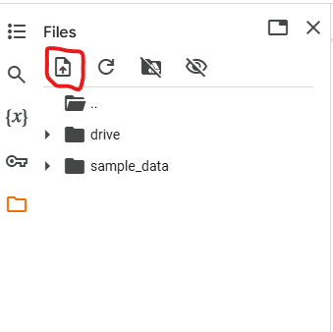

**Step 3: Run all the code**

Run all the code cell by cell or use this option to run all cells directly

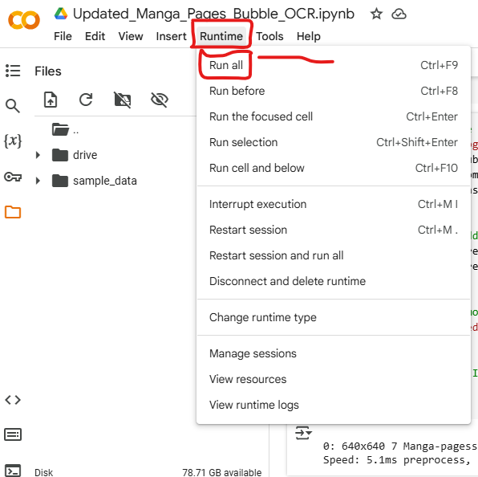

**Step 4: Output**

You will get these results by running the code:

* detected_bubble.jpg
* translated_image.jpg

