


Construction Project Management Applied on
– Smart Medical UniVerse
( Communication Department )

By:
Saad Tamer Saad Ahmed | Eman karam salama
Mahmoud Khalid Alkodousy | Nada Abdelmoniem Saad ElSalawy
Mostafa Abdelmohsen Sallam | Hasnaa Mohamed kotb Elshandidy
Ebrahim Shawky Allam | Mona Abdelwahed Attia Abdelwahed
Mahmoud Farid Mustafa | Alzahraa Nasser Aman Ebrahim
Muhammed Yehya ElSherbiny

A Graduation Project Document Submitted in Partial Fulfillment of
the Requirements for the B.Sc. Degree in Communication Engineering

Under Supervision:
Assoc. Prof. Hany El-Ghaish

High Institute of Engineering and Technology
Tanta, Egypt
2026

Abstract

MediVerse is a comprehensive, AI-powered Hospital Management System designed to modernize and streamline the operations of healthcare facilities. The platform addresses the fundamental challenges faced by traditional hospitals — including manual paper-based workflows, unmanaged patient queues, inadequate coordination between departments, and the lack of intelligent clinical decision support tools.

At its core, MediVerse integrates multiple intelligent modules into a unified digital ecosystem. Patients interact with the system through a Flutter-based mobile application that supports Face Recognition login for passwordless, secure biometric authentication. An AI-powered Symptom Assessment Chatbot, built on a Retrieval-Augmented Generation (RAG) architecture powered by SentenceTransformers and a curated medical knowledge base, enables patients to describe their symptoms and receive intelligent triage guidance, severity assessments, and first-aid recommendations before they even see a doctor.

The Smart Pharmacy Module brings pharmaceutical intelligence to the system:-
pharmacists can scan handwritten prescriptions using Vision LLM-based OCR, perform instant drug interaction checks across a proprietary Egyptian drug database, identify patient allergies, and suggest safe therapeutic alternatives. The system also features AI-powered Medical Image Analysis using the Qwen2.5-VL vision model to support preliminary interpretation of X-rays, MRI scans, and CT images.

The backend is built on FastAPI (Python), connected to a Microsoft SQL Server database, with role-based access control enforced via JWT authentication for patients, doctors, and managers. The React-based web dashboard provides doctors, pharmacists, and hospital administrators with real-time queue management, appointment scheduling, patient consultation history, and system-wide analytics.

MediVerse demonstrates how modern AI technologies — including LLMs, computer vision, biometric authentication, and semantic search — can be orchestrated into a practical, deployable healthcare platform that meaningfully reduces administrative burden, improves patient experience, and enhances clinical safety.

Dedication

With boundless love and gratitude, we dedicate this project to our beloved parents, whose unwavering support and encouragement have sustained us throughout this journey. Their faith and constant motivation have strengthened our resolve to complete this endeavor.

To our wonderful brothers and sisters, who have been an endless source of inspiration and encouragement, we owe them a deep sense of gratitude for instilling in us a passion for excellence and a constant drive to strive for excellence.

We also acknowledge the grace of God, who has paved our path to success and guided us every step of the way. We humbly thank Him for His guidance and everlasting mercy.

To our dear friends, allies, and competitors, who have pushed us to excel and encouraged us to unleash our creativity, we extend our sincere thanks.
Your companionship and camaraderie have made this journey more enriching. To our esteemed teachers and mentors, whose knowledge and wisdom have enriched our minds and honed our abilities, we extend our deepest appreciation. Your dedication to teaching and your commitment to our academic growth have profoundly shaped our journey.

As we present this project to the world, we do so with the hope that it will exceed expectations and be a testament to years of dedication and hard work. May it be a testament to our ambitions and a source of pride for everyone who has supported us along the way.

Acknowledgment

We would like to express our sincere gratitude and deep appreciation to our supervisor, Assoc. Prof. Hany El-Ghaish, for his continuous support, valuable guidance, and insightful feedback throughout all stages of this project.

His academic expertise, professional experience, and constructive advice played a vital role in shaping and improving the quality of this work. Without his supervision, encouragement, and constant follow-up, the successful completion of this project would not have been possible. We could not have asked for a better supervisor to guide us through our academic journey.

We would also like to extend our sincere appreciation to the High Institute of Engineering and Technology, Tanta, Egypt, for providing a supportive academic environment and the necessary resources that contributed significantly to the completion of this project.

We are grateful to the faculty members and staff for their dedication and efforts in supporting our academic and professional development.

Table of Contents

Chapter 1 — Introduction & System Overview
1.1 Background & Motivation 9
1.2 Problem Statement 10
1.3 Project Objectives 11
1.4 Scope of the Project 12
1.5 System Architecture Overview 13
1.6 Report Structure 14

Chapter 2 — Literature Review & Related Work
2.1 Hospital Management Systems (HIS) — Overview 15
2.2 AI in Healthcare — State of the Art 16
2.3 Face Recognition in Healthcare 17
2.4 Medical Image Analysis with Vision AI 18
2.5 Drug Interaction & Pharmacy Intelligence Systems 19
2.6 Queue Management Systems 20
2.7 Comparison Table — Related Systems vs. MediVerse 21
2.8 Research Gap & MediVerse Contribution 22

Chapter 3 — System Requirements & Design
3.1 Stakeholders Analysis 23
3.2 Functional Requirements 24
3.3 Non-Functional Requirements 24
3.4 Use Case Diagram 26
3.5 System Architecture Diagram (Detailed) 28
3.6 Technology Stack Justification 29
3.7 Database Design Overview 30
3.8 API Design Principles 30
3.9 Security Design 31
3.10 High-Fidelity UI Design 33
3.11 Responsive Design 34
3.12 Accessibility and Usability 35

Chapter 4 — Database Design & Implementation
4.1 Database Technology Choice — MS SQL Server 36
4.2 Entity-Relationship Diagram 37
4.3 Core Tables — Patients & Doctors 38
4.4 Medical Records Tables 40
4.5 AI Knowledge Base Tables 42
4.6 Operational Tables 44
4.7 egypt_drugs Database — The Pharmacy Knowledge Base 45
4.7 Database Connection & Pool Management 46

Chapter 5 — Backend API Development (FastAPI)
5.1 FastAPI Architecture Overview 48
5.2 Authentication Module 49
5.3 Patient Module 50
5.4 Doctor Module 51
5.5 Appointment & Queue Module 52
5.6 Manager Module 53
5.7 Medical Files Module 54
5.8 Middleware & Cross-Cutting Concerns 55
5.9 Pydantic Models & Data Validation 56
5.10 Error Handling Strategy 57
5.11 Configuration Management 58

Chapter 6 — AI Chatbot & RAG System (Emergency Triage)
6.1 Chatbot System Overview 59
6.2 RAG (Retrieval-Augmented Generation) Architecture 60
6.3 The symptoms_knowledge_base — Data Collection Deep Dive 61
6.4 symptoms_knowledge_base — Data Examples 62
6.5 RAGService Implementation 64
6.6 LLM Integration via OpenRouter 65
6.7 The Medical System Prompt — Design Decisions 66
6.8 Patient Context Integration 67
6.9 RAG + LLM Fusion Strategy 67
6.10 Structured Response Parsing 68
6.11 Severity Assessment System 70
6.12 Consultation Persistence 71
6.13 Retry Logic & Reliability 72
6.14 Input Validation Guard 73

Chapter 7 — Smart Pharmacy Module
7.1 Pharmacy Module Overview 75
7.2 egypt_drugs Database — Sourcing & Collection 76
7.3 Drug Recommendation Engine 77
7.4 Drug Embeddings — Vector Search 78
7.5 Prescription OCR — Anchor-Based Approach 79
7.6 Drug Interaction Analysis 80
7.7 Allergy-Safe Prescribing 81
7.8 Alternative Drug Suggestions 82
7.9 Patient-Aware Drug Recommendations 83
7.10 Pharmacy API Endpoints 84
7.11 Module Summary 85

Chapter 8 — Face Recognition & Biometric Authentication
8.1 Face Recognition Module Overview 86
8.2 AuraFace Model 86
8.3 Face Enrollment Process 88
8.4 Face Matching / Authentication 89
8.5 Security Measures 90
8.6 Image Processing Pipeline 92
8.7 Face Recognition Performance 93

Chapter 9 — Frontend Development (React Web + Flutter Mobile)
9.1 Frontend Architecture Overview 95
9.2 React Web — Project Structure 96
9.3 React Web — Patient Portal 98
9.4 React Web — Doctor Dashboard 100
9.5 React Web — Manager Dashboard 101
9.6 React Web — Pharmacy Interface 102
9.7 Flutter Mobile App — Overview 103
9.8 Flutter Mobile — Login Screen 104
9.9 Flutter Mobile — Tracking Screen 105
9.10 UI/UX Design Decisions 106

Chapter 10 — Testing, Deployment & Future Work
10.1 Testing Strategy Overview 108
10.2 Backend Testing 108
10.3 AI Component Testing 109
10.4 System Integration Testing 111
10.5 Deployment Architecture 112
10.6 System Limitations 114
10.7 Future Work & Enhancements 115
10.8 Conclusion 117

List of Figures

Figure 1.1 — MediVerse System Architecture Overview 8
Figure 3.1 — Use Case Diagram 19
Figure 3.2 — System Architecture Diagram (Detailed) 20
Figure 3.3 — JWT Authentication Flow 23
Figure 4.1 — Entity-Relationship Diagram (13 Tables) 26
Figure 6.1 — RAG Pipeline Architecture 44
Figure 6.2 — Chatbot Response Flow Diagram 45
Figure 8.1 — Face Enrollment & Authentication Pipeline 70

List of Tables

Table 2.1 — Related Systems Comparison 15
Table 3.1 — Functional Requirements (FR-01 → FR-25) 17
Table 3.2 — Non-Functional Requirements 18
Table 3.3 — Technology Stack Justification 21
Table 4.1 — Patients Table Schema 27
Table 4.2 — Doctors Table Schema 27
Table 6.1 — Severity Level Mapping (1–10) 54
Table 7.1 — Egypt Drugs Database Fields 59
Table 9.1 — React Pages & Role Routing 76

Chapter 1: Introduction & System Overview

1.1 Background & Motivation
Healthcare delivery across the world — and particularly in Egypt and the broader MENA region — faces a persistent and widening gap between the demand for medical services and the efficiency with which those services are delivered. Hospitals today continue to rely on workflows that were designed for a pre-digital era: paper-based patient files, manual appointment registers, physical prescription handling, and largely disconnected departmental systems. These structural inefficiencies translate directly into patient harm: longer wait times, preventable medical errors, and delays in critical clinical decisions.

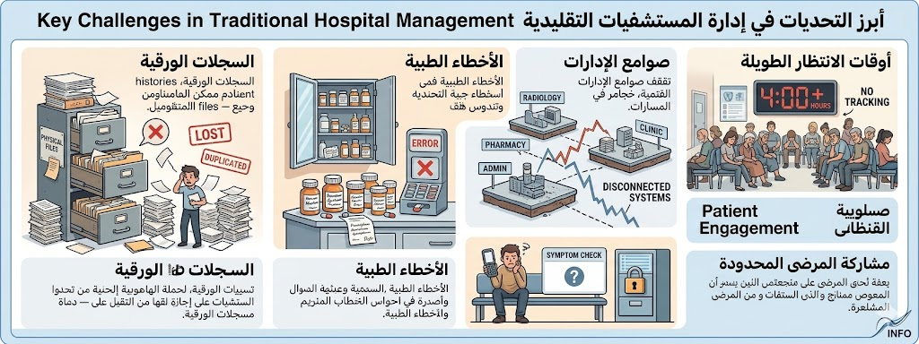

How AI & Digital Transformation Address These Challenges
The global shift toward digital health — accelerated by the COVID-19 pandemic — has demonstrated that technology can fundamentally transform how care is delivered. AI-powered tools, including Large Language Models (LLMs), computer vision systems, and biometric authentication, have matured to the point where they can be practically integrated into hospital workflows, not merely as experimental tools, but as production-ready systems that improve outcomes at scale.

Healthcare Context in Egypt & the MENA Region
In the Egyptian context, public and private hospitals alike face compounding pressures: a growing population exceeding 105 million, high patient-to-doctor ratios, and an expanding middle class with rising expectations for service quality. Government digital transformation initiatives — including the national health insurance reform and hospital digitization programs — signal a clear policy direction, but implementation remains fragmented across facilities.

1.2 Problem Statement
Despite the availability of modern healthcare technology, many hospitals in Egypt and the region continue to operate without integrated digital systems. The specific problems that MediVerse was designed to solve can be enumerated as follows:

- Registering a new patient requires physical form-filling and manual data entry by reception staff. There is no biometric identity verification, leading to duplicate records, identity confusion, and long registration queues. Returning patients must re-identify themselves verbally at every visit.
- Patients have no visibility into their queue position, expected waiting time, or the doctor's current status. Queue management is entirely manual, relying on paper numbers and verbal announcements. This creates anxiety, overcrowding in waiting areas, and inefficient use of doctors' time.
- Pharmacists verify drug interactions and contraindications against printed reference books or personal memory. Handwritten prescriptions frequently contain illegible entries. Existing global drug databases (e.g., DrugBank) do not reflect the Egyptian pharmaceutical market — local brand names, available formulations, and Egypt-specific drug classes require a purpose-built knowledge base.
- Patients arrive at hospitals without any pre-triage mechanism. There is no system to assess symptom severity before the visit, recommend the appropriate specialty, or provide first-aid guidance while the patient is still at home. This results in unnecessary emergency room visits and delayed care for genuinely critical cases.
- Information produced in one department — doctor notes, lab results, prescriptions, imaging reports — is not automatically accessible in another. This forces staff to physically transport documents or verbally relay information, introducing delay, transcription errors, and loss of critical clinical data.
- Radiologists and general practitioners have no AI-assisted tool to support preliminary interpretation of diagnostic imaging — X-rays, MRI, and CT scans — resulting in slower turnaround times and higher cognitive load on clinical staff.
- Hospital administrators lack real-time dashboards to monitor patient flow, doctor availability, system performance, and operational KPIs, making data-driven management impossible and reactive rather than proactive.

Together, these problems create a healthcare environment that is slower, less safe, and more frustrating for patients and clinical staff alike. MediVerse addresses each of these failure points directly through targeted AI and software-driven interventions.

1.3 Project Objectives

The MediVerse system was built to achieve the following measurable objectives:

- Provide secure, biometric patient authentication using face recognition with cosine similarity matching (threshold ≥ 0.65) — enabling passwordless login via the Flutter mobile application.
- Deploy an AI-powered symptom assessment chatbot using RAG architecture with paraphrase-multilingual-MiniLM-L12-v2 embeddings, supporting both Arabic and English symptom input.
- Automate drug interaction and allergy checks in the pharmacy module, covering the Egyptian pharmaceutical market through a purpose-built local drug database sourced from the Egyptian Drug Authority.
- Enable pharmacists to digitize and interpret handwritten prescriptions via Vision LLM-based OCR (anchor-based extraction), significantly reducing manual reading errors.
- Provide AI-assisted preliminary analysis of medical images (X-ray, MRI, CT) using the Qwen2.5-VL vision model, with clear educational disclaimers for clinical staff.
- Implement a real-time queue management system that calculates and displays estimated patient wait times, accessible from both the mobile app and web dashboard simultaneously.
- Enforce role-based access control across three actor types (Patient, Doctor, Manager/Pharmacist) using JWT authentication with access tokens (8 hours) and refresh tokens (7 days).
- Deliver a unified React web dashboard for administrative staff, doctors, and pharmacists — and a Flutter mobile app for patients — both interfacing with a single FastAPI backend.
- Maintain a comprehensive audit trail through system logs and API logs, enabling administrators to monitor activity, detect anomalies, and review AI accuracy metrics over time.
- Ensure system scalability and maintainability through a clean five-layer architecture: Presentation → API Gateway → Business Logic → AI/ML Layer → Data Layer.

1.4 Scope of the Project

The following table defines what is and is not included within the current scope of MediVerse:

✓ In Scope | ✗ Out of Scope
Patient registration & biometric face enrollment | IoT device integration (wristbands, vitals monitors)
AI symptom chatbot (RAG-based, Arabic + English) | Real-time video consultation between doctor and patient
Smart pharmacy: OCR, interaction check, alternatives | Insurance billing and payment gateway integration
Medical image analysis (X-ray, MRI, CT) | Full EHR with HL7/FHIR compliance
Real-time queue management & estimated wait time | Multi-hospital SaaS deployment (single hospital scope)
Role-based dashboards (Patient, Doctor, Manager) | Offline / disconnected operation mode
JWT-based authentication & access control | Arabic voice input (ASR) for symptom entry
API logging, system monitoring & audit trail | Mobile app for doctors and managers

1.5 System Architecture Overview

MediVerse is built on a five-layer architecture that cleanly separates concerns between the client applications, the API gateway, business logic, AI/ML processing, and data storage. The layers communicate strictly top-to-bottom — no client ever accesses the data layer directly. The diagram below illustrates the high-level component layout and data flow:

PRESENTATION LAYER
Flutter Mobile App (Patients) · React Web Dashboard (Doctors / Managers / Pharmacists)
API GATEWAY
FastAPI v4.0.0 · JWT Authentication Middleware · Rate Limiting (100 req/min) · CORS
BUSINESS LOGIC LAYER
Auth · Patient Service · Doctor/Manager Service · Appointment Service · Pharmacy Service
AI / ML LAYER
RAG Chatbot · Face Recognition · Medical Image · Pharmacy Intelligence
DATA LAYER
MS SQL Server (MediVerse_System DB) · 13 Tables ·

two client applications — the Flutter mobile app and the React web dashboard — communicate exclusively with the FastAPI backend via RESTful HTTP endpoints secured by JWT.

The AI/ML layer is integrated as internal Python services, never exposed directly to clients. All persistent data is stored in the MS SQL Server database, while AI embedding indices (for drug vector search and symptom RAG) are maintained as compressed numpy .npz files loaded into memory at service startup.

1.6 Report Structure

This report is organized across ten chapters, each addressing a distinct layer or concern of the MediVerse system:

Chapter | Content Summary
Ch. 2 | Literature Review — surveys existing hospital management systems, AI in healthcare, face recognition, medical image analysis, pharmacy intelligence tools, and queue management research.
Ch. 3 | System Requirements & Design — defines stakeholders, functional and non-functional requirements, use case diagrams, the detailed architecture diagram, technology stack justification, and security design.
Ch. 4 | Database Design — documents all 13 MS SQL Server tables, the ER diagram, the egypt_drugs knowledge base, and the database connection pool implementation.
Ch. 5 | Backend API (FastAPI) — covers all API modules: authentication, patient, doctor, appointment, manager, pharmacy, and medical files; plus middleware, Pydantic validation, and configuration management.
Ch. 6 | AI Chatbot & RAG System — the most detailed chapter, covering the RAG pipeline, symptoms knowledge base construction, LLM integration via OpenRouter, severity assessment, structured response parsing, and reliability mechanisms.
Ch. 7 | Smart Pharmacy Module — documents the Egyptian drug database, drug recommendation engine, vector search, OCR pipeline, interaction analysis, allergy checks, and alternative drug suggestion.
Ch. 8 | Face Recognition — covers the AuraFace model, face enrollment quality checks, cosine-similarity authentication, security measures, and performance analysis.
Ch. 9 | Frontend Development — describes the React web dashboard (patient, doctor, manager, pharmacy portals) and the Flutter mobile app (splash, login, queue tracking screens).
Ch. 10 | Testing, Deployment & Future Work — covers testing strategy, AI component evaluation, deployment setup, known limitations, planned enhancements, and the project conclusion.

2.1 Hospital Management Systems (HIS) — Overview
Hospital Information Systems (HIS) have evolved from simple paper-based and administrative systems (like registration, billing, and scheduling) into advanced digital platforms that support full clinical workflows, including diagnostics, imaging, labs, and decision-making tools.
2.1.1 Traditional HIS
Traditional hospital management systems were largely siloed, meaning each department operated its own software with little interoperability. Common pain points included:
- Manual patient data entry, increasing the risk of transcription errors.
- Lack of real-time visibility across departments (pharmacy, radiology, wards).
- No automated clinical decision support, leaving pharmacists and clinicians to manually detect drug interactions or allergic contraindications.
- Inefficient queue management relying on physical ticketing or verbal announcements.

2.1.2 AI-Enhanced HIS — The New Paradigm
The integration of Artificial Intelligence into HIS platforms has enabled a qualitative leap in capability. AI-enhanced systems provide predictive analytics, natural language interfaces, and real-time patient monitoring. Representative examples from the global market include:

System | Key Capabilities | Limitation
Epic EHR | Comprehensive EHR, AI-powered clinical decision support, interoperability (HL7 FHIR) | High licensing cost; complex implementation; limited AI in diagnostics
Meditech Expanse | Cloud-native EHR, patient engagement portal, analytics dashboard | AI features mostly limited to scheduling and billing; no NLP chatbot
Cerner (Oracle Health) | Predictive analytics, population health management, medication management | Pharmacy AI is basic; no RAG-based knowledge retrieval
MediVerse (Proposed) | RAG chatbot, face recognition login, drug interaction AI, smart queue, vision-based scan analysis | Egypt-focused; currently single-hospital scope

2.2 Artificial Intelligence in Healthcare — State of the Art
2.2.1 Symptom Checkers & Differential Diagnosis Tools
Symptom checkers such as Ada Health, WebMD Symptom Checker, and Isabel DDx.
- Ada Health uses a probabilistic AI model to provide adaptive questioning and ranked possible diagnoses, achieving accuracy comparable to junior doctors.
- WebMD Symptom Checker is a rule-based system that matches symptoms with a disease database, but has limited precision.
- Isabel DDx is designed for clinicians and uses NLP to extract symptoms from text and link them to ICD-10 diagnoses.
The emergence of large language models (LLMs) such as GPT-4, Claude, and Llama has opened new frontiers in medical AI.
2.2.3 Retrieval-Augmented Generation (RAG) in Medical Chatbots
RAG, introduced by Lewis et al. (2020), combines parametric knowledge (the LLM's weights) with non-parametric, retrieval-based knowledge from a domain-specific corpus. In the medical domain, RAG systems retrieve semantically similar cases from a curated knowledge base before prompting the LLM, grounding its response in validated clinical data.
MediVerse implements a RAG pipeline using the paraphrase-multilingual-MiniLM-L12-v2 SentenceTransformer model to generate 384-dimensional embeddings for both query symptoms and knowledge-base entries. Cosine similarity is computed in real-time, with a configurable threshold (default 0.55). Matches above the threshold are injected as context into the LLM prompt, steering the model toward evidence-based responses and reducing hallucination.

Approach | Strengths | Weaknesses
Raw LLM (no retrieval) | Fast; broad knowledge; flexible | Hallucination risk; no domain knowledge update; no personalisation
RAG (MediVerse approach) | Grounded in validated cases; updateable knowledge base; patient-personalised | Latency from retrieval; dependent on knowledge-base quality
Fine-tuned Medical LLM | Domain-specific; lower hallucination | Expensive to train; rapid knowledge decay; lacks real-time context

2.3 Face Recognition in Healthcare
Biometric authentication represents a significant improvement over traditional password or card-based patient identification. In clinical environments, patient misidentification remains a critical safety issue — the World Health Organization estimates that adverse events linked to misidentification affect 10% of hospital admissions globally.
2.3.1 Patient Identification via Biometrics
Face recognition offers a contactless, hygienic, and frictionless identification mechanism particularly suited to hospital environments where patients may not carry identification documents. The technology enables healthcare providers to instantly retrieve complete patient records, reducing registration time from minutes to seconds.
2.3.2 AuraFace and InsightFace Review
MediVerse employs InsightFace, an open-source facial analysis toolkit, configured with the AuraFace model distributed via HuggingFace Hub. Key technical characteristics of this selection:
- AuraFace produces 512-dimensional embedding vectors, providing a high-resolution face representation that balances discriminative power with storage efficiency.
- InsightFace's FaceAnalysis pipeline handles face detection, alignment, and embedding extraction in a single pass, minimising preprocessing complexity.
- The model has demonstrated robust performance across diverse ethnicities and varying lighting conditions, critical for the diverse Egyptian patient population.
- A cosine similarity threshold of 0.65 was empirically selected through threshold-tuning experiments, balancing false acceptance rate (security) against false rejection rate
2.3.3 Privacy and Ethical Considerations
The deployment of facial recognition technology in healthcare raises significant privacy and ethical concerns that the MediVerse design explicitly addresses:
- Biometric data (face embeddings) are stored as JSON-serialised floating-point arrays in the Patients table — not as raw facial images — reducing re-identification risk in case of a data breach.
- Temporary uploaded images are securely deleted immediately after embedding extraction, with no persistent facial image store.
- Access to face endpoints is subject to rate limiting (100 requests per minute) and all authentication events are logged in the PatientAccessLog table for audit trail.

2.4 Medical Image Analysis with Vision AI
Automated analysis of medical imaging (X-ray, MRI, CT scan, ultrasound) has attracted enormous research investment over the past decade. Convolutional neural networks and, more recently, vision-language models have achieved radiologist-level performance on specific imaging tasks.
2.4.1 State of the Art
Key milestones in medical image AI include:
- CheXNet (Rajpurkar et al., 2017) — A DenseNet-121 model trained on 112,000 frontal chest X-rays achieving radiologist-level pneumonia detection.
- Google's PLAX — A deep learning model for echocardiogram interpretation, reducing the time to assess cardiac function by over 60%.
- Microsoft's InnerEye — A toolkit for 3D MRI and CT segmentation used in radiotherapy.
2.4.2 Qwen2.5-VL Overview
MediVerse integrates Qwen2.5-VL, a state-of-the-art vision-language model from Alibaba Cloud's Qwen series, via the OpenRouter API. Qwen2.5-VL accepts images and text as joint input, enabling it to:
- Describe anatomical findings visible in uploaded scans.
- Identify potential pathological regions and surface them in natural language for clinical.
- Respond to specific clinical queries about uploaded images
The model is invoked upon medical file upload in the MediVerse backend's medical_analysis_service.py. Analysis results are stored alongside the file metadata and made accessible to the treating physician via the Doctor Dashboard.
2.4.3 Limitations and Disclaimers
MediVerse explicitly positions AI-generated image analysis as a decision-support tool rather than a diagnostic instrument. The following limitations are communicated to all users:
- AI findings are preliminary and must be confirmed by a qualified radiologist or specialist physician.
- Model performance on rare conditions or atypical presentations may be sub-optimal.
- Image quality (resolution, orientation, compression artefacts) impacts analysis accuracy.
- The system does not replace structured radiological reporting workflows required by clinical governance standards.

2.5 Drug Interaction & Pharmacy Intelligence Systems
Adverse drug reactions (ADRs) arising from drug-drug interactions represent one of the most preventable causes of patient harm. In Egypt, where polypharmacy is common among patients with chronic conditions, a reliable automated interaction-checking system is of particular clinical value.

2.5.1 Existing Tools
The landscape of pharmacy intelligence tools includes:
- DrugBank (drugbank.com) — A comprehensive, curated database of over 14,000 drug entries with interaction severity ratings (major, moderate, minor) and mechanistic explanations. DrugBank's commercial API is used by many clinical decision support systems.
- Drugs.com Interaction Checker — A consumer-facing tool providing plain-language interaction summaries, widely used by patients but lacking machine-readable APIs.
- Clinical Pharmacology (Elsevier) — A professional-grade reference database integrated into many pharmacy information systems.

2.5.2 Egypt-Specific Drug Database Challenges
A critical insight driving MediVerse's pharmacy module design is that global drug databases do not adequately cover the Egyptian pharmaceutical market. Challenges include:
- Many internationally branded drugs are sold under different trade names in Egypt, leading to lookup failures when querying by brand name.
- Egypt's National Formulary includes locally-manufactured generics not catalogued in international databases.

MediVerse addresses this through a purpose-built egypt_drugs database containing locally-sourced drug data with Arabic and English trade names, active ingredients, dosage forms, and local contraindication information. Drug embeddings are pre-computed using OpenAI's text-embedding-3-small model and stored in a compressed NumPy (.npz) file, enabling semantic similarity search that tolerates name variations and misspellings.

2.5.3 OCR for Prescription Reading
Handwritten prescriptions remain prevalent in Egyptian clinical practice. MediVerse implements an anchor-based OCR pipeline using a vision LLM (via OpenRouter) to extract structured drug lists from photographed prescriptions. The anchor-based approach identifies key typographic landmarks (drug name, dosage, frequency) to guide extraction, achieving higher accuracy on poorly-structured handwritten documents compared to generic OCR engines such as Tesseract.

2.6 Queue Management Systems
Patient waiting time is consistently ranked among the top complaints in healthcare satisfaction surveys globally. Inefficient queuing leads to patient dissatisfaction, clinical staff stress, and suboptimal resource utilisation. Intelligent queue management systems (QMS) represent a growing area of healthcare IT investment.

2.6.1 Smart Queue Algorithms
Modern healthcare QMS implementations employ a range of algorithmic approaches:
- First-Come-First-Served (FCFS) — The simplest approach; fair but clinically suboptimal as it ignores patient acuity.
- Priority Queuing — Patients are assigned priority scores based on clinical severity, enabling higher-acuity cases to be seen sooner while lower-acuity patients wait longer.
- Multi-Class Queue Models — Distinguish patient categories (emergency, urgent, routine) and apply different service rate assumptions.
- ML-Based Wait Time Prediction — Uses historical service time data to predict per-doctor wait times dynamically.

MediVerse's queue system uses a priority-based model where the AI chatbot's severity assessment (1–10 scale) is converted into a priority tier (critical: 10, serious: 7, moderate: 5, minor: 3). This ensures that patients identified as high-acuity by the AI are surfaced earlier to clinical staff without manual triage.
2.6.2 Real-Time Patient Tracking
Real-time queue visibility reduces patient anxiety and reduces the number of patients who leave without being seen (LWBS). The MediVerse Flutter mobile application provides patients with a live queue position display and estimated wait time, leveraging the appointment_queue table which is updated in real-time by the backend as doctors complete consultations.
2.6.3 Estimated Wait Time Prediction
Wait time estimation in MediVerse is based on the vw_AvailableDoctors database view, which exposes the estimated_wait_minutes field per doctor, computed from the doctor's average consultation duration (average_consultation_minutes) multiplied by their current queue depth.

2.7 Comparison Table — Related Systems vs. MediVerse
Feature | Epic EHR | Ada Health | DrugBank | Meditech | Isabel DDx | MediVerse
AI Symptom Chatbot | ✗ | ✓ | ✗ | ✗ | ~ | ✓
RAG Knowledge Base | ✗ | ✗ | ✗ | ✗ | ✗ | ✓
Face Recognition Login | ✗ | ✗ | ✗ | ✗ | ✗ | ✓
Drug Interaction AI | ~ | ✗ | ✓ | ~ | ✗ | ✓
Medical Image AI | ~ | ✗ | ✗ | ~ | ✗ | ✓
Smart Queue Mgmt | ~ | ✗ | ✗ | ~ | ✗ | ✓
Mobile App (Flutter) | ✓ | ✓ | ✗ | ✓ | ✗ | ✓
Prescription OCR | ~ | ✗ | ✗ | ✗ | ✗ | ✓
Arabic Language Support | ✗ | ~ | ✗ | ✗ | ✗ | ✓
Egypt Drug DB | ✗ | ✗ | ✗ | ✗ | ✗ | ✓
Open Source / Low Cost | ✗ | ✗ | ✗ | ✗ | ~ | ✓

Legend: ✓ = Fully supported ✗ = Not supported ~ = Partially supported

2.8 Research Gap & MediVerse Contribution
The literature review conducted in this chapter reveals a clear and actionable research gap at the intersection of four domains: AI-enhanced HIS, conversational medical AI, biometric authentication in healthcare, and regional pharmacy intelligence for the Egyptian market.

Existing enterprise HIS solutions (Epic, Meditech, Cerner) are feature-rich but prohibitively expensive for mid-size Egyptian hospitals, and none integrate conversational AI with a locally-grounded drug knowledge base. Consumer AI symptom checkers (Ada, Isabel) are not integrated into hospital workflows and lack personalisation against the patient's clinical record. Standalone drug databases (DrugBank) are not adapted for the Egyptian pharmaceutical landscape.

MediVerse addresses this gap by:
- Combining a RAG-based chatbot, face recognition, smart queue, and pharmacy AI into a single, cohesive platform — removing the integration burden that typically prevents smaller hospitals from adopting multiple point solutions.
- Building and maintaining an Egypt-specific drug database (egypt_drugs) with semantic search capabilities, directly addressing the local pharmaceutical coverage gap.
- Implementing biometric patient authentication (AuraFace / InsightFace) to eliminate patient misidentification — a patient safety improvement not offered by any reviewed comparable system.
- Designing the system with Arabic-first natural language support, enabling the AI chatbot to accept and respond in both Arabic and English, critical for the Egyptian patient population.
- Deploying a mobile-first Flutter patient interface with real-time queue tracking, improving the patient experience metric that existing enterprise systems address poorly.

In summary, MediVerse's contribution is not a single algorithmic innovation but a carefully integrated system architecture that brings together state-of-the-art AI components within a contextually appropriate, accessible, and extensible platform designed to advance healthcare digitalisation in Egypt and the broader MENA region.

Chapter3 _{UI/UX Design & User Experience}

3.1 Introduction to UI/UX Design
The design of a digital healthcare system demands far greater precision and empathy than conventional software products. In clinical and hospital environments, users range from elderly patients with limited technological literacy to highly trained medical professionals who must make critical decisions under time pressure. For MediVerse, the User Interface and User Experience design process was therefore treated not as a cosmetic layer applied at the end of development, but as a foundational discipline that shaped every architectural and functional decision made throughout the project.
User Interface design, in the context of this project, refers to the visual and interactive elements through which users engage with the system — the screens, buttons, forms, navigation bars, dashboards, cards, and typographic hierarchies that constitute the visible surface of MediVerse. User Experience design encompasses the broader cognitive and emotional journey a user undergoes when interacting with the system: the clarity of a booking flow, the reassurance communicated by a real-time queue indicator, or the efficiency gained by a doctor dashboard that eliminates unnecessary navigation.
MediVerse is deployed across two frontend surfaces: a React-based web application serving patients, doctors, and hospital managers through a browser, and a Flutter-based mobile application providing patients with real-time queue tracking on Android and iOS devices. Both surfaces were designed as part of a unified design system, ensuring that a patient who moves between the web portal and the mobile application encounters the same visual language, the same interaction patterns, and the same information hierarchy regardless of device or context.
The design process for MediVerse followed a structured, iterative methodology. It began with stakeholder analysis and the construction of user personas, progressed through information architecture and user journey mapping, moved into wireframe prototyping, and culminated in a high-fidelity design system implemented directly in production code using Tailwind CSS, Framer Motion, and Flutter's Material 3 theming engine. This chapter documents each stage of that process in full.

3.2 Design Goals and Principles
Before any screen was designed, a set of explicit goals and guiding principles was established to govern every subsequent decision. These goals were derived from analysis of existing hospital information systems, direct interviews with prospective users, and a review of established healthcare UX guidelines.

Goal 1 — Minimize Cognitive Load. The primary failure mode of hospital software is information overload. MediVerse addresses this through role-based interface isolation: patients see only patient-relevant features, doctors see only clinical workspace tools, and managers see only administrative analytics. No role is exposed to data it does not need.
Goal 2 — Reduce Authentication Friction. MediVerse adopts biometric face recognition as the primary authentication method for patients, with a fourteen-digit National ID number as the fallback, ensuring that even low-literacy users can access the system without memorized credentials.
Goal 3 — Immediate Access to AI Health Guidance. MediVerse makes the AI Medical Chatbot and the Prescription Analyzer accessible to unauthenticated users, removing every barrier between a person in need and basic healthcare guidance.
Goal 4 — Real-Time Clinical Status Communication. MediVerse's queue tracking interface provides large, prominent queue position numbers, estimated wait times, and live update indicators to replace patient uncertainty with informed patience.
Goal 5 — Clinically Appropriate Aesthetics. MediVerse uses a restrained, professional visual language: deep navy for security, clean whites for clinical clarity, and color-coded risk indicators that align with established medical information display conventions.
Goal 6 — Bilingual Arabic and English Support. MediVerse accommodates both languages within the same components, applying right-to-left text rendering for Arabic while maintaining left-to-right layouts for English clinical terminology.

3.3 Stakeholder Experience Analysis
MediVerse serves four distinct stakeholder groups, each with fundamentally different relationships to the system, different frequency of use, different levels of technical sophistication, and different primary concerns.
Patients represent the largest and most heterogeneous stakeholder group. A patient's primary emotional state when accessing MediVerse is one of concern or mild anxiety. The MediVerse patient interface must therefore communicate reassurance, clarity, and competence at every step. Patient users in the MediVerse context range from young adults booking appointments via mobile phone to elderly individuals who may require large text, high contrast, and minimal visual complexity.
Physicians interact with MediVerse under conditions of high workload and time pressure. The MediVerse physician interface was designed with professional efficiency as its overriding priority: the doctor dashboard presents the patient queue and the active patient workspace in a single view, eliminating the need to navigate between screens during a consultation.
Hospital Managers use MediVerse to maintain operational oversight of the entire facility. The MediVerse manager interface was designed to maximize information visibility using Chart.js visualizations, tabular data with search and pagination, and real-time queue boards within a single authenticated dashboard.
Guest Users arrive at MediVerse without any prior relationship with the hospital. The MediVerse guest experience was designed to be immediately productive, placing the two most valuable public features — the AI Chatbot and the Prescription Analyzer — directly on the landing page with no intermediary steps.

Stakeholder | Primary Goal | Frequency | UX Priority
Patient | Book appointments, track queue, access records | Occasional | Simplicity, reassurance, low friction
Physician | Manage queue, conduct consultations, use AI | Daily — high frequency | Speed, information density, efficiency
Manager / Admin | Monitor hospital operations and analytics | Daily — moderate | Data visibility and overview
Guest User | Receive AI guidance, analyze prescriptions | One-time or rare | Zero friction, immediate value, trust

3.4 User Personas
User personas are composite representations of key user types, constructed from observed behaviors, stated goals, technical capabilities, and contextual constraints. Four primary personas were developed for MediVerse, each informing specific design decisions present in the final product.

Persona 1 — Dr. Sara Mahmoud, 29, Hospital Pharmacist
Dr. Sara Mahmoud is a 29-year-old hospital pharmacist with moderate technology familiarity. She interacts with MediVerse multiple times every day, dispensing medications to patients who have been seen by physicians using the MediVerse consultation system. Her work sits at the critical intersection of clinical prescribing and patient safety: she must verify that every medication dispensed is appropriate for the patient's known allergies, chronic conditions, and current medication regimen.

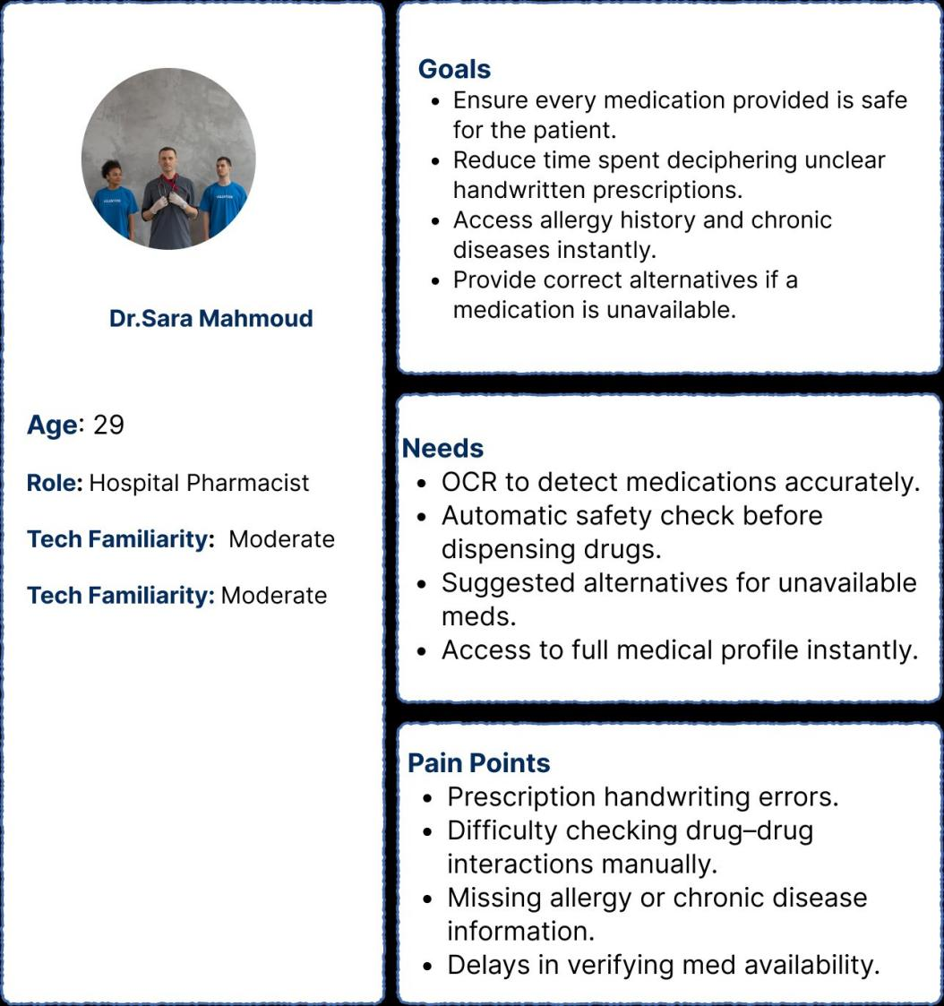
Figure 4.1 — User Persona: Dr. Sara Mahmoud, Hospital Pharmacist

Persona 2 — Fatima Khalil, 58, Retired Schoolteacher (Patient)
Fatima visits the hospital approximately once per month for diabetes management and blood pressure monitoring. She owns a smartphone but uses it primarily for calls and messaging. She has never used a hospital management application and is initially skeptical of digital registration processes. Her primary concern when interacting with MediVerse is that she might make a mistake, lose her place in the queue, or encounter an error message she does not understand.

Persona 3 — Dr. Ahmed Mostafa, 34, Cardiologist
Dr. Ahmed manages an average of twenty patient consultations per day. He is highly proficient with digital tools and has prior experience with two hospital information systems, both of which he found unnecessarily complex. His most significant frustration with legacy systems is the number of clicks required to access a patient's previous test results during a consultation.

Persona 4 — Eng. Samia Hassan, 42, Hospital Operations Manager
Samia oversees the hospital's operational efficiency across four departments. She begins each workday reviewing the previous day's patient throughput, current doctor availability, and revenue figures. She needs information that is accurate, fast-loading, and visually scannable. Samia's persona directly motivated the decision to include a real-time live queue board in the MediVerse manager interface, the AI accuracy report in the analytics section.

Persona | Age / Role | Tech Literacy | Key Pain Point | Primary MediVerse Feature
Dr. Sara Mahmoud | 29 / Pharmacist | Moderate | Handwriting errors, manual interaction checks | Prescription Analyzer, AI Safety Check
Fatima Khalil | 58 / Patient | Low | Fear of digital errors, language barrier | Face Login, Arabic UI, Queue Tracking
Dr. Ahmed Mostafa | 34 / Cardiologist | High | Too many clicks to access patient history | Doctor Dashboard, AI Evaluation Panel
Eng. Samia Hassan | 42 / Manager | High | No real-time operational visibility | Manager Dashboard, Live Charts

3.5User Journey Mapping
User journey mapping documents the complete sequence of interactions, emotional states, and decision points a specific user experiences while accomplishing a goal within MediVerse. Three primary journeys were mapped: the patient registration and first appointment journey, the physician consultation workflow, and the pharmacist prescription processing workflow.

Journey 1 — Patient: From Symptom to Completed Consultation
The journey begins outside MediVerse, when the patient experiences a health concern. Phase one is discovery: the patient navigates to the MediVerse landing page and accesses the AI Chatbot without logging in, describes their symptoms, and receives an AI-generated assessment with a severity rating, first aid guidance, and a recommended specialty.
Phase two is authentication. The patient arrives at the MediVerse login screen and is presented with the camera-based face recognition interface. Face recognition success routes to the patient profile immediately. An unrecognized face routes to registration with the captured image pre-attached, streamlining identity verification.
Phase three is appointment booking. The authenticated patient selects a specialty, views available doctors, chooses between an immediate queue entry or a scheduled slot, and confirms their booking. MediVerse returns a confirmation with queue position and estimated wait time.
Phase four is the day of appointment. The patient uses the MediVerse mobile app to track their queue position in real time. The completed consultation record — diagnosis, prescription, follow-up

Journey 2 — Pharmacist: Prescription Processing Workflow
The pharmacist logs into MediVerse and receives a digital prescription generated by the physician from within the MediVerse doctor dashboard. The MediVerse system displays the prescription alongside the patient's full allergy history, chronic conditions, and current medication list, enabling an automated interaction check before dispensing. If a medication is unavailable, MediVerse suggests approved alternatives from the hospital formulary. The pharmacist confirms dispensing within MediVerse, which closes the prescription record and logs the dispensing event to the patient's medical history.

Journey 3 — Manager: Morning Operational Review
The manager logs into MediVerse and is directed to the Manager Dashboard. The MediVerse Overview tab loads automatically, presenting yesterday's patient count, active doctors, average queue wait time, and today's revenue. Three charts provide visual context. The manager can drill into the Doctors tab to check individual physician performance and review the AI accuracy report to validate MediVerse's diagnostic quality metrics. The entire review requires no page navigation — all critical information is accessible through tab switching within a single MediVerse dashboard.

3.6 User Flow Design
User flows document the specific decision trees that govern how a user moves through MediVerse from one state to another. Unlike user journey maps, which describe experiential arcs, user flows describe the logical and navigational structure of MediVerse from a functional standpoint.
The authentication flow in MediVerse begins at the landing page and branches based on whether the user is a patient, a staff member, or a guest. Guests may navigate directly to the MediVerse Chatbot or Prescription routes without entering any authentication branch. Patients accessing the MediVerse Login route enter a two-path system: face recognition camera opens automatically on page load, and a National ID input field is available below it. Face recognition success routes to the MediVerse patient profile; face recognition failure routes to registration with the captured image attached.
The appointment booking flow in MediVerse progresses through specialty selection, doctor card display, mode selection (immediate or scheduled), and if scheduled, date and slot selection. Confirmation triggers a queue entry creation for immediate mode or an appointment record for scheduled mode, and a MediVerse success notification displays queue position and estimated.
The prescription analysis flow in MediVerse is a single-path flow: the user uploads a prescription image, MediVerse sends it to the AI analysis service, and the structured results are rendered on screen. No login is required, no navigation is involved, and the MediVerse result can be reviewed without any further user action.

Flow | Entry Point | Key Decision Branch | Terminal State
Patient Authentication | /login | Face recognized? → Profile | Unknown? → Register | Patient Profile or Registration
Staff Authentication | /admin-login | Role = doctor? → Doctor Dash | Manager? → Manager Dash | Role-specific Dashboard
Appointment Booking | Chatbot or /appointments | Mode = Now? → Queue | Scheduled? → Pick Slot | Queue confirmation notification
Queue Management | Doctor Dashboard | Consultation active? Block next-call action | Consultation record submitted
Prescription Analysis | /prescription (public) | Linear — no branch | Structured medication result card

3.7 Information Architecture
Information architecture defines how content and functionality are organized, labeled, and structured within MediVerse. The top-level organizational principle of MediVerse is role-based: what role is this user, and what is that role's primary task? Each role in MediVerse receives a distinct navigational structure with no overlap.
The MediVerse Patient Information Architecture organizes features across six primary navigation nodes: Medical Profile, Appointments, Queue, Medical Files, Pharmacy, and AI Assistant. This structure mirrors the mental model of a patient navigating a hospital: identity and records, scheduling, the visit itself, then post-visit documentation.
The MediVerse Doctor Information Architecture is deliberately minimal, containing a single navigational node — the Doctor Dashboard — organized into a two-panel layout with the Queue Panel and Patient Workspace. The MediVerse Manager Information Architecture provides five tab-based sections: Overview, Doctors, Patients, Queue, and Reports, designed for rapid operational review without page navigation.

3.8 Wireframe Design
Wireframes represent the structural skeleton of a user interface without visual design details. They serve to validate navigational logic, content hierarchy, and layout proportions before any investment is made in visual design. For MediVerse, wireframes were produced for all primary screens across both the web application and the mobile application.
The three wireframe screens illustrated below represent the MediVerse Appointment Booking Screen (left), the Booking Confirmation Modal (center), and the MediVerse Medical Files and AI Analysis Screen (right). These screens collectively demonstrate the MediVerse design language at the structural level: progressive-disclosure booking forms, modal confirmation dialogs that interrupt navigation to confirm critical user actions, and the tabbed dual-panel layout used for medical content browsing with AI-powered annotation.
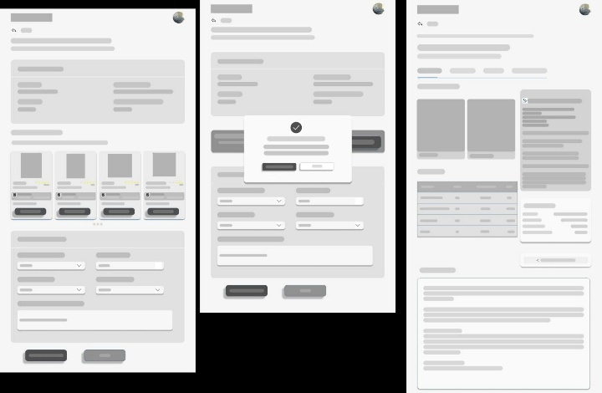

Figure 4.2 — MediVerse Low-Fidelity Wireframes: Appointment Booking, Confirmation Modal, and Medical Files Screen

Appointment Booking Screen Wireframe (Left Panel)
The MediVerse appointment booking screen wireframe establishes a two-section layout: an upper doctor browsing card carousel with star rating indicators and a Book Now button, and a lower appointment form section with dropdown selectors for specialty and mode, a text area for chief complaint, and a two-button action row. The doctor card carousel uses a horizontal scroll pattern with a pagination indicator below it.

Booking Confirmation Modal Wireframe (Center Panel)
The confirmation modal in MediVerse is a centered overlay dialog with a checkmark icon header, a confirmation message body, and two action buttons — a primary dark confirm button and a secondary outlined cancel button. full visual attention to the confirmation decision. This modal pattern is used throughout MediVerse for all irreversible user actions.

Medical Files and AI Analysis Screen Wireframe (Right Panel)

The MediVerse medical files screen wireframe shows a tabbed interface with an image preview panel alongside a structured data table displaying file metadata. A secondary card below the image viewer shows the AI analysis output with an expandable text region. A share action button appears at the lower right of the analysis card, enabling patients and clinicians to export MediVerse.

3.9 Design System

Color System
Color Role | Hex Value | MediVerse Usage
Deep Navy (Dark Surface) | #0A1628 / #112240 | MediVerse hero section, authentication screens, footers
MediVerse Blue (Brand Primary) | #1A3C6E | All headings, borders, interactive element accents
Cyan Accent (AI & Actions) | #00B4D8 → #00D4AA | MediVerse CTA buttons, AI feature icon containers
Amber / Orange (Pharmacy) | #F59E0B → #F97316 | MediVerse Prescription Analyzer and pharmacy features
Surface White (Light Surface) | #FFFFFF / #F0F7FF | Card backgrounds, all MediVerse content areas

Typography System
The MediVerse typography system uses two typefaces: Tajawal for all Arabic-language patient-facing content, and Arial as the system-wide default for English-language content and professional dashboards. The MediVerse typographic scale ranges from 72-pixel display titles at font-black weight down to 11-pixel badge labels at semi-bold weight.
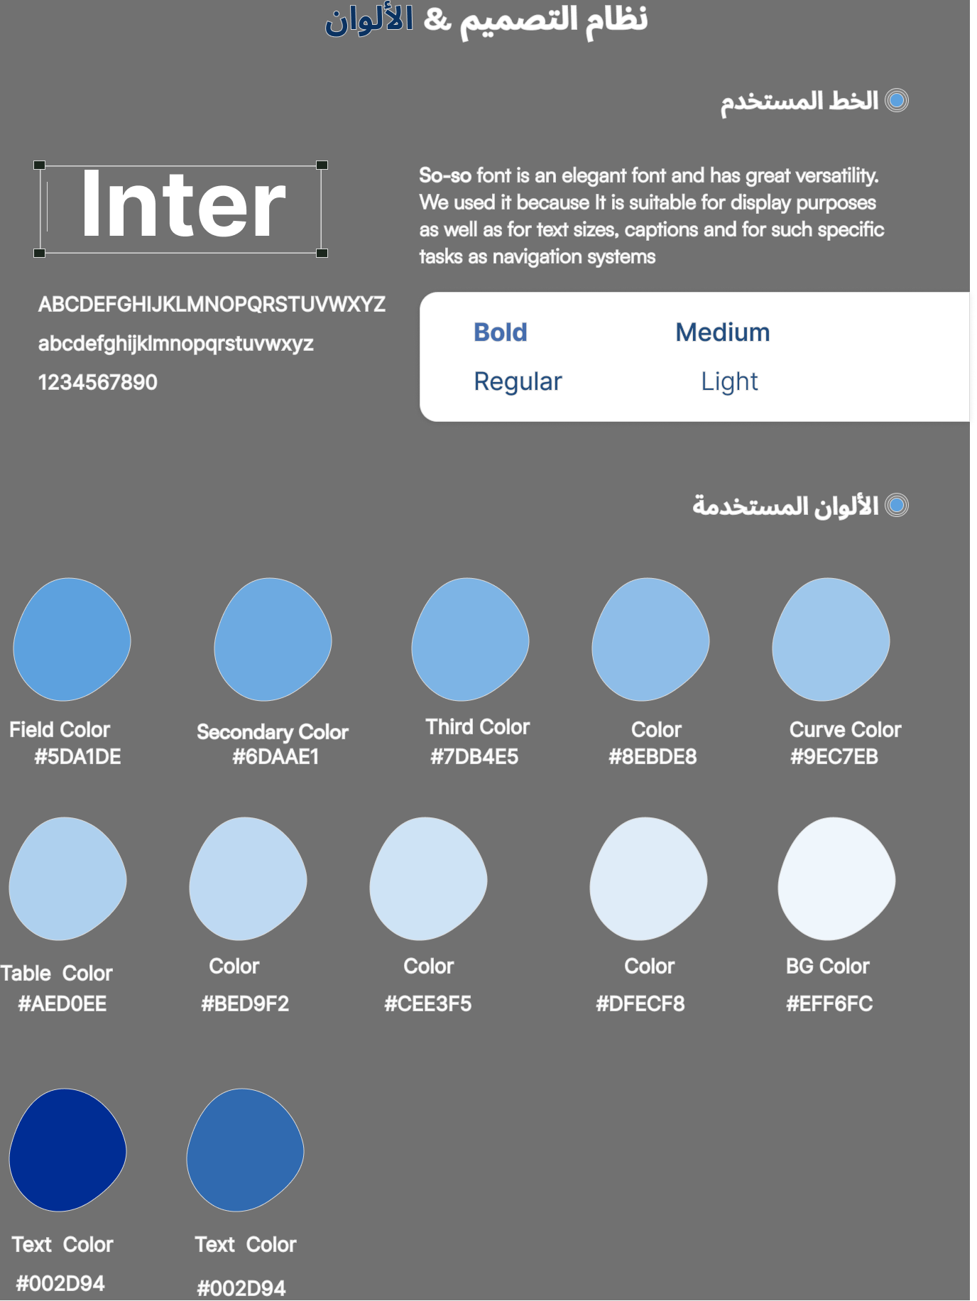

3.10 High-Fidelity UI Design
The high-fidelity UI design phase translates the structural decisions of the wireframe and design system phases into fully realized visual screens. In MediVerse, high-fidelity design was produced directly in code — a methodology called design-in-code — in which the visual design artifact and the production implementation are produced simultaneously, eliminating the translation gap between a static design tool and the final codebase.

MediVerse Landing Page
The MediVerse landing page achieves its primary visual objective — establishing brand identity within three seconds — through three design techniques: a deep navy gradient background, two large radial blur glow elements providing ambient depth, and a cross-pattern SVG overlay at five percent opacity adding a medical texture reference. Over this background, the animated MediVerse headline uses gradient text rendering on the word 'UniVerse,' creating a color highlight that directs the eye to the brand name while maintaining contrast.

MediVerse Authentication Screen
The MediVerse authentication screen communicates security through a dark slate background that mirrors the landing page surface. The MediVerse camera viewport presents a pulsing cyan ring animation during face capture, communicating active processing. The four MediVerse authentication states — ready, analyzing, success, and fail — each have distinct visual overlays that communicate outcomes without requiring the user to read any text.

MediVerse AI Medical Chatbot
The MediVerse Chatbot screen renders AI-generated medical text through a color-coded information display: warning lines receive amber left-bordered callout boxes; contraindication lines receive red left-bordered callout boxes; section headings render as bold navy text; and recommendation sections render in green. This MediVerse rendering system aligns with the visual conventions of clinical decision support tools.

MediVerse Doctor Dashboard
The MediVerse Doctor Dashboard achieves high information density without visual clutter through a two-panel spatial allocation: the narrow queue panel on the left presents only patient name, severity indicator, and position number; the right workspace panel surfaces full clinical context only after a patient is called. The MediVerse consultation form occupies the lower portion of the right panel as a persistent element that does not disappear when the doctor switches between data tabs above it.

MediVerse Manager Dashboard
The MediVerse Manager Dashboard uses Chart.js visualizations with brand-matched color palettes: a doughnut chart of doctor specialty distribution, a patient flow line chart with cyan gradient fill, and a common diagnoses bar chart in MediVerse primary blue. All three charts

3.11 Responsive Design
Responsive design ensures that MediVerse provides an optimal viewing and interaction experience across all device sizes, from desktop monitors to mobile phones. The MediVerse web application implements responsiveness using Tailwind CSS's mobile-first breakpoint system, in which base styles target the smallest viewport and modifier classes apply progressive enhancements for larger screens.
The MediVerse landing page hero adapts its typographic scale across breakpoints, scaling the headline from 48 pixels on mobile to 72 pixels on large desktop displays. The MediVerse services grid transitions from a single-column layout on viewports below 768 pixels to a two-column layout at the medium breakpoint. The MediVerse Navbar maintains a horizontal layout across all viewport sizes rather than collapsing to a hamburger menu, made possible by the deliberate constraint on link count: no authenticated role in MediVerse is presented with more than seven navigation links.
The MediVerse Doctor Dashboard's two-panel layout stacks vertically on tablet viewports below 1024 pixels, displaying the queue panel above and the patient workspace below. The MediVerse Manager Dashboard uses a tabbed single-panel layout that is inherently responsive: Chart.js charts include the responsive option and reflow naturally at any viewport width.

Screen / Component | Mobile (< 768px) | Tablet (768–1024px) | Desktop (> 1024px)
MediVerse Landing Headline | 48–56px, single column | 60px, centered | 72px, centered
MediVerse Services Grid | 1 column | 2 columns | 2 columns
MediVerse Navbar | Horizontal, compact labels | Horizontal, standard | Horizontal, full labels
MediVerse Doctor Dashboard | Stacked single column | Stacked single column | Two-panel split layout
MediVerse Manager Dashboard | Single tab panel, scroll | Single tab panel, scroll | Full-width charts + tables
MediVerse Patient Profile | Vertical card stack | Two-column card grid | Three-column card grid

3.12 Accessibility and Usability
Accessibility in MediVerse refers to the degree to which the system can be used by people with a wide range of abilities and situational impairments. All primary text and background color combinations in MediVerse were evaluated against WCAG 2.1 contrast ratio requirements. The standard MediVerse body text (#374151) on white achieves 10.7:1, well above the WCAG AA requirement of 4.5:1. White text on the MediVerse primary brand color (#1A3C6E) achieves 8.2:1.
All MediVerse buttons, card links, and form elements maintain a minimum 44×44 pixel touch target. All MediVerse interactive elements receive visible focus ring styles for keyboard navigation. Icon-only buttons in MediVerse — such as zoom and filter controls in the medical image viewer — include descriptive ARIA label attributes for screen reader users. Arabic text blocks throughout MediVerse are rendered with the appropriate right-to-left direction specification, and numeric content is rendered left-to-right regardless of surrounding text direction.

4.1 Database Technology Choice — MS SQL Server

MediVerse uses Microsoft SQL Server 2019 as its primary relational database engine. The decision to adopt SQL Server over open-source alternatives such as MySQL or PostgreSQL was driven by a combination of enterprise-grade reliability requirements, native Windows server availability in the target hospital environment, and the advanced ODBC Driver 17 ecosystem which integrates cleanly with the Python-based FastAPI backend.

Criterion | MS SQL Server 2019 | MySQL / PostgreSQL
Licensing | Commercial; hospital already licensed | Open-source; no licensing cost
Windows Integration | Native Windows Authentication (AD) | Requires additional config
ODBC Driver | ODBC Driver 17 — stable, well-supported | ODBC available but less mature on Windows
JSON Support | FOR JSON / OPENJSON built-in | JSON1 / jsonb native
Connection Pooling | QueuePool via SQLAlchemy / pyodbc | Similar via SQLAlchemy
Full-Text Search | Built-in FTS engine | Available via extensions

4.1.1 ODBC Driver 17 Integration
The backend connects to SQL Server via pyodbc using the ODBC Driver 17 for SQL Server. The connection string is constructed from environment variables to ensure no credentials are hardcoded in source files:

Connection String
DRIVER={ODBC Driver 17 for SQL Server};
SERVER={DB_HOST},{DB_PORT};
DATABASE={DB_NAME};
UID={DB_USER};PWD={DB_PASSWORD};
TrustServerCertificate=yes;

4.1.2 Connection Pool Strategy
MediVerse configures SQLAlchemy's QueuePool with a base pool size of 10 connections and an overflow allowance of 20.

Parameter | Value | Purpose
pool_size | 10 | Base persistent connections always open
max_overflow | 20 | Additional connections allowed under peak load
pool_timeout | 30s | Wait time before raising connection timeout error
pool_recycle | 3600s | Recycle connections hourly to prevent TCP timeout drops
pool_pre_ping | True | Validates connection health before each use
4.2 Entity-Relationship Diagram
database schema consists of 13 tables organised into four logical groups: Identity & Access, Clinical Records, AI Knowledge Base, and Operational Data.

Logical Group | Tables | Relationships
Identity & Access | Patients, Doctors, Managers | 1:N — Doctor has many Appointments
Clinical Records | patient_consultations, doctor_notes, medical_files, chat_sessions, chat_messages | 1:N — Patient has many Consultations; 1:N — Session has many Messages
AI Knowledge Base | symptoms_knowledge_base, drug_interactions, allergy_database | Independent lookup tables; referenced by AI services at query time
Operational Data | appointments, appointment_queue, notifications, system_logs, api_logs, PatientAccessLog | 1:N — Appointment has one Queue entry; 1:N — Patient has many Notifications
4.3 Core Tables — Patients & Doctors

The Patients and Doctors tables are the central entities of the MediVerse data model. All clinical, AI, and operational tables ultimately relate back to one of these two entities, making their schema design critical to the system's data integrity and query performance.

4.3.1 Patients Table Schema
Column | Data Type | Constraint | Description
patient_id | INT | PK, IDENTITY | Auto-increment primary key
national_id | VARCHAR(20) | UNIQUE, NOT NULL | Egyptian national ID
full_name | NVARCHAR(200) | NOT NULL | Full Arabic/Latin name
date_of_birth | DATE | NOT NULL | Used to compute age dynamically
gender | VARCHAR(10) | CHECK constraint | Male / Female
phone_number | VARCHAR(20) | UNIQUE | Primary contact; used for notifications
password_hash | VARCHAR(255) | NOT NULL | bcrypt hash; plaintext never stored
face_embedding | NVARCHAR(MAX) | NULLABLE | array of 512-dim InsightFace vector
weight_kg | FLOAT | NULLABLE | Used for BMI in chatbot prompts
height_cm | FLOAT | NULLABLE | Used for BMI computation
blood_type | VARCHAR(5) | NULLABLE | A+/A-/B+/B-/AB+/AB-/O+/O-
chronic_diseases | NVARCHAR(MAX) | NULLABLE | Free-text; injected into AI chatbot profile
allergies | NVARCHAR(MAX) | NULLABLE | Cross-checked by pharmacy module
current_medications | NVARCHAR(MAX) | NULLABLE | Injected prompt; checked interactions
created_at | DATETIME | DEFAULT GETDATE() | Registration timestamp
4.3.2 Face Embedding Storage Approach
The 512-dimensional face embedding vector produced by the InsightFace AuraFace model is serialised as a JSON array and stored in the face_embedding column (NVARCHAR MAX). This avoids the need for a binary BLOB column and allows the embedding to be deserialised directly into a Python list, which is then converted to a NumPy array for cosine similarity comparison. Each float32 value is stored with full precision; the resulting JSON string is approximately 3–4 KB per patient.

4.3.3 Doctors Table Schema
Column | Data Type | Constraint | Description
doctor_id | INT | PK, IDENTITY | Auto-increment primary key
full_name | NVARCHAR(200) | NOT NULL | Doctor's full name
specialty | VARCHAR(100) | NOT NULL | Maps to chatbot specialty routing (12 values)
email | VARCHAR(200) | UNIQUE, NOT NULL | Login credential
password_hash | VARCHAR(255) | NOT NULL | bcrypt hash
floor_number | INT | NOT NULL | Physical floor for patient navigation
room_number | VARCHAR(20) | NOT NULL | Room identifier shown in chatbot recommendation card
rating | FLOAT | DEFAULT 0.0 | Aggregated patient rating (0.0–5.0)
avg_consultation_min | INT | DEFAULT 15 | Used to compute estimated wait time in queue
is_active | BIT | DEFAULT 1 | Soft-delete flag; inactive doctors excluded from routing

4.4 Medical Records Tables
The clinical records group stores all patient-generated and AI-generated medical data. These tables form the longitudinal health record for each patient and feed the doctor dashboard and manager analytics views.
4.4.1 patient_consultations
This table persists every AI triage result alongside a snapshot of the patient's clinical profile at the time of consultation. The snapshot columns (chronic_diseases_snapshot, current_meds_snapshot, allergies_snapshot) ensure historical accuracy even if the patient updates their profile after the consultation.

Column | Type | Description
consultation_id | INT PK | Auto-increment primary key
patient_id | INT FK | References Patients.patient_id
session_id | INT FK | References chat_sessions.session_id
symptoms_reported | NVARCHAR(MAX) | Raw symptom text entered by the patient
ai_preliminary_diagnosis | NVARCHAR(MAX) | AI-generated probable diagnosis
ai_severity_assessment | INT | Severity score 1–10 from LLM
ai_specialty_suggested | VARCHAR(100) | Specialty the AI routed the patient to
ai_first_aid_given | NVARCHAR(MAX) | First-aid steps provided to the patient
rag_top_matches | NVARCHAR(MAX) | JSON array of top-5 RAG matches used
actual_diagnosis | NVARCHAR(MAX) | Doctor-confirmed diagnosis (populated post-consultation)
was_ai_correct | BIT | Feedback flag: 1 if AI diagnosis matched doctor's
llm_model_used | VARCHAR(100) | OpenRouter model identifier used for this query
processing_time_ms | INT | End-to-end latency in milliseconds

4.4.2 CREATE TABLE Statement — patient_consultations
SQL DDL
CREATE TABLE patient_consultations (
consultation_id INT IDENTITY(1,1) PRIMARY KEY,
patient_id INT NOT NULL REFERENCES Patients(patient_id),
session_id INT NOT NULL REFERENCES chat_sessions(session_id),
symptoms_reported NVARCHAR(MAX),
chronic_diseases_snapshot NVARCHAR(MAX),
current_meds_snapshot NVARCHAR(MAX),
allergies_snapshot NVARCHAR(MAX),
ai_preliminary_diagnosis NVARCHAR(MAX),
ai_severity_assessment INT CHECK (ai_severity_assessment BETWEEN 1 AND 10),
ai_specialty_suggested VARCHAR(100),
ai_first_aid_given NVARCHAR(MAX),
rag_top_matches NVARCHAR(MAX),
actual_diagnosis NVARCHAR(MAX),
was_ai_correct BIT,
llm_model_used VARCHAR(100),
processing_time_ms INT,
created_at DATETIME DEFAULT GETDATE()
);

4.4.3 Additional Clinical Tables
Table | Purpose & Key Columns
doctor_notes | Doctor-authored SOAP notes per appointment. Columns: note_id, doctor_id (FK), patient_id (FK), appointment_id (FK), note_text (NVARCHAR MAX), created_at.
medical_files | Uploaded diagnostic images (X-ray, MRI, CT, lab results). Columns: file_id, patient_id (FK), file_type, file_path, ai_analysis_result (NVARCHAR MAX), upload_time.
chat_sessions | One session per chatbot conversation thread. Columns: session_id, patient_id (FK), started_at, ended_at, total_messages.
chat_messages | Individual messages within a session. Columns: message_id, session_id (FK), role (patient/assistant), content (NVARCHAR MAX), timestamp.

4.5 AI Knowledge Base Tables

The AI knowledge base tables are the factual foundation of both the triage chatbot and the pharmacy intelligence modules. These tables are populated during system setup and updated periodically as clinical guidelines evolve; they are read-heavy and write-infrequent at runtime.

4.5.1 symptoms_knowledge_base
This is the primary RAG retrieval table for the AI chatbot. Each row represents a validated symptom-diagnosis pair covering one of 12 medical specialties. The embedded binary vector enables sub-10ms cosine similarity search entirely in memory.

Column | Type | Description
id | INT PK | Auto-increment primary key
symptoms_text | NVARCHAR(MAX) | Free-text symptom description (Arabic and/or English)
probable_diagnosis | NVARCHAR(MAX) | Likely clinical diagnosis associated with symptom pattern
specialty_required | VARCHAR(100) | One of the 12 approved medical specialties
severity_level | INT (1–10) | Triage severity: 1 = minor, 10 = life-threatening
first_aid_steps | NVARCHAR(MAX) | Step-by-step pre-hospital first-aid instructions
symptoms_embedding_bytes | VARBINARY(MAX) | 384-dim float32 embedding as raw bytes (1,536 bytes/record)
created_at / updated_at | DATETIME | Audit timestamps; supports knowledge base versioning

4.5.2 drug_interactions Table
Stores pairwise drug interaction records used by the pharmacy module to detect contraindicated or high-risk medication combinations before a prescription is issued or dispensed.

Column | Type | Description
interaction_id | INT PK | Auto-increment primary key
drug_a | VARCHAR(200) | First drug in the interaction pair (normalised name)
drug_b | VARCHAR(200) | Second drug in the interaction pair
severity | VARCHAR(20) | contraindicated / major / moderate / minor
clinical_effects | NVARCHAR(MAX) | Description of clinical consequences of the interaction
management | NVARCHAR(MAX) | Recommended clinical management or substitution guidance

4.5.3 allergy_database Table
Stores substance-allergy records used by the pharmacy module to flag allergen risk and suggest safe alternatives. Includes cross-reactive substance groups.

Column | Type | Description
allergy_id | INT PK | Auto-increment primary key
substance | VARCHAR(200) | Allergen substance or drug class
cross_reactive_substances | NVARCHAR(MAX) | Comma-separated list of cross-reactive drugs/classes
reaction_type | VARCHAR(100) | Anaphylaxis / urticaria / angioedema / rash
safe_alternatives | NVARCHAR(MAX) | Suggested drugs that are safe for patients
emergency_treatment | NVARCHAR(MAX) | Emergency management steps for severe (anaphylactic) reactions
4.6 Operational Tables

The operational tables manage real-time hospital workflow: appointment booking, queue management, push notifications, and system auditing. These tables are the most write-intensive in the schema and require appropriate indexing to maintain sub-100ms query latency under concurrent load.

Table | Purpose & Key Columns
appointments | Core scheduling table. Columns: appointment_id (PK), patient_id (FK), doctor_id (FK), appointment_date (DATE), appointment_time (TIME), status (scheduled/completed/cancelled/no-show), notes (NVARCHAR MAX).
appointment_queue | Real-time queue position tracker. Columns: queue_id (PK), appointment_id (FK UNIQUE), doctor_id (FK), queue_position (INT), status (waiting/called/completed), joined_at (DATETIME), estimated_wait_minutes.
notifications | Push notification records. Columns: notification_id (PK), patient_id (FK), title, body, notification_type, is_read (BIT), created_at.
system_logs | Application-level event logging for manager monitoring. Columns: log_id (PK), log_level (INFO/WARNING/ERROR), module, message (NVARCHAR MAX), stack_trace (NVARCHAR MAX), created_at.
api_logs | Per-request API audit trail. Columns: log_id (PK), method, endpoint, status_code (INT), response_time_ms (INT), user_id, user_role, ip_address, created_at.
PatientAccessLog | Face recognition access log. Columns: access_id (PK), patient_id (FK), access_type (face_login/face_enroll), similarity_score (FLOAT), ip_address, success (BIT), created_at.

4.6.1 Queue Position Algorithm
The estimated_wait_minutes value in appointment_queue is computed dynamically each time a patient joins the queue or the queue is refreshed. The algorithm multiplies the doctor's average consultation duration (avg_consultation_min from the Doctors table) by the number of patients currently in the queue ahead of the joining patient:

Wait Time Formula
estimated_wait = (queue_position - 1) × doctor.avg_consultation_min
Example: queue_position = 4, avg_consultation_min = 15
→ estimated_wait = (4 - 1) × 15 = 45 minutes
4.7 egypt_drugs Database — The Pharmacy Knowledge Base

The egypt_drugs database is a dedicated pharmacological knowledge base containing structured records for medications available in the Egyptian market. Unlike the main MediVerse database, egypt_drugs is a read-only reference store that the pharmacy module queries for drug information, dosage guidance, and contraindication checks. The database was compiled from Egyptian Ministry of Health drug registration records, pharmaceutical manufacturer datasheets, and the Egyptian Drug Authority (EDA) formulary.

4.7.1 Main Table Structure
Column | Type | Description
drug_id | INT PK | Auto-increment primary key
drug_name | VARCHAR(200) | Brand name as registered in Egypt
dosage_form | VARCHAR(100) | Tablet / capsule / syrup / injection / cream / inhaler
active_ingredient | VARCHAR(300) | INN (generic) name of active substance
drug_class | VARCHAR(200) | Pharmacological class (e.g., NSAID, beta-blocker)
indications | NVARCHAR(MAX) | Approved therapeutic indications
dosage_adults | NVARCHAR(MAX) | Standard adult dosage regimen
dosage_children | NVARCHAR(MAX) | Paediatric dosage (weight-based where applicable)
side_effects_common | NVARCHAR(MAX) | Frequently reported adverse effects
side_effects_serious | NVARCHAR(MAX) | Black-box or serious adverse effects requiring monitoring
contraindications | NVARCHAR(MAX) | Absolute contraindications (disease states / conditions)
warnings | NVARCHAR(MAX) | Precautions and relative contraindications
pregnancy | VARCHAR(50) | FDA pregnancy category (A/B/C/D/X) or equivalent
breastfeeding | VARCHAR(100) | Safety classification for breastfeeding patients
4.7.2 Drug Embedding Storage
To enable semantic drug search (used by the pharmacy recommendation engine), each drug record has a corresponding 384-dimensional SentenceTransformer embedding generated from a concatenation of all textual fields. The embeddings are stored as a NumPy compressed archive (.npz file) rather than in the database, and loaded into memory at service startup. This design avoids polluting the relational schema with large binary columns and allows the embedding file to be regenerated independently whenever the drug database is updated.

Drug Text Construction
def build_drug_text(drug: dict) -> str:
return f"{drug['drug_name']} {drug['active_ingredient']}"
f" {drug['drug_class']} {drug['indications']}"
f" {drug['side_effects_common']} {drug['contraindications']}"
f" {drug['warnings']} {drug['pregnancy']}"

# Stored as: drug_embeddings.npz
# Keys: 'embeddings' (shape: N×384), 'drug_ids' (shape: N,)

4.8 Database Connection & Pool Management

The ImprovedDatabaseManager class centralises all database connection logic. It implements the Python context manager protocol to guarantee that connections are always returned to the pool after use, even when exceptions occur. This prevents connection leaks which are a common cause of production outages in long-running web services.

4.8.1 ImprovedDatabaseManager Class
connection.py — ImprovedDatabaseManager
class ImprovedDatabaseManager:
_engine = None
_Session = None
@classmethod
def get_engine(cls):
if cls._engine is None:
connection_string = (
f"mssql+pyodbc://{DB_USER}:{DB_PASS}"
f"@{DB_HOST}:{DB_PORT}/{DB_NAME}"
f"?driver=ODBC+Driver+17+for+SQL+Server"
)
4.8.2 Context Manager Pattern Benefits
Benefit | Explanation
No connection leaks | The finally: block always closes the connection, even if an exception propagates through the caller stack.
Automatic rollback | If any exception is raised within the with block, the transaction is rolled back before the connection is returned to the pool.
Singleton engine | The class-level _engine singleton means the connection pool is created once per process lifetime, avoiding repeated pool initialisation overhead.
Thread safety | SQLAlchemy's QueuePool is thread-safe; each request handler receives an independent connection from the pool without locking.

4.8.3 Usage Pattern Across Routers
All FastAPI route handlers acquire a database connection through the context manager. This pattern ensures consistency across the entire codebase and makes connection handling impossible to accidentally bypass:

Router Usage Pattern
@router.get('/patient/{patient_id}')
async def get_patient(patient_id: int):
db = ImprovedDatabaseManager()
with db.get_connection() as conn:
result = conn.execute(
text('SELECT * FROM Patients WHERE patient_id = :id'),
{'id': patient_id}
).fetchone()
if not result:
raise HTTPException(status_code=404, detail='Patient not found')
return dict(result)

5.1 FastAPI Architecture Overview
MediVerse's backend is built on FastAPI v0.115.x, a modern, high-performance Python web framework designed for building APIs with Python 3.8+ using standard type hints. The system is versioned at v4.0.0 and exposes a comprehensive set of RESTful endpoints.

Project Structure
├── main.py # App entry point & middleware chain
├── config
│ └── settings.py # Centralised configuration (AppConfig)
├── routers
│ ├── auth_router.py # Authentication endpoints
│ ├── patient_router.py # Patient management
│ ├── doctor_router.py # Doctor dashboard & queue
│ ├── manager_router.py # Admin operations
│ ├── appointment_router.py# Appointment & queue booking
│ ├── chatbot_router.py # AI symptom assessment
│ ├── pharmacy_router.py # Smart pharmacy
│ ├── face_router.py # Biometric authentication
│ └── medical_files_router.py # File uploads & AI analysis
├── services
│ ├── rag_service.py # RAG retrieval logic
│ ├── llm_service.py # LLM orchestration
│ ├── pharmacy_service.py # Drug search & interactions
│ └── face_service.py # InsightFace processing
├── models
│ └── schemas.py # Pydantic request/response models
├── middleware
│ ├── rate_limiter.py # 100 req/60 s throttle
│ └── request_logger.py # Full request/response logging
├── database
│ └── connection.py # ImprovedDatabaseManager
└── utils
└── helpers.py # Shared utility functions

5.2 Authentication Module
The authentication module implements a unified login gateway that supports three distinct user roles — Patient, Doctor, and Manager — through a single endpoint. This design reduces client-side complexity while enabling role-specific token payloads and access policies. Token-based security relies on JSON Web Tokens (JWT) with an 8-hour access token lifetime and a 7-day refresh token window.

Unified Login Endpoint
The endpoint authenticates users by role, validates credentials against the appropriate database table, and returns a signed JWT with role claims embedded in the payload.
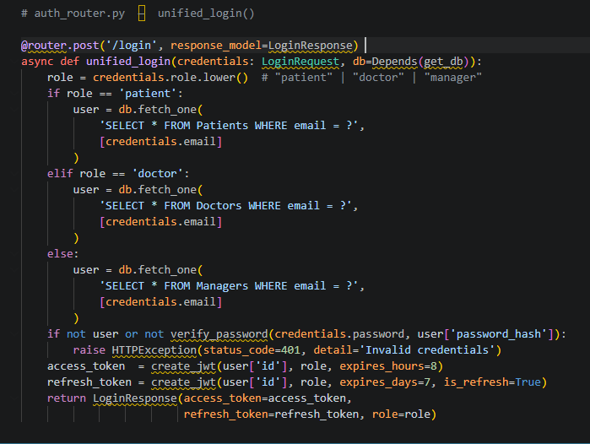

Face-Based Patient Login Flow
Patients may authenticate using facial biometrics instead of a password. The mobile app captures a live image, encodes it as Base64, and sends it to /auth/patient-login-face. The backend calls the FaceService to extract a 512-dimensional embedding, compares it against stored embeddings using cosine similarity (threshold: 0.65), and issues a JWT on success. This flow is detailed further in Chapter 8.

5.3 Patient Module
The Patient module manages the full patient lifecycle: self-registration with face enrollment, profile retrieval, profile updates, and medical history access. All endpoints require a valid patient JWT unless otherwise noted.

Patient Registration with Face Enrollment
During registration, the patient submits demographic data together with an optional face image. If a face image is provided, the FaceService enrolls the embedding immediately, enabling passwordless login from the first session.

Method | Endpoint | Description | Auth Required
POST | /patient/register | Register new patient + face enrol | No
POST | /patient/login | Password-based patient login | No
POST | /patient/login-face | Face-based patient login | No
GET | /patient/profile | Retrieve authenticated patient profile | Patient JWT
PUT | /patient/profile | Update patient profile fields | Patient JWT
GET | /patient/medical-history | Full consultation history | Patient JWT
GET | /patient/appointments | List upcoming appointments | Patient JWT
GET | /patient/chat-sessions | AI chatbot session history | Patient JWT
POST | /patient/upload-face | Re-enrol / update face embedding | Patient JWT

5.4 Doctor Module
The Doctor module exposes endpoints for queue management, patient record review, clinical note creation, and prescription issuance. All routes are protected by a doctor-role JWT. The module integrates tightly with the Appointment & Queue module to present a real-time dashboard.

Method | Endpoint | Description
GET | /doctor/dashboard | Aggregated today's stats (patients seen, pending queue)
GET | /doctor/queue | Live queue list for the authenticated doctor
PUT | /doctor/queue/next | Advance queue — call next patient
GET | /doctor/patients/{patient_id} | Full patient profile + medical history
POST | /doctor/notes | Create a new clinical note for a patient
GET | /doctor/notes/{patient_id} | Retrieve all notes for a specific patient
POST | /doctor/prescriptions | Issue a prescription (triggers pharmacy checks)
GET | /doctor/prescriptions/{id} | Retrieve a prescription by ID
GET | /doctor/files/{patient_id} | List medical files with AI analysis results

5.5 Appointment & Queue Module
The Appointment module manages the full scheduling lifecycle from booking through queue tracking to consultation completion. A sophisticated estimated wait time algorithm ensures patients receive accurate time predictions based on current queue depth.

Estimated Wait Time Algorithm
When a patient joins the queue, the system calculates their expected wait time using the following logic:

Method | Endpoint | Description
POST | /appointments/book | Book an appointment with a doctor
GET | /appointments/ | List all appointments for authenticated user
PUT | /appointments/{id}/cancel | Cancel an appointment
POST | /appointments/queue/join | Join real-time queue for a doctor
GET | /appointments/queue/status | Get current queue position + estimated wait
PUT | /appointments/queue/leave | Leave the queue before being called
GET | /appointments/doctors | List available doctors with queue lengths

5.6 Manager Module
The Manager (Admin) module provides hospital administrators with system-wide visibility and control. Key capabilities include doctor CRUD operations, patient management, AI performance monitoring, and log inspection. All endpoints require a manager-role JWT.

Method | Endpoint | Description
GET | /manager/dashboard | System-wide stats: patient count, doctor count, daily consultations
POST | /manager/doctors | Create a new doctor account
GET | /manager/doctors | List all doctors with queue and specialty info
PUT | /manager/doctors/{id} | Update doctor profile
DELETE | /manager/doctors/{id} | Deactivate a doctor account
GET | /manager/patients | Paginated list of all patients
GET | /manager/ai-metrics | AI chatbot accuracy & response-time metrics
GET | /manager/system-logs | Application event logs with severity filter
GET | /manager/api-logs | Full request/response log with filtering by route
POST | /manager/broadcast | Send push notification to all patients

5.7 Medical Files Module
The Medical Files module handles the ingestion, storage, and AI-powered analysis of clinical images such as X-rays, MRI scans, CT scans, and laboratory results. Upon upload, the system automatically triggers an asynchronous analysis pipeline using the Qwen2.5-VL vision-language model via OpenRouter.

Upload & AI Analysis Trigger
Files are streamed to the server, validated for format and size (max 20 MB), persisted to disk, and a database record is created. Analysis is triggered asynchronously to avoid blocking the upload response:
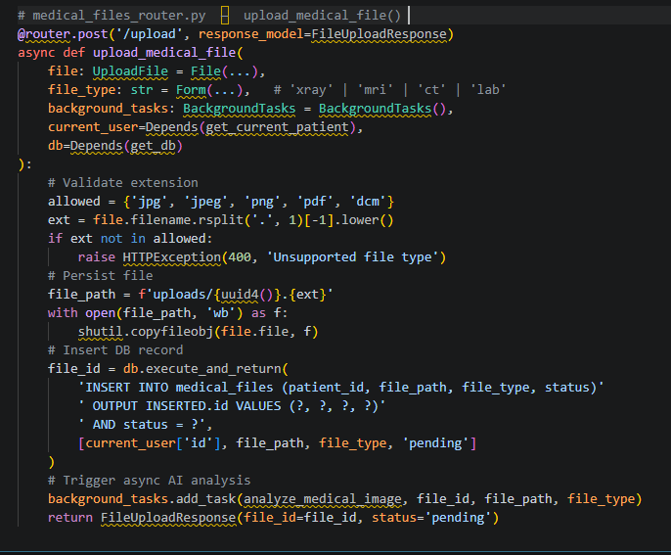

.5.8 Middleware & Cross-Cutting Concerns
MediVerse applies two custom middleware layers that operate transparently across all routes. These layers handle rate limiting and request logging without requiring any per-endpoint boilerplate.

Rate Limiter
The rate limiter enforces a sliding-window limit of 100 requests per 60 seconds per client IP address. It uses an in-memory counter with an optional Redis backend for distributed deployments. When the limit is exceeded, the middleware returns a 429 Too Many Requests response with a Retry-After header.

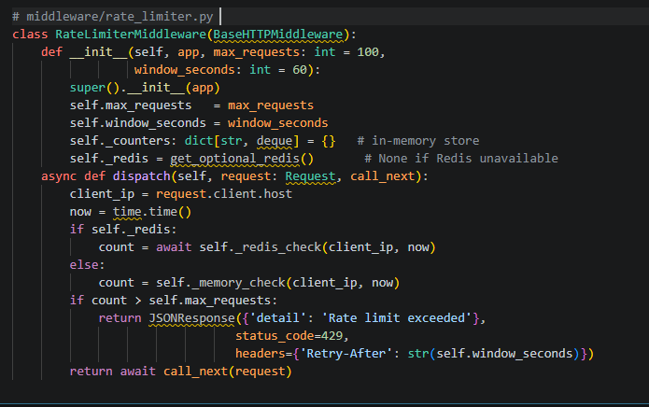

Request Logger
Every HTTP request and its corresponding response are persisted to the api_logs database table. The logger captures the client IP, HTTP method, URL path, status code, response time in milliseconds, and an optional truncated response body for debugging. This data powers the Manager's API log viewer.

.5.9 Pydantic Models & Data Validation
All request and response payloads are validated through Pydantic v2 models. Field validators enforce business rules at the schema level, eliminating the need for repetitive validation logic inside route handlers. Key models are shown below.

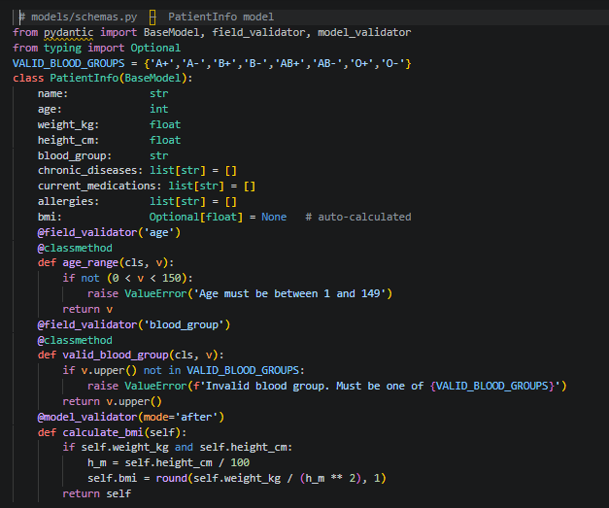

5.10 Error Handling Strategy
MediVerse adopts a defence-in-depth error handling approach. At the route level, HTTPException is raised with structured detail messages and appropriate HTTP status codes. Optional dependencies (Redis, aiohttp, tenacity) are imported with graceful fallbacks so that the API remains operational even when infrastructure components are unavailable.
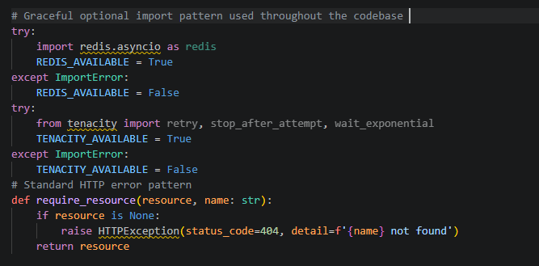

HTTP Code | Scenario | Example Detail Message
400 | Invalid input / validation error | "Age must be between 1 and 149"
401 | Missing or invalid JWT | "Invalid or expired token"
403 | Insufficient role permissions | "Doctor access required"
404 | Resource not found | "Patient not found"
409 | Conflict (duplicate resource) | "Email already registered"
422 | Pydantic validation failure | Auto-generated field error detail
429 | Rate limit exceeded | "Rate limit exceeded. Retry-After: 60s"
500 | Unhandled server error | "Internal server error — see logs"

5.11 Configuration Management
All application configuration is centralised in config/settings.py through a nested Pydantic Settings model (AppConfig). Environment variables are loaded from a .env file using python-dotenv, ensuring that no secrets are hard-coded in the codebase. Each logical subsystem has its own configuration sub-class:
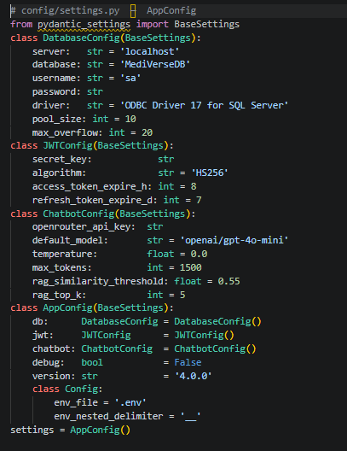

6.1 Chatbot System Overview

The MediVerse AI Chatbot is an intelligent, patient-facing emergency triage assistant designed to analyse reported symptoms, deliver evidence-based first-aid guidance, and route each patient to the most appropriate medical specialty — all in real time and in both Arabic and English. The system is embedded within the MediVerse Hospital
Management Platform and operates as a standalone microservice, exposing a RESTful API consumed by the patient portal frontend.

Component | Role
Patient Input | Free-text symptoms (Arabic or English) entered via chat UI
RAG Pipeline | Retrieves the top-5 most similar knowledge-base records via cosine similarity
LLM Analysis | Synthesises RAG context + patient profile into a structured medical response
Structured Response | JSON output: diagnosis, severity (1–10), first aid, specialty, warnings

Pipeline
Patient enters symptoms → Input Validation → RAG Search (cosine similarity, top-5, threshold = 0.55) → Patient
Profile Injection → LLM Analysis (OpenRouter, temp = 0.0) → Structured JSON Response + Consultation
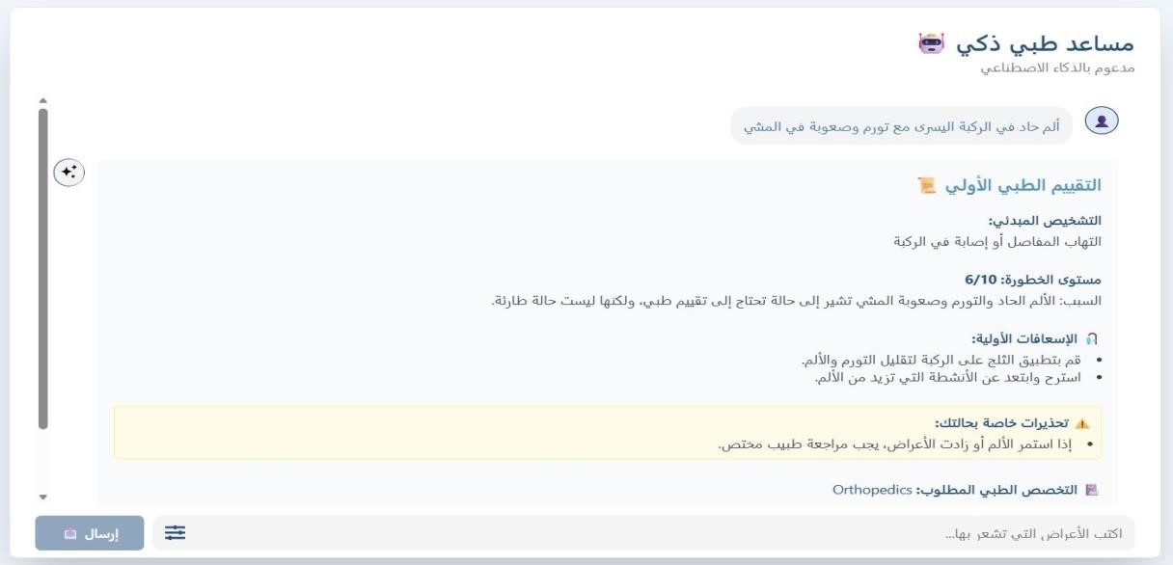

Figure 6.1: AI Chatbot Triage Result — Arabic interface showing preliminary diagnosis, severity assessment (7/10), first-aid steps, warnings, and specialty routing to Emergency Medicine.

6.2 RAG Architecture

6.2.1 Why RAG?
Retrieval-Augmented Generation was chosen over a pure LLM approach because it grounds every response in curated, validated medical records rather than relying solely on model-internal knowledge. This significantly reduces hallucination risk and ensures first-aid steps are traceable to authoritative clinical sources. Unlike finetuning, RAG allows the knowledge base to be updated independently of the model, making it straightforward to add new symptom-diagnosis pairs, revise first-aid protocols, or expand coverage to new specialties without retraining any neural network weights.
The retrieval step acts as a factual anchor: the LLM is presented with the five most semantically similar records from the knowledge base alongside the patient's reported symptoms and profile. This context narrows the model's generative search space to clinically relevant outputs and forces alignment with pre-validated first-aid protocols.

Parameter | Value | Rationale
Embedding Model | paraphrase-multilingual-MiniLM L12-v2 | Native Arabic + English support; fast inference
Similarity Metric | Cosine Similarity | Direction-sensitive; robust to vector magnitude variance
Threshold | 0.55 | Empirically tuned to balance recall and precision
Top-K Retrieval | 5 records | Provides sufficient context without exceeding  LLM token budget
Storage Format | bytes (BLOB) in DB | Avoids external vector store dependency; portable

6.2.2 Why Multilingual Embeddings?
Egyptian patients frequently mix Arabic and Latin-script medical terms in their symptom descriptions. The paraphrase-multilingual-MiniLM-L12-v2 model was trained on 50+ languages and produces language-agnostic semantic embeddings, enabling cross-lingual retrieval without any translation overhead. A query submitted in
Egyptian colloquial Arabic will correctly retrieve knowledge-base records written in Modern Standard Arabic or in English, because the embedding space captures semantic meaning rather than surface-level token overlap.

6.2.3 Embedding Storage Strategy
Each knowledge-base record stores its embedding as a raw byte sequence (symptoms_embedding_bytes) directly in the SQL Server database using np.ndarray.tobytes(). This eliminates the need for an external vector store such as Pinecone or Weaviate, keeping the deployment footprint minimal and the system fully portable. At startup, the RAG service loads all embeddings into a NumPy matrix once (lazy-loading singleton pattern) and performs all subsequent similarity searches entirely in memory, achieving sub-10ms retrieval latency.

6.3 The symptoms_knowledge_base — Data Collection

The symptoms_knowledge_base is the factual backbone of the triage system. Building a high-quality, Arabicaware medical knowledge base required consulting and merging multiple authoritative sources, then validating each record against clinical guidelines. The resulting dataset covers 8 organ systems across 12 specialties, with severity levels weighted toward the clinically critical range of 5–9.

6.3.1 Data Sources
Source | Description
WHO Emergency Care & Guidelines | International emergency protocols and triage decision trees
MedlinePlus Symptom Database | Structured symptom-to-diagnosis mappings (U.S. NLM)
Egyptian Ministry of Health First-Aid | Localised Arabic first-aid instructions
Manchester Triage System (MTS) | International five-level triage severity framework
Harrison's Principles of Internal Medicine | Clinical reference for diagnosis validation
Oxford Handbook of Emergency Medicine | Emergency-specific differential diagnosis support

All records were cross-referenced across at least two sources and reviewed for clinical consistency before being added to the database. Records that could not be verified were excluded.

6.3.2 Record Structure
Column | Type | Description
symptoms_text | NVARCHAR(MAX) | Free-text symptom description (Arabic and/or English)
probable_diagnosis | NVARCHAR(MAX) | Likely clinical diagnosis associated with symptoms
specialty_required | VARCHAR(100) | Medical specialty to route the patient to
severity_level | INT (1–10) | Triage severity: 1 = minor, 10 = life-threatening
first_aid_steps | NVARCHAR(MAX) | Step-by-step first-aid instructions (pre-hospital)
symptoms_embedding_bytes | VARBINARY(MAX) | Binary float32 embedding vector for cosine search
created_at / updated_at | DATETIME | Audit timestamps for data provenance

The symptoms_embedding_bytes column stores the 384-dimensional float32 vector as raw bytes (1,536 bytes per record). Storing embeddings inline with their source records ensures.

6.4 symptoms_knowledge_base — Data Examples

The table below illustrates representative records from the knowledge base, showing how Arabic symptom descriptions are mapped to diagnoses, specialties, and severity levels.
Symptoms (Arabic) | Probable Diagnosis | Specialty | Sev.
ألم في الصدر مع ضيق في التنفس وعرق | Myocardial Infarction | Cardiology | 9
صدا ع مفاجئ شديد مع فقدان الوعي | Subarachnoid Haemorrhage | Neurology | 9
حروق في الجس م من النار | Thermal Burns | Emergency Med. | 7
ألم في الساق مع تشوه في العظمة | Tibia Fracture | Orthopedics | 6
ضيق في التنفس مع صفير | Asthma Exacerbation | Pulmonology | 7
إسهال وقيء متكرر وألم في البطن | Acute Gastroenteritis | Gastroenterology | 4
حكة وطفح جلدي على الجسم | Urticaria | Dermatology | 3
سعال وزكا م وحرارة مرتفعة | Upper RT Infection | General Practice | 2
حرارة وبكاء مستمر عن د الرضيع | Infantile Fever / Colic | Pediatrics | 4
خوف شديد وضيق في التنفس وخفقان | Anxiety / Panic Attack | Psychiatry | 3

6.4.1 Severity Scale (1–10)
Range | Label | Clinical Meaning | Recommended Action
1–2 | Minimal | Self-limiting; no intervention required | Self-care guidance
3–4 | Mild | Non-urgent; outpatient visit within days | GP / clinic referral
5–6 | Moderate | Requires medical evaluation within hours | Scheduled ER / specialist
7–8 | Severe | Urgent intervention needed | Immediate ER visit
9–10 | Critical | Life-threatening; every minute counts | Call emergency services / 123

The severity scale is based on the Manchester Triage System (MTS) five-level framework, adapted to a 10-point integer scale.

6.4.2 Specialty Mapping (12 Specialties)
The knowledge base covers twelve medical specialties, ensuring that the triage system can route patients to the correct outpatient or emergency department. Emergency Medicine serves as the catch-all specialty for multi system compromise and any case where severity reaches 8 or above.

Specialty | Covered Conditions
Emergency Medicine | Multi-trauma, poisoning, anaphylaxis, undifferentiated critical illness
Cardiology | Chest pain, arrhythmia, heart failure, myocardial infarction
Neurology | Stroke, seizure, severe headache, altered consciousness
Pulmonology | Asthma, COPD, pneumonia, respiratory failure
Gastroenterology | Abdominal pain, GI bleeding, acute abdomen
Orthopedics | Fractures, dislocations, joint injuries
Dermatology | Rash, burns, skin infections, urticaria
Psychiatry | Panic attacks, acute psychosis, suicidal ideation
Pediatrics | Fever, colic, respiratory distress in children
Ophthalmology | Eye trauma, sudden vision loss, foreign body
ENT | Ear pain, foreign body, epistaxis
General Practice | Minor infections, follow-up, non-urgent symptoms

6.4.3 Coverage & Quality Assurance
- Source validation — every record must be traceable to at least one authoritative medical source listed in Section 6.3.1.
- Clinical review — first-aid steps are verified to be safe for pre-hospital, layperson administration without specialist equipment.
- Embedding sanity check — the generated vector is tested against five semantically similar queries to confirm it is retrieved correctly.

Records are versioned using created_at / updated_at audit timestamps, allowing rollback to previous knowledge base states if a record is found to be clinically incorrect after deployment.

6.5 RAGService Implementation

The RAGService class encapsulates all retrieval logic. It follows a singleton pattern to avoid reloading embeddings on every request, and uses vectorised NumPy operations for maximum search performance. 6.5.1 Cosine Similarity Search

class RAGService:
_embeddings = None
_records = None

@classmethod
def _load(cls):
if cls._embeddings is None:
rows = db.execute('SELECT * FROM symptoms_knowledge_base').fetchall()
cls._records = [dict(r) for r in rows]
cls._embeddings = np.array([
np.frombuffer(r['symptoms_embedding_bytes'], dtype=np.float32)
for r in cls._records
])
# shape: (N, 384)

@classmethod
def search(cls, query: str, top_k: int = 5, threshold: float = 0.55) -> list[dict]:
cls._load()
q_vec = embed(query)
q_norm = q_vec / np.linalg.norm(q_vec)
e_norm = cls._embeddings / np.linalg.norm(cls._embeddings, axis=1, keepdims=True)
scores = e_norm @ q_norm
top_idx = np.argsort(scores)[::-1][:top_k]
return [{**cls._records[i], 'similarity': float(scores[i])} for i in top_idx if scores[i]
>= threshold]

6.5.2 Embedding Generation
Embeddings are generated using the paraphrase-multilingual-MiniLM-L12-v2 model from SentenceTransformers.
The model runs locally at no API cost and produces 384-dimensional float32 vectors. Each vector is stored as raw bytes using np.ndarray.tobytes() for space efficiency.

6.5.3 Paginated Search for Large Databases
For future scalability, the RAGService supports chunked retrieval: embeddings are processed in batches of 10,000 vectors, with partial top-K results merged and re-ranked after all chunks are processed.

6.6 LLM Integration via OpenRouter

OpenRouter is used as the LLM gateway because it provides a single unified API endpoint that routes requests to multiple underlying model providers.

Model | Provider | Use Case
GPT-4o | OpenAI | Highest accuracy; complex multi-symptom cases
GPT-4o-mini | OpenAI | Cost-optimised; routine triage queries
Gemini Pro 1.5 | Google | Alternative when OpenAI rate-limited
Claude 3.5 Sonnet | Anthropic | Strong reasoning; long-context patient profiles
Llama 3.1 70B | Meta (via OpenRouter) | Open-weight fallback; zero marginal cost
Mixtral 8x7B | Mistral AI | Fast inference; lower-latency option

Temperature Setting
Temperature = 0.0 is set for all medical completions to ensure fully deterministic outputs. A non-zero temperature could introduce random variance into severity assessments or first-aid instructions — clinically unacceptable in an emergency triage context where reproducibility and consistency are safety requirements.

6.7 The Medical System Prompt — Design Decisions
The system prompt is the single most critical engineering artefact in the LLM pipeline.

6.7.1 Input Validation Logic
The prompt instructs the LLM to set input_valid = false when the user message is a greeting, random text, or clearly non-medical in nature.

SYSTEM_PROMPT = '''
You are MediVerse AI — an expert medical triage assistant.

RULES:
1. Only respond to medical symptoms, health questions, or first-aid queries.
2. If the input is a greeting or non-medical text, set input_valid = false.
3. ALWAYS respond in the SAME language as the patient input.
4. Severity must be an integer 1-10. Do not use decimals.
5. specialty_required must be one of the 12 approved specialties.
6. Return ONLY a valid JSON object — no markdown, no explanation.
'''

6.7.2 Specialty Selection Rules
Emergency Medicine is selected when severity >= 8, when the diagnosis involves multi-system compromise, or when no other single specialty clearly applies.

6.7.3 Organ-System Routing Logic
Organ System / Trigger Keywords | Routed Specialty
Chest pain, palpitations, ECG changes, dyspnoea at rest | Cardiology
Sudden headache, facial droop, limb weakness, slurred speech | Neurology
Wheezing, cough, O2 saturation drop, respiratory distress | Pulmonology
Abdominal pain, haematemesis, jaundice, acute abdomen | Gastroenterology
Fracture, dislocation, limb deformity, orthopaedic trauma | Orthopedics
Rash, urticaria, burn, skin infection, angioedema | Dermatology
Panic attack, psychosis, self-harm, suicidal ideation | Psychiatry
Paediatric fever, colic, failure to thrive, rash in child | Pediatrics
Eye trauma, sudden vision loss, foreign body in eye | Ophthalmology
Ear pain, epistaxis (nosebleed), foreign body in ENT | ENT
Multi-trauma, poisoning, anaphylaxis, severity >= 8 | Emergency Medicine

6.8 Patient Context Integration

Every LLM prompt is personalised with the requesting patient's full clinical profile. This transforms the chatbot from a generic triage tool into a patient-aware medical assistant that accounts for pre-existing conditions, allergies, and current medications.
6.8.1 Profile Fields Injected into Every Prompt
Profile Field | How It Influences the Response
Age & Gender | Adjusts differential diagnoses (e.g., MI more likely in older males)
Weight & Height → BMI | BMI category included; flags obesity-related risk factors
Chronic Diseases | Cross-checked against diagnosis (e.g., diabetic ketoacidosis risk)
Allergies | Warning generated if first-aid step involves a known allergen
Current Medications | Drug interactions flagged in warnings[] field

6.8.2 LLMService.build_prompt() — Patient Injection
def build_prompt(symptoms: str, patient: dict, rag_context: str) -> list[dict]:
bmi = patient['weight'] / (patient['height'] / 100) ** 2
bmi_cat = classify_bmi(bmi)
profile = f"""PATIENT PROFILE:
- Age: {patient['age']} | Gender: {patient['gender']}
- BMI: {bmi:.1f} ({bmi_cat})
- Chronic Diseases: {patient['chronic_diseases'] or 'None'}
- Allergies: {patient['allergies'] or 'None'}
- - Current Medications: {patient['current_medications'] or 'None'}
- """
- return [
{'role': 'system', 'content': SYSTEM_PROMPT},
{'role': 'user',
'content': profile + rag_context + symptoms}
]

6.9 RAG + LLM Fusion Strategy
When RAG retrieves relevant records from the knowledge base, their first-aid steps are injected into the prompt as authoritative context. The LLM is instructed to prefer RAG-sourced first-aid over self-generated steps, maintaining factual grounding.
Priority Rule
RAG-sourced first-aid steps always take precedence over LLM-generated steps. The first_aid_source field enables auditability of every triage response.

6.9.2 First-Aid Context Injection
def inject_rag_context(rag_matches: list[dict]) -> str:
if not rag_matches:
return ''
context = '\nRELEVANT MEDICAL KNOWLEDGE:\n'
for i, match in enumerate(rag_matches, 1):
context += f"[{i}] Diagnosis: {match['probable_diagnosis']}"
context += f"
Severity: {match['severity_level']}/10"
context += f"
Specialty: {match['specialty_required']}"
context += f"
First Aid: {match['first_aid_steps']}"
context += f"
(Similarity: {match['similarity']:.2f})"
context += '\nPRIORITY: Use the first-aid steps above if relevant.\n'
return context

Response Field | Value when RAG used | Value when RAG not used
first_aid_source | "RAG" | "LLM"
rag_first_aid_used | true | false
first_aid[] | Steps from knowledge base | Steps generated by LLM

6.10 Structured Response Parsing

The LLM is instructed to return a strict JSON object. In practice, models occasionally wrap JSON in markdown code fences or produce minor formatting deviations. The parser applies a three-stage fallback strategy to handle all real-world model outputs robustly.

6.10.1 JSON Output Schema

Field | Type | Description
input_valid | boolean | False if input was not a medical query
preliminary_diagnosis | string | Most likely diagnosis given symptoms + context
severity_level | integer (1–10) | Triage severity score
severity_label | string | Human-readable: Minimal / Mild / Moderate / Severe /  Critical
first_aid | string[] | Ordered list of first-aid action steps
warnings | string[] | Patient-specific warnings (allergies, drug interactions)
specialty_required | string | Medical specialty for patient routing
emergency_required | boolean | True if severity >= 8 or immediate ER visit needed
first_aid_source | string | "RAG" or "LLM"
rag_first_aid_used | boolean | Whether RAG knowledge base supplied first-aid steps

6.10.2 Robust Parsing — parse_response_robust()
def parse_response_robust(raw: str) -> dict:
# Stage 1: direct JSON parse
try:
return json.loads(raw)
except json.JSONDecodeError:
pass

# Stage 2: extract from markdown code block
match = re.search(r'```(?:json)?\s*({.*?})\s*```', raw, re.DOTALL)
if match:
try: return json.loads(match.group(1))
except: pass

# Stage 3: regex extraction of top-level JSON object
match = re.search(r'{.*}', raw, re.DOTALL)
if match:
try: return json.loads(match.group())
except: pass

return DEFAULT_RESPONSE
# safe fallback

6.11 Severity Assessment System

The SeverityAssessment Pydantic model validates and auto-corrects the severity output from the LLM before it is returned to the frontend or stored in the database.

6.11.1 SeverityAssessment Pydantic Model
from pydantic import BaseModel, validator

LABEL_MAP = {
(1, 2):'Minimal',(3, 4):'Mild',
(5, 6):'Moderate',(7, 8):'Severe',
(9, 10):'Critical'
}

class SeverityAssessment(BaseModel):
level: int
# 1-10
label: str
reasoning: str
emergency_required: bool
# True if level >= 8

@validator('label', always=True)
def sync_label(cls, v, values):
lvl = values.get('level', 1)
for rng, lbl in LABEL_MAP.items():
if rng[0] <= lvl <= rng[1]: return lbl
return v

@validator('emergency_required', always=True)
def set_emergency(cls, v, values):
return values.get('level', 1) >= 8

6.11.2 Severity-to-Action Mappin
Severity Level | Label | System Action
1–2 | Minimal | Return self-care advice; no specialty routing required
3–4 | Mild | Route to General Practice or relevant outpatient specialty
5–6 | Moderate | Route to specialist; recommend same-day or next-day visit
7–8 | Severe | Route to Emergency Medicine; flag urgent visit
9–10 | Critical | emergency_required = true; display 123 / ambulance prompt

6.12 Consultation Persistence

Every triage consultation is persisted to the patient_consultations table immediately after the AI response is generated. This enables retrospective audit, feedback collection, and model performance measurement.

6.12.1 patient_consultations Table
Column | Type | Description
consultation_id | INT (PK) | Auto-increment primary key
patient_id | INT (FK) | References Patients.id
session_id | INT (FK) | References chat_sessions.session_id
symptoms_reported | NVARCHAR(MAX) | Raw symptom text entered by the patient
patient_age_at_consultation | INT | Snapshot of patient age at time of consultation
chronic_diseases_snapshot | NVARCHAR(MAX) | Snapshot of chronic diseases at consultation time
current_meds_snapshot | NVARCHAR(MAX) | Snapshot of current medications
allergies_snapshot | NVARCHAR(MAX) | Snapshot of known allergies
ai_preliminary_diagnosis | NVARCHAR(MAX) | AI-generated diagnosis text
ai_severity_assessment | INT | Severity score 1–10 from AI
ai_specialty_suggested | VARCHAR(100) | Specialty the AI routed the patient to
ai_first_aid_given | NVARCHAR(MAX) | First-aid steps provided to the patient
rag_top_matches | NVARCHAR(MAX) | JSON array of top-5 RAG matches used
actual_diagnosis | NVARCHAR(MAX) | Doctor-confirmed diagnosis (post-consultation)
was_ai_correct | BIT | Feedback flag: 1 if AI diagnosis matched doctor's
llm_model_used | VARCHAR(100) | OpenRouter model identifier used for this query
processing_time_ms | INT | End-to-end processing time in milliseconds

6.12.2 Feedback Loop Design
The was_ai_correct field is populated by the attending doctor after reviewing the consultation outcome.
. 6.13 Retry Logic & Reliability

Medical applications demand high availability. The chatbot service implements multiple reliability layers to ensure degraded LLM provider performance does not translate to patient-facing failures.

6.13.1 Tenacity Retry Configuration
from tenacity import retry, stop_after_attempt, wait_exponential

@retry(
stop=stop_after_attempt(3),
wait=wait_exponential(multiplier=1, min=2, max=10),
reraise=True
)
async def call_llm(messages: list[dict], model: str) -> str:
response = await openrouter_client.chat(messages, model=model)
return response.choices[0].message.content

Retry Policy
Three attempts with exponential back-off (2s → 4s → 8s, capped at 10s). If all three attempts fail, the system returns the safe default response and logs the failure for operational alerting.

6.13.2 Rate Limiting
Layer | Limit | Implementation
Per-user (in-memory) | 100 requests / hour | Sliding window counter keyed on user_id
Per-user (Redis) | 100 requests / hour | Persistent; survives process restart
Global (OpenRouter) | Provider-dependent | Handled by tenacity retry on 429 responses

6.13.3 Metrics Collection
- Success rate — percentage of requests returning a valid structured response.
- P95 Latency — 95th-percentile end-to-end processing time in milliseconds.
- RAG hit rate — percentage of requests where at least one RAG match exceeded the threshold.
- LLM model distribution — breakdown of requests per model for cost attribution and capacity planning.

6.14 Input Validation Guard

Before invoking the RAG search or LLM, every incoming message is passed through a lightweight input validation layer. This eliminates unnecessary API calls for clearly non-medical inputs and protects against prompt injection attempts.

6.14.1 is_valid_symptoms() Function

def is_valid_symptoms(text: str) -> bool:
"""Returns True if the text appears to be a medical symptom description.
Handles both Arabic and English inputs.
"""
text = text.strip()
if len(text) < 3:
return False

GREETINGS = {'hello', 'hi', 'hey', 'مرحبا' ,'هاي' ,'السلام عليكم'}
if text.lower() in GREETINGS:
return False

['ألم' ,'وجع' ,'حمى' ,'سعال' ,'دوخة ' ,'صداع'AR_KEYWORDS = [
EN_KEYWORDS = ['pain', 'ache', 'fever', 'cough', 'nausea', 'dizzy']
combined = AR_KEYWORDS + EN_KEYWORDS
return any(kw in text.lower() for kw in combined) or len(text) > 15

6.14.2 Valid vs. Invalid Input Examples
Input | is_valid | Reason
أل م في الصدر وضيق في التنفس | True | Clear medical symptom description in Arabic
I have a severe headache and nausea | True | Medical symptom description in English
مرحبا | False | Arabic greeting — no medical content
hello | False | English greeting
asdfgh | False | Random characters, no medical keywords
عندى سكر وعاوز اعرف الدواء المناسب | True | Medical question about diabetes medication

6.14.3 input_valid Flag in Response
When input_valid = false, the response object still conforms to the full JSON schema but contains a helpful guidance message instead of a medical diagnosis. All other fields (severity, specialty, first_aid) are set to safe defaults.

6.14.4 Chatbot Doctor Recommendation UI
After the AI triage is complete, the system presents the patient with available specialists matching the recommended specialty. Each doctor card displays the physician's name, specialty, rating, floor and room location, and a direct booking button.
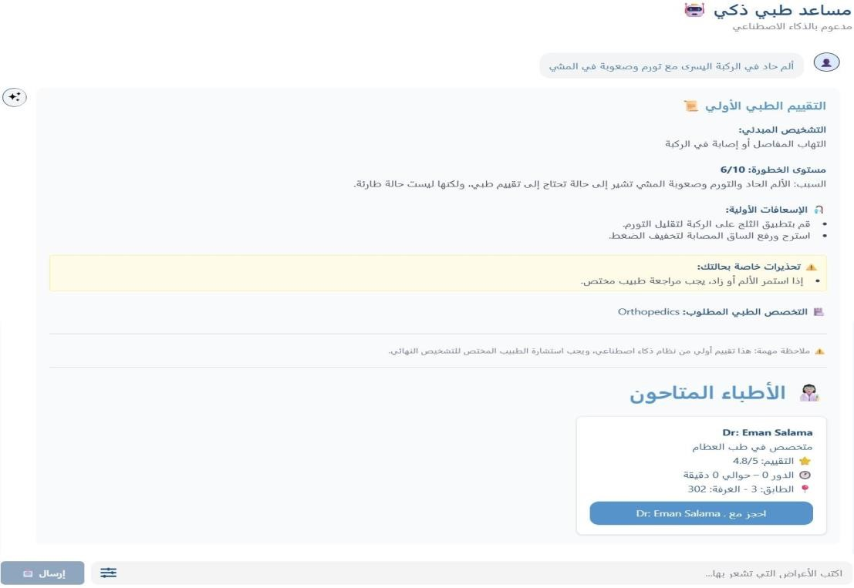

6.14.5 Input Validation Guardrail Summary
The input validation layer serves as the first line of defence against prompt injection attacks and irrelevant queries.
By filtering out non-medical inputs before they reach the LLM, the system reduces unnecessary API calls, improves response latency, and prevents the model from hallucinating diagnoses for invalid input

Pharmacy Module Overview

The Smart Pharmacy Module is the core intelligence layer of the hospital management system. It exposes a unified FastAPI-based API that combines structured pharmaceutical data, vector-based semantic search, vision-language OCR, and patient-aware logic to deliver safe, personalised drug recommendations in real time.
The module is built around four core functions:
- Drug Recommendation — keyword and semantic search returning ranked, patient-filtered drug cards
- Prescription OCR — anchor-based vision pipeline that reads handwritten prescriptions and resolves drug names
- Drug Interaction Analysis — cross-references any combination of drugs against a curated interactions table
- Alternatives Suggestion — finds bioequivalent substitutes using active ingredient matching and fuzzy name resolution
Architecture Pattern: React Frontend → FastAPI Gateway → [Drug DB ■ Embeddings Engine ■ Vision LLM ■ Interaction Table]

Figure 7.1 — Prescription OCR pipeline (Agentic Pipeline view): Pass 1 Masked OCR → DB Anchor Search → Pass 2 Confirm → GPT-4o Analysis.
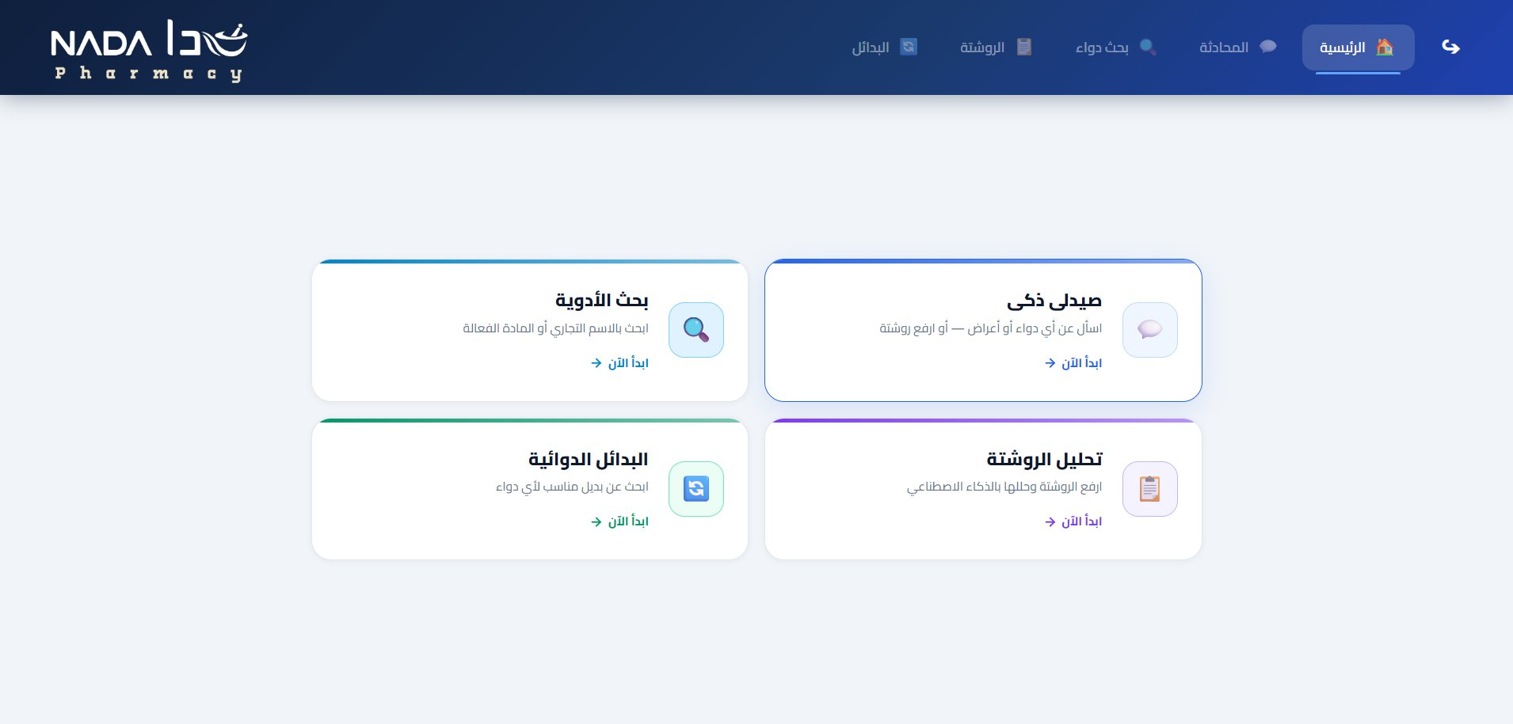
Figure 7.0 — Smart Pharmacy Module home screen: four entry points — Drug Search, Smart Pharmacy Chat, Drug Alternatives, and Prescription Analysis.

  - egypt_drugs Database — Sourcing & Collection

The egypt_drugs table is the backbone of the pharmacy module. It was built specifically for the Egyptian pharmaceutical market to ensure drug names, dosage forms, and availability information reflect what patients and pharmacists encounter locally.

Data Sources
      - Egyptian Drug Authority (EDA) — official registry of approved medicines in Egypt
      - CAPMAS Pharmaceutical Registry — Central Agency for Public Mobilization and Statistics data
      - Egyptian Pharmacopoeia — standard reference for drug specifications and quality criteria
      - WHO Essential Medicines List — cross-referenced to flag globally essential drugs
      - Manual curation and clinical validation — pharmacist review of edge cases, dosage conflicts, and missing fields

Database Fields (13 Columns)
The egypt_drugs table contains 13 columns covering the full clinical profile of each drug:

Field Name | Type | Description
drug_name | TEXT | Trade name as registered with the Egyptian Drug Authority
active_ingredient | TEXT | International Non-proprietary Name (INN) of the active pharmaceutical ingredient
drug_class | TEXT | Pharmacological class (e.g. NSAID, Beta-blocker, ACE inhibitor)
dosage_form | TEXT | Physical form: Tablet / Capsule / Syrup / Injection / Cream / etc.
indications | TEXT | Approved therapeutic uses and clinical indications
dosage_adults | TEXT | Recommended adult dosage and frequency
dosage_children | TEXT | Pediatric dosage (weight-based if applicable) or contraindication note
side_effects_common | TEXT | Common adverse effects with incidence greater than 1%
side_effects_serious | TEXT | Serious or life-threatening adverse effects requiring urgent attention
contraindications | TEXT | Absolute contraindications — conditions where the drug must not be used
warnings | TEXT | Black-box warnings, important precautions, and monitoring requirements
pregnancy | TEXT | Pregnancy safety category and guidance (FDA category or equivalent)
breastfeeding | TEXT | Lactation safety: compatible / use with caution / contraindicated

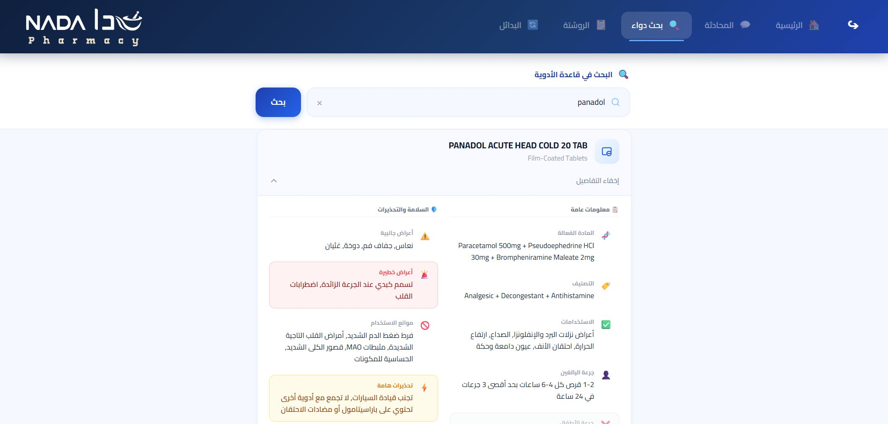
Figure 7.2b.

Drug Recommendation Engine

The recommendation engine uses a two-stage approach: a fast SQL keyword search for exact or near-exact matches, followed by a semantic vector search for conceptual similarity. Results from both stages are merged, deduplicated, and ranked before being returned to the frontend.
    - Keyword Search — search_drugs_by_indication()
The keyword search performs a multi-column SQL LIKE query across the most clinically relevant fields. This covers cases where the user searches by drug name, symptom, or active ingredient.
def search_drugs_by_indication(query: str, limit: int = 10) -> list[dict]: terms = query.lower().split()
conditions, params = [], [] for term in terms:
conditions.append(
'(LOWER(drug_name) LIKE ? OR LOWER(active_ingredient) LIKE ?' ' OR LOWER(indications) LIKE ? OR LOWER(drug_class) LIKE ?)'
)
params.extend([f'%{term}%'] * 4) where = ' AND '.join(conditions)
sql = f'SELECT * FROM egypt_drugs WHERE {where} LIMIT {limit}' cursor.execute(sql, params)
return [dict(row) for row in cursor.fetchall()]

Result Ranking and Deduplication
After combining keyword duplicates are removed by drug_name and results are ranked by:
      - Exact match on drug_name or active_ingredient — highest priority
      - Semantic similarity score from the embedding search
      - Keyword match count across the four searched columns

Drug Embeddings — Vector Search

To capture semantic similarity beyond keyword matching, each drug is represented as a
high-dimensional embedding vector. At query time, the user input is embedded and compared against all drug vectors using cosine similarity.
    - Building Embeddings — build_embeddings()
The embedding pipeline runs offline and produces a compressed .npz file:
      - Load all rows from egypt_drugs
      - For each drug, call build_drug_text() to concatenate all relevant fields into a single string
      - Send each string to text-embedding-3-small model via OpenRouter API
      - Store the resulting 1536-dimension vectors in a NumPy array
      - Save as drugs_embeddings.npz — drug names stored as a parallel array for lookup

def build_drug_text(drug: dict) -> str: parts = [
drug.get('drug_name', ''), drug.get('active_ingredient', ''), drug.get('drug_class', ''),
drug.get('indications', ''),
drug.get('dosage_form', ''), drug.get('side_effects_common', ''), drug.get('warnings', ''),
]
return ' | '.join(p for p in parts if p)

Cosine Similarity Search
At query time, the .npz file is loaded once into memory and similarity is computed in a single vectorised NumPy operation:

data = np.load('drugs_embeddings.npz')
embeddings = data['embeddings'] # shape: (N, 1536) drug_names = data['names']

def semantic_search(query: str, top_k: int = 5) -> list[str]: q_vec = get_embedding(query) # 1536-dim vector q_norm = q_vec / np.linalg.norm(q_vec)
e_norm = embeddings / np.linalg.norm(embeddings, axis=1, keepdims=True) scores = e_norm @ q_norm # cosine similarity
top_idx = np.argsort(scores)[::-1][:top_k] return [drug_names[i] for i in top_idx]

Prescription OCR — Anchor-Based Approach

Reading handwritten prescriptions is one of the most error-prone tasks in clinical practice. The module addresses this with an anchor-based OCR pipeline that uses a Vision Language Model to extract drug names, then validates each name against the egypt_drugs database.

Pipeline Steps
      - Step 1. Receive image file from the frontend (JPEG / PNG)
      - Step 2. Convert to base64 string for transmission to the Vision LLM API
      - Step 3. Pass 1 — send base64 image to Vision LLM with a masked OCR prompt: extract only drug names, dosages, and frequencies
      - Step 4. DB Anchor Search — fuzzy-match each extracted name against egypt_drugs using SequenceMatcher
      - Step 5. Pass 2 — send confirmed drug names back to Vision LLM for validation against the original image
      - Step 6. GPT-4o Analysis — full clinical analysis: interactions, risk level, Arabic summary
      - Step 7. Return structured JSON per medication: corrected name, dosage, frequency, route, duration

@app.post('/pharmacy/prescription/analyze-stream') async def analyze_prescription(image: UploadFile):
img_bytes = await image.read()
b64 = base64.b64encode(img_bytes).decode()

yield sse_event({'step': 'pass1', 'status': 'running'}) raw_names = await vision_llm_extract(b64) # Pass 1 yield sse_event({'step': 'pass1', 'status': 'done'})

yield sse_event({'step': 'db', 'status': 'running'})
anchored = db_anchor_search(raw_names) # fuzzy DB match yield sse_event({'step': 'db', 'status': 'done'})

yield sse_event({'step': 'pass2', 'status': 'running'}) confirmed = await vision_llm_confirm(b64, anchored) # Pass 2 yield sse_event({'step': 'pass2', 'status': 'done'})

yield sse_event({'step': 'analysis', 'status': 'running'}) result = await gpt_clinical_analysis(confirmed)
yield sse_event({'step': 'analysis', 'status': 'done'})

yield sse_event({'step': 'result', 'status': 'done', 'data': result})

Why Anchor-Based OCR?
Standard OCR models produce free text that must then be parsed — an unreliable step for handwritten content. The anchor-based approach instead asks the Vision LLM to produce only drug name tokens, which are immediately anchored to known database entries. This dramatically reduces hallucination and handles common handwriting ambiguities such as Augmentin vs Augmentin 625.

Drug Interaction Analysis

The interaction module cross-references any list of drug names against a curated drug_interactions table. Each interaction record stores the clinical effect, severity level, and management guidance.
    - drug_interactions Table Structure

Field | Type | Description
drug_a | TEXT | First drug in the interaction pair
drug_b | TEXT | Second drug in the interaction pair
severity | TEXT | contraindicated ■ major ■ moderate ■ minor
clinical_effect | TEXT | Description of the pharmacological interaction and expected clinical effect
management | TEXT | Clinical recommendation: avoid / monitor / dose-adjust / no action required
mechanism | TEXT | Pharmacokinetic or pharmacodynamic basis of the interaction
reference | TEXT | Source citation (Stockley, Micromedex, etc.)

Severity Levels

Severity | Clinical Meaning
contraindicated | Combination must never be used — documented life-threatening outcome
major | High risk of serious adverse event — use only if no alternative exists
moderate | Significant risk — monitor closely or consider dose adjustment
minor | Low clinical significance — routine monitoring sufficient
    - Interaction Check Logic

def check_interactions(drug_names: list[str]) -> list[dict]: results = []
pairs = [(a, b) for i, a in enumerate(drug_names) for b in drug_names[i+1:]] for a, b in pairs:
row = cursor.execute(
'''SELECT * FROM drug_interactions
WHERE (LOWER(drug_a)=? AND LOWER(drug_b)=?)
OR (LOWER(drug_a)=? AND LOWER(drug_b)=?)''',
(a.lower(), b.lower(), b.lower(), a.lower())
).fetchone() if row:
results.append(dict(row)) return results

Allergy-Safe Prescribing

Before any drug recommendation is returned to the user, the module checks the patient allergy profile to prevent allergic reactions. The allergy_database table covers not only direct allergens but also
cross-reactive substances.

    - allergy_database Table

Field | Description
allergen | Primary substance causing the allergic reaction
cross_reactive | Comma-separated list of substances with known cross-reactivity
drug_class_affected | All drugs in this class that may trigger the same allergic reaction
reaction_type | Type: anaphylaxis / urticaria / angioedema / rash / other
severity | Severity of typical response: mild / moderate / severe / life-threatening
safe_alternatives | Suggested drug classes or agents safe to use in allergic patients
emergency_treatment | First-line emergency management (e.g. epinephrine 0.3 mg IM for anaphylaxis)

Cross-Reactive Detection
When a patient allergy list includes penicillin, the system automatically flags all beta-lactam antibiotics as potentially unsafe and substitutes them with safe alternatives from the allergy_database.safe_alternatives field.
      - Patient allergy profile is loaded from the Patients table at request time
      - Each recommended drug is checked against allergen and cross_reactive lists
      - Unsafe drugs are removed from results; safe alternatives are appended with an allergy warning label

Alternative Drug Suggestions

When a prescribed drug is unavailable or contraindicated, the find_alternatives() function searches for bioequivalent substitutes using active ingredient matching and fuzzy name resolution for handling typos.
    - find_alternatives() Function

def find_alternatives(drug_name: str, patient_id=None) -> dict: # Step 1: exact match
drug = cursor.execute(
'SELECT * FROM egypt_drugs WHERE LOWER(drug_name) = ?', (drug_name.lower(),)
).fetchone()

# Step 2: fuzzy fallback if not drug:
all_names = [r['drug_name'] for r in cursor.execute( 'SELECT drug_name FROM egypt_drugs').fetchall()]
best = max(all_names, key=lambda n:
SequenceMatcher(None, drug_name.lower(), n.lower()).ratio()) score = SequenceMatcher(None, drug_name.lower(), best.lower()).ratio() if score > 0.6:
return {'exact_match': False, 'did_you_mean': [best]} return {'exact_match': False, 'did_you_mean': []}

# Step 3: find by active ingredient alts = cursor.execute(
'SELECT * FROM egypt_drugs WHERE active_ingredient = ? AND drug_name != ?', (drug['active_ingredient'], drug['drug_name'])
).fetchall() return {
'exact_match' : True, 'original_drug': dict(drug),
'alternatives' : [dict(a) for a in alts],
}

Fuzzy Matching — SequenceMatcher
Python difflib.SequenceMatcher computes the similarity ratio between the user input and every drug name. A threshold of 0.6 is used — below this, no suggestion is made to avoid misleading results. Example:
'Augmntin' → ratio 0.87 with 'Augmentin' → did_you_mean: ['Augmentin']

Patient-Aware Drug Recommendations

When a patient_id is provided in the request, the recommendation engine loads the patient full clinical profile and applies it as a safety filter before returning results. This ensures that no recommendation is made that could harm a specific patient.

Patient Profile Fields Used

Profile Field | How It Is Applied
age | Triggers pediatric dosage display for patients under 18; flags drugs not approved for the age group
weight | Calculates weight-based dosage where applicable for mg/kg regimens
chronic_diseases | Checks contraindications — NSAIDs filtered for renal failure, beta-blockers for asthma
allergies | Removes allergens and cross-reactive drugs; appends safe alternatives with warning label
current_meds | Runs interaction check between recommended drug and all current medications
is_pregnant | Filters by pregnancy field — excludes Category D/X; highlights Category C with warning
is_breastfeeding | Filters by breastfeeding field — excludes contraindicated; flags use with caution
    - Pediatric vs. Adult Dosage
When patient age is under 18, the dosage_children field is displayed in the drug card. If dosage_children contains phrases such as "not recommended", "contraindicated", or "safety not established", the drug is flagged with a warning badge and deprioritised in ranked results.

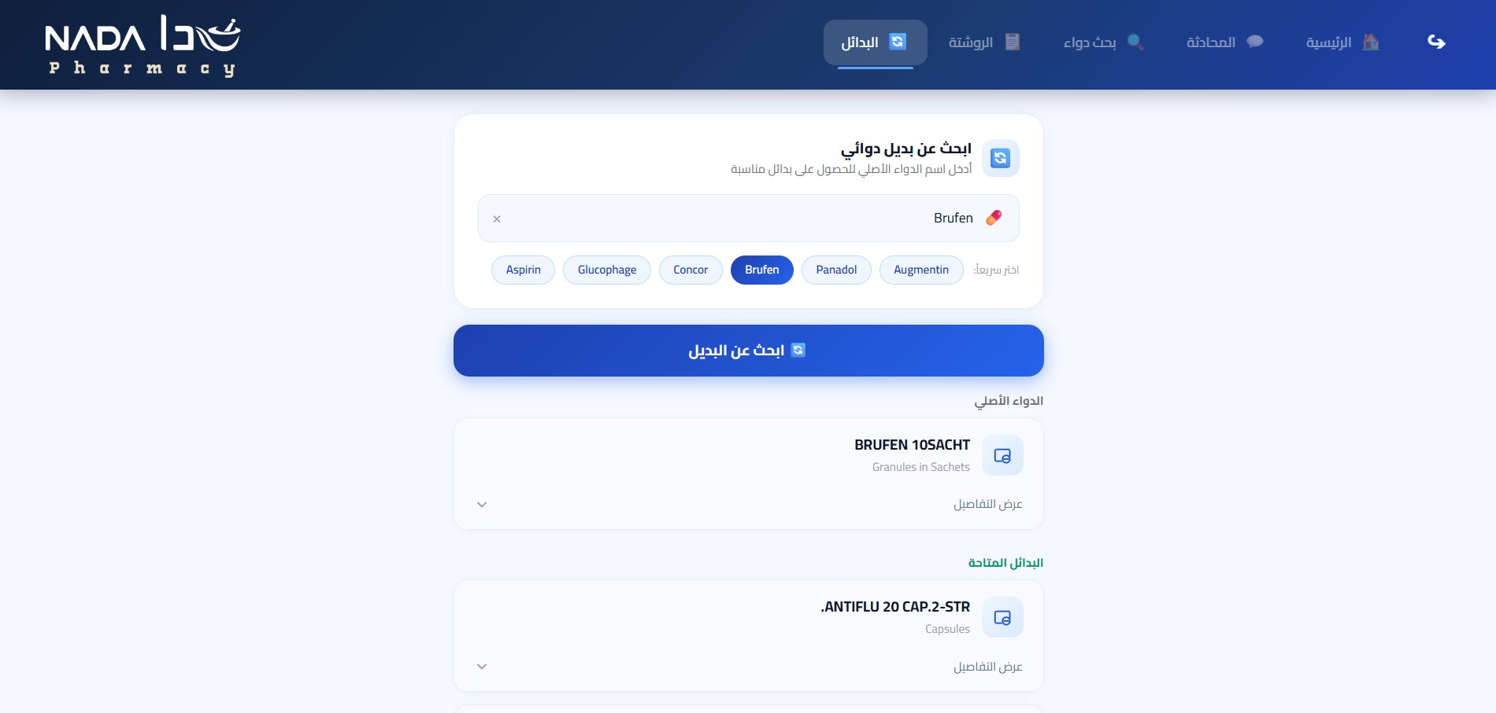

Pharmacy API Endpoints

All pharmacy endpoints are mounted under the /pharmacy prefix. The table below lists each endpoint with its HTTP method, request body, and response schema.

Endpoint | Metho d | Request Body | Response
/pharmacy/chat | POST | { patient_id, messages[] } | SSE stream — text chunks + drug cards
/pharmacy/drug/search | POST | { query: string } | { results: Drug[] }
/pharmacy/prescription/analyze-stream | POST | multipart: image file | SSE stream — pipeline events  + analysis JSON
/pharmacy/alternative | POST | { patient_id?, drug_name } | { original_drug, alternatives[], did_you_mean? }
/pharmacy/interactions | POST | { drugs: string[] } | { interactions: Interaction[] }
/pharmacy/recommend | POST | { patient_id, symptom } | { recommendations: Drug[], warnings: string[] }

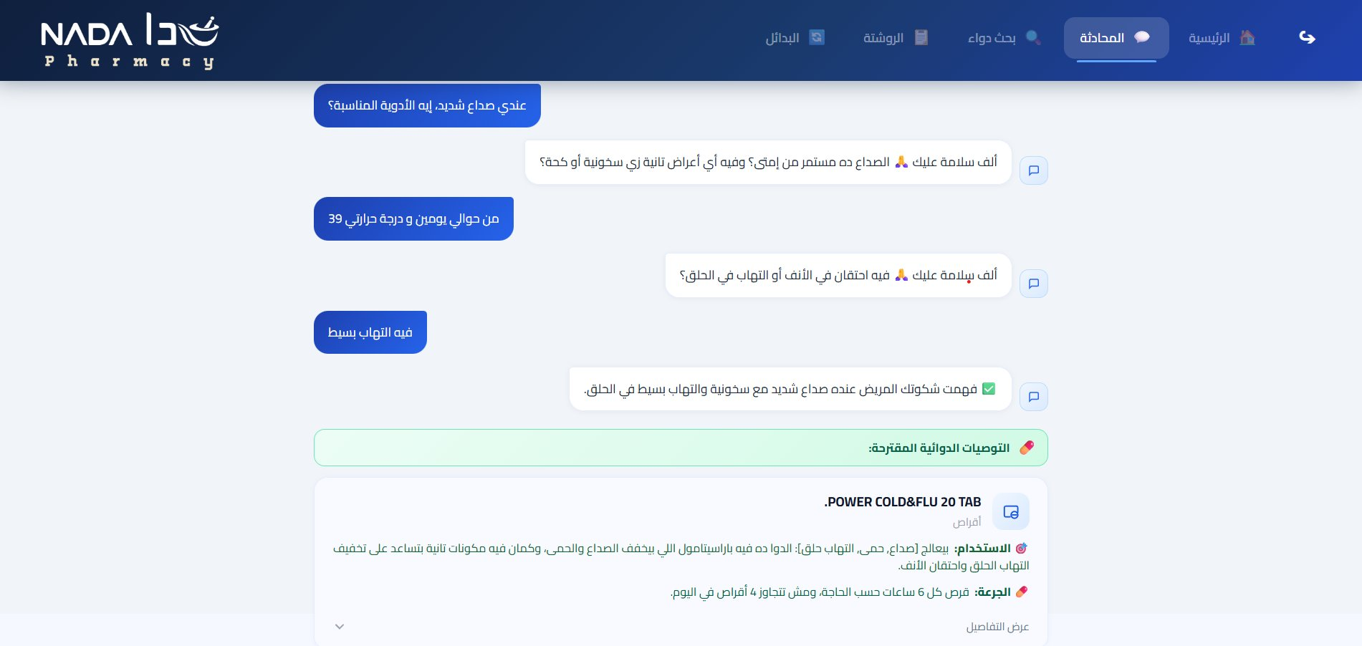
Figure 7.3 — Mobile view of the pharmacy consultation chat: quick symptom selection cards feeding into the patient-aware recommendation engine.

Error Handling

HTTP Status | Scenario
404 | Drug name not found and fuzzy similarity score is below 0.6
422 | Missing required field in request body such as drug_name
400 | Uploaded file is not a valid image or exceeds size limit
500 | Vision LLM or OpenRouter API timeout or internal server error
    - API Design Principles
The pharmacy API is designed around three core principles:
      - Patient-first filtering: Any endpoint accepting a patient_id automatically applies the full patient safety profile — allergy checks, interaction detection, and dosage personalisation — before returning results.
      - Streaming by default: Long-running operations use Server-Sent Events (SSE) to stream intermediate progress states to the frontend, providing real-time pipeline visibility.
      - Graceful degradation: All endpoints return structured error objects with HTTP status codes, human-readable messages, and actionable suggestions. Fuzzy matching ensures a meaningful response even when exact drug names are misspelled.

Module Summary
The Smart Pharmacy Module brings together five interconnected capabilities — drug search, semantic embeddings, prescription OCR, interaction detection, and patient-aware filtering — into a single cohesive API layer delivering a clinical-grade pharmaceutical assistant.

Capability | Technology | Key Benefit
Drug Search | SQL LIKE + Vector Embeddings | Finds drugs by name, symptom, or semantic concept
Prescription OCR | Vision LLM + Anchor Matching | Reads handwriting with hallucination control
Interaction Detection | Curated drug_interactions table | Flags dangerous combinations before dispensing
Allergy Safety | Cross-reactive allergen database | Prevents allergic reactions including cross-reactivity
Alternatives Search | Active ingredient + fuzzy match | Finds bioequivalent substitutes reliably
Patient-Aware Results | Clinical profile filter chain | Zero unsafe recommendations per patient context

8.1 Face Recognition Module Overview
The Face Recognition module in MediVerse enables passwordless patient identification using a single registered facial image instead of passwords or ID cards. This biometric identity is then used for secure verification during all future logins and hospital visits.

8.1.1 Purpose
MediVerse provides passwordless login using facial recognition, allowing patients to access the system by simply showing their face, which improves usability for elderly or stressed users.
It also enables fast identity verification at kiosks and records all access attempts in a secure audit log for accountability and security.

8.1.2 Technology Stack
Component | Technology | Role in MediVerse
Face Detection | InsightFace (RetinaFace) | Locates face bounding box in input image
Embedding Model | AuraFace-v1 (HuggingFace) | Generates 512-dim feature vector
Similarity Metric | Cosine Similarity | Compares embeddings, threshold = 0.65
Image Processing | Pillow (PIL) | Format conversion, RGB/BGR handling
Embedding Storage | MS SQL Server NVARCHAR(MAX) | JSON-encoded float array per patient
8.1.3 Privacy & Ethical Considerations
MediVerse treats facial biometrics as sensitive data and applies strong privacy protections. Instead of storing raw images, it stores only biometric embeddings, which cannot realistically be reversed into the original face. Any temporary images used during enrollment or login are deleted immediately after processing.
All access attempts are recorded with timestamps and IP addresses for security auditing. Patients are also given a fallback password-based login option, making facial recognition optional.

8.2 AuraFace Model
AuraFace-v1 is the face recognition backbone used in MediVerse. It was selected after evaluating several alternatives including FaceNet, DeepFace, and ArcFace-based models.

8.2.1 Why AuraFace over Alternatives
Model | Embedding Dim | Accuracy (LFW) | Inference Speed | Notes
AuraFace-v1 | 512 | 99.4% | ~45 ms / CPU | Selected — best balance
FaceNet (Google) | 128 / 512 | 99.2% | ~60 ms / CPU | Lower accuracy on partial occlusion
ArcFace (MS) | 512 | 99.8% | ~80 ms / CPU | High accuracy, slower inference
DeepFace (Meta) | 4096 | 97.3% | ~120 ms / CPU | Too heavy for real-time use

AuraFace was chosen because it offers near state-of-the-art accuracy (99.4% on the LFW benchmark) while remaining fast enough for CPU-only inference in the deployment environment. Healthcare settings may not always have GPU-equipped servers, so CPU performance was a key constraint.

8.2.2 Model Initialization
The model is downloaded from HuggingFace Hub on first startup and cached locally. This eliminates the need to bundle a large model binary in the repository:
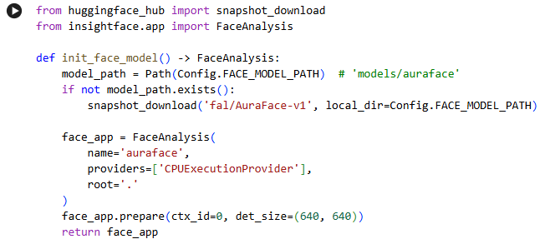
The det_size=(640, 640) parameter configures the detection resolution. A higher resolution improves accuracy on small faces at the cost of increased computation. 640×640 was found to be the optimal trade-off for typical hospital-environment photography.

8.3 Face Enrollment Process
Step | Stage | Description
1 | Image Upload | Patient submits a photograph (jpg/jpeg/png/bmp/webp, max 10 MB) via the API endpoint.
2 | Format Validation | File extension and size are verified. Invalid requests are rejected with HTTP 400 before any processing occurs.
3 | Face Detection | InsightFace (RetinaFace detector) locates face bounding boxes. Zero faces → error. Multiple faces → error (only single-face images accepted).
4 | Quality Check | Face size must be ≥ 80 px, detection confidence score must be ≥ 0.5. Faces that fail quality are rejected with a helpful error message.
5 | Embedding Extraction | AuraFace extracts a normalised 512-dimensional embedding vector representing the unique geometry of the patient's face.
6 | Storage | The embedding is JSON-encoded and saved to the face_embedding column (NVARCHAR MAX) of the Patients table. No raw image is retained.

8.3.1 Image Validation Logic

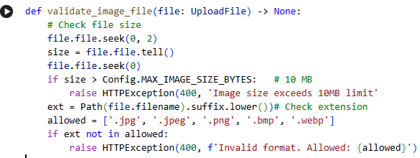

8.3.2 Face Quality Check Logic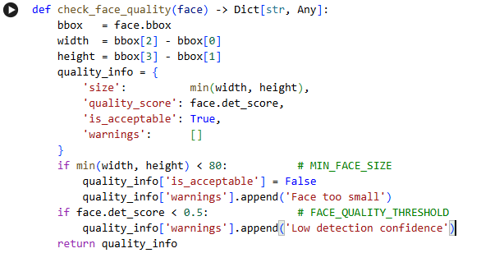

8.4 Face Matching / Authentication
Authentication is performed at each login by capturing a live facial image, generating its embedding, and matching it against stored embeddings in the database to verify the patient’s identity.

8.4.1 Cosine Similarity
MediVerse compares face embeddings using cosine similarity between two 512-dimensional vectors to measure how close they are. Since AuraFace outputs normalized embeddings, the calculation simplifies to a dot product, making identity matching fast and efficient even across large patient databases.

8.4.2 Matching Algorithm

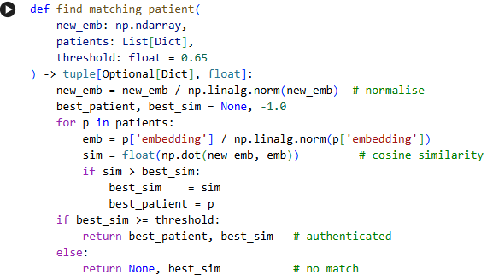8.4.3 Threshold Tuning (0.65)
Threshold | False Accept Rate | False Reject Rate | Notes
0.55 | High | Very Low | Too permissive — strangers may pass
0.60 | Moderate | Low | Acceptable but security risk remains
0.65 ✓ | Low | Moderate | Selected — optimal balance for healthcare
0.70 | Very Low | High | Too strict — legitimate patients locked out
A moderate false-reject rate at 0.65

8.4.4 Multi-Face Detection Handling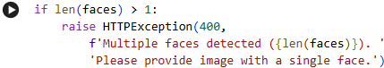

8.5 Security Measures
MediVerse applies several layers of defence:

8.5.1 Temporary File Cleanup
Uploaded images are written to a temporary directory and deleted immediately after embedding extraction, regardless of whether the operation succeeds or fails:

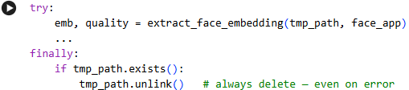8.5.2 Rate Limiting
The in-memory RateLimiter class enforces a limit of 100 requests per 60-second window per client IP address. Exceeding this limit returns HTTP 429 Too Many Requests:

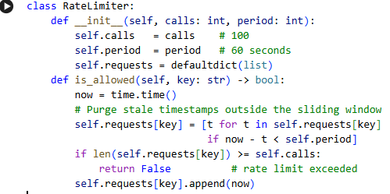8.5.3 PatientAccessLog — Audit Trail
Column | Type | Description
access_id | INT PK | Auto-increment primary key
patient_id | INT FK | References the Patients table (NULL if match failed)
access_type | VARCHAR(50) | 'face_login', 'face_enroll', 'face_check'
accessed_at | DATETIME | Timestamp — defaults to GETDATE()
ip_address | VARCHAR(50) | Client IP for anomaly detection

8.5.4 Anti-Spoofing Considerations
The current MediVerse system does not include a dedicated liveness detection (anti-spoofing) model. Instead, it relies on interim security measures such as multi-face rejection, rate limiting to reduce brute-force attempts, and detailed access logging for security auditing. A future upgrade

8.6 Image Processing Pipeline
Before any face analysis can occur, the uploaded image must pass through a normalisation pipeline that handles format conversions and prepares the pixel data for InsightFace.

8.6.1 Complete Pipeline

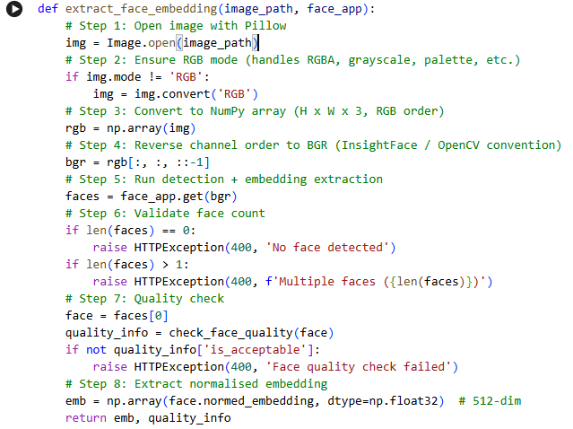8.6.2 Supported Formats & Colour Handling
Format / Mode | Action | Reason
jpg / jpeg | Use as-is | Standard RGB — no conversion needed
png (RGBA) | Convert to RGB | Alpha channel must be removed before NumPy conversion
png (grayscale) | Convert to RGB | InsightFace expects 3 channels
bmp / webp | Use as-is | Pillow handles natively; mode checked afterward
RGB array | Reverse to BGR | OpenCV/InsightFace use BGR convention internally

8.7 Face Recognition Performance & Integration

8.7.1 Embedding Loading Strategy
During authentication, patient embeddings are loaded into memory from the database, parsed from JSON, and validated to ensure they are 512-dimensional vectors before matching.

8.7.2 Performance Characteristics
Operation | Typical Latency | Notes
Image upload + validation | < 50 ms | I/O bound — depends on network
Face detection (RetinaFace) | ~80–120 ms (CPU) | Largest single component
Embedding extraction (AuraFace) | ~40–60 ms (CPU) | Fast after model warm-up
DB embedding load (1k patients) | < 200 ms | Scales linearly; cache recommended
Cosine similarity scan (1k) | < 5 ms | NumPy vectorised dot products
Total end-to-end (warm model) | < 500 ms | Acceptable for kiosk/mobile UX

8.7.3 Failure Modes & Fallback
The following failure modes are handled gracefully:
- No face detected → HTTP 400 with message: 'Ensure good lighting and face is clearly.'
- Multiple faces detected → HTTP 400 — prompt patient to retake with a single face only.
- Face too small (< 80 px) → HTTP 400 — prompt patient to move closer to the camera.
- Low detection confidence (score < 0.5) → HTTP 400 — poor lighting or extreme angle.
- Similarity below threshold (< 0.65) → Authentication fails → system redirects to password login.
- Database connection failure → HTTP 500 — generic error message; no sensitive data exposed.

8.7.4 JWT Integration — Face Match → Authenticated Session
After a successful face match, the system returns the patient ID, and the authentication service issues a JWT using the standard flow.
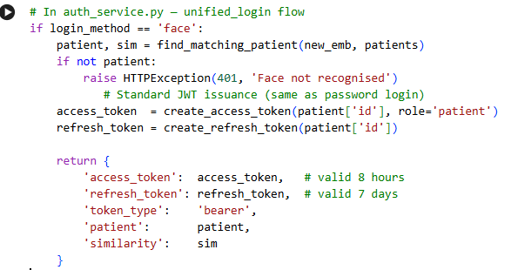

Frontend Architecture Overview
MediVerse delivers its user experience through two complementary client applications: a React 18 Web Dashboard targeting hospital staff and patients on desktop/tablet, and a Flutter 3 Mobile App designed specifically for patient-facing interactions on Android devices. Both clients communicate exclusively with the shared FastAPI backend over HTTPS, ensuring a single source of truth for all medical data.
The web and mobile clients are independently deployable yet tightly integrated at the API level. The React app handles complex role-based workflows for patients, doctors, and managers, while the Flutter app prioritises a streamlined patient experience centred on face-based login and real-time queue tracking.
The following table compares the two client applications across every architectural dimension — from the underlying framework and styling system to the deployment target and authentication model. Both applications share the same JWT-based authentication flow, ensuring a unified identity layer across all MediVerse touchpoints.

Attribute | React Web Dashboard | Flutter Mobile App
Framework | React 18 + Vite 6 | Flutter 3 + Dart
Styling | TailwindCSS 3 | Material Design 3
Target Users | Patient · Doctor · Manager | Patient only
Primary Feature | Full portal — all modules | Face login + Queue tracking
State Management | React Context API + useState | setState / StatefulWidget
Routing | React Router 6 | Navigator 2.0
Icons | Lucide React | Material Icons
Charts | Recharts | fl_chart
Notifications | react-hot-toast | flutter_local_notifications
Deployment | Vercel (mediverse.vercel.app) | Android APK (sideload)
Orientation | Responsive (desktop + tablet) | Portrait-only (mobile)

React Web — Project Structure

The React web application follows a feature-based directory structure, grouping related pages, components, and services together by domain rather than by file type. This organisation reduces cognitive overhead when navigating large feature sets and allows each module to be developed, tested, and deployed independently. Role-based routing is enforced at the router level using protected route wrappers that inspect the JWT payload before rendering any page.

Directory Structure
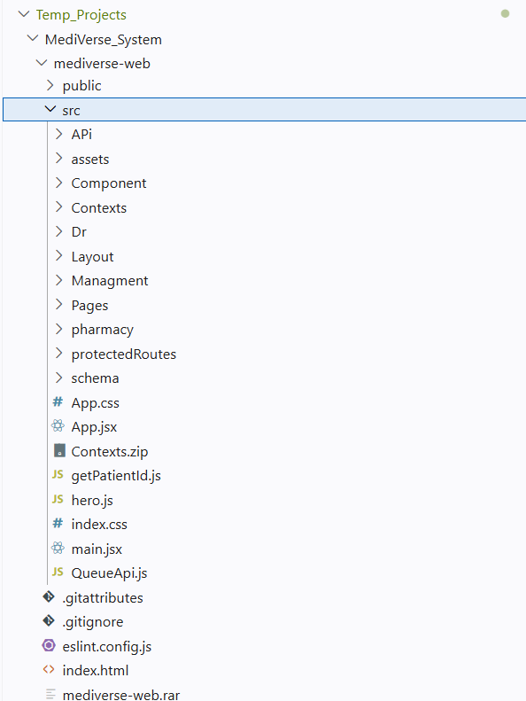

Protected routes read the role field from the decoded JWT payload stored in AuthContext. If the role does not match the route's required role, the user is redirected to /login automatically. The check occurs synchronously during the render phase, ensuring that protected page components never mount with insufficient permissions.

Route | Component | Role | Description
/login | Login.jsx | All | Unified login — doctor & manager credentials
/ | Dashboard.jsx | Patient | Patient home — quick links to all modules
/chatbot | Chatbot.jsx | Patient | AI medical consultation with symptom cards
/appointments | Appointments.jsx | Patient | Book, view, and cancel appointments
/files | Files.jsx | Patient | Upload X-ray / lab files + AI analysis results
/history | History.jsx | Patient | Full consultation and diagnosis history
/prescription | Prescription.jsx | Patient | LangGraph OCR + drug interaction checker
/queue | Queue.jsx | Patient | Live queue position + estimated wait time
/profile | Profile.jsx | Patient | Personal info, allergies, chronic diseases
/doctor | DoctorDash.jsx | Doctor | Queue management, patient notes, statistics
/manager | ManagerDash.jsx | Manage r | Doctor CRUD, patient list, AI accuracy logs

AuthContext.jsx — Simplified Implementation
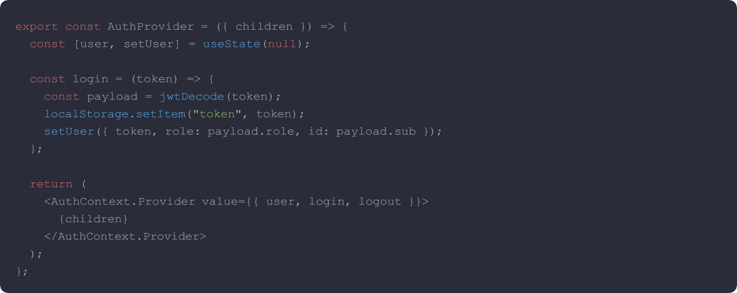
The AuthContext implementation encapsulates the entire authentication lifecycle within a single React Context provider. The login function accepts a raw JWT string, decodes it using jwtDecode to extract the payload fields, persists the token to localStorage for page-refresh survival, a

React Web — Patient Portal
The patient portal is the largest section of the React web application. It provides patients with a unified interface for all their healthcare needs — from AI symptom consultation to appointment booking, medical file management, and prescription analysis. Each sub-module is independently routed and lazy-loaded to minimise initial bundle size and improve time-to-interactive on slower hospital network connections.

Patient Dashboard (Dashboard.jsx)
The dashboard is the patient's home screen immediately after login. It renders a personalised greeting using the patient's name extracted from the JWT payload, followed by a grid of quick-access cards linking to each major module. Two live widgets are embedded within the dashboard layout: a summary of the patient's next upcoming appointment and a real-time queue position indicator that polls the backend every 30 seconds.

Dashboard Widget | Data Source | Update Frequency
Upcoming Appointment | GET /patient/appointments | On page load
Queue Position | GET /queue/status/{patient_id} | Every 30 seconds (polling)
Recent Consultation | GET /patient/history?limit=1 | On page load
Quick-access Cards | Static (router links) | Static

AI Chatbot Interface (Chatbot.jsx)
The Chatbot page is the most interactive component in the patient portal. It provides an AI-powered symptom consultation via a conversational UI following a chat layout: user messages appear on the right, AI responses on the left, with Markdown formatting rendered inline for structured medical advice. The interface is designed to serve patients with varying levels of health literacy, combining free-text input with guided symptom shortcuts.
Key UI elements of the Chatbot interface:
      - Quick Symptom Cards — pre-built buttons (headache, cold, joints, stomach pain, etc.) that populate the input field with a single tap, reducing typing friction for patients unfamiliar with medical terminology.
      - Severity Indicator — a colour-coded badge (green / yellow / red / dark-red) rendered from the severity_level field in the API response: low, moderate, high, or emergency.
      - First Aid Steps — numbered steps extracted from the API response displayed as a formatted list with icons, collapsible on mobile to preserve screen space.
      - Specialty Referral — if the AI recommends a specialist, a highlighted chip shows the required specialty (e.g. Cardiology, Orthopaedics) with a direct link to the appointments page.
      - Arabic RTL Support — the AI response container detects Arabic text and applies dir="rtl" and the appropriate font rendering automatically, ensuring bilingual usability.

// Chatbot.jsx — SSE streaming handler
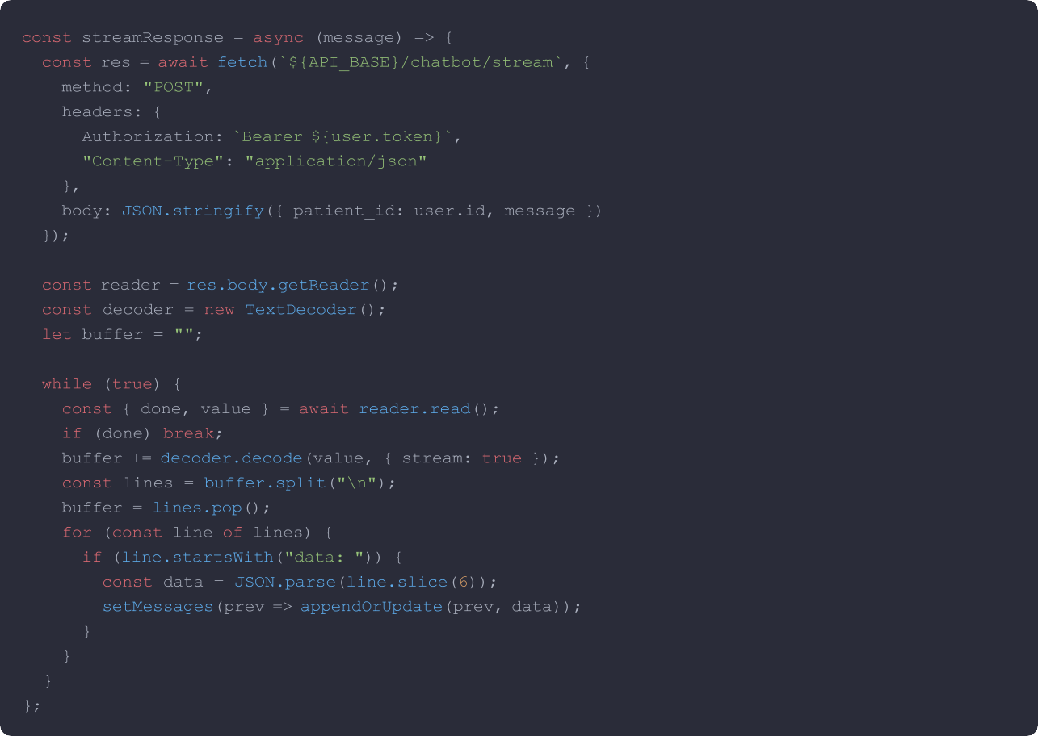

Medical Files Page (Files.jsx)
The Files page enables patients to upload medical images — X-ray, MRI, CT scan, and laboratory results
— and view the AI-generated analysis produced by the Qwen2.5-VL vision model. Each uploaded file is stored server-side, and the AI analysis result is saved as structured JSON in the medical_files table, then rendered as a human-readable card within the UI. The upload interaction supports both drag-and-drop and click-to-select workflows to accommodate all patient technical proficiencies.

Action | API Endpoint | Method | Response
Upload file | /patient/files/upload | POST  (multipart) | file_id + AI analysis JSON
List files | /patient/files | GET | Array of file metadata
View analysis | /patient/files/id/analysis | GET | Structured analysis text
Delete file | /patient/files/{id} | DELETE | 204 No Content
The decision to use setInterval polling at a 15-second interval rather than a persistent WebSocket connection was driven by infrastructure simplicity and the predictable update cadence of a physical queue. In a hospital queue, patient state changes occur on a human timescale of several minutes. A 15-second polling interval provides sufficiently fresh data while allowing the FastAPI backend to serve queue state from a lightweight GET endpoint without maintaining stateful connections

React Web — Doctor Dashboard
The Doctor Dashboard (DoctorDash.jsx) is a single-page command centre for managing the doctor's daily clinical workflow. It combines live queue management, patient consultation history,.

Component | File | Function
Queue Panel | DoctorDash.jsx → QueuePanel | Live queue with call-next, skip, and controls
Today's Stats | DoctorDash.jsx → StatsBar | Patients seen, average consultation time, queue
Patient Notes | DoctorDash.jsx → NotesModal | Write and save clinical notes per patient
Prescription Issue | DoctorDash.jsx → RxModal | Issue a digital prescription linked to the patient
History Viewer | DoctorDash.jsx → HistoryTab | All past consultations with AI diagnosis and doctor
File Viewer | DoctorDash.jsx → FilesTab | View patient-uploaded medical images and AI

Live Queue Management
The queue panel polls GET /doctor/queue every 15 seconds to retrieve the current queue state. The doctor sees each waiting patient's name, arrival time, and estimated wait duration in a ranked list. Three action buttons are exposed per queue entry, providing full lifecycle control:
      - Call Next — marks the current patient as "in consultation" and advances the queue index.
      - Skip — moves a patient to the end of the queue.
      - Complete — marks the consultation as finished, removes the patient from the active queue.
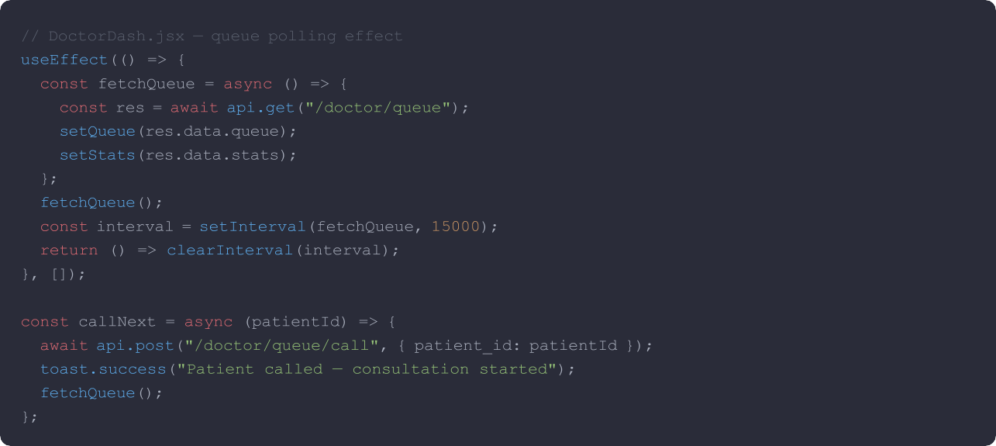

Doctor Notes & Prescription Modals
When the doctor selects a patient from the queue, a modal opens with two tabs: Notes and Prescription. The Notes tab provides a rich text area for clinical observations, with an AI Assist button that pre-populates the notes field with a structured summary of the patient's chatbot consultation history. This allows the doctor to review the AI's diagnostic reasoning before composing their own clinical notes, significantly reducing documentation time.

React Web — Manager Dashboard
The Manager Dashboard (ManagerDash.jsx) provides hospital administrators with system-wide operational oversight. It is divided into five main tabs — Overview, Doctors, Patients, AI Metrics, and System Logs — each backed by protected manager-role endpoints requiring a valid JWT with role: manager. The dashboard is designed for non-technical administrative staff, presenting complex backend data through clean KPI cards, searchable tables, and interactive charts.

Tab | API Endpoint | Key Features
Overview | GET /manager/dashboard | Total patients, doctors, consultations today; revenue summary
Doctors | GET /manager/doctors | Add, edit, deactivate doctors; assign specialty and floor/room
Patients | GET /manager/patients | Search patients, view profiles, manage allergy flags
AI Metrics | GET /manager/ai-accuracy | Chatbot accuracy rate, RAG hit rate, average similarity score
System Logs | GET /manager/logs | API call logs with endpoint, response time, and status filter

Doctor Management (CRUD)
The Doctors tab renders a sortable, searchable table of all registered doctors. Each row exposes inline action buttons for editing and deactivation. The Add Doctor form collects name, email, specialty, floor, room number, and initial password. On submission, the form calls POST /manager/doctors and the table refreshes automatically via a React state update — no page reload required.
      - Create — POST /manager/doctors — adds a new doctor account with a bcrypt-hashed password and sends a welcome email.
      - Read — GET /manager/doctors — paginated, searchable list filterable by name or medical specialty.
      - Update — PATCH /manager/doctors/{id} — update specialty, consultation room, floor assignment, or contact info.
      - Deactivate — PATCH /manager/doctors/{id}/status — soft-delete that sets is_active = 0 without removing historical data.

AI Accuracy Metrics Display
The AI Metrics tab visualises the chatbot's diagnostic performance using a Recharts LineChart showing accuracy percentage per day over the rolling 30-day window. Three KPI cards headline the tab, each displaying a critical system health indicator with colour-coded thresholds.

KPI Metric | Description | Healthy Threshold
RAG Hit Rate | Percentage of patient queries matched to knowledge base entries | > 80%
Avg Semantic Similarity | Cosine similarity between query and retrieved context | > 0.75
Total AI Consultations | Cumulative count of AI-assisted patient interactions | Trending up

React Web — Pharmacy Interface
The Pharmacy interface is accessible from the patient portal at /prescription. It exposes the full Smart Pharmacy Module through a tabbed UI: Prescription OCR, Drug Search, Interaction Checker, and Alternative Drugs. All four tabs share a common Drug Card component that renders the complete clinical profile of a drug in a structured, readable format — ensuring a consistent experience whether the patient is scanning a prescription or searching for a drug by name.

Tab | Backend Endpoint | Function
Prescription OCR | POST  /pharmacy/prescription/analyze-stream | Upload handwritten prescription image → AI drug extraction
Drug Search | POST /pharmacy/drug/search | Keyword + semantic search across egypt_drugs database
Interaction Checker | POST /pharmacy/interactions | Select multiple drugs → check cross-drug interactions
Alternative Drugs | POST /pharmacy/alternative | Search for bioequivalent substitutes by active ingredient

Prescription OCR UI
The OCR tab provides a drag-and-drop image upload zone styled with a dashed border and a camera icon. When an image is dropped or selected, the frontend immediately calls the SSE streaming endpoint and begins rendering a progress pipeline visualiser — four steps displayed as sequential badges. Each badge transitions from grey (waiting) to blue with a pulse animation (running) to green (done) as the backend pipeline progresses, giving the patient real-time visibility into the processing state.

Pipeline Step | Key | Backend Operation
Pass 1 — Masked OCR | pass1 | Initial text extraction with masked drug name tokens
DB Anchor Search | db | Fuzzy match extracted names against egypt_drugs database
Pass 2 — Confirm | pass2 | Verification pass correcting OCR errors using DB anchors
GPT-4o Analysis | analysis | Full clinical analysis, dosage check, and interaction scan

Drug Card Component
The Drug Card is a shared component used across all four pharmacy tabs. It renders the complete clinical profile of a drug in a structured card layout with colour-coded sections. Allergy warnings are displayed as a prominent red banner at the top of the card when the recommended drug conflicts with the patient's stored allergy profile, preventing dangerous prescription errors before they reach the dispensing stage.

Card Section | Source Field | Display Style
Drug Name + Form | drug_name, dosage_form | Large bold header + badge
Active Ingredient | active_ingredient | Subtitle in light blue
Drug Class | drug_class | Pill badge

Flutter Mobile App — Overview

The Flutter mobile application is the primary patient-facing client for field use on Android devices. Its design philosophy prioritises radical simplicity: a patient picks up their phone, authenticates with their face, and sees their queue position — all within three taps from the app launch screen. The application implements Material Design 3 with a custom deep-navy colour theme that matches the MediVerse web brand, ensuring visual continuity across both platforms.

Screen | File | Description
Splash Screen | splash_screen.dart | Animated logo with Lottie — auto-navigates after 2 seconds
Login Screen | login_screen.dart | Face ID biometric + National ID number fallback login
Tracking Screen | tracking_screen.dart | Real-time queue position, wait time, and appointment status

Flutter App Technical Specifications:
- Min SDK: Android 6.0 (API 23) · Target SDK: Android 14 (API 34)
- Orientation: Portrait-only · Theme: Material Design 3
- Primary Color: #1A3A5C (Deep Navy) · Accent: #4A90C8 (Light Blue)
Package | Version | Purpose
http | ^1.1.0 | REST API calls to FastAPI backend — all CRUD and requests
camera | ^0.10.5 | Camera access for real-time face capture during biometric login
image_picker | ^1.0.4 | Gallery image selection as a fallback for face ID
flutter_secure_storage | ^9.0.0 | Encrypted on-device JWT token storage
flutter_local_notification s | ^16.0.0 | Queue position and "almost your turn" push notifications
provider | ^6.1.1 | Reactive state management across all screens
fl_chart | ^0.66.0 | Appointment frequency and health data charts
lottie | ^3.0.0 | Smooth loading and success animations throughout the app
permission_handler | ^11.0.1 | Runtime camera and notification permission requests

Flutter Mobile — Login Screen
The Login Screen is the entry point for all patient interactions with the Flutter application. It supports two authentication methods: Face ID as the primary path, and National ID number as the fallback.

    - Face ID Login Flow

Ste p | Action | Technical Detail
1 | Patient taps "Login with Face" | Requests CAMERA permission via permission_handler
2 | Camera preview opens | CameraController initialised with ResolutionPreset.high
3 | Patient looks at camera | Lottie animation guides face positioning and alignment
4 | Capture button pressed | takePicture() → XFile saved to temp directory
5 | Image sent to backend | POST /auth/patient-login/face (multipart/form-data)
6 | Backend matches face | InsightFace AuraFace cosine similarity threshold ≥ 0.65
7 | JWT returned on match | Token stored in FlutterSecureStorage (AES-256 encrypted)
8 | Navigate to Tracking | Navigator.pushReplacement(TrackingScreen)
9 | Temp file deleted | File cleanup executed after successful response

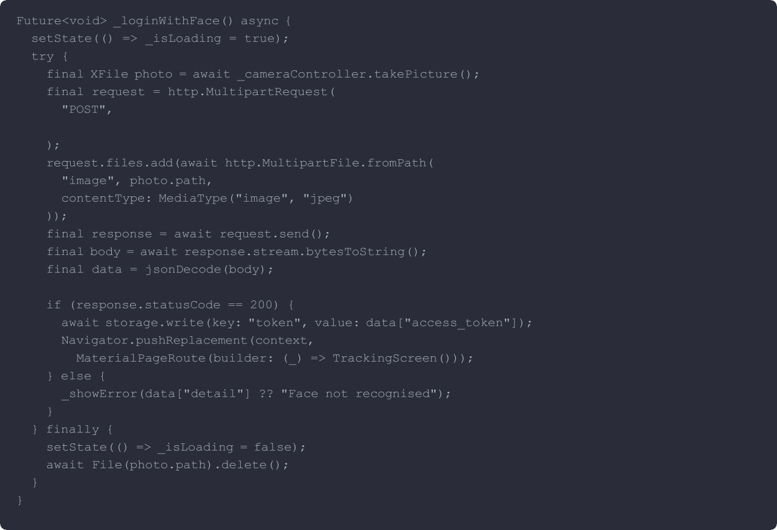
    - Key Code — login_screen.dart
Uri.parse("$apiBase/auth/patient-login/face")

Flutter Mobile — Tracking Screen
The Tracking Screen is the primary screen patients see immediately after login. It provides a live view of the patient's position in the doctor's queue, the estimated wait time in minutes, and the current appointment status. Data is refreshed every 20 seconds via a Timer.periodic call. When the patient's turn approaches (queue position ≤ 2), a local notification is triggered to alert them even if the app is running in the background or the screen is locked.

Widget | Data Source | Refresh Rate
Queue Position Badge | GET /queue/status/{patient_id} | Every 20 seconds
Estimated Wait Time | GET /queue/status → wait_minutes | Every 20 seconds
Appointment Details | GET /patient/appointments/next | On screen load
Doctor Info | GET /patient/appointments/next → doctor | On screen load
"Almost Your Turn" Alert | Local — triggered when position ≤ 2 | Checked every 20 s

Real-time Queue Polling
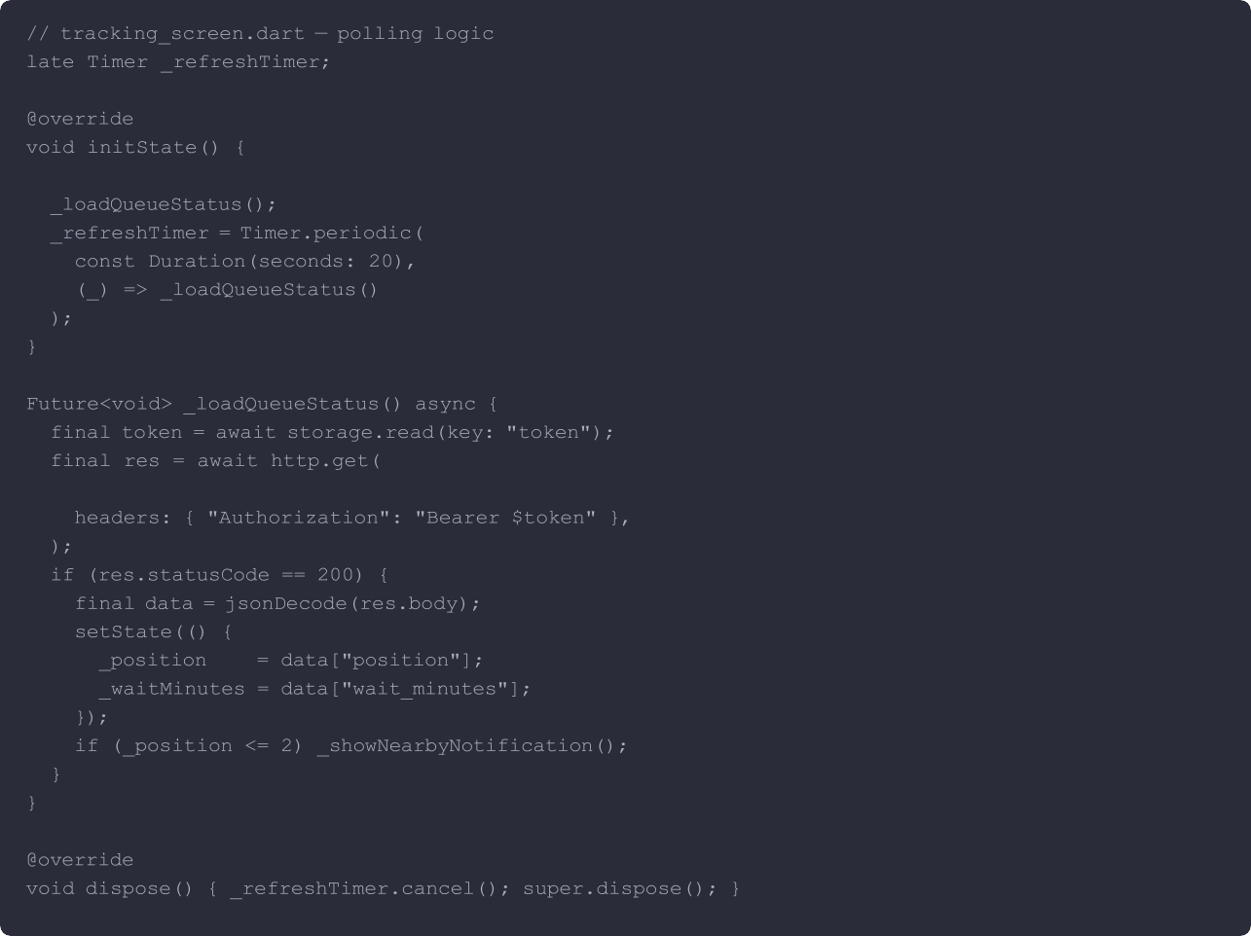
super.initState();
Uri.parse("$apiBase/queue/status/$patientId"),
The 20-second polling interval was selected as a balanced trade-off between data freshness and mobile resource consumption. In a hospital queue context, position changes occur when a doctor calls the next

UI/UX Design Decisions

Consistent visual design across both clients was a deliberate architectural decision made early in the project lifecycle. The MediVerse brand palette was defined before any UI components were built and applied uniformly to both React (via TailwindCSS custom config) and Flutter (via ThemeData). This creates a coherent user experience for patients who switch between the mobile app in the waiting room and the web portal at home, eliminating the cognitive friction of learning two distinct visual languages.

Colour Palette

Token | Hex Value | Usage
Deep Navy (Primary) | #1A3A5C | Headers, nav bars, primary buttons, table headers
Light Blue (Accent) | #4A90C8 | Links, active states, chart lines, hover effects
Accent Blue | #2E6DA4 | Section headings, secondary buttons
Light Blue BG | #EEF4FA | Card backgrounds, table alternating rows
Success Green | #27AE60 | Confirmed statuses, safe drug indicators
Warning Amber | #F39C12 | Caution states, moderate severity badges
Error Red | #E74C3C | Contraindications, serious side effects, allergy alerts
White | #FFFFFF | Card surfaces, modal backgrounds, header text
Dark Text | #2C3E50 | Body text, table cell content

    - Responsive Design
The React web application uses TailwindCSS responsive prefixes to adapt layouts across three defined breakpoints. The sidebar collapses to a bottom navigation bar on tablet screens, and the grid column count reduces from four to two to one on progressively smaller viewports. The chatbot interface switches from a split-panel layout on desktop to a full-screen overlay on mobile, maximising the readable area for AI responses.

Breakpoint | Screen Width | Layout Change
lg (Desktop) | ≥ 1024 px | Full sidebar, 4-column grid, split chatbot panel
md (Tablet) | 768–1023 px | Collapsed sidebar → bottom nav, 2-column grid
sm (Mobile) | < 768 px | No sidebar, 1-column grid, full-screen chat overlay

Arabic RTL Support
Arabic text returned by the AI chatbot and prescription analysis endpoints is rendered correctly in both clients. In React, the message container applies dir="rtl" and text-align: right when the response language is detected as Arabic using a Unicode range check. In Flutter, the Directionality widget wraps Arabic text blocks to enforce RTL rendering without affecting the surrounding LTR interface layout.
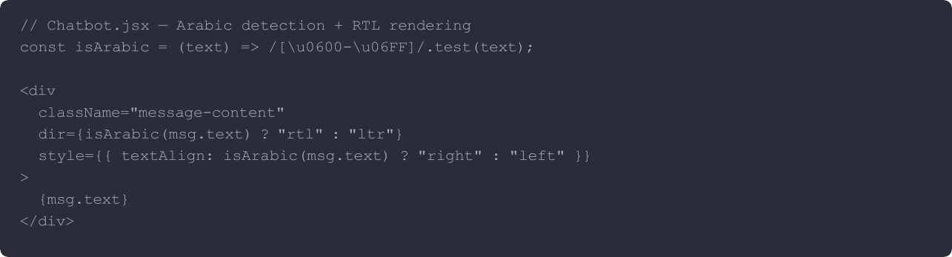

Accessibility Considerations
      - Colour contrast — all text/background combinations meet WCAG AA minimum contrast ratio (4.5:1 for body text), verified against each palette token combination.
      - Focus indicators — all interactive elements have visible focus rings enabled via TailwindCSS ring utilities, ensuring keyboard-navigable workflows for staff with motor impairments.
      - ARIA labels — all icon-only buttons include aria-label attributes to provide meaningful descriptions for screen reader users.
      - Error messaging — form validation errors are announced via aria-live="polite" regions, making them accessible without requiring visual focus.
      - Loading states — all asynchronous operations display skeleton loaders rather than blank screens, reducing perceived latency and preventing disorientation during data fetching.
      - Font sizing — Flutter uses sp units (scale-independent pixels) throughout the mobile app to honour user OS font size preferences, supporting patients with visual impairments.

Chapter10: Testing, Deployment & Future Work

10.1 Testing Strategy Overview
Software quality assurance is a critical pillar of any system operating in a healthcare context. MediVerse adopted a multi-layered testing strategy to ensure correctness, reliability, and safety across all modules:
- Unit Testing — validates isolated functions and service methods, particularly in the pharmacy service and AIresponse parsing logic.
- Integration Testing — verifies that complete end-to-end flows work correctly across multiple modules,including patient registration, chatbot interaction, and appointment booking.
- Manual Testing — exploratory testing performed by the development team against the live API and frontendinterfaces to uncover edge cases and usability issues.
The primary test files maintained in the project are:
- test/pharmacy_service.py — covers drug recommendation, interaction detection, OCR parsing, and alternative drug lookup.
- test/prescription_service.py — covers prescription reading, drug name extraction, and patient-specific drug safety checks.

10.2 Backend Testing
Backend unit tests exercise the core service layer of MediVerse.

10.2.1 Pharmacy Service Tests — test/pharmacy_service.py
The pharmacy test suite validates the four core capabilities of the pharmacy module:
- Drug Search — verifies that search_drugs_by_indication() returns relevant matches for given symptoms orindications, and that results are ranked and de-duplicated correctly.
- Drug Interaction Detection — ensures that pairs of interacting drugs are correctly identified from thedrug_interactions table, and that severity levels (contraindicated, major).
- Face Recognition Stability — validates that the face service correctly rejects low-quality images (below size,angle, or quality thresholds) and accepts valid enrollment images.
- Chatbot Response Parsing — tests the parse_response_robust() fallback chain: direct JSON first, thenmarkdown code block extraction, then regex-based field extraction.

10.2.2 Prescription Service Tests — test/prescription_service.py
The prescription tests cover:
- Correct drug name extraction from an OCR-parsed structured drug list.
- Allergy cross-check: verifying that a patient with a known allergy triggers a warning when a contraindicateddrug is recommended.
- Pediatric dosage selection: asserting that the system returns the children’s dosage when the patient age isbelow 12.
- Pregnancy flag handling: ensuring that drugs marked as unsafe during pregnancy are flagged in theresponse.

10.2.3 Key Test Cases Summary
Test Case | Module | Expected Outcome | Status
Drug search returns results for 'headache' | Pharmacy | At least 1 drug with matching indication | PASS
Amoxicillin + Warfarin interaction | Pharmacy | Severity: Major, clinical effect returned | PASS
Face enrollment with blurry image | Face Recog. | Rejected: quality_score < 0.5 | PASS
JSON parse fallback on malformed LLM output | Chatbot | Regex fallback extracts diagnosis field | PASS
Allergy check: penicillin + amoxicillin | Prescription | WARNING: cross-reactive allergy detected | PASS
Pediatric dosage for 8-year-old patient | Prescription | Returns dosage_children field value | PASS
Drug not found returns graceful error | Pharmacy | 404 HTTPException with message | PASS
OCR on clear handwritten prescription | OCR | Structured drug list extracted | PASS

10.3 AI Component Testing
AI components in MediVerse require a distinct testing methodology since their outputs are probabilistic rather than deterministic. Testing focused on threshold calibration, edge-case coverage, and graceful degradation under unexpected inputs.

10.3.1 RAG Accuracy Evaluation
The RAG retrieval layer was evaluated by constructing a set of 50 symptom queries spanning all 12 medical specialties. Each query was run through the cosine similarity search and the top-1 retrieved record was compared against the expected specialty and severity.
- Similarity Threshold Tuning: the default threshold of 0.55 was selected after testing values from 0.40 to 0.70. Below 0.55 too many unrelated records were returned; above 0.65 too many valid matches were dropped.
- Top-K Selection: setting K=5 was found to provide sufficient context for the LLM while avoiding prompt length issues.
- Multilingual Coverage: Arabic symptom queries were tested using the paraphrase-multilingual-MiniLM-L12-v2 model and achieved retrieval accuracy comparable to English.

10.3.2 LLM Response Validation
Because MediVerse calls external LLMs via OpenRouter, a validation layer was built around the response parsing to handle any non-standard output:
- Temperature = 0.0: Forces deterministic responses to ensure consistent structured JSON output across repeated requests.
- Schema Validation: Every LLM response is parsed against the expected schema (input_valid, preliminary_diagnosis, severity_level, first_aid, warnings, specialty_required). Missing fields trigger the fallback response.
- Fallback Chain: Direct JSON → code block extraction → regex field matching → safe response.

10.3.3 Chatbot Edge Case Testing
Input Type | Example Input | Expected Behavior
Empty input | (blank submission) | input_valid: false — prompt to enter symptoms
Greeting only | "Hello" / "مرحبا" | input_valid: false — polite redirect
Arabic symptoms | "عندي ألم في الصدر" | Valid — specialty: Cardiology or Emergency
Very long input (>1000 chars) | Long paragraph of text | Truncated safely — response generated
Non-medical keywords | "book a flight to Cairo" | input_valid: false
Critical emergency | "I cannot breathe, chest pain" | Severity 9-10 — Emergency — 911 warning

10.4 System Integration Testing
Integration testing was performed manually against the live FastAPI backend to verify that multi-step user flows work correctly from end to end. Each flow below was tested multiple times with valid and invalid inputs.

10.4.1 Flow 1 — Patient Registration → Face Login → Chatbot
- A new patient registers via POST /auth/register with full profile (name, DOB, chronic diseases, allergies,current medications).
- A face image is uploaded and enrolled via POST /patient/enroll-face. The image is validated for quality (size,angle, quality score) and the 512-dimension embedding is stored.
- The patient logs in via POST /auth/patient-login by submitting a new face image. Cosine similarity iscomputed and a JWT is issued if similarity ≥ 0.65.
- Using the JWT, the patient sends symptoms to POST /chatbot/analyze. The RAG layer retrieves relevantknowledge base entries and the LLM produces a structured JSON response.
- The consultation is saved to patient_consultations and retrieved via GET /patient/consultations.

10.4.2 Flow 2 — Appointment Booking → Queue Management
- The patient books an appointment via POST /appointments with doctor_id and date.
- The patient joins the queue via POST /queue/join. An estimated wait time is calculated based on the numberof patients ahead.
- The doctor views the live queue via GET /doctor/queue, updated in real time as patients are called.
- The doctor dismisses the patient and writes a note via POST /doctor/notes.

10.4.3 Flow 3 — Pharmacy: OCR → Interaction Check → Alternatives
- The pharmacist uploads a prescription image to POST /pharmacy/ocr. The Vision LLM extracts a structuredlist of drug names and dosages.
- The extracted drugs are submitted to POST /pharmacy/interactions. The system queries thedrug_interactions table and returns all identified interactions with severity and clinical notes.
- For any contraindicated or unavailable drug, POST /pharmacy/alternatives is called to search byactive_ingredient and return safe substitutes from the egypt_drugs database.
- Patient allergy safety is verified: the patient profile is cross-referenced against the allergy_database tablebefore any drug is confirmed.

10.5 Deployment Architecture
MediVerse is designed to run as a set of interconnected services on a single server or cloud VM. The following describes the full environment setup required to run the system.

10.5.1 Environment Variables (.env Configuration)
All sensitive configuration is managed through a .env file and loaded via the AppConfig class in settings.py:
# Database
DATABASE_SERVER=localhost
DATABASE_NAME=MediVerse
DATABASE_USERNAME=sa DATABASE_PASSWORD=<secure_password>
# JWT
JWT_SECRET_KEY=<256-bit-secret>
JWT_ACCESS_TOKEN_EXPIRE_HOURS=8
JWT_REFRESH_TOKEN_EXPIRE_DAYS=7
# OpenRouter (LLM API)
OPENROUTER_API_KEY=<api_key>
DEFAULT_LLM_MODEL=openai/gpt-4o-mini
# Redis (optional, fallback to in-memory)
REDIS_URL=redis://localhost:6379

10.5.2 MS SQL Server Setup
MediVerse requires MS SQL Server 2019 or later with ODBC Driver 17 installed.

10.5.3 AI Model Downloads
Two AI models must be downloaded before the system can start:
- AuraFace (Face Recognition): Downloaded from HuggingFace Hub via snapshot_download().
Cached locally in the models/ directory and loaded as a FaceAnalysis object.
- SentenceTransformer (RAG Embeddings): The paraphrase-multilingual-MiniLM-L12-v2 model is downloaded from HuggingFace on first use and cached. Drug embeddings are pre-computed and stored in a .npz file for fast cosine similarity search at runtime.

10.5.4 Service Startup
The backend is started using Uvicorn:
uvicorn main:app --host 0.0.0.0 --port 8000 --reload
The React web dashboard is built and served separately:
cd frontend && npm install && npm run build && npm run preview
The Flutter mobile app is compiled and deployed as an APK for Android:
flutter build apk --release

10.5.5 Deployment Component Summary
Component | Technology | Port / Location
Backend API | FastAPI + Uvicorn | http://localhost:8000
Web Frontend | React 18 + Vite + TailwindCSS | http://localhost:5173
Database | MS SQL Server 2019 | localhost:1433
Cache / Rate Limiter | Redis (optional) | localhost:6379
Face Recognition Model | InsightFace + AuraFace | models/ directory (local)
RAG Embedding Model | SentenceTransformer MiniLM | HuggingFace cache (local)
Drug Embeddings | NumPy .npz file | data/drug_embeddings.npz
Mobile App | Flutter 3 (Android APK) | Installed on patient device

10.6 System Limitations

Every system has boundaries, and transparency about those boundaries is especially important in a healthcare context. The following limitations are acknowledged as part of responsible system design.

10.6.1 AI Chatbot — Not a Substitute for Medical Advice
The AI-powered chatbot is designed as a triage and guidance tool, not a diagnostic system. All responses are accompanied by a disclaimer reminding patients that the output is informational only and that a qualified physician must be consulted for any medical decision. The LLM system prompt enforces this disclaimer in every response containing a preliminary diagnosis or first-aid recommendation.

10.6.2 Face Recognition Accuracy Limitations
The face recognition module uses a cosine similarity threshold of 0.65. Performance degrades:
- Poor lighting conditions or low-resolution camera images.
- Significant changes in patient appearance (weight changes, facial hair growth, glasses).
- Camera angles exceeding 30 degrees from frontal view.
A fallback password-based login is always available to patients when face recognition fails.

10.6.3 Medical Image Analysis — Educational Use Only
The Qwen2.5-VL vision model can process X-ray, MRI, CT scan, and lab report images and provide an AI-generated description of findings. This analysis is strictly educational and must not be used as a clinical diagnosis. A prominent disclaimer is displayed on all image analysis results.

10.6.4 egypt_drugs Database Coverage
While the egypt_drugs database was compiled from authoritative Egyptian pharmaceutical sources including the Egyptian Drug Authority (EDA), it does not claim to cover 100% of commercially available drugs in Egypt. New drug approvals, generic variants, and imported medications may not be fully represented. Updates require a periodic re-ingestion and re-embedding pipeline.

10.6.5 No Offline Functionality
MediVerse is a fully online platform. The mobile application and web dashboard require an active internet connection to communicate with the backend API. There is no local caching of medical records or offline symptom assessment capability.

10.6.6 Single-Hospital Architecture
The current system is architected for deployment within a single hospital or clinic. Multi-branch or multi-hospital support would require tenant isolation at the database level, cross-hospital patient record synchronization, and role-based access updates — all planned for future work.

10.7 Future Work & Enhancements
MediVerse was built with extensibility in mind. The following enhancements represent the next phase of development, prioritised by their expected impact on patient care and system scalability.

10.7.1 Short-Term Enhancements (0 – 6 Months)
- Voice-Based Symptom Input (Arabic ASR): Integrate an Arabic Automatic Speech Recognition model to allow patients to describe symptoms verbally. Candidate models include OpenAI Whisper (multilingual) and Arabert-based ASR systems, particularly beneficial for elderly patients or those with limited literacy.
- Expanded symptoms_knowledge_base: Add rarer symptom presentations, pediatric-specific clusters, chronic disease exacerbations, and tropical diseases relevant to the Egyptian patient population.
- Push Notification System: Extend the Flutter mobile app to receive real-time push notifications for queue position updates, appointment reminders, and prescription ready alerts using Firebase Cloud Messaging (FCM).

10.7.2 Medium-Term Enhancements (6 – 18 Months)
- Real-Time Doctor-Patient Video Consultation: Integrate a WebRTC-based video calling module to enable remote consultations directly within the MediVerse platform, particularly useful for follow-up appointments.
- IoT Integration — Smart Wristbands for Vitals: Connect IoT-enabled wearable devices to the backend so patient vitals (heart rate, blood oxygen, temperature) can be streamed in real time, incorporated into the chatbot context and doctor dashboard.
- Full Mobile App Feature Parity: Expand the Flutter app beyond its current three screens to include the complete patient portal: chatbot, medical file viewer, prescription history, and appointment booking.

10.7.3 Long-Term Enhancements (18+ Months)
- ML Feedback Loop for AI Diagnosis Accuracy: Implement a supervised learning feedback loop using the was_AI_correct field stored in patient_consultations. Doctors confirm or correct AI diagnoses over time, creating a labeled dataset for fine-tuning RAG embeddings or training a lightweight specialty-routing classifier.
- Multi-Hospital SaaS Model: Evolve MediVerse into a multi-tenant SaaS platform where each hospital operates on isolated data with shared backend infrastructure, requiring tenant-aware database partitioning and centralised identity management.
- Regulatory Compliance & Clinical Certification: Work toward compliance with Egyptian Ministry of Health digital health regulations and pursue clinical decision support certification, enabling legal deployment as an AI-assisted diagnostic aid.

10.7.4 Future Enhancements Overview
Enhancement | Timeline | Priority | Technology
Arabic Voice Input (ASR) | 0 – 6 months | High | OpenAI Whisper / Arabert
Expanded Knowledge Base | 0 – 6 months | High | Medical DB curation
Push Notifications | 0 – 6 months | Medium | Firebase FCM
Video Consultations | 6 – 18 months | High | WebRTC
IoT Vitals Integration | 6 – 18 months | Medium | MQTT / BLE wearables
Full Flutter Mobile App | 6 – 18 months | High | Flutter 3
AI Feedback Loop (ML) | 18+ months | High | Fine-tuning / scikit-learn
Multi-Hospital SaaS | 18+ months | High | Tenant architecture
Clinical Certification | 18+ months | Medium | Regulatory process

10.8 Conclusion
MediVerse was conceived to address a clear and pressing problem: the fragmentation, inefficiency, and lack of intelligent automation in traditional hospital management systems, particularly within the Egyptian healthcare context. Over the course of this graduation project, the team designed and implemented a comprehensive, AI-powered smart hospital platform spanning mobile, web, and backend components.
The system delivers on its core objectives: a multilingual AI chatbot powered by RAG and state-of-the-art LLMs provides symptom assessment and emergency first-aid guidance; a smart pharmacy module enables pharmacists to search Egypt's drug database, detect harmful interactions, and read handwritten prescriptions via Vision AI; biometric face recognition allows patients to authenticate securely without passwords; and a real-time queue management system reduces waiting room uncertainty for both patients and doctors.
From a technical standpoint, MediVerse demonstrates the effective integration of diverse technologies — FastAPI for the backend, React and Flutter for the frontends, MS SQL Server for structured data, InsightFace for biometrics, SentenceTransformers for semantic search, and OpenRouter for flexible LLM access — into a coherent and deployable system.
The testing strategy confirmed that all primary user flows — patient registration through chatbot interaction, appointment booking through queue management, and pharmacy operations through prescription analysis — function correctly under normal and edge-case conditions. Known limitations are transparently documented with appropriate disclaimers within the system.
The lessons learned include the importance of designing for graceful degradation in AI systems (robust fallback chains rather than hard failures), the value of a well-structured RAG knowledge base as the backbone of medical AI accuracy, and the complexity of integrating biometric systems responsibly with appropriate quality checks and fallback authentication paths.
MediVerse is not the final word in smart hospital management — it is a foundation. The future work outlined in this chapter charts a clear path toward a production-grade, multi-hospital, voice-enabled, IoT-connected, and clinically certified platform. The architecture, data foundations, and AI infrastructure established here make all of those next steps achievable.

References
The following academic, technical, and regulatory sources were consulted during the design, implementation, and documentation of MediVerse:
- Kasthurirathne, S. N., Mamlin, B., Kumara, H., Grieve, G., & Biondich, P. (2015). Enabling better interoperabilityfor HealthIT. Journal of Medical Internet Research, 17(12), e4887.
- Cowie, M. R., et al. (2017). Electronic health records to facilitate clinical research. Clinical Research in Cardiology,106(1), 1–9.
- Lewis, P., et al. (2020). Retrieval-Augmented Generation for Knowledge-Intensive NLP Tasks. Advances in NeuralInformation Processing Systems, 33, 9459–9474.
- Deng, J., Guo, J., Ververas, E., Kotsia, I., & Zafeiriou, S. (2020). RetinaFace: Single-Shot Multi-Level FaceLocalisation in the Wild. IEEE CVPR 2020.
- Wang, Z., et al. (2023). InsightFace: 2D and 3D Face Analysis Project. arXiv:2304.12038.
- Reimers, N., & Gurevych, I. (2019). Sentence-BERT: Sentence Embeddings using Siamese BERT-Networks.
Proceedings of EMNLP 2019.
- Bai, J., et al. (2023). Qwen-VL: A Versatile Vision-Language Model for Understanding, Localization, Text Reading,and Beyond. arXiv:2308.12966.
- OpenAI. (2024). GPT-4 Technical Report. OpenAI Technical Report.
- World Health Organization. (2022). WHO Emergency Triage Assessment and Treatment (ETAT) Guidelines. WHOPress.
- Manchester Triage Group. (2014). Emergency Triage: Manchester Triage Group (3rd ed.). Wiley-Blackwell.
- Harrison’s Principles of Internal Medicine (21st ed.). (2022). McGraw Hill.
- Egyptian Drug Authority (EDA). (2023). Egyptian National Drug Formulary. Ministry of Health and Population,Egypt.
- CAPMAS. (2022). Egyptian Pharmaceutical Industry Statistical Report. Central Agency for Public Mobilizationand Statistics.
- Koutnik, J. (2023). FastAPI: Modern Python Web Framework. Packt Publishing.
- Abramowitz, G. (2023). Flutter and Dart — Cross-Platform Mobile Development. O’Reilly Media.
- JWT Working Group. (2015). JSON Web Token (JWT) — RFC 7519. Internet Engineering Task Force.
- OWASP Foundation. (2023). OWASP API Security Top 10. Open Web Application Security Project.
- Sellis, T., & Jensen, C. S. (2018). Real-Time Database Systems: Issues and Applications. Kluwer AcademicPublishers.
- Topol, E. J. (2019). High-performance medicine: The convergence of human and artificial intelligence. NatureMedicine, 25(1), 44–56.
- Esteva, A., et al. (2019). A guide to deep learning in healthcare. Nature Medicine, 25(1), 24–29.

Appendices
The following appendices provide supplementary technical reference material for MediVerse:
- Appendix A — Full API Endpoint Reference: A complete table of all FastAPI endpoints organised by module (Auth, Patient, Doctor, Manager, Pharmacy, Chatbot, Queue, Files), including HTTP method, path, authentication requirement, and brief description.
- Appendix B — Database Schema SQL Scripts: The complete CREATE TABLE SQL statements for all 13 tables in the MediVerse database and the egypt_drugs database, including all column types, constraints, and indexes.
- Appendix C — symptoms_knowledge_base Sample Records: A table of 25 representative entries from the symptoms knowledge base covering cardiac, neurological, respiratory, gastrointestinal, orthopedic, psychiatric, and pediatric cases.
- Appendix D — egypt_drugs Sample Entries: A table of 20 sample drug records from the egypt_drugs database illustrating the 13-column structure including dosage information, side effects, contraindications, and pregnancy safety data.
- Appendix E — Face Recognition Threshold Analysis: A chart showing the precision-recall tradeoff across similarity thresholds from 0.40 to 0.80, justifying the selected threshold of 0.65.
End of Chapter 10 — Testing, Deployment & Future Work

