F23 Midterm: Configuring OSPF – 45 points

Topology

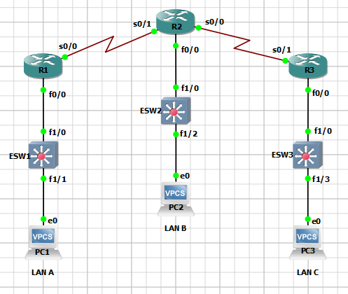

Figure 1: The Network Topology for This Lab

Reference Tables

For convenience, Table 1 provides the IP addresses and mask necessary for all interfaces used to complete this lab.

Table 1: Computer IP Addresses, Subnet Masks, and Gateway Addresses

|  |  |  |  |
| --- | --- | --- | --- |
| Computer/Interface – R1 | IP Address | Subnet Mask | Gateway Address |
| PC1 | 172.10.1.10 | 255.255.255.0 | 172.10.1.254 |
| R1-Fa0/0 | 172.10.1.254 | 255.255.255.0 | ------------------ |
| R1-S0/0 | 10.10.10.1 | 255.255.255.0 | ------------------ |
| Computer/Interface – R2 | IP Address | Subnet Mask | Gateway Address |
| PC2 | 172.20.2.20 | 255.255.255.0 | 172.20.2.254 |
| R2-Fa0/0 | 172.20.2.254 | 255.255.255.0 | ------------------ |
| R2-S0/1 | 10.10.10.2 | 255.255.255.0 | ------------------ |
| R2-S0/0 | 10.20.10.1 | 255.255.255.0 | ------------------ |
| Computer/Interface – R3 | IP Address | Subnet Mask | Gateway Address |
| PC3 | 192.168.3.30 | 255.255.255.0 | 192.168.3.254 |
| R3-Fa0/0 | 192.168.3.254 | 255.255.255.0 | ------------------ |
| R3-S0/1 | 10.20.10.2 | 255.255.255.0 | ------------------ |

Detailed Lab Steps

Configure OSPF routes to the adjacent LANs: Use the IP addresses provided in Table 1. You will be asked to verify that the computers in your LAN can ping the neighboring LAN.

1. Configure the PCs IP addresses for your LAN A, B, and C according the addresses provided in Table 1. You also need to enable the interfaces. Use screen capture to show commands used to configure the IP addresses, the subnet mask, and gateway. (6 points)

1. Configure the gateway address for your LAN routers (R1 R2 R3) according the addresses provided in Table 1. You also need to enable the interfaces. Use screen capture to show commands used to configure the IP addresses, the subnet mask for your gateway, and the command used to enable the interface. (6 points)

1. Configure the hostname for your routers. R1 will be renamed as YOURNAMELAN-A (i.e BRIANLAN-A), R2 will be renamed YOURNAMELAN-B, and R3 will be renamed YOURNAMELAN-C. Use screen capture to show command used to configure the router’s hostname. (6 points)

 



1. Configure the router serial interface’s IP addresses and subnet masks according the addresses specified in Table 1. Use screen capture to show the each command used to configure the interfaces. (6 points)

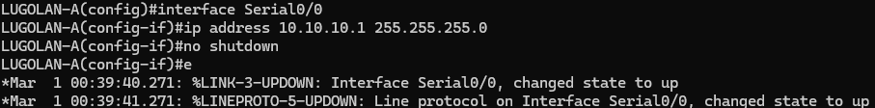

1. Use screen capture to show that the interfaces have been configured correctly on all routers. (6 points)

1. Configure OSPF routes for LAN-A router, LAN-B router, and LAN-C routers using a process ID of 20 and an area of 0. Use screen capture to show the proper commands have been used to configure OSPF. (6 points)

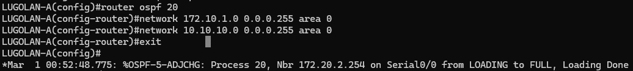

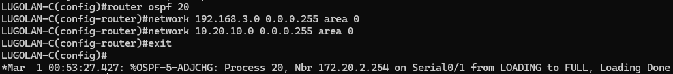

1. Use screen capture to show the proper commands to verify that the routes are configured on each router. (3 points)

1. Use the computer in each LAN to ping the computers in the other LANs. Use screen capture to show connectivity across the LANs. (6 points)

Pings from PC terminals

