TUGAS ULANGAN TENGAH SEMESTER

MATA KULIAH:
BASIS DATA



Dosen Pengampu:
Ranny Meilisa, S.Kom.,M.Pd.T

Dibuat Oleh:
Teguh Tegar Aulia ( 20230801124 )

TEKNIK INFORMATIKA
UNIVERSITAS ESA UNGGUL
2024
- Suatu nilai otomatis merupakan suatu field yang diisi secara otomatis oleh sistem. Biasanya paling banyak digunakan pada Primary Key. Tipe data kolom yang akan diset nilai autoincrement adalah int.
Perintahnya :
Auto_Increment
Contoh :
Mysql>Create Table Mahasiswa (
ID int(5) not null primary key auto_increment,
NIM char(8) not null,
Nama_Mhs varchar(50),
Jurusan varchar(200),
Fakultas varchar(30));
Lakukan perintah tersebut kemudian tampilkan hasilnya dalam bentuk gambar (screenshoot)

JAWABAN:
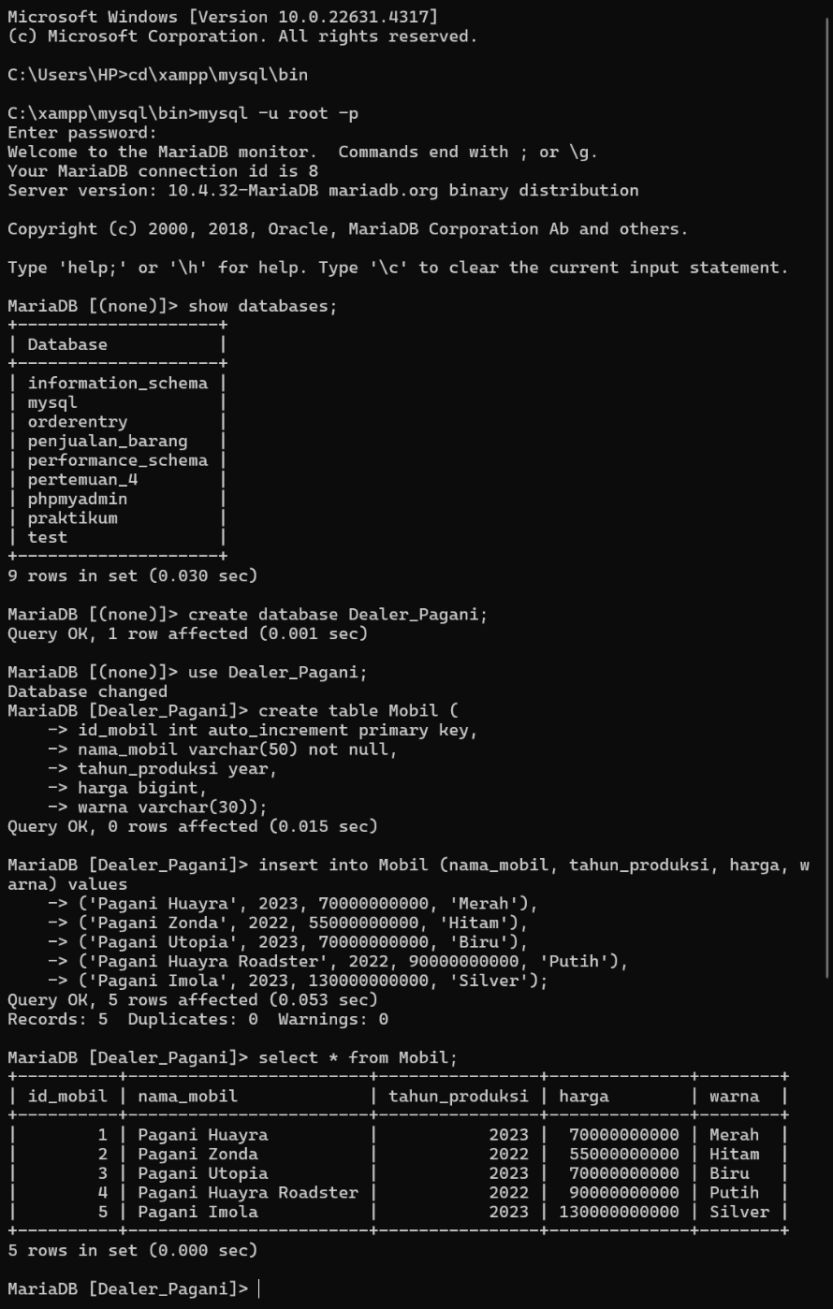
- Buatlah sebuah database baru dengan nama Penjualan_Barang

JAWABAN:

- Gunakan database Penjualan_Barang kemudian buatlah table hasil dari diagram relationship penjualan barang

JAWABAN:
Microsoft Windows [Version 10.0.22631.4317]
(c) Microsoft Corporation. All rights reserved.

C:\Users\HP>cd\xampp\mysql\bin

C:\xampp\mysql\bin>mysql -u root -p
Enter password:
Welcome to the MariaDB monitor. Commands end with ; or \g.
Your MariaDB connection id is 10
Server version: 10.4.32-MariaDB mariadb.org binary distribution

Copyright (c) 2000, 2018, Oracle, MariaDB Corporation Ab and others.

Type 'help;' or '\h' for help. Type '\c' to clear the current input statement.

MariaDB [(none)]> show databases;
+--------------------+
| Database |
+--------------------+
| dealer_pagani |
| information_schema |
| mysql |
| orderentry |
| penjualan_barang |
| performance_schema |
| pertemuan_4 |
| phpmyadmin |
| praktikum |
| test |
+--------------------+
10 rows in set (0.001 sec)

MariaDB [(none)]> create database penjualan_barang_uts;
Query OK, 1 row affected (0.001 sec)

MariaDB [(none)]> use penjualan_barang_uts;
Database changed
MariaDB [penjualan_barang_uts]> create table barang (
-> id_barang int auto_increment primary key,
-> nama_barang varchar(100) not null,
-> kategori varchar(50),
-> harga bigint,
-> stok int
-> );
Query OK, 0 rows affected (0.007 sec)

MariaDB [penjualan_barang_uts]> create table transaksi (
-> id_transaksi int auto_increment primary key,
-> id_barang int,
-> jumlah int,
-> total_harga bigint,
-> tanggal_transaksi date,
-> foreign key (id_barang) references barang(id_barang)
-> );
Query OK, 0 rows affected (0.016 sec)

MariaDB [penjualan_barang_uts]> create table pelanggan (
-> id_pelanggan int auto_increment primary key,
-> nama_pelanggan varchar(100),
-> alamat varchar(200),
-> telepon varchar(20)
-> );
Query OK, 0 rows affected (0.005 sec)

MariaDB [penjualan_barang_uts]> create table supplier (
-> id_supplier int auto_increment primary key,
-> nama_supplier varchar(100),
-> alamat varchar(200),
-> telepon varchar(20)
-> );
Query OK, 0 rows affected (0.015 sec)

MariaDB [penjualan_barang_uts]> create table pembelian (
-> id_pembelian int auto_increment primary key,
-> id_supplier int,
-> id_barang int,
-> jumlah int,
-> harga_pembelian bigint,
-> tanggal_pembelian date,
-> foreign key (id_supplier) references supplier(id_supplier),
-> foreign key (id_barang) references barang(id_barang)
-> );
Query OK, 0 rows affected (0.015 sec)

MariaDB [penjualan_barang_uts]>

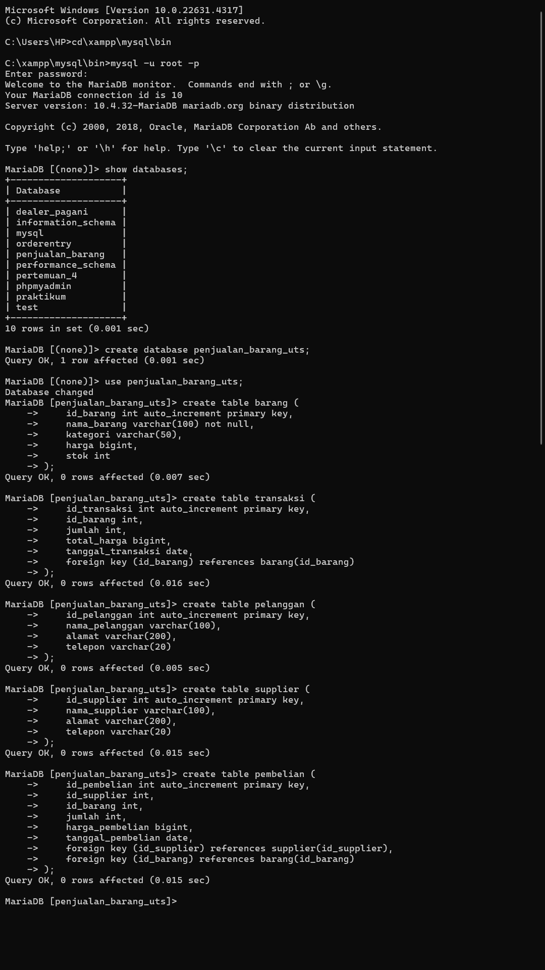
Table Diagram Relationship

