Title: 1 or 2 Lines, Single Space, Times 16pt, Bold

Name,(Times New Roman 12pt, Bold)
Author’s Affiliation and Short Address (Times New Roman 12pt, Bold)

*For correspondence
Email: ******
Phone: +91-*********

Title: 1 or 2 Lines, Single Space, Times 16pt, Bold

Abstract (Times New Roman 12pt, Bold)
Each paper must be accompanied by a 150 to 500-word abstract, written as a single paragraph, having a 40 mm distance from the left and 40 mm from the right sides. It should be a summary (not an introduction) and complete, indicating the subjects, objectives, method of investigation, and distinct achievements. The abstract should be prepared in Times New Roman font size 12pt.
Keywords: Maximum 6 words separated by comma, Times New Roman 10pt Bold.

Introduction (Times New Roman 14 Bold, 20pt from above, 10pt from bellow)
Use Times New Roman, 12 pt for the main text.
- Seismicity and tectonic setting of the study region.
- Need for the study and existing model limitations.
- Research gap and motivation.
- How the current model is better than existing ones (e.g., new predictors, ML architecture, FAS-based, or non-ergodic treatment).
- Description of the ground-motion network used (number of stations, coverage, IMs considered).
- Clearly mention novelty of the study.

Ground motion dataset
(describe the dataset, including filtering criteria, statistics of the dataset)
• Describe the dataset structure, sources (e.g., NGA-West2, regional network, etc.).
• Explain the filtering criteria.
• statistics of the dataset

Ground motion model

Methodology
• Explain the principle of the model
• Include all governing equations (correlation structure, if any).
• Ensure this section is at least 1.5 pages long, with clear, step-by-step justification of each term.

3.2 Network Architecture
• Describe the neural-network/ML architecture.
• Mention the number of layers, hidden units, activation functions, input-output structure, and any special design (e.g., lagged inputs, attention).
• Keep this section at least 1 page.

Hyperparameter Tuning
• List all key hyperparameters (learning rate, batch size, epochs, optimizer, regularisation, number of components in GMM, etc.).
• Explain the tuning process (e.g., grid search, random search, validation set).
• Justify the final choice based on criteria such as minimum validation error, optimum bias–variance trade-off, or best-fit attenuation curves.

Performance of GMM
Comment on model perf based on residual and std deviation, discuss the parametric and attenuation plots

Residual Analysis
discuss residuals vs Mw, distance, Vs30, and period.
Comment on trends, bias, and any non-ergodic behaviour.

Std Deviation
Discuss the total, intra-event, and inter-event standard deviations of the model.

Parametric Study and Attenuation
Discuss how the model behaves with changes in magnitude, distance, and site conditions compared with observations.

Relative Importance of Input Parameters

Discussion and Conclusion
(discuss the results, include limitations and future scope)
• Summarise the key findings and how they address the research gap.
• Mention limitations (e.g., data sparsity, limited period range, station-distribution bias, assumptions in the model).
• Suggest future scope (e.g., extending to other regions, incorporating more non-ergodic terms, using physics-based simulations to augment data, real-time applications).

References
Sample:
- Engelke, C., Helm, L., Sadegh-Azar, H.: Experimental study on the displacement- and frequency-dependency of ring springs under dynamic loads, in: Nuclear Engineering and Design Volume 85, 2026, https://doi.org/10.1016/j.istruc.2026.111181
- Heibges, L.; Sadegh-Azar, H.: Schräger Projektilaufprall auf Stahlbetonkonstruktionen, in: Nuclear Engineering and Design Volume 438, 2025, 114043, ISSN 0029-5493, https://doi.org/10.1016/j.nucengdes.2025.114043

NOTE:
1 Cite all the figures and tables within the text
2 Use high resolution image (Minimum 300 dpi)
3 All the figures and tables must have a caption and numbering
- Font: Times New Roman
5 Font size: 12 (normal text); 14 (headings)
6 Use Justify alignment

Figures:
- Distribution of data on map
- Statistics plot
- Network architecture
- Hyperparameter tuning
- Actual vs pred with R2
- Residual
- Standard deviation
- Parametric plots
- Attenuation plots with data
- Importance factor and SHAP analysis

Sample:
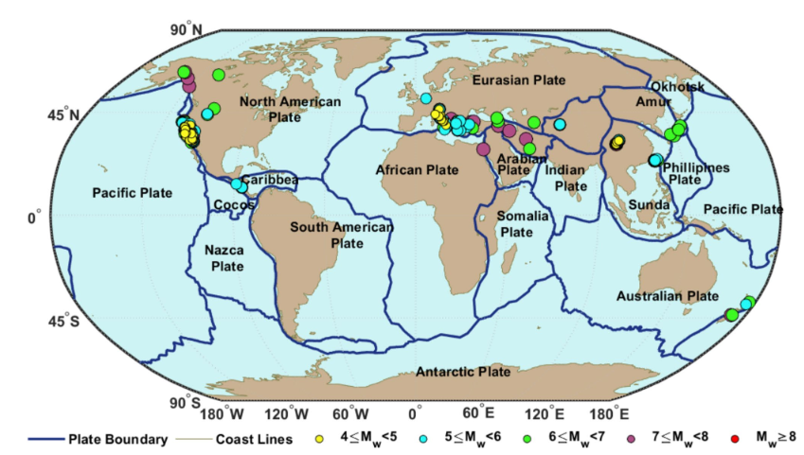
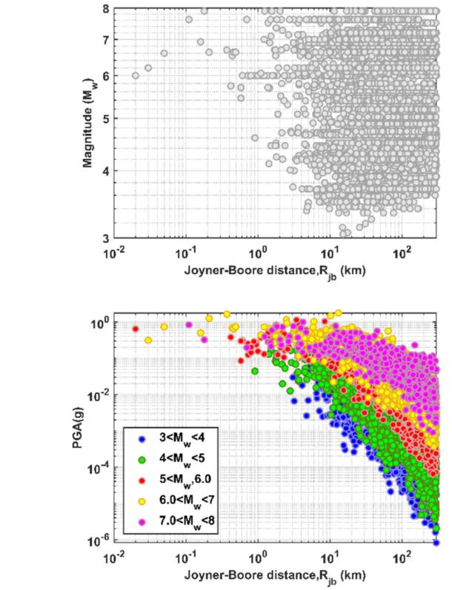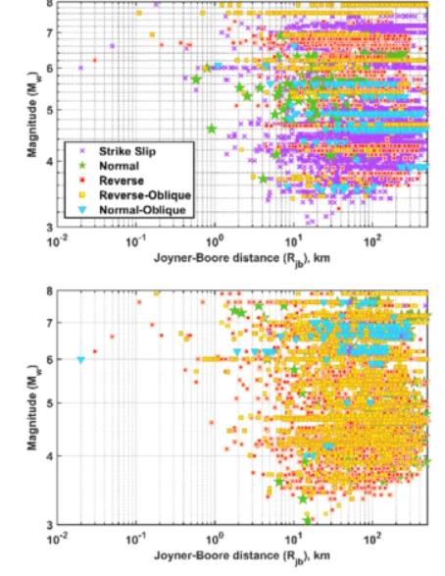

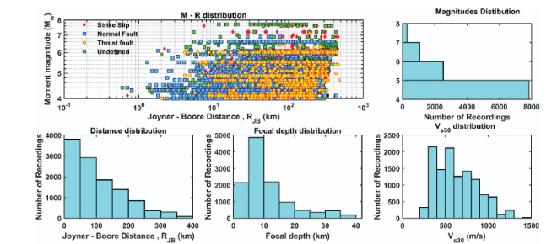
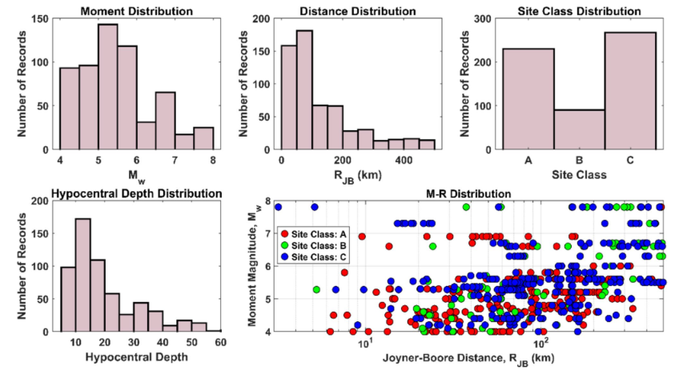
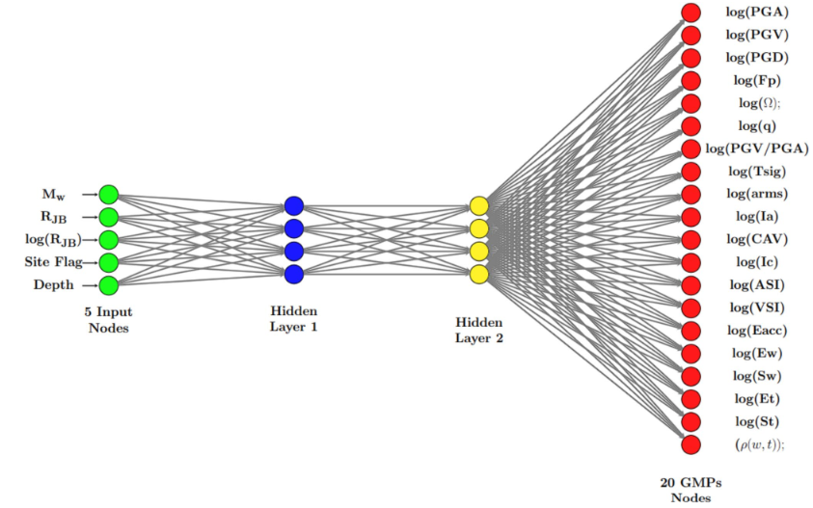
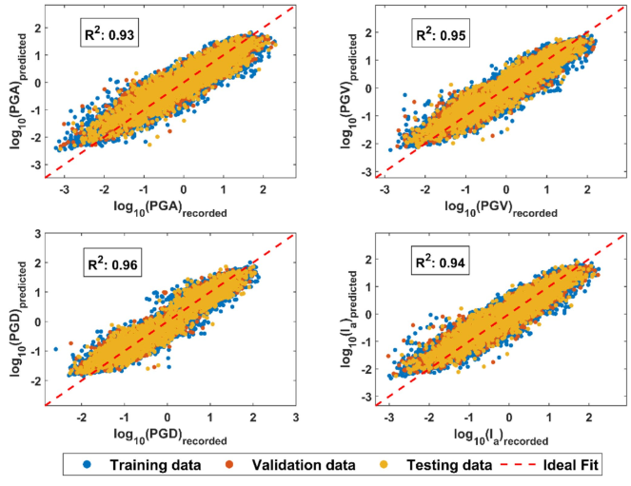
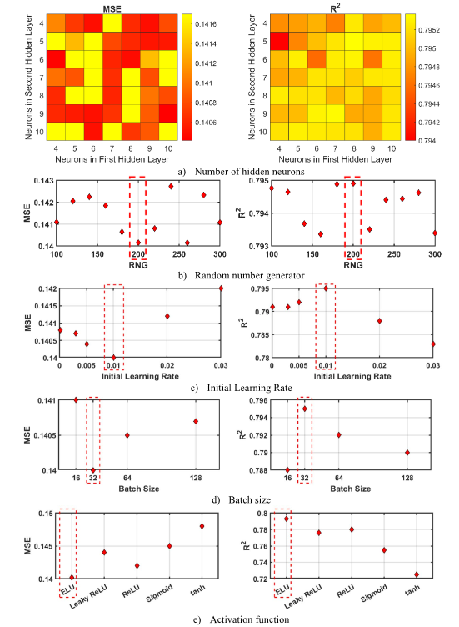

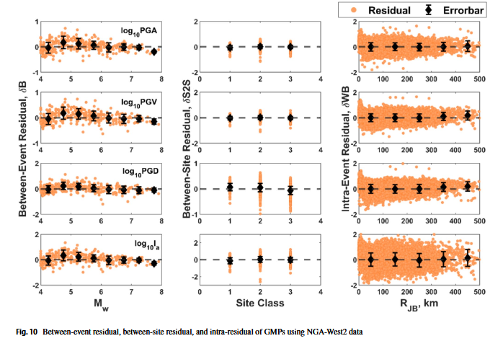
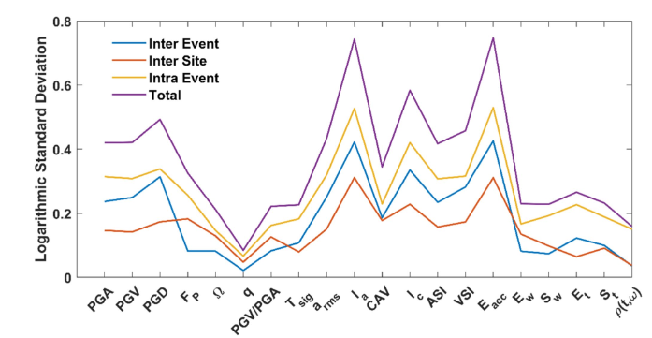
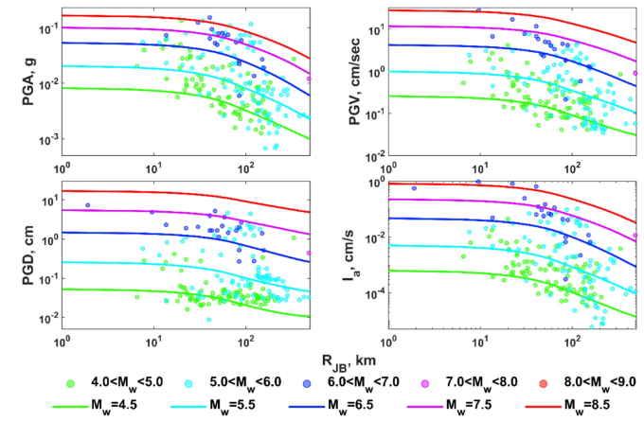
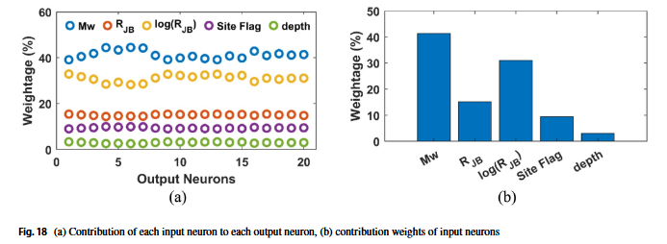

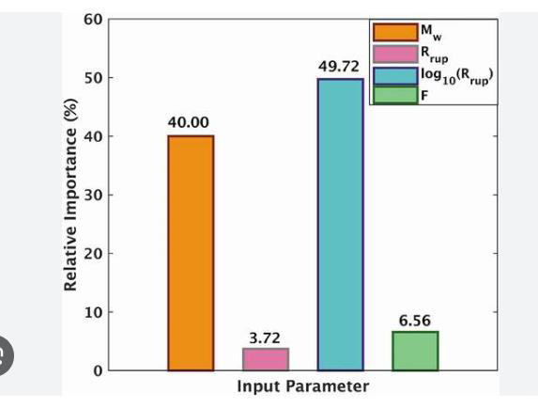

Tables:
- Statistics of data
- R2 and std deviation
- Performance parameters

Samples:

