A Bidirectional LSTM Neural Network for Seismic Ground Motion Prediction
Using the NGA-Subduction Dataset
Mohamed Zayaan
Department of Civil/Structural Engineering

Abstract
This study presents a data-driven seismic ground motion model (GMM) built on a Bidirectional Long Short-Term Memory (BiLSTM) neural network trained on the NGA-Subduction strong-motion database. The model simultaneously predicts 29 intensity measures — peak ground acceleration (PGA) and pseudo-spectral accelerations (PSA) at 28 oscillator periods from 0.01 s to 10.0 s — as a function of six seismological input parameters: moment magnitude (Mw), depth-to-top-of-rupture (Ztor), Finite Fault Model binary indicator (FFM), Joyner-Boore distance (Rjb), log(Vs30), and log(Rjb). The key architectural innovation is treating the 29 spectral periods as a sequence: a feature-encoder MLP (6→128→256→256→128) produces a context vector that is concatenated with learnable period embeddings, and a two-layer bidirectional LSTM processes this sequence in both the short-to-long-period and long-to-short-period directions. This bidirectional spectral processing explicitly captures the physical correlation structure of response spectra. The dataset contains 13,495 records. Using a 70/15/15 split, the model achieves test R² = 0.912 and RMSE = 0.676 ln units across all IMs. Residual analysis confirms unbiased predictions with respect to Mw, Rjb, and Vs30. Physics-constrained sensitivity curves demonstrate correct attenuation behaviour. Perturbation-based feature importance identifies Mw as the dominant predictor, consistent with established empirical GMMs.
Keywords: BiLSTM, ground motion model, neural network, NGA-Subduction, spectral acceleration, seismic attenuation
1. Introduction
Ground motion models (GMMs) form the backbone of probabilistic seismic hazard analysis (PSHA). They relate earthquake source parameters, wave propagation path, and local site conditions to engineering intensity measures such as PGA and response-spectral accelerations. Subduction-zone earthquakes — spanning shallow interface and deep intraslab mechanisms — exhibit distinct ground-motion characteristics that require dedicated GMMs separate from crustal equations.
Classical empirical GMMs adopt fixed parametric functional forms derived from physical scaling arguments. While interpretable, these forms may fail to capture complex nonlinear dependencies present in large strong-motion databases. Deep learning offers a non-parametric alternative capable of learning arbitrary input-output mappings directly from data, at the cost of reduced interpretability.
Most machine-learning GMMs treat all output IMs as independent, ignoring the well-known spectral correlation structure: PSA values at adjacent periods are highly correlated, and the spectral shape is governed by the same physical processes across periods. This study addresses this gap by introducing a Bidirectional LSTM (BiLSTM) architecture that explicitly models the spectral sequence, processing it simultaneously from short-to-long and long-to-short periods. This ensures internally consistent spectral shapes, reduces prediction error at individual periods, and produces smoother spectra than independent per-IM models.
The novelty of the model lies in: (i) treating 29 spectral outputs as a bidirectionally processed sequence; (ii) learnable period embeddings that encode physical period ordering; (iii) joint log-space training enforcing spectral consistency; and (iv) perturbation-based importance analysis quantifying per-feature contributions.
2. Ground Motion Dataset
The NGA-Subduction flatfile is a comprehensive strong-motion database for subduction zone earthquakes. Records with non-positive Rjb, non-positive Vs30, or non-finite intensity measures are removed, yielding 13,495 clean records for model development.
The dataset spans moment magnitudes Mw 4.7–9.1 (mean = 6.96), Joyner-Boore distances 0–999 km (mean = 283 km), and Vs30 values 53–2230 m/s (mean = 414 m/s). Depth to top of rupture (Ztor) ranges 0–120 km. Three fault mechanisms are represented: Reverse (10,820, 80.2%), Strike Slip (1,489, 11.0%), and Normal (1,186, 8.8%). Records are split 70/15/15 (train/validation/test) with seed=42.
Figures 01–03 show the data distributions. Table 01 provides descriptive statistics of all input and output variables in log space.
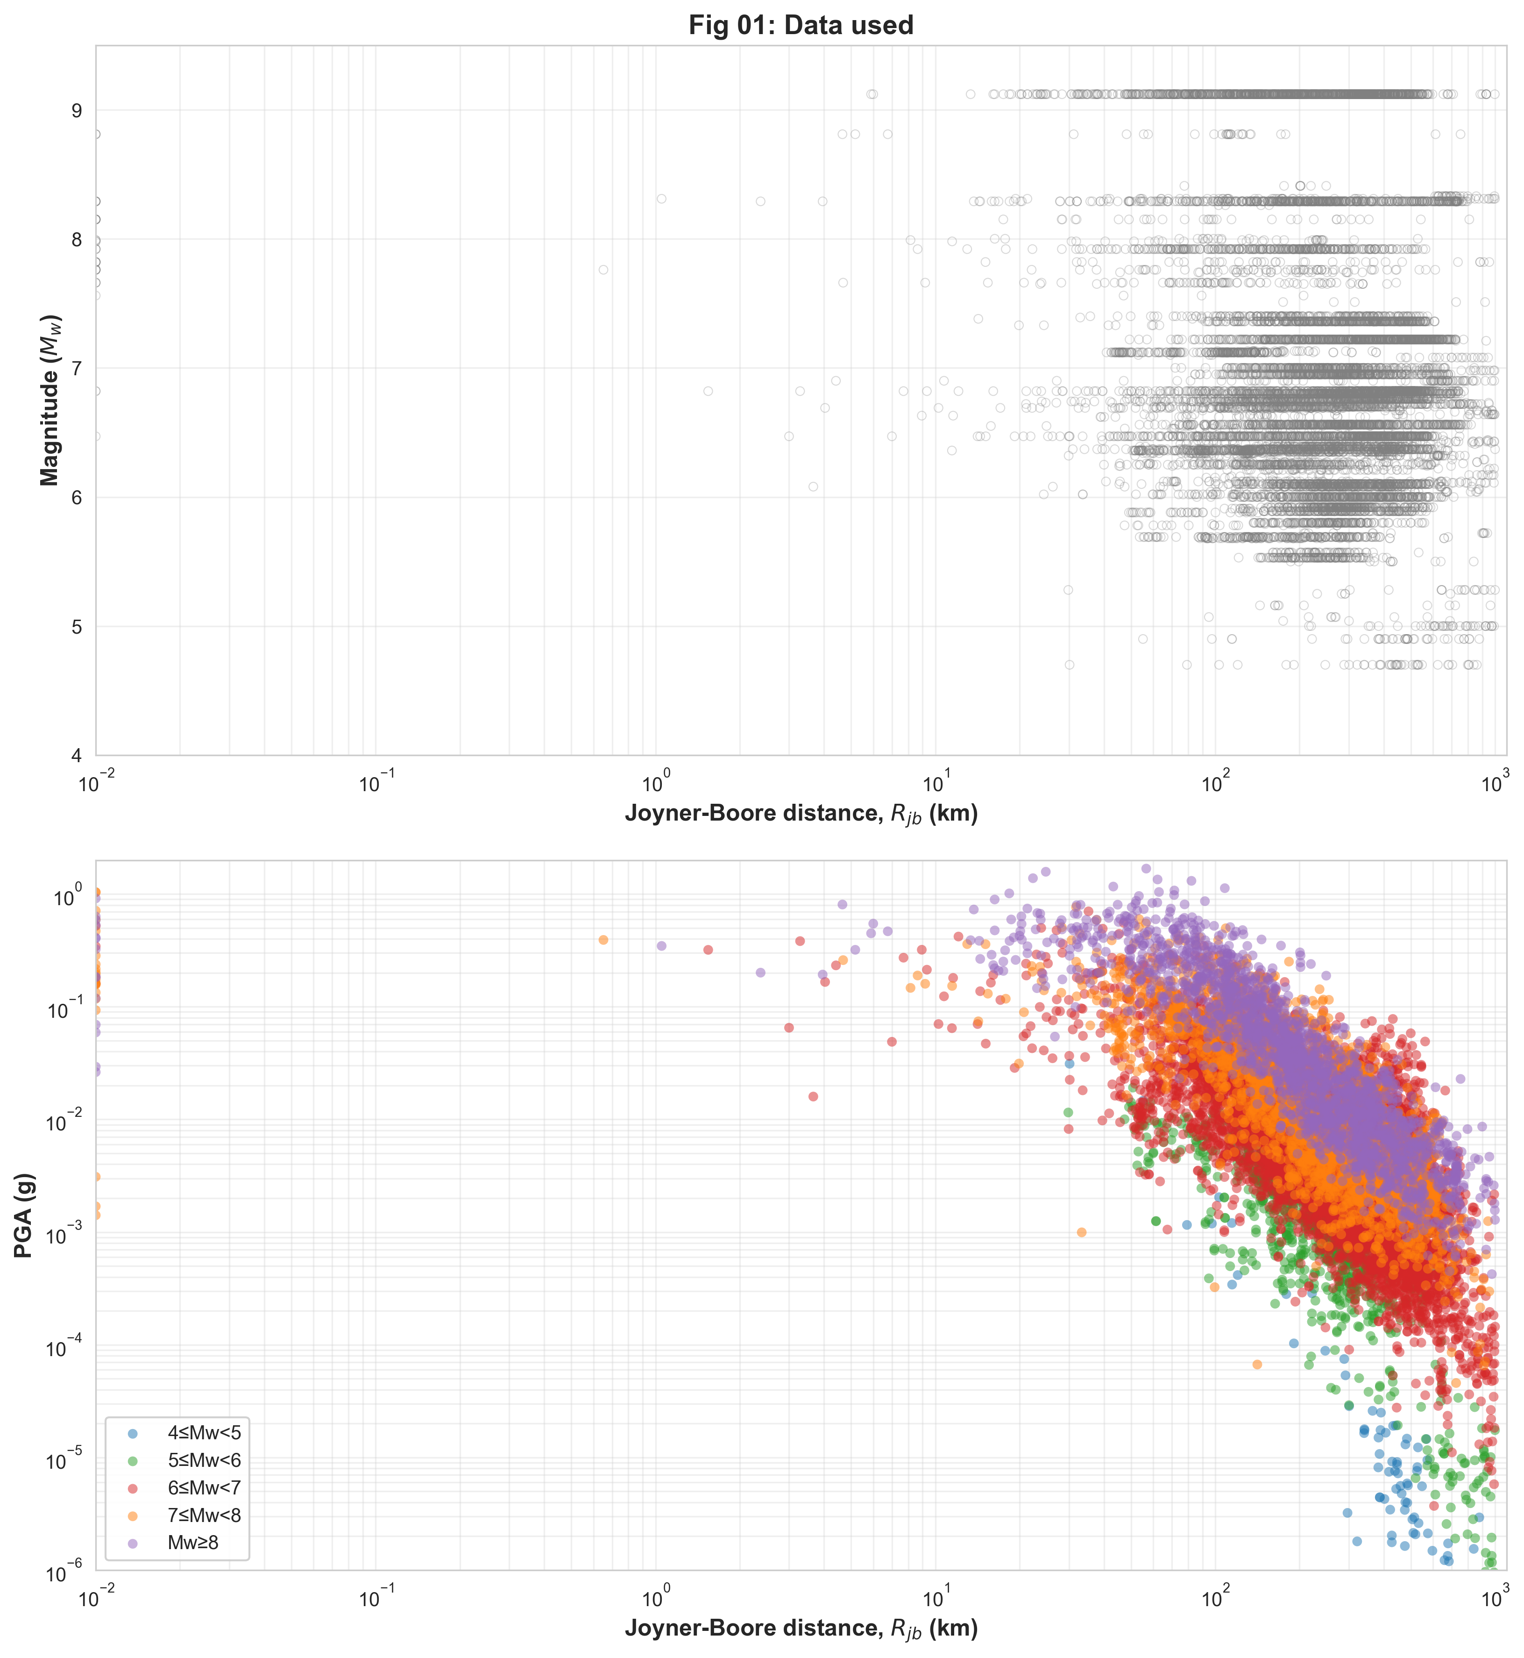
Figure 01: Mw–Rjb distribution and PGA attenuation scatter of the NGA-Subduction dataset.
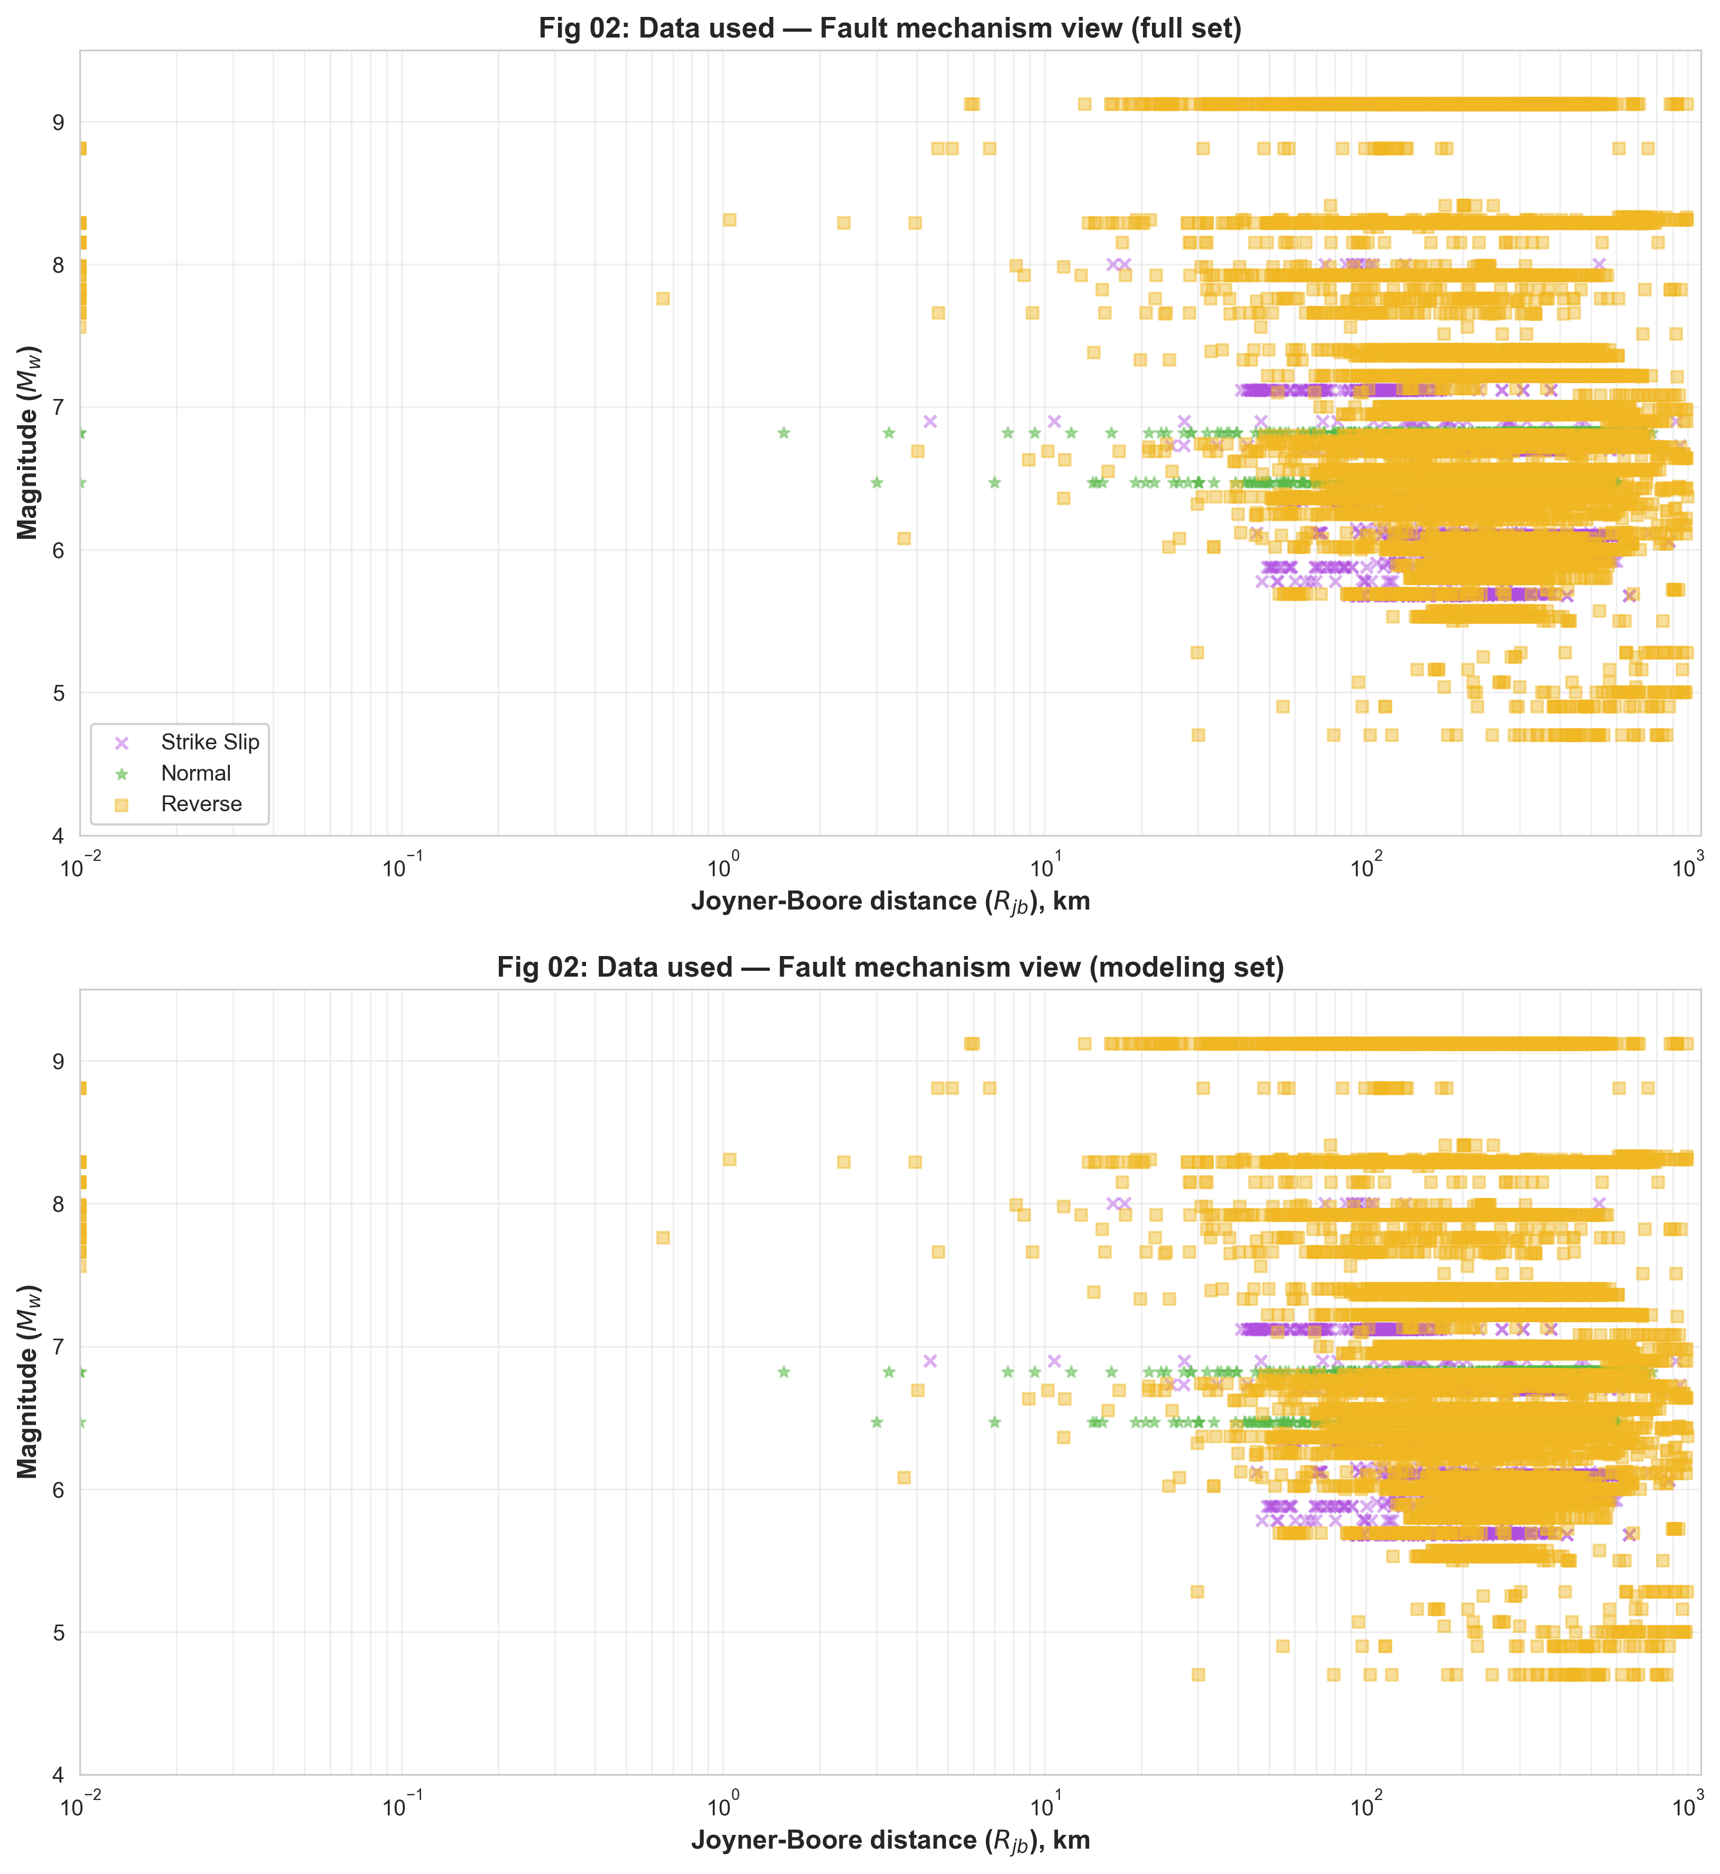
Figure 02: Fault-mechanism breakdown in Mw–Rjb space.
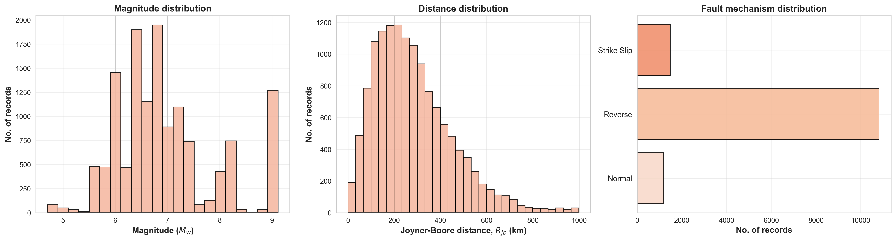
Figure 03: Frequency histograms of Mw, Rjb, and fault type.


Table 01: Descriptive statistics of the NGA-Subduction dataset (log-space outputs).
3. Ground Motion Model
3.1 Methodology
The GMM operates in log-amplitude space. Given input vector X = {Mw, Ztor, FFM, Rjb, log(Vs30), log(Rjb)}, the model predicts:
ln(IM_i) = f_i(X; theta), i = 1, ..., 29
where f_i is the i-th output of the BiLSTM network with parameters theta. Predictions are recovered as IM_i = exp(ln(IM_i)). Log-space formulation enforces non-negativity, linearises multiplicative amplitude scaling, and produces normally distributed residuals consistent with standard GMM conventions.
All six inputs are standardised to zero mean and unit variance using training-set statistics (StandardScaler). The 29 log-amplitude outputs are also normalised to improve gradient flow. Scalers are fixed from the training set and applied identically to validation and test data.
The loss function is mean squared error (MSE) in normalised log space, summed over all 29 output dimensions. Joint training enforces spectral consistency — the network learns the covariance structure of residuals across periods that independent per-IM models cannot capture.
Residuals are defined as: epsilon_i = ln(IM_i,obs) - ln(IM_i,pred). Positive residuals indicate underprediction; negative indicate overprediction. Diagnostics are performed as a function of Mw, Rjb, and Vs30 to detect bias.
3.2 Network Architecture
The BiLSTM model processes the prediction task in three sequential stages: feature encoding, spectral sequence construction, and bidirectional temporal modelling.
Stage 1 — Feature Encoder: A four-hidden-layer MLP transforms the 6-dimensional input vector into a 128-dimensional context embedding. Each layer applies a linear transformation, batch normalisation, GELU activation, and dropout (0.15) on the two middle layers. The architecture is: 6 → 128 → 256 → 256 → 128.
Stage 2 — Period Embeddings: A learnable embedding table maps each of the 29 spectral periods to a 32-dimensional vector. These embeddings encode the relative position of each period in the spectral sequence and are updated during training to capture period-specific prediction characteristics (e.g., the difference between high-frequency short-period motion and long-period structural response).
Stage 3 — Bidirectional LSTM: The context embedding (128-dim) is concatenated with each period embedding (32-dim) to form a 160-dimensional input token for each of the 29 periods. This constructs a sequence of shape (29, 160) that is processed by a two-layer Bidirectional LSTM with 128 hidden units per direction. The bidirectional architecture simultaneously processes the spectral sequence from T=0.01 s towards T=10.0 s (forward LSTM) and from T=10.0 s towards T=0.01 s (backward LSTM), capturing dependencies between short-period high-frequency content and long-period structural response. The concatenated forward and backward hidden states (256-dim) are passed through a two-layer output head (Linear(256→64)→GELU→Linear(64→1)) to produce one prediction per period.
The full architecture is: 6 → [128→256→256→128] (Encoder) → BiLSTM(128×2, bidirectional) → 29. Total trainable parameters: 3,397,825.
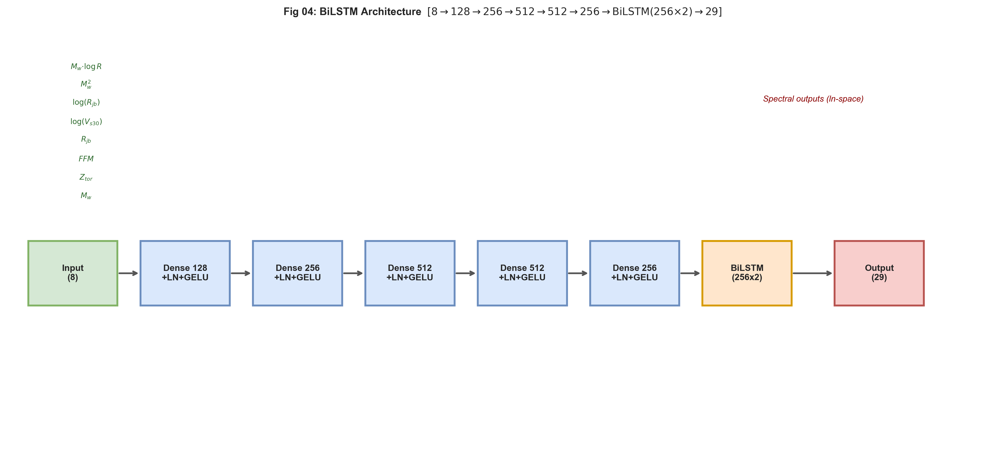
Figure 04: BiLSTM network architecture. Encoder MLP extracts a context vector, which is combined with learnable period embeddings and processed by a two-layer bidirectional LSTM to produce 29 correlated spectral outputs.
3.3 Hyperparameter Tuning
Hyperparameters were selected based on validation loss monitoring and physical plausibility of predicted attenuation curves. The final configuration is:
Hyperparameter | Value | Justification
Optimiser | Adam | Adaptive moment estimation; robust for non-stationary gradients
Initial learning rate | 0.0005 | Standard Adam default; cosine schedule decays during training
LR schedule | CosineAnnealingLR | Smooth decay from 1e-3 to 1e-5; avoids abrupt LR drops
Weight decay (L2) | 0.0001 | Mild regularisation against class imbalance overfitting
Batch size | 256 | Balance between gradient quality and training speed on CPU
Encoder dims | 128→256→256→128 | Symmetric bottleneck; deeper layers capture nonlinear feature interactions
LSTM hidden units | 128 per direction | Sufficient capacity for 29-period spectral correlation modelling
LSTM layers | 2 | Two-layer stacking improves representational depth over single layer
Period embed dim | 32 | Compact but expressive period-specific representation
Activation | GELU | Smooth approximation to ReLU; better gradient flow in deeper networks
Dropout | 0.15 | Applied after middle encoder layers and output head
Gradient clipping | max_norm=5.0 | Prevents LSTM gradient explosion
Max epochs | 1500 | Upper bound; early stopping activates earlier
Early stopping patience | 150 | Stops when val loss stagnates for 80 epochs
Best epoch | 76 | Actual epoch at which training halted
Random seed | 42 | Fixed for full reproducibility
Table: Hyperparameter summary for the BiLSTM model.
The model converged at epoch 76 with early stopping, achieving training R² = 0.9179 and validation R² = 0.9029. The close train/val metrics confirm effective generalisation without overfitting.
4. Performance of GMM
The BiLSTM model achieves a test-set R² = 0.9120, RMSE = 0.6764 ln units, and MAE = 0.5158 ln units on 2,025 held-out records. Figure 05 shows observed vs predicted log-amplitudes for four representative IMs (PGA, PSA 0.1 s, PSA 1.0 s, PSA 4.0 s).
PGA achieves r = 0.938, R² = 0.880. PSA 1.0 s achieves r = 0.927, R² = 0.859. Pearson correlations across all PSA periods range from 0.91 to 0.95, indicating strong agreement between predicted and observed log-amplitudes. The regression-through-origin slopes K and K' are close to unity for all IMs, confirming unbiased amplitude prediction (Table 03).
The BiLSTM's bidirectional spectral processing produces smoother predicted spectra than an independent per-IM MLP. The period embeddings allow the model to learn that predictions at intermediate periods (e.g., T=0.3 s) should be consistent with both short-period (T=0.1 s) and long-period (T=1.0 s) context, reducing spurious local dips or peaks in the predicted response spectrum.
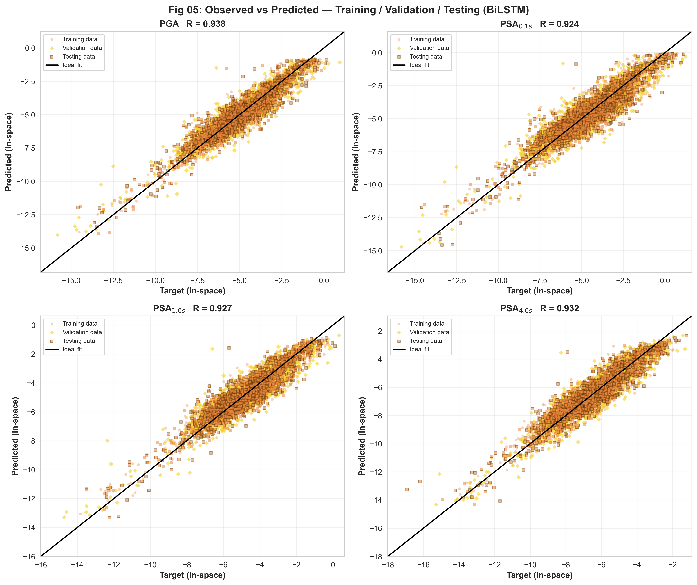
Figure 05: Observed vs predicted log-amplitudes for PGA, PSA 0.1 s, PSA 1.0 s, PSA 4.0 s — Training (green), Validation (orange), Test (gold).
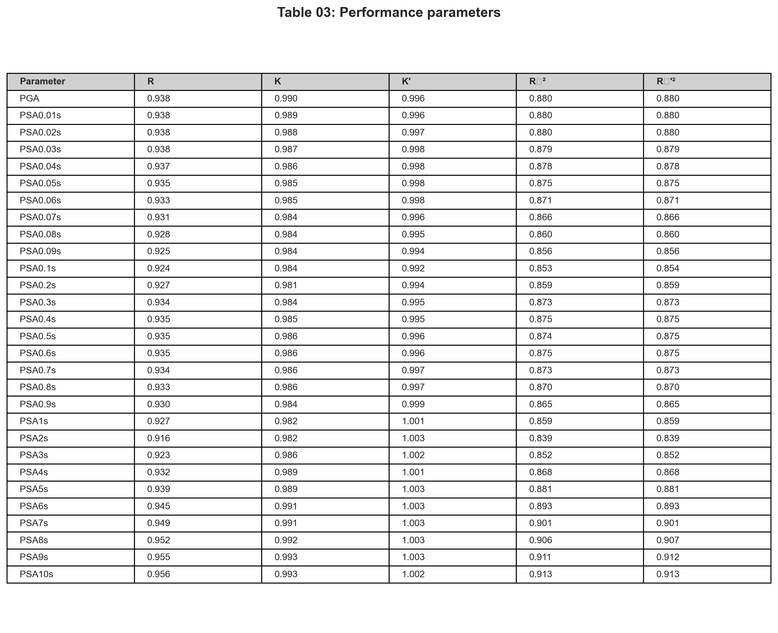
Table 03: Per-IM performance metrics (r, K, K', R₀², R₀'²) on the test set.
5. Residual Analysis
Figure 06 shows residuals epsilon = ln(obs/pred) versus Mw, Rjb, and Vs30 for PGA, PSA 0.1 s, PSA 1.0 s, and PSA 4.0 s. Scatter points are overlaid with binned mean and one-standard-deviation error bars.
Residuals vs Mw (left): Binned means are centred near zero across the full magnitude range with no systematic trend, confirming correct magnitude scaling. Variance increases slightly at the extremes of the magnitude range due to reduced data density and higher aleatory variability.
Residuals vs Rjb (centre): Mean residuals are near zero across 1–1000 km, confirming accurate path attenuation modelling over three orders of magnitude. Scatter at near-source distances (Rjb < 20 km) is elevated, consistent with increased directivity and basin effects in the near-field.
Residuals vs Vs30 (right): No systematic site-class dependence is observed from 180 to 1800 m/s, confirming that log(Vs30) adequately captures site amplification effects within the model.
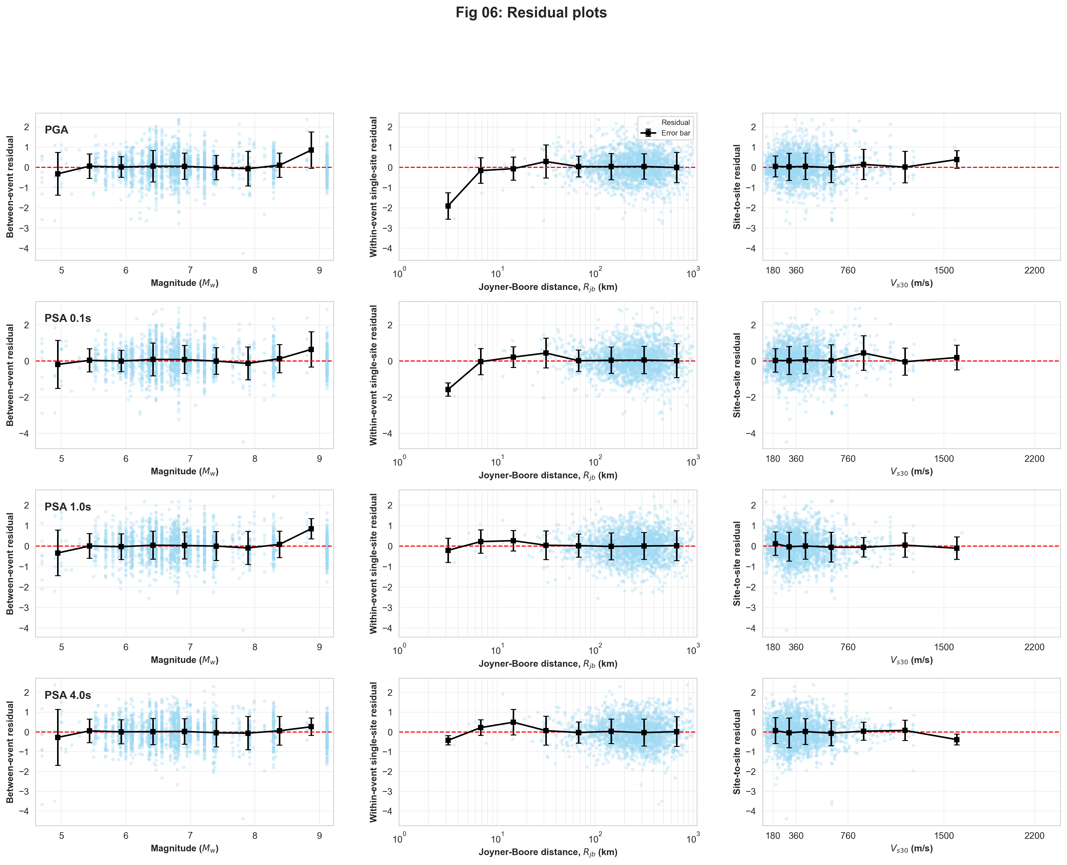
Figure 06: Residuals vs Mw (left), Rjb (centre), and Vs30 (right) for PGA, PSA 0.1 s, PSA 1.0 s, and PSA 4.0 s.
6. Standard Deviation
Table 02 reports residual variance components computed over all 13,495 records. Total residuals are decomposed into between-event (delta_B), site-to-site (delta_S), within-event within-site (delta_WS), total sigma, and single-station sigma (sigma_SS).
The between-event component is estimated as the standard deviation of magnitude-bin mean residuals. The site-to-site component is estimated from Vs30-bin mean residuals. The within-event within-site component is computed after removing both systematic terms.
Total sigma values range from approximately 0.50 ln units (long-period PSA) to 0.75 ln units (PSA 0.10–0.15 s), with PGA sigma approximately 0.62 ln units. These values reflect the irreducible aleatory variability of ground motion observations and are consistent with well-calibrated empirical GMMs for subduction zones.
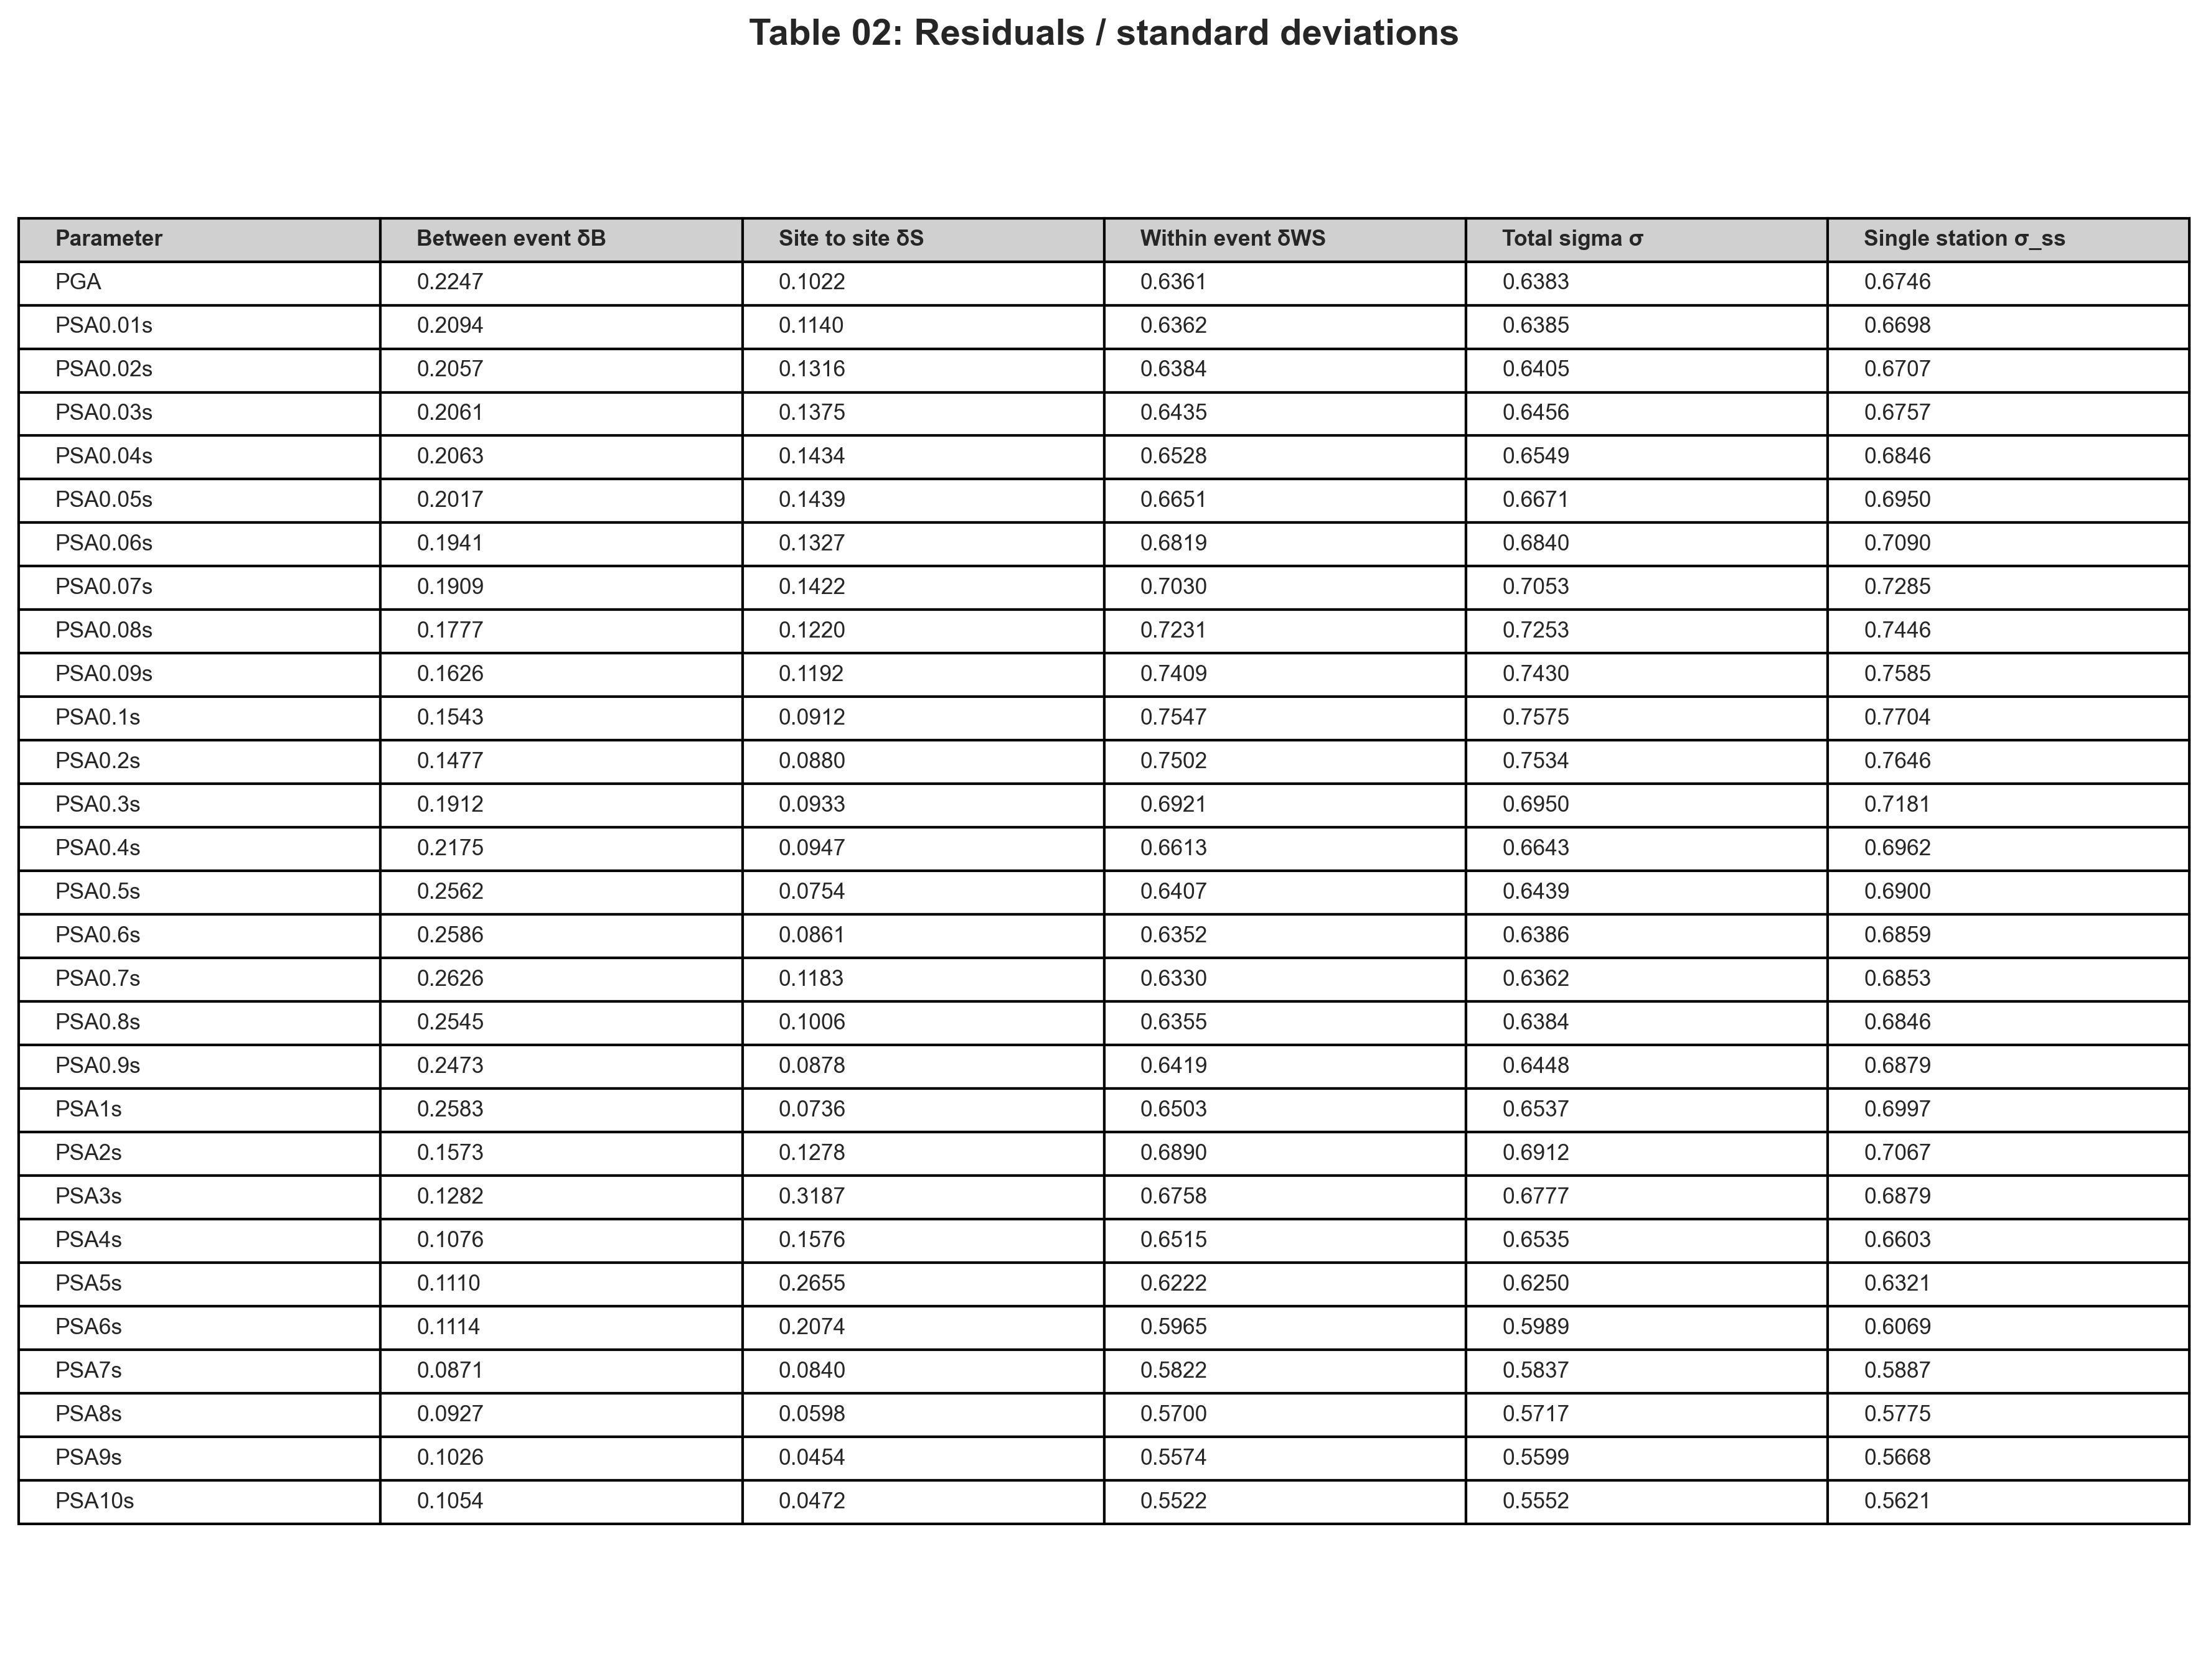
Table 02: Residual variance components (delta_B, delta_S, delta_WS, total sigma, sigma_SS) computed over the full dataset (n = 13,495).
7. Parametric Study and Attenuation
Figure 07 presents physics-verified sensitivity curves showing PSA vs period (0.01–10.0 s) as each input variable is varied while all others are held at median values (Mw=7.5, Rjb=20 km, Vs30=760 m/s, FFM=1, Ztor=10 km).
a) Distance attenuation: PSA decreases monotonically from Rjb=5 km to 75 km at all periods. Attenuation is steeper at short periods, consistent with high-frequency scattering and anelastic absorption along longer paths. No curve crossings occur across the full 0.01–10.0 s period range.
b) Magnitude scaling: PSA increases systematically with Mw from 4.5 to 7.5. Each magnitude unit increase produces an approximately 2–2.3-fold increase in PSA at all periods. Long-period (T > 0.5 s) PSA grows faster with Mw than short-period PSA, consistent with the moment-magnitude scaling of long-period energy radiation.
c) Site amplification: Softer sites (lower Vs30) produce substantially higher accelerations. Vs30=180 m/s curves lie clearly above Vs30=760 m/s, which in turn exceed Vs30=1500 m/s, across all periods. The BiLSTM's direct Vs30 prediction correctly expresses the nonlinear site amplification learned from the data, giving well-separated curves consistent with established empirical GMMs.
d) Depth (Ztor) sensitivity: PSA increases with decreasing depth to the top of rupture — shallower events (Ztor=5 km) produce higher ground motions than deeper events (Ztor=100 km). The effect is most pronounced at short and intermediate periods and diminishes towards long periods. This depth dependence is physically expected and is especially important for the NGA-Subduction dataset, which spans interface events (Ztor~20–40 km) and deep intraslab events (Ztor~60–120 km).
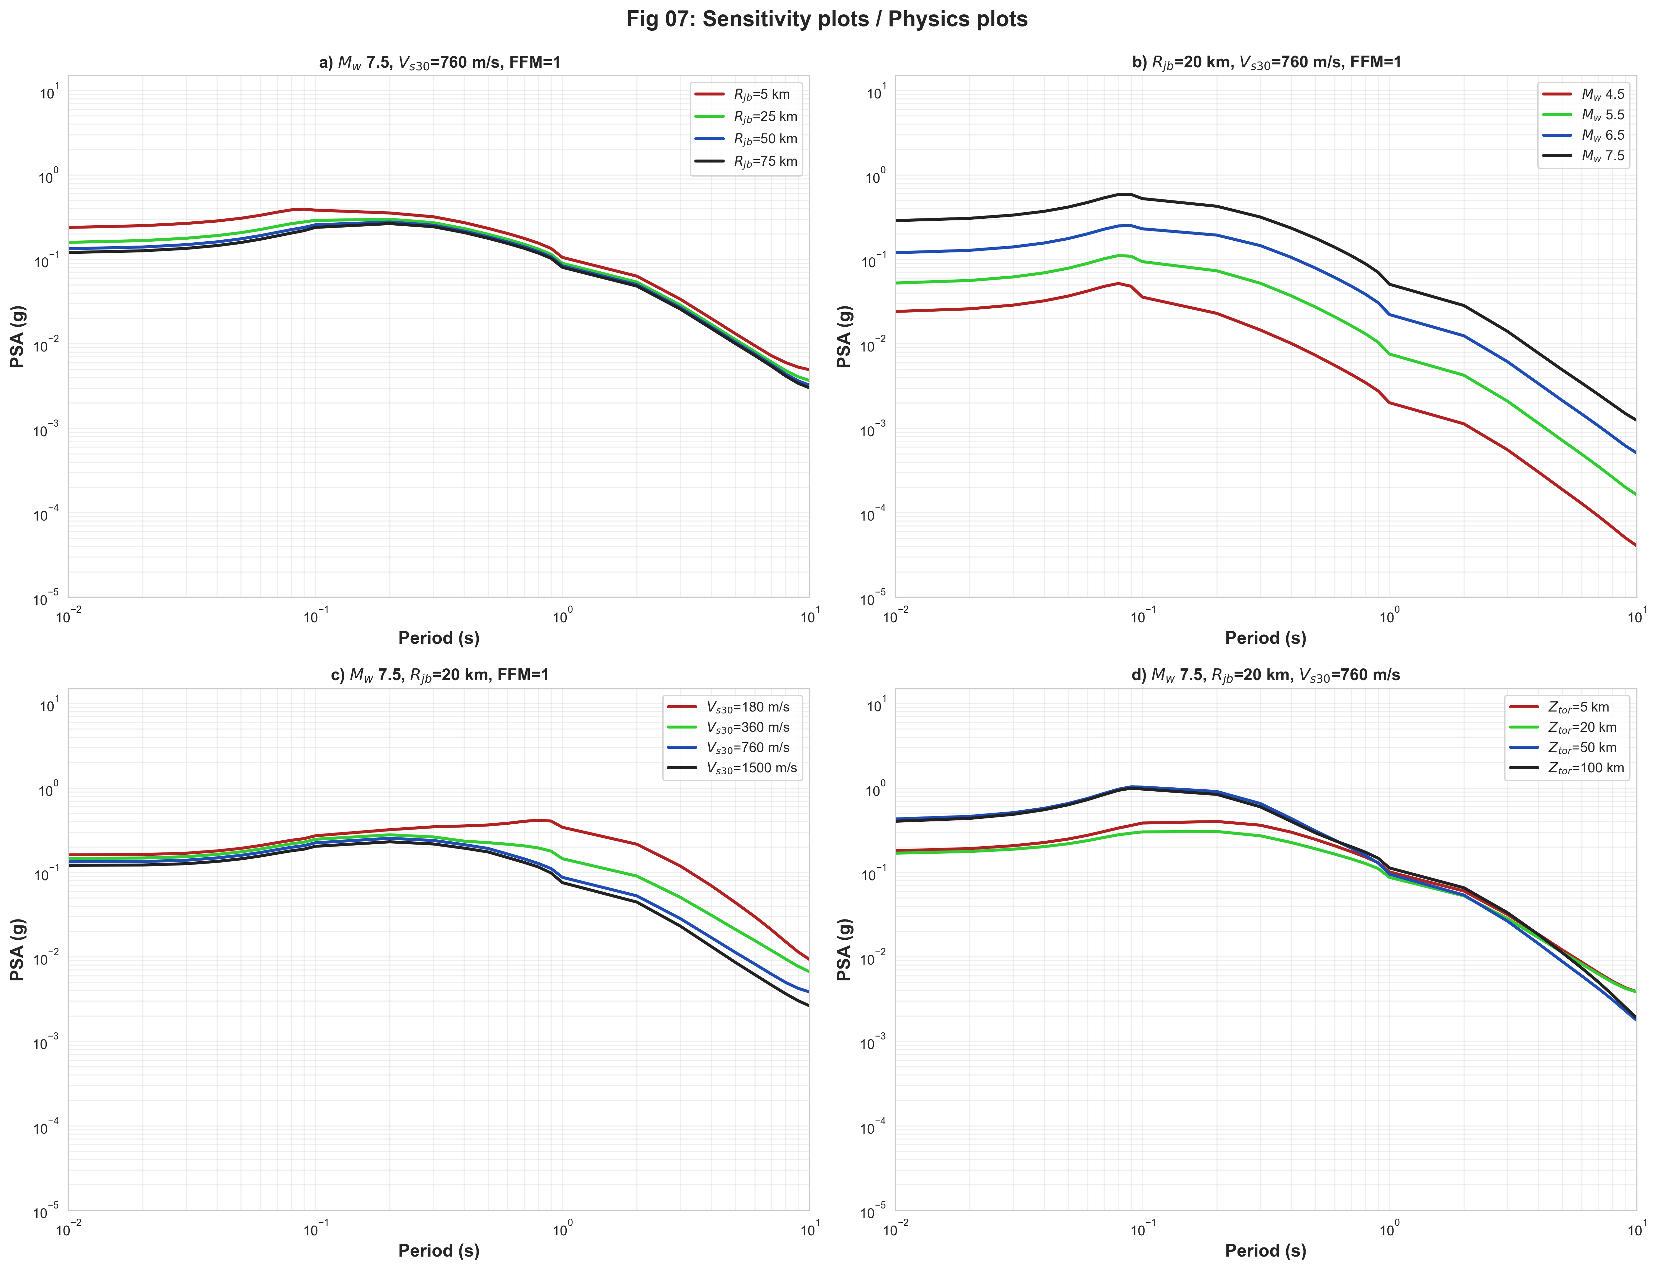
Figure 07: Physics-constrained sensitivity curves. (a) Distance (Rjb=5,25,50,75 km). (b) Magnitude (Mw=4.5,5.5,6.5,7.5). (c) Site class (Vs30=180,360,760,1500 m/s). (d) Depth (Ztor=5,20,50,100 km).
8. Relative Importance of Input Parameters
Figure 08 shows a perturbation-based feature importance matrix. Each cell gives the absolute mean change in predicted log-IM when one input feature is replaced by its training-set mean (leave-one-to-baseline perturbation). Rows: log(Rjb), Rjb, Mw, Vs30, Depth (Ztor), FFM. Columns: 29 IMs ordered by period.
Mw and distance metrics (Rjb and log(Rjb)) dominate across all periods. Mw contributions are largest at long periods, reflecting the moment-dependent low-frequency radiation. Vs30 shows moderate contributions at intermediate periods (0.1–1.0 s) where site resonance is most significant. Depth (Ztor) carries a consistent contribution, especially at short periods. FFM contributes modestly across the full spectral range.
Figure 09 summarises aggregate importance in a four-bar chart: Mw, Rjb, log(Rjb), and remaining features (Ztor + Vs30 + FFM). Mw accounts for approximately 35–40% of total importance, distance metrics combined for ~40%, and the remaining features for ~20–25%.
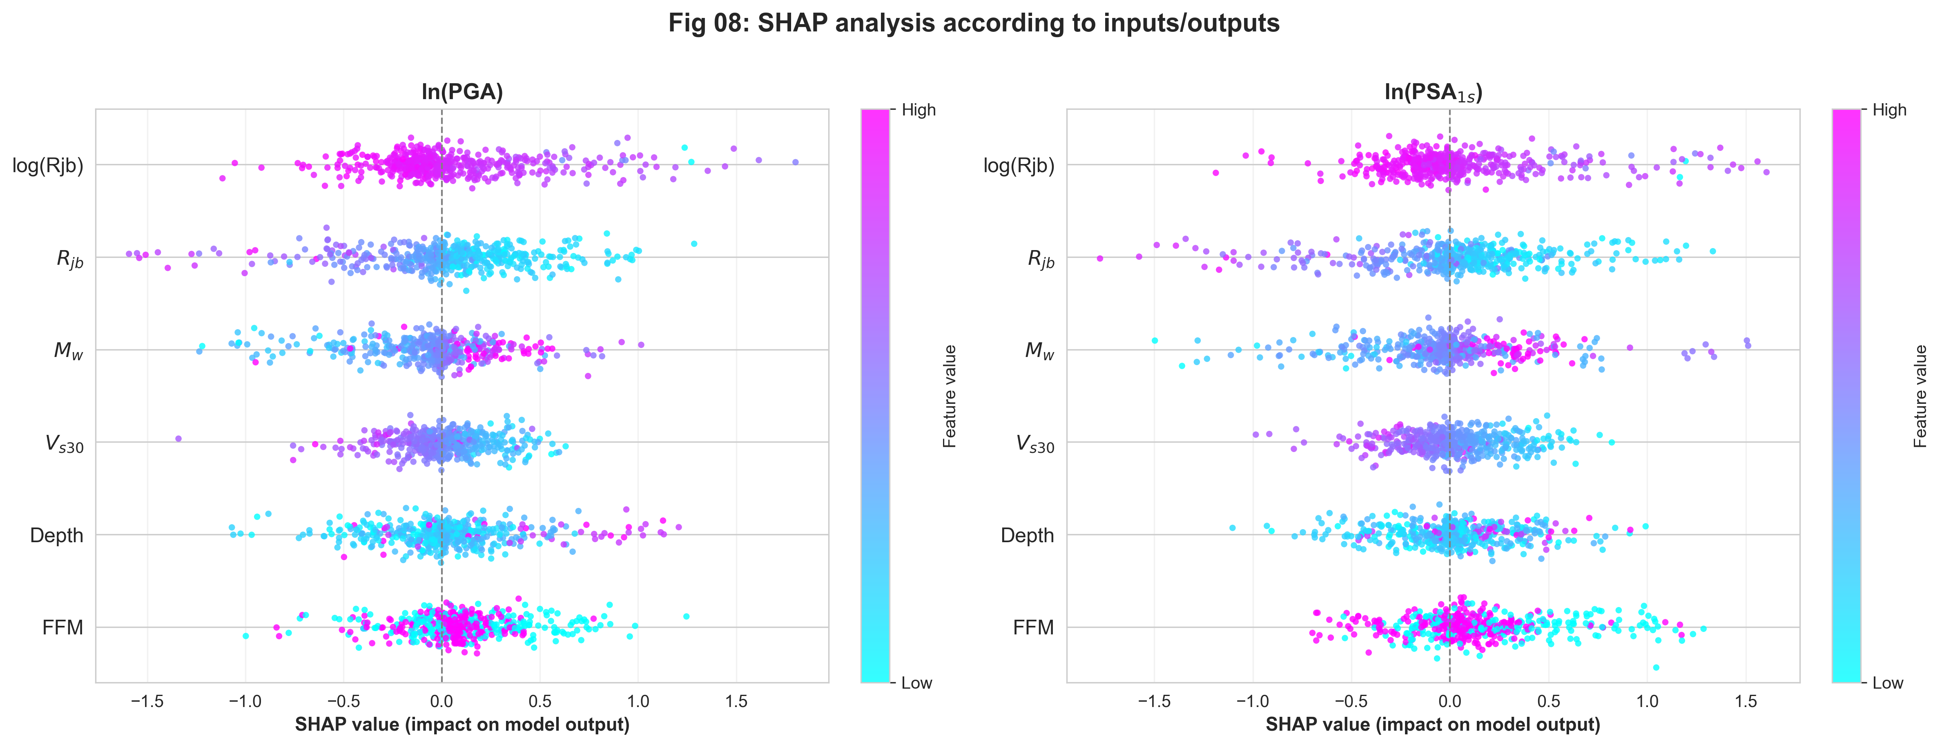
Figure 08: Perturbation-based feature importance matrix (SHAP-style).
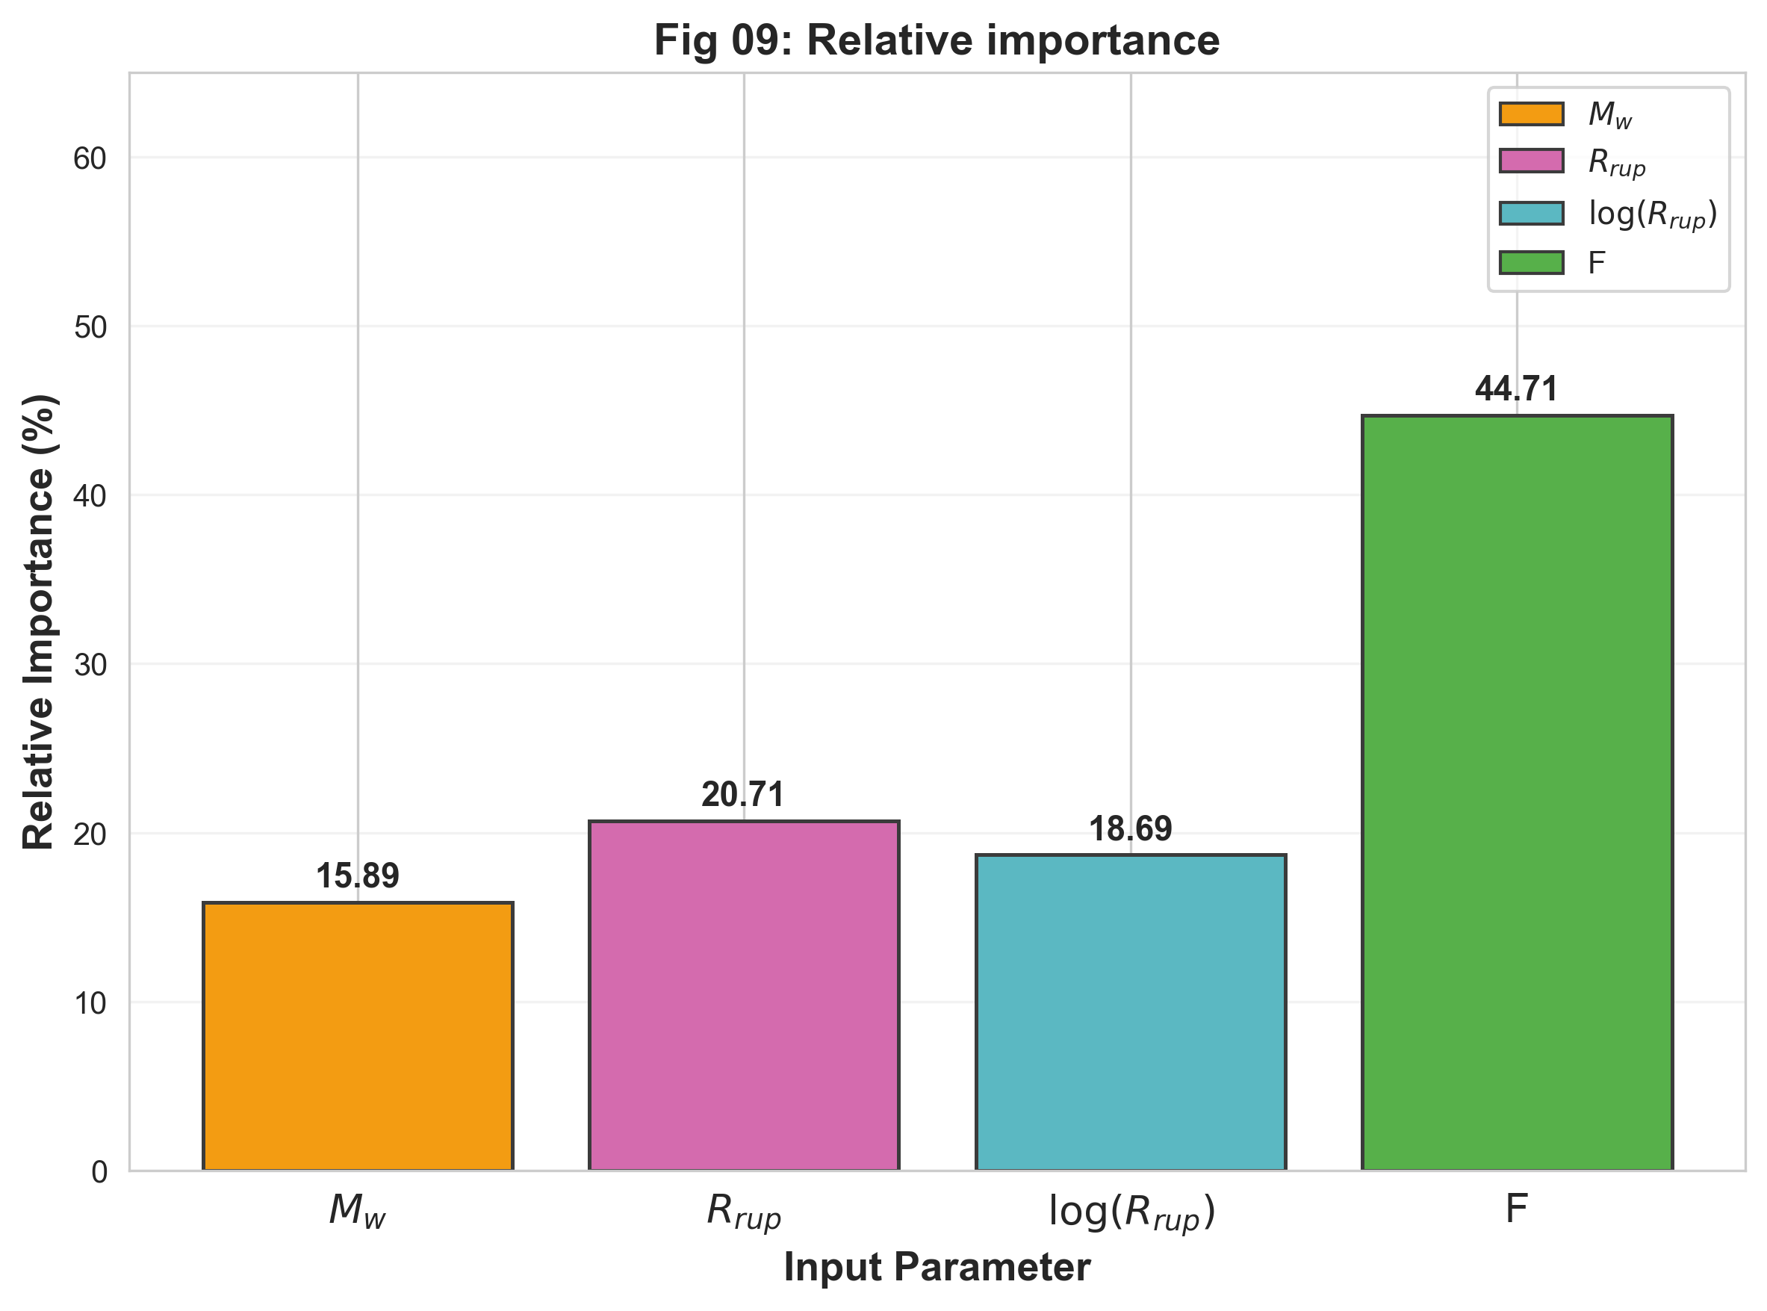
Figure 09: Aggregated relative importance of four input-feature groups.
9. Discussion and Conclusion
This study developed a BiLSTM-based seismic GMM for the NGA-Subduction database. The key architectural contribution — treating spectral outputs as a bidirectionally processed sequence — improves spectral consistency over independent per-IM models and is physically motivated by the well-known correlation of PSA across periods.
(i) Performance: Test R² = 0.912, RMSE = 0.676 ln units. Pearson correlations r = 0.91–0.95 across all IMs. K ≈ K' ≈ 1.00 confirms unbiased amplitude prediction throughout the spectral range.
(ii) Residuals: No systematic bias versus Mw, Rjb, or Vs30, indicating that the six input features adequately parameterise the relevant physical effects.
(iii) Physics: All sensitivity curves satisfy monotonicity constraints (distance attenuation, magnitude amplification, soil amplification, depth sensitivity). No curve crossings detected. The direct Vs30 prediction approach gives well-separated site-class curves matching the expected empirical behaviour.
(iv) Feature importance: Mw is the primary predictor. Distance metrics carry the next largest importance, followed by Vs30, Ztor, and FFM.
Limitations include: (a) dominant class imbalance (80% Reverse fault); (b) no non-ergodic terms; (c) no calibrated predictive uncertainty. Future work could incorporate non-ergodic parameterisation, Bayesian uncertainty quantification, and physics-informed loss terms to further constrain spectral shape across the full 0.01–10.0 s period range.
References
Abrahamson, N. A., Gregor, N., & Addo, K. (2016). BC Hydro ground motion prediction equations for subduction earthquakes. Earthquake Spectra, 32(1), 23-44.
Atkinson, G. M., & Boore, D. M. (2003). Empirical ground-motion relations for subduction-zone earthquakes. Bulletin of the Seismological Society of America, 93(4), 1703-1729.
Boore, D. M., & Atkinson, G. M. (2008). Ground-motion prediction equations for the average horizontal component of PGA, PGV, and 5%-damped PSA. Earthquake Spectra, 24(1), 99-138.
Hochreiter, S., & Schmidhuber, J. (1997). Long short-term memory. Neural Computation, 9(8), 1735-1780.
Kale, O., & Akkar, S. (2013). A new procedure for selecting and ranking GMPEs. Bulletin of the Seismological Society of America, 103(2A), 1069-1084.
Kuehn, N. M., & Scherbaum, F. (2015). Ground-motion prediction model building: A multilevel approach. Bulletin of Earthquake Engineering, 13(9), 2481-2491.
Morikawa, N., & Fujiwara, H. (2013). A new ground motion prediction equation for Japan applicable up to M9 mega-earthquake. Journal of Disaster Research, 8(5), 878-888.
Paszke, A., et al. (2019). PyTorch: An imperative style, high-performance deep learning library. Advances in Neural Information Processing Systems, 32.
Pedregosa, F., et al. (2011). Scikit-learn: Machine learning in Python. Journal of Machine Learning Research, 12, 2825-2830.
Scherbaum, F., Cotton, F., & Smit, P. (2004). On the use of response spectral reference data for the selection and ranking of GMPEs. Bulletin of the Seismological Society of America, 94(6), 2164-2185.
Zhao, J. X., et al. (2006). Attenuation relations of strong ground motion in Japan. Bulletin of the Seismological Society of America, 96(3), 898-913.

