Zayaan Nashird 011161127

Software Lab(C) Online Class Test

Repository Link: <https://github.com/ZayaanNashrid/SELab-Online>

Question 1 and 2:

Link provided above. Proof of repository in image below

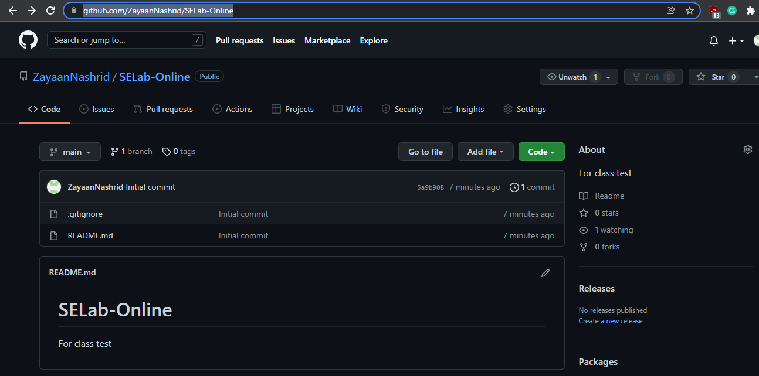

Question 3:

An empty repository has been initialized and now, I am (trying) to pull from the created online repository.

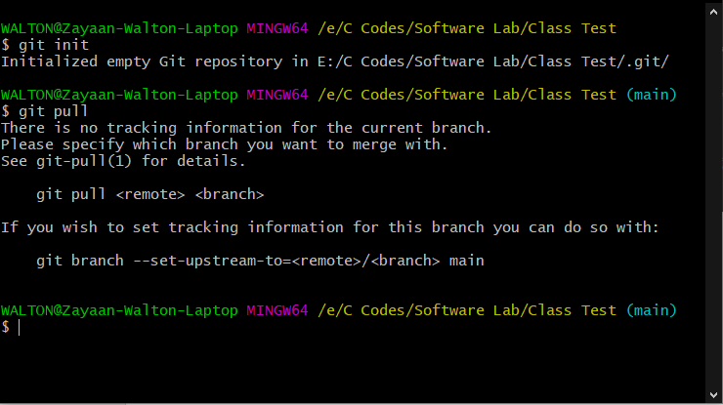

Pull successful, so the online repository has been cloned.

