BrainWave

**Name of Software:**

BrainWave

**Problem:**

Mental health is a significant issue faced by individuals in our society. Many people struggle with anxiety, depression, and other mental health issues but lack access to professional help due to various reasons such as financial constraints, social stigma, lack of availability of mental health services in their area. Moreover, when individuals visit a Psychiatrist or Psychologist, society tends to label them as having mental or psychological issues, which leads to stigmatization. This perception has led to a decrease in the number of people seeking professional help. Furthermore, the COVID-19 pandemic has exacerbated the mental health crisis, with more people experiencing anxiety, depression, and stress due to the pandemic's impact on their daily lives.

**Idea:**

BrainWave is an online mental health platform that aims to connect individuals with licensed mental health professionals such as Psychiatrists and Psychologists who provide therapy and counselling services. The platform will be accessible through a mobile application, allowing individuals to book appointments with mental health professionals based on their availability and preferences. BrainWave will also provide various mental health resources, including articles, videos, and self-help tools to support individuals in managing their mental health. Additionally, BrainWave will offer the feature of receiving guidance and therapy from professionals in real-time. The platform will prioritize user privacy and confidentiality, ensuring that all conversations between users and mental health professionals are secure and confidential.

**Use Case Diagram:**

The BrainWave use case diagram includes three primary actors: the user, mental health professional and administrator. The user can create an account, search for a mental health professional, book an appointment, and access mental health resources. The mental health professional can manage their availability, view their schedule, and conduct therapy sessions with users. The administrator oversees the platform's operation, ensures compliance with regulations and policies, and manages user accounts and data and administrator also have functionalities such as payment gateways and messaging services, integrate with the platform to provide a seamless user experience.

**Following are the Three actors with their use cases:**

1. **User:**

* Sign Up
* Search for mental health professional
* Book an appointment
* Receive therapy and counselling
* Payment

1. **Mental Health Professional:**

* Manage availability
* View schedule
* Conduct therapy sessions

1. **Administrator:**

* Manage user accounts and data
* Rules and Regulations
* Payment
* Messaging services

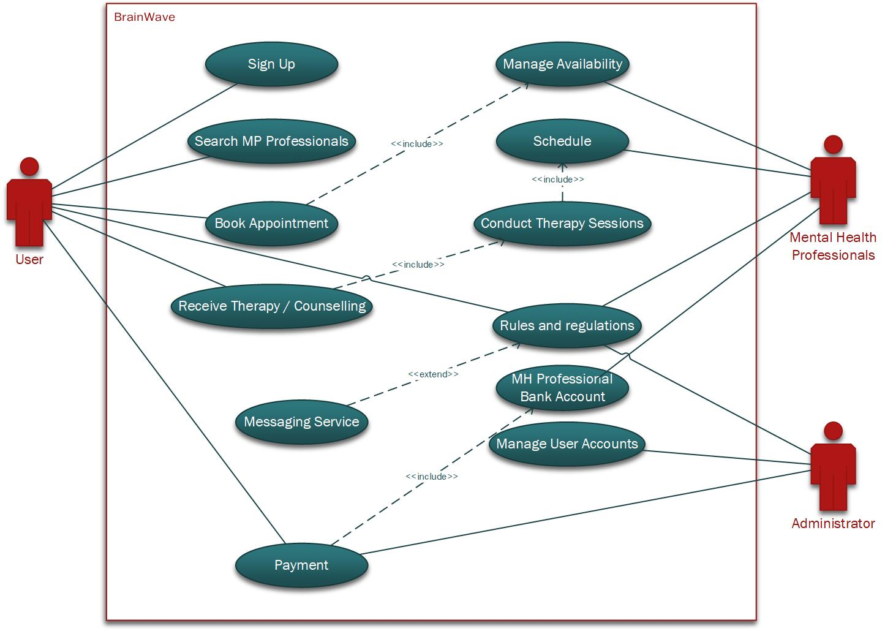

**State Machine Diagram:**

The diagram shows the states that the system will pass through in order to book an appointment. The system starts in the initial state and then transitions to the "Requesting Appointment" state when the user requests to book an appointment. The system then requests the user's information and verifies the information. If the information is verified, the system transitions to the "Searching for Appointments" state and searches for available appointments. If appointments are found, the system transitions to the "Displaying Appointments" state and displays the appointments to the user. The user then selects an appointment and the system transitions to the "Confirming Appointment" state. The system confirms the appointment details with the user and then transitions to the "Sending Confirmation" state. The system sends a confirmation email to the user and then transitions to the "Notifying Mental Health Professional" state. The system sends a notification of the new appointment to the mental health professional and then transitions to the "Awaiting Response" state. The system waits for the mental health professional to accept or reject the appointment. If the mental health professional accepts the appointment, the system transitions to the "Appointment Accepted" state and updates the user with the mental health professional's decision. If the mental health professional rejects the appointment, the system transitions to the "Appointment Rejected" state and updates the user with the mental health professional's decision. The system then terminates in the final state.

**System Sequence Diagram:**

The diagram shows the sequence of interactions between the user, the system, and the mental health professional when a user books an appointment. The system first requests the user's information and then the user's preferred mental health professional. The system then displays the available appointment slots for the user's preferred mental health professional and the user selects an appointment slot. The system then confirms the appointment details with the user and sends a confirmation email to the user. The system also sends a notification of the new appointment to the mental health professional. The mental health professional then accepts or rejects the appointment. The system then updates the user with the mental health professional's decision.

