Camera-motion compensation for DeepSORT: research process report
Omar Hussain and Zayed Mohammed | Abu Dhabi University | MAI502
This report shows, in pictures and short notes, how the study was built, what the professor asked us to check, and what changed. All numbers come from the result files in the supporting material.

1 Starting point
- The capstone “Multiple Object Tracker Under Camera Motion” (Qamhieh and Abueida, 2025) built a personal protective equipment (PPE) monitor: YOLOv8 detects workers and safety gear, DeepSORT keeps an identity for each worker, and a user interface reports missing gear.
- A PPE item is assigned to the worker box that contains it, so an identity switch can blame the wrong worker.
- The capstone named camera motion as a problem, but its tests used fixed cameras, it did not compensate camera motion, and it reported no tracking scores.
Our question: how much does camera-motion compensation (CMC) help DeepSORT, for which camera motions, and what does it cost in processing time?

2 Our initial experiment
We used the MOT17 benchmark: real street videos with every pedestrian boxed and numbered by hand. The download is a ZIP of about 5.9 GB (5,860,214,001 bytes); we used its seven training videos (5,316 frames), three filmed by fixed cameras and four by moving cameras.
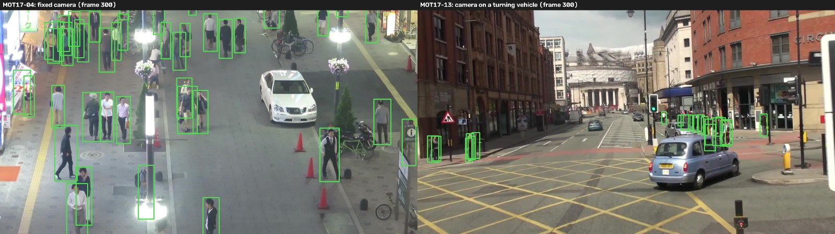
Figure 1. Real MOT17 footage with the hand-made person boxes (green). Left: fixed camera. Right: camera on a turning vehicle, where everything in the image moves.
Step | What we did
Detect once | YOLOv8n (same settings as the capstone) and, as a second detector, the public Faster R-CNN (FRCNN) boxes; appearance features computed once and cached.
Track twice | DeepSORT with and without CMC on the identical cached inputs, so CMC is the only difference.
Estimators | Similarity transform (tracked background points), translation-only, ECC (image alignment) and an exploratory hybrid.
Score | TrackEval: HOTA and IDF1 (higher is better) and identity switches (IDSW).
Uncertainty | Paired differences (CMC minus baseline) with 95% intervals from resampling blocks of frames.
Table 1. Design of the controlled comparison.
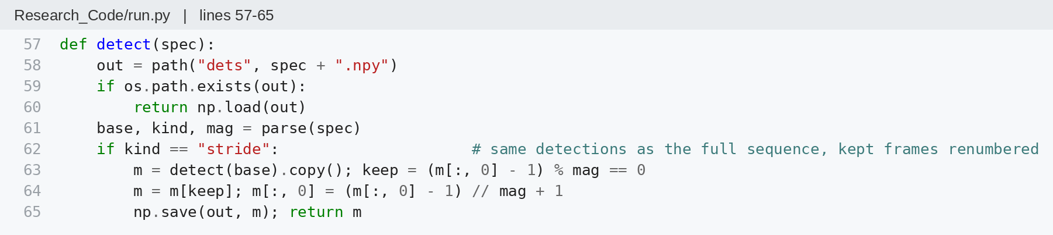
Code 1. Detections are computed once and loaded from the cache afterwards; frame-skipping runs reuse the same detections.
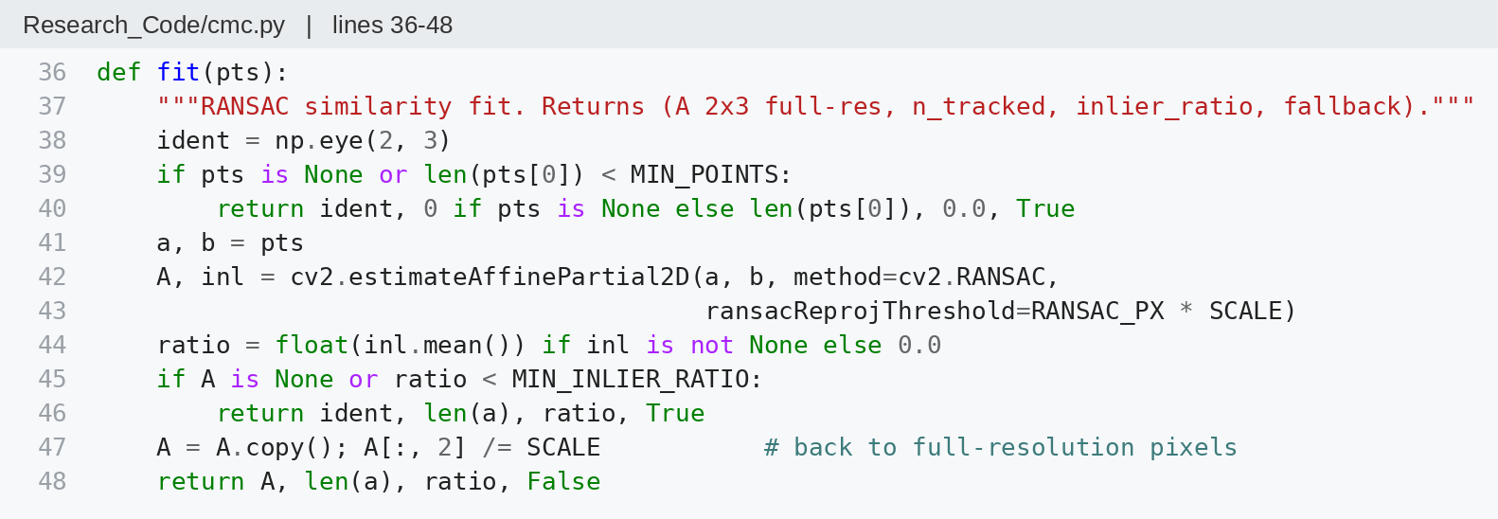
Code 2. Estimating the camera motion. The estimate is rejected (identity transform) if fewer than 30 points are tracked or fewer than half agree.
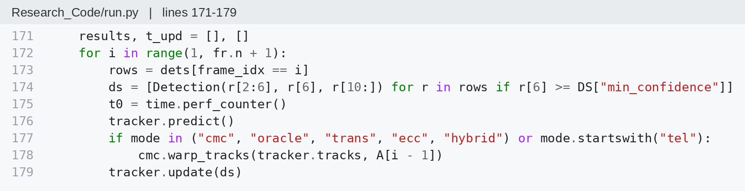
Code 3. Compensation sits between DeepSORT’s prediction and its matching step: predicted boxes are moved by the camera motion before they are matched.
In plain terms: if the camera turns so that the scene shifts 10 pixels left, CMC shifts every predicted box 10 pixels left before matching, so a person who did not move is still found where expected.

3 Initial findings
Test | Change with similarity CMC | 95% interval | Evidence
Fixed cameras (MOT17), HOTA | −0.01 | – | Reproduced on two machines
Moving cameras (MOT17), HOTA, YOLOv8n | +0.48 | [0.18, 0.78] | Reproduced on two machines
Moving cameras (MOT17), HOTA, FRCNN | +0.45 | [0.08, 0.83] | Measured once
Synthetic fast pan 20 px/frame, IDF1 | +12.4 (run 2), +14.3 (run 1) | – | Simulated, reproduced
Every 6th frame, ECC, HOTA, YOLOv8n | +5.43 | [3.83, 6.83] | Measured once (later revised)
Table 2. Results reported before the review. Synthetic pans are simulated camera motion (a moving crop of fixed-camera video).
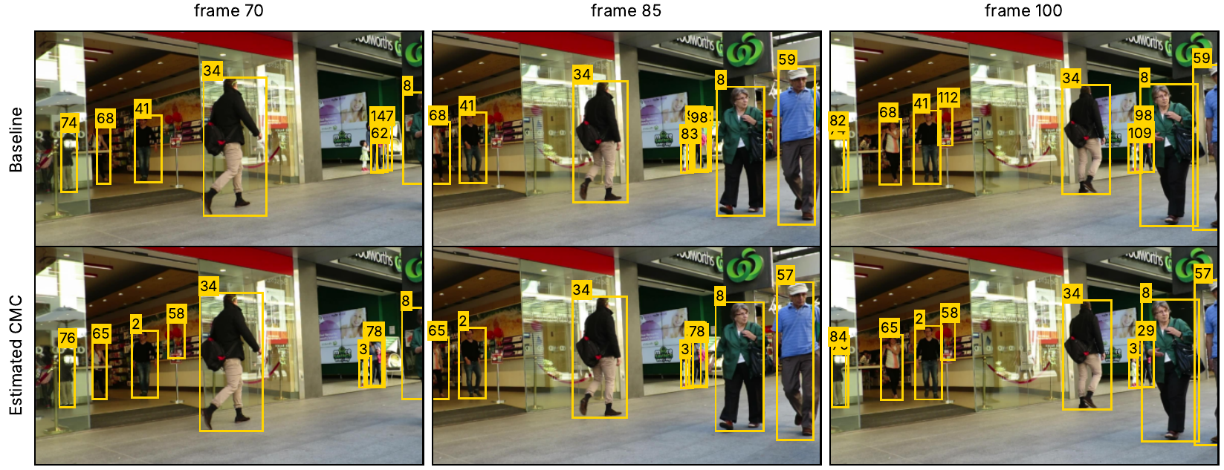
Figure 2. Simulated 20 px/frame pan of fixed-camera footage (MOT17-09, frames 70, 85, 100; first run). Beside the shop window the baseline (top) changes identities, while CMC (bottom) keeps identity 3.
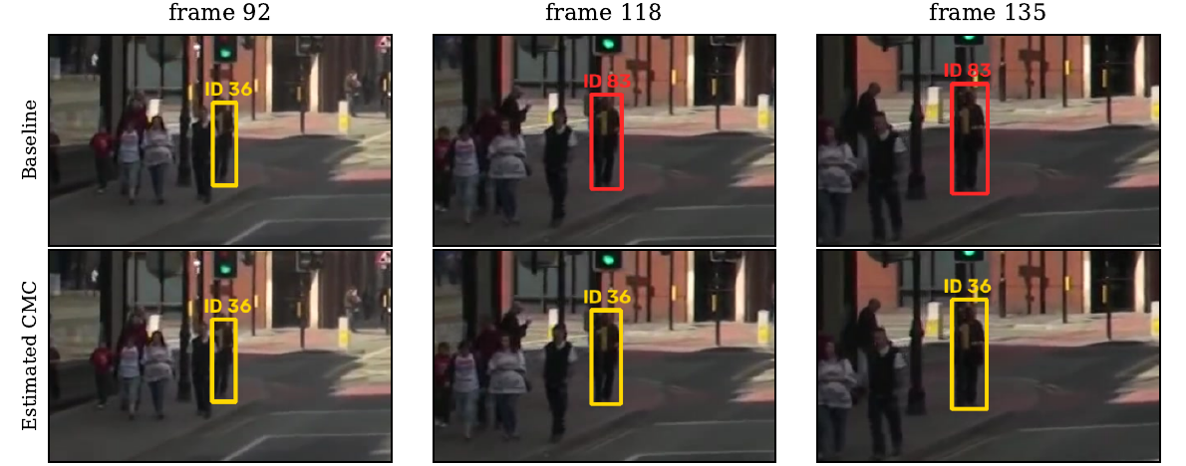
Figure 3. Real moving camera (MOT17-13). The baseline renames one pedestrian from 36 to 83 at frame 102; with CMC the identity stays 36.

4 Professor’s feedback
The reviewer judged the work promising but asked for a minor revision. The main concerns were:
- only four real moving videos, and intervals that resample frames rather than scenes;
- the Kalman time step was not adjusted when frames were skipped;
- the hybrid estimator was designed on the same videos it was tested on;
- synthetic results differed between two computers;
- missing method details, no modern-tracker comparison and no ethics statement;
- PPE benefits were claimed but never measured on PPE assignment.

5 What we did afterwards
Professor’s concern | What we did | What we learned
Few moving videos | Leave-one-video-out; 3 new MOT15 videos; 13 real sweeping SportsMOT clips; virtual PTZ camera on 7 scenes | MOT17 gain is not driven by one video; forward-moving cameras did not benefit; a real sweep gained +1.43
Kalman time step | Re-ran frame skipping with time-aware prediction; separately checked track lifetime and the combined time-step/noise change. | Most of the large frame-skip gain came from the Kalman setting; ECC kept a smaller gain
Hybrid tuned on test data | Labelled exploratory; tested on new videos under a protocol recorded in advance | The hybrid did not show a consistent advantage on independent MOT15 footage.
Differences between computers | Repeated runs on one computer from the same cached inputs | 54 of 54 checked outputs were identical on one computer; the source of the cross-computer differences remains unresolved.
Frame-level intervals | Explained the limit; added leave-one-out and a sign test | Intervals describe uncertainty within the observed videos only
PPE not measured | Simulated PPE status per person and counted wrongly credited and duplicate alerts | Fewer duplicate alerts at fast sweeps; no fewer wrong-person alerts (simulated)
Details, ethics, trackers | Parameter table, pseudocode, ethics statement; tracker comparison explained as out of scope | –
Table 3. How each main concern was handled.
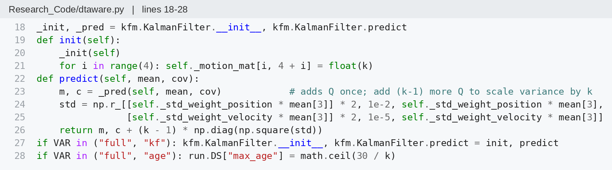
Code 4. Time-aware Kalman check: the step length and process noise are scaled by k and the maximum track age is set to about 30 real frames.
Frame skipping, revised. With the time-aware filter the baseline improved by 5–9 HOTA and the ECC gain at every 6th frame shrank from +5.43 to +0.69 with YOLOv8n (interval [−0.27, 1.77], not significant) and from +10.12 to +2.74 with FRCNN ([1.62, 3.91]).
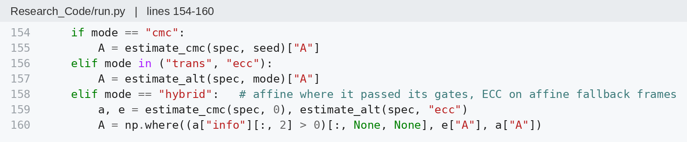
Code 5. Hybrid rule: use the similarity estimate when it passes its checks, otherwise ECC. The code calls this partial-affine estimation.
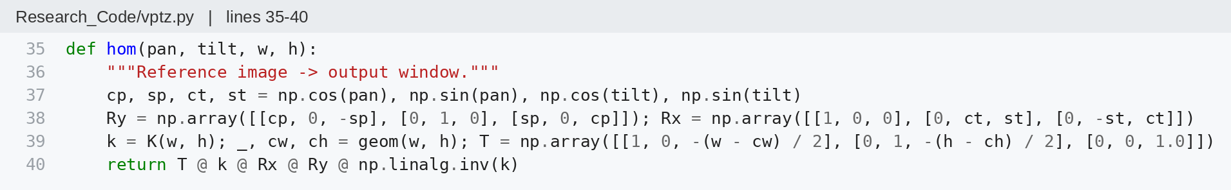
Code 6. Virtual PTZ camera: a pure rotation of the camera is applied to fixed-camera frames, so the true motion is known exactly.
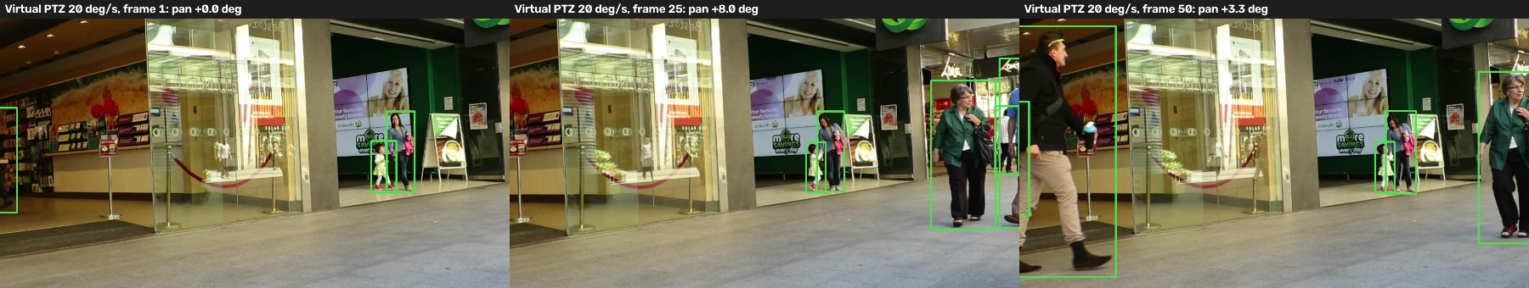
Figure 4. Simulated PTZ sweep at 20°/s over real fixed-camera footage (MOT17-09). Person boxes (green) move with the virtual camera.
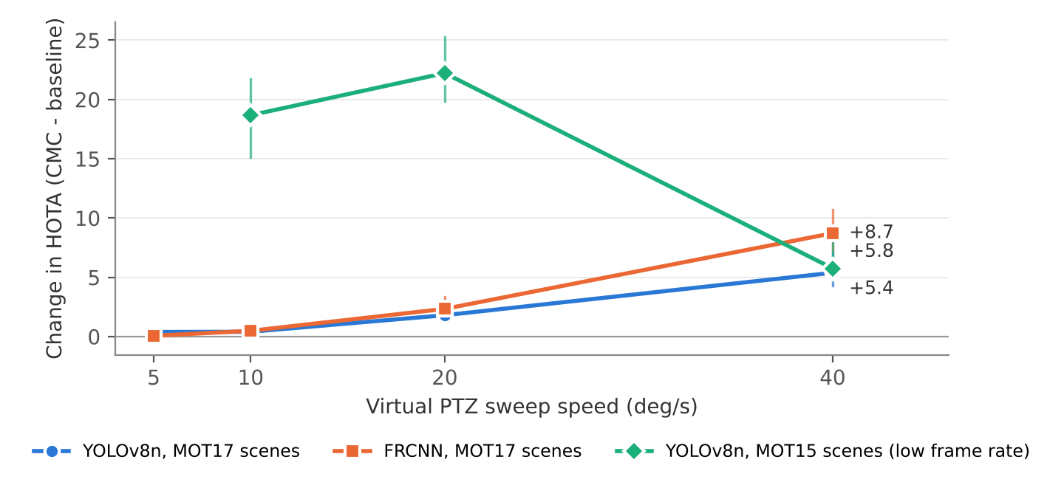
Figure 5. Simulated pan sweeps. On MOT17, gains generally grew with speed for both detection sources. The lower-frame-rate MOT15 scenes gained +5.8 HOTA at 40°/s, compared with +22.8 using the known-motion similarity reference. This reference approximates the true image transformation. Lines show 95% intervals where computed.
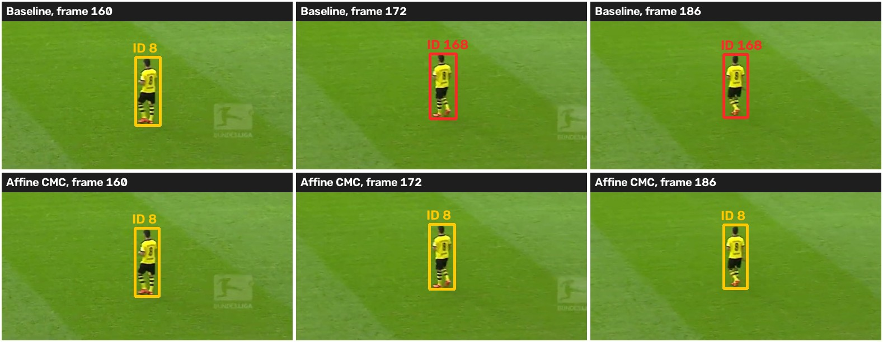
Figure 6. Real sweeping broadcast camera (SportsMOT). The baseline renames this player from 8 to 168 at frame 172; with CMC the identity stays 8. Footage: SportsMOT validation split (CC BY-NC 4.0).
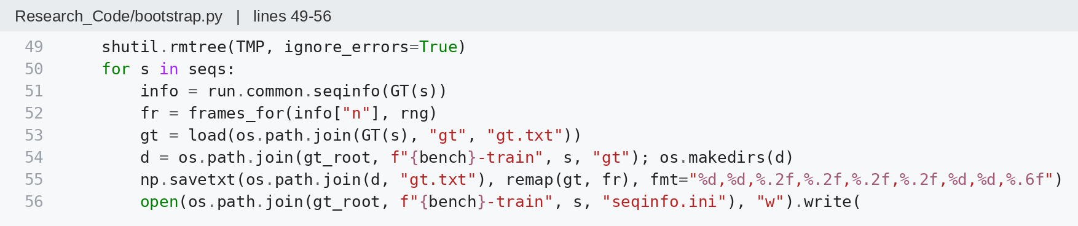
Code 7. Uncertainty: the same randomly drawn blocks of frames are applied to the ground truth and to every tracker, so differences stay paired.
Other checks. On independent moving MOT15 videos, CMC lowered IDF1 by 1.61 with YOLOv8n (interval [−2.84, −0.10]); public detections gave an inconclusive change. At 40°/s, simulated angle readings gained 5.32 HOTA without delay, 3.32 with one-frame delay and lost 0.98 with three-frame delay. Simulated reports per matched non-compliant person fell from 6.05 to 3.30; the matched-person count changed from 19 to 20. This does not establish better real PPE assignment.
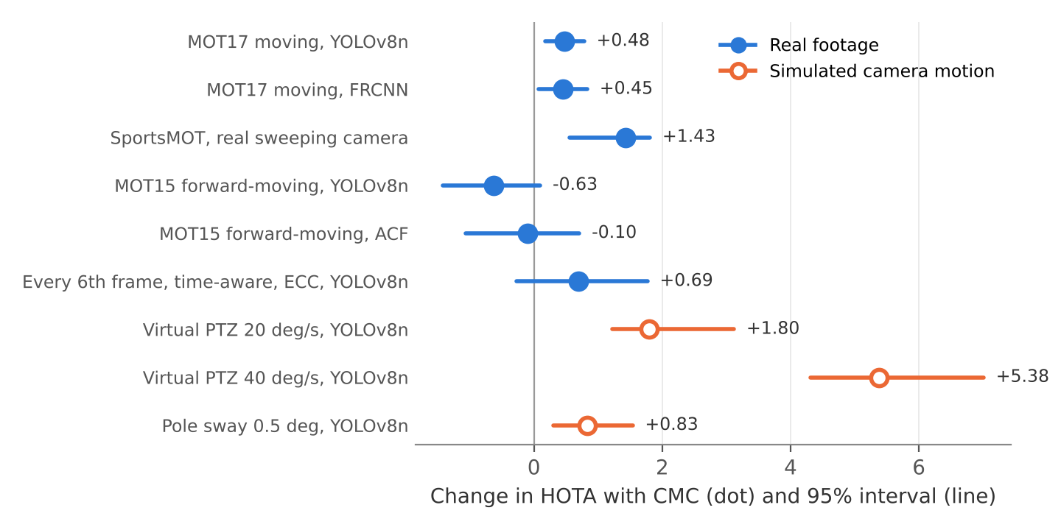
Figure 7. Summary of measured effects with 95% intervals. Filled dots: real footage. Open dots: simulated camera motion. Each value was measured once except the MOT17 YOLOv8n result, which was reproduced on two machines.

6 Final conclusions

Still supported
- CMC produced negligible changes on the tested fixed cameras and a small HOTA gain on moving MOT17 videos (+0.48).
- Fast simulated sweeps on three MOT17 scenes gained +5.4 and +8.7 HOTA with two detection sources. Real sports footage from 13 clips gained +1.43.
- Point-based estimation took 2.0–11.4 ms per frame on the tested CPU, excluding image preprocessing. The approximately 7% overhead is estimated from component medians, not measured end to end.

Weakened or changed
- The large frame-skipping gains mostly disappear when the Kalman filter accounts for the skipped frames.
- CMC is not a general fix for moving cameras: forward-moving videos did not benefit.
- The hybrid estimator remains exploratory; moderate synthetic effects did not reproduce across machines.

Not yet tested
- Real construction workers, real PPE assignment and real PTZ angle readings; complete modern trackers such as BoT-SORT.

7 Supporting files
Experiment_Results.xlsx contains the results overview and detailed experiment sheets. Samples.zip contains short footage examples. The code screenshots in this report show the main implementation steps; they are illustrative snippets, not a runnable software package.

