Nutanix Cluster Deployment – As Built Guide

Copyright 2018 Nutanix, Inc.

Nutanix, Inc.

1740 Technology Drive, Suite 150

San Jose, CA 95110

All rights reserved. This product is protected by U.S. and international copyright and intellectual property laws.

Nutanix is a trademark of Nutanix, Inc. in the United States and/or other jurisdictions. All other marks and names mentioned herein may be trademarks of their respective companies.

Table of Contents

Executive Summary 4

Nutanix Enterprise Cloud Overview 4

Distributed Storage Fabric 4

App Mobility Fabric 5

AHV 5

Nutanix Acropolis Architecture 5

Field Installation Using Nutanix Foundation 5

# Executive Summary

Nutanix Enterprise Cloud Overview

Nutanix delivers a web-scale, hyperconverged infrastructure solution purpose-built for virtualization and cloud environments. This solution brings the scale, [resilience](http://download.nutanix.com/solutionsDocs/TN-2068-Infrastructure-Resiliency.pdf), and economic benefits of web-scale architecture to the enterprise through the Nutanix Enterprise Cloud Platform, which combines three product families—Nutanix Acropolis, Nutanix Prism, and Nutanix Calm.

Attributes of this Enterprise Cloud OS include:

* Optimized for storage and compute resources.
* Machine learning to plan for and adapt to changing conditions automatically.
* Self-healing to tolerate and adjust to component failures.
* API-based automation and rich analytics.
* Simplified one-click upgrade.
* Native file services for user and application data.
* Native backup and disaster recovery solutions.
* Powerful and feature-rich virtualization.
* Flexible software-defined networking for visualization, automation, and security.
* Cloud automation and life cycle management.

Nutanix Acropolis provides data services and can be broken down into three foundational components: the Distributed Storage Fabric (DSF), the App Mobility Fabric (AMF), and AHV. Prism furnishes one-click infrastructure management for virtual environments running on Acropolis. Acropolis is hypervisor agnostic, supporting three third-party hypervisors—ESXi, Hyper-V, and Citrix Hypervisor—in addition to the native Nutanix hypervisor, AHV.

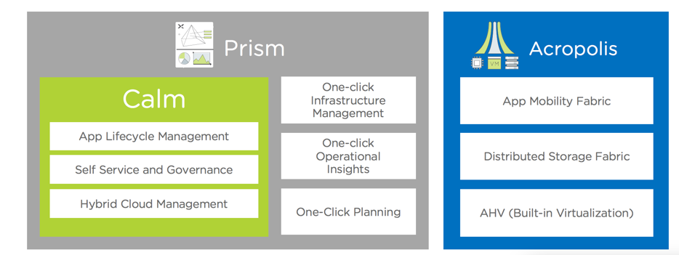

*Figure 1 Nutanix Enterprise Cloud*

Distributed Storage Fabric

The Distributed Storage Fabric (DSF) delivers enterprise data storage as an on-demand service by employing a highly distributed software architecture. Nutanix eliminates the need for traditional SAN and NAS solutions while delivering a rich set of VM-centric software-defined services. Specifically, the DSF handles the data path of such features as snapshots, clones, high availability, disaster recovery, deduplication, compression, and erasure coding.

The DSF operates via an interconnected network of Controller VMs (CVMs) that form a Nutanix cluster, and every node in the cluster has access to data from shared SSD, HDD, and cloud resources. The hypervisors and the DSF communicate using the industry-standard NFS, iSCSI, and SMB3 protocols.

App Mobility Fabric

The App Mobility Fabric (AMF) is the Nutanix virtualization solution that allows apps to move across hypervisors. When virtual machines can move between hypervisors (for example, between VMware ESXi and AHV), administrators can host production and dev/test environments concurrently on different hypervisors and shift workloads between them as needed. AMF is implemented via a distributed, scale-out service that runs inside the CVM on every node within a Nutanix cluster.

AHV

Nutanix ships with a hardened, enterprise-ready hypervisor based on proven open source technology. AHV is managed with the Prism interface, a robust REST API, and an interactive command-line interface called aCLI (Acropolis CLI). These tools combine to eliminate the management complexity typically associated with open source environments and allow out-of-the-box virtualization on Nutanix—all without the licensing fees associated with other hypervisors.

Nutanix Acropolis Architecture

Acropolis does not rely on traditional SAN or NAS storage or expensive storage network interconnects. It combines highly dense storage and server compute (CPU and RAM) into a single platform building block. Each building block delivers a unified, scale-out, shared-nothing architecture with no single points of failure.

The Nutanix solution requires no SAN constructs, such as LUNs, RAID groups, or expensive storage switches. All storage management is VM-centric, and I/O is optimized at the VM virtual disk level. The software solution runs on nodes from a variety of manufacturers that are either all-flash for optimal performance, or a hybrid combination of SSD and HDD that provides a combination of performance and additional capacity. The DSF automatically tiers data across the cluster to different classes of storage devices using intelligent data placement algorithms. For best performance, algorithms make sure the most frequently used data is available in memory or in flash on the node local to the VM.

Field Installation Using Nutanix Foundation

Nutanix installs AHV and the Nutanix CVM on each node at the factory before shipping it to a customer. To use a different hypervisor (ESXi, Hyper-V, or XenServer) on factory nodes, or to use any hypervisor on bare metal nodes, Nutanix offers a tool called Foundation that images the nodes in the field. The [Nutanix Field Installation Guide](http://bit.ly/2E1hfhP) provides step-by-step instructions on how to use Foundation for a field installation, which consists of installing a hypervisor and the Nutanix CVM on each node and then creating a cluster. You can also use Foundation to create a cluster from nodes that are already imaged or to image nodes without creating a cluster.

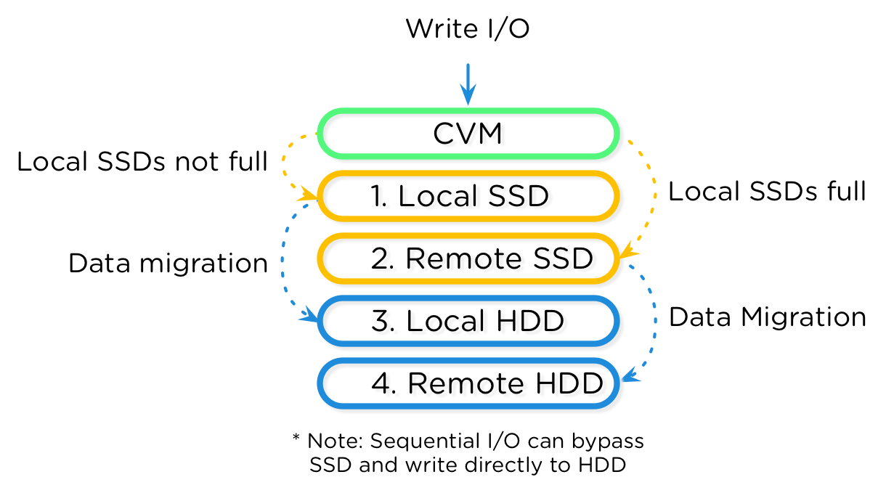

Figure 2 Information Life Cycle Management

With the DSF, a CVM writes data to local flash memory for fast acknowledgment; the CVM also handles read operations locally for reduced latency and fast data delivery.

The figure below shows an overview of the Nutanix architecture, including the hypervisor of your choice (AHV, ESXi, or Hyper-V), user VMs, the Nutanix storage CVM, and its local disk devices. Each CVM connects directly to the local storage controller and its associated disks. Using local storage controllers on each host localizes access to data through the DSF, thereby reducing storage I/O latency. The DSF replicates writes synchronously to at least one other Nutanix node in the system, distributing data throughout the cluster for resiliency and availability. Replication factor 2 (RF2) creates two identical data copies in the cluster, and replication factor 3 (RF3) creates three identical data copies. Having a local storage controller on each node ensures that storage performance as well as storage capacity increase linearly with node addition.

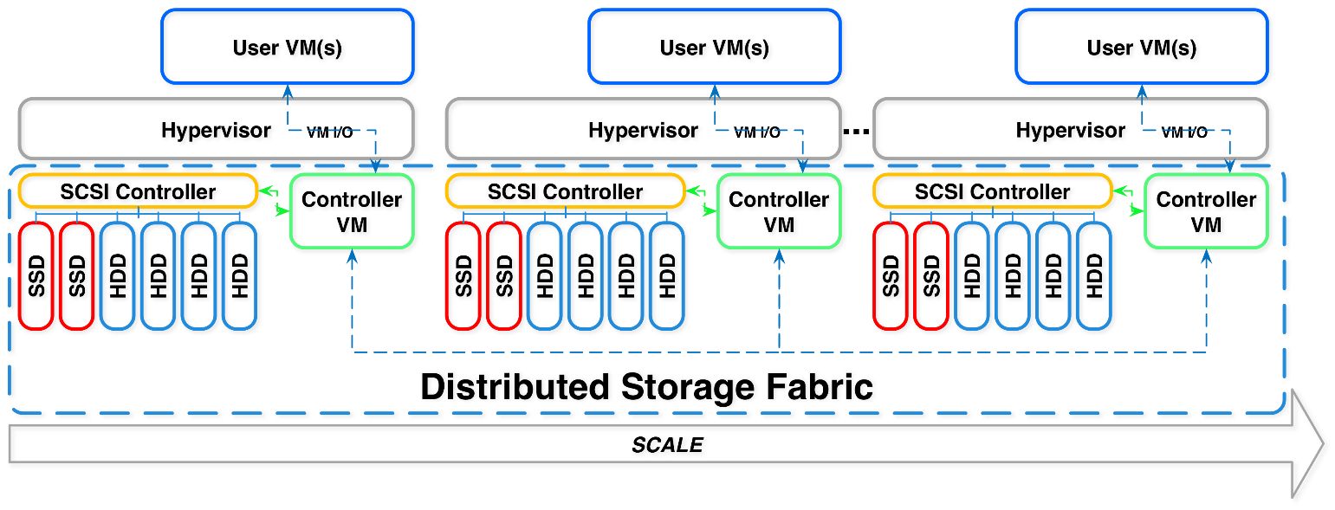

Figure 3 Overview of the Nutanix Architecture

Local storage for each Nutanix node in the architecture appears to the hypervisor as one large pool of shared storage. This allows the DSF to support all key virtualization features. Data localization maintains performance and quality of service (QoS) on each host, minimizing the effect noisy VMs have on their neighbors’ performance. This functionality allows for large, mixed-workload clusters that are more efficient and more resilient to failure when compared to traditional architectures with standalone, shared, and dual-controller storage arrays.

When VMs move from one hypervisor to another, such as during live migration/vMotion and high availability, the now local CVM serves a newly migrated VM’s data. When reading old data (stored on the now remote CVM) the local CVM forwards the I/O request to the remote CVM. All write I/O occurs locally. The DSF detects that I/O is occurring from a different node and migrates the data to the local node in the background, allowing for all read I/O to now be served locally. The data only migrates when there have been enough reads and writes from the remote node to minimize network utilization.

The next figure shows how data follows the VM as it moves between hypervisor nodes.

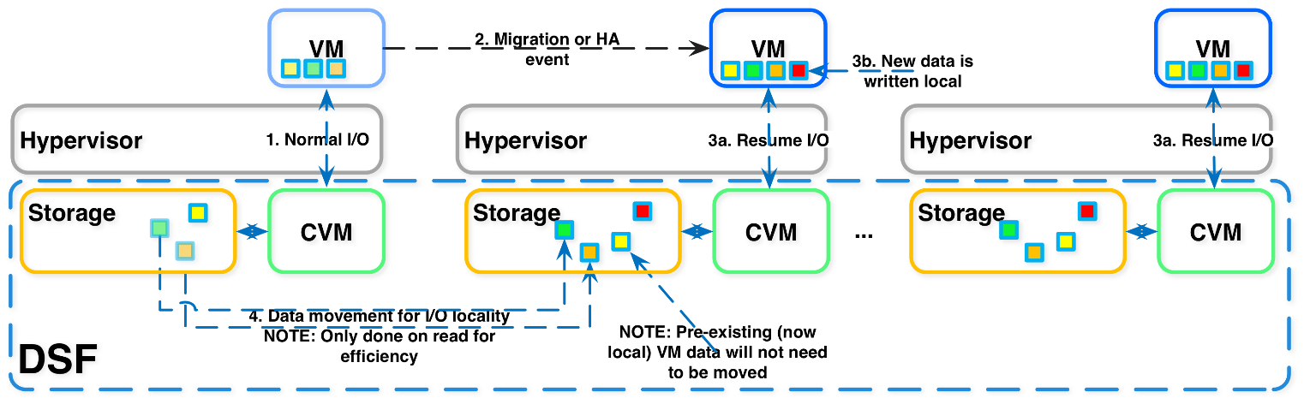

Figure 4 Data Locality and Live Migration

# Environment Build

Site Installation Details

|  |  |
| --- | --- |
| Install Location Details |  |
| Site Address |  |
| Rack Location |  |
| Rack Units |  |
| Switch Location |  |

High Level Overview

KT has engaged Nutanix Services to implement a Nutanix cluster solution to serve virtual infrastructure workloads.

<Insert diagram from the Cluster Deployment Diagram. Specify physical design elements such as usable capacity, cores and RAM>

Network Cabling Diagram

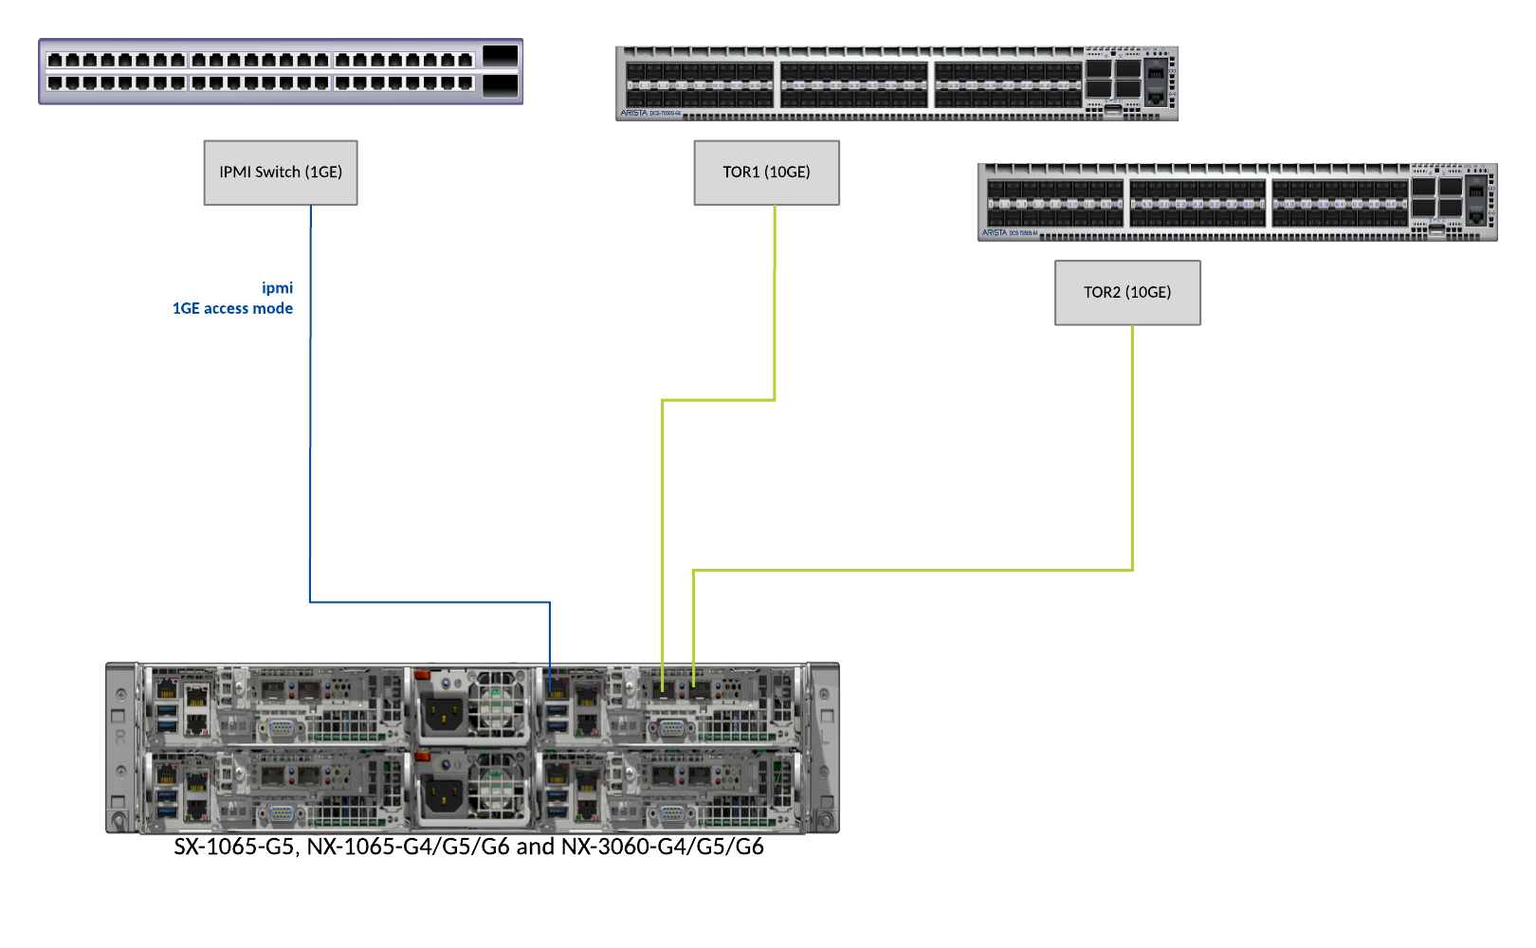

Physical Rack Layout

<Insert Picture of rack from Cluster Deployment Diagrams to show positioning of cluster in regards to switches (If Required)>

|  |  |
| --- | --- |
| RUID | RACK ID |
| 42 |  |
| 41 |  |
| 40 |  |
| 39 |  |
| 38 |  |
| 37 |  |

Nutanix Node – Port Layout

The Nutanix blocks for KT are cabled to a pair of 10GbE Top of Rack Switches for Redundancy. The dedicated IPMI port is cabled to a secondary 1GbE switch for out of band management.

<The resources/images/GCP.png image is unavailable. Please manually insert correct image for node here.>

# Hypervisor Host Design

Logical Design

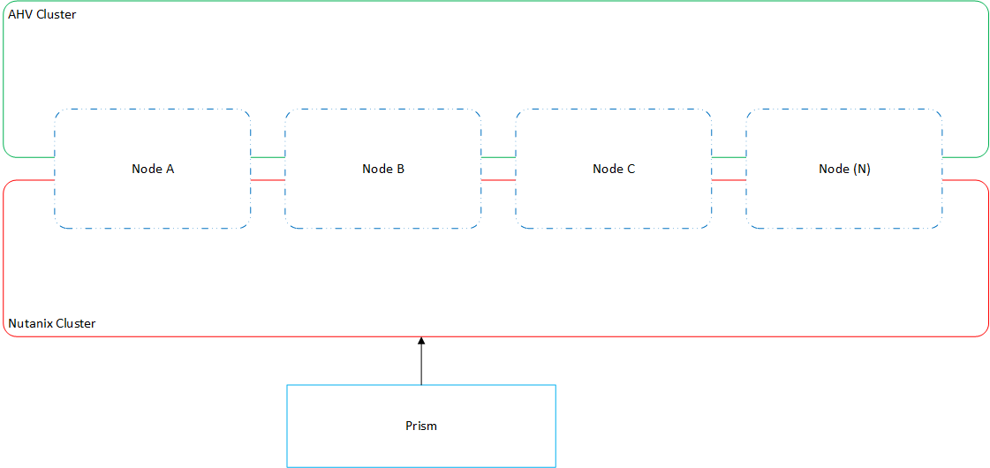

AHV Host Information

|  |  |  |  |
| --- | --- | --- | --- |
| Hostname | CVM IP | Management IP | IPMI IP |
| 172-30-0-4 | 172.30.0.5 | 172.30.0.4 | None |

Host Details Table

|  |  |
| --- | --- |
| Hostname | Hypervisor Version |
| 172-30-0-4 | Nutanix 20170830.122 |

Management Server Table

|  |  |  |
| --- | --- | --- |
| Management Server Type | IP Address | Registered |
| Not Setup |  |  |

Host Model Information

|  |  |  |
| --- | --- | --- |
| Host Name | Model | Serial |
| 172-30-0-4 | GCP | 172-30-0-5 |

Host CPU and Memory Information

|  |  |  |  |
| --- | --- | --- | --- |
| Host Name | CPU Cores | CPU Threads | Memory |
| 172-30-0-4 | 4 | 8 | 19.48 GB |

Firmware Information

### BIOS and BMC Information

|  |  |  |  |  |
| --- | --- | --- | --- | --- |
| Hostname | Bios Version | Bios Model | BMC Version | BMC Model |
| 172-30-0-4 | None | None | None | None |

### HBA Information

|  |  |  |
| --- | --- | --- |
| Hostname | HBA Version | HBA Model |

# Nutanix Configuration

Cluster Information

|  |  |  |  |
| --- | --- | --- | --- |
| Cluster Name | Cluster UUID | Cluster IP | Cluster RF |
| HybridCloud | d1e98274-f286-4882-9487-b0f804a95393 | 172.30.0.2 | 1 |

|  |  |  |  |
| --- | --- | --- | --- |
| Cluster Name | Time Zone | NCC Version | AOS Version |
| HybridCloud | UTC | ncc-3.9.4.1 | 5.15 |

|  |  |  |
| --- | --- | --- |
| NTP Server(s) | DNS Server(s) | Global Whitelist |
| pool.ntp.org | 169.254.169.254 8.8.8.8 |  |

### Networks

|  |  |  |  |
| --- | --- | --- | --- |
| Name | VLAN ID | Subnet IP | Prefix Length |
| default-net | 1 | 172.31.0.0 | 24 |
| managed network production | 0 | 172.31.0.0 | 24 |
| unmanaged network develop | 101 | 172.31.101.0 | 24 |

### VM Network Info

|  |  |  |  |
| --- | --- | --- | --- |
| VM Name | VLANs | NIC Type | NIC IPs |
| App-prod | managed network production, | NORMAL_NIC, | 172.31.0.222 |
| Web-prod | managed network production, | NORMAL_NIC, | 172.31.0.212 |
| db-prod | managed network production, | NORMAL_NIC, | 172.31.0.225 |
| Web-dev | unmanaged network develop, | NORMAL_NIC, | 172.31.101.5 |
| db-dev | unmanaged network develop, | NORMAL_NIC, | 172.31.101.6 |
| App-dev | unmanaged network develop, | NORMAL_NIC, | 172.31.101.7 |
| Nutanix-Clone-Web-prod | managed network production, | NORMAL_NIC, | 172.31.0.221 |
| Nutanix-Clone-db-prod | managed network production, | NORMAL_NIC, | 172.31.0.218 |
| Nutanix-Clone-App-prod | managed network production, | NORMAL_NIC, | 172.31.0.223 |

### High Availability (HA)

|  |  |  |  |  |
| --- | --- | --- | --- | --- |
| HA State | Failover Enabled | Number of Host Failures to Tolerate | Reservation Type | Reserved Hosts UUIDs |
| BestEffort | True | 0 | NoReservations | None |

Licensing

### Cluster License

|  |  |  |  |
| --- | --- | --- | --- |
| License | License Type | Block Serial Number | Expiration |
| Starter | appliance | null | Never |

### Node Licenses

** Note: If a cluster includes nodes with different license types, the cluster and each node in the cluster defaults to the minimum feature set enabled by the lowest license type. For example, if two nodes in the cluster have Ultimate licenses and two nodes in the same cluster have Pro licenses, all nodes effectively have Pro licenses and access to that feature set only. Attempts to access Ultimate features in this case result in a warning in the web console.

|  |  |  |  |
| --- | --- | --- | --- |
| Model | License | License Type | Expiration |
| Null | Starter | appliance | Never |

Storage Pool and Container Configuration

### Containers

|  |  |  |  |  |
| --- | --- | --- | --- | --- |
| Container Name | Max Usable Capacity | Total Raw Capacity | Reserved Capacity | NFS Whitelist |
| SelfServiceContainer | 287.14 GB | 287.14 GB | 0.00 MB |  |
| Images | 287.14 GB | 287.14 GB | 0.00 MB |  |
| default-container-999 | 287.14 GB | 287.14 GB | 0.00 MB |  |
| NutanixManagementShare | 287.14 GB | 287.14 GB | 0.00 MB |  |

### Container Options

|  |  |  |  |  |  |  |
| --- | --- | --- | --- | --- | --- | --- |
| Container Name | RF | Compression Enabled | Compression Delay (InSecs) | SSD Dedup | HDD Dedup | Erasure Coding |
| SelfServiceContainer | 1 | False | None | off | OFF | off |
| Images | 1 | True | 3600 | off | OFF | off |
| default-container-999 | 1 | False | None | off | OFF | off |
| NutanixManagementShare | 1 | True | None | off | OFF | off |

### Storage Pools

|  |  |  |  |
| --- | --- | --- | --- |
| Name | Storage Pool ID | Max Capacity | ILM Threshold |
| default-storage-pool-999 | 5ad0870d-c43d-4b2d-92b2-63002151b242 | 287.14 GB | 75 |

Nutanix CVM settings

|  |  |  |  |
| --- | --- | --- | --- |
| CVM Name | Memory | vCPU | IP Address |
| NTNX-172-30-0-5-A-CVM | 64.00 MB | 1 |  |

Nutanix Prism Settings

### SNMP

|  |  |  |
| --- | --- | --- |
| User Name | Privacy Type | Auth Type |

|  |  |  |  |  |  |
| --- | --- | --- | --- | --- | --- |
| Trap Addr | Port | Protocol | Trap User Name | Engine ID | Inform |

### SMTP

|  |  |  |  |  |
| --- | --- | --- | --- | --- |
| Host Name | Port | Security Mode | User Name | From Email Address |
| None | None | None | None | None |

Authentication Information

### Authentication

|  |
| --- |
| Authentication Types |
| LOCAL |

### Directory List

|  |  |  |  |  |
| --- | --- | --- | --- | --- |
| Name | Directory Type | Connection Type | Directory URL | Domain |

Data Protection Information

### Protection Domains

|  |  |
| --- | --- |
| Name | Active |
| prod-env-pd | True |

### Metro Availability

|  |  |  |  |  |  |
| --- | --- | --- | --- | --- | --- |
| Protection Domain | Status | Storage Container | Remote Site | Role | Failure Handling |
| prod-env-pd | Not setup |  |  |  |  |

### Remote Sites

|  |  |  |  |
| --- | --- | --- | --- |
| Name | Remote Site Addresses | Capabilities | Bandwidth Limit |

### Remote Site Options

|  |  |  |  |
| --- | --- | --- | --- |
| Name | Compress On Write | Use SSH Tunnel | Proxy Enabled |

### Protection Domain Schedules

|  |  |  |  |  |  |
| --- | --- | --- | --- | --- | --- |
| Protection Domain | Type | Repeat On | Start Date | Local Retention Policy | Remote Retention Policy |
| prod-env-pd | Minutely | Every 60 minutes | Feb 10, 2021 02:28:00 AM | 1 |  |

Alert Information

### Alert Configuration

|  |  |  |
| --- | --- | --- |
| Alerts Enabled | Email Digest Enabled | Pulse Enabled |
| True | True | False |

### Alert Email Configuration

|  |  |  |
| --- | --- | --- |
| Email Contact List | Email Configuration Rules | Default Nutanix Email |
|  | None | nos-alerts@nutanix.com |

# Document Information

Version Control

|  |  |  |  |
| --- | --- | --- | --- |
| Version | Date | Author | Comments |
| 1.0 | - | Harsha Hosur | Version 1 final release |
| 1.1 | November 6, 2016 | Harsha Hosur | Optional items highlighted in lieu of the document being automated. |
| 2.0 | November 23, 2016 | Dave Keefe | Converted to automation Template. |
| 2.1 | January 23, 2017 | Dave Keefe | Added new table style. |
| 2.2 | April 17, 2017 | Dave Keefe | Updated automation. |
| 2.3 | June 5, 2017 | Dave Keefe | Enabled spell check. |
| 2.4 | June 5, 2017 | Dave Keefe | Update status output. |
| 3.1 | October 18, 2017 | Dave Keefe | Additional data gathered. |
| 3.1.1 | December 12, 2017 | Dave Keefe | Open SSL update |
| 3.3 | May 22, 2018 | Dave Keefe | Added debug flag and educational recources |
| 3.4 | June 6, 2018 | Dave Keefe | Added network diagram |
| 3.5 | Nov 21, 2018 | Pearlin Sargunar | Added G6 Images |
| 3.6 | Nov 22, 2018 | Pearlin Sargunar | Added vCenter Information Added |
| 4.0 | Dec 28, 2018 | Prince Raj | Fixed minor bugs |
| 4.1 | Jan 14, 2019 | Prince Raj | Fixed bug for vCenter |
| 4.2 | Jan 31, 2019 | Prince Raj | Minor Fixes and updated the template file |
| 4.3 | Feb 28, 2019 | Prince Raj | Added support for Excel output |
| 4.3.1 | Mar 21, 2019 | Prince Raj | Added vcenter flag and fixed bugs |
| 4.4 | May 2, 2019 | Prince Raj | Added new flags and fixed vcenter IP bug |
| 4.4.1 | May 2, 2019 | Prince Raj | Added functionality to read list of IPs from file |
| 4.5 | May 8, 2019 | Pearlin Sargunar | Added a feature for summary workbook generation |
| 4.6 | May 20, 2019 | Prince Raj | Added VM Network Info to Excel and bug fixes |
| 4.7 | Jun 10, 2019 | Pearlin Sargunar | Added Prism Central Feature |
| 4.8 | Jul 15, 2019 | Pearlin Sargunar | Vcenter efficiency improved and minor features |
| 4.8.1 | Jul 19, 2019 | Prince Raj | Bug fixes |