MEDS: MODULE 2

Zain Saeed
2026msee25

Section:7

Task:6

(I) Decoder 2x4

Terminal Output:
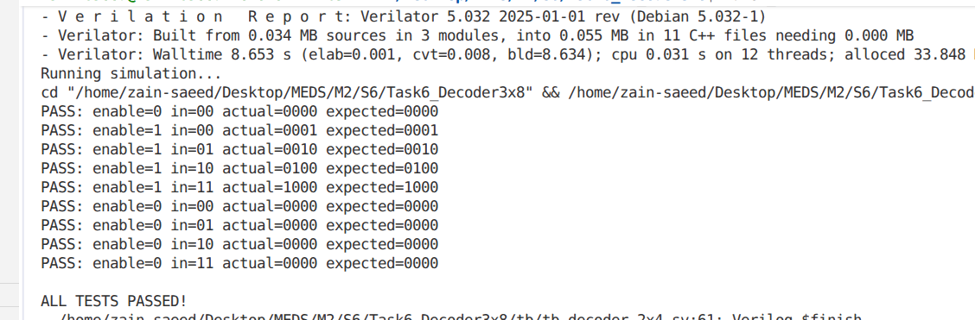
Simulation:
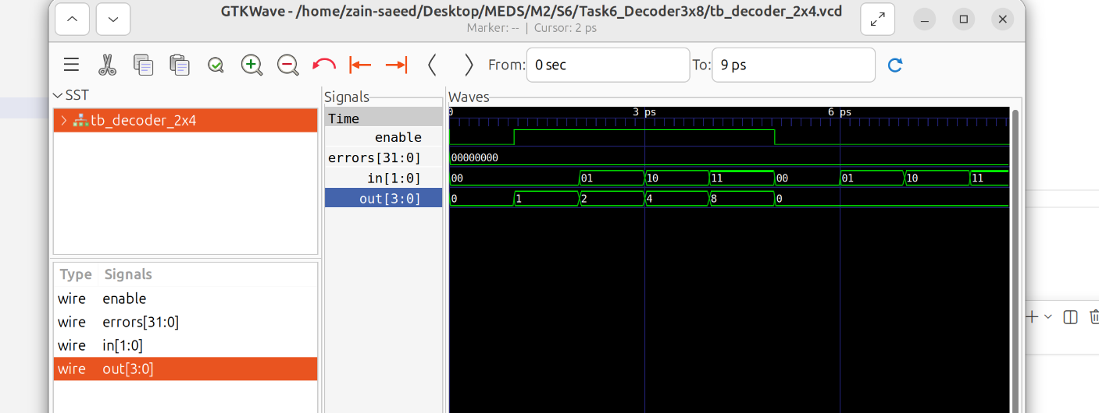

Schematics:
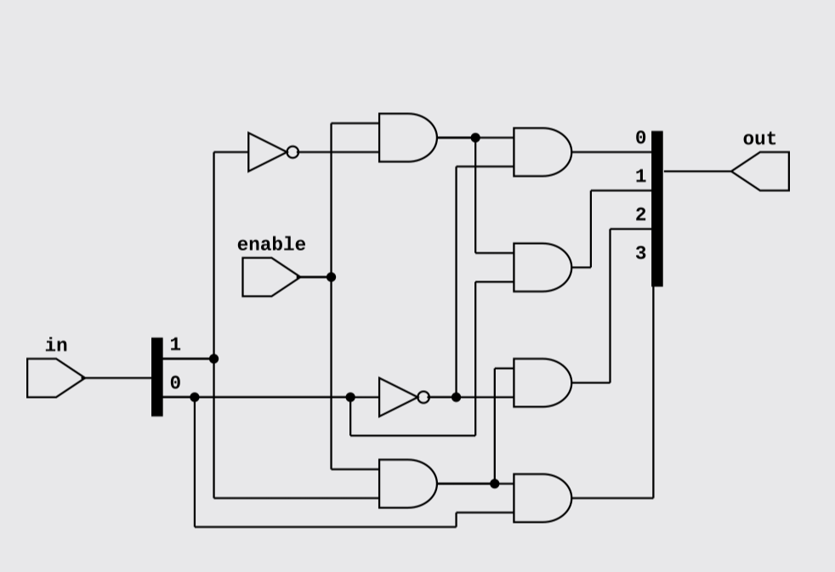

(II) Decoder 3x8

Schematics:

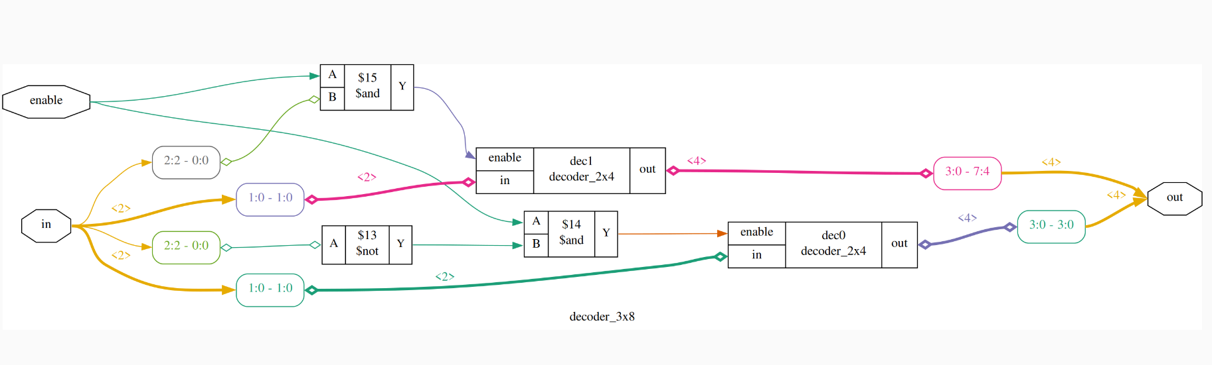

Also;

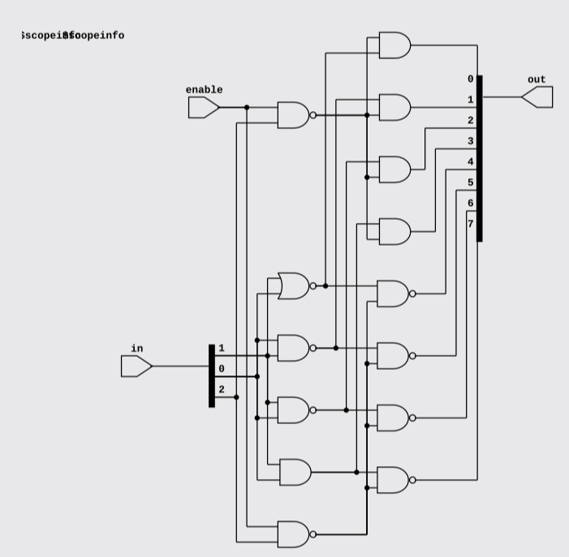

Terminal Output:
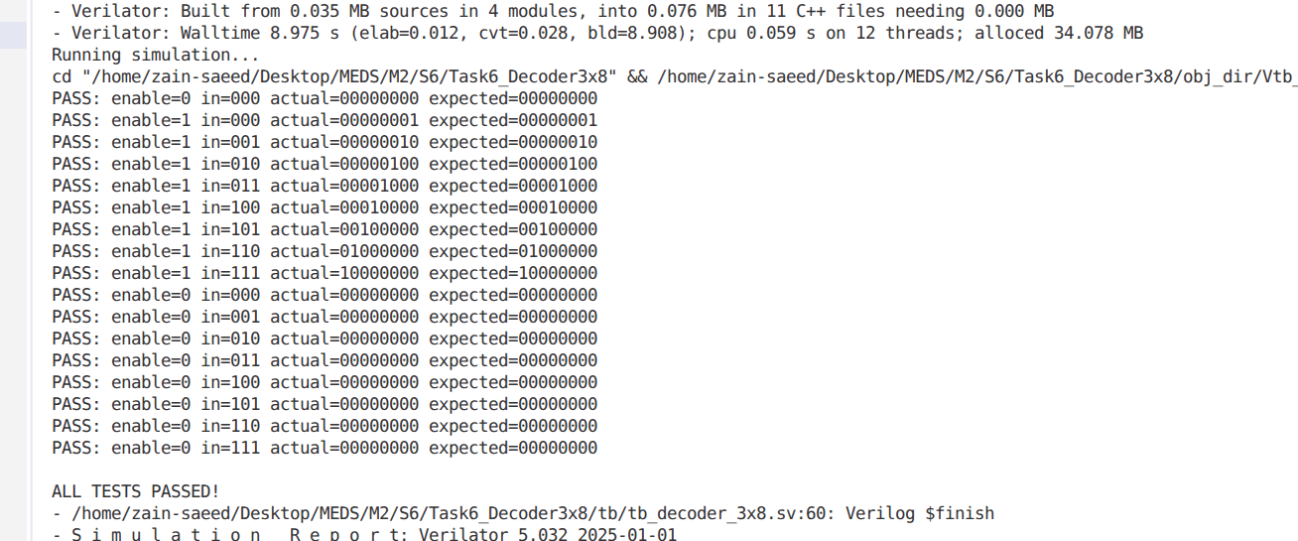
Simulation:

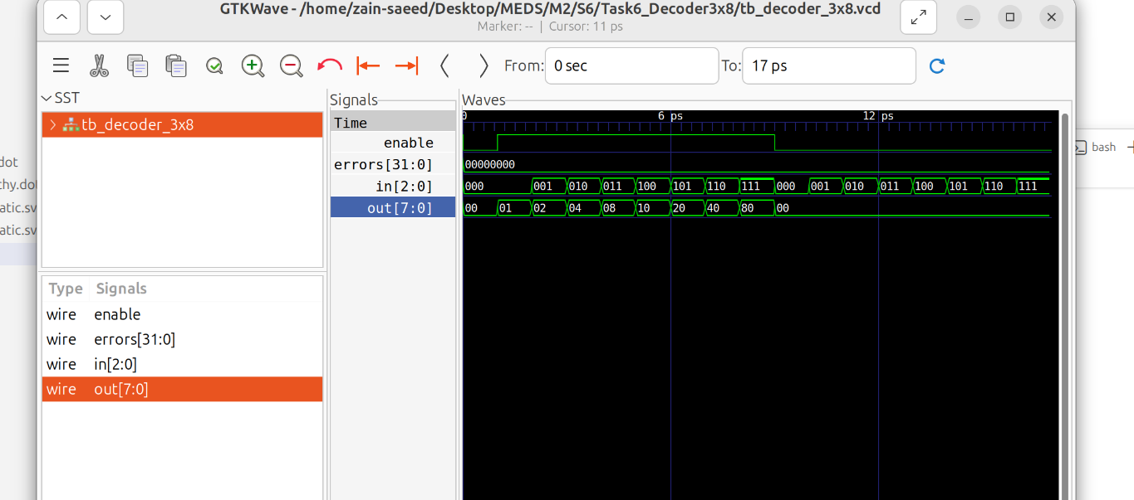

Explanation:

First, I made a 2×4 decoder that takes 2 input bits and activates one of its 4 outputs based on the input combination. Then, I used two 2×4 decoders to build a 3×8 decoder, using the MSB (in[2]) to enable one decoder at a time. When the MSB is , the first decoder handles outputs out[3:0], and when it is 1, the second decoder handles out[7:4], giving me 8 outputs in total.

Task7:
(I) First implement a simple version using a priority-encoder-style casez or a for-loop inside always_comb

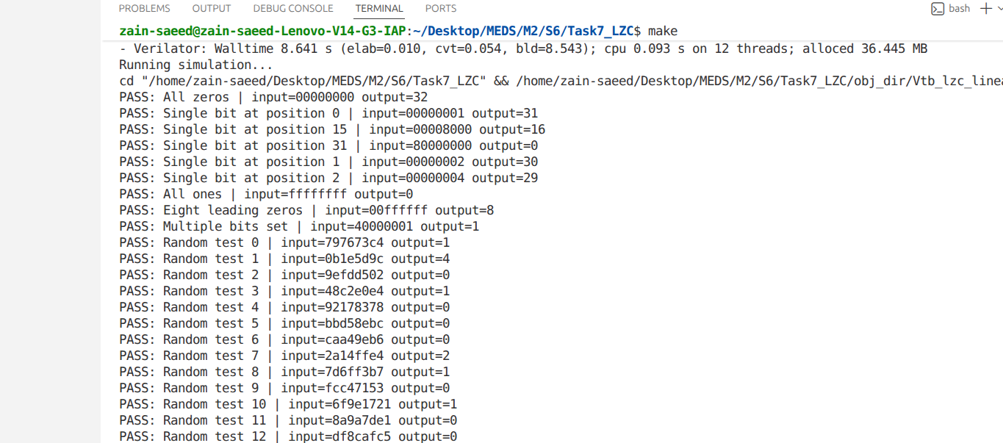
Terminal Output:

Simulation:

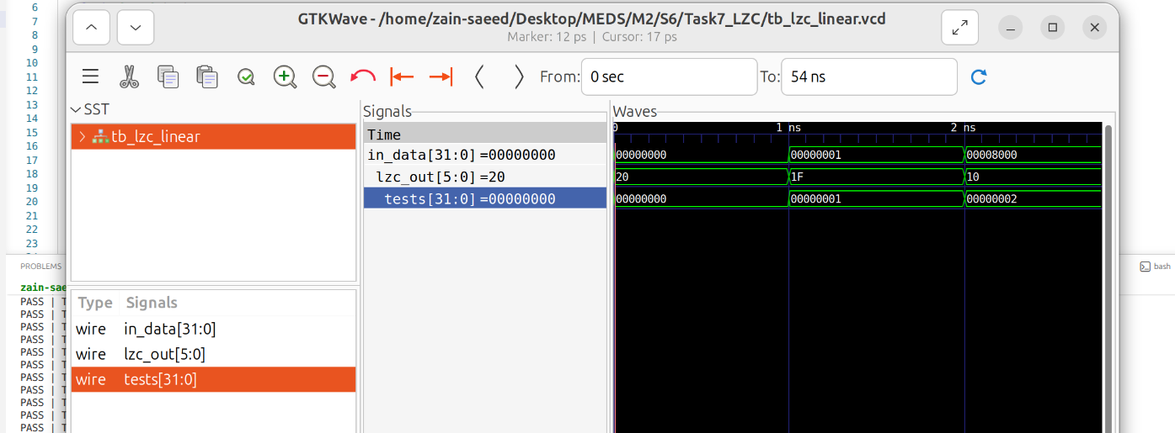

Top level RTL:
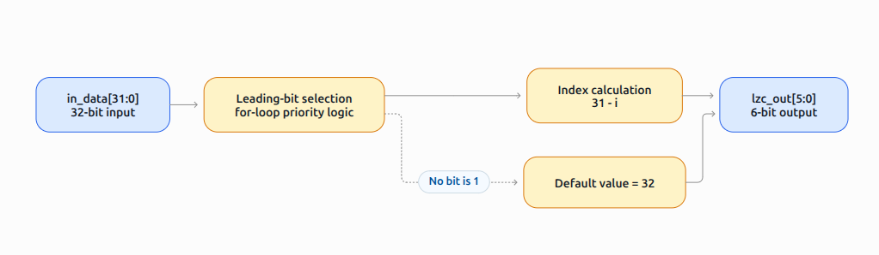
(II)
Explanation:
I designed the tree-structured LZC to find leading zeros faster by checking groups of bits instead of examining each bit one by one. It starts with 16-bit groups, then narrows the search to 8, 4, 2, and finally 1 bit, adding to the count whenever the upper group is zero. If the entire input is zero, it returns 32. Unlike the linear approach, which can require up to 32 priority decisions, the tree uses five main decision stages, reducing the potential logic depth from (O(N)) to (O(log_2 N)). This can make it faster for wider inputs, depending on synthesis and hardware implementation.

Terminal Output:
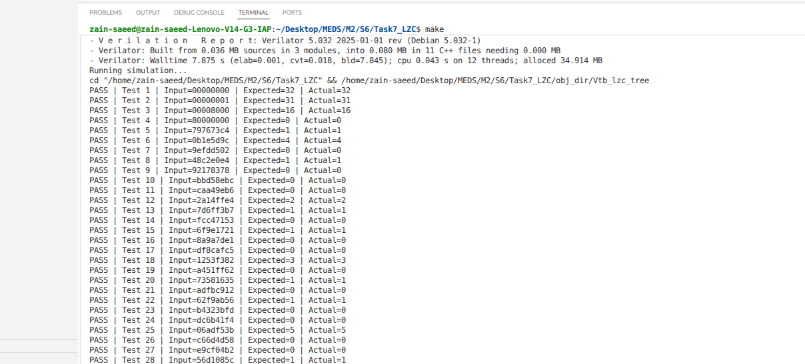

Simulation:

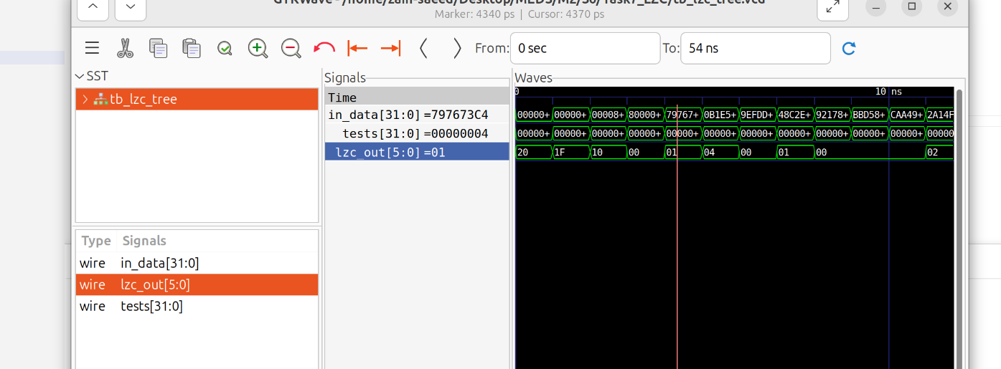

Schematics:

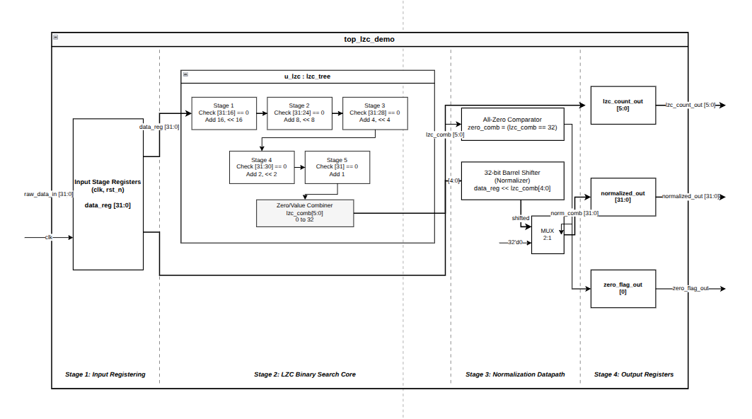

Explanation:
I first implemented a 32-bit Leading Zero Counter using a for loop inside always_comb to find the first 1 from the MSB. I initialized the output to 32 to handle the all-zero input and used break to stop searching once the first 1 was found. Then, I implemented a tree-structured version that checks groups of bits to reduce the logic depth. I created a testbench to verify all-zero input, single bits at positions 0, 15, and 31, and 50 random input vectors against a reference model. I compared the linear and tree approaches to understand their critical paths and performance. Finally, I used Verilator to compile and simulate my designs and check that the outputs matched the expected results.

