MEDS: MODULE 2 2026msee25

Section 6. Combinational Design Practices

Task3:Adders

1) Half adder (using assign) | rtl/half_adder_dual.sv

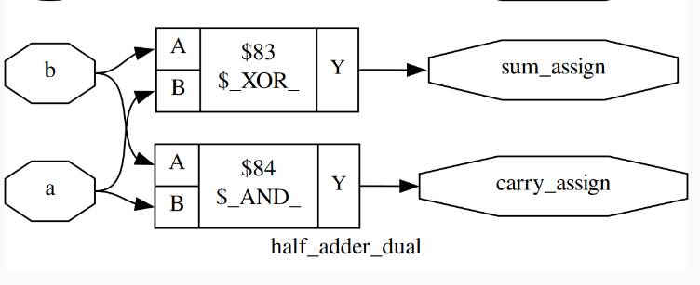

2) Half adder(using case) | rtl/half_adder_dual.sv

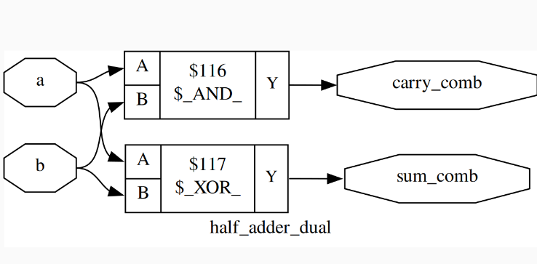

Terminal Output:
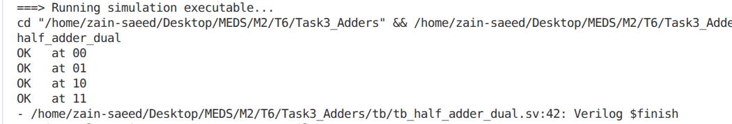
This is same of both assign and case statement.

Simulation:
This is considering only assign (as case statement also result in same waveform)
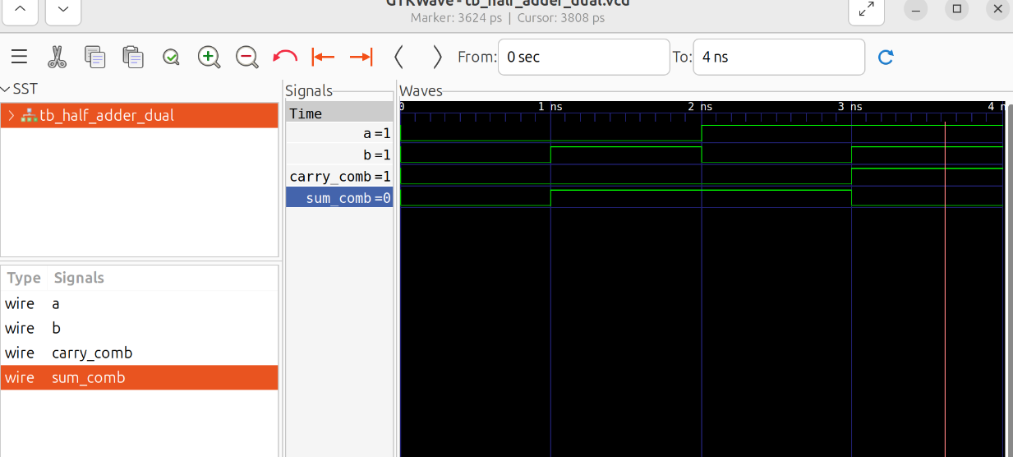

2) Full adder structural ( Using 2 half adders )

Terminal Output:

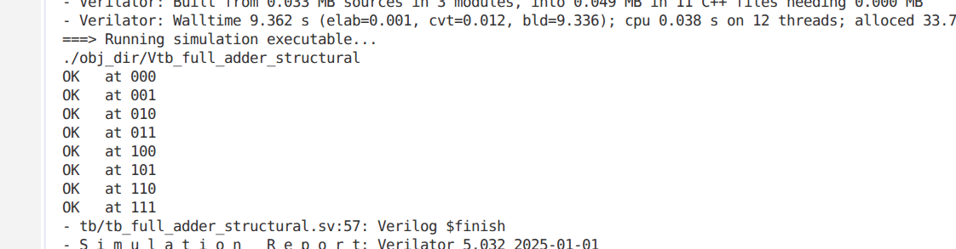

Schematics:
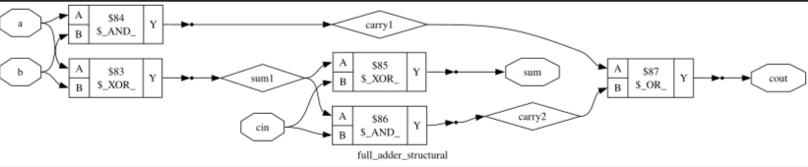

Simulation:
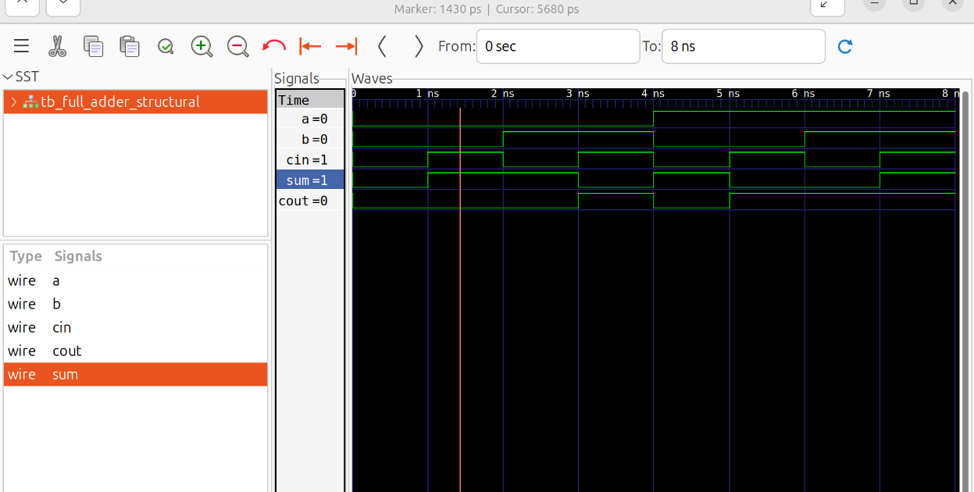

Why both assign and always comb results to same gate level diagram the reason is synthesis tools looks at the underlying truth table or boolean logic instead of how I make it – basically the logic I am trying to build and it make gates out of it.

Task4: NOR based realization
Expression: Y = ~ ( ~(b+c+d) +~(~a+b+c) + ~(~a+d) )
1) Direct Assign

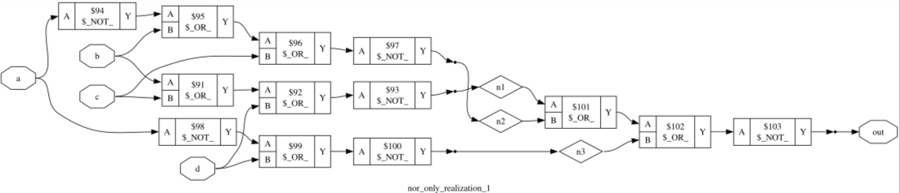
2) Using reduction operator
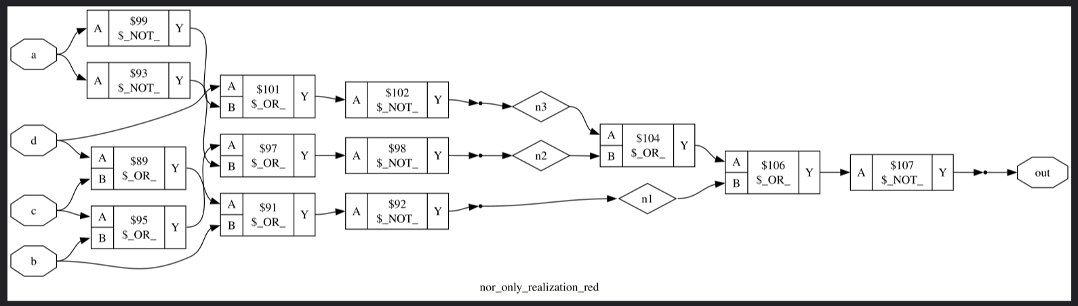

Terminal Output and Simulation:
1)Using direct approach
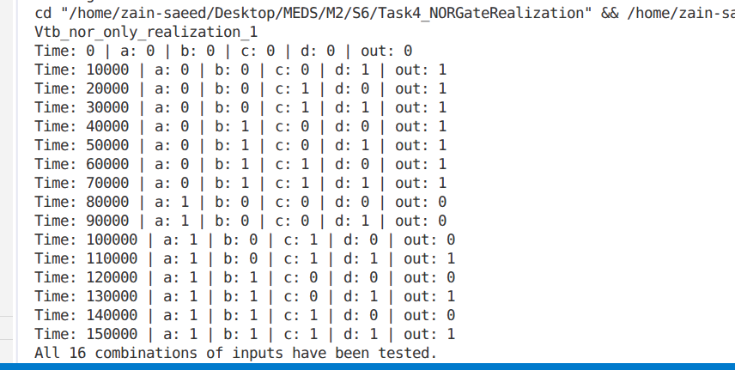

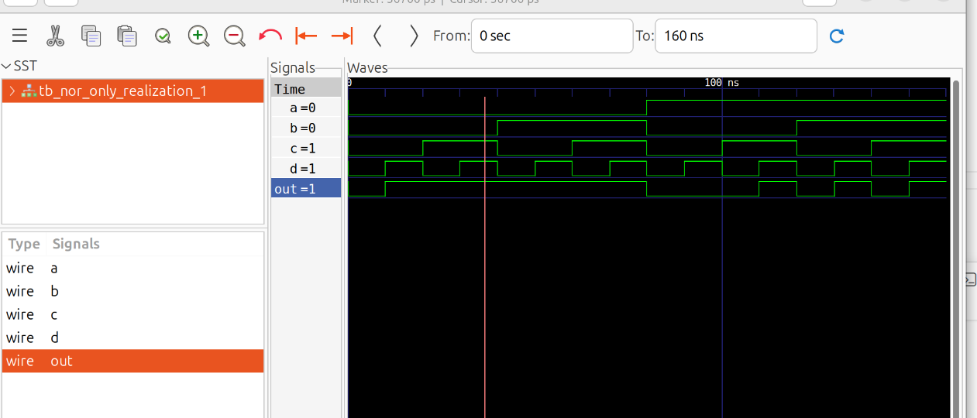
2)Using reduction operator

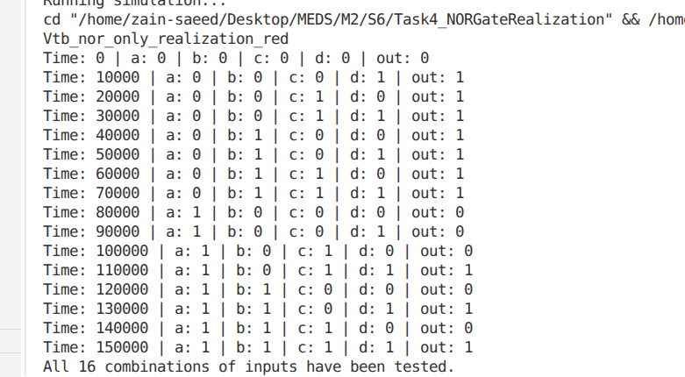

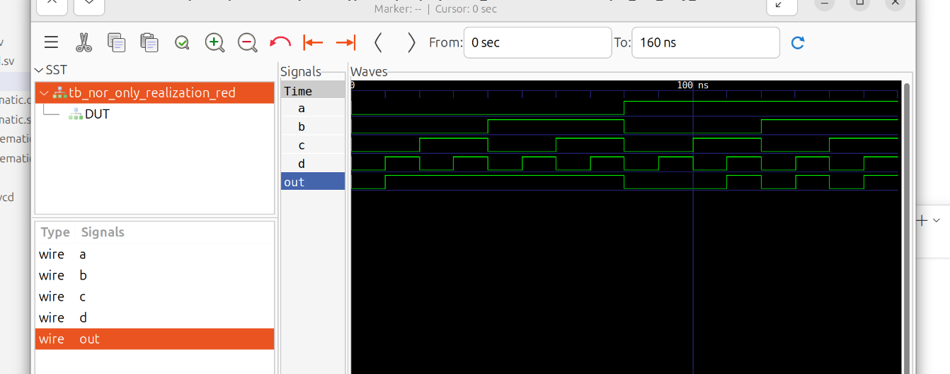

Explanation:
Both implementations match because De Morgan's laws algebraically prove that double negation preserves the exact logical function. Therefore, both circuits evaluate to the identical truth table for every input combination.

Task6:4 bit parity generator.

Terminal Output:
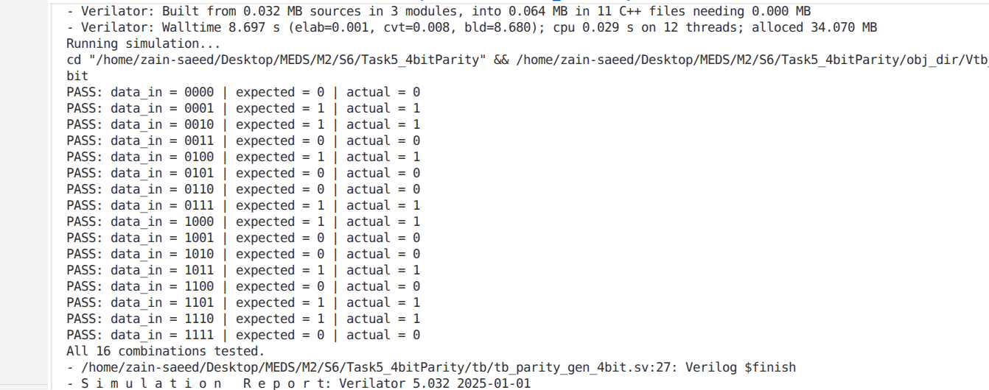
Simulation:
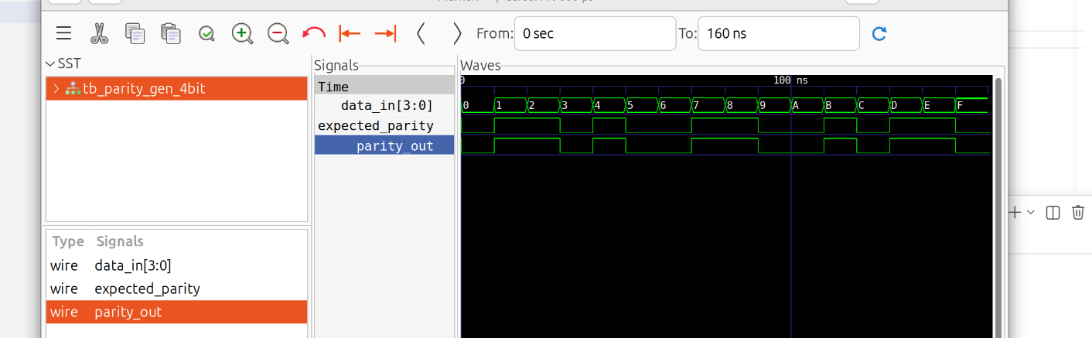

Schematics:
Created by yosys: As its physically impossible to make 4 input xor gate;
