# **Name :** Zainab Riaz

# **ID :** F2023105129

# **Course :** Web Technology

# **Section:** Y4

# **Assignment no 01**

**RESUME**

**Code:**

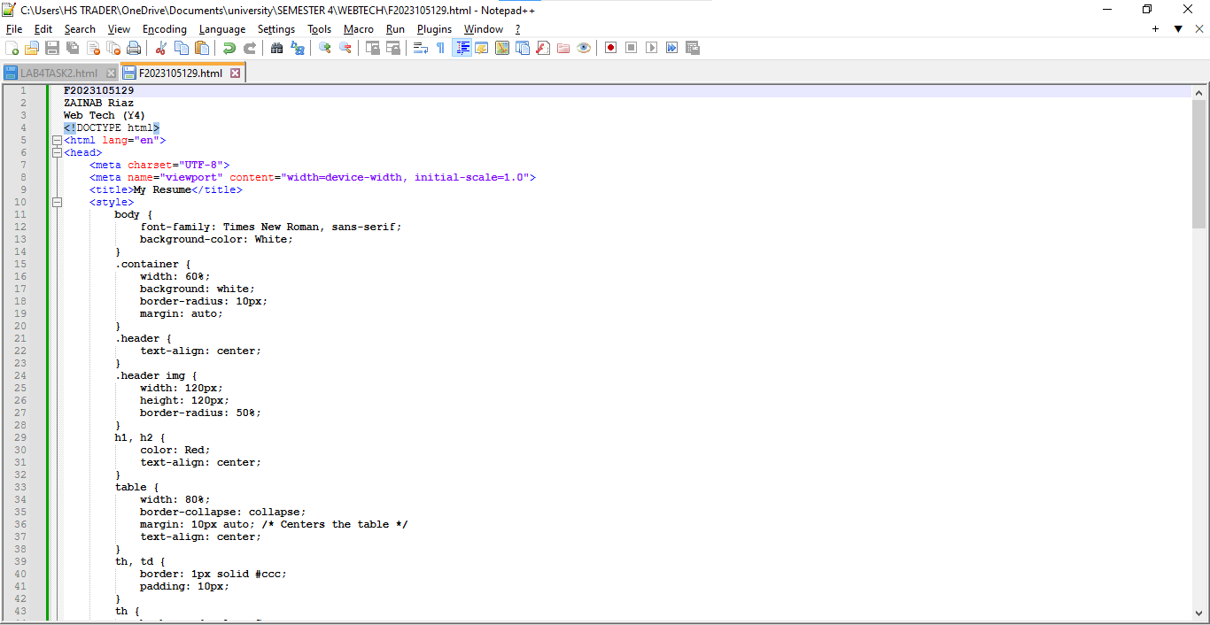

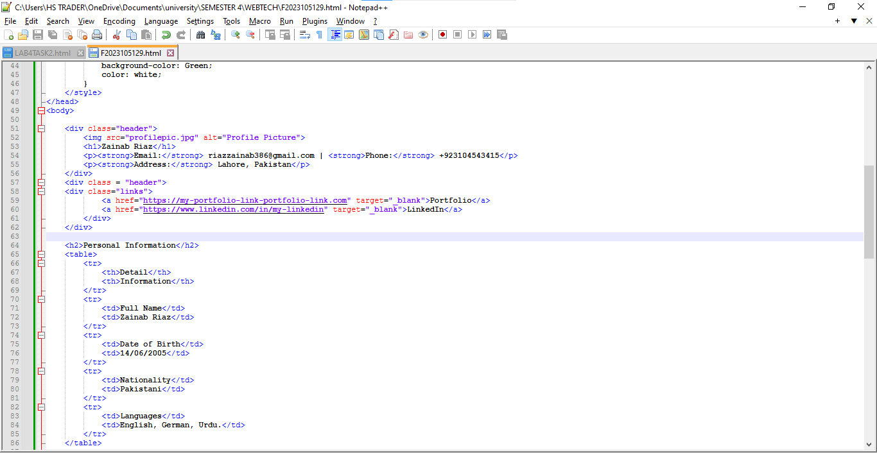

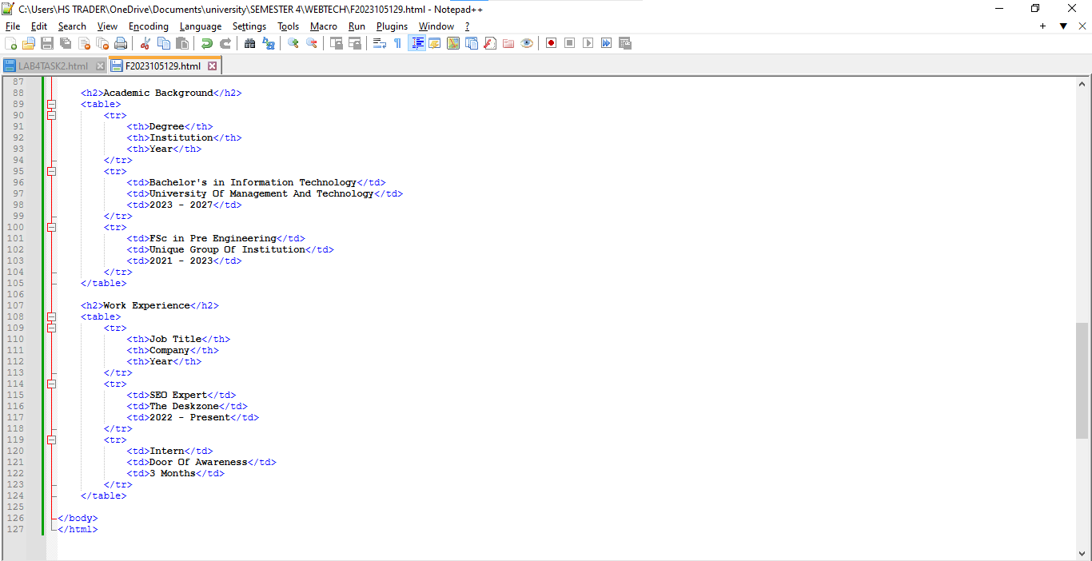

**Output**

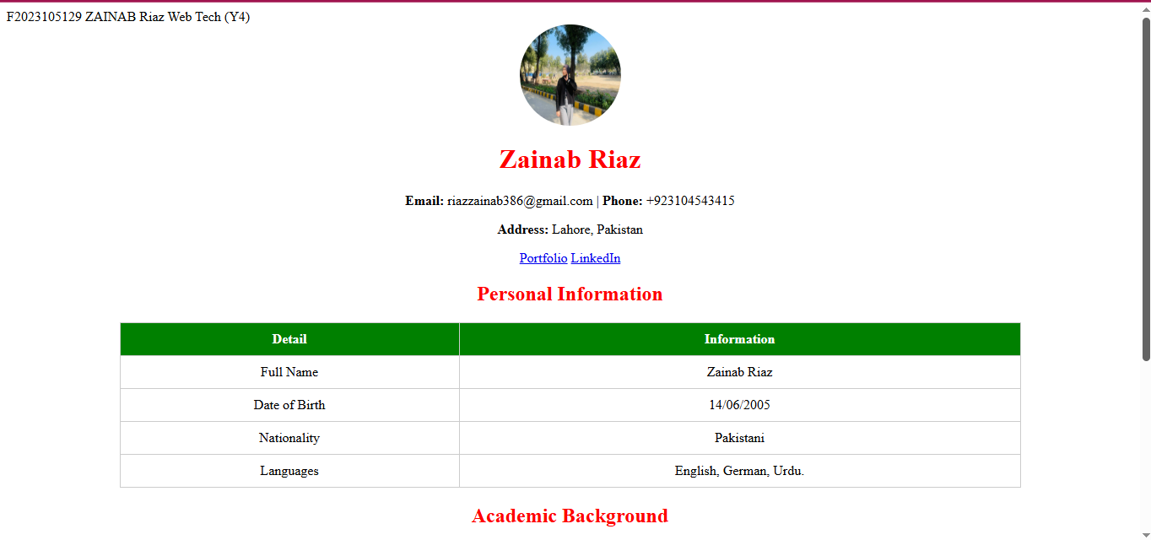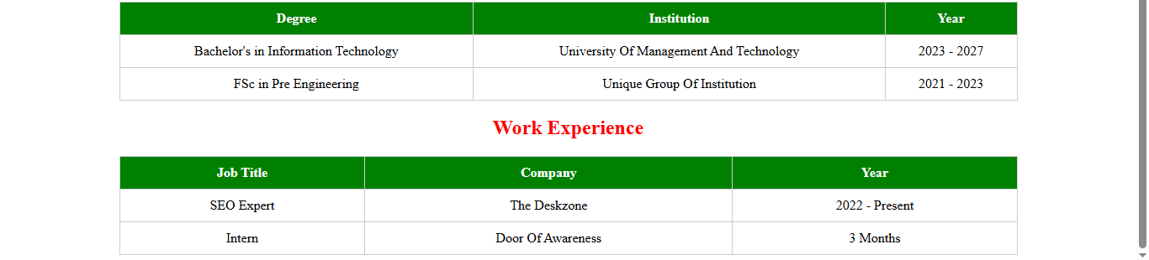

**THE END**