Case Study Report



**Tech Saksham**

Data Analytics with Power BI

**“INVENTORY AND SALES ANALYSIS OF DEPARTMENTAL STORE”**

“GOVERNMENT ARTS AND SCIENCE COLLEGE MODAKKURICHI”

|  |  |
| --- | --- |
| **NM ID** | **NAME** |
| ID2EAB5BB916D1CAD7E412A984BAFC19 | MADHAN KUMAR N |

Trainer Name : R UMAMAHESWARI

Master Trainer : R UMAMAHESWARI

**ABSTRACT**

In this Case Study, we utilize Power BI to analyze data across three primary datasets: customer information, product details, and sales transactions. Our objective is to derive actionable insights and facilitate decision-making processes within the organization.

The first dataset encompasses customer data, including attributes such as customer code, name, country, city, gender, and birthdate. Leveraging Power BI's visualization capabilities, we generate informative visualizations like bar charts, pie charts, and tables to showcase customer demographics, distribution by country, and birthdate trends.

Moving to the product dataset, we explore product-related information such as product code, name, category, and unit price. Through Power BI's functionalities, we visualize product categories' distribution, top-selling products, and unit prices to gain insights into product performance and market trends.

In the sales dataset, we analyze transactional data, including customer-product relationships, quantity, unit price, discounts, and total amounts. By establishing relationships between customer, product, and sales tables, we create comprehensive reports and dashboards revealing sales trends, revenue distribution by product category, and customer purchase behavior.

By effectively managing relationships between datasets and harnessing Power BI's visualization capabilities, our project empowers stakeholders to make data-driven decisions, optimize marketing strategies, identify growth opportunities, and enhance overall business performance.

**INDEX**

|  |  |  |
| --- | --- | --- |
| **Sr. No.** | **Table of Contents** | **Page No.** |
| 1 | Chapter 1: Introduction | 4 |
| 2 | Chapter 2: Services and Tools Required | 7 |
| 3 | Chapter 3: Project Architecture | 8 |
| 4 | Chapter 4: Modeling and Result | 10 |
| 5 | Conclusion | 15 |
| 6 | Future Scope | 16 |

***CHAPTER - 1***

***INTRODICTION***

***1.1 Problem Statement:***

The organization faces a critical obstacle in effectively utilizing customer, product, and sales data to drive strategic decision-making. The fragmented nature of data storage across these domains leads to inefficiencies in analysis and prevents a comprehensive understanding of business operations. Manual analysis processes further exacerbate the challenge, impeding timely insights generation. Consequently, the organization lacks the depth of insights necessary to optimize marketing strategies, enhance product offerings, and improve overall business performance. To overcome these hurdles, there's an imperative need for a cohesive data integration and analysis framework powered by advanced tools like Power BI.

***1.2 Proposed Solution:***

Our proposed solution revolves around harnessing the full potential of Power BI to streamline data integration, analysis, and visualization processes. Firstly, we will establish seamless data integration pipelines, consolidating customer, product, and sales data into a unified repository. Leveraging Power BI's robust data modeling capabilities, we will meticulously define relationships between these datasets, facilitating cross-domain analysis and insights generation.

Moreover, by leveraging Power BI's advanced analytics features, including DAX and machine learning integrations, we will conduct sophisticated analyses such as customer segmentation and sales forecasting. These insights will be presented through interactive dashboards and reports, meticulously designed using Power BI's visualization tools to offer stakeholders intuitive access to critical business metrics.

Automation will play a pivotal role in our solution, ensuring data accuracy and streamlining analysis processes. Scheduled data refreshes, anomaly alerts, and performance monitoring will be seamlessly integrated into the Power BI environment, guaranteeing the reliability and timeliness of insights.

To ensure the successful adoption of our solution, comprehensive training programs will be provided to equip stakeholders with the necessary Power BI skills. This will empower users at all levels of the organization to leverage data effectively in decision-making processes, fostering a culture of data-driven decision-making.

Through the implementation of this comprehensive solution, our organization aims to transform data into a strategic asset, driving innovation, optimizing operational efficiency, and ultimately achieving sustainable growth in today's competitive business landscape.

***1.3 FEATURES***

1. **Customer Segmentation:** Utilizing data analysis techniques to segment customers based on various attributes such as demographics, purchasing behavior, and geographical location. This allows for targeted marketing strategies, personalized customer experiences, and optimized product offerings.

2. **Product Performance Analysis:** Analyzing product sales data to identify top-performing products, sales trends over time, and product categories with the highest profitability. This analysis helps in optimizing inventory management, pricing strategies, and product development efforts.

3. **Sales Forecasting:** Using historical sales data to forecast future sales volumes and revenue. By applying predictive modeling techniques, such as time series analysis or machine learning algorithms, the organization can anticipate demand fluctuations, allocate resources effectively, and plan inventory levels accordingly.

4. **Cross-Selling and Up-Selling Opportunities:** Analyzing customer purchase histories and product associations to identify cross-selling and up-selling opportunities. By understanding which products are frequently purchased together or which complementary products customers are likely to be interested in, the organization can increase sales revenue and enhance customer satisfaction.

5. **Customer Lifetime Value (CLV) Analysis:** Calculating the lifetime value of customers based on their past purchase behavior, frequency of purchases, and average transaction value.

This analysis helps in identifying high-value customers, tailoring marketing efforts to retain them, and optimizing customer acquisition strategies to maximize long-term profitability.

By leveraging these data analysis features within the Power BI platform, the organization can gain valuable insights into customer behavior, product performance, and sales trends, enabling data-driven decision-making and strategic planning for business growth.

***1.4 ADVANTAGES***

1. **Enhanced Decision-Making:** Power BI provides intuitive visualizations and interactive dashboards that enable stakeholders to quickly and easily understand complex data relationships and patterns. This facilitates informed decision-making across various business functions, from marketing and sales to operations and finance.

2. **Improved Operational Efficiency:** By centralizing data from multiple sources and automating data integration processes, Power BI streamlines data analysis workflows and reduces manual effort. This leads to improved operational efficiency, allowing employees to focus on higher-value tasks rather than data preparation and manipulation.

3. **Real-Time Insights:** Power BI offers real-time data connectivity and streaming capabilities, enabling organizations to monitor key metrics and KPIs in real time. This allows for timely identification of trends, anomalies, and opportunities, empowering stakeholders to take proactive actions and respond swiftly to changing market conditions.

4. **Scalability and Flexibility:** Power BI is highly scalable and can handle large volumes of data with ease. As business needs evolve and grow, Power BI can seamlessly scale to

accommodate increasing data volumes and user demands. Additionally, Power BI's flexible architecture allows for customization and integration with other tools and systems, ensuring compatibility with existing infrastructure.

5. **Cost-Effectiveness:** Compared to traditional BI solutions, Power BI offers a cost-effective alternative with its subscription-based pricing model and cloud-based deployment options. This makes it accessible to organizations of all sizes, including small and medium-sized enterprises, without the need for significant upfront investment in hardware or software

licenses. Additionally, Power BI's self-service capabilities reduce the reliance on IT departments for data analysis, further lowering operational costs.

***1.5 SCOPE***

The scope of this data analysis project encompasses comprehensive analysis of customer, product, and sales data utilizing Power BI's robust capabilities. The project aims to integrate disparate data sources, including customer demographics, product attributes, and sales transactions, into a unified data model within the Power BI environment.

Key objectives within the project scope include establishing meaningful relationships between datasets, conducting in-depth analysis to derive actionable insights, and presenting findings through interactive visualizations and reports. Specifically, the analysis will encompass customer segmentation, product performance analysis, sales forecasting, cross-selling and up-selling opportunities identification, and customer lifetime value analysis.

Furthermore, the project scope includes the development of interactive dashboards and reports tailored to the needs of various stakeholders within the organization. These dashboards will provide stakeholders with real-time access to key performance indicators, enabling data-driven decision-making and strategic planning.

Additionally, the scope encompasses training and knowledge transfer activities to ensure successful adoption of the Power BI solution across the organization. This will involve providing stakeholders with the necessary skills and resources to leverage Power BI effectively for data analysis and visualization purposes.

Throughout the project lifecycle, adherence to timelines, budget constraints, and stakeholder requirements will be paramount. Regular communication and collaboration with key stakeholders will also be essential to ensure alignment with business objectives and the successful delivery of project outcomes.

***CHAPTER-2***

***SERVICES AND TOOL REQURIED***

***2.1 SERVICES USED***

* **Data Collection and Storage Services:** Banks need to collect and store customer data in real-time. This could be achieved through services like Azure Data Factory, Azure Event Hubs, or AWS Kinesis for real-time data collection, and Azure SQL Database or AWS RDS for data storage.
* **Data Processing Services:** Services like Azure Stream Analytics or AWS Kinesis Data Analytics can be used to process the real-time data.
* **Machine Learning Services:** Azure Machine Learning or AWS SageMaker can be used to build predictive models based on historical data.

***2.2 TOOLS AND SOFTWARE***

**Tools:**

* **Power BI:** The main tool for this project is Power BI, which will be used to create interactive dashboards for real-time data visualization.
* **Power Query:** This is a data connection technology that enables you to discover, connect, combine, and refine data across a wide variety of sources.

**Software Requirements:**

* **Power BI Desktop:** This is a Windows application that you can use to create reports and publish them to Power BI.
* **Power BI Service:** This is an online SaaS (Software as a Service) service that you use to publish reports, create new dashboards, and share insights.
* **Power BI Mobile:** This is a mobile application that you can use to access your reports and dashboards on the go.

***CHAPTER-3***

***PROJECT ARCHITCTURE***

***3.1 ARCHITECTURE***

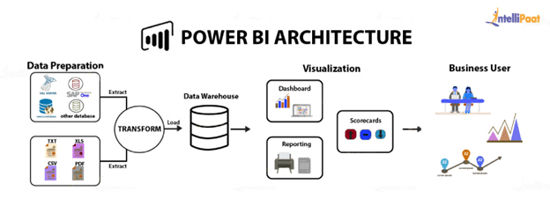

For the case study involving customer, product, and sales data analysis using Power BI, the architecture can be designed to ensure efficient data integration, analysis, and visualization. Here's a high-level overview of the architecture:

**1. Data Sources:**

* or in the cloud.

**2. Data Integration Layer:**

* Data from disparate sources is ingested into a centralized data repository or data warehouse.
* Integration processes involve extracting data from source systems, transforming it to fit the target data model, and loading it into the data warehouse.
* Integration tools such as Azure Data Factory, SSIS (SQL Server Integration Services), or custom ETL (Extract, Transform, Load) scripts can be utilized for this purpose.

**3. Data Storage:**

* The integrated data is stored in a structured format within the data warehouse.

Data storage options may include relational databases (e.g., SQL Server, Azure SQL Database) or cloud-based data warehouses (e.g., Azure Synapse Analytics, Amazon Redshift)

* Customer data, product data, and sales data are sourced from various systems such as CRM systems, ERP systems, and transactional databases.
* These data sources may reside on-premises

**4. Data Modeling and Analysis Layer:**

* Power BI connects to the data warehouse and performs data modeling tasks to establish relationships between customer, product, and sales datasets.
* Data modeling involves defining primary keys, foreign keys, and measures for aggregation.
* Advanced analytics and calculations, such as customer segmentation, sales forecasting, and profitability analysis, are performed using Power BI's DAX (Data Analysis Expressions) language.

**5. Visualization Layer:**

* Power BI is used to create interactive dashboards, reports, and visualizations based on the analyzed data.
* Visualizations include bar charts, line charts, pie charts, tables, and maps to present key insights and trends.
* Power BI's built-in visualization capabilities, custom visuals, and third-party integrations enhance the presentation of data.

**6. Deployment Options:**

* Power BI reports and dashboards can be deployed to the Power BI Service for sharing and collaboration.
* Additionally, on-premises deployment options, such as Power BI Report Server, can be considered for organizations with specific security or compliance requirements.

**7. Governance and Security:**

* Governance policies are established to ensure data integrity, security, and compliance with regulatory standards.
* Role-based access control (RBAC), data encryption, and data masking techniques are implemented to protect sensitive data.

**8. Monitoring and Optimization:**

* Monitoring tools and processes are implemented to track performance, usage, and data quality within the Power BI environment.
* Regular optimization efforts, such as query performance tuning and data model optimization, are undertaken to ensure efficient operation and scalability.

By following this architecture, organizations can effectively leverage Power BI to analyze customer, product, and sales data, derive actionable insights, and drive informed decision-making across the business.

***CHAPTER – 4***

***MODELING AND RESULT***

***4.1 MANAGE RELATIONSHIP***

In this scenario, the customer serves as the mediator between sales transactions and products, facilitating a nuanced understanding of customer behavior and preferences. The relationships between the Customer, Sales, and Product tables are pivotal in revealing intricate insights within the data.

The Customer table acts as the central entity, representing individual customers and their interactions with both sales transactions and products. Each record in the Customer table corresponds to a unique customer entity, capturing attributes such as customer ID, name, demographics, and contact information.

The relationship between Customer and Sales is established to track the transactions made by each customer. This relationship reflects the one-to-many nature, signifying that a single customer can engage in multiple sales transactions over time. The Customer table's primary key (e.g., Customer ID) serves as the link to the Sales table's foreign key (e.g., Customer ID), enabling the association of customers with their respective purchases.

Similarly, the relationship between Customer and Product delves into the products purchased by each customer. It provides insights into customer preferences, buying patterns, and product affinity. Through this relationship, organizations can identify which products resonate most with specific customer segments, enabling targeted marketing efforts and personalized recommendations.

Lastly, the Sales and Product relationship captures the transactions between customers and products, detailing the quantity, unit price, and total amount of each sale. This relationship allows for a comprehensive analysis of sales performance, product popularity, and revenue generation. The Sales table's foreign key (e.g., Product ID) links to the Product table's primary key (e.g., Product ID), establishing the association between sales transactions and the products involved.

By establishing these relationships and analyzing the interactions between customers, sales transactions, and products, organizations can gain valuable insights to drive strategic decision-making, optimize marketing strategies, and enhance overall business performanc

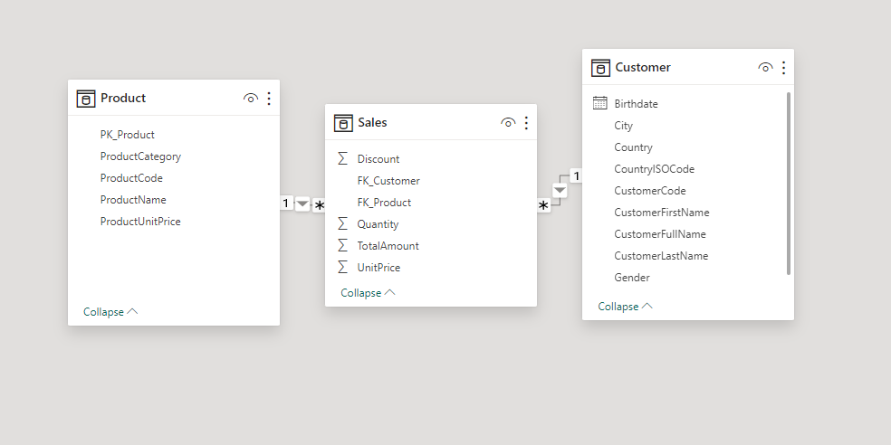

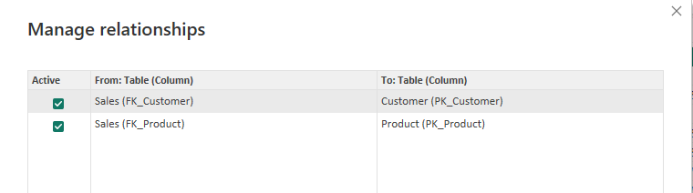

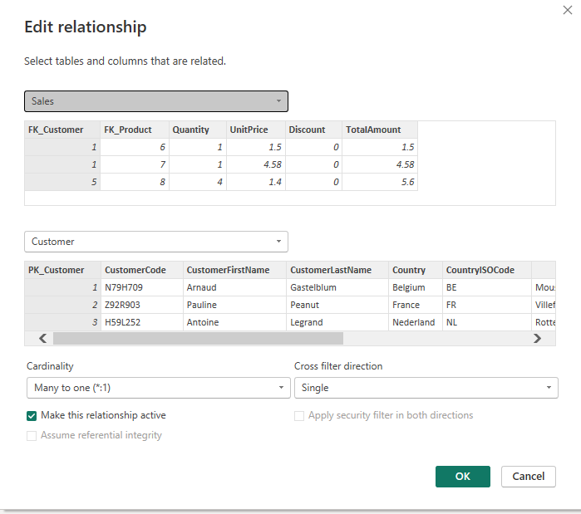

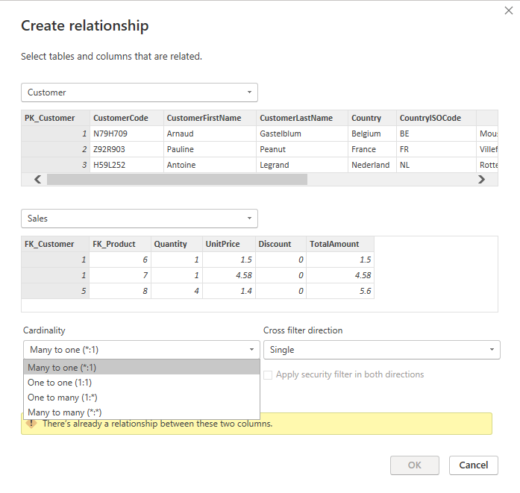

**Dashboard**

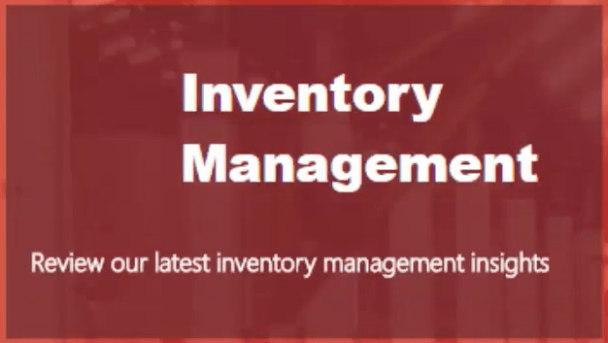

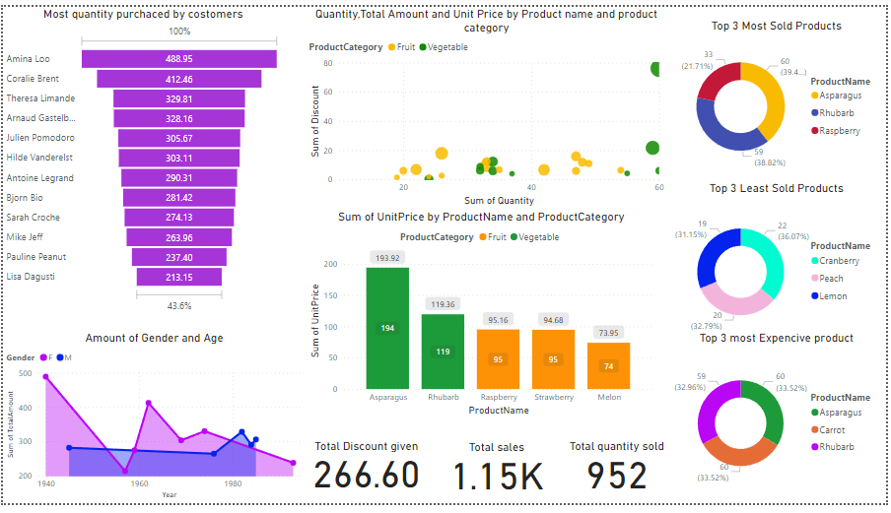

***CONCLUSION***

In leveraging Power BI for inventory management, organizations gain a powerful tool to optimize operations, enhance decision-making, and drive efficiency throughout the supply chain. Through the analysis of inventory data, organizations can derive actionable insights that lead to improved inventory management practices, reduced costs, and increased profitability.

By integrating data from various sources such as sales, procurement, and warehousing, Power BI enables organizations to gain a comprehensive view of their inventory levels, trends, and performance metrics. This holistic perspective allows for better forecasting, demand planning, and inventory optimization strategies.

Furthermore, Power BI's intuitive visualizations and interactive dashboards provide stakeholders with real-time visibility into inventory metrics, enabling quick identification of trends, anomalies, and areas for improvement. Whether it's monitoring stock levels, tracking inventory turnover, or analyzing supplier performance, Power BI empowers users to make data-driven decisions that drive operational excellence.

Additionally, Power BI's advanced analytics capabilities enable organizations to conduct predictive analysis, identifying potential stockouts or excess inventory situations before they occur. By leveraging predictive models and machine learning algorithms, organizations can optimize inventory levels, minimize carrying costs, and improve customer satisfaction.

Overall, the adoption of Power BI for inventory management offers organizations a competitive advantage in today's dynamic business environment. By harnessing the power of data, organizations can optimize their inventory management processes, reduce risks, and capitalize on opportunities for growth and innovation. Through continuous analysis and optimization, organizations can ensure that their inventory management practices remain agile, responsive, and aligned with strategic objectives.

***FUTURE SCOPE***

The future scope for inventory management using Power BI is ripe with potential for transformative advancements. With ongoing technological innovation and the expanding capabilities of Power BI, organizations can anticipate significant enhancements in inventory optimization, supply chain visibility, and decision-making processes.

One avenue for future development lies in predictive analytics, where Power BI can leverage advanced algorithms to forecast demand, optimize inventory levels, and mitigate supply chain risks. By harnessing machine learning and predictive modeling techniques, organizations can proactively address inventory challenges and capitalize on emerging opportunities, paving the way for more agile and responsive inventory management practices.

Furthermore, the integration of Power BI with Internet of Things (IoT) devices holds promise for real-time monitoring and management of inventory assets. This integration enables organizations to collect and analyze data on inventory levels, environmental conditions, and asset location in real time, facilitating proactive decision-making and preventive maintenance to optimize inventory performance.

Additionally, as organizations seek to gain greater visibility and control over their supply chains, Power BI can evolve to provide end-to-end visibility from raw material procurement to final product delivery. By integrating data from suppliers, manufacturers, logistics providers, and retailers, Power BI can empower organizations to optimize inventory management practices, enhance collaboration, and drive efficiencies across the entire supply chain ecosystem.

Moreover, advancements in inventory optimization algorithms within Power BI can enable organizations to dynamically adjust reorder points, safety stock levels, and lead times based on evolving market conditions and demand patterns. This proactive approach ensures optimal inventory levels while minimizing carrying costs and stockouts, thereby improving overall operational efficiency and customer satisfaction.

As Power BI continues to evolve, enhanced mobile and cloud integration capabilities will enable organizations to access inventory data, dashboards, and reports from anywhere, at any time. This flexibility empowers decision-makers with real-time insights, fosters collaboration among stakeholders, and enables organizations to respond rapidly to changing market dynamics and business requirements.

In conclusion, the future of inventory management using Power BI is bright, with opportunities for innovation and optimization across the entire supply chain. By embracing these future advancements, organizations can unlock new possibilities for enhancing operational efficiency, driving strategic decision-making, and achieving sustainable growth in an increasingly complex and competitive business environment.

Links : https://azee19062004.github.io/Kesavan/