NAMELESS
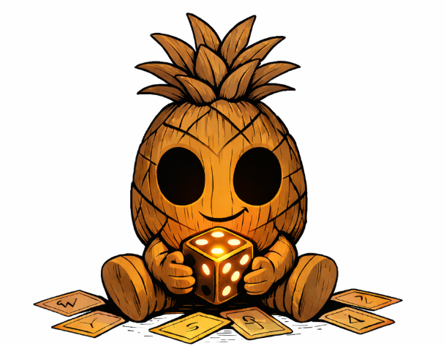
  - Combat Physical Playtest Rulebook
Prototype Edition — For Playtesters Only

This booklet contains the rules for the physical prototype of Nameless, an duelling game of wagers, fate, and tactical manipulation.
All components, mechanics, and visuals are work-in-progress and subject to change based on your feedback.
FindPineapple Studios
Prototype v0.1 — Not for resale

Thank you for being the guinea pigs of our debut game, Nameless. You're helping shape this game while it’s still messy, experimental, and rough. Your honesty, critique, and patience are deeply appreciated — and most importantly, we hope you have fun.

If you’d like to join future playtests or stay updated on the game’s progress, scan the QR code below to join our Discord server.


Contents
What to Expect 4
What We Need From You 4
What You Need to Play 4
The Wager 5
The Deck 6
Phase 1 Cards 6
Phase 2 Cards 7
Trap Cards (default rules) 8
Alternate rules for trap cards 9
How to Play (Round Structure) 9
Before starting 9
1. Choose a Wager 10
2. Phase 1 10
3. Roll Dice 10
4. Phase 2 10
Preparing for the Next Round 11
How to Win 11
Table Layout 12

What to Expect
This is an early prototype.
- The art is temporary
- The balance is rough
- The rules might need to be adjusted (that's what you are here for!)

What We Need From You
Please focus your feedback on:
- Clarity— what confused you
- Flow — what felt smooth or clunky
- Fun — what moments felt exciting or frustrating. Was the gameplay loop interesting at its core.
- Balance — any cards that felt too strong or too weak
- Traps — did they feel fair, predictable, or annoying
- Strategy — did your choices feel meaningful
- Design – Were the cards easy to ready and understand
Short notes are perfect — don’t overthink it.

What You Need to Play
Each player needs:
- A deck of made up of 15 cards
  - The playtest comes with 30 cards (please experiment with the building different decks)
      - 10 Phase 1 cards
      - 10 Phase 2 cards
      - 10 Trap cards
- 1 d6 Dice (at least 2 if possible, there are some cards effects that let you roll multiple dice)
- Some way to record Health pool
  - this could be 12 tokens
  - A piece of paper to keep track
Optional: a pen and paper for notes.

The Wager
At the start of each round, the players will select a wager, the wager dictates which trap cards can be played and what wager bonuses the players receive. Once a round has been completed the Loser will remove their wager HP from their Health Pool (starts with 12HP)
- A high risk wager (⚡⚡⚡ )
  - Wagering 5 HP
  - Allows for some strong card effects
- A medium risk Wager (⚡⚡)
  - Wagering 3 HP
  - Middle ground card effects
- A low risk wager (⚡)
  - Wagering 2 HP
  - Safe card effects

The Deck
There are the cards are split into 3 categories which can be identified as follows

Phase 1 Cards
- These cards have Purple Details
- A ◖ at the top left of the card next to the card name
- These cards are played before the dice are rolled and are designed to influence the dice themselves

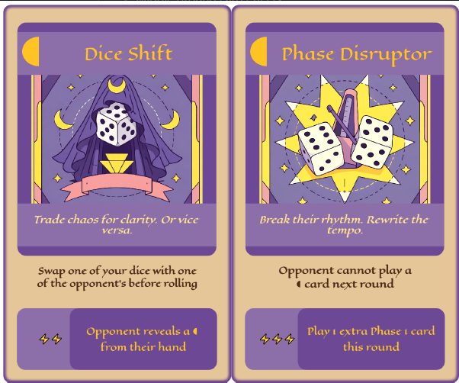

Phase 2 Cards
- These cards have Blue details
- A ◗ at the top left of the card next to the card name
- These cards are played after the dice have been rolled and are designed to influence the result of the dice

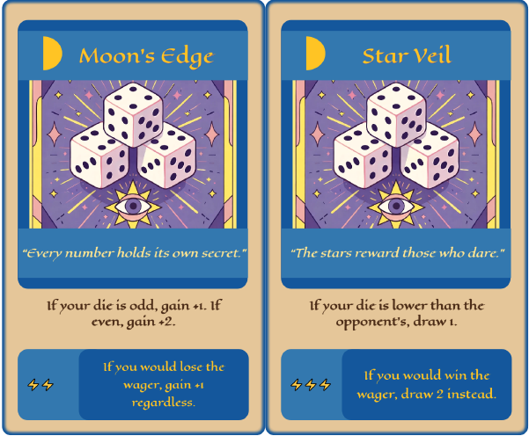

Trap Cards (default rules)
- These Cards have black details
- A ⬤ at the top left of the card next to the card name
- These cards can be played in either phase 1 or 2 face down
  - They can only be played when the player has wagered the matching level of risk
  - They can not be triggered the same round they are placed
  - You can only play 1 trap card at a time

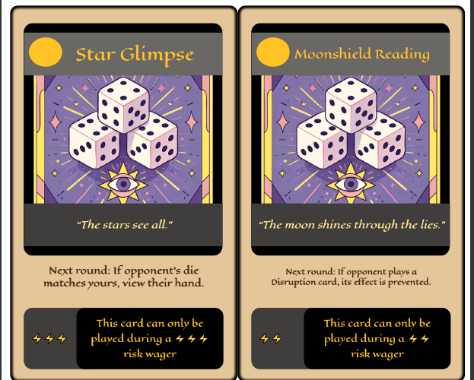

Alternate rules for trap cards

Optional Trap Experiments
The rules above are the default rules used for this playtest.
Given the evolving nature of the prototype, below are alternative trap rules we encourage you to try after playing a few rounds with the default.

Alternative Rule #1
Trap cards can be played immediately straight from the hand if the conditions are met and you are using the matching wager type

Alternate Rule #2
Trap cards are played at the END of a round, and are based on the opponent’s wager, not yours. They arm immediately and just activate when the condition is triggered

How to Play (Round Structure)

Before starting
- build your own deck made up of 15 cards
    - it is recommended to try have 5 of each (Phase 1, Phase 2, Trap) but feel free to build the deck how you want
  - Each player deals themselves 5 cards to their hand
  - Each Player starts with 12 HP

1. Choose a Wager
Both players secretly choose a wager and reveal. Wagers determine:
- which wager bonuses can activate
- which trap cards can be set up this round

2. Phase 1
Both players play one Phase 1 card face‑up. These modify dice before rolling. They can be played at any wager but only gain their wager bonus if the wager matches.

3. Roll Dice
Roll your dice pool, adjusted by Phase 1 effects.

4. Phase 2
Both players play one Phase 2 card face‑up. These modify dice after rolling. They can be played at any wager, but only gain their wager bonus if the wager matches.
5. Resolve Totals
Apply all modifiers. Highest total wins the round.
- The Loser will remove their wager HP from their total Health Pool
- In the case of a draw no damage is taken on either side

Preparing for the Next Round
- Discard all Phase 1 and Phase 2 cards from the play area into their owner’s discard pile
- Any face-down Traps remain in play until triggered
- Each player draws **1 card**, unless an effect instructs otherwise
- If a player’s deck is empty, shuffle their discard pile to form a new deck

Trigger Traps
Reminder (Default rules)
If you armed a trap last round, it becomes active this round.
When its condition is met, the trap triggers immediately.
- Traps are played face-down during Phase 1 or Phase 2
- They do nothing the round they are played
  - They may trigger at any point in the next round when their condition is met
- Only one trap may be armed at a time
NOTE: Try give alternative trap rules a try after playing a game with the default rules (see under Trap Cards for a reminder)

How to Win
Outplay your opponent and reduce their HP to 0.

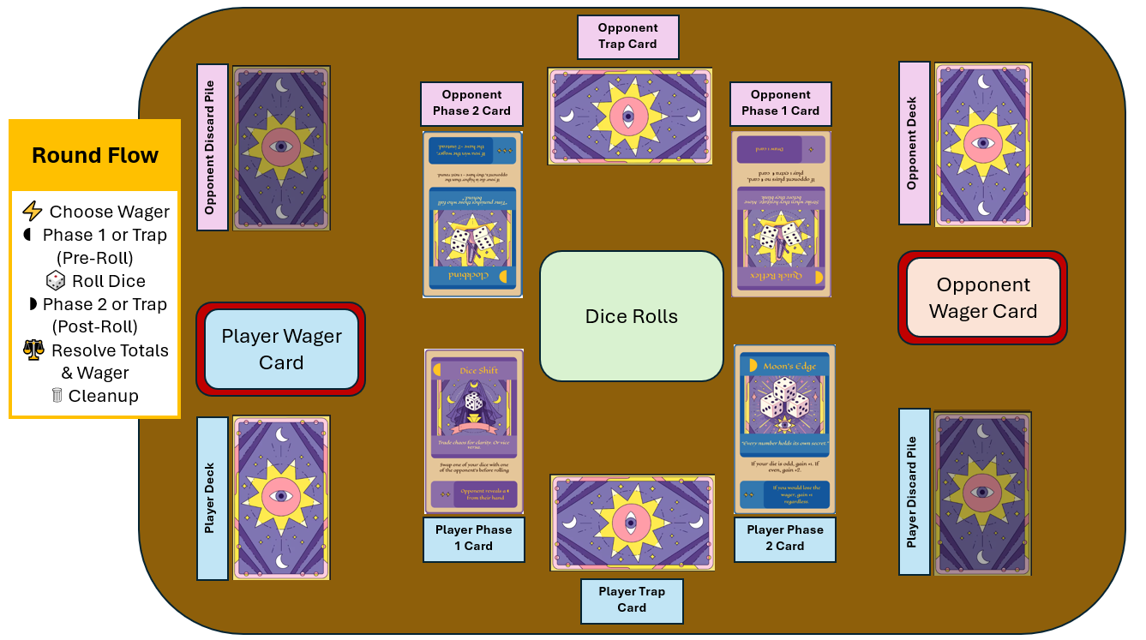
Table Layout

