**Introduction**

The main problem of this project is to find out the starting pattern of game of life, which is proven to grow over time and generate the most generations among all populations.We need to use Genetic Algorithms to solve this problem. Genetic Algorithms use the same techniques as does nature in order to find a good solution for a problem. In this project we used Jenetics to implement genetic problems.

**Observation**

Our goal is to use the genetic algorithm to find the optimal starting pattern. This starting pattern can make a group of cells live more than 1000 generations in Game of Life games. Actually, it is easy to find those start patterns by genetic algorithms. For example, we can get a result after about 16 generations of evolutions without any optimizations:

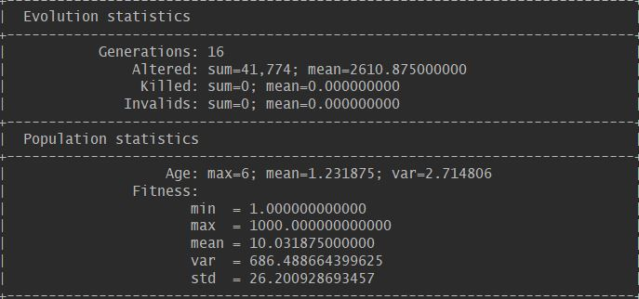

Here is the result when population size is 1000, the probability of crossover is 0.2, number of maximum evolution is 1000.

|  |  |  |  |  |  |  |  |  |  |  |  |
| --- | --- | --- | --- | --- | --- | --- | --- | --- | --- | --- | --- |
| probability of mutation | generations number | | | |  |  |  |  |  |  | average generations |
|  | No. 1 | No. 2 | No. 3 | No. 4 | No. 5 | No. 6 | No. 7 | No. 8 | No. 9 | No. 10 |  |
| 0.1 | 7 | 8 | 1 | 6 | 5 | 18 | 41 | 7 | 4 | 4 | 10.1 |
| 0.2 | 4 | 3 | 3 | 9 | 6 | 1 | 5 | 2 | 6 | 4 | 4.3 |
| 0.3 | 6 | 3 | 8 | 14 | 11 | 4 | 8 | 5 | 3 | 12 | 7.4 |
| 0.4 | 6 | 25 | 8 | 1 | 17 | 14 | 13 | 2 | 11 | 6 | 10.3 |
| 0.5 | 9 | 14 | 4 | 45 | 24 | 10 | 6 | 5 | 2 | 9 | 12.8 |

According to this graph, when mutation probability is 0.2, the generations is more stable and the average generation is the least among the five.

Here is the result when population size is 1000, mutation probability is 0.2 and the number of maximum evolution is 1000.

|  |  |  |  |  |  |  |  |  |  |  |  |
| --- | --- | --- | --- | --- | --- | --- | --- | --- | --- | --- | --- |
| probability of crossover | generation number | | | |  |  |  |  |  |  | average generations |
|  | No. 1 | No. 2 | No. 3 | No. 4 | No. 5 | No. 6 | No. 7 | No. 8 | No. 9 | No. 10 |  |
| 0.1 | 11 | 40 | 26 | 27 | 9 | 2 | 30 | 8 | 11 | 7 | 17.1 |
| 0.2 | 8 | 14 | 7 | 11 | 5 | 25 | 12 | 1 | 24 | 3 | 11 |
| 0.3 | 2 | 3 | 10 | 4 | 7 | 2 | 3 | 2 | 14 | 12 | 5.9 |
| 0.4 | 1 | 7 | 12 | 8 | 5 | 6 | 4 | 5 | 4 | 7 | 5.9 |
| 0.5 | 7 | 3 | 8 | 8 | 5 | 2 | 8 | 5 | 3 | 4 | 5.3 |

According to this graph, when crossover probability is 0.5, the generations is more stable and the average generation is the least among the five.

We selected 3 types of survivorsSelector as candidate selector, which are TournamentSelector, TruncationSelector and Linear-rank Selector. The TournamentSelector selects best individual from a random sample of s individuals is chosen from the population Pg. In truncation selection individuals are sorted according to their fitness and only the n best individuals are selected. In linear-ranking selection the individuals are sorted according to their fitness values. The rank N is assigned to the best individual and the rank 1 to the worst individual. Here is the results when mutation probability is 0.2, crossover probability is 0.5.

|  |  |  |  |  |  |  |  |  |  |  |  |
| --- | --- | --- | --- | --- | --- | --- | --- | --- | --- | --- | --- |
| type of selector | generation number | | | |  |  |  |  |  |  | average generations |
|  | No. 1 | No. 2 | No. 3 | No. 4 | No. 5 | No. 6 | No. 7 | No. 8 | No. 9 | No. 10 |  |
| TournamentSelector | 7 | 3 | 8 | 8 | 5 | 2 | 8 | 5 | 3 | 4 | 5.3 |
| TruncationSelector | 16 | 2 | 2 | 2 | 6 | 9 | 9 | 3 | 4 | 3 | 5.6 |
| Linear-rank Selector | 13 | 8 | 159 | 17 | 5 | 6 | 10 | 11 | 1 | 3 | 23.3 |

As we can see, tournamentSelector has the least average generation, so we choose TournamentSelector as the selector.

**Design**

Firstly, we make the game of life problem convert to a problem which can be finished by genetics algorithms. We define the genotype, phenotype and fitness function of this problem.

Before starting genetic algorithms, the program randomly generates a vector with size of 100, and the value of every element is 0 or 1. We define this vector as genotype in our project. Every genotype in our program has only one chromosome with the length of 100. The phenotype of our problem is a list of points derived from genotype. We iterate the genotype ( an int array with the size of 100). And if the value of the element is 1, it means a live cell in the grid.We use a simple mathematical method to get the position and initialize a point with the position. Then after the iteration, we get a list of points. This is our genotype.

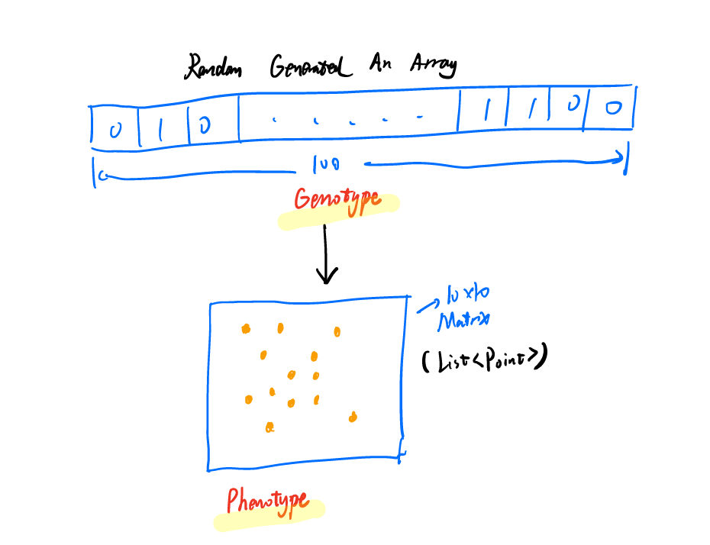

Fitness function is essential to a GA problem. In our project, we directly define the generation of the Game of Life last as the fitness. Because we want to get the pattern who can last longer. So the generation of the game lasts is the fitness of every individual in this system.

There is a group of cells in the generation of 875 in the game, and the count of points reached 394.It is only about 50 at the beginning. That means it has a strong fitness:

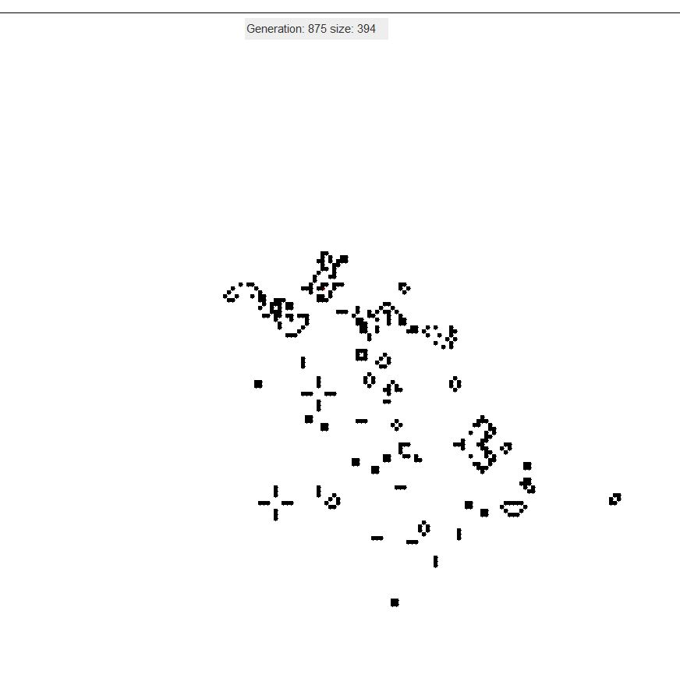

Then we chose the mutator and selector of the program. We test several mutators and we chose the classical one with the probability of 0.5. Everytime we have a survivor selector and a offspring selector. RouletteWheelSelector is a good fitness proportional selector, it has a good performance on our program.

**Test**



Since we choose to use Jenetics as our library. So what we need to test is to test our expression from genotype to phenotype.

**Conclusion**

According to the analysis above, we used Genetic Algorithms to find better starting pattern, which generated 1000 generations by game of life rules. Our program illustratutes that GA is a very useful method to find the optimal solution.