カルドゥドク

*The amount of points you can obtain will be reduced by 20% of the total for every 5 incorrect submissions you make. Make sure that you run and check your code before you mark it.*

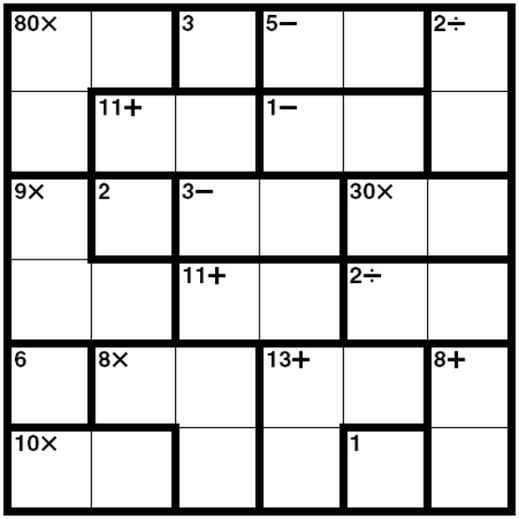

Bored of sudoku? Try calcudoku!

The puzzle is simple. Upon a square *n*×*n* grid, each row and column must contain a permutation of the numbers from 1 to *n*. Consequently, each row or column must contain each of these *exactly once.*

Overlaid upon the grid are a number of cages. Each cage consists of one or more contiguous cells, and contains a label. A label is a target value *V*, and optionally an operator, which may be any one of +, −, ∗, /.

A player must place numbers in every cage such that its indicated condition is satisfied. The rule for a given cage depends on its operator:

•

**no operator** : the cage must consist of a single square containing *V*;

•

∗ : the product of the numbers in the cage must be equal to *V*;

•

+ : the sum of the numbers in the cage must be equal to *V*;

•

/ : the cage must be exactly two squares, the smaller value of the two must divide the larger one evenly so that the quotient is *V*;

•

−: the cage must contain two cells, where the difference of the two members is *V*.

**Your task**

Puzzles will be provided in the following way. Here is an example using the picture above.

0 0 1 2 2 3

0 4 4 5 5 3

6 7 8 8 9 9

6 6 10 10 11 11

12 13 13 14 14 15

16 16 13 14 17 15

80* 3 5- 2/ 11+ 1- 9* 2 3- 30* 11+ 2/ 6 8* 13+ 8+ 10* 1

The first six lines describe the cage shapes. All cells assigned the same number share a common cage.

The seventh line contains the cage labels. Which cage a label belongs to depends on its index in the line. So, 80∗ is the condition for cage 0, while 6 is the label upon cage 12. A label will always be a number, followed optionally by an operator symbol.

You should print your solution to standard out, as follows:

5 4 3 1 6 2

4 6 5 2 3 1

3 2 1 4 5 6

1 3 6 5 2 4

6 1 2 3 4 5

2 5 4 6 1 3

Each row must be on a line by itself. Each number is to be separated from the next by a single space.

If a puzzle is unsolvable, you should output No solution.

**Notes**

•

All test puzzles will be 6×6.

•

All test puzzles will have a unique solution, if one exists.

•

The first six input lines will each consist of exactly six decimal integers separated by spaces.

•

The cage numbers will be numbered from 0 to *m*, increasing as new cages are encountered, scanning left to right, top to bottom.

•

There will be exactly *m*+1 labels provided on the 7th line, space-separated as above.

**Examples**

An unsolvable example puzzle:

Input:

0 1 2 2 3 3

4 4 4 5 5 5

4 4 6 6 7 8

9 10 10 11 7 8

9 12 12 13 13 8

14 14 12 13 15 15

6 6 2* 3/ 10+ 6* 6+ 5 24* 2- 2- 2 7+ 20* 8+ 2-

Output:

No solution.

**Hints**

•

Consider the use of recursion.

•

Functions are your friends. Break the problem up into more manageable chunks.

•

For certain puzzles, direct deduction will only get you so far. At some point you may be forced to make a guess and see if it leads to a violation of the rules.