PhoneFIX
1. Launch Details
Key Summary USP | Introducing the new CelcomDigi PhoneFIX - New offer under device protection, offering repair only service to all CelcomDigi subscribers with no contract required. ​  Get your phone repaired for any screen cracks and damage. Easy sign up via CelcomDigi App.​
Channels | Subscription channel: -  - CelcomDigi app  - CelcomDigi Website  Service Request/Claim channels: -  - CelcomDigi app  - CelcomDigi Website  Unsubscribe channel: -  - CelcomDigi app

2. Product or Campaign Details
What is PhoneFIX? | PhoneFIX is an affordable phone repair for all, anytime and any device exclusively for CelcomDigi customers. CelcomDigi is a Malaysia’s first telco to offer repair coverage regardless of where the phone was bought.  Benefits of PhoneFIX  - CelcomDigi users: Open for every CelcomDigi customers  - Any phone from any store: Coverage no matter where you bought it  - From RM3/month: Afforable with no contract  - Fast & Easy claims: Quick approval and same-day delivery  Some of the PhoneFIX Coverage:  Cracked Screen 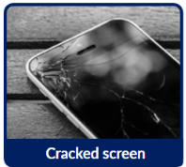  Water Damage 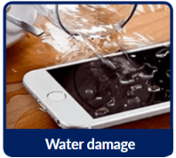  Battery Related 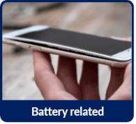  Camera Issue 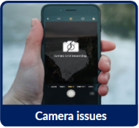  Audio Issue 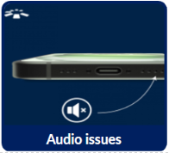  - PhoneFIX also covered many more issues  - Repair Warranty: 6 months
Fee | Two types of fees apply, and they vary based on the device's recommended retail price.  Subscription Fee (Monthly) Service Request Fee (Each Request)  The monthly recurring subscription that customers pay to CelcomDigi - Monthly Fee for postpaid will appear (in full) in the next bill - Monthly Fee for Prepaid will be deducted up front - Both are monthly recurring charges One time charge that customer pay to PhoneFIX service provider, SwapAsia - This fee is charged when customer requests for a repair service - Customer to request via CelcomDigi app - Payment via Credit Card or Cash on delivery  Device price tier​ PhoneFIX​  Repair Only ​  Subscription Fee (RM)​ Service Request Fee ​ (RM) ​  ​*Promo Price​ Monthly Price​  RM0 – RM500 ​ 1​ 3​ 30 ​  RM501 – RM1,000 ​ 1​ 5​ 50 ​  RM1,001 - RM1,500​ ​ 1​ 6 ​ 100 ​  RM1,501 - RM3,000​ ​ 1​ 10 ​ 200 ​  RM3,001 - RM6,000​ ​ 1​ 17 ​ 330 ​  Above RM6,000 ​ 1​ 20 ​ 470 ​  Note: ​  - *Promo price is valid from 20th November 2025 until 13th April 2026 for new users in the first month only. Normal monthly fee applies from the second month onward.​  - PhoneFIX Subscription Fee & Service Request Fee both are subjected to 8% SST.​  - Device is repaired at authorised service centres using genuine or equivalent parts.​If unable to repair (BER - Beyond Economic Repair), swap option is offered by SwapAsia directly to customer  - Termination of subscription will happen if customer: -  - Port-out  - Payment lapses due to failed charging  - Account status is BARRED or Suspended.
Key Difference between PhoneFIX and PhoneCARE | ​ PhoneFIX​ PhoneCARE​  Summary​ - PhoneFIX is an affordable phone repair for all, anytime and any device exclusively for CelcomDigi customers. ​ - CelcomDigi is a Malaysia’s first telco to offer repair coverage regardless of where the phone was bought.​ - PhoneCARE is a device-care subscription plan offered by CelcomDigi.​ - It allows you to swap or replace your enrolled mobile device for almost any reason (subject to their terms) rather than just traditional insurance covering damage/theft.​  What does it cover​ - Screen Crack​ - Accidental Damage ​ - Liquid Damage​ - And more​ - Swap for any issues ​ - Replace if lost/stolen​  Price​ - From RM3/mth RM1/mth (for new user on 1st month)​ - From RM4/mth​

3. Eligibility and Criteria
Eligibility & Criteria | Customers eligibility: -  All CelcomDigi customers (regardless of where they purchased their devices)  Device eligibility: -  - New or used devices (contracted or non-contracted),​  - Up to 2 years from manufacturing date.  - Must pass diagnostic test.​ Please refer to the journey to do diagnostic test.  * This offer is extended to CelcomDigi devices that have exceeded the 30-day eligibility period for PhoneCARE, as well as to customers’ own devices.

4. Customer Journey (current journey / campaign only)
Customer Journey

5. Customer Communications (Active)
FAQ | EN: https://help.celcomdigi.com/en/support/solutions/articles/70000677549-faq-celcomdigi-phonefix  BM:  https://bantuan.celcomdigi.com/en/support/solutions/articles/70000677550-soalan-lazim-celcomdigi-phonefix
Website | Eng: https://www.celcomdigi.com/devices/phonefix​  BM: https://www.celcomdigi.com/ms/devices/phonefix

6. Internal Information
Visuals | NA

7. Reference Guide (Agent Guide, Scenario Handling and Other References)
Reference Guide
Operation Guide
SwapAsia Support Team | - SwapAsia Support team​  - Email: protect@swap-asia.com​  - Helpline: 0379402099  Operation Hour: 9am-5pm Monday – Friday Except Public Holiday

