《信息系统分析与设计》课程实验指导书

**实验一 结构化方法进行系统分析与设计**

**实验目标:**

**（1）熟悉业务流程图、数据流程图的基本功能和使用方法。**

**（2）掌握如何使用 Microsoft Visio 建模工具绘制的方法。**

**第一部分：完成如下实验内容**

**1、 业务流程图**

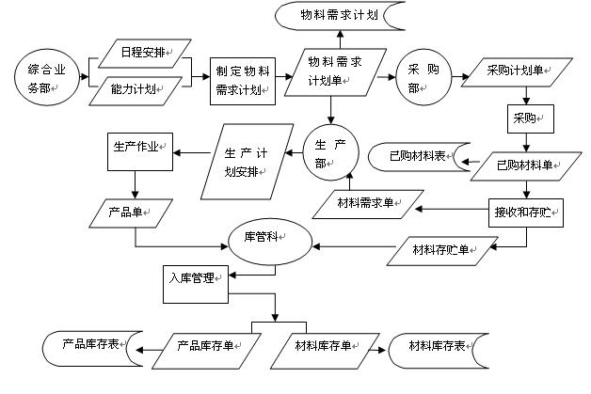

图 1 业务流程图实例

**2、销售系统数据流程图**

1

|  |  |  |  |  |  |  |  |  |  |  |  |  |  |
| --- | --- | --- | --- | --- | --- | --- | --- | --- | --- | --- | --- | --- | --- |
|  |  |  |  |  | 订单 | |  | 备货单 | |  |  |  |  |
|  |  |  |  |  |  |  | 仓库 | |  |
|  |  |  |  |  |  |  |  |
|  | 顾客 | |  |  |  |  |  |  |  |  |  |
|  |  |  |  |  |  |  |  |  |  |  |  |
|  |  |  |  |  |  |  |  |  |  |  |  |  |  |
|  |  |  |  |  |  |  | 销售管 | | | |  |  |  |
|  |  |  |  |  |  |  |  |  |  |
|  |  |  |  |  |  |  |  |  |  |
|  |  |  |  |  |  |  |  |  |  |
|  |  |  |  |  | 进货通知单 | | 理系统 | | |  |  |  |  |
|  |  |  |  |  |  |  |  |  |
|  |  |  |  |  |  | 统计表 | |  | 经理 | |  |
|  | 采购 | |  |  |
|  |  |  |  |  |  |  |  |  |  |
|  |  |  |  |  |  |  |  |  |  |
|  | 部门 | |  |  | 缺货通知单 | |  |  |  |  |  |  |  |
|  |  |  |  |  |  |  |  |
|  |  |  |  |  |  |  |  |  |  |  |  |  |  |
|  |  |  |  |  |  |  |  |  |  |  |  |  |  |

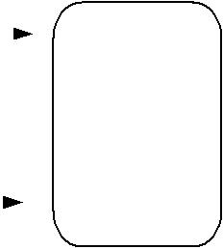

图 2 销售系统关联图

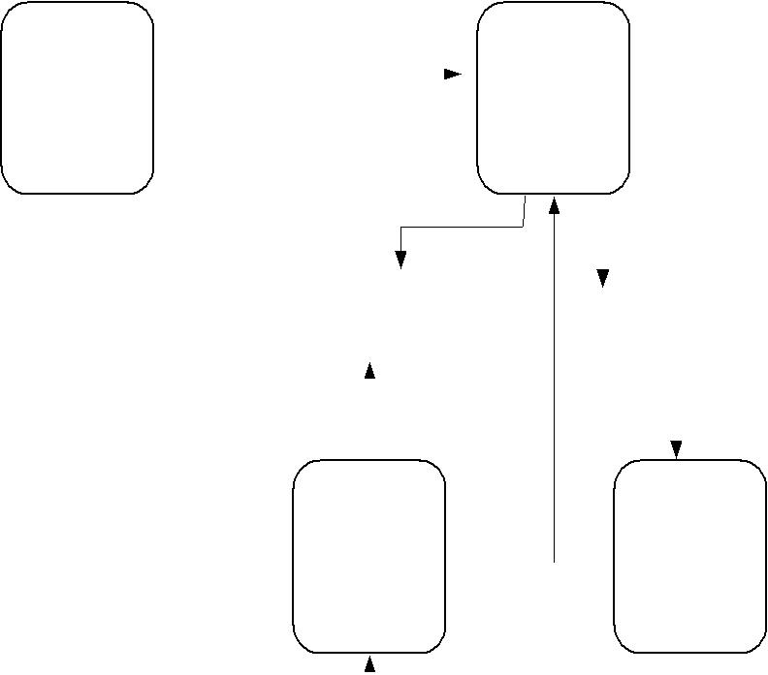

|  |  |  |  |  |  |  |  |  |  |  |  |  |
| --- | --- | --- | --- | --- | --- | --- | --- | --- | --- | --- | --- | --- |
| 订单 | | P1 | |  | 可供货单 | | | P2 | |  | 备货单 |  |
|  |  | 处理 | |  |  |  |  | 供货 | |  |  |  |
|  |  |  |  |  |  |  |  |  |
|  |  | 订单 | |  |  |  |  | 处理 | |  |  |  |
|  |  |  |  |  |  |  |  |  |
|  |  |  |  |  |  |  |  |  |  |  |  |  |
|  |  |  |  |  |  |  |  |  |  |  |  |  |
|  |  |  |  |  |  |  |  |  |  |  |  |  |



|  |  |  |  |  |  |  |  |  |  |  |  |  |  |  |  |  |  |  |  |  |  |  |  |  |
| --- | --- | --- | --- | --- | --- | --- | --- | --- | --- | --- | --- | --- | --- | --- | --- | --- | --- | --- | --- | --- | --- | --- | --- | --- |
| D2 | 缺货记录 | | | |  | | D1 | | | 库存记录 | | |  | |  |  |  |  |  |  |  |  |  |  |
|  | D3 | | 订单记录 | | | | | |  |
|  |  |  |  |  |  |  |  |  |  |  |  |  |  |  |  |  |  |  |  |  |  |  |  |  |
|  |  |  |  |  |  |  |  |  |  |  |  |  |  |  |  |  |  |  |  |  |  |  |  |  |
|  |  |  |  |  |  |  |  |  |  |  |  |  |  |  | 进 | | |  |  |  |  |  |  |  |
|  |  |  |  |  |  |  |  |  |  |  |  |  |  |  |  |  |  |  |  |  |  |
|  |  |  |  |  |  |  |  |  |  |  |  |  |  |  |  |  |  |  |  |  |  |
|  |  |  |  |  |  |  |  |  |  |  |  |  |  |  | 货 | | |  |  |  |  |  |  |  |
|  |  |  |  |  |  |  |  |  |  |  |  |  |  |  |  |  |  |  |  |  |  |
|  |  |  |  |  |  |  |  |  |  |  |  |  |  |  |  |  |  |  |  |  |  |
|  | P4 | | |  |  | |  |  |  | P3 | | | | | 统 | | | P5 | | | | | |  |
|  |  |  |  |  |  |  |  |  |  |  |  |  |  |  | 计 | |  |  |  |  |  |  |  |  |
| 缺货 | | | |  |  |  |  |  |  |  |  |  |  |  |  |  |  |  |  |  |  |
|  |  |  |  |  |  | 处理进 | |  |  |  |  | 销售 | | | | | |  |
|  |  | |  |  |  |  | | | 单 | | |  |
|  |  | |  |  |  |  | | |  |
| 统计 | | | | | | |  |  |  | 货单 | | | | |  |  |  | 统计 | | | | | |  |
|  |  | 缺货通知单 | | | | |  |  |  |  | 进货通知单 | | | |  |  |  |  |  | 统计表 | | | |  |
|  |  |  |  |  |  |  |  |  |  |  |  |
|  |  |  |  |  |  |  |  |  |  |  |  |
|  |  |  |  |  |  |  |  |  |  |  |  |  |  |  |  |  |  |  |  |  |  |  |  |  |
|  |  |  |  |  |  |  |  |  |  |  |  |  |  |  |  |  |  |  |  |  |  |  |  |  |

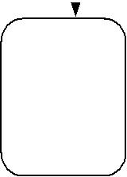

图 3 销售系统顶层数据流程图

|  |  |  |  |  |  |  |  |  |  |  |  |  |  |  |  |
| --- | --- | --- | --- | --- | --- | --- | --- | --- | --- | --- | --- | --- | --- | --- | --- |
| 订单 | | P1.1合格订单 | | | | P1.2库存单 | | | | | | P1.3可供货订单 | | |  |
|  |  |  |  |  |  |  |  |  |  |  |  |  |  |  |  |
|  |  | 检验 | | | | 检阅 | | | | | | 确定能 | | |  |
|  |  | 订单 | | | | 库存 | | |  | |  | 否供货 | | |  |
|  |  | 订货单 | | |  |
|  |  |  |  |  |  |  |  |  |  |  |  |  |

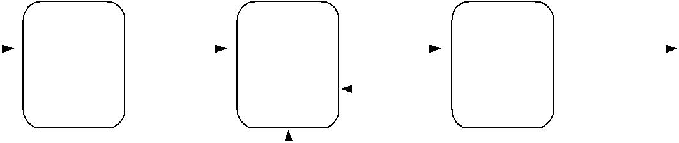

|  |  |  |  |  |  |  |  |  |
| --- | --- | --- | --- | --- | --- | --- | --- | --- |
|  |  |  |  |  |  |  |  |  |
|  |  |  |  |  |  |  |  |  |
|  |  |  |  |  |  |  |  |  |
| D1 | 库存记录 | | |  | D2 | 缺货记录 | |  |
|  |  |  |  |  |  |  |  |  |



图 4 处理订单一层数据流程图

2

|  |  |  |  |  |  |  |  |  |  |
| --- | --- | --- | --- | --- | --- | --- | --- | --- | --- |
| 可供货订单 | | P2.1登记过的订 | | | | P2.2 | | 备货单 |  |
|  |  | 单 |  |  |  |  |  |
|  |  |  |  |  |  |  |  |  |
|  |  | 根据订货单 | | | | 开备货单 | |  |  |
|  |  | 修改库存 | | | |  |  |
|  |  |  |  |  |  |

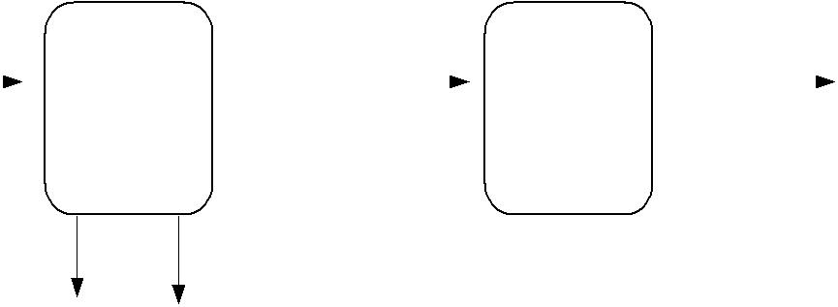

|  |  |  |  |  |  |  |
| --- | --- | --- | --- | --- | --- | --- |
| D1 | 库存记录 |  |  | D2 | 缺货记录 |  |
|  |  |  |  |  |  |  |

图 5 供货处理一层数据流程图

|  |  |  |  |  |  |  |  |  |  |  |  |  |  |  |  |  |  |  |  |  |  |  |  |  |  |  |
| --- | --- | --- | --- | --- | --- | --- | --- | --- | --- | --- | --- | --- | --- | --- | --- | --- | --- | --- | --- | --- | --- | --- | --- | --- | --- | --- |
| 进货通知单 | | |  |  | P3.1 | |  |  |  | 核对后的 | |  |  | P3.2 | | | | 可供货订单 | | | | | | | |  |
|  |  |  |  |  | 进货单 | |  |  |  |  |  |  |  |  |  |  |  |
|  |  |  |  |  |  |  |  |  |  |  |  |  |  |  |  |
|  |  |  |  |  |  |  |  |  |  |  |  |  |  |  |  |  |  |  |  |  |  |  |  |  |
|  |  |  |  | 根据供货单 | | |  | 处理缺货 订单变更信息 | | | | | | | | | | | | |  |
|  |  |  |  |  |  |  |  |  |  |  |
|  |  |  |  |  |  |  |  |  |  |  |
|  |  |  |  | 修改库存 | | |  |  |  |  |  |  |  | 订单 | | |  |  |  |  |  |  |  |  |  |  |
|  |  |  |  |  |  |  |  |  |  |  |  |  |  |  |  |  |  |  |  |  |
|  |  |  |  |  |  |  |  |  |  |  |  |  |  |  |  |  |  |  |  |  |  |  |  |  | |  |
|  |  |  |  |  |  |  |  |  |  |  |  |  |  |  |  |  |  |  |  |  |  |  | P3.3 | | |  |
|  |  |  |  |  |  |  |  |  |  |  |  |  |  |  |  |  |  |  |  |  |  |  |  |
|  |  |  |  |  |  |  |  |  |  |  |  |  |  |  |  |  |  |  |  |  |  |  |  |  |  |  |
|  |  |  |  |  |  |  |  |  |  |  |  |  |  |  |  |  |  |  |  |  |  |  | 修改缺货记 | | |  |
|  |  |  | D1 | | 库存记录 | |  |  |  |  |  | D2 | | 缺货记录 | | | |  |  |
|  |  |  |  |  |  |  |  |  |  |  |  |  |  | 录 | |  |
|  |  |  |  |  |  |  |  |  |  |  |  |  |  |  |
|  |  |  |  |  |  |  |  |  |  |  |  |  |  |  |  |  |  |  |  |  |  |  |  |  |
|  |  |  |  |  |  |  |  |  |  |  |  |  |  |  |  |  |  |  |  |  |  |  |  |  |  |  |

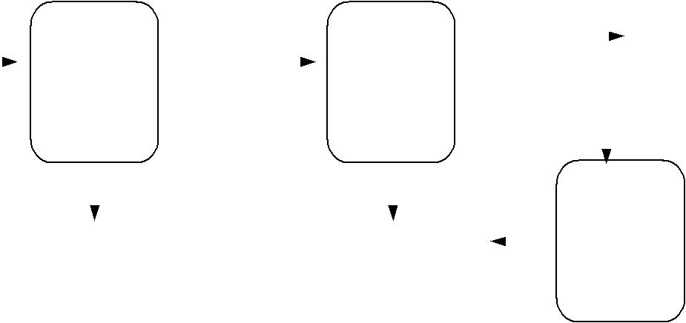

图 6 处理进货一层数据流程图

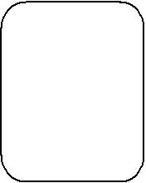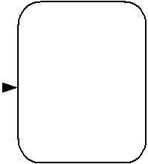

|  |  |  |  |  |  |  |  |  |  |  |  |  |  |
| --- | --- | --- | --- | --- | --- | --- | --- | --- | --- | --- | --- | --- | --- |
|  |  |  |  |  | P4.1 |  |  |  | P4.2 | | | |  |
|  |  |  |  |  |  |  | 缺货量 | |  |  | 缺货通知单 | |  |
|  |  |  |  |  | 汇总各项 |  | 打印缺货 | |  |
| D1 | 缺货记录 |  |  |  |  |  |
|  |  |  |  |  |  |  |
|  |  |  |  |  |  |  |  |  |
|  |  |  |  |  |  |  |  |
|  |  |  |  |  | 缺货量 |  |  |  | 通知单 | | | |  |
|  |  |  |  |  |  |  |



图 7 缺货统计一层数据流程

.

3

顾客地区 P5.2

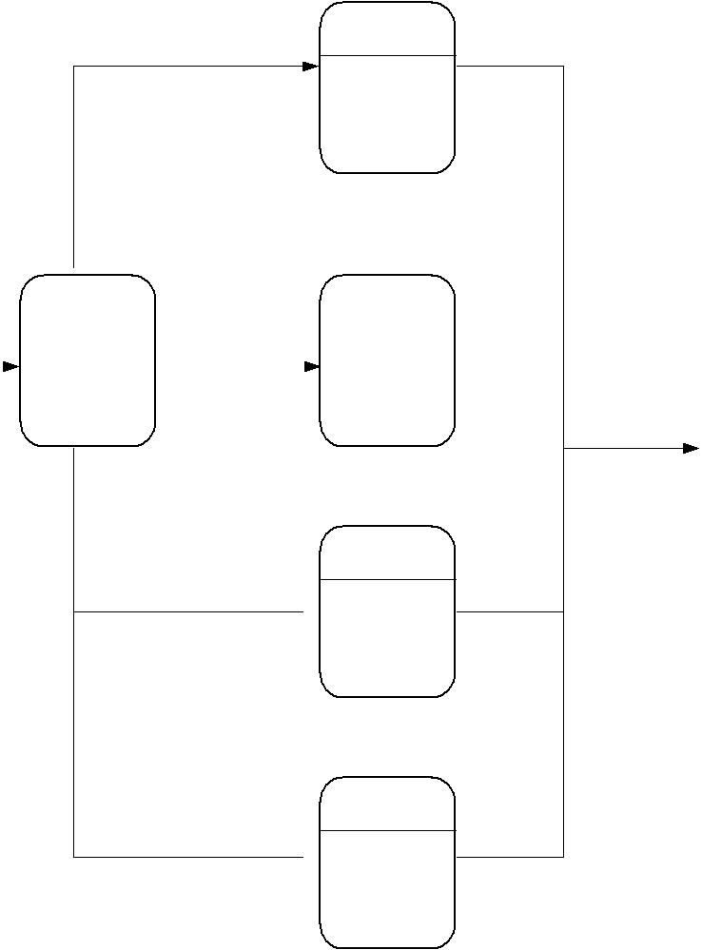

按顾客所

在地统计

|  |  |  |  |  |  |  |  |  |  |  |  |  |  |  |
| --- | --- | --- | --- | --- | --- | --- | --- | --- | --- | --- | --- | --- | --- | --- |
|  |  |  |  |  |  | P5.1 | | 日期 | | P5.3 | |  |  |  |
|  |  |  |  |  |  |  |  |  |  |  |  |  |
|  |  |  |  |  |  | 统计 |  |  |  |  |  |  |
| D3 | 订单记录 |  |  |  |  |  |  |  |  |  |  |  |  |
|  |  |  |  |  |  |  | 按销售日 | |  |  |  |
|  |  |  |  |  |  | 选择 | |  |  |  |  |  |
|  |  |  |  |  |  |  |  | 期统计 | |  | 统计表 |  |
|  |  |  |  |  |  |  |  |  |  |  |  |
|  |  |  |  |  |  |  |  |  |  |  |  |  |  |

P5.4

货物

按销售货物

名统计

顾客名 P5.5

 按顾客名

统计

图 8 销售统计一层数据流程

**第二部分：实验报告**

完成本次实验的报告，写清实验步骤及实验结果。





4

图 1 业务流程图



图 2 销售系统关联



图 3 销售系统顶层数据流程图



图 4 处理订单一层数据流程图



图 5 供货处理一层数据流程图



图 6 处理进货一层数据流程图

图 8 销售统计一层数据流程

图 7 缺货统计一层数据流程

**实验二 面向对象方法进行系统分析与设计**

**实验目标:**

**（1）熟悉用例图、活动图、顺序图及类图的基本功能和使用方法。**

**（2）掌握如何使用 Microsoft Visio 建模工具绘制用例图、活动图、顺序图及类图的方法。**

**第一部分：完成如下实验内容**

**1.图书借阅管理用例图**

借阅者

教师 学生

图书借阅管理

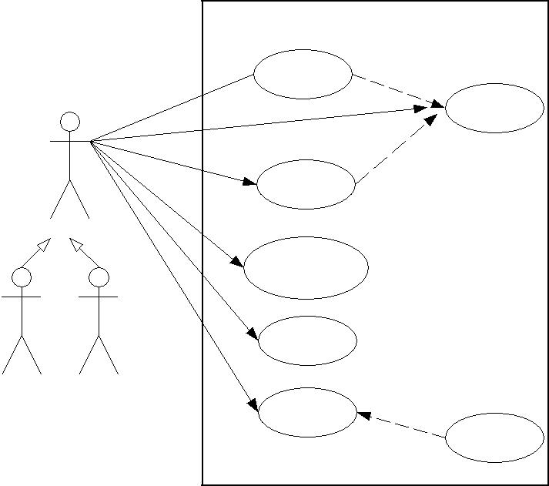

书籍查询 《include》

登录系统

》

include

《

书籍预订

查询借阅信息

借书

|  |  |  |  |
| --- | --- | --- | --- |
|  | 《extend | 》 |  |
| 还书 |  |  |
|  |  |  |

交纳罚金

图 1 图书借阅管理用例图

**2．网上选课系统学生用例图**

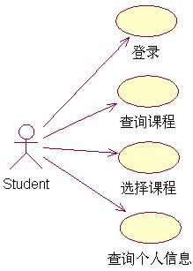

图 2 网上选课系统学生用例图

5

**3．网上选课系统管理员用例图**

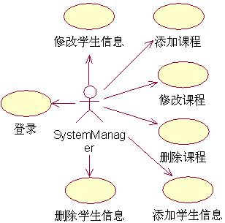

图 3 网上选课系统管理员用例图

**4．学生查询课程活动图**

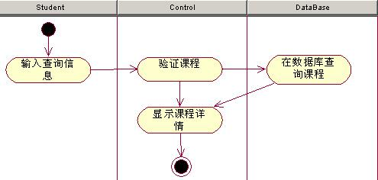

图 4 学生查询课程活动图

**5．学生选课活动图**

6

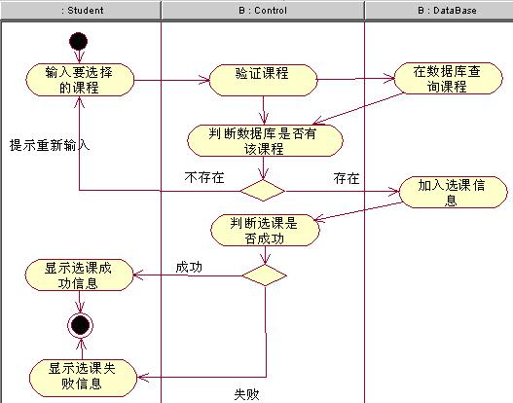

图 5 学生选课活动图

**6．系统管理员添加选修课程活动图**

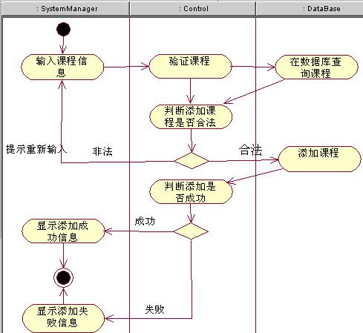

图 6 系统管理员添加选修课程活动图

7

**7．系统管理员修改课程活动图**

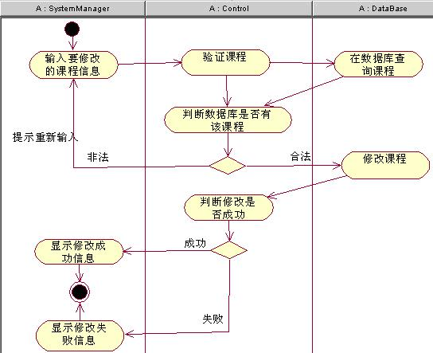

图 7 系统管理员修改课程活动图

**8．学生登录选课系统顺序图**

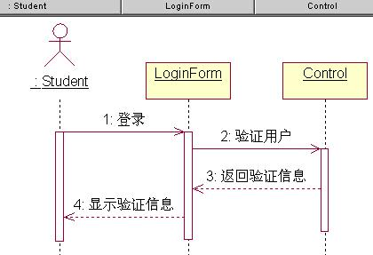

图 8 学生登录选课系统顺序图

8

**9．学生查询选修课的顺序图**

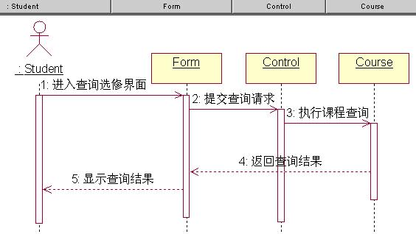

图 9 学生查询选修课的顺序图

**10．学生选课用例顺序图**

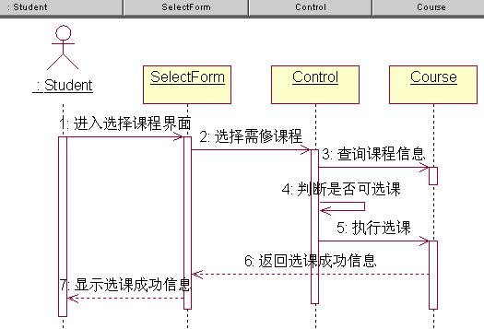

图 10 学生选课用例顺序

**11．学生查询个人信息用例图**

9

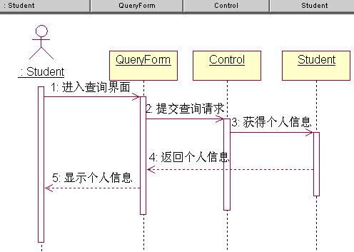

图 11 学生查询个人信息用例图

**12．系统管理员添加选修课程顺序图**

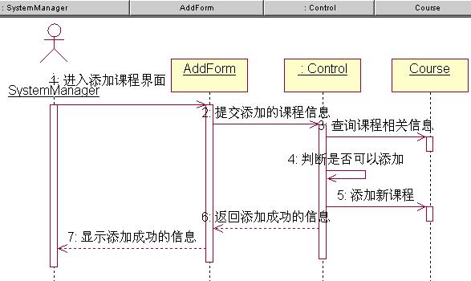

图 12 系统管理员添加选修课程顺序图

**13．系统管理员修改选修课程顺序图**

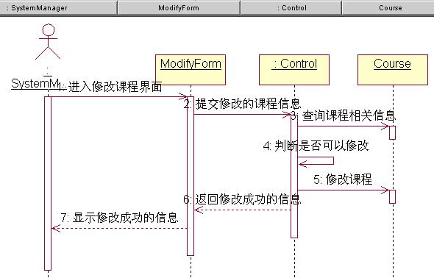

图 13 系统管理员修改选修课程顺序图

10

**14．系统管理员删除选修课程顺序图**

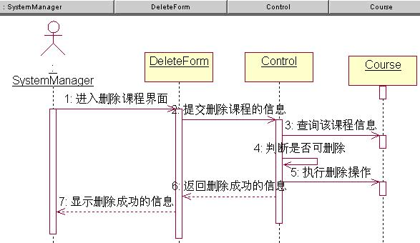

图 14 系统管理员删除选修课程顺序图

**15．图书馆管理系统类图实例**

|  |  |  |  |  |  |  |  |  |  |  |  |  |  |  |  |  |  |  |  |  |  |  |  |  |  |  |
| --- | --- | --- | --- | --- | --- | --- | --- | --- | --- | --- | --- | --- | --- | --- | --- | --- | --- | --- | --- | --- | --- | --- | --- | --- | --- | --- |
|  |  |  |  |  |  |  |  |  |  |  |  | *被预定* | | | | | |  |  |  | 预定记录 | | | |  |  |
|  |  |  |  |  |  |  |  |  |  |  |  |  |  |  | 预定日期 | | | |  |  |
|  |  |  |  |  |  |  |  | **1** |  |  |  |  |  |  |  |  |  |  | **\*** | |  |  |
|  |  |  |  |  |  |  |  |  |  |  |  |  |  |  |  |  |  |  |  |  |  |  |
|  |  |  |  |  |  | | |  |  |  |  |  |  |  |  |  |  |  |  |  |  |  |  |  |  |  |
|  |  |  |  |  | *馆藏资源品种* | | | |  |  |  |  |  |  |  |  |  |  |  |  |  |  |  | **\*** |  |  |
|  |  |  |  |  | 资源名称 | | | |  |  |  |  |  |  |  |  |  |  |  |  |  |  |  |  |  |  |
|  |  |  |  |  |  |  |  |  | 资源项 | |  |  |  |  |  |  |  |  |  |
|  |  |  |  |  | 国际出版号 | | | |  |  |  | *拥有* |  |  |  |  |  |  |  |  |  |  |  |  |
| 馆藏目录 |  |  |  |  | 价格 | |  |  |  |  |  |  |  |  | 馆藏流水号 | |  |  |  |  |  |  |  |  |  |
|  |  |  |  |  |  |  |  |  |  |  |  |  |  |  |  |  |  |  |  |  |  |
|  | **1** | **1..\*** | | | 简介 | |  |  |  | **1** |  |  | **\*** | |  | 状态 | |  |  |  |  |  |  |  |  |  |
|  |  |  |  |  | 馆藏数量 | | | |  |  |  |  |  |  |  |  |  |  |  |  |  |  |  | **1** |  |  |
|  |  |  |  |  | 可借数量 | | | |  |  |  |  |  | |  |  | **1** |  |  |  |  |  |  |  |  |  |
|  |  |  |  |  |  |  |  |  |  |  | 读者 | |  |  |
|  |  |  |  |  |  |  |  |  |  |  |  |  |  |  |  |  | **0..1** |  |  |  | 姓名 | | | |  |  |
|  |  |  |  |  |  |  |  |  |  |  |  |  |  |  |  | 借书记录 | |  |  |  | 身份证号 | | | |  |  |
|  |  |  |  |  |  |  |  |  |  |  |  |  |  |  |  | 借书日期 | |  |  |  | 借书卡号 | | | |  |  |
|  | 碟片品种 | | | | |  |  | 图书品种 | | |  |  |  |  | **\*** | 归还日期 | |  |  |  | 图书限额 | | | |  |  |
|  | 碟片类型 | | | | |  | 作者 | |  |  |  | *登记* |  | |  |  |  | 已借图书数 | | | |  |  |
|  |  |  |  |  |  |  |  |  |  |  |  |  |  |  |
|  | 碟片数 | | | | |  | 出版社 | |  |  |  |  |  |  |  |  |  |  |  | 碟片限额 | | | |  |  |
|  | 制作公司 | | | | |  | 出版日期 | | | |  |  |  | | | | **1** |  |  |  | 已借碟片数 | | | |  |  |
|  |  |  |  |  |  |  |  |  |  |  |  |  |  |
|  |  |  |  |  |  |  |  |  |  |  |  | **1** |  | | | | **0..1** |  |  |  |  |  |  |  |  |  |
|  |  |  |  |  |  |  |  |  | 图书管理员2 | | | |  |  |  | 逾期记录 | |  | *使用* | |  |  | 罚款细则 | |  |  |
|  |  |  |  |  |  |  |  |  | 职工号 | | |  |  |  |  | 逾期天数 | | **\*** | 0..1 | | | |  |  |  |  |
|  |  |  |  |  |  |  |  |  | 姓名 | | |  |  |  |  |  |  |  |  |  |  |  |  |  |  |  |
|  |  |  |  |  |  |  |  |  |  |  |  |  |  |  |  |  |  |  |  |  |  |  |  |  |  |  |



图 15 图书馆管理系统类图实例

**第二部分：实验报告**

完成本次实验的报告，写清实验步骤及实验结果。

11





图1

图2





图3

图4





图6



图7





图8

图9





图10

图11





图12

图13



